**数据库设计文档**

1. **数据库总体设计图**

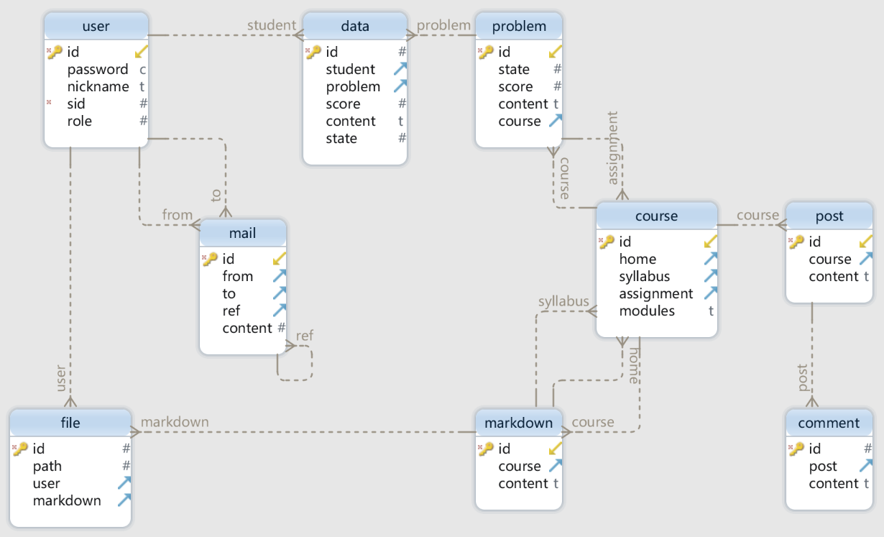

1. **数据表详细设计图**

**Table comment**

此数据表存储评论内容

|  |  |  |  |
| --- | --- | --- | --- |
| **Idx** | **Field Name** | **Data Type** | **Description** |
| * | id | int AUTOINCREMENT | 评论ID |
|  | post | int | 评论属于哪一个帖子的ID |
|  | content | varchar( 1024 ) | 评论的内容 |
| **Indexes** | | | |
|  | pk_comment_id | ON id |  |
| **Foreign Keys** | | | |
|  | fk_comment_post | ( post ) ref post (id) |  |

**Table course**

此数据表存储课程信息

|  |  |  |  |
| --- | --- | --- | --- |
| **Idx** | **Field Name** | **Data Type** | **Description** |
| * | id | int AUTOINCREMENT | 课程ID |
|  | home | int | 课程本周教学内容的文本资源ID |
|  | syllabus | int | 课程大纲文本资源ID |
|  | assignment | int | 课程当前激活的作业的问题ID |
|  | modules | varchar( 512 ) | 课程的模块结构与对应资源ID，JSON格式 |
| **Indexes** | | | |
|  | pk_course_id | ON id |  |

|  |  |  |  |
| --- | --- | --- | --- |
| **Idx** | **Field Name** | **Data Type** | **Description** |
| **Foreign Keys** | | | |
|  | fk_course_markdown_h | ( home ) ref markdown (id) |  |
|  | fk_course_markdown_s | ( syllabus ) ref markdown (id) |  |
|  | fk_course_problem | ( assignment ) ref problem (id) |  |

**Table data**

此数据表存储学生回答老师问题的记录

|  |  |  |  |
| --- | --- | --- | --- |
| **Idx** | **Field Name** | **Data Type** | **Description** |
| * | id | int AUTOINCREMENT | 回答记录ID |
|  | student | int | 学生ID |
|  | problem | int | 问题ID |
|  | score | int | 得分 |
|  | content | varchar( 1024 ) | 回答内容 |
|  | state | int | 当前回答状态 |
| **Indexes** | | | |
|  | pk_data_id | ON id |  |
| **Foreign Keys** | | | |
|  | fk_data_problem | ( problem ) ref problem (id) |  |
|  | fk_data_user | ( student ) ref user (id) |  |

**Table file**

此数据表存储上传文件信息

|  |  |  |  |
| --- | --- | --- | --- |
| **Idx** | **Field Name** | **Data Type** | **Description** |
| * | id | int AUTOINCREMENT | 文件ID |
|  | path | int | 文件在服务器上的 URL |
|  | user | int | 上传此文件用户ID |
|  | markdown | int | 此文件附属于的文本资源ID |
| **Indexes** | | | |
|  | pk_file_id | ON id |  |
| **Foreign Keys** | | | |
|  | fk_file_user | ( user ) ref user (id) |  |
|  | fk_file_markdown | ( markdown ) ref markdown (id) |  |

**Table mail**

此数据表存储用户间来往邮件

|  |  |  |  |
| --- | --- | --- | --- |
| **Idx** | **Field Name** | **Data Type** | **Description** |
| * | id | int AUTOINCREMENT | 邮件主键 |
|  | from | int | 寄件人ID |
|  | to | int | 收件人ID |
|  | ref | int | 回复邮件ID |
|  | content | int | 邮件内容 |
| **Indexes** | | | |

|  |  |  |  |
| --- | --- | --- | --- |
| **Idx** | **Field Name** | **Data Type** | **Description** |
|  | pk_mail_id | ON id |  |
| **Foreign Keys** | | | |
|  | fk_mail_mail | ( ref ) ref mail (id) |  |
|  | fk_mail_user | ( from ) ref user (id) |  |
|  | fk_mail_user_to | ( to ) ref user (id) |  |

**Table markdown**

存储文本资源

|  |  |  |  |
| --- | --- | --- | --- |
| **Idx** | **Field Name** | **Data Type** | **Description** |
| * | id | int AUTOINCREMENT | 文本资源ID |
|  | course | int | 文本资源属于哪一个课程ID |
|  | content | varchar( 1024 ) | 文本资源的内容 |
| **Indexes** | | | |
|  | pk_markdown_id | ON id |  |
| **Foreign Keys** | | | |
|  | fk_markdown_course | ( course ) ref course (id) |  |

**Table post**

此数据表存储帖子

|  |  |  |  |
| --- | --- | --- | --- |
| **Idx** | **Field Name** | **Data Type** | **Description** |
| * | id | int AUTOINCREMENT | 帖子ID |
|  | course | int | 帖子属于哪一个课程的ID |
|  | content | varchar( 1024 ) | 帖子的具体内容 |
| **Indexes** | | | |
|  | pk_post_id | ON id |  |
| **Foreign Keys** | | | |
|  | fk_post_course | ( course ) ref course (id) |  |

**Table problem**

此数据表存储问题，可以用考试或作业

|  |  |  |  |
| --- | --- | --- | --- |
| **Idx** | **Field Name** | **Data Type** | **Description** |
| * | id | int AUTOINCREMENT | 问题ID |
|  | state | int | 问题当前的状态 |
|  | score | int | 满分得分 |
|  | content | varchar( 1024 ) | 问题内容，JSON 格式 |
|  | course | int | 问题属于的课程ID |
| **Indexes** | | | |
|  | pk_problem_id | ON id |  |
| **Foreign Keys** | | | |
|  | fk_problem_course | ( course ) ref course (id) |  |

**Table user**

用户数据表

|  |  |  |  |
| --- | --- | --- | --- |
| **Idx** | **Field Name** | **Data Type** | **Description** |
| * | id | int AUTOINCREMENT | 用户ID |
|  | password | char( 32 ) | 加密后的密码 |
|  | nickname | varchar( 100 ) | 用户昵称 |
| * | sid | int | 用户学号 / 教师工号 |
|  | role | int | 用户角色：学生、老师、管理员 |
| **Indexes** | | | |
|  | pk_table_id | ON id |  |

1. **数据流图设计**
   1. **顶层数据流图**

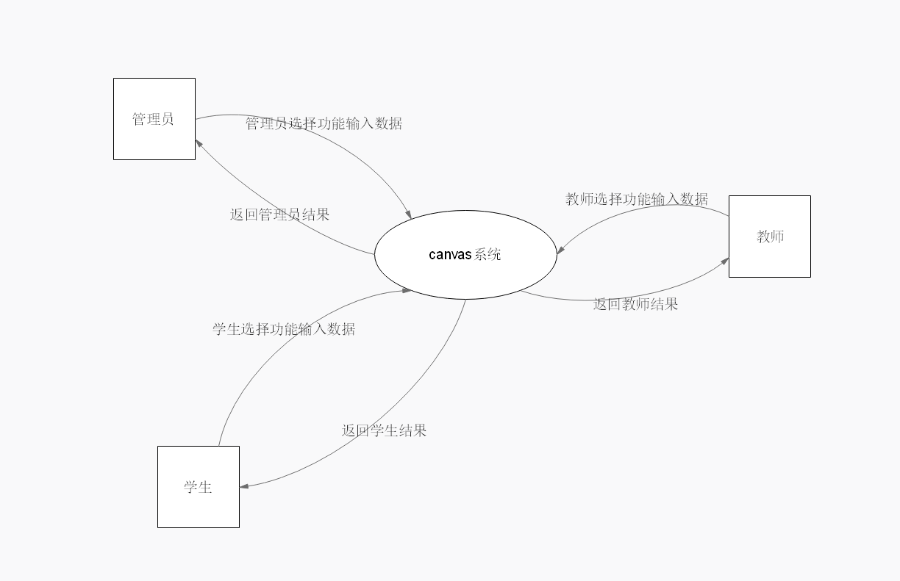

* 1. **0层数据流图**

