SUPERSTORE Data Analysis Report

Compiled by
Name: Nduvah Wilfred Kamau
Email: Wnduvah@gmail.com
Nationality: Kenyan
Languages: English, Kiswahili

1. Executive Summary
An analysis of the Superstore dataset was conducted to understand company revenue, product performance, and regional profitability. The analysis shows that the Technology category generated the highest revenue and profit, with Phones being the most frequently sold product. Furniture recorded relatively high sales but lower profitability compared to other categories.
Regionally, the West generated the highest revenue and overall profit, while the South region experienced the lowest profitability, with several orders generating negative profit. High discounts were identified as a major factor reducing profitability in certain regions and product categories.
Sub-category analysis revealed that Copiers generated the highest sales and profits per sale, while categories such as Tables, Bookcases, and Supplies recorded negative profit margins in several transactions.

2. Problem Statement / Objective
The objective of this analysis was to evaluate business performance using the Superstore sales dataset and answer key business questions related to revenue generation, product performance, and regional sales trends.
- Total company sales revenue
- Total company profit
- Average order value
- Highest performing product categories and sub-categories
- Regional sales and profitability
- Identification of underperforming products and regions

3. Data Overview
The dataset used in this analysis was obtained from Kaggle (Superstore Sales Dataset). It contains transactional retail data from the United States.
Dataset characteristics:
- Number of rows: 9,995
- Columns include: Ship Mode, Segment, Country, City, State, Postal Code, Region, Category, Sub-Category, Sales, Quantity, Discount, Profit
- Each row represents a product order transaction

4. Data Cleaning & Preparation
The dataset was inspected for missing values, duplicates, and irrelevant fields before analysis.
- No missing values were detected in the dataset.
- A small number of duplicate records (<10) were identified.
- The 'Country' column was removed because all observations belonged to the same country.
- The 'Postal Code' column was removed as it did not contribute to the analysis.

5. Exploratory Data Analysis (EDA)

5.1 Category and Sub-Category Performance
The Technology category generated the highest overall revenue and profit. Phones were the most frequently sold items in this category. Furniture generated strong sales but comparatively lower profit margins.
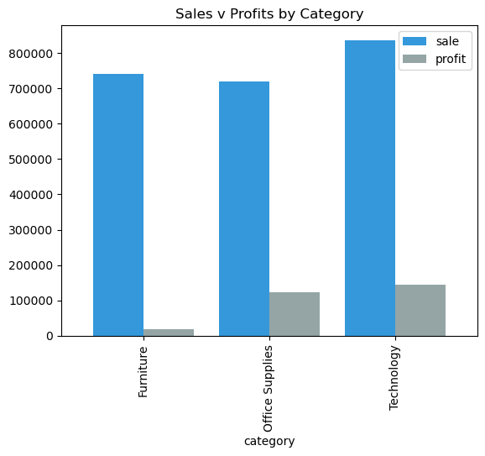

5.2 Product Performance
Copiers generated the highest sales and profit per sale among sub-categories. In contrast, products such as Tables, Bookcases, and Supplies recorded several transactions with negative profit margins.
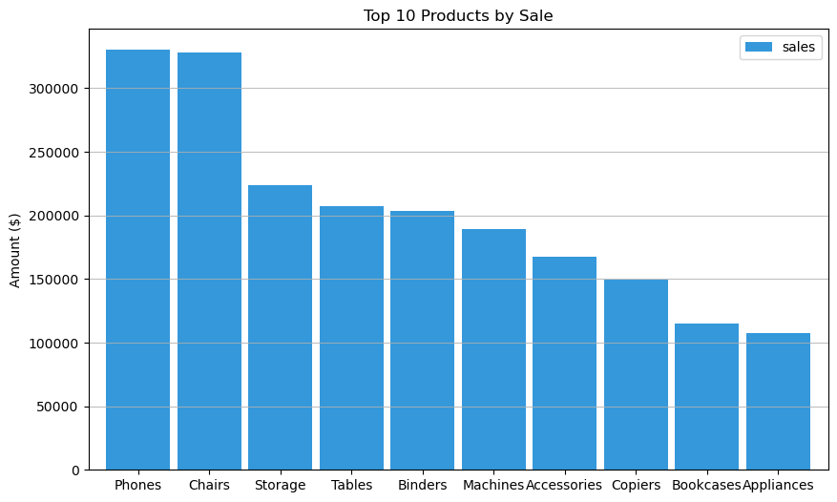

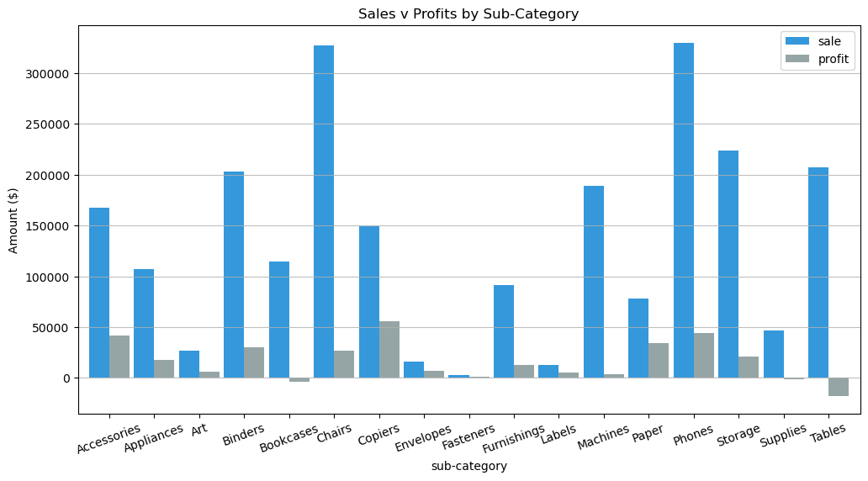

5.3 Regional and State Performance
The West region generated the highest total revenue and profit. The South region recorded the lowest profitability, with several orders producing negative profits. High discount levels contributed significantly to these losses.
At the state level, California generated the highest total sales, while states such as Wyoming, Washington, South Carolina, and North Carolina produced significantly lower sales volumes.
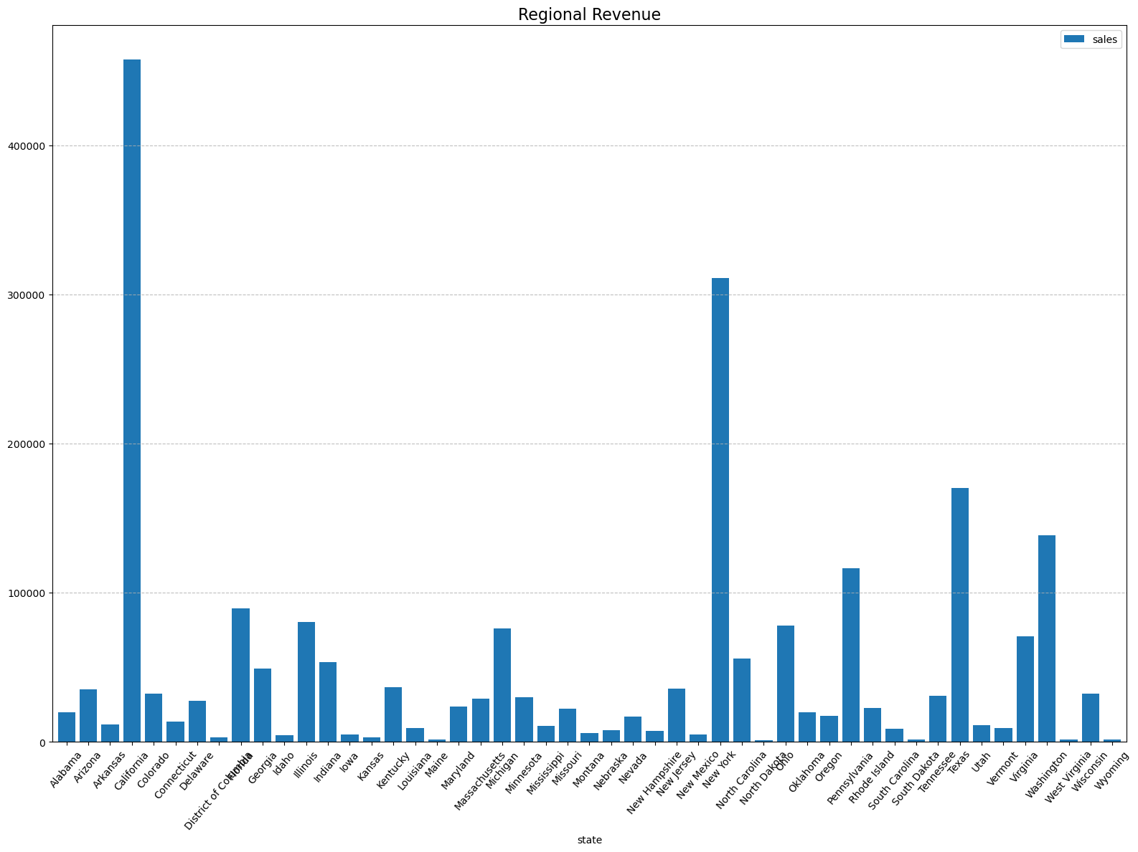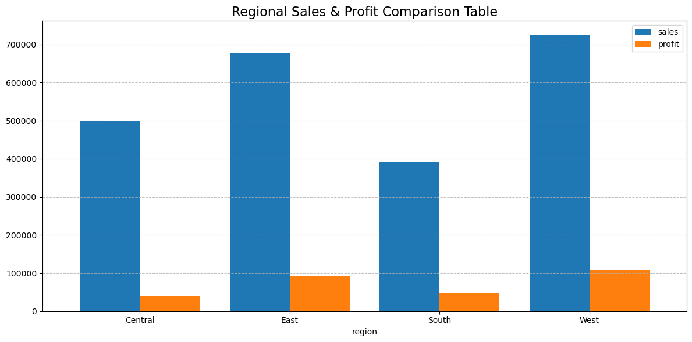

6. Key Insights
- Technology is the most profitable product category.
- Furniture produces strong sales but lower profit margins.
- Copiers are the most profitable sub-category per transaction.
- High discount levels reduce profitability in several regions.
- The West region is the strongest performing market.

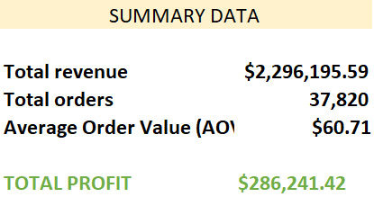

7. Recommendations
- Review discount policies, particularly in the South region where discounts significantly reduce profit margins.
- Focus marketing and sales strategies on high-performing categories such as Technology.
- Re-evaluate pricing and discount strategies for loss-making products such as Tables and Bookcases.
- Increase investment in high-performing regions such as the West and East markets.
- Promote high-margin products such as Copiers and Phones.

8. Conclusion
The company demonstrates strong sales performance but relatively lower profitability in certain categories and regions due to discount strategies and loss-making products. By focusing on high-performing product categories, optimizing discount policies, and reducing the impact of unprofitable items, the company can significantly improve overall profit margins and operational efficiency.

