Problem Statement
Our global e-commerce company is experiencing inconsistent revenue performance across regions, product categories, and customer segments. While overall sales volume is growing, profitability and customer purchasing behaviour vary significantly.
Management wants a data-driven assessment of:
- Revenue concentration
- Regional performance differences
- Product category effectiveness
You are tasked with analysing transactional sales data to identify the key drivers of revenue performance and variation.

About Dataset
Brazilian E-Commerce Public Dataset by Olist
Welcome! This is a Brazilian ecommerce public dataset of orders made at Olist Store. The dataset has information of 100k orders from 2016 to 2018 made at multiple marketplaces in Brazil. Its features allow viewing an order from multiple dimensions: from order status, price, payment and freight performance to customer location, product attributes and finally reviews written by customers. We also released a geolocation dataset that relates Brazilian zip codes to lat/lng coordinates.
This is real commercial data, it has been anonymised, and references to the companies and partners in the review text have been replaced with the names of Game of Thrones great houses.
Join it With the Marketing Funnel by Olist
We have also released a Marketing Funnel Dataset. You may join both datasets and see an order from Marketing perspective now!

Context
This dataset was generously provided by Olist, the largest department store in Brazilian marketplaces. Olist connects small businesses from all over Brazil to channels without hassle and with a single contract. Those merchants are able to sell their products through the Olist Store and ship them directly to the customers using Olist logistics partners. See more on our website: www.olist.com
After a customer purchases the product from Olist Store a seller gets notified to fulfill that order. Once the customer receives the product, or the estimated delivery date is due, the customer gets a satisfaction survey by email where he can give a note for the purchase experience and write down some comments.
Attention
- An order might have multiple items.
- Each item might be fulfilled by a distinct seller.
- All text identifying stores and partners were replaced by the names of Game of Thrones great houses.

Data Schema

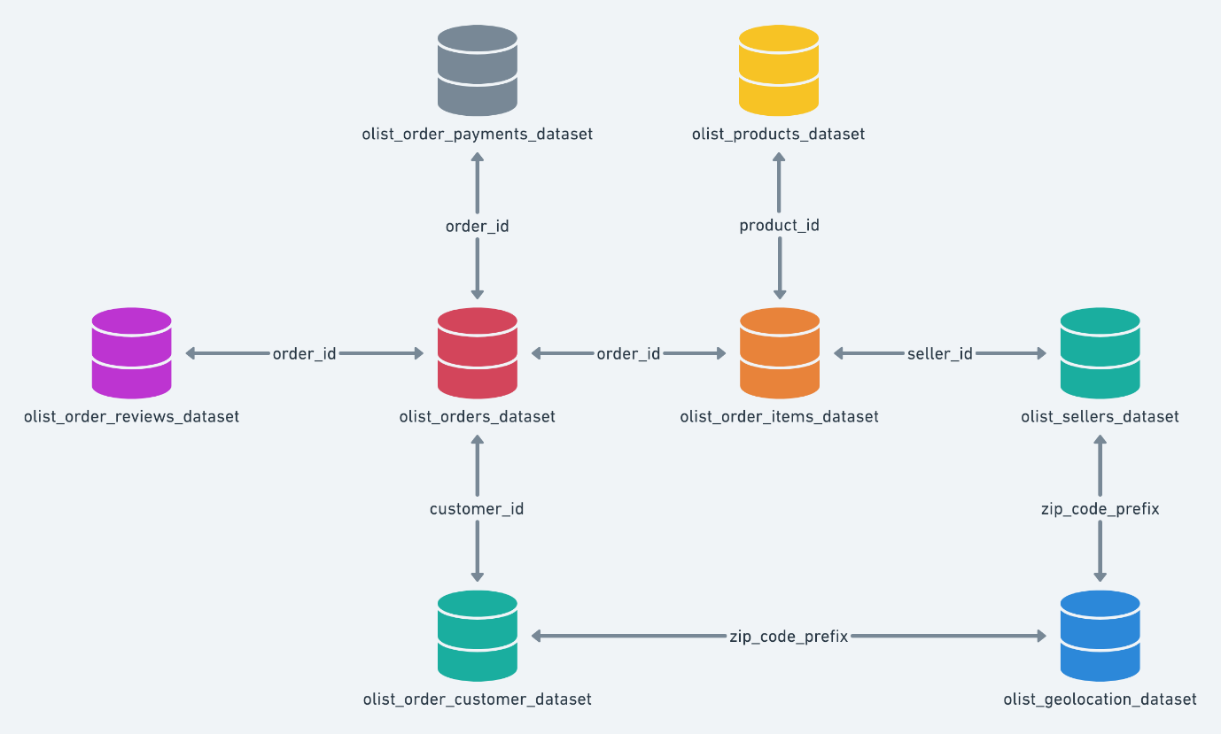

Acknowledgements
Thanks to Olist for releasing this dataset.

OLIST EDA FRAMEWORK
- 💰 Business KPIs
- What is total revenue over time?
- What is distribution of order values?
- Which products/categories generate most revenue?
- Which sellers generate most revenue?
- How concentrated is revenue (top 10%)?
Freight charges were excluded from revenue calculations to focus on product-level revenue performance, isolating the value generated by goods sold rather than logistics-related charges.
Cleaning
Started with checking the mathematical description and information of the rows and columns using (df. describe () and df.info ()).
The dataset (sql view table) contains 10 columns and 110,197 rows of data representing each order over the period from 2016 to 2018.
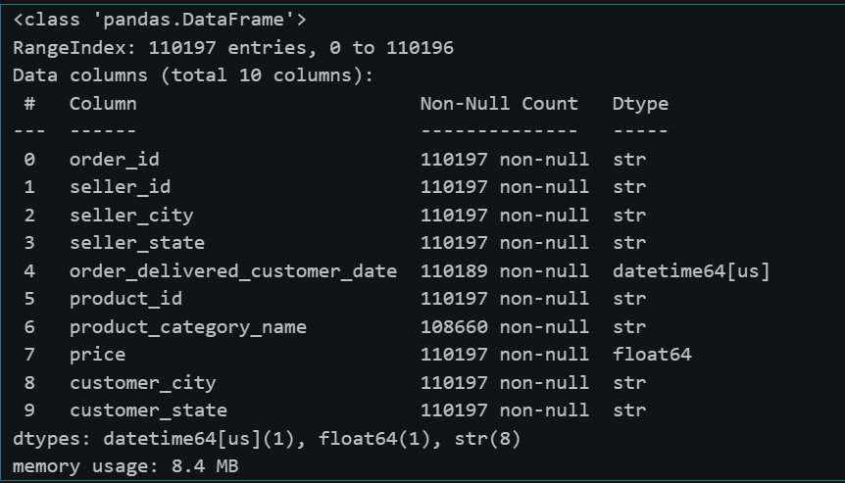
1,537 products lacked category labels and were retained as “Unknown”.
Appended the translated product category names in English.
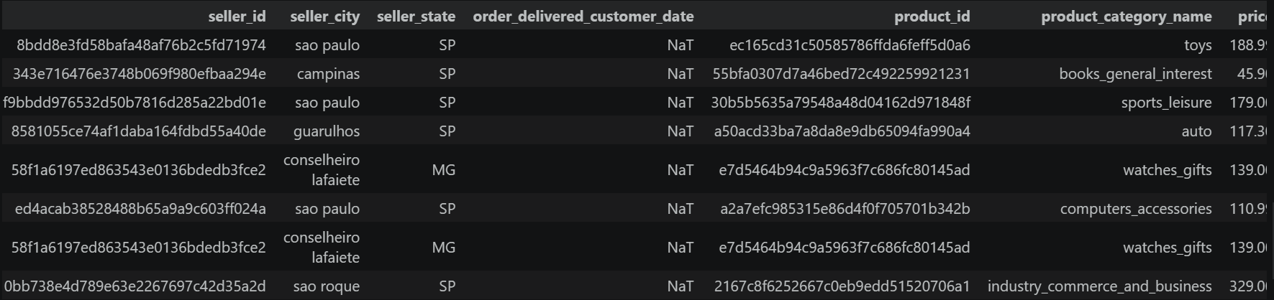

The small subset of orders (~8) above is marked as “delivered” but lacks a recorded customer delivery timestamp. There are inconsistent delivery timestamps (data issue). This will be added towards the total revenue but excluded in calculating delivery times.

EDA

The total revenue over the 2-year period is ($ 13,221,498.11)
Revenue = sum(price).

The health beauty category has the highest revenue of ($ 1,233,131.72) which is approximately 9.3% of the revenue.

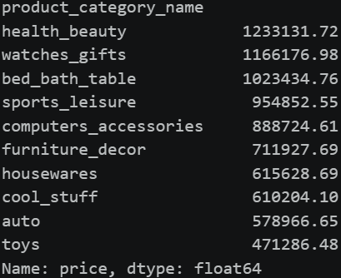

The state with the highest revenue is: São Paulo (SP) with a generated revenue of

($ 5,067,633.16) that is 38% of the total revenue.

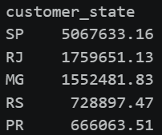

The top 5 cities where sellers sell from are: with Sao Paulo grossing the highest at

($ 2,628,634.52) which is approximately 19.9% of the total revenue.

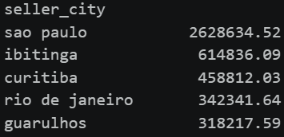

The top 5 cities where consumers buy from are: with Sao Paulo also having the highest grossing revenue of ($ 1,859,556.83) which is 14% of the total revenue.

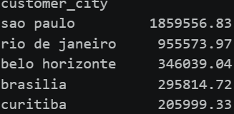
The average order value is approximately $ 159.83 and $ 137 excluding the shipping cost.

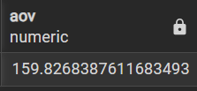

2. 🌍 Regional Performance (Demand vs Supply Geography)
Focus: “Where is demand strongest?”
- Orders by state
- Revenue by state
- Seller distribution by state
- Review score by state
Cleaning
The dataset has 110,197 rows of data (orders).
The freight value column is not included (shipping cost).
Revenue = sum(price).
There are 7 columns in this dataset.
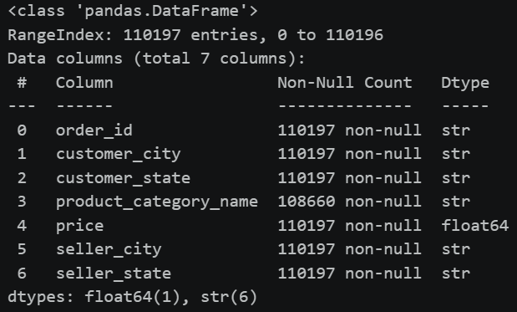
1,537 products lacked category labels and were retained as “Unknown”.
Appended the translated product category names in English.
To check the percentage of customers against the actual population of the states, a web scraping was conducted from Wikipedia. And states and their populations were adopted.
A new dataset (customers state and unique id) from the original dataset was added to accommodate for this and checked against the actual population.
There are 27 states included (26 states and the federal district).

EDA
A scrapping of the Wikipedia web app on population was done to compare the population of the states by the revenue.
A new column was created as state percentage (state_pct).
State_pct = 100 * (number of customers / total population of state).
A new metric of revenue per capita was created per state.
Rev_per_capita = state revenue / total state population.

3. 📦 Product & Category Performance
Focus: “What sells and why?”
- Revenue per category
- Price distribution per category
- Product characteristics (weight, size vs price) affect demand?
- Which products have the highest and lowest average order value?
cleaning
The view is one row per order item so review score is repeated per item
Metrics created:
- volume_cm3 = height * width * height
- density_g_cm3 = mass / volume
- freight_per_cm3(shipping per size) = freight value / volume
- 1,537 products lacked category labels and were retained as “Unknown”.

EDA
The top 10 most sold items by count (total orders) are:

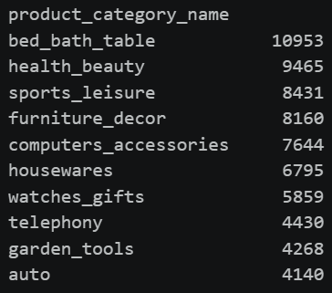
Top ten products by revenue:
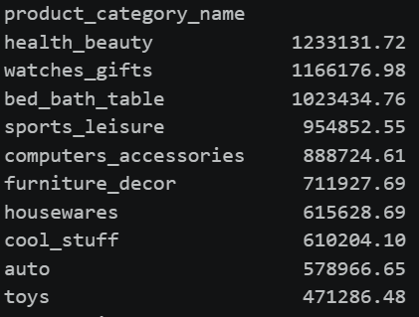
The unknown section is 21st according to revenue of $175967:
Top ten products by reviews
Reviews = category by mean (reviews)
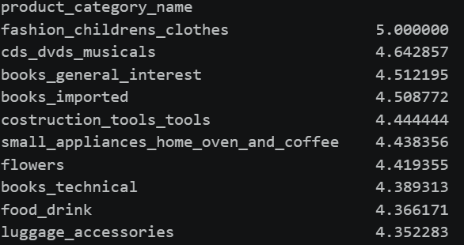
Ten products with the lowest mean reviews:
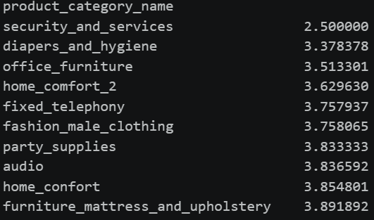
Freight ratio = mean(freight) / revenue

Insights

Revenue Concentration
- Total revenue = $13.22M over ~110K orders → relatively low revenue per order scale business
- Top category (Health & Beauty) contributes $1.23M (9.3%) → no single category dominates
- Top 10 categories combined contribute roughly >60% of total revenue (based on page 8 rankings)
Insight:
Revenue is moderately concentrated but still diversified, meaning:
- The business is not overly dependent on one category (good for risk)
- But growth requires multi-category optimization, not just one segment

Geographic Revenue Imbalance
- São Paulo (SP) alone generates:
  - $5.07M (38% of total revenue)
- Next states (RJ, MG, etc.) are significantly lower (~1.5M range)
Insight:
- Revenue distribution is highly skewed toward one state
- Indicates:
  - Strong market maturity in SP
  - Under-penetration in other regions

City-Level Supply & Demand Concentration
- Seller city (São Paulo): $2.63M (19.9%)
- Customer city (São Paulo): $1.86M (14%)
Insight:
- Supply (sellers) is more concentrated than demand
- Suggests:
  - Logistics hubs are centralized
  - Potential delivery inefficiencies to distant regions

Order Value & Customer Behaviour
- Average Order Value (AOV):
  - $159.83 (with freight)
  - $137 (without freight)
Insight:
- Freight contributes ~14%–16% uplift in order value
- Indicates:
  - Shipping costs are significant to customers
  - Potential friction in conversion for low-value items

Category Performance vs Volume
From page 8:
- Bed_bath_table → highest volume (10,953 orders)
- Health_beauty → highest revenue ($1.23M)
Insight:
- High volume ≠ high revenue
- Some categories:
  - Drive traffic (volume categories)
  - Others drive profit (high-value categories)

Customer Satisfaction (Reviews)
- Best categories: ratings around 4.6–5.0
- Worst categories: as low as 2.5–3.8
Insight:
- Large quality inconsistency across categories
- Poor-performing categories likely:
  - Increasing returns
  - Damaging brand trust

Data Quality & Operational Gaps
- ~1,537 products (≈1.4%) missing categories
- Some “delivered” orders missing timestamps
Insight:
- Data gaps may:
  - Distort category analysis
  - Affect delivery performance metrics

2. Key Findings

1. Revenue is heavily location-dependent
- 38% of revenue comes from one state → over-reliance risk

2. Business has dual category structure
- Volume drivers: bed_bath_table, sports_leisure
- Revenue drivers: health_beauty, watches_gifts

3. Logistics and supply are centralized
- Sellers concentrated in São Paulo → uneven distribution network

4. Customer experience is inconsistent
- Rating spread from 2.5 → 5.0 shows:
  - Some categories perform excellently
  - Others are serious risk areas

5. Freight plays a major economic role
- ~15% contribution to AOV
- Likely affecting:
  - Conversion rates
  - Customer satisfaction

6. Growth opportunity is external to core markets
- SP is saturated
- Other states show:
  - Lower revenue
  - Likely lower penetration (confirmed by your state_pct metric)

3. Recommendations

A. Reduce Revenue Concentration Risk
- Target top 5 underperforming states (outside SP)
- Use:
  - Local promotions
  - Regional pricing strategies
👉 Goal:
- Reduce SP contribution from 38% → <30%

B. Optimize Category Strategy
Split categories into 2 groups:
- Scale Categories (High Volume)
  - e.g., bed_bath_table
  - Strategy:
    - Upselling
    - Bundling
- Profit Categories (High Revenue)
  - e.g., health_beauty
  - Strategy:
    - Premium positioning
    - Marketing focus

C. Decentralize Seller Network
- Incentivize sellers in low-performing states
- Benefits:
  - Reduce delivery time
  - Lower freight costs
  - Improve regional penetration

D. Improve Low-Performing Categories
- Target categories with ratings <3.5
- Actions:
  - Audit sellers
  - Improve product quality
  - Remove poor performers
👉 Expected outcome:
- Increase repeat purchases
- Improve platform trust

E. Optimize Freight Strategy
- Since freight ≈ 15% of order value:
  - Introduce:
    - Free shipping thresholds
    - Regional shipping subsidies
👉 Goal:
- Increase conversion rate on low-ticket items

F. Fix Data Quality Issues
- Resolve:
  - Missing product categories (1,537 items)
  - Delivery timestamp inconsistencies
👉 Impact:
- More accurate forecasting & KPI tracking

G. Expand Based on Revenue per Capita
(From your engineered metric)
- Focus on:
  - States with high population but low revenue per capita
👉 This is your highest ROI expansion opportunity

Final Strategic Takeaway
The business is:
- Strong but imbalanced
- Growing but inefficiently distributed
Growth will not come from São Paulo or top categories anymore.
It will come from:
- Geographic expansion
- Operational efficiency
- Customer experience consistency

Dashboards
