Title: Grocery Tracker Program Documentation

Program Overview:

The Grocery Tracker is designed to read item data from "CS210_Project_Three_Input_File.txt", calculate the frequency of each item sold, and offer various reporting features. It employs a user-friendly menu system to navigate through its functionalities.

Structure and Design:

Central to the program is the GroceryTracker class, which encapsulates key functionalities:

File Reading: Reads item data and calculates frequencies.

Data Reporting: Provides different reporting options like item search, frequency listing, and histogram display.

File Writing: Outputs the latest item frequencies to "frequency.dat" for data persistence.

Key Features:

Search for an Item:

Users can search for a specific item, and the program will display its sales frequency.

Print Frequency of All Items:

Displays a list of all grocery items and their respective sales frequencies.

Print Histogram:

Generates a visual histogram, representing the frequency of each item using asterisks.

Exit Program:

Safely exits the program and saves current item frequencies to "frequency.dat".

Screenshots:

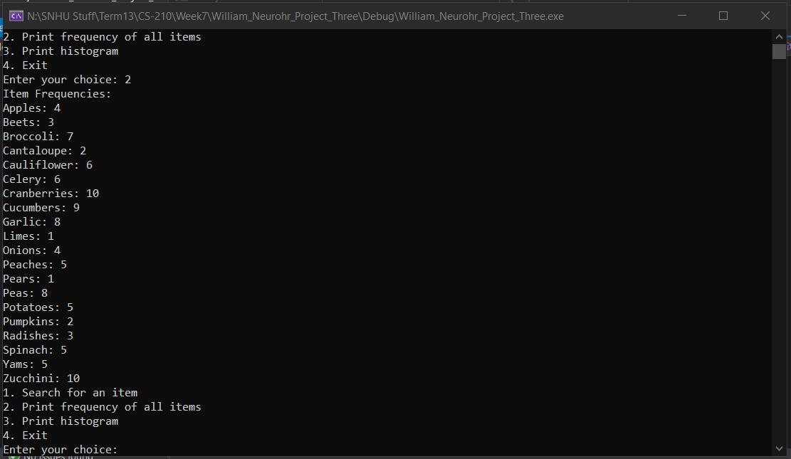

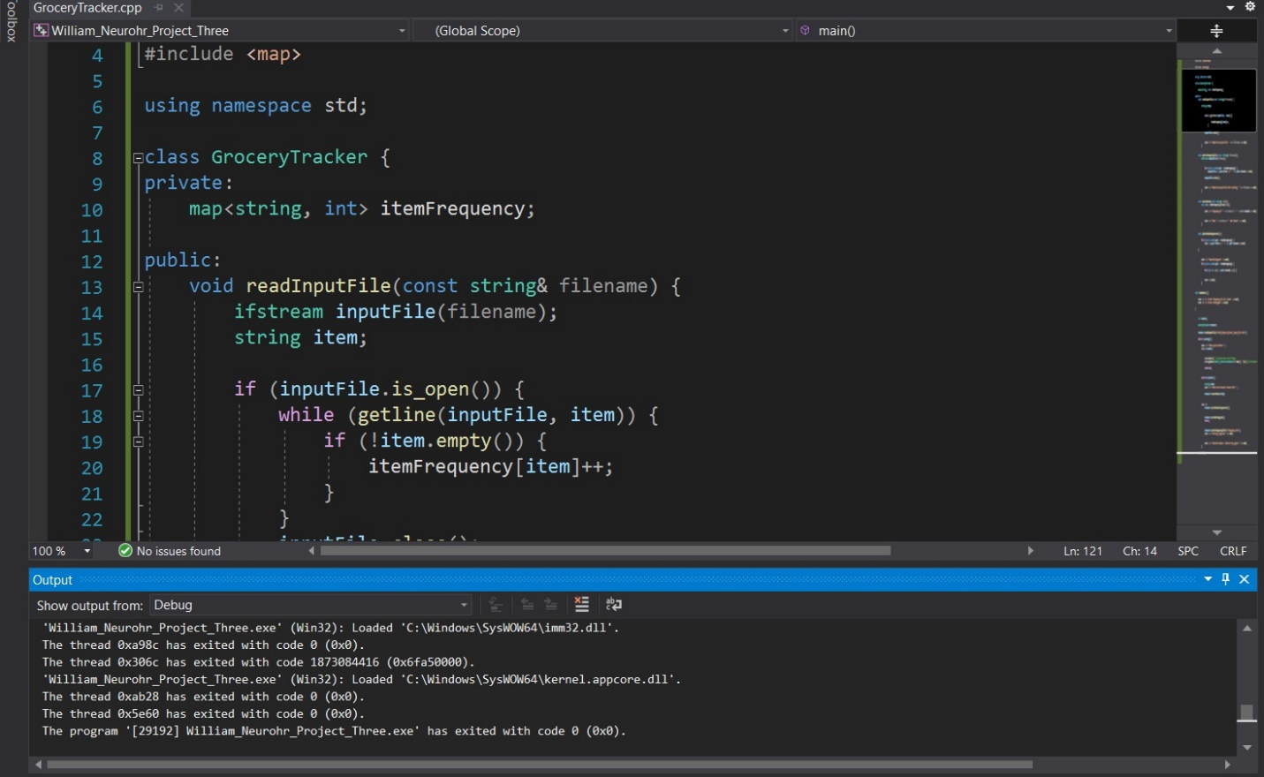Conclusion:

The Grocery Tracker program serves as an efficient tool for the Corner Grocer, providing essential insights into sales trends. Its intuitive interface and comprehensive reporting capabilities make it an invaluable resource for business analytics and decision-making.