GSP 330 - Mobile Mapping

**Vegetation of the Ma-le’l Dunes**

Whitney Newcomb, Christina Perez, Joshua Rodriguez and Samantha Ureel

horizontal line

## Introduction and Background

The Ma-la’l Dunes is a multi-use dynamic coastal landscape that is part of the Humboldt Bay National Wildlife Refuge with the southern portion of the dunes managed by the Bureau of Land Management (BLM). The Ma-le’l dunes has limited trail access for pedestrians only which is intended to protect the fragile landscape and vegetation. Currently the Ma-le’l dunes host both native and non-native vegetative species to an undefined extent. Knowing the parameters of invasive species extent is essential for restoration efforts. Our project aimed at gathering vegetative informations in the Ma-le’l dunes and the information collected may potentially be useful for restoration purposes.

Our team collected vegetation data for the Ma-le’l Dunes specifically located near 81 Vera Linda Ln. Arcata, CA 95521 (40.862337, -124.159839) on April, 29th 2016 around 11am. We collected about 100 data points with information about the placement, species and endemic aspects of the vegetation at present date. Polygons were collected for large swatches of monolithic vegetation while points were used for smaller patches and individual species. Rooting of vegetation is primarily the way dunes and hills are created within the area. Surveying the area will also give an idea of how dominant invasive species are or are not and whether or not the endemic species are being crowded out by invasives in this Ma-le’l Dunes. The information in our data collection may be potentially useful for further land surveys, restoration efforts or land use zoning. The objectives consist of collecting point and polygon features of plant life and the study area of interest, as mentioned above.

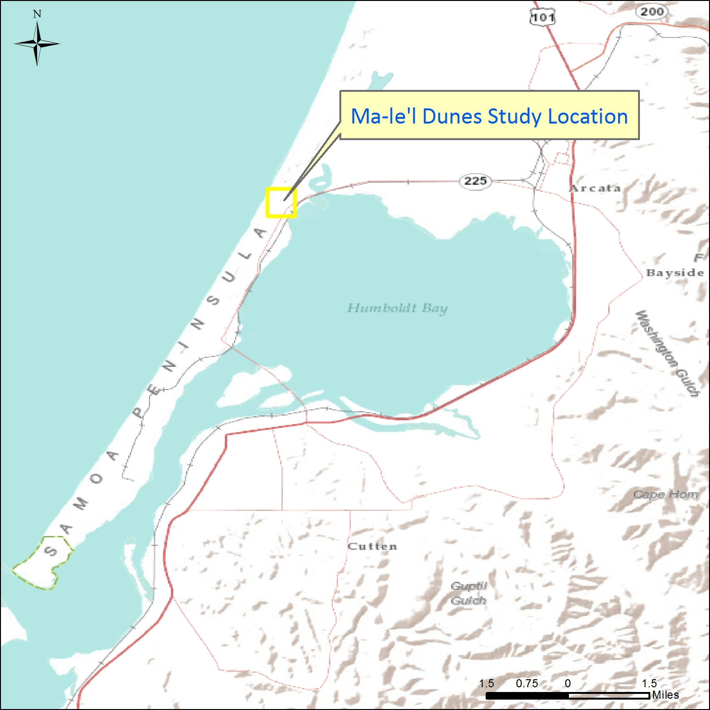

**Figure 1**: Locator Map showing northern extent of Humboldt Bay and surrounding area.

## Methods

Information on the native vegetation was gathered from the Friends of the Dunes (Humboldt Coastal Nature Center) located at 220 Stamp Lane in Manila California to assist in plant identification (1).

The Junos were set up with TerraSync to collect features in WGS1984; a generic data dictionary was created to collect single plants as point features and hummocks and large groupings of vegetation as polygons. Our data collection used a feature based process. Two groups were created (Newcomb/Ureel and Perez/Rodriguez) each with Juno. The study area was split in half down the length of the study area and each group collected data which communicating to the other group so as not to overlap on the collection process, see *figure 2* to see the study area with partitions. In each group one person collected the data on the Juno unit while the other took field notes and identified species.

Once collected the it was uploaded, corrected, and exported as shapefiles using GPS Pathfinder Office. Some data processing was done using Google Tables before bringing the shapefiles ArcGIS for processing and to display the results visually via maps, see *figures 3 and 4*.

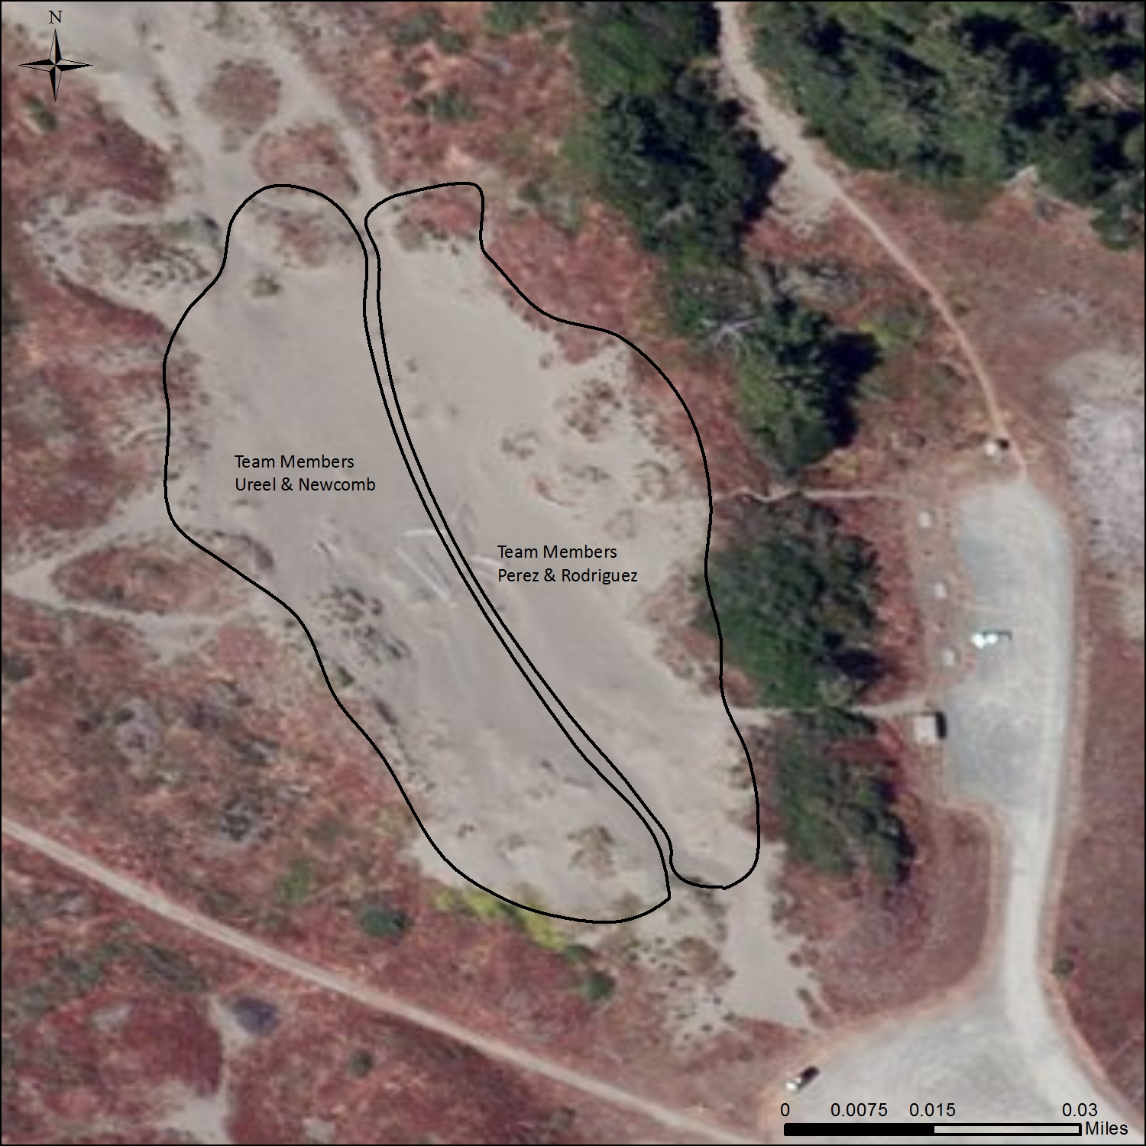

**Figure 2**: Field Plan with group partitions

## Results

Our data collection and analysis resulted in a clean visualization of the vegetation within Ma-le’l Dunes as well as identification of invasive species. Within our study area, our group was able to collect 96 point and polygons (hummocks), 56 on the south side and 40 on the north side. We were able to identify 14 different vegetative species, two of those are invasive. Invasives species took up more than 10% of our study area. Within the Polygons that are 9,462.308 sq ft, 961.7374 sqft of those are invasive species. Constantly monitoring vegetation in multi-use dynamic coastal landscape is very important for understanding invasive species and restoration. This data will allow for more monitoring over the years and allow restoration efforts to start. Understanding how vegetation changes over the years is extremely important and helpful for restoration.

The U.S. Fish and Wildlife service has actually been doing restoration efforts on Ma-le’l dunes since 2011. Annual efforts to replant Native Dune Grass and eradicate invasive plants such as Yellow Bush Lupine and Rattlesnake Grass (2). Our data would help them continue to go back to area previously invaded and understand differences between areas improving and areas not improving.

**Table 1**: List of plants mapped

|  |  |
| --- | --- |
| **Common Name** | **Scientific Name** |
| **Beach Buckwheat** | *Eriogonum latifolium* |
| **Beach Evening Primrose** | *Camissonia cheiranthifolia* |
| **Beach Morning Glory** | *Calystegia soldanella* |
| **Dune Golden Rod** | *Soldago spathulata* |
| **Dune Sedge** | *Carex obnupta* |
| **Grass(various)** | ~~~ |
| **Yellow Bush Lupine** | *Lupinus arboreus* |
| **Native Dune Grass** | *Leymus mollis* |
| **Rattlesnake Grass** | *Briza maxima* |
| **Silvery Phacella** | *Phacelia argentea* |
| **Beach Strawberry** | *Fragaria chiloensis* |
| **Coastal Sagewort** | *artemesia pyconophla* |
| **Yarrow** | *Achellia millefolium* |
| **Yellow Sand Verbena** | *Aronia latifolia* |
| **Hummock** |  |

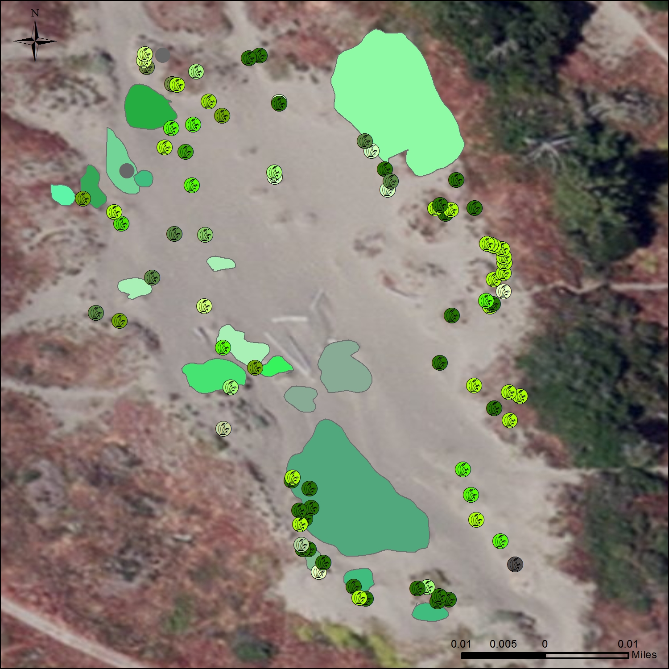

**Figure 3**: Vegetation of study area; legends below.

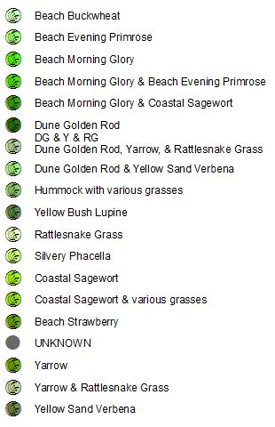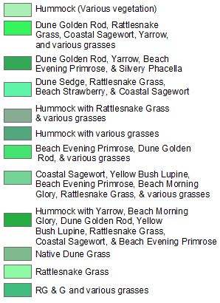

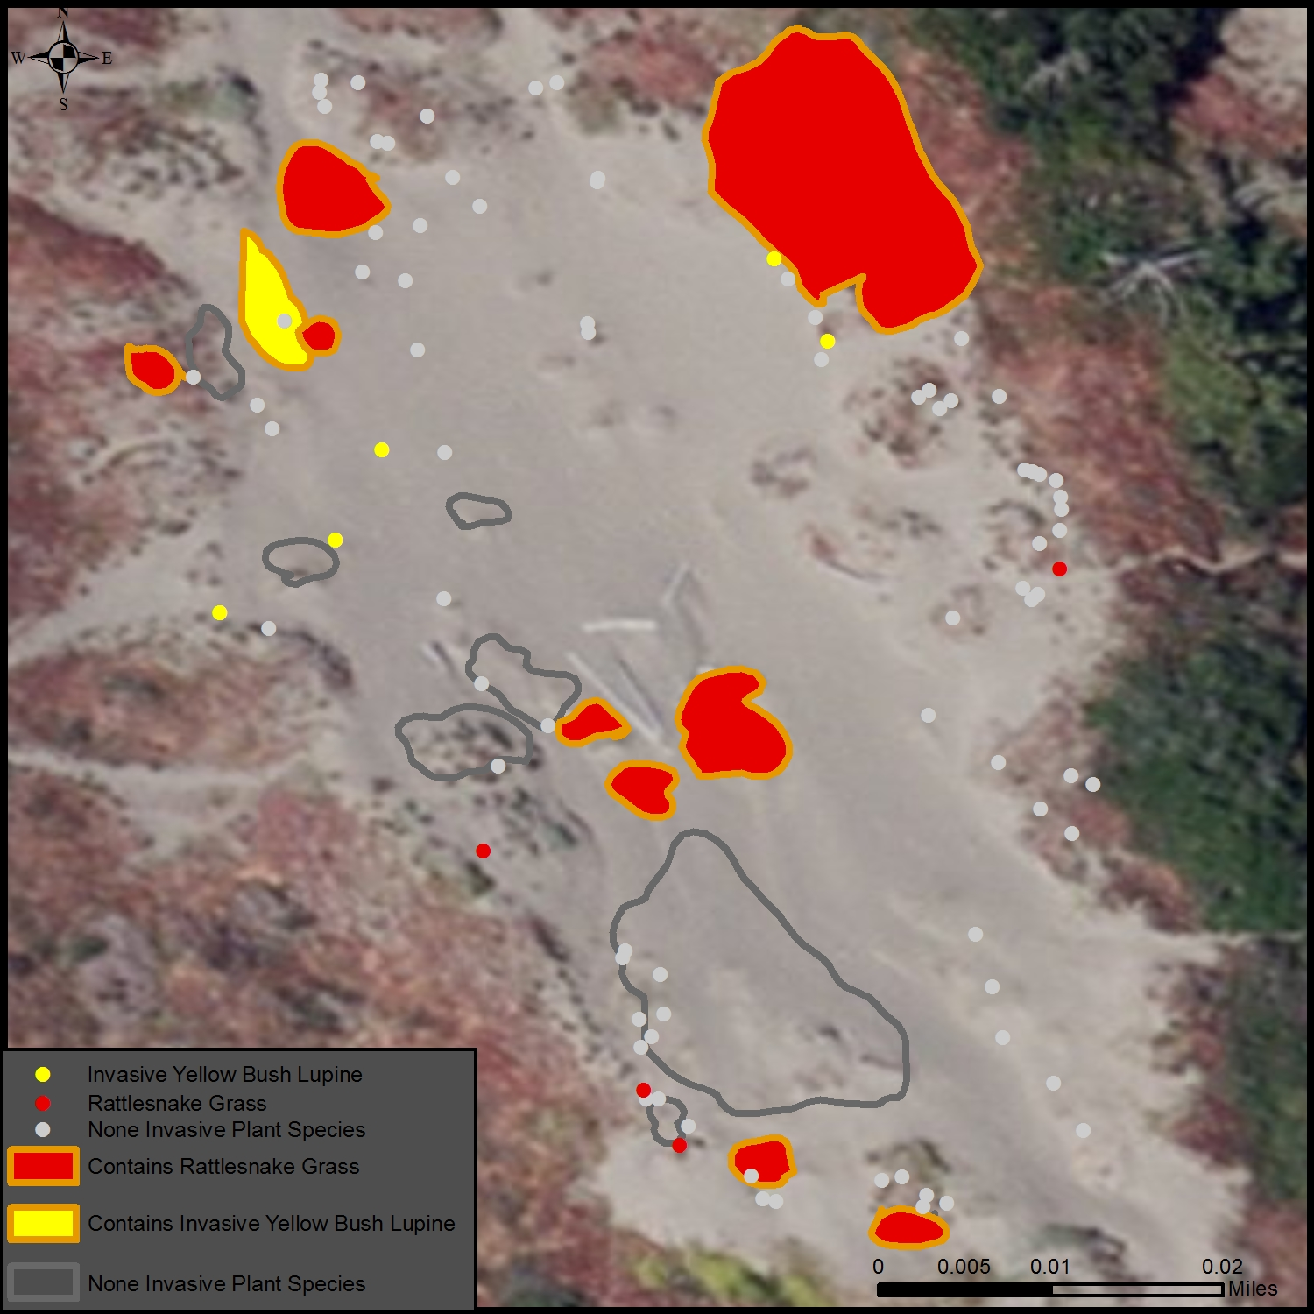

**Figure 4**: Locations of 2 invasive plant species: Yellow Bush Lupin and Rattesnake Grass

## Discussion and Conclusion

Plant species misidentification was the main error associated with this project. The expertise of plant identification is limited to the pamphlet reference guide provided by “Friends of the Dunes”.

Possible improvements to our existing field plan are as followed:

* Properly identifying plants within the study area by collaborating with a Botanist specialist;
* Distinguishing native and invasive plant species;
* Collecting more data points to improve the analysis of plant diversity within the study area;
* Create a more organized course of action for data collection.

To improve the precision, especially collecting areas of vegetation such as rattlesnake grass as displayed in *figure 4,* the trimble unit with a satellite receiver attachment may prove to collect higher resolution polygon data; it can be used to collect high precision plant data points. However the time required with such a device is a drawback. There would be no difference in processing the data, as the data consists of points and polygons that would be generated through the same fashion as mentioned in the “Methods” section.

Since rooting of vegetation is primarily the way dunes and hills are created within the area, it would be interesting to see the correlation with vegetation type and the hill size or elevation for the next step of this project.

Based on our findings approximately 10% of species identified were invasive which means that restoration efforts are likely successful and to further the research more vegetation mapping should be done over time to see the long term effects of dune restoration.

## References

(1) Northern California Beach & Dune Guide: An Introduction to the Plant and Animals, by James Kavanagh, Illustrated by Raymond Leung, Waterford Press

(2) U.S. Fish and Wildlife Service. Ma-le’l Dunes Restoration Summary and Photodocumentation. June 2014.