**Exp: no: 2**

Analyze the network traffic using Packet tracer tool .

**Aim:**

To analyse the network traffic using Cisco Packet tracer tool and write the syntax, execute and place the screenshot for all the commands worked on.

1. Configure a simple network connecting two LANs using Cisco Packet Tracer.

**Equipment:**

* 2 x 2960-24TT Switches
* 1 x ISR4331 Router
* 4 x PCs

**Syntax:**

**Step 1: Open Cisco Packet Tracer**

1. Open Cisco Packet Tracer on your computer.

**Step 2: Create the Network Topology**

1. **Drag and Drop Devices**: Drag two 2960-24TT Switches, one ISR4331 Router, and four PCs onto the workspace.
2. **Connect Devices**:
   * Use the Copper Straight-Through cable to connect:
     + PC0 to Switch0 (Port FastEthernet0/1)
     + PC1 to Switch0 (Port FastEthernet0/2)
     + PC2 to Switch1 (Port FastEthernet0/1)
     + PC3 to Switch1 (Port FastEthernet0/2)
     + Switch0 (Port GigabitEthernet0/1) to Router (Port GigabitEthernet0/0)
     + Switch1 (Port GigabitEthernet0/1) to Router (Port GigabitEthernet0/1)

**Step 3: Configure IP Addresses on PCs**

1. **PC0**:
   * IP Address: 192.168.1.2
   * Subnet Mask: 255.255.255.0
   * Default Gateway: 192.168.1.1
2. **PC1**:
   * IP Address: 192.168.1.3
   * Subnet Mask: 255.255.255.0
   * Default Gateway: 192.168.1.1
3. **PC2**:
   * IP Address: 192.168.2.2
   * Subnet Mask: 255.255.255.0
   * Default Gateway: 192.168.2.1
4. **PC3**:
   * IP Address: 192.168.2.3
   * Subnet Mask: 255.255.255.0
   * Default Gateway: 192.168.2.1

**Step 4: Configure IP Addresses on Router**

1. **Router**:
   * Enter the CLI of the ISR4331 Router.
   * Execute the following commands:

Router> enable

Router# configure terminal

Router(config)# interface GigabitEthernet0/0

Router(config-if)# ip address 192.168.1.1 255.255.255.0

Router(config-if)# no shutdown

Router(config-if)# exit

Router(config)# interface GigabitEthernet0/1

Router(config-if)# ip address 192.168.2.1 255.255.255.0

Router(config-if)# no shutdown

Router(config-if)# exit

1. Configure a network using Ring/Bus/Tree Topology using Packet tracer tool.

**Equipment:**

* 2960-24TT Switches
* ISR4331 Router
* PCs
* Appropriate cables (Copper Straight-Through and Copper Cross-Over)

**Steps for Different Topologies:**

**1. Ring Topology:**

**Ring Topology** connects each device to exactly two other devices, forming a single continuous pathway for signals through each device.

**Step 1: Open Cisco Packet Tracer**

1. Open Cisco Packet Tracer on your computer.

**Step 2: Create the Network Topology**

1. **Drag and Drop Devices**: Drag three 2960-24TT Switches and four PCs onto the workspace.
2. **Connect Devices**:
   * Use the Copper Cross-Over cable to connect:
     + Switch0 (Port GigabitEthernet0/1) to Switch1 (Port GigabitEthernet0/1)
     + Switch1 (Port GigabitEthernet0/2) to Switch2 (Port GigabitEthernet0/1)
     + Switch2 (Port GigabitEthernet0/2) to Switch0 (Port GigabitEthernet0/2)
   * Use the Copper Straight-Through cable to connect:
     + PC0 to Switch0 (Port FastEthernet0/1)
     + PC1 to Switch1 (Port FastEthernet0/1)
     + PC2 to Switch2 (Port FastEthernet0/1)
     + PC3 to Switch0 (Port FastEthernet0/2)

**Step 3: Configure IP Addresses on PCs**

1. **PC0**:
   * IP Address: 192.168.1.2
   * Subnet Mask: 255.255.255.0
2. **PC1**:
   * IP Address: 192.168.1.3
   * Subnet Mask: 255.255.255.0
3. **PC2**:
   * IP Address: 192.168.1.4
   * Subnet Mask: 255.255.255.0
4. **PC3**:
   * IP Address: 192.168.1.5
   * Subnet Mask: 255.255.255.0

**2. Bus Topology:**

**Bus Topology** connects all devices to a single central cable, called the bus or backbone.

**Step 1: Open Cisco Packet Tracer**

1. Open Cisco Packet Tracer on your computer.

**Step 2: Create the Network Topology**

1. **Drag and Drop Devices**: Drag one 2960-24TT Switch and four PCs onto the workspace.
2. **Connect Devices**:
   * Use the Copper Straight-Through cable to connect:
     + PC0 to Switch0 (Port FastEthernet0/1)
     + PC1 to Switch0 (Port FastEthernet0/2)
     + PC2 to Switch0 (Port FastEthernet0/3)
     + PC3 to Switch0 (Port FastEthernet0/4)

**Step 3: Configure IP Addresses on PCs**

1. **PC0**:
   * IP Address: 192.168.1.2
   * Subnet Mask: 255.255.255.0
2. **PC1**:
   * IP Address: 192.168.1.3
   * Subnet Mask: 255.255.255.0
3. **PC2**:
   * IP Address: 192.168.1.4
   * Subnet Mask: 255.255.255.0
4. **PC3**:
   * IP Address: 192.168.1.5
   * Subnet Mask: 255.255.255.0

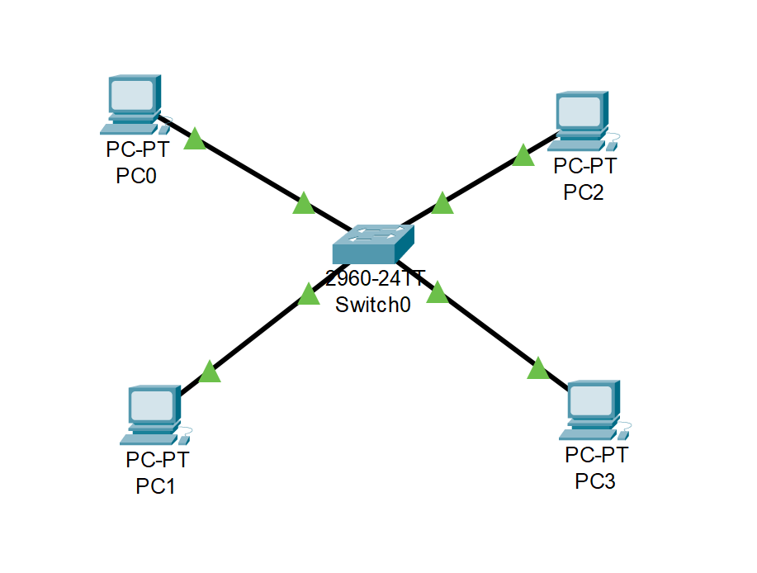

**3. Tree Topology:**

**Tree Topology** combines characteristics of Star and Bus topologies. It consists of groups of star-configured networks connected to a linear bus backbone.

**Step 1: Open Cisco Packet Tracer**

1. Open Cisco Packet Tracer on your computer.

**Step 2: Create the Network Topology**

1. **Drag and Drop Devices**: Drag three 2960-24TT Switches, one ISR4331 Router, and six PCs onto the workspace.
2. **Connect Devices**:
   * Use the Copper Straight-Through cable to connect:
     + Router (Port GigabitEthernet0/0) to Switch0 (Port GigabitEthernet0/1)
     + Switch0 (Port GigabitEthernet0/2) to Switch1 (Port GigabitEthernet0/1)
     + Switch0 (Port GigabitEthernet0/3) to Switch2 (Port GigabitEthernet0/1)
     + PC0 to Switch1 (Port FastEthernet0/1)
     + PC1 to Switch1 (Port FastEthernet0/2)
     + PC2 to Switch1 (Port FastEthernet0/3)
     + PC3 to Switch2 (Port FastEthernet0/1)
     + PC4 to Switch2 (Port FastEthernet0/2)
     + PC5 to Switch2 (Port FastEthernet0/3)

**Step 3: Configure IP Addresses on PCs**

1. **PC0**:
   * IP Address: 192.168.1.2
   * Subnet Mask: 255.255.255.0
2. **PC1**:
   * IP Address: 192.168.1.3
   * Subnet Mask: 255.255.255.0
3. **PC2**:
   * IP Address: 192.168.1.4
   * Subnet Mask: 255.255.255.0
4. **PC3**:
   * IP Address: 192.168.1.5
   * Subnet Mask: 255.255.255.0

1. Configure a network for four departments in your college with a minimum of five PCs in a network.

**Equipment:**

* 2960-24TT Switches
* PCs
* Appropriate cables (Copper Straight-Through)

**Steps:**

**Step 1:** Open Cisco Packet Tracer

**Step 2:** Create the Network Topology

1. Drag and Drop Devices:
   * Drag four 2960-24TT Switches onto the workspace (one for each department).
   * Drag twenty PCs onto the workspace (five for each department).

**Step 3: Connect Devices**

1. **CSE Department:**
   * **Switch0 (CSE Department):**
     + **Use Copper Straight-Through cable to connect:**
       - PC0 to Switch0 (Port FastEthernet0/1)
       - PC1 to Switch0 (Port FastEthernet0/2)
       - PC2 to Switch0 (Port FastEthernet0/3)
       - PC3 to Switch0 (Port FastEthernet0/4)
       - PC4 to Switch0 (Port FastEthernet0/5)
2. **IT Department:**
   * **Switch1 (IT Department):**
     + **Use Copper Straight-Through cable to connect:**
       - PC5 to Switch1 (Port FastEthernet0/1)
       - PC6 to Switch1 (Port FastEthernet0/2)
       - PC7 to Switch1 (Port FastEthernet0/3)
       - PC8 to Switch1 (Port FastEthernet0/4)
       - PC9 to Switch1 (Port FastEthernet0/5)
3. **AIDS Department:**
   * **Switch2 (AIDS Department):**
     + **Use Copper Straight-Through cable to connect:**
       - PC10 to Switch2 (Port FastEthernet0/1)
       - PC11 to Switch2 (Port FastEthernet0/2)
       - PC12 to Switch2 (Port FastEthernet0/3)
       - PC13 to Switch2 (Port FastEthernet0/4)
       - PC14 to Switch2 (Port FastEthernet0/5)
4. **MECH Department:**
   * **Switch3 (MECH Department):**
     + **Use Copper Straight-Through cable to connect:**
       - PC15 to Switch3 (Port FastEthernet0/1)
       - PC16 to Switch3 (Port FastEthernet0/2)
       - PC17 to Switch3 (Port FastEthernet0/3)
       - PC18 to Switch3 (Port FastEthernet0/4)
       - PC19 to Switch3 (Port FastEthernet0/5)

**Step 4: Configure IP Addresses on PCs**

**CSE Department (Subnet: 192.168.1.1/24):**

1. PC0: IP Address: 192.168.1.2, Subnet Mask: 255.255.255.0
2. PC1: IP Address: 192.168.1.3, Subnet Mask: 255.255.255.0
3. PC2: IP Address: 192.168.1.4, Subnet Mask: 255.255.255.0
4. PC3: IP Address: 192.168.1.5, Subnet Mask: 255.255.255.0
5. PC4: IP Address: 192.168.1.6, Subnet Mask: 255.255.255.0

**IT Department (Subnet: 192.168.2.1/24):**

1. PC5: IP Address: 192.168.1.7, Subnet Mask: 255.255.255.0
2. PC6: IP Address: 192.168.1.8, Subnet Mask: 255.255.255.0
3. PC7: IP Address: 192.168.1.9, Subnet Mask: 255.255.255.0
4. PC8: IP Address: 192.168.1.10, Subnet Mask: 255.255.255.0
5. PC9: IP Address: 192.168.1.11, Subnet Mask: 255.255.255.0

**AIDS Department (Subnet: 192.168.3.1/24):**

1. PC10: IP Address: 192.168.1.12, Subnet Mask: 255.255.255.0
2. PC11: IP Address: 192.168.1.13, Subnet Mask: 255.255.255.0
3. PC12: IP Address: 192.168.1.14, Subnet Mask: 255.255.255.0
4. PC13: IP Address: 192.168.1.15, Subnet Mask: 255.255.255.0
5. PC14: IP Address: 192.168.1.16, Subnet Mask: 255.255.255.0

**MECH Department (Subnet: 192.168.4.1/24):**

1. PC15: IP Address: 192.168.1.17, Subnet Mask: 255.255.255.0
2. PC16: IP Address: 192.168.1.18, Subnet Mask: 255.255.255.0
3. PC17: IP Address: 192.168.1.19, Subnet Mask: 255.255.255.0
4. PC18: IP Address: 192.168.1.20, Subnet Mask: 255.255.255.0
5. PC19: IP Address: 192.168.1.20, Subnet Mask: 255.255.255.0

**Step 5: Connect Switches**

1. **Use Copper Straight-Through cables to interconnect the switches:**
   * Switch0 (Port GigabitEthernet0/1) to Switch1 (Port GigabitEthernet0/1)
   * Switch0 (Port GigabitEthernet0/2) to Switch2 (Port GigabitEthernet0/1)
   * Switch3 (Port GigabitEthernet0/1) to Switch1 (Port GigabitEthernet0/2)
   * Switch3 (Port GigabitEthernet0/2) to Switch2 (Port GigabitEthernet0/2)

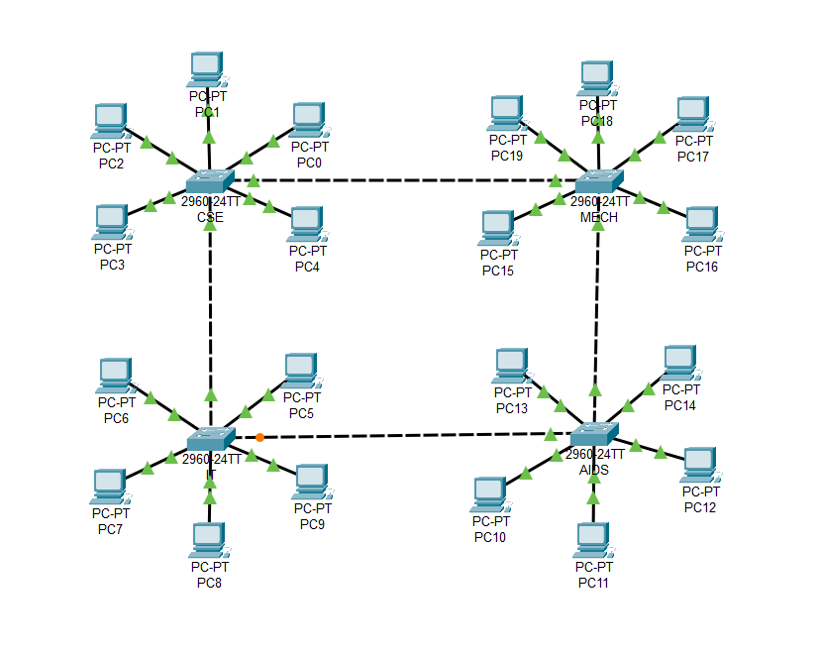

**PostLab:**

Completion of the Cisco Packet tracer fundamental course and attachment of the certificate.

[https://skillsforall.com/topics/cisco-packet-tracer?utm_source=n...](https://skillsforall.com/topics/cisco-packet-tracer)

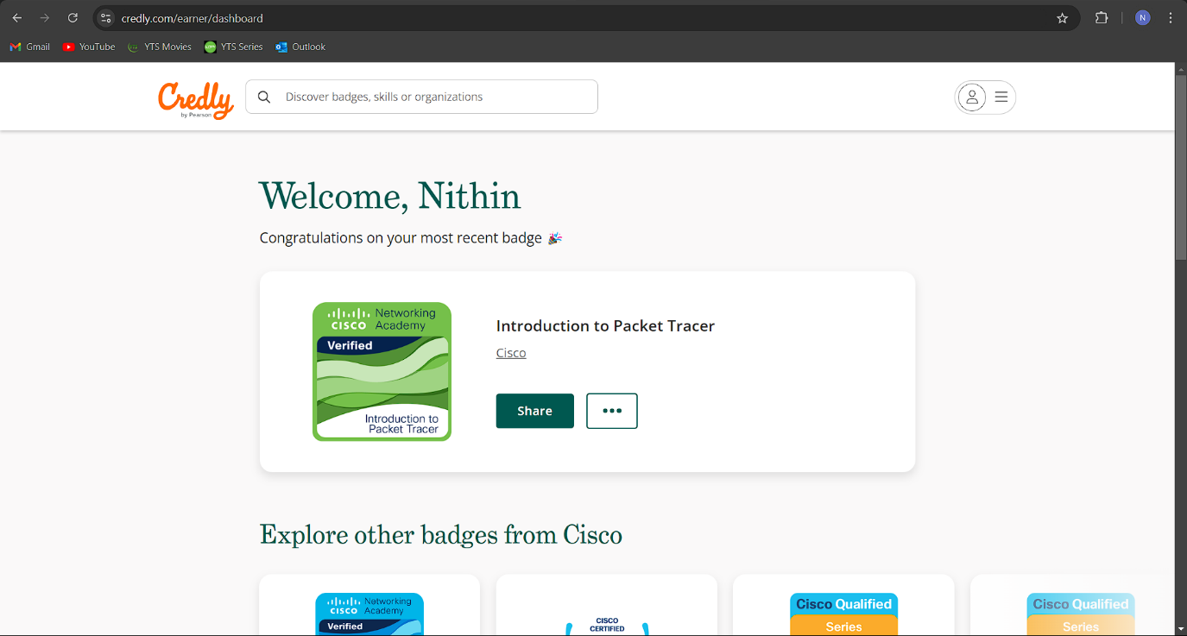

Certificate Verification Link:

<https://www.credly.com/badges/dc101725-a8e7-412d-85de-5a96cdb14653/public_url>

**Result:**

All experiments have been successfully executed, with no errors or issues encountered. The expected results have been achieved, as demonstrated by the attached screenshots.