



**NEW ERA UNIVERSITY COLLEGE**

**TPRG113 PROGRAMMING CONCEPTS**

**PET SHOP PROGRAM**

***Beatrice Leong Zhi Xin 2320023-DEC***

***Angel Yong Zu Er 2320130-DEC***

***Wong Jie Ying 2350080-DCS***

***Su Zhi Lun 2320013-DCS***

**Lecturer:**

**Ms Suhailah binti Fauzi**

**DEPARTMENT OF INFORMATION COMPUTING TECHNOLOGY**

**FACULTY OF COMPUTER SCIENCE & INFORMATION COMPUTING TECHNOLOGY**

# GROUP MEMBERS’ DETAILS

| **No** | **Name** | **ID Number** | **Phone Number** | **Picture** |
| --- | --- | --- | --- | --- |
| 1 | Beatrice Leong Zhi Xin | 2320023-DEC | 012-7093726 |  |
| 2 | Angel Yong Zu Er | 2320130-DEC | 011-11262900 |  |
| 3 | Su Zhi Lun | 2320013-DCS | 011-31097962 |  |
| 4 | Wong Jie Ying | 2350080-DCS | 012-6916319 |  |

**TABLE OF CONTENTS**

COVER 1

GROUP MEMBERS’ DETAILS 2

TABLE OF CONTENTS 3

1. INTRODUCTION 4-5
2. PSEUDOCODE/FLOWCHART 6-7
3. PROGRAM – SOURCE CODE 8-14
4. SAMPLE OF PROGRAM EXECUTION (SCREEN SHOT) 15-18

**LIST OF FIGURES**

* 1. Figure 1 – Sample Screen When Program is ran 15
  2. Figure 2 - Display the menu 15
  3. Figure 3 – Display error message for wrong input. 15
  4. Figure 4 - Display “About us” Page when user inputs 1. 16
  5. Figure 5 - Display “Buy Pets” when users input “2”. 16
  6. Figure 6 - Choose Fish and enter 1 for quantity. 16
  7. Figure 7 - Display “Buy Pets Food” when users input “3”. 17
  8. Figure 8 - Choose Fish Food and enter 1 for quantity. 17
  9. Figure 9 - Confirm the payment and receive your receipt. 17
  10. Figure 10 - Exiting the Page 18

# INTRODUCTION

The theme of our program is a pet shop. The Pet Shop allows users to purchase pet-related items. On the first page, there is a logo on the Pet Shop display. Then, the Pet Shop main menus will be displayed, there are five options. The first option allows users to explore an introduction to our store. The second option guides users through the process of selecting pet types. The third option involves assisting users in choosing a pet food. The fourth option is designed for payment confirmation, while the fifth and final option permits users to gracefully exit the program. Subsequently, users proceed to the main menu, which is a cornerstone of the program. Here, users are presented with five distinct options which are to access the store introduction, buy pets, buy pets food, confirm payment, and exit the program.

If the user selects the "Buy Pets" option, there will be 5 types of pets which are Dog, Cat, Bird, Rabbit, and Fish. Once the user selects a pet type, the system will proceed to inquire about the quantity of the chosen pet that they wish to purchase. For example, users choose dogs and the system will directly display the price of the dogs and after that, the system asks the user to enter the quantity. If the user chooses to continue, then the program will go back to the shop menu. If the user selects the "Buy Pets Food" option, there will be 5 types of pets food which are Dog Food, Cat Food, Bird Food, Rabbit Food, and Fish Food. Once the user selects a pet food, the system will proceed to inquire about the quantity of the chosen pet food that they wish to purchase. Then, the system will prompt the user to confirm the payment and receive the receipt. Inside the receipt, it displays each item purchased by the user and the quantity of the item, and the price of the item, showing the price of all products combined. Finally, the system will directly go back to the home page.

The language we use in this project is Java version JDK 20, and the IDE we use is Apache NetBeans IDE 18. The program's design is straightforward and transparent, using JOptionPane and dialog boxes to provide users with an intuitive interface and convenient interactions. Users only need a few clicks to navigate through various functions of the pet shop and effortlessly purchase pets and related items. While selecting pets, confirming purchases, or exploring store insights, this pet shop program delivers an enjoyable shopping experience through its streamlined interface and user-friendly interactions. The use of JOptionPane and dialog boxes simplifies the program's functionality, making it intuitive and user-accessible. Regardless of whether users are pet enthusiasts or gift shoppers, this pet shop program ensures convenience and delight for all users. In our program, we've implemented methods to categorize each component, resulting in a more concise, comprehensible, and maintainable program structure. During the course of this assignment, our team encountered various challenges that proved difficult to surmount. Some features had to be relinquished due to these challenges, resulting in a slowdown of the overall project progress. This experience led to introspection. We acknowledge that our diligence during the project could have been greater, as certain errors within the final program went unnoticed and unresolved. Of course, this assignment has also been a valuable learning experience. Our problem-solving skills have significantly improved, as we faced and tackled various obstacles.

# 

# 

# 

# 

# 

# 

# 

# 

# 

# 

# 

# 

# 

# 

# PSEUDOCODE/FLOWCHART

Start

Initialize homepage

Display homepage

User then must click “Enter”

Loop

User must input between 1 to 5

Get user input

Loop

If user input is “1”

Display “About Us” page

Else if user input is “2”

Prompt the user to put between 1 to 5

If user input between 1 to 5

Prompt user to input quantity of item1

Else

Display Invalid Selection Message

Else If user input “3”

Prompt the user to put between 1 to 5

If user input between 1 to 5

Prompt user to input quantity of item2

Else

Display Invalid Selection Message

Else If user input is “4”

Display receipt by calculating from input in “2” and “3”

If user has input only “2” and has entered an item input and a quantity input

Calculate the total by the price of item choice from item1 input and quantity input with SST Tax included and the sub total.

Total = Price1 * Quantity1

SST = Total * 0.06

SubTotal = SST + Total

Display Receipt Page

Else If user has input only “3” and has entered an item input and a quantity input

Calculate the total by the price of item choice from item2 input and quantity input with SST Tax included and the sub total.

Total = Price2 * Quantity2

SST = Total * 0.06

SubTotal = SST + Total

Display Receipt Page

Else If user has input “2”,“3” and has entered an item input and a quantity input

Calculate the total by the price of item choice from item input and quantity input with SST Tax included and the sub total.

Total = (Price1 * Quantity1) + (Price2 * Quantity2)

SST = Total * 0.06

SubTotal = SST + Total

Display Receipt Page

Else If user input “5”

Close the program

End

# PROGRAM – SOURCE CODE

/*

* Click nbfs://nbhost/SystemFileSystem/Templates/Licenses/license-default.txt to change this license

*/

package com.mycompany.groupno2_petshopprogram;

import java.util.LinkedList;

import javax.swing.JOptionPane;

/**

*

* @author HP

*/

public class GroupNo2_PetShopProgram {

//Stack<String>s = new Stack<String>();

static LinkedList<String> Item1 = new LinkedList<>();

static LinkedList<Double> Price1 = new LinkedList<>();

static LinkedList<Integer> Quantity1 = new LinkedList<>();

static LinkedList<String> Item2 = new LinkedList<>();

static LinkedList<Double> Price2 = new LinkedList<>();

static LinkedList<Integer> Quantity2 = new LinkedList<>();

public static void main(String[] args)

{

WelcomePage();

Menu();

AboutUs();

BuyPets();

BuyPetsFood();

ConfirmPayment();

}

public static void WelcomePage()

{

JOptionPane.showMessageDialog(null,

String.format(" / \\ _ / \\ ( . - \" - . \n"+

" ( ^ . ^ ) ) / | ^ ^ | \\ \n"+

" \\ \" / ( { / (_0_) \\ } \n"+

" ( | | ) _ / ^ \\ _ \n"+

" (__d b__) ( / / ^ \\ \\ )\n\n"+

"(*~*~*~*~*~*~*~*~*~*~*~*~*~*~*~*~*~*~*~*~*~*~*~*~(\n"+

")* ! ! ^ ^ ^ [ * * * \\ { ~ ~ ~ \\ \\ / *)\n"+

"(* ! ! / \\ [ ] { } \\ / *(\n"+

")* !$$$$$! |@@@@| [ * * * / { ~ ~ ~ / < *)\n"+

"(* ! ! | | [ { > *(\n"+

")* ! ! | | [ { < *)\n"+

"(*~*~*~*~*~*~*~*~*~*~*~*~*~*~*~*~*~*~*~*~*~*~*~*~(\n\n"+

"WELCOME TO HAPPY PETS SHOP!^^"));

}

public static void Menu()

{

while (true)

{

String Menu = JOptionPane.showInputDialog(

"Please select the number:\n"+

"1. About Us\n"+

"2. Buy Pets\n"+

"3. Buy Pets Food\n"+

"4. Confirm Payment\n"+

"5. Exit");

int selection = Integer.parseInt(Menu);

switch (selection)

{

case 1: AboutUs();break;

case 2: BuyPets();break;

case 3: BuyPetsFood();break;

case 4: ConfirmPayment();break;

case 5: JOptionPane.showMessageDialog(null,

String.format(" Thank you for visit Happy Pets Shop"));

System.exit(0); break;

default:

JOptionPane.showMessageDialog(null,

String.format(" Invalid Selection"));

}

}

}

public static void AboutUs()

{

JOptionPane.showMessageDialog(null,

String.format("############################################\n"+

"# ABOUT US #\n"+

"############################################\n"+

"# Company name | Happy Pets Shop #\n"+

"#-----------------|------------------------#\n"+

"# Registration No | 123456789101(1234567A) #\n"+

"#-----------------|------------------------#\n"+

"# Representative | Su Zhi Lun #\n"+

"# | Wong Jie Ying #\n"+

"# | Beatrice Leong Zhi Xin #\n"+

"# | Angel Yong Zu Er #\n"+

"#-----------------|------------------------#\n"+

"# Date of | 19/08/2023 #\n"+

"# establishment | 19 August 2023 #\n"+

"#-----------------|------------------------#\n"+

"$ Business | Pets #\n"+

"# description | Sales #\n"+

"#-----------------|------------------------#\n"+

"# Address | Kajang, Malaysia #\n"+

"############################################\n"));

}

public static void BuyPets()

{

String Pets [] = {"Cat", "Dog", "Fish", "Rabbit","Bird"};

double PetsPrice [] = {1800.00, 1500.00, 500.00, 1000.00, 1200.00};

int PetsQuantity;

String PetsMenu = JOptionPane.showInputDialog(

"Please select the number:\n"+

"1. Cat (RM 1,800.00)\n"+

"2. Dog (RM 1,500.00)\n"+

"3. Fish (RM 500.00)\n"+

"4. Rabbit (RM 1,000.00)\n"+

"5. Bird (RM 1,200.00)\n");

int PetsSelection = Integer.parseInt(PetsMenu);

if (PetsSelection >= 1 && PetsSelection <= 5)

{

String SelectedPets = Pets[PetsSelection - 1];

double SelectedPetsPrice = PetsPrice[PetsSelection - 1];

String InputPetsQuantity = JOptionPane.showInputDialog("Enter the quantity of pets: ");

PetsQuantity = Integer.parseInt(InputPetsQuantity);

Item1.push(SelectedPets);

Price1.push(SelectedPetsPrice);

Quantity1.push(PetsQuantity);

}

else

{

JOptionPane.showMessageDialog(null,

String.format("Invalid Selection"));

}

}

public static void BuyPetsFood()

{

String PetsFood [] = {"Cat Food", "Dog Food", "Fish Food", "Rabbit Food","Bird Food"};

double PetsFoodPrice [] = {85.00, 80.00, 50.00, 65.00, 55.00};

int PetsFoodQuantity;

String PetsFoodMenu = JOptionPane.showInputDialog(

"Please select the number:\n"+

"1. Cat Food (RM 85.00)\n"+

"2. Dog Food (RM 80.00)\n"+

"3. Fish Food (RM 50.00)\n"+

"4. Rabbit Food (RM 65.00)\n"+

"5. Bird Food (RM 55.00)\n");

int PetsFoodSelection = Integer.parseInt(PetsFoodMenu);

if (PetsFoodSelection >= 1 && PetsFoodSelection <= 5)

{

String SelectedPetsFood = PetsFood[PetsFoodSelection - 1];

double SelectedPetsFoodPrice = PetsFoodPrice[PetsFoodSelection - 1];

String InputPetsFoodQuantity = JOptionPane.showInputDialog("Enter the quantity of pets food: ");

PetsFoodQuantity = Integer.parseInt(InputPetsFoodQuantity);

Item2.push(SelectedPetsFood);

Price2.push(SelectedPetsFoodPrice);

Quantity2.push(PetsFoodQuantity);

}

else

{

JOptionPane.showMessageDialog(null,

String.format("Invalid Selection"));

}

}

public static void ConfirmPayment()

{

double Total = 0;

double SST;

double SubTotal;

StringBuilder Receipt = new StringBuilder("Item \t\tPrice (RM) \tQuantity \tTotal (RM)\n");

for (int i = 0; i < Item1.size(); i++)

{

double Total1 = Price1.get(i) * Quantity1.get(i);

Total += Total1;

Receipt.append(Item1.get(i)).append(" \t").append(

String.format("%.2f", Price1.get(i))).append(" \t").append(Quantity1.get(i)).append(" \t").append(

String.format("%.2f", Total1)).append("\n\n");

}

for (int i = 0; i < Item2.size(); i++)

{

double Total2 = Price2.get(i) * Quantity2.get(i);

Total += Total2;

Receipt.append(Item2.get(i)).append(" \t").append(

String.format("%.2f", Price2.get(i))).append(" \t").append(Quantity2.get(i)).append(" \t").append(

String.format("%.2f", Total2)).append("\n\n");

}

if (Item1.isEmpty() && Item2.isEmpty()) {

Receipt.append("No items purchased.\n");

}

else

{

Receipt.append("Total: \t\t\t\t\t").append(String.format("%.2f", Total)).append("\n");

SST = Total * 0.06;

SubTotal = SST + Total;

Receipt.append("SST TAX (6%): \t\t\t\t\t").append(String.format("%.2f", SST)).append("\n");

Receipt.append("Sub Total: \t\t\t\t\t").append(String.format("%.2f", SubTotal));

}

JOptionPane.showMessageDialog(null, Receipt.toString());

}

}

# SAMPLE OF PROGRAM EXECUTION (SCREEN SHOT)

## 4.1: Figure 1 – Sample Screen When Program is ran

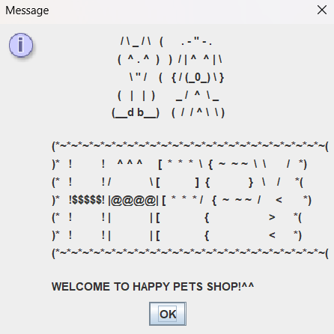

*figure 4.1: Sample Output 1*

**4.2: Figure 2 - Display the menu**

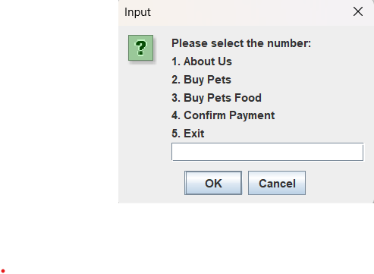

*Figure 4.2: Menu*

## 4.3: Figure 3 – Display error message for wrong input.

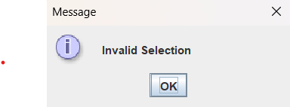

*Figure 4.3: Sample Output 2*

**4.4: Figure 4 - Display “About us” Page when user inputs 1.**

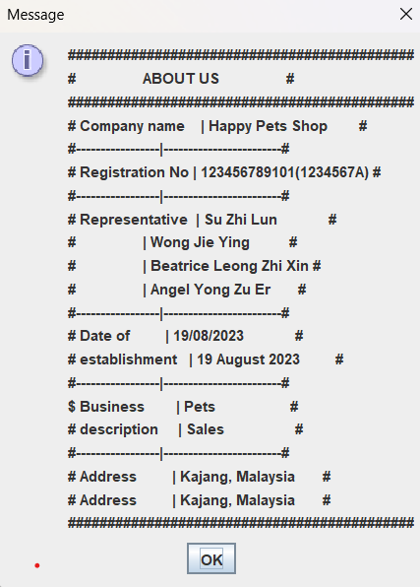

Figure 4.4 - About us Page

**4.5: Figure 5 - Display “Buy Pets” when users input “2”.**

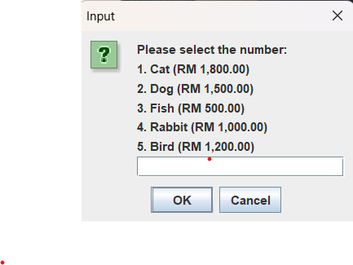

Figure 4.5 - Buy Pets Page

**4.6: Figure 6 - Choose Fish and enter 1 for quantity.**

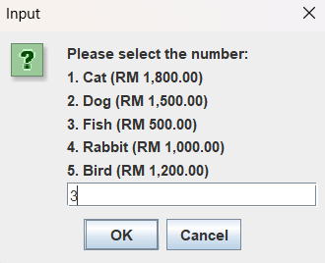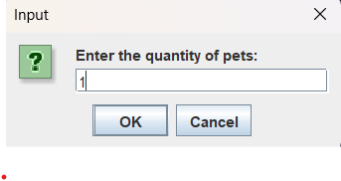

Figure 4.6 - Choosing fish with 1 quantity

**4.7: Figure 7 - Display “Buy Pets Food” when users input “3”.**

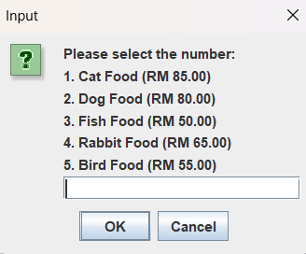

Figure 4.7 - Buy Pets Food Menu

**4.8: Figure 8 - Choose Fish Food and enter 1 for quantity.**

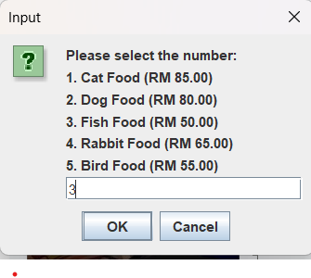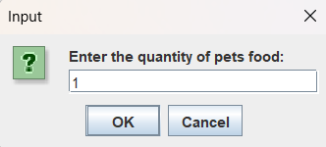

Figure 4.8 - Choosing fish with 1 quantity

**4.9: Figure 9 - Confirm the payment and receive your receipt.**

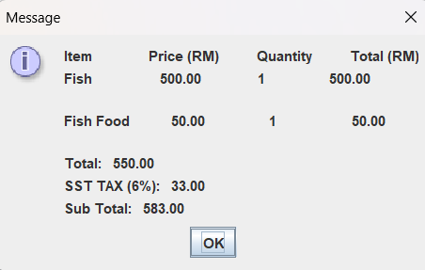

Figure 4.9 - Printing receipt

**4.10: Figure 10 - Exiting the Page**

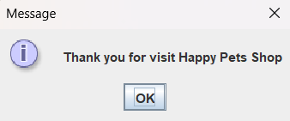

Figure 4.10 - Exiting page