Screenshot 1 — Geocoding API response JSON
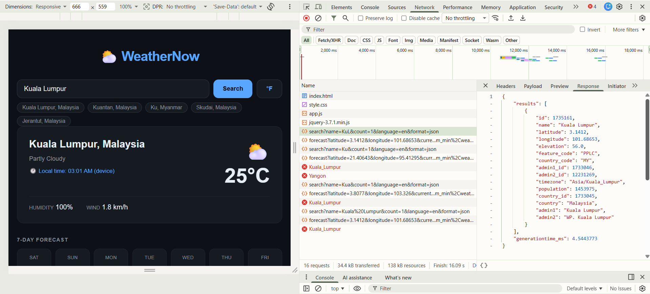

Screenshot 2 — Weather API response JSON
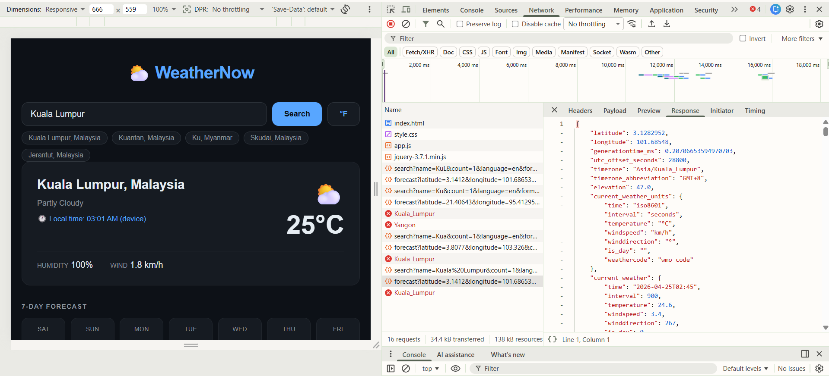
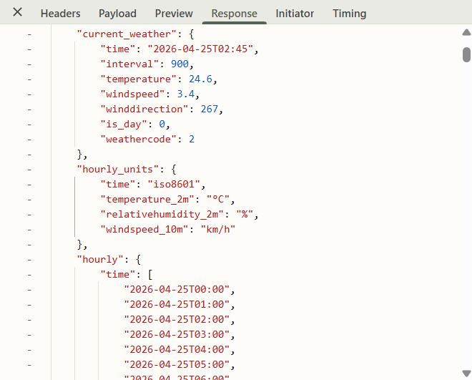

Screenshot 3 — Error state (offline simulation)
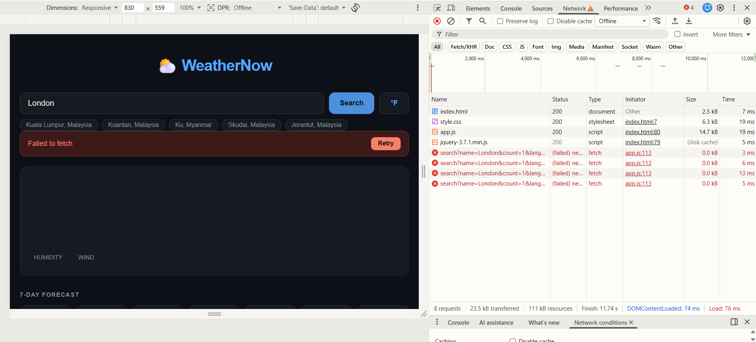

Reflection: Fetch API vs jQuery AJAX

In this lab, I experimented with both the Fetch API and jQuery's $getJSON() to make requests to various APIs. Having both in the same project allowed me to compare their pros and cons.
In terms of syntax, jQuery is more succinct for basic GET requests. A single $.getJSON(url) can be used instead of several lines of Fetch code that involves creating the request, checking the response.ok status, and then using .json() to parse the response. But Fetch is more transparent, with each step clearly defined and easier to comprehend when reading the code.
jQuery's asynchronous methods, .done(), .fail(), and .always(), are straightforward and easy to grasp. On the other hand, Fetch uses new async/await syntax, which is native to JavaScript and leads to more readable code, particularly when dealing with multiple requests, such as a geocoding API followed by a weather API.
Error handling is different. Fetch does not reject promises for HTTP errors (e.g., 404 or 500), and requires checking response.ok. In contrast, jQuery's .fail() is called on both network and HTTP errors, which is safer for novices but less versatile for advanced use.
As for browser compatibility, jQuery was once important for cross-browser support. Nowadays, Fetch is well supported, making jQuery less necessary.
I recommend the Fetch API with async/await for its modern syntax, simplicity, and flexibility, even though jQuery is easier for basic operations.

