COMP7940 Cloud Computing
Lab 5: GitHub Actions with AWS EC2 Deployment

Student Name: WANG Zifeng Student ID: 25432478

Write-Up Questions
Submit answers to Moodle:
- Identify the command used in deploy.yml that uploads/deploys your chatbot. → ssh ...
- Draw a diagram showing connections and data flow between local repo, GitHub repo, and AWS EC2 instance.
- Explain why storing passwords in config.ini is insecure, and how GitHub Secrets improve security.
- Provide screenshots of your GitHub Actions run and explain them.

Questions 1
Identify the command used in deploy.yml that uploads/deploys your chatbot. → ssh ...
Answer:
SSH securely connects to AWS EC2 instances using the EC2 username(ec2-user), host address(Pblic DNS), and private key(.pem file) stored in GitHub Secrets.
"-o StrictHostKeyChecking=no" Avoids host key verification prompts during initial connections.

Questions 2
Draw a diagram showing connections and data flow between local repo, GitHub repo, and AWS EC2 instance.
Answer:
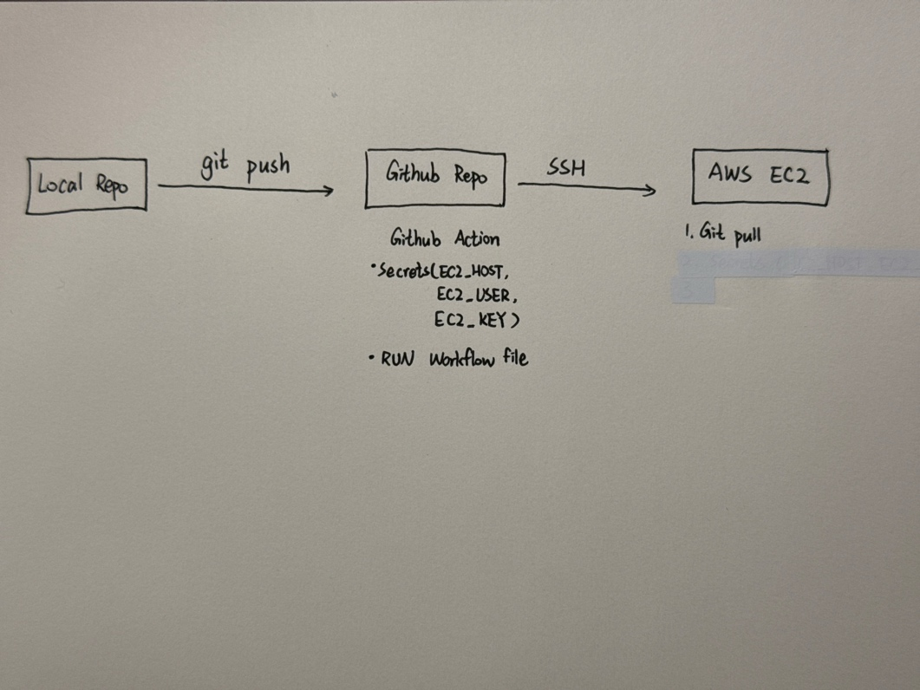

Questions 3
Explain why storing passwords in config.ini is insecure, and how GitHub Secrets improve security.
Answer:
Config.ini is usually stored in the Github repository in plain text. Once the repository is made public or maliciously accessed, sensitive information such as passwords will be directly leaked. Configuration files may be unintentionally backed up, shared or included in the log, further expanding the exposure.
GitHub Secrets encrypts and stores sensitive information (such as SSH private keys and host addresses). It is only injected through ${{ secrets.NAME }} when the workflow is running and will not be displayed in plain text in the log or code. Only GitHub Actions with appropriate permissions can access these Secrets, and the values of Secrets will never be exposed to the outside world.

Questions 4
Provide screenshots of your GitHub Actions run and explain them.
Answer:
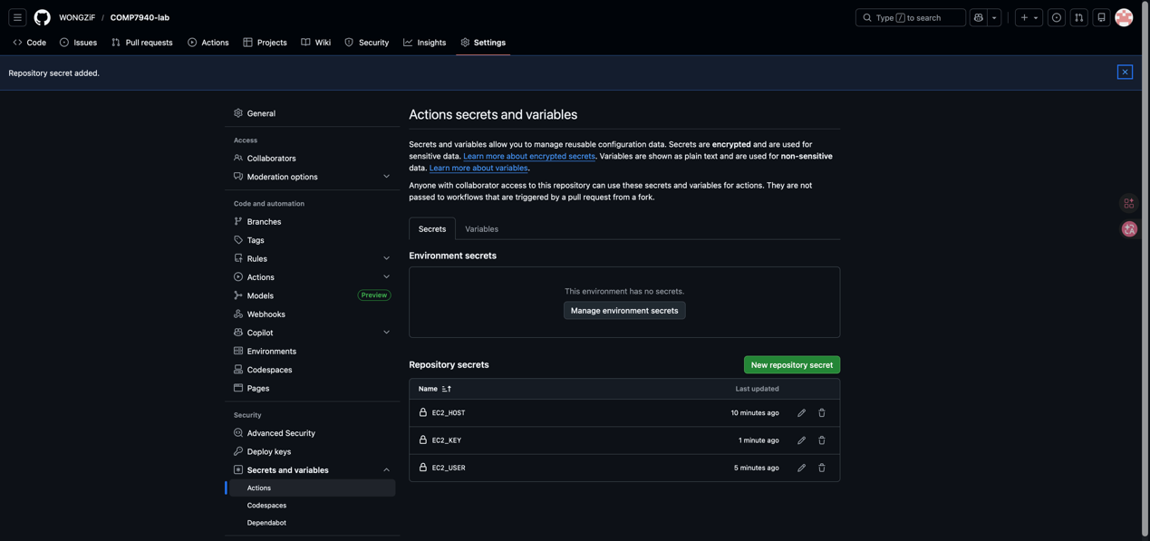
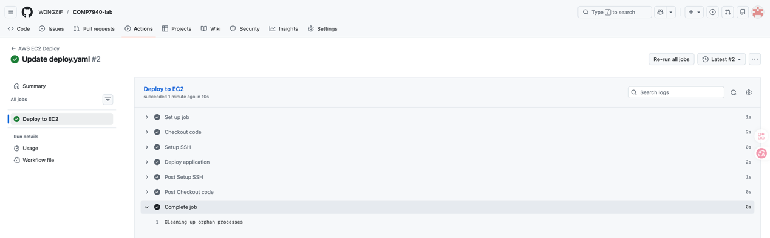
Screenshots of WANG Zifeng's GitHub Actions run
Explain:
This screenshot proves that when the code is pushed to the main branch, GitHub Actions is automatically triggered and successfully deployed to EC2.
By checking the log, it can be confirmed that the SSH connection is normal, the code update is successful, the old process is terminated, and the new process is running in the background.

Github URL for Lab: https://github.com/WONGZiF/COMP7940-lab.git

