# Exam Style Questions

# Regular Expression/BNF/Syntax Diagrams/Reverse Polish Notation

**Q1 - Easy**

Table 1 shows three definitions of a language for signed binary numbers, each written using a different standard notation.

All three definitions are supposed to be of the same language for signed binary numbers, but one of them contains an error which means that its defines a different language.

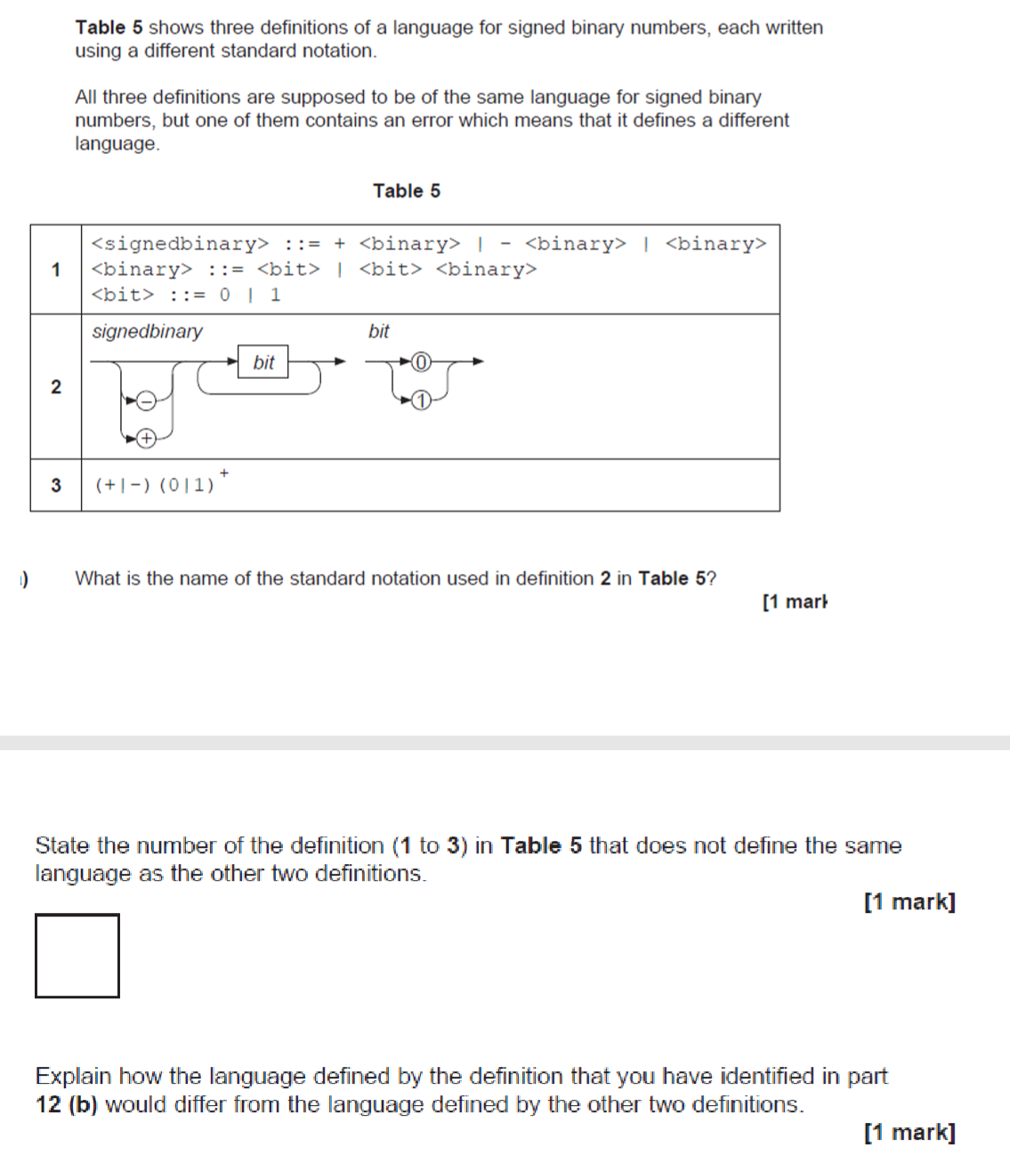

1. What is the name of the standard notation used in definition **2** in **Table 1**

**(1mark)**

1. State the number of the definition (1 to 3) in Table 1 that does not define the same language as the other two definitions.

**(1mark)**

1. Explain how the language defined by the definition that you identified in part **1b)** would differ from the language defined by the other two definitions.

.

.

.

**(1mark)**

## Regular Expression

**Q2 - Easy**

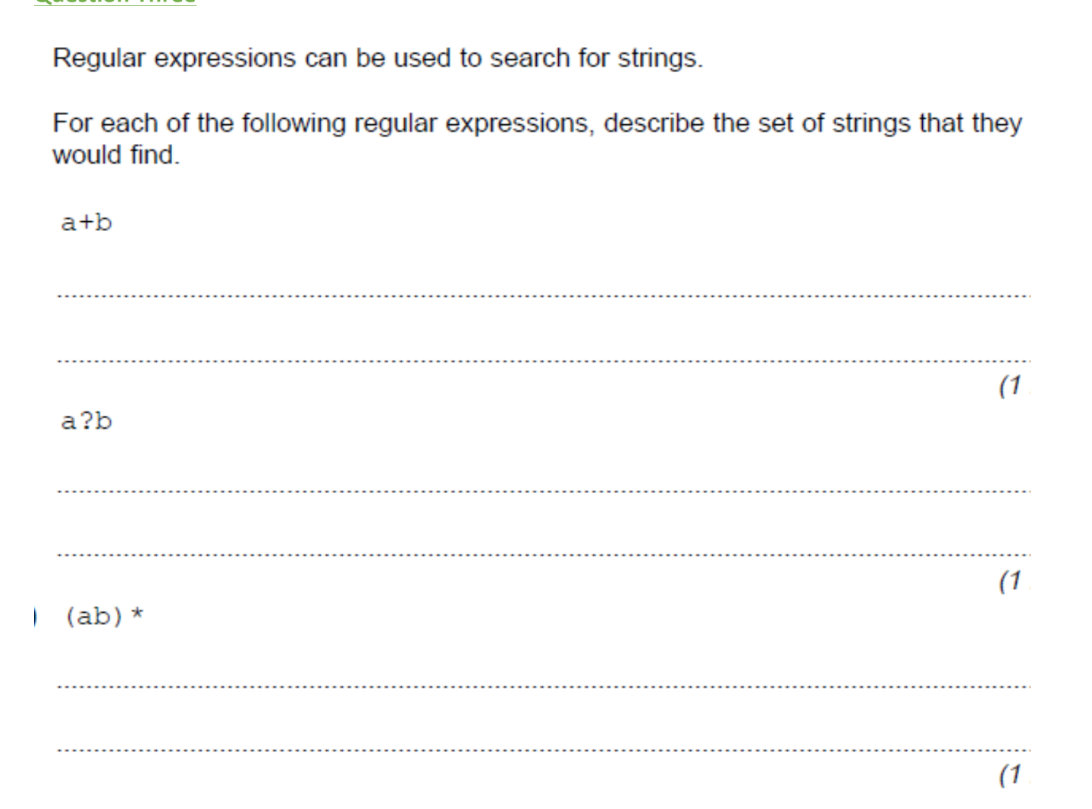

**Q3 – Easy**

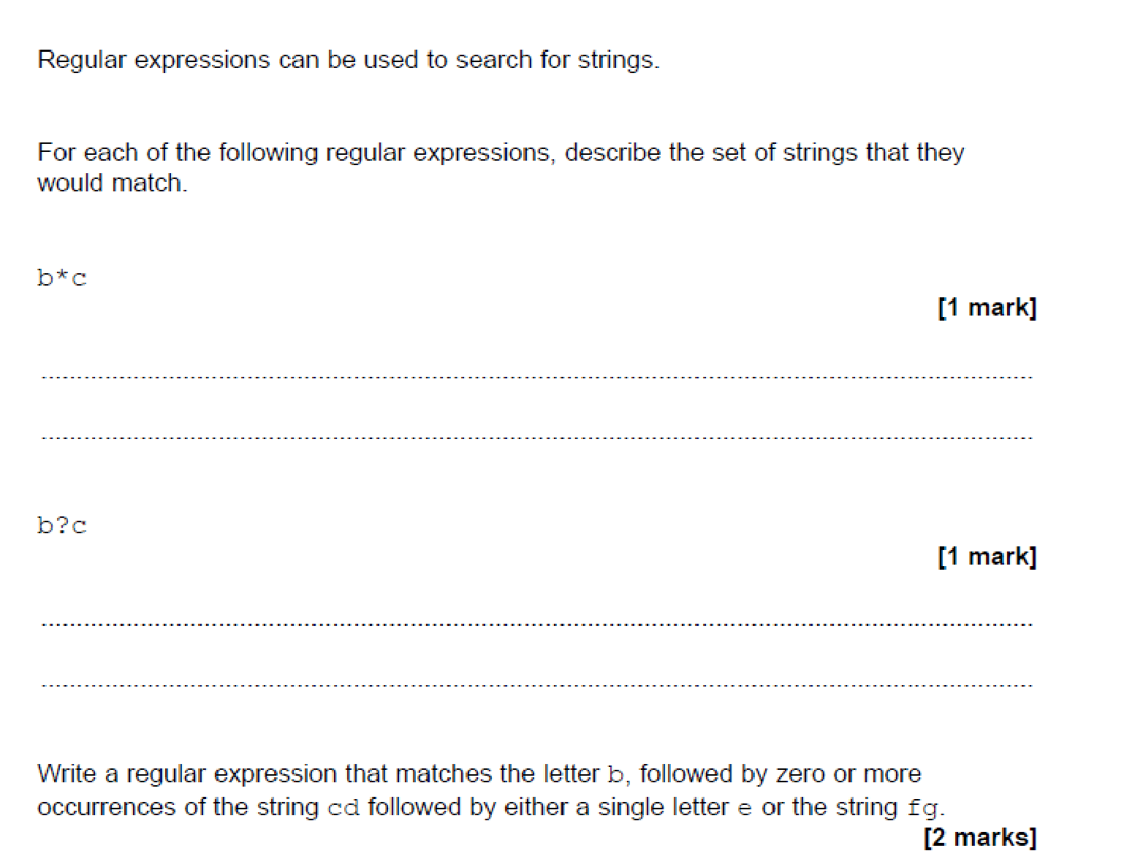

**Q4 – Medium**

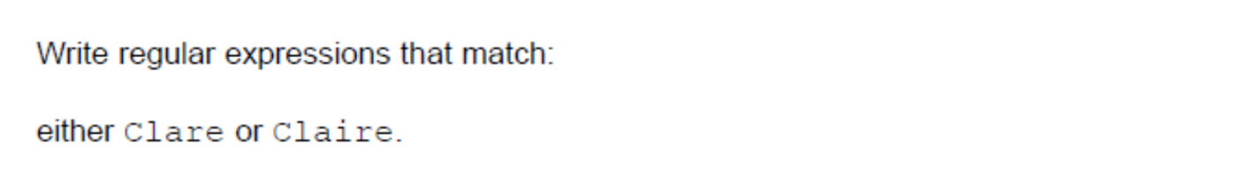

.

.

.

.

.

**Q5 – Medium**

Write a regular expression that represents any non-empty string that:

* Starts with 10
* Has zero or more occurrences of any combination of 0 or 1 in the middle
* Ends with 01

Example string that the expression should match are 1001, 100010101, 101111101010101001

.

.

.

.

.

**Q6 – Hard**



**Q7 - Hard**

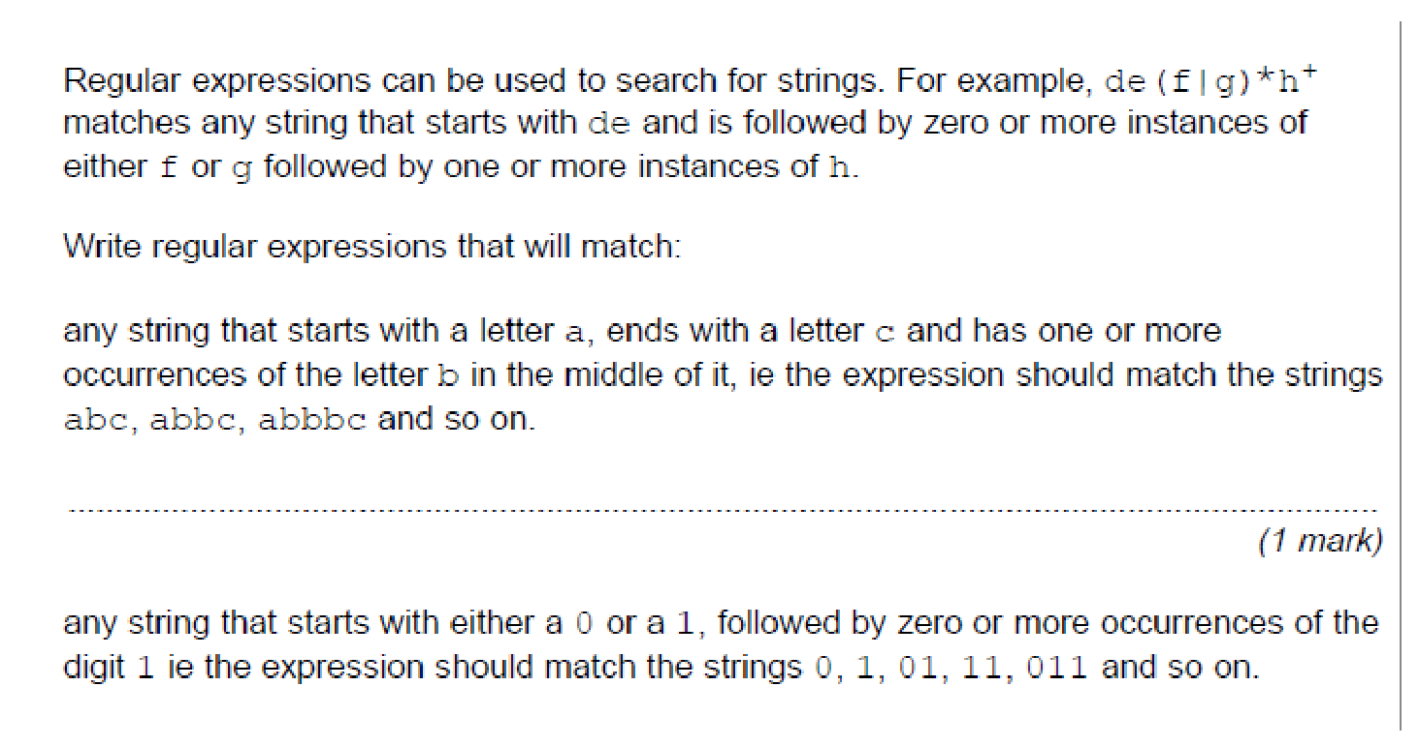

.

*(1 mark)*

**Q8 - Hard**

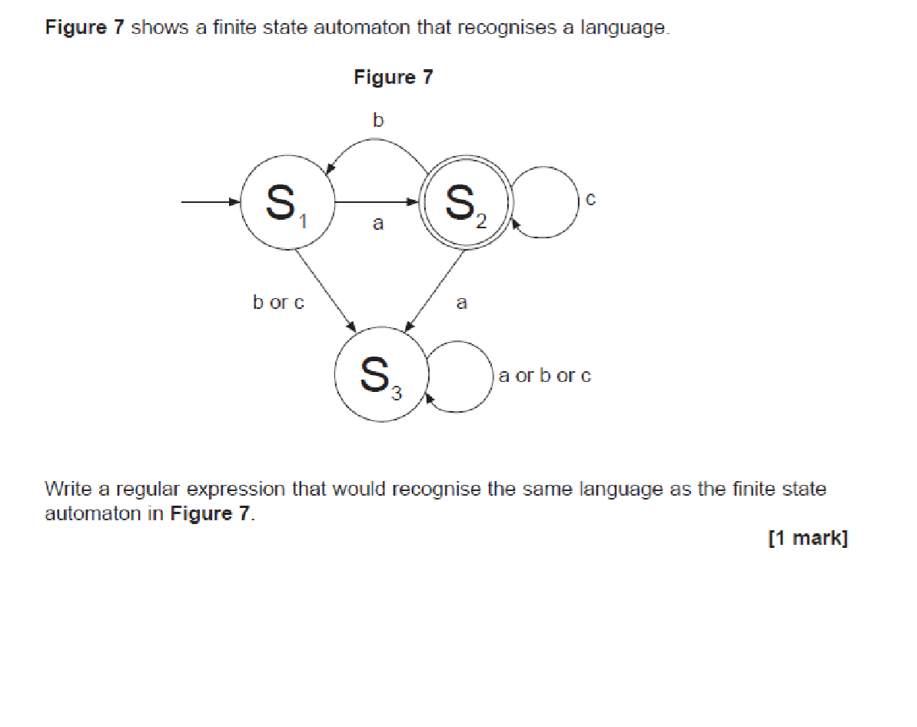

## BNF

**Q9 - Easy**

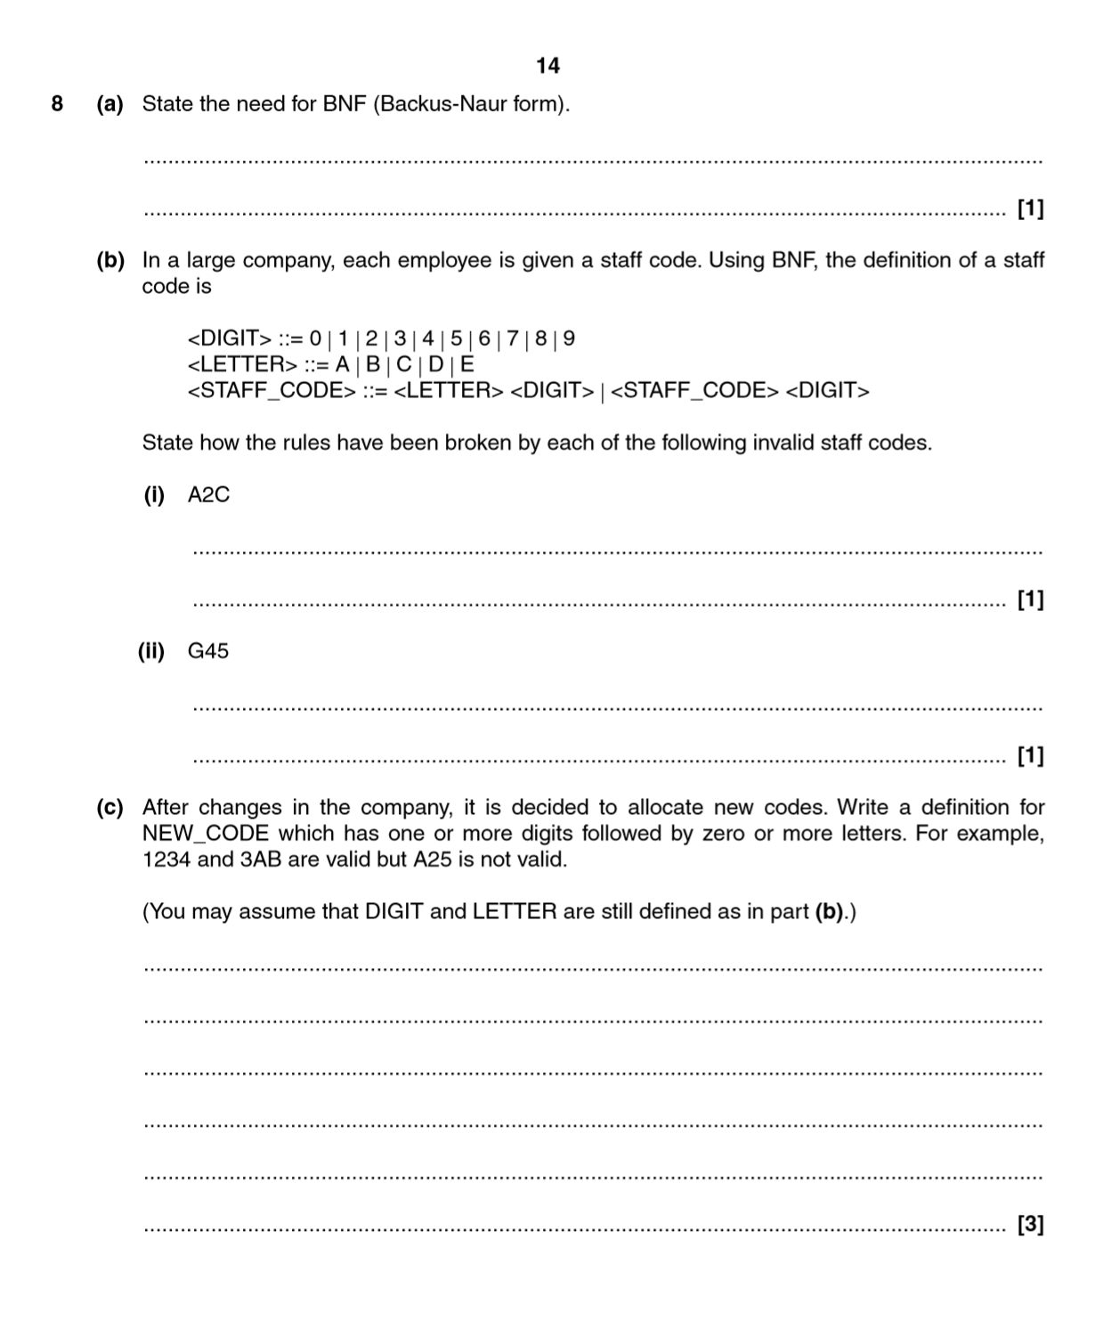

**Q10 – Easy**

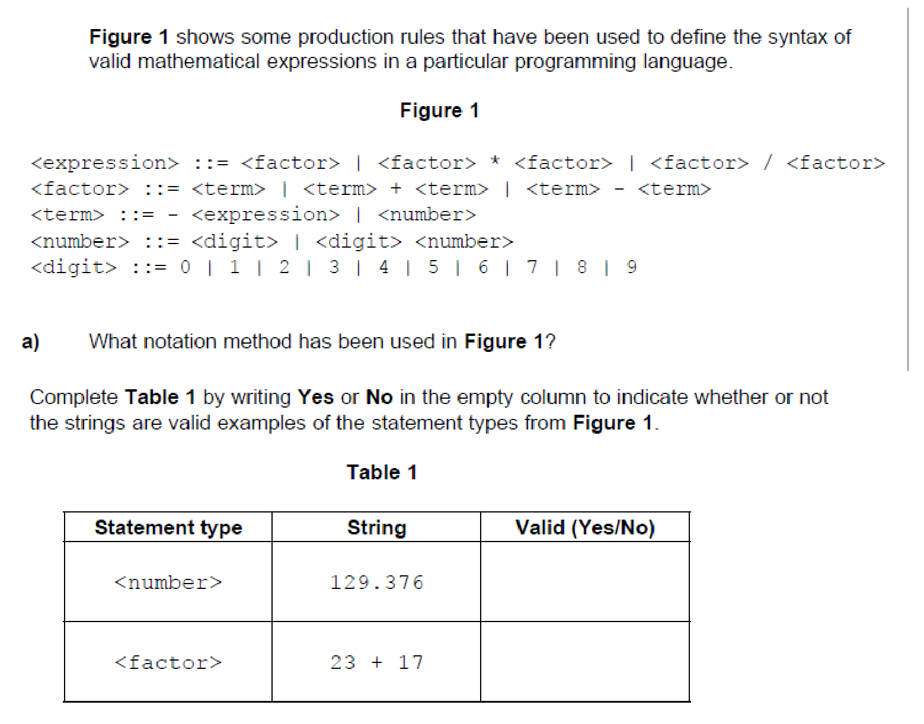

**Q11 – Medium**

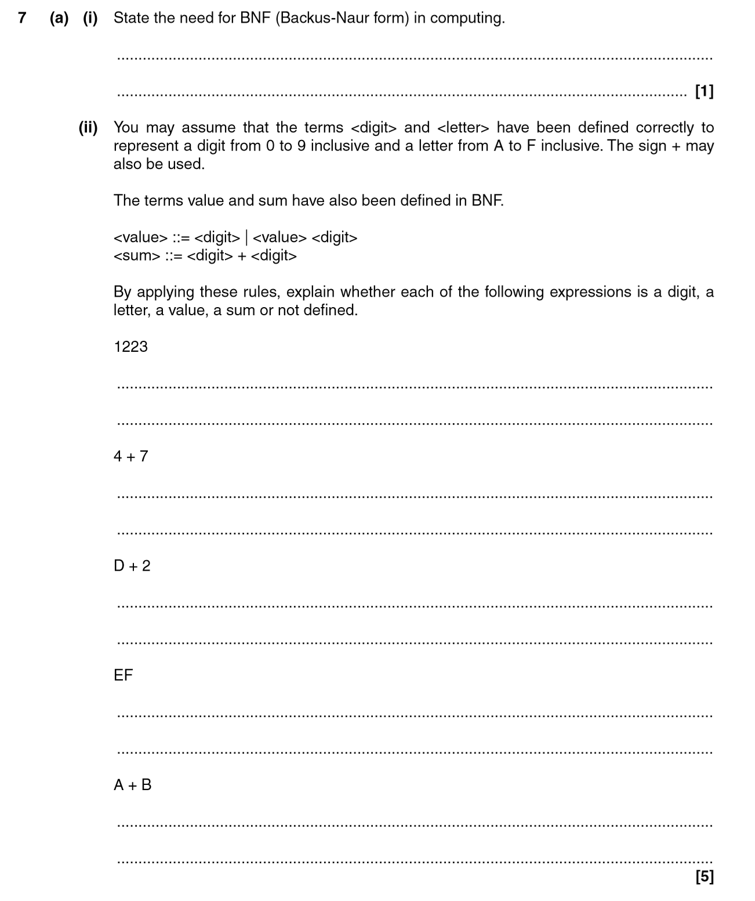

**Q 11 - Continued - Hard**

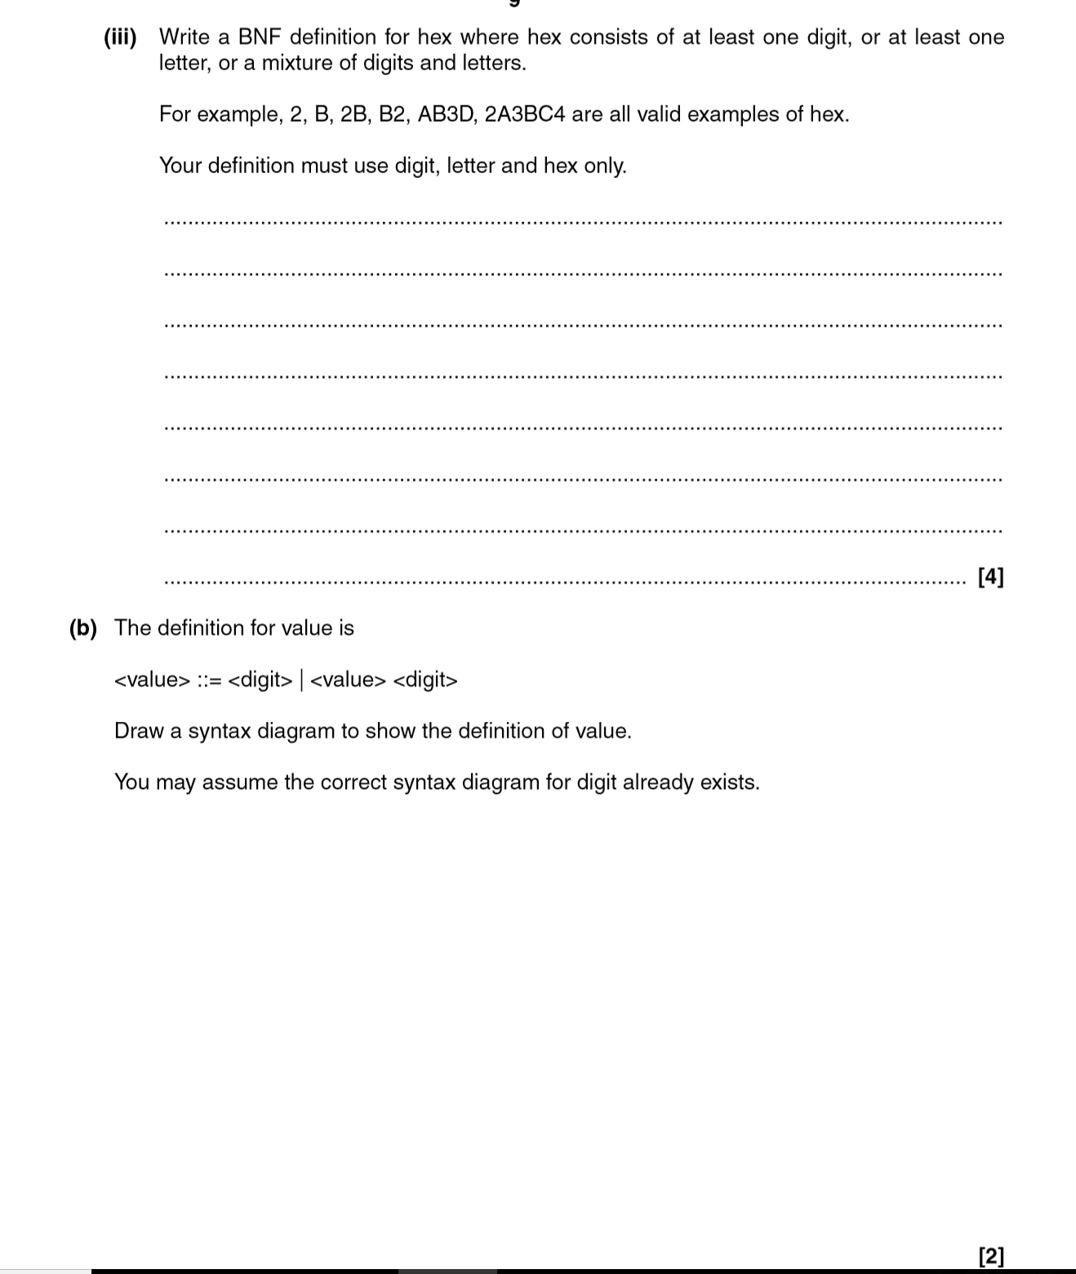

**Q12 - Hard**

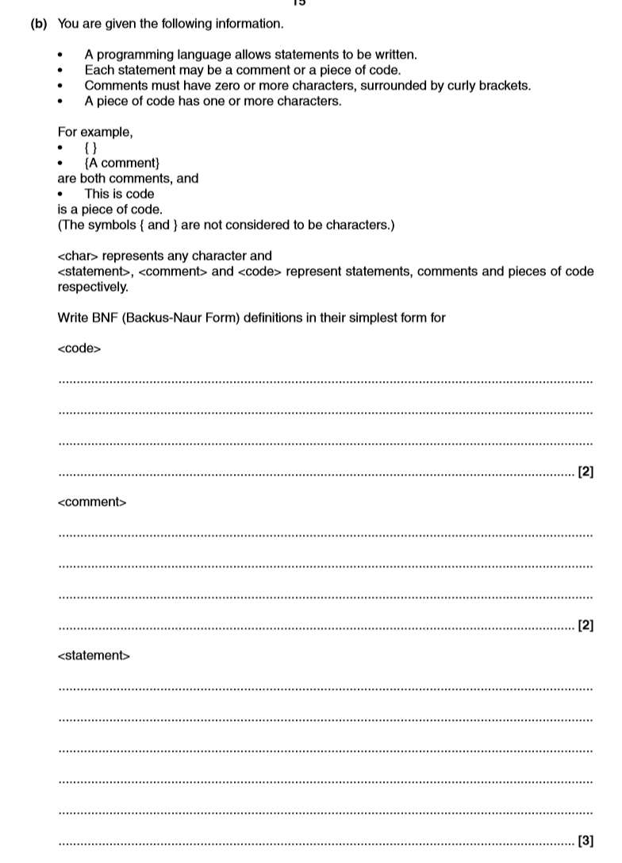

## Syntax Diagrams

**Q13 - Easy**

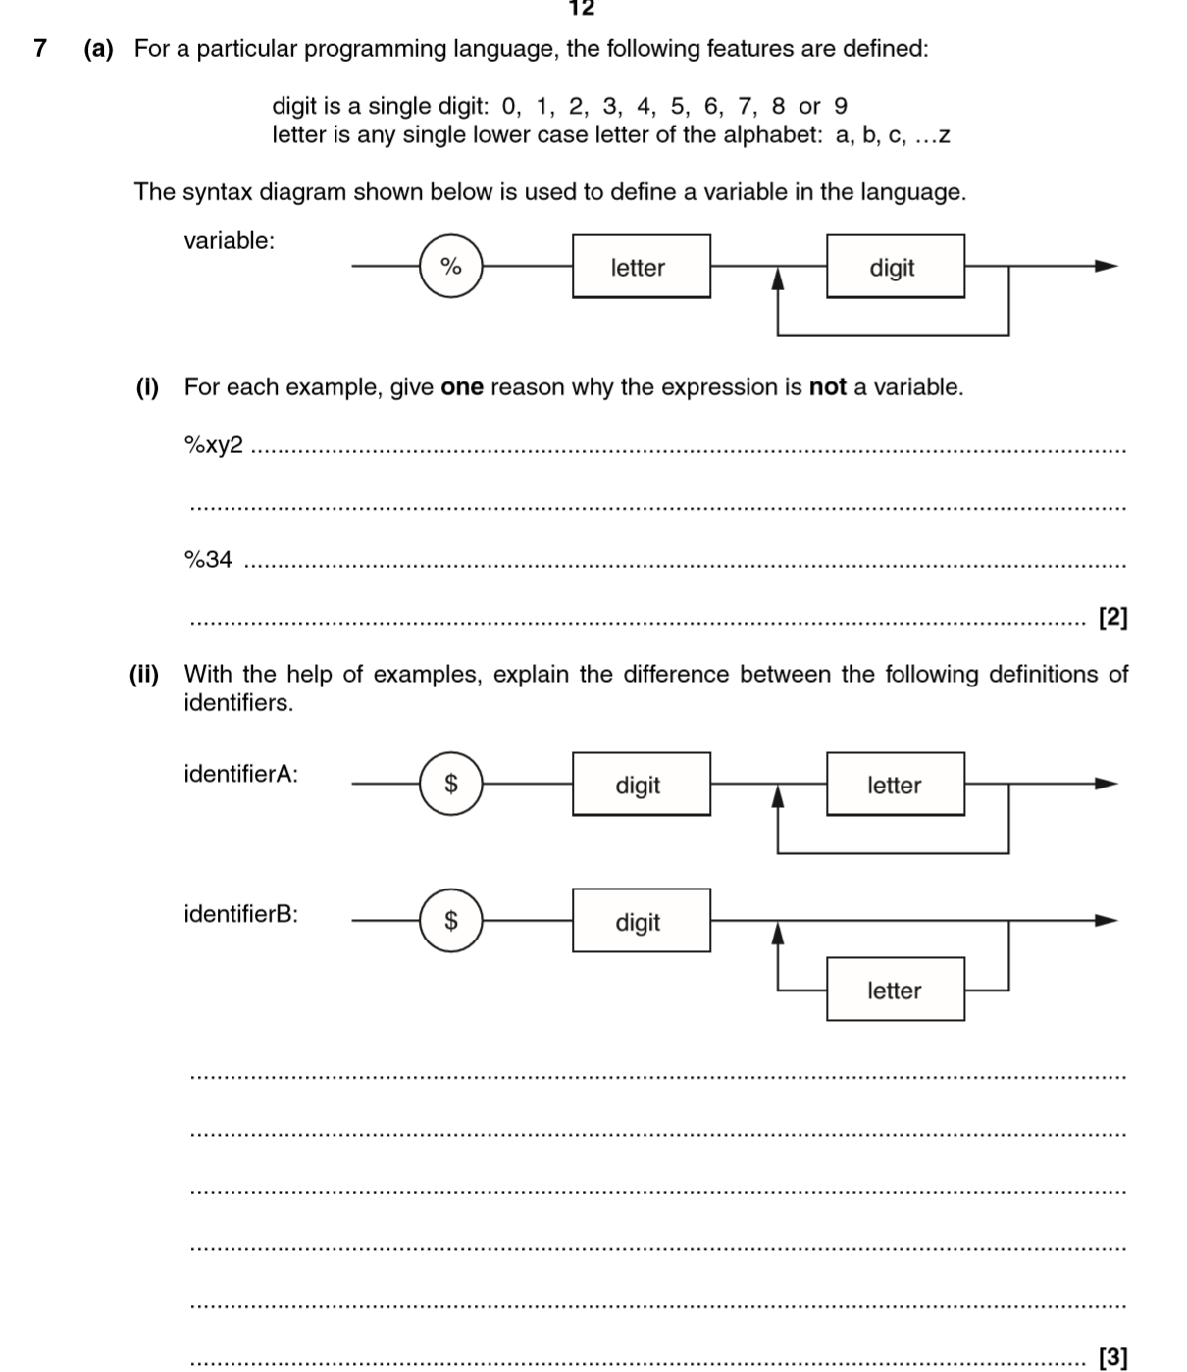

**Q14 – Medium**

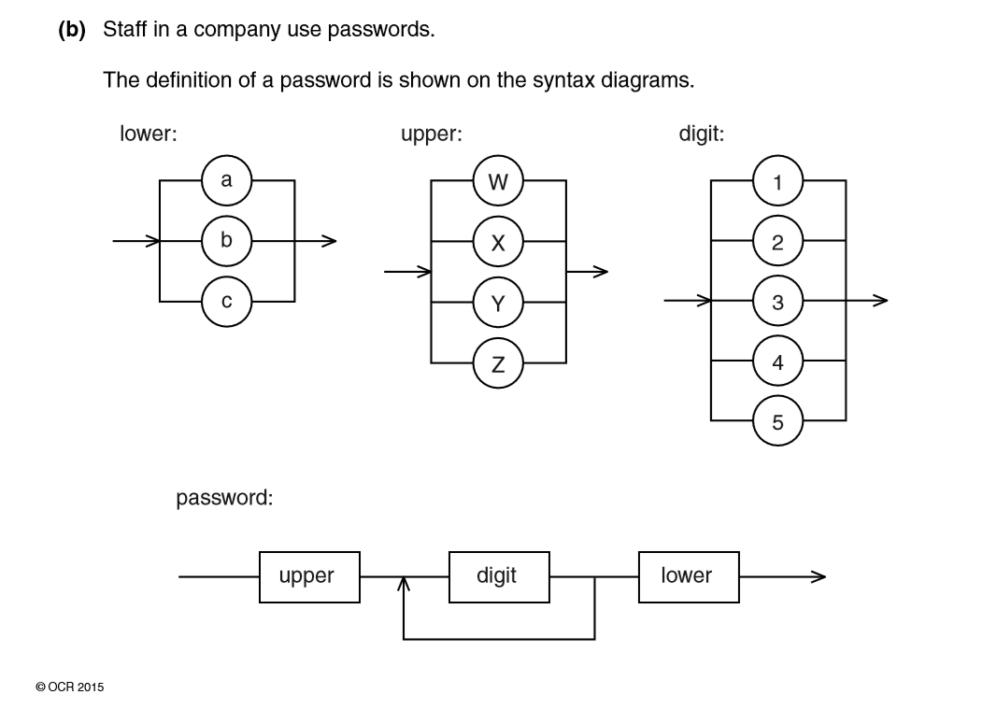

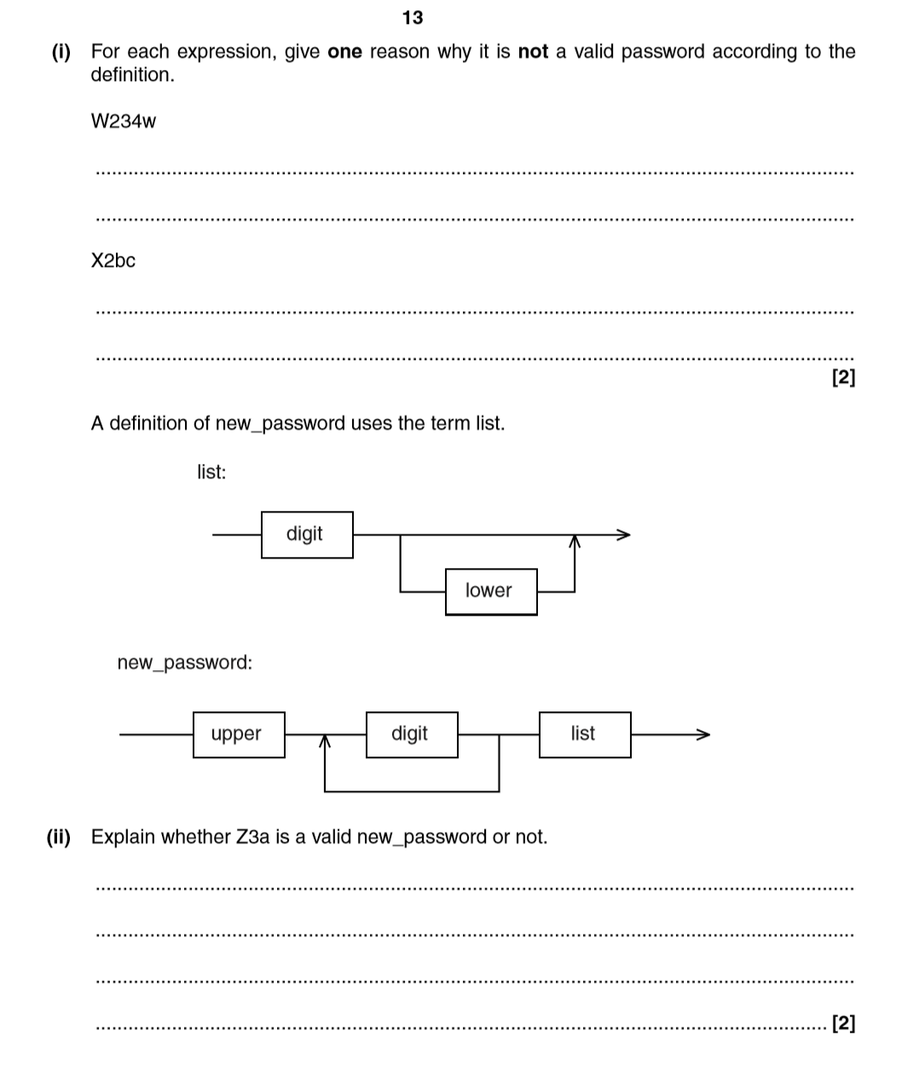

**Q15 – Hard**

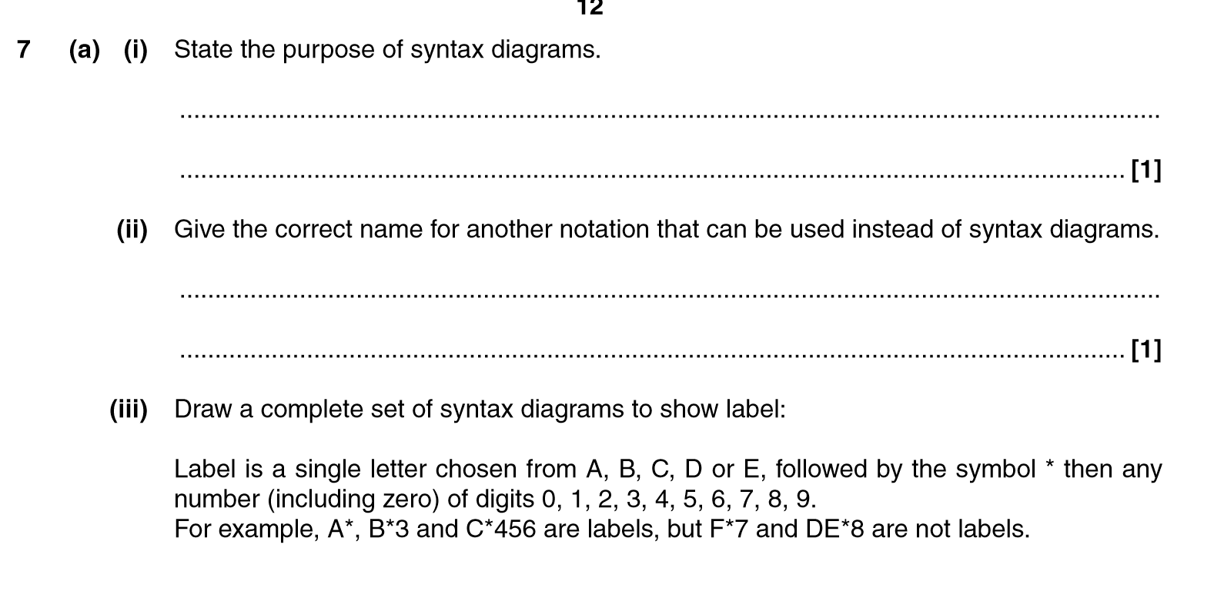

## Reverse Polish Notation – Extension Questions

**Q16**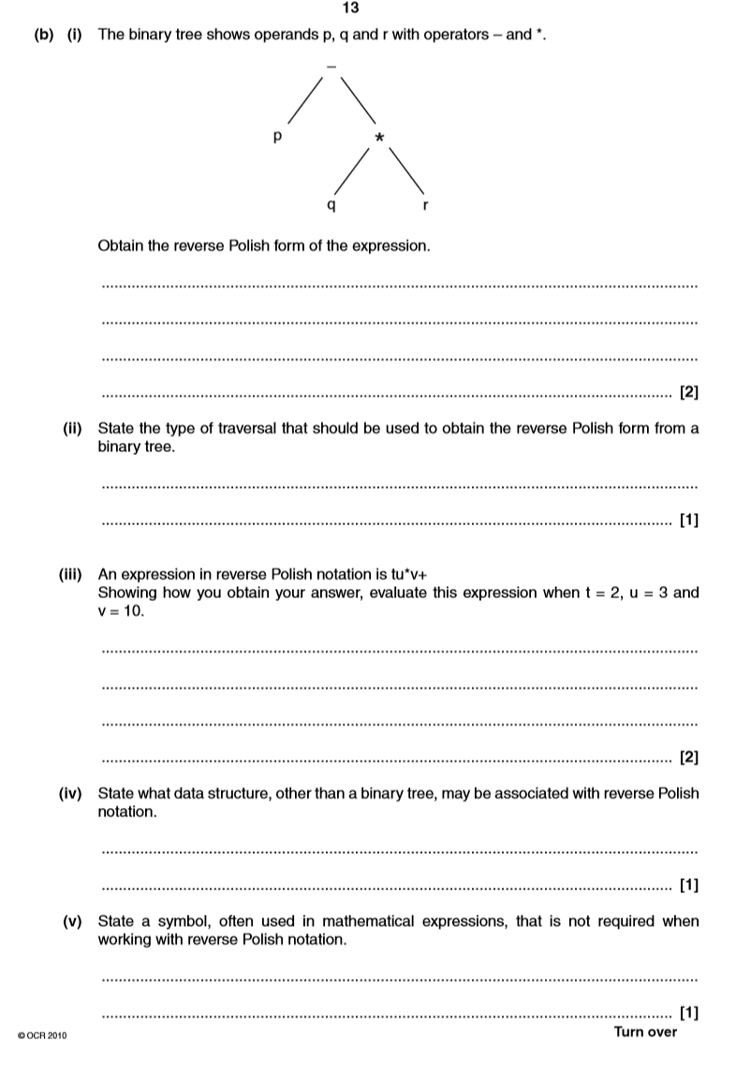

**Q17**

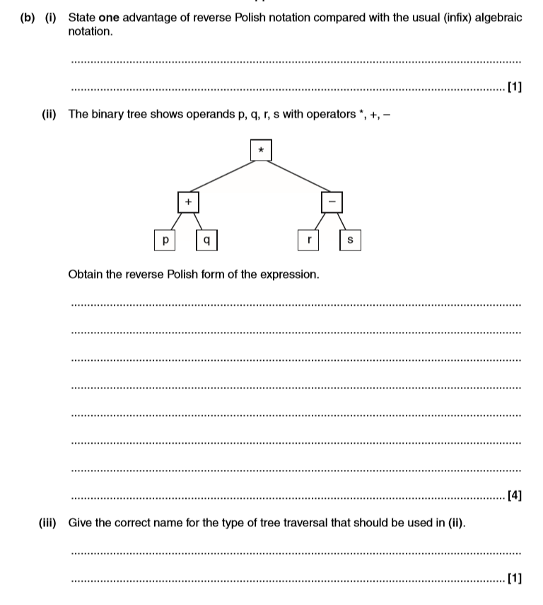

**Q18**