STATA ASSIGNMNET NUMBERS 1,2,3,4 AND 5a,5b,6,7,8,9

- Open relate.dta. The R3828700 variable represents the gender of the adolescent and is coded as a 1 for males and 2 for females. There are 775 people who are missing because they dropped out of the study after a previous wave of data collection. These people have a missing value on R3828700 of -5. Run a tabulation R3828700. Then modify the variable so that the code of -5 will be recognized by Stata as a missing value. Label the variable so that a 1 is male and a 2 is female. Finally, run another tabulation and compare this with your first tabulation.

. tabulate R3828700

SYMBOL!KEY! |
SEX 1999 | Freq. Percent Cum.
------------+-----------------------------------
-5 | 775 8.63 8.63
1 | 4,170 46.42 55.04
2 | 4,039 44.96 100.00
------------+-----------------------------------
Total | 8,984 100.00
. mvdecode R3828700, mv(-5)
R3828700: 775 missing values generated

Change of the variable names
. label define gender 1 "male" 2 "female"
. label values R3828700 gender
Final Tabulations
. tabulate R3828700

SYMBOL!KEY! |
SEX 1999 | Freq. Percent Cum.
------------+-----------------------------------
male | 4,170 50.80 50.80
female | 4,039 49.20 100.00
------------+-----------------------------------
Total | 8,209 100.00

- Open relate. dta. Using the R3483600 variable, repeat the process you did for Lice first exercise. Go to the webpage for the book and examine the dictionary file relate. dct to see how this variable is coded. Modify the missing values so that -5 is. a, -4 is. b, -3 is. c, -2 is. d, and -1 is. e. Then label the values for the variable and run a tabulation.

. tabulate R3483600

MOTH |
PRAISES R |
DOING WELL |
1999 | Freq. Percent Cum.
------------+-----------------------------------
-5 | 775 8.63 8.63
-4 | 3,669 40.84 49.47
-2 | 3 0.03 49.50
-1 | 20 0.22 49.72
0 | 118 1.31 51.04
1 | 235 2.62 53.65
2 | 917 10.21 63.86
3 | 1,546 17.21 81.07
4 | 1,701 18.93 100.00
------------+-----------------------------------
Total | 8,984 100.00

. . mvdecode _all, mv(-5=.a\-4=.b\-3=.c\-2=.d\-1=.e)
R3483700: 4469 missing values generated
R3483800: 4468 missing values generated
R3483900: 4470 missing values generated
R3485200: 5608 missing values generated
R3485300: 5611 missing values generated
R3485400: 5610 missing values generated
R3485500: 5611 missing values generated
R3828100: 775 missing values generated

Structure of the Data after assigning the missing variables values

. codebook R3483600

-----------------------------------------------------------------------------------------------------------------
R3483600 MOTH PRAISES R DOING WELL 1999
-----------------------------------------------------------------------------------------------------------------

type: numeric (float)

range: [0,4] units: 1
unique values: 5 missing .: 0/8,984
unique mv codes: 4 missing .*: 4,467/8,984

tabulation: Freq. Value
118 0
235 1
917 2
1,546 3
1,701 4
775 .a
3,669 .b
3 .d
20 .e

.
label the values for the variable and run a tabulation.

. label define often 4 "always" .a "Noninterview" .b "ValidSkip" .c "InvalidSkip" .d "Don'tKnow" .e "Refused", re
> place

. label values R3483600 often
. tabulate R3483600

MOTH PRAISES |
R DOING WELL |
1999 | Freq. Percent Cum.
-------------+-----------------------------------
0 | 118 2.61 2.61
1 | 235 5.20 7.81
2 | 917 20.30 28.12
3 | 1,546 34.23 62.34
always | 1,701 37.66 100.00
-------------+-----------------------------------
Total | 4,517 100.00

. codebook R3483600

-----------------------------------------------------------------------------------------------------------------
R3483600 MOTH PRAISES R DOING WELL 1999
-----------------------------------------------------------------------------------------------------------------

type: numeric (float)
label: often, but 4 nonmissing values are not labeled

range: [0,4] units: 1
unique values: 5 missing .: 0/8,984
unique mv codes: 4 missing .*: 4,467/8,984

tabulation: Freq. Numeric Label
118 0
235 1
917 2
1,546 3
1,701 4 always
775 .a Noninterview
3,669 .b ValidSkip
3 .d Don'tKnow
20 .e Refused

- Using the result of the second exercise, run the command numlabel, add. Repeat the tabulation of R3483600, and compare it with the tabulation for the second exercise. Next run the command numlabel, remove. Finally, repeat the tabulation, but add the missing option; that is, insert a comma and the ward " at the end of the command. Why is it good to include this option when you are screenittg your data?

. numlabel, add mask("#. ")
(dataset has no value labels)
. tabulate R3483600

R3483600 | Freq. Percent Cum.
------------+-----------------------------------
0 | 118 2.61 2.61
1 | 235 5.20 7.81
2 | 917 20.30 28.12
3 | 1,546 34.23 62.34
4 | 1,701 37.66 100.00
------------+-----------------------------------
Total | 4,517 100.00

. . numlabel, remove mask("#. ") force detail
(dataset has no value labels)

. tabulate R3483600

R3483600 | Freq. Percent Cum.
------------+-----------------------------------
0 | 118 2.61 2.61
1 | 235 5.20 7.81
2 | 917 20.30 28.12
3 | 1,546 34.23 62.34
4 | 1,701 37.66 100.00
------------+-----------------------------------
Total | 4,517 100.00

Conclusion- There is no difference in the tabulations
4.relate.dta is data from the third year of a long-term study. Because of this, some of the youth who were adolescents the first year (1997) are more than 18 years old. Assign a missing value on R3828100(age) for those with a code of -5.Drop observations that are 18 or older. Keep only R0000100,R3483600,R3483800,R3485200,R3485400,and R3828700.Save this as a dataset called positive.dta .
Replace the missing values with -5
. mvdecode R3828100 , mv(-5)
Show Data
. mvdecode R3828100 , mv(-5)
. codebook R3828100

-----------------------------------------------------------------------------------------------------------------
R3828100 SYMBOL!KEY!AGE 1999
-----------------------------------------------------------------------------------------------------------------

type: numeric (float)

range: [14,20] units: 1
unique values: 7 missing .: 0/8,984
unique mv codes: 1 missing .*: 775/8,984

tabulation: Freq. Value
109 14
1,664 15
1,632 16
1,728 17
1,622 18
1,387 19
67 20
775 -5

Drop observations that are 18 or older
. drop if R3828100 >=18
. tabulate R3828100

SYMBOL!KEY! |
AGE 1999 | Freq. Percent Cum.
------------+-----------------------------------
14 | 109 2.12 2.12
15 | 1,664 32.42 34.54
16 | 1,632 31.79 66.34
17 | 1,728 33.66 100.00
------------+-----------------------------------
Total | 5,133 100.00
Keep only R0000100,R3483600,R3483800,R3485200,R3485400,and R3828700
. keep R0000100 R3483600 R3483800 R3485200 R3485400 R3828700
Final Data saved as positive.dta
. summarize

Variable | Obs Mean Std. Dev. Min Max
-------------+---------------------------------------------------------
R0000100 | 5,133 4464.604 2600.985 2 9022
R3483600 | 4,487 2.990862 1.012255 0 4
R3483800 | 4,486 2.944494 1.032491 0 4
R3485200 | 3,352 2.775656 1.106301 0 4
R3485400 | 3,350 2.641493 1.157941 0 4
-------------+---------------------------------------------------------
R3828700 | 5,133 1.483928 .4997903 1 2

Lab Assignment # 5

5.In recent decades, the Hispanic population of many counties throughout the US has grown dramatically. Test the hypothesis that Hispanics represent more than 10% of the population at the county level in 2000.
  - State the H₀ and H_{a}. Explain why this is a one-sided or two-sided significance test and why?

This is a one-sided significance test as we are testing for the directional property “more than” deriving from the laws that one-sided significance tests are directional.

  - Perform the test in Stata using the “ttest” command and interpret the results.

Hypothesis for the Test is given as

H_{a} ; $u$ $<$10
H₀ ; $u$ $>$10

Type of Significance Test: This is a one-sided significance test as we are testing whether the claim is larger than the given parameter value.

Distribution of Data

. mean PctH05

Mean estimation Number of obs = 3,141

--------------------------------------------------------------
| Mean Std. Err. [95% Conf. Interval]
-------------+------------------------------------------------
PctH05 | 7.081293 .2231758 6.643707 7.518878

Histogram Representation

. histogram PctH05
(bin=34, start=0, width=2.8697059)
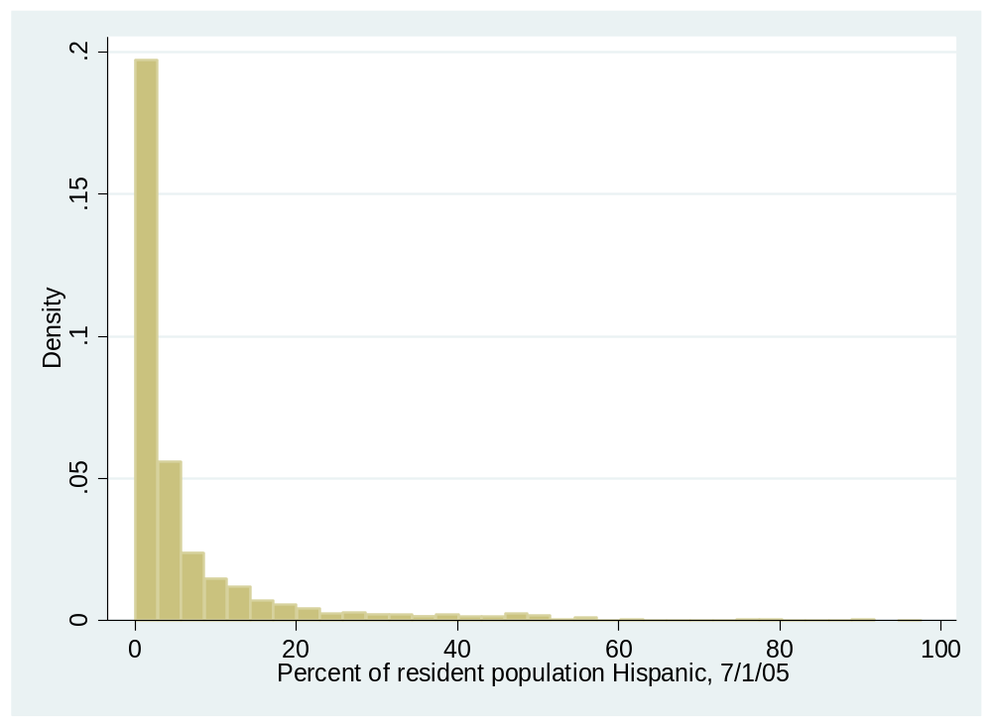

Hypothesis test for one sample mean test

. db ttest

. ttest PctH05 == 10

One-sample t test
------------------------------------------------------------------------------
Variable | Obs Mean Std. Err. Std. Dev. [95% Conf. Interval]
---------+--------------------------------------------------------------------
PctH05 | 3,141 7.081293 .2231758 12.5078 6.643707 7.518878
------------------------------------------------------------------------------
mean = mean(PctH05) t = -13.0781
Ho: mean = 10 degrees of freedom = 3140

Ha: mean < 10 Ha: mean != 10 Ha: mean > 10
Pr(T < t) = 0.0000 Pr(|T| > |t|) = 0.0000 Pr(T > t) = 1.0000

Conclusion : Evidently the assumption that Hispanics represent more than 10% of the population at the county level in 2000 is wrong.
Ha: mean > 10
Pr(T > t) = 1.0000

6. Given California’s proximity to Mexico, one researcher expects that its population of Hispanic residents is higher than 25%. Test this hypothesis in Stata using only California counties. State the H₀ and H_{a}. Select an alpha value and perform the test. Interpret the results. (Note: The Census uses a state “FIPS code” to denote specific states and this code is labeled “State” in our dataset. California has a FIPS code of 6).

Hypothesis for the Test is given as
H₀ ; ; $u$ $>$ 25
H_{a} ; ; $u$ $<$25

Condition : State-> California

Histogram for the State

.histogram State

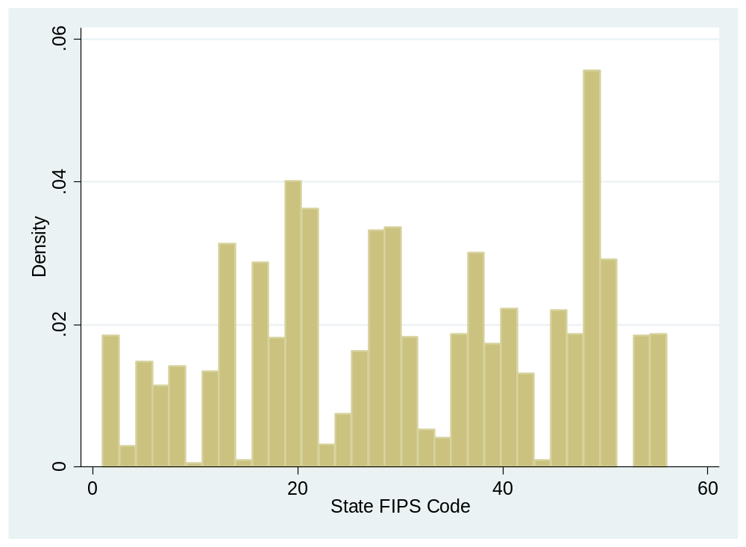

Call the ttest function
.db ttest
Hypotheses Results
ttest PctH05 == 25 if State==6

One-sample t test
------------------------------------------------------------------------------
Variable | Obs Mean Std. Err. Std. Dev. [95% Conf. Interval]
---------+--------------------------------------------------------------------
PctH05 | 58 25.48569 2.121513 16.15696 21.23743 29.73395
------------------------------------------------------------------------------
mean = mean(PctH05) t = 0.2289
Ho: mean = 25 degrees of freedom = 57

Ha: mean < 25 Ha: mean != 25 Ha: mean > 25
Pr(T < t) = 0.5901 Pr(|T| > |t|) = 0.8197 Pr(T > t) = 0.4099

.

- Another researcher wants to test whether the average percentage of Hispanic residents differ across larger and smaller California counties. Instead of utilizing a random sample, we will select our observations based on population size. Test the hypothesis that Hispanics represent more than 25% of the population in large California counties (i.e., counties with a population of more than 100,000 persons). For this research question, state the hypotheses, appropriate test statistic, p-value, and assess the results of the test. (Note: Similar to assignment 4, you will need to use the PopCen00 variable and an “if” statement to run this test.)

Hypothesis for the Test is given as
H₀ ; $u>$25
H_{a} ; u $<$25

Condition : California Counties with A Population of more than 100,000 persons

. scatter PctH05 State
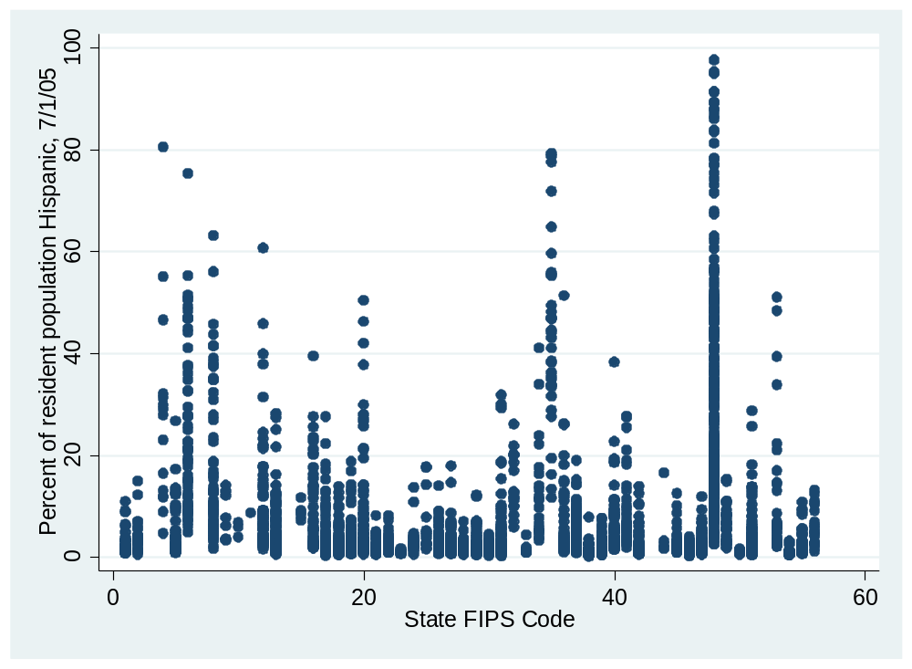

Call for hypotheses test
. db ttest
Hypotheses test
. ttest PctH05 == 25 if State==6 & PopCen00 >100000

One-sample t test
------------------------------------------------------------------------------
Variable | Obs Mean Std. Err. Std. Dev. [95% Conf. Interval]
---------+--------------------------------------------------------------------
PctH05 | 35 30.976 2.72502 16.12144 25.43809 36.51391
------------------------------------------------------------------------------
mean = mean(PctH05) t = 2.1930
Ho: mean = 25 degrees of freedom = 34

Ha: mean < 25 Ha: mean != 25 Ha: mean > 25
Pr(T < t) = 0.9824 Pr(|T| > |t|) = 0.0352 Pr(T > t) = 0.0176

8.Test the hypothesis that Hispanics represents more than 25% of the population in small California counties (i.e., areas with a population of less than 100,000 persons). As above, state the hypotheses, appropriate test statistic, p-value, and assess the results of the test.

Hypothesis for the Test is given as
H₀ ; $u>$25
H_{a} ; u $<$25

Condition for the hypothesis : areas with a population of less than 100,000 persons
Histogram of Hispanics

.histogram PctH05

Call for Hypotheses test
. db ttest

Results of the Hypotheses Test

. ttest PctH05 == 25 if State==6 & PopCen00 <100000

One-sample t test
------------------------------------------------------------------------------
Variable | Obs Mean Std. Err. Std. Dev. [95% Conf. Interval]
---------+--------------------------------------------------------------------
PctH05 | 23 17.13087 2.585529 12.39976 11.76881 22.49293
------------------------------------------------------------------------------
mean = mean(PctH05) t = -3.0435
Ho: mean = 25 degrees of freedom = 22

Ha: mean < 25 Ha: mean != 25 Ha: mean > 25
Pr(T < t) = 0.0030 Pr(|T| > |t|) = 0.0060 Pr(T > t) = 0.9970

Hispanics do not represent 25% of the small counties of California
9.Finally, another researcher argues that Hispanics do not represent more than 25% of the population in small California counties. However, this researcher isn’t sure what size the Hispanic population is in these areas. Test the hypothesis that Hispanics does not represent 25% of the population in small California counties (i.e., areas with a population of less than 100,000 persons). As above, state the hypotheses, appropriate test statistic, p-value, and assess the results of the test. How do these results compared to those described above?

Hypothesis for the Test is given as
H_{a} ; u $<$25
H₀ ; $u>$ 25

Appropriate test statistic is One-Significance Test

P-value>0.001 to any Infer Statistical Significance

Hypothesis Test Results

. ttest PctH05 == 25 if State==6 & PopCen00 <100000

One-sample t test
------------------------------------------------------------------------------
Variable | Obs Mean Std. Err. Std. Dev. [95% Conf. Interval]
---------+--------------------------------------------------------------------
PctH05 | 23 17.13087 2.585529 12.39976 11.76881 22.49293
------------------------------------------------------------------------------
mean = mean(PctH05) t = -3.0435
Ho: mean = 25 degrees of freedom = 22

Ha: mean < 25 Ha: mean != 25 Ha: mean > 25
Pr(T < t) = 0.0030 Pr(|T| > |t|) = 0.0060 Pr(T > t) = 0.9970

.

Conclusion

Ha: mean != 25 and Ha: mean != 25 therefore Hispanics
Still do not represent more than 25% of the population

DO FILE
QUESTION 1
. tabulate R3828700
. mvdecode R3828700, mv(-5)
. label define gender 1 "male" 2 "female"
. label values R3828700 gender
. tabulate R3828700
QUESTION 2
. tabulate R3483600
. . mvdecode _all, mv(-5=.a\-4=.b\-3=.c\-2=.d\-1=.e)
. codebook R3483600
. label define often 4 "always" .a "Noninterview" .b "ValidSkip" .c "InvalidSkip" .d "Don'tKnow" .e "Refused", re
> place
. label values R3483600 often
. tabulate R3483600
. codebook R3483600

. numlabel, add mask("#. ")
. tabulate R3483600
. . numlabel, remove mask("#. ") force detail
(dataset has no value labels)
. tabulate R3483600
QUESTION 4
. mvdecode R3828100 , mv(-5)
. codebook R3828100
. drop if R3828100 >=18
. tabulate R3828100
. keep R0000100 R3483600 R3483800 R3485200 R3485400 R3828700
. summarize

QUESTION 5
. mean PctH05
. histogram PctH05
. db ttest
. ttest PctH05 == 10

QUESTION 6
.histogram State
.db ttest
. ttest PctH05 == 25 if State==6

QUESTION 7
. scatter PctH05 State
. db ttest
. ttest PctH05 == 25 if State==6 & PopCen00 >100000

QUESTION 8
.histogram PctH05
. db ttest
. ttest PctH05 == 25 if State==6 & PopCen00 <100000

QUESTION 9
. ttest PctH05 == 25 if State==6 & PopCen00 <100000

