Lab Assignment # 6

Acock problems:
Acock Ch. 7 problems 5 & 8 (skip questions 6 & 7). Type your responses out using Microsoft Word.

Stata Exercises:
For this assignment, use the “County Characteristics, 2000-2007.dta” dataset.

For all of the questions involving a hypothesis, please use the following format when answering the question.
1. Assumptions:
2. Hypotheses:
3. Statistic:
4. P-value:
5. Conclusion:

Unless stated otherwise, you can assume that the alpha level is 0.05 since that is the standard for most social science research.

Stata exercises:
- (a)

Point Estimate for Population of Hispanics in counties of less than a 100000 people

The population distribution

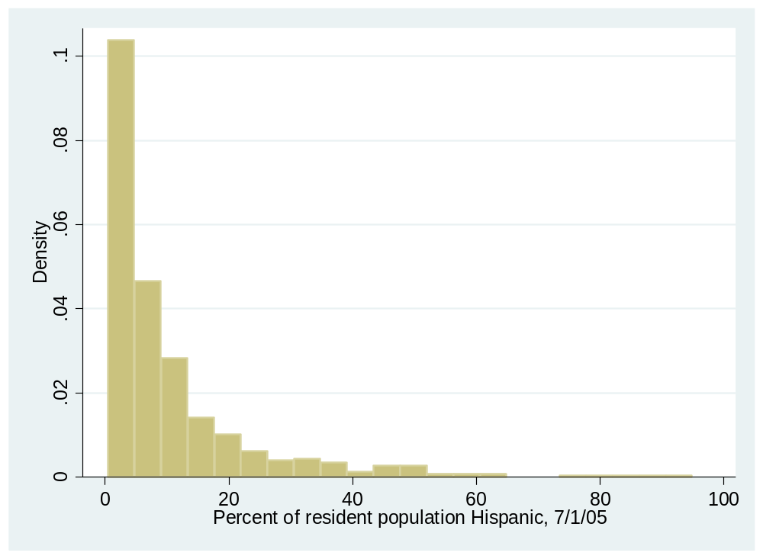

. histogram PctH05 if large_county==0
(bin=34, start=0, width=2.8697059)
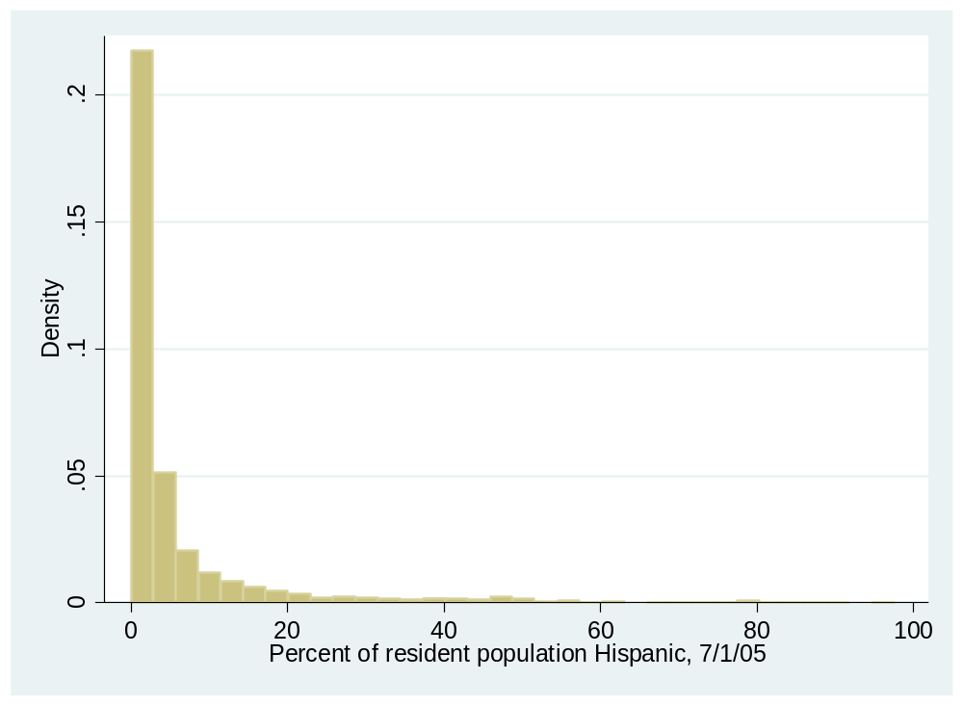
Point Estimate for Population of Hispanics in counties of less than a 100000 people

Variable | Type Obs Mean [95% Conf. Interval]
-------------+---------------------------------------------------------------
PctH05 | Arithmetic 525 10.69968 9.527907 11.87145
| Geometric 525 5.921834 5.39667 6.498103
| Harmonic 525 3.524007 3.232737 3.872961
-----------------------------------------------------------------------------

Variable | Type Obs Mean [95% Conf. Interval]
-------------+---------------------------------------------------------------
PctH05 | Arithmetic 2,616 6.355126 5.889876 6.820377
| Geometric 2,615 2.595284 2.478628 2.717431
| Harmonic 2,615 1.541223 1.487718 1.598719
-----------------------------------------------------------------------------

.
Summary Analysis : There are more Hispanics living in large-county (10.69968) than in small-counties(6.355126).

Analysis for African-Americans
Data Distribution

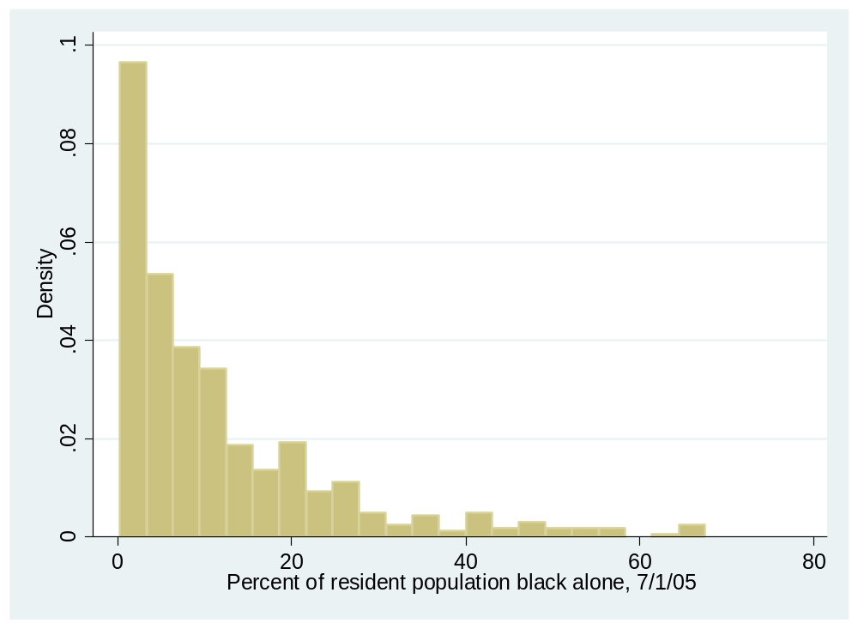

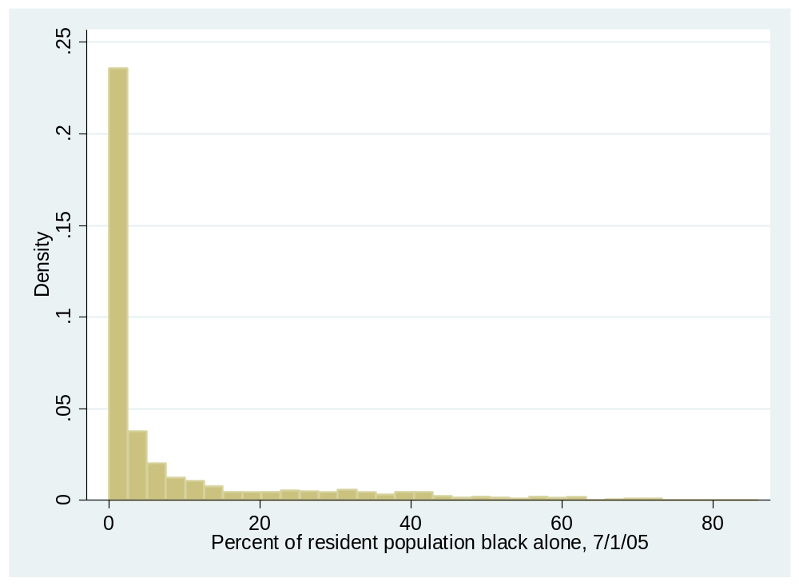

Point Estimate of the population

Variable | Type Obs Mean [95% Conf. Interval]
-------------+---------------------------------------------------------------
PctBlack05 | Arithmetic 525 11.79987 10.70369 12.89604
| Geometric 525 6.489834 5.860902 7.186257
| Harmonic 525 3.168186 2.822318 3.610663
-----------------------------------------------------------------------------

Variable | Type Obs Mean [95% Conf. Interval]
-------------+---------------------------------------------------------------
PctBlack05 | Arithmetic 2,616 8.421533 7.853707 8.989358
| Geometric 2,550 1.86893 1.736916 2.010977
| Harmonic 2,550 .4763294 .4421305 .5162625

Summary Analysis:There are more African-American living in large-county(11.79987) than small-counties(8.421533).

(b)
Hypothesis
H_{a} ; $HL-HS>0$
H₀ ; $HL-HS<0$

One-sample t test
------------------------------------------------------------------------------
Variable | Obs Mean Std. Err. Std. Dev. [95% Conf. Interval]
---------+--------------------------------------------------------------------
PctH05 | 2,616 6.355126 .2372672 12.13547 5.889876 6.820377
------------------------------------------------------------------------------
mean = mean(PctH05) t = 22.5700
Ho: mean = 1 degrees of freedom = 2615

Ha: mean < 1 Ha: mean != 1 Ha: mean > 1
Pr(T < t) = 1.0000 Pr(|T| > |t|) = 0.0000 Pr(T > t) = 0.0000

One-sample t test
------------------------------------------------------------------------------
Variable | Obs Mean Std. Err. Std. Dev. [95% Conf. Interval]
---------+--------------------------------------------------------------------
PctH05 | 525 10.69968 .5964714 13.66688 9.527907 11.87145
------------------------------------------------------------------------------
mean = mean(PctH05) t = 16.2618
Ho: mean = 1 degrees of freedom = 524

Ha: mean < 1 Ha: mean != 1 Ha: mean > 1
Pr(T < t) = 1.0000 Pr(|T| > |t|) = 0.0000 Pr(T > t) = 0.0000

One-sample t test
------------------------------------------------------------------------------
Variable | Obs Mean Std. Err. Std. Dev. [95% Conf. Interval]
---------+--------------------------------------------------------------------
PctBl~05 | 525 11.79987 .5579919 12.7852 10.70369 12.89604
------------------------------------------------------------------------------
mean = mean(PctBlack05) t = 19.3549
Ho: mean = 1 degrees of freedom = 524

Ha: mean < 1 Ha: mean != 1 Ha: mean > 1
Pr(T < t) = 1.0000 Pr(|T| > |t|) = 0.0000 Pr(T > t) = 0.0000

One-sample t test
------------------------------------------------------------------------------
Variable | Obs Mean Std. Err. Std. Dev. [95% Conf. Interval]
---------+--------------------------------------------------------------------
PctBl~05 | 2,616 8.421533 .2895781 14.81101 7.853707 8.989358
------------------------------------------------------------------------------
mean = mean(PctBlack05) t = 25.6288
Ho: mean = 1 degrees of freedom = 2615

Ha: mean < 1 Ha: mean != 1 Ha: mean > 1
Pr(T < t) = 1.0000 Pr(|T| > |t|) = 0.0000 Pr(T > t) = 0.0000

Summary Analysis : From the above ttest is is evident that the population of Hispanics and African-Americans differs greatly for small and large counties .A larger population offers a higher degree of freedom of sampling and data extraction thus therefore a greater mean for the populations in large-county.

2 (a).

Data Distribution
--------------------------------------------------------------------------------------------------------
County County FIPS Code
--------------------------------------------------------------------------------------------------------

type: numeric (int)

range: [1,760] units: 1
unique values: 122 missing .: 0/209

mean: 151.067
std. dev: 157.465

percentiles: 10% 25% 50% 75% 90%
21 47 93 189 391

.

(b)

Test for African-American

One-sample t test
------------------------------------------------------------------------------
Variable | Obs Mean Std. Err. Std. Dev. [95% Conf. Interval]
---------+--------------------------------------------------------------------
PctBl~05 | 209 35.63703 1.958417 28.3125 31.77614 39.49792
------------------------------------------------------------------------------
mean = mean(PctBlack05) t = 17.6862
Ho: mean = 1 degrees of freedom = 208

Ha: mean < 1 Ha: mean != 1 Ha: mean > 1
Pr(T < t) = 1.0000 Pr(|T| > |t|) = 0.0000 Pr(T > t) = 0.0000

One-sample t test
------------------------------------------------------------------------------
Variable | Obs Mean Std. Err. Std. Dev. [95% Conf. Interval]
---------+--------------------------------------------------------------------
PctBl~05 | 2,932 7.086467 .1984753 10.74703 6.697301 7.475632
------------------------------------------------------------------------------
mean = mean(PctBlack05) t = 30.6661
Ho: mean = 1 degrees of freedom = 2931

Ha: mean < 1 Ha: mean != 1 Ha: mean > 1
Pr(T < t) = 1.0000 Pr(|T| > |t|) = 0.0000 Pr(T > t) = 0.0000

.

Ttest for Hispanics

One-sample t test
------------------------------------------------------------------------------
Variable | Obs Mean Std. Err. Std. Dev. [95% Conf. Interval]
---------+--------------------------------------------------------------------
PctH05 | 2,932 5.604737 .1508817 8.169934 5.308893 5.900582
------------------------------------------------------------------------------
mean = mean(PctH05) t = 30.5189
Ho: mean = 1 degrees of freedom = 2931

Ha: mean < 1 Ha: mean != 1 Ha: mean > 1
Pr(T < t) = 1.0000 Pr(|T| > |t|) = 0.0000 Pr(T > t) = 0.0000

One-sample t test
------------------------------------------------------------------------------
Variable | Obs Mean Std. Err. Std. Dev. [95% Conf. Interval]
---------+--------------------------------------------------------------------
PctH05 | 209 27.79545 2.142396 30.97226 23.57186 32.01905
------------------------------------------------------------------------------
mean = mean(PctH05) t = 12.5072
Ho: mean = 1 degrees of freedom = 208

Ha: mean < 1 Ha: mean != 1 Ha: mean > 1
Pr(T < t) = 1.0000 Pr(|T| > |t|) = 0.0000 Pr(T > t) = 0.0000

.
Summary Analysis :There is a significant difference on the mean percentage between the large and small counties

3.
Hypothesis Formulation
P<0.05

One-sample t test
------------------------------------------------------------------------------
Variable | Obs Mean Std. Err. Std. Dev. [95% Conf. Interval]
---------+--------------------------------------------------------------------
Pop00 | 209 206980.1 53987.4 780486.8 100547.5 313412.8
------------------------------------------------------------------------------
mean = mean(Pop00) t = 3.8329
Ho: mean = 50 degrees of freedom = 208

Ha: mean < 50 Ha: mean != 50 Ha: mean > 50
Pr(T < t) = 0.9999 Pr(|T| > |t|) = 0.0002 Pr(T > t) = 0.0001

One-sample t test
------------------------------------------------------------------------------
Variable | Obs Mean Std. Err. Std. Dev. [95% Conf. Interval]
---------+--------------------------------------------------------------------
Pop00 | 2,932 81492.03 4040.224 218769.8 73570.07 89413.99
------------------------------------------------------------------------------
mean = mean(Pop00) t = 20.1578
Ho: mean = 50 degrees of freedom = 2931

Ha: mean < 50 Ha: mean != 50 Ha: mean > 50
Pr(T < t) = 1.0000 Pr(|T| > |t|) = 0.0000 Pr(T > t) = 0.0000

One-sample t test
------------------------------------------------------------------------------
Variable | Obs Mean Std. Err. Std. Dev. [95% Conf. Interval]
---------+--------------------------------------------------------------------
Pop05 | 2,932 85690.97 4221.149 228566.6 77414.25 93967.69
------------------------------------------------------------------------------
mean = mean(Pop05) t = 20.2885
Ho: mean = 50 degrees of freedom = 2931

Ha: mean < 50 Ha: mean != 50 Ha: mean > 50
Pr(T < t) = 1.0000 Pr(|T| > |t|) = 0.0000 Pr(T > t) = 0.0000

One-sample t test
------------------------------------------------------------------------------
Variable | Obs Mean Std. Err. Std. Dev. [95% Conf. Interval]
---------+--------------------------------------------------------------------
Pop05 | 209 216097.9 56425.16 815729.1 104859.4 327336.5
------------------------------------------------------------------------------
mean = mean(Pop05) t = 3.8289
Ho: mean = 50 degrees of freedom = 208

Ha: mean < 50 Ha: mean != 50 Ha: mean > 50
Pr(T < t) = 0.9999 Pr(|T| > |t|) = 0.0002 Pr(T > t) = 0.0001

.
Summary Analysis : Averagely Pr(T < t) = 0.9999 which is greater than p<0.05…there the hypothesis cannot be rejected that African-Americans and Hispanics are more in large-counties for both Pop00 and Pop05

4.
Call for the ttests
Paired t test
------------------------------------------------------------------------------
Variable | Obs Mean Std. Err. Std. Dev. [95% Conf. Interval]
---------+--------------------------------------------------------------------
Pop00 | 525 404911.4 27373.06 627195.7 351137 458685.8
Pop05 | 525 427096.4 28504.06 653109.9 371100.2 483092.7
---------+--------------------------------------------------------------------
diff | 525 -22185.01 2076.306 47574.15 -26263.92 -18106.1
------------------------------------------------------------------------------
mean(diff) = mean(Pop00 - Pop05) t = -10.6848
Ho: mean(diff) = 0 degrees of freedom = 524

Ha: mean(diff) < 0 Ha: mean(diff) != 0 Ha: mean(diff) > 0
Pr(T < t) = 0.0000 Pr(|T| > |t|) = 0.0000 Pr(T > t) = 1.0000

Paired t test
------------------------------------------------------------------------------
Variable | Obs Mean Std. Err. Std. Dev. [95% Conf. Interval]
---------+--------------------------------------------------------------------
Pop00 | 2,616 26611.23 444.6209 22740.96 25739.39 27483.08
Pop05 | 2,616 27593.57 475.617 24326.31 26660.95 28526.2
---------+--------------------------------------------------------------------
diff | 2,616 -982.3383 57.81485 2957.047 -1095.706 -868.9708
------------------------------------------------------------------------------
mean(diff) = mean(Pop00 - Pop05) t = -16.9911
Ho: mean(diff) = 0 degrees of freedom = 2615

Ha: mean(diff) < 0 Ha: mean(diff) != 0 Ha: mean(diff) > 0
Pr(T < t) = 0.0000 Pr(|T| > |t|) = 0.0000 Pr(T > t) = 1.0000

.
Summary Analysis : The Difference in mean between Pop00 and Pop05 indicates a an increase in population between the years from the ttes.

Acock problems:

5.
Distribution of Data

Variable Obs Unique Mean Min Max Label
--------------------------------------------------------------------------------------------------------
hh18_97 8984 12 2.451803 0 12 # in household < age 18 1997
ethnic97 8960 2 .211942 0 1 youth ethnicity 1997
--------------------------------------------------------------------------------------------------------

.
Hypothesis Testing
H₀ ; $u<$1
H_{a} ; u $>$1
One-sample t test
------------------------------------------------------------------------------
Variable | Obs Mean Std. Err. Std. Dev. [95% Conf. Interval]
---------+--------------------------------------------------------------------
hh18_97 | 7,061 2.384365 .0148875 1.250996 2.355181 2.413549
------------------------------------------------------------------------------
mean = mean(hh18_97) t = 92.9882
Ho: mean = 1 degrees of freedom = 7060

Ha: mean < 1 Ha: mean != 1 Ha: mean > 1
Pr(T < t) = 1.0000 Pr(|T| > |t|) = 0.0000 Pr(T > t) = 0.0000

One-sample t test
------------------------------------------------------------------------------
Variable | Obs Mean Std. Err. Std. Dev. [95% Conf. Interval]
---------+--------------------------------------------------------------------
hh18_97 | 1,899 2.708268 .0314648 1.371158 2.646558 2.769977
------------------------------------------------------------------------------
mean = mean(hh18_97) t = 54.2914
Ho: mean = 1 degrees of freedom = 1898

Ha: mean < 1 Ha: mean != 1 Ha: mean > 1
Pr(T < t) = 1.0000 Pr(|T| > |t|) = 0.0000 Pr(T > t) = 0.0000

.

From the mean analysis the Hypotheses that there are more Hispanic families children under 18 than other ethnic groups hold as the Hispanics(2.708268) have a higher mean than the Ethnic Groups(2.384365).

8.

Hypothesis formulation
Hypothesis for the Test is given as
H₀ ; $u<$1
H_{a} ; u $>$1

Distribution of Data

--------------------------------------------------------------------------------------------------------
abany abortion if woman wants for any reason
--------------------------------------------------------------------------------------------------------

type: numeric (byte)
label: abany

range: [1,2] units: 1
unique values: 2 missing .: 1,865/2,765

tabulation: Freq. Numeric Label
387 1 yes
513 2 no
1,865 .

--------------------------------------------------------------------------------------------------------
sex respondents sex
--------------------------------------------------------------------------------------------------------

type: numeric (byte)
label: sex

range: [1,2] units: 1
unique values: 2 missing .: 0/2,765

tabulation: Freq. Numeric Label
1,228 1 male
1,537 2 female
Data Frequency for Allocation

abortion if |
woman wants |
for any |
reason | Freq. Percent Cum.
------------+-----------------------------------
yes | 387 43.00 43.00
no | 513 57.00 100.00
------------+-----------------------------------
Total | 900 100.00

Mean Test for Males

One-sample t test
------------------------------------------------------------------------------
Variable | Obs Mean Std. Err. Std. Dev. [95% Conf. Interval]
---------+--------------------------------------------------------------------
abany | 484 1.555785 .0226087 .4973924 1.511361 1.600209
------------------------------------------------------------------------------
mean = mean(abany) t = 24.5828
Ho: mean = 1 degrees of freedom = 483

Ha: mean < 1 Ha: mean != 1 Ha: mean > 1
Pr(T < t) = 1.0000 Pr(|T| > |t|) = 0.0000 Pr(T > t) = 0.0000

Mean Test for Females

One-sample t test
------------------------------------------------------------------------------
Variable | Obs Mean Std. Err. Std. Dev. [95% Conf. Interval]
---------+--------------------------------------------------------------------
abany | 416 1.586538 .0241736 .4930471 1.53902 1.634056
------------------------------------------------------------------------------
mean = mean(abany) t = 24.2636
Ho: mean = 1 degrees of freedom = 415

Ha: mean < 1 Ha: mean != 1 Ha: mean > 1
Pr(T < t) = 1.0000 Pr(|T| > |t|) = 0.0000 Pr(T > t) = 0.0000
From the Mean Analysis Females(1.586538 ) have a higher chance of saying yes to abortion than Males(1.555785).

DO FILE
1(a). . generate large_county=0
replace large_county=1 if PopCen00>100000
replace large_county=0 if PopCen00<100000
. histogram PctH05 if large_county==1
. histogram PctH05 if large_county==0
. . ameans PctH05 if large_county==1
. . ameans PctH05 if large_county==0
. histogram PctBlack05 if large_county==1
histogram PctBlack05 if large_county==0
. ameans PctBlack05 if large_county==1
. ameans PctBlack05 if large_county==0

(b). . ttest PctH05 == 1 if large_county==0
. ttest PctH05 == 1 if large_county==1
. ttest PctBlack05 == 1 if large_county==1
. ttest PctBlack05 == 1 if large_county==0

2.(a) generate majority_black_hispanic=0
replace majority_black_hispanic=1 if PctBlack05 + PctH05>50
. replace majority_black_hispanic=0 if PctBlack05 + PctH05<50
. codebook County if majority_black_hispanic==1

(b)ttest PctBlack05 == 1 if majority_black_hispanic==0
ttest PctBlack05 == 1 if majority_black_hispanic==1
. ttest PctH05 == 1 if majority_black_hispanic==0
. ttest PctH05 == 1 if majority_black_hispanic==1

3. . db ttest

. ttest Pop00 == 50 if majority_black_hispanic==1
. db ttest

. ttest Pop00 == 50 if majority_black_hispanic==0
. ttest Pop05 == 50 if majority_black_hispanic==0
. ttest Pop05 == 50 if majority_black_hispanic==1

4. . ttest Pop00 == Pop05 if large_county==1
. ttest Pop00 == Pop05 if large_county==0

5. . codebook hh18_97 ethnic97 ,compact
. db ttest

. ttest hh18_97 == 1 if ethnic97==0
. ttest hh18_97 == 1 if ethnic97==1

8. . codebook abany sex
. tabulate abany
. ttest abany == 1 if sex==1
. . ttest abany == 1 if sex==2

