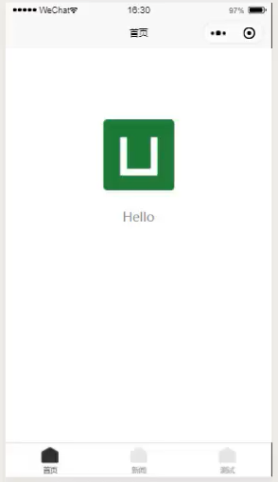“tavBar”模块：页面下方可选项属性配置

"tabBar": {

"color": "#7A7E83",//未选中时的区块颜色

"selectedColor": "#3cc51f",//选中时的区块颜色

"borderStyle": "black",

"backgroundColor": "#ffffff",

"list": [{

"pagePath": "pages/index/index",//页面路径

"text": "首页"//区块文字内容

“iconPath”//未选中时区块图片

“SelectedIconPath”//选中时区块图片

}, {

"pagePath": "pages/news/news",

"text": "新闻"

}, {

"pagePath": "pages/test/test",

"text": "测试"

}]

}