***Nama: Ahmad Zaki Kusnaedi  
NIM: 1920131   
link git:*** https://github.com/WP2AhmadZakiKusnaedi/WP2AhmadZakiKusnaedi

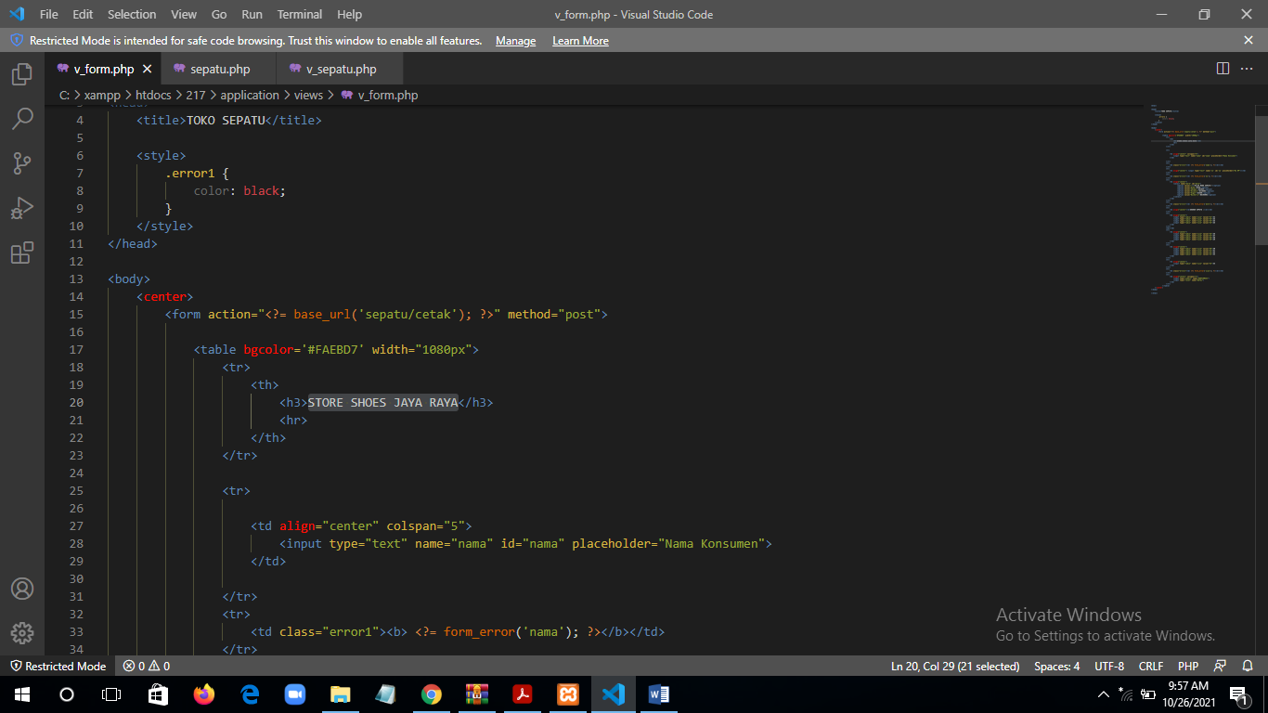***Proses codingan***

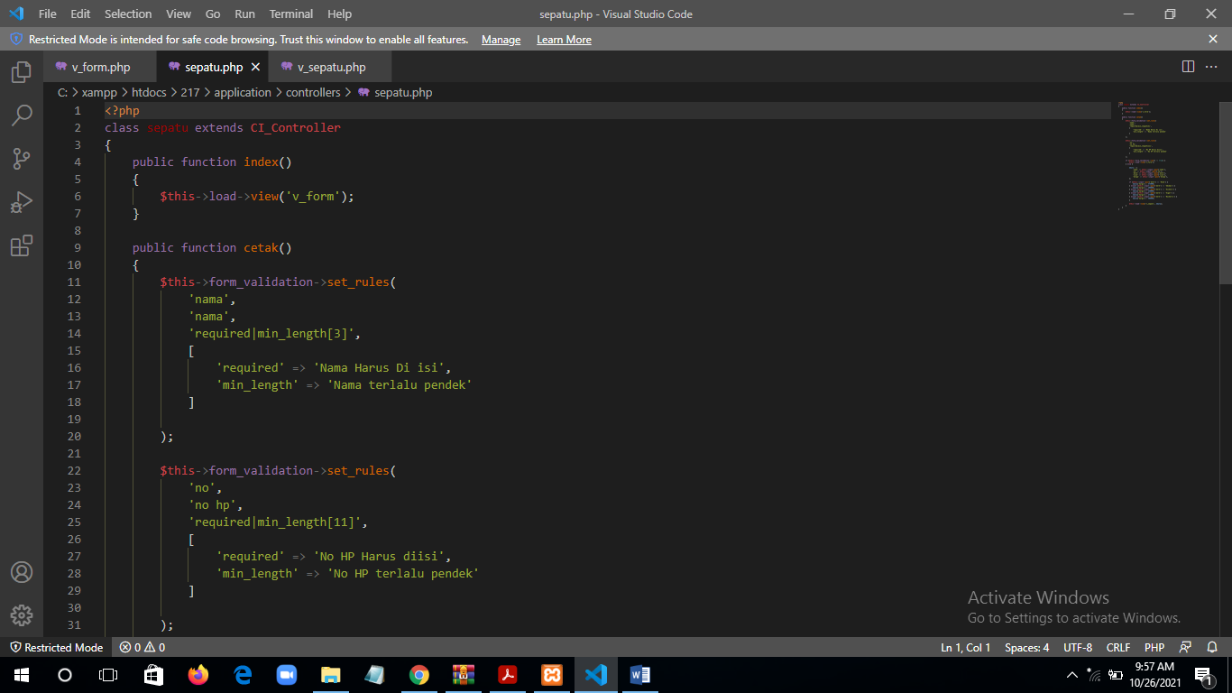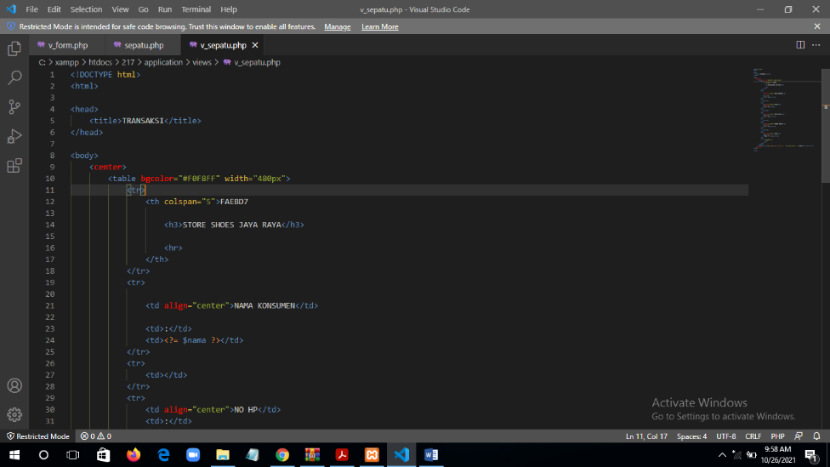

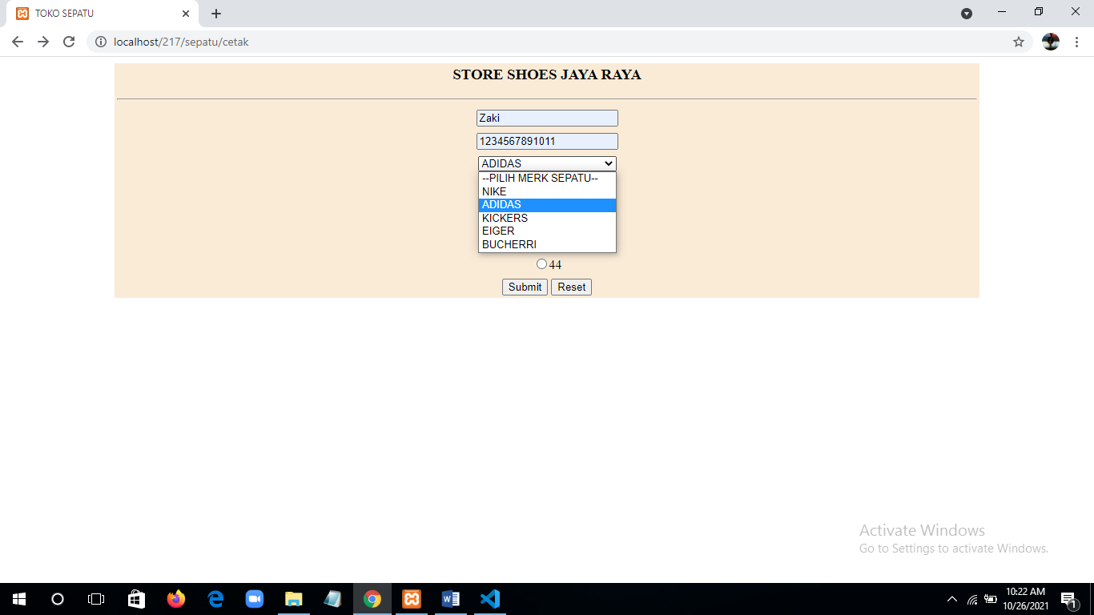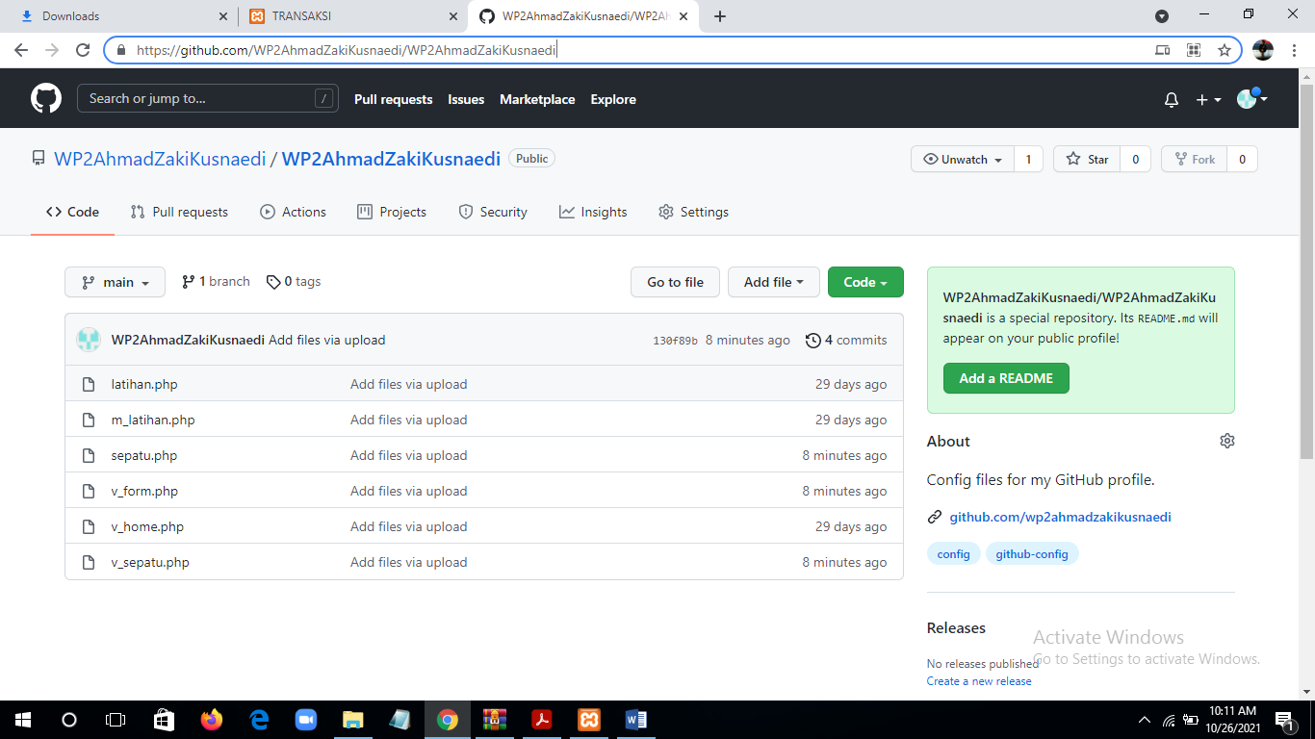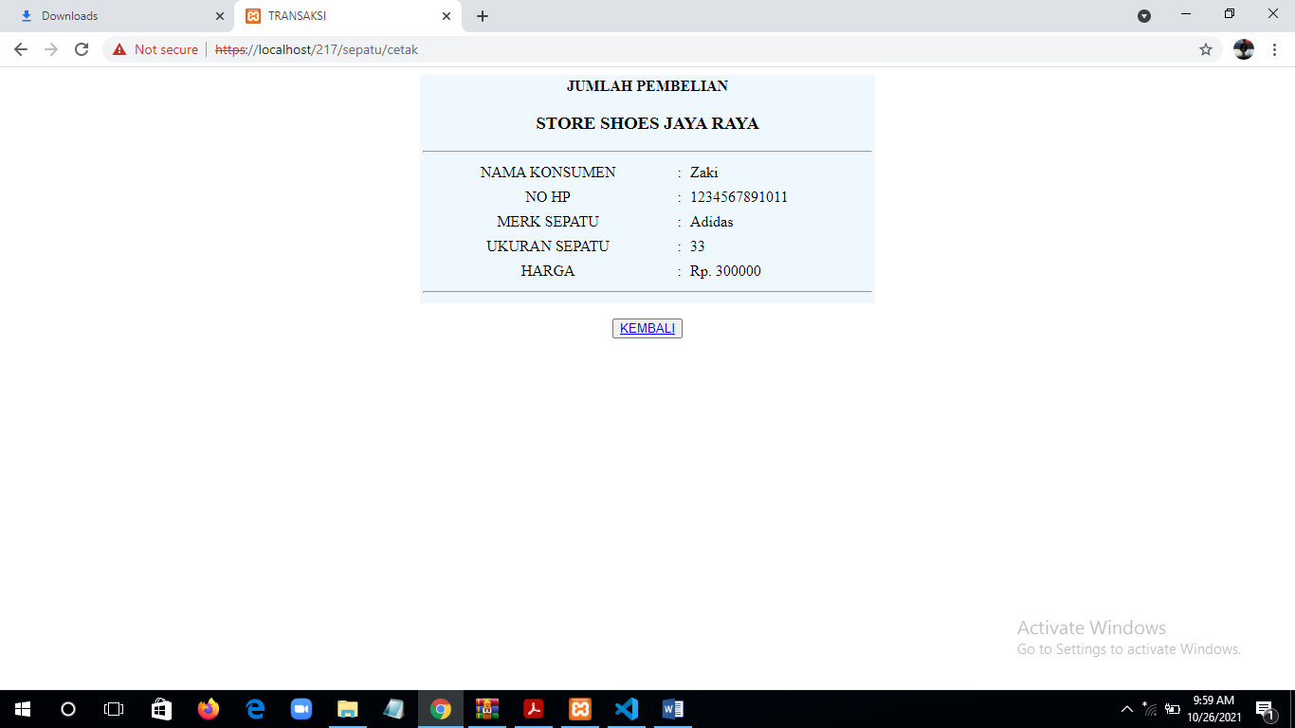***Hasil***