Nama: Ahmad Zaki Kusnaedi  
Nim: 1920131

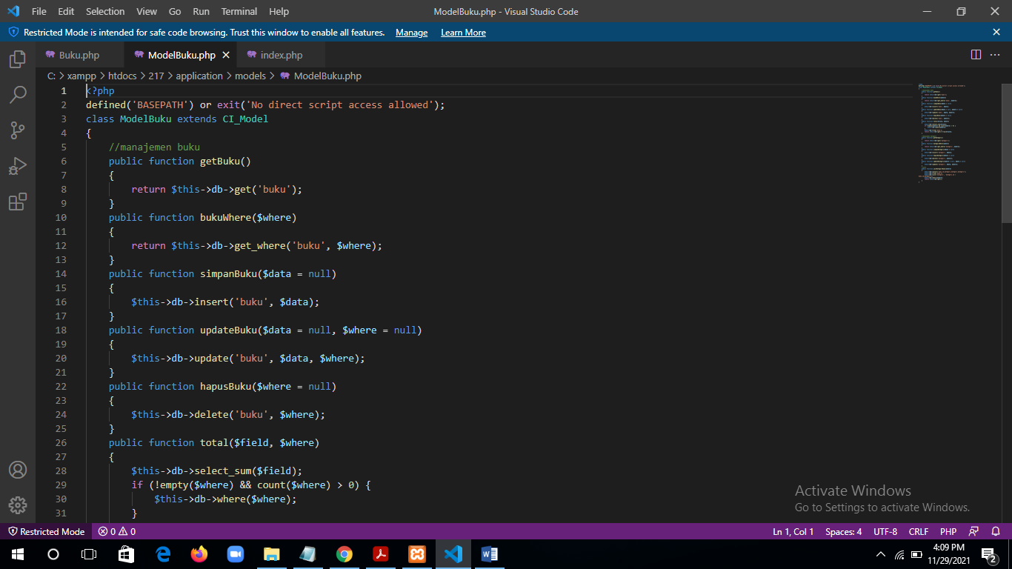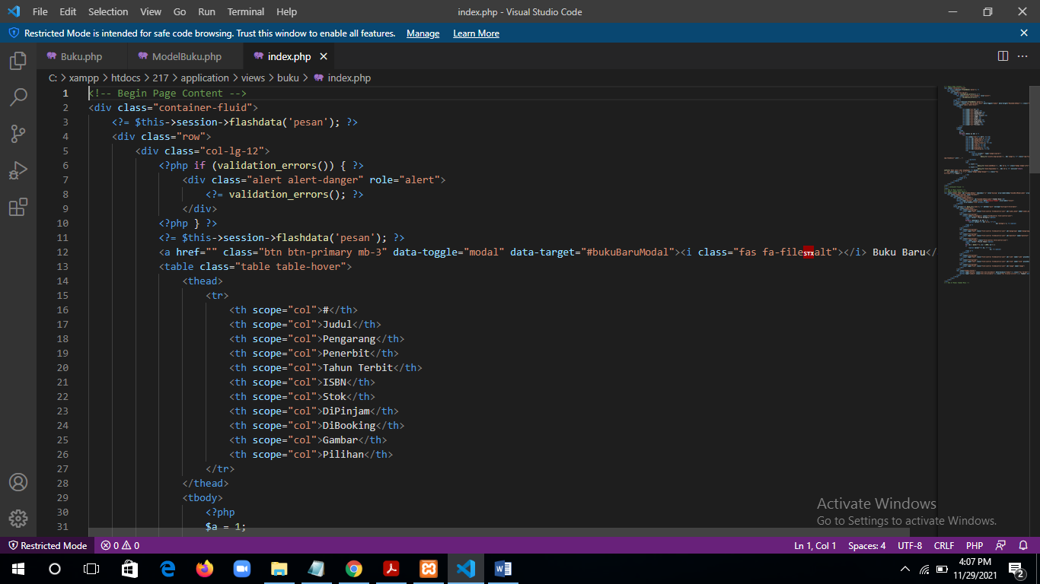Web Pertemuan 12  
Link git: https://github.com/WP2AhmadZakiKusnaedi

