Nama: Ahmad Zaki Kusnaedi  
Kelas: 19.3A.24  
Nim: 19201031  
Matkul: Web Programming 2

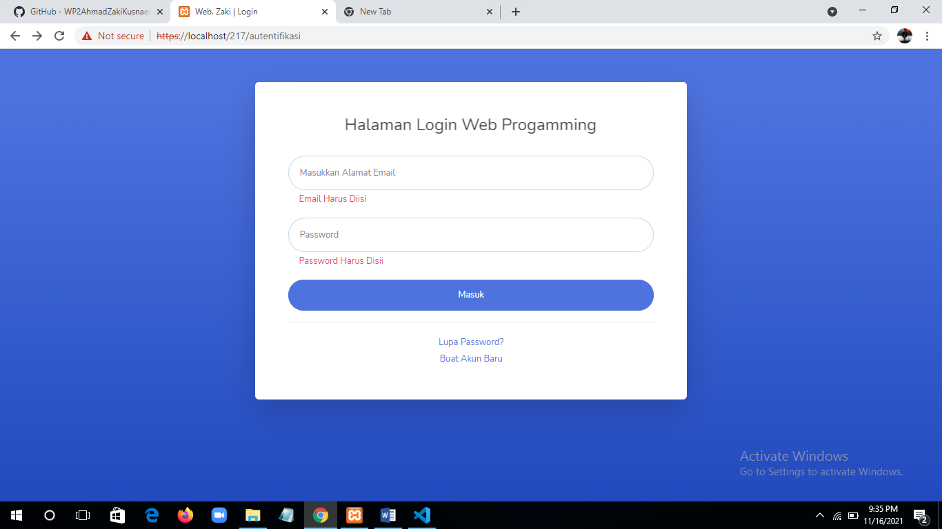

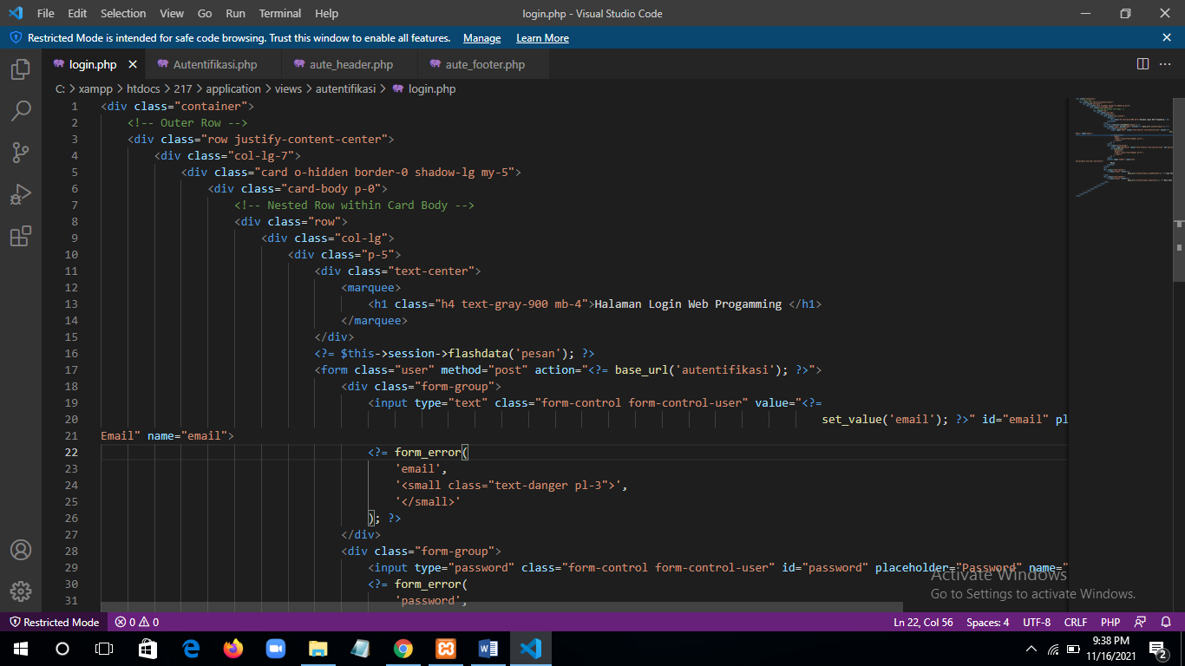

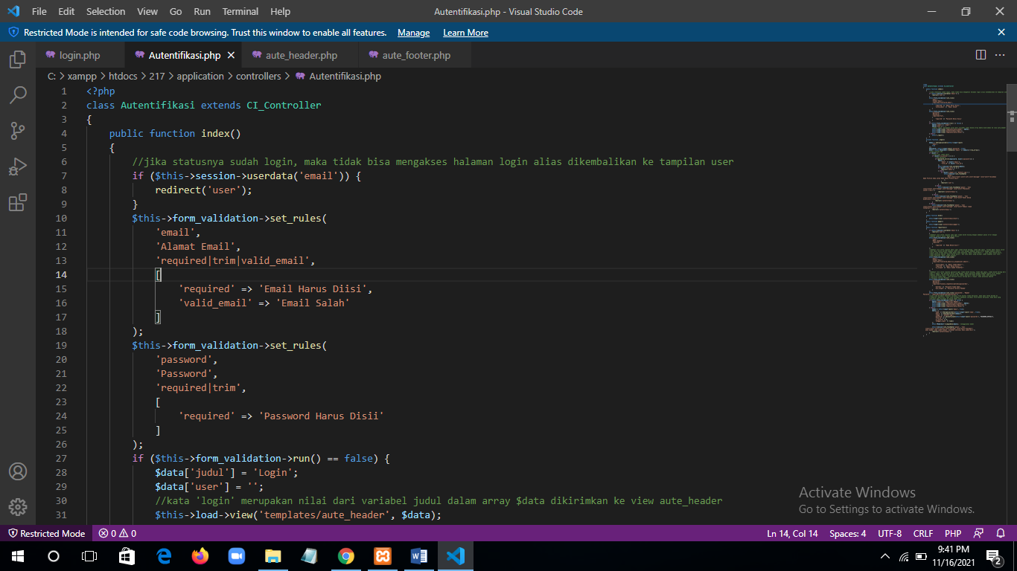

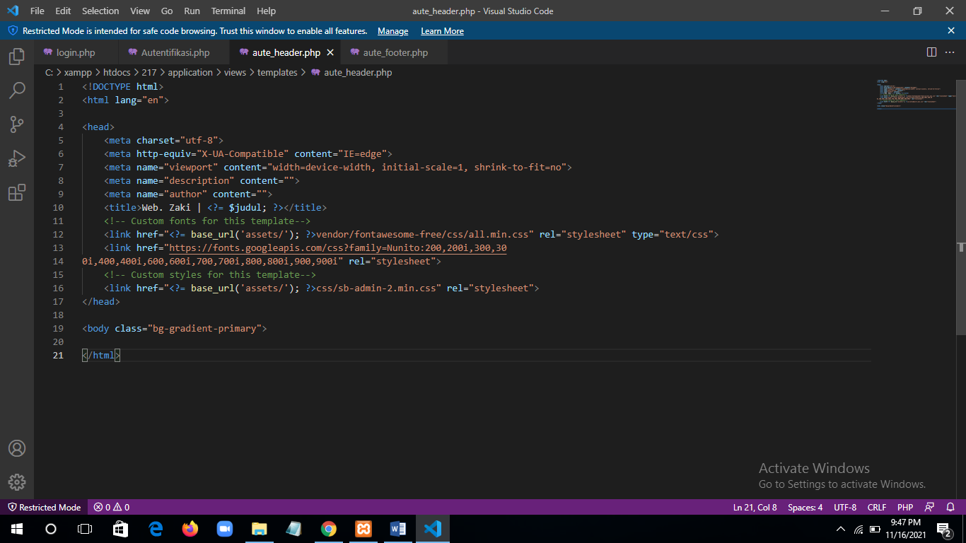

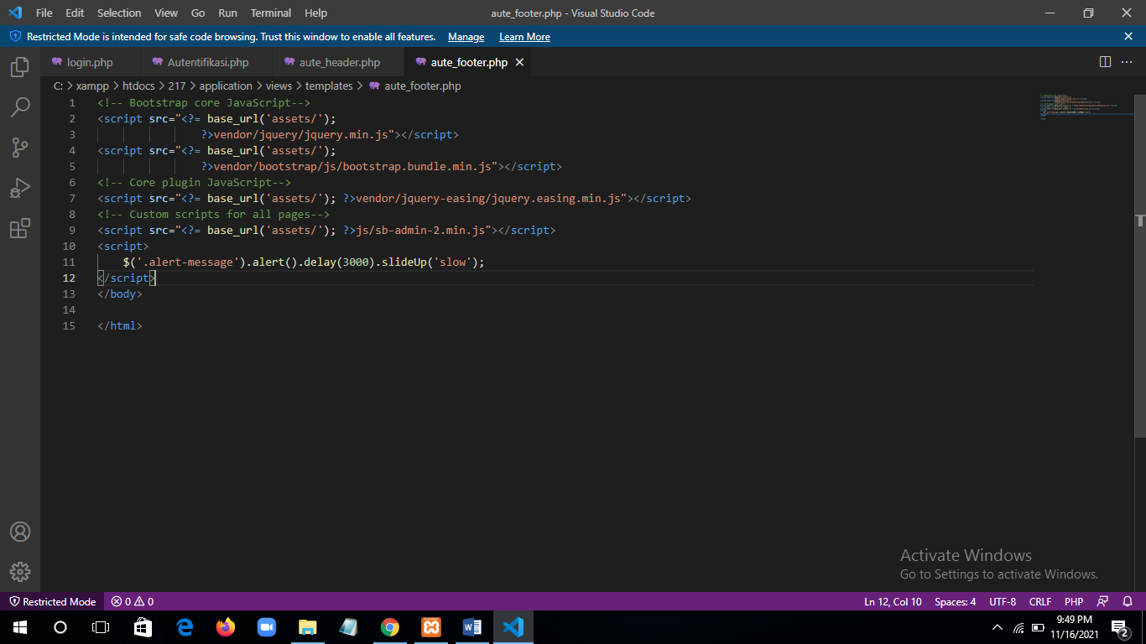

Link update sampai pertemuan 9: <https://github.com/WP2AhmadZakiKusnaedi/WP2AhmadZakiKusnaedi>

<https://github.com/WP2AhmadZakiKusnaedi/WP2_Perpus_AhmadZakiKusnaedi>