Tugas mata kuliah web programming 2

Nama : Ahmad Zaki Kusnedi  
Kelas : 19.3A.24  
Nim : 19201031

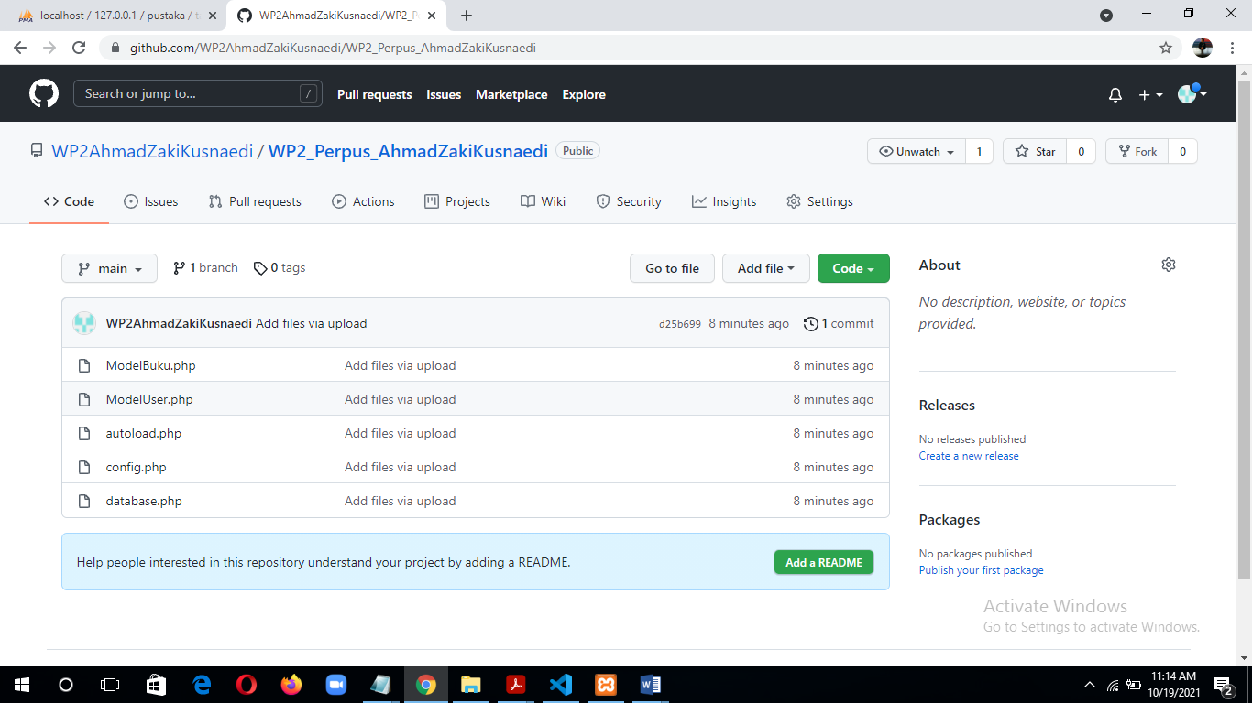

Link: <https://github.com/WP2AhmadZakiKusnaedi/WP2_Perpus_AhmadZakiKusnaedi>

**Model User dan Model Buku**

