Troubleshooting:
PX4 SIMULATION

TURTLEBOT SIMULATION
camera system:
- check that portable battery is charged and plugged in.
- check if you can ssh into the rpi
- check that cameras are plugged into the right ports

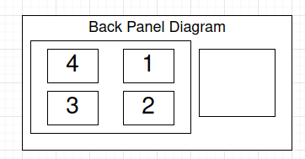
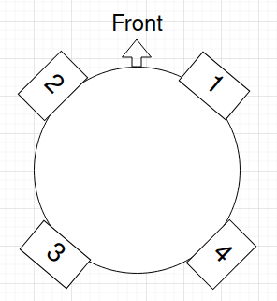

Turtlebot Navigation:
Threat Field Generation:
Projector system:

MATLAB
Run matlab:
/usr/local/MATLAB/R2024b/bin/matlab

