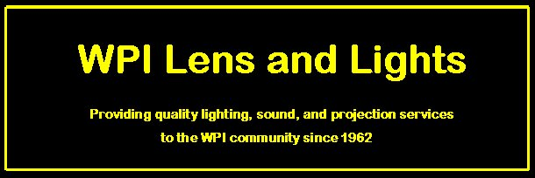

WPI Lens and Lights Rental Contract & Disclaimer

This Contract is to insure the safety, proper care and usage of WPI Lens and Lights equipment. Lens and Lights acknowledges that the equipment is rented for the period beginning _________ and ending ________. LnL assumes that the equipment will be used accordingly and within its specified limits and is not responsible for damage due to misuse or neglect. All equipment should be returned in the same condition as it was signed out to avoid damage and inventory fees. LnL will not involve itself with safety and security issues during the period of rental. If a situation is to arise where a consultation from LnL is required, LnL can be contacted via E-Mail: lnl@wpi.edu or Phone: 508.831.5595 and will respond within twenty-four (24) hours of contact.

In the event any of the rented equipment fails or is damaged and is in need of replacement or repair, the LnL Technical Director can be contacted at lnl@wpi.edu, and proper action will be taken. Possible equipment failures may include but are not limited to: lamps, cables, connectors, etc. This is for your own safety and the safety of the patrons of the event.

By signing below you agree to the terms of the above contract and agree to pay any necessary fees if equipment is damaged.

______________________________ ______________
LnL Executive Board Member Date

______________________________ ______________
Renting Organization Representative Date

______________________________
Renting Organization

