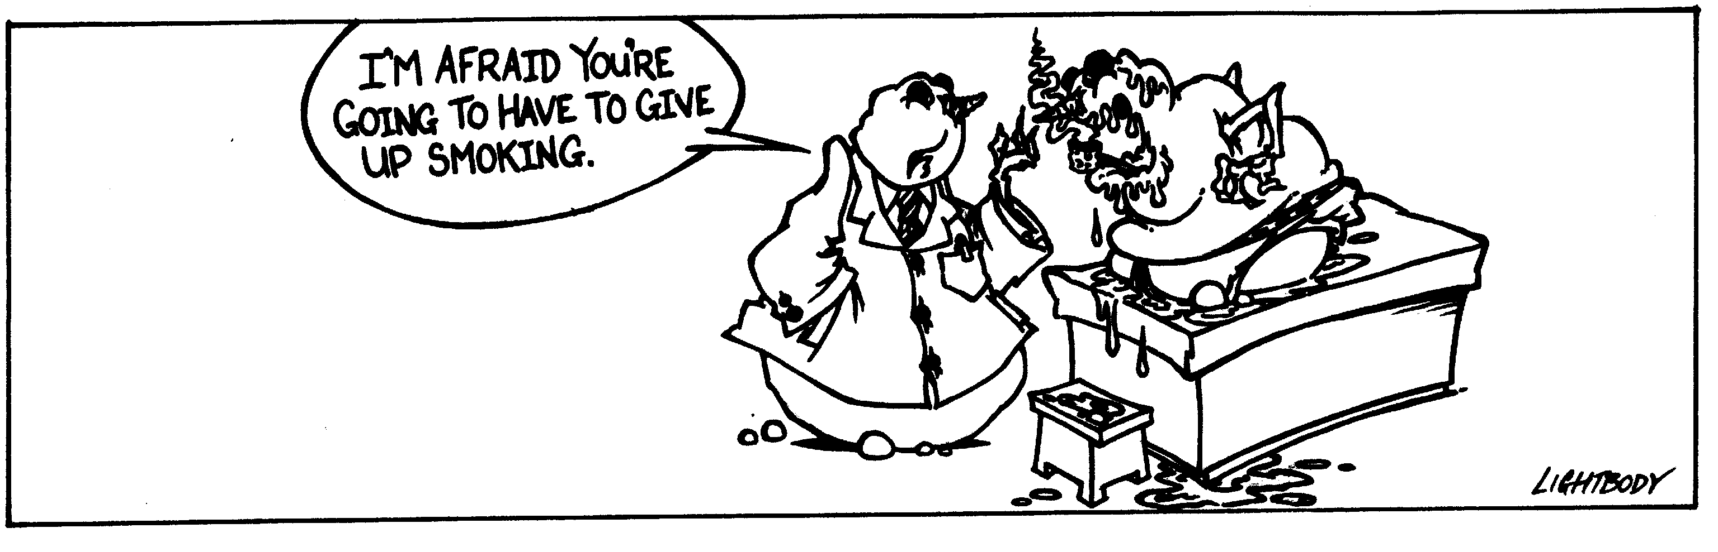
Almost There by Jacob M. Lightbody
(714) 330-8174 jacobmlightbody@yahoo.com




