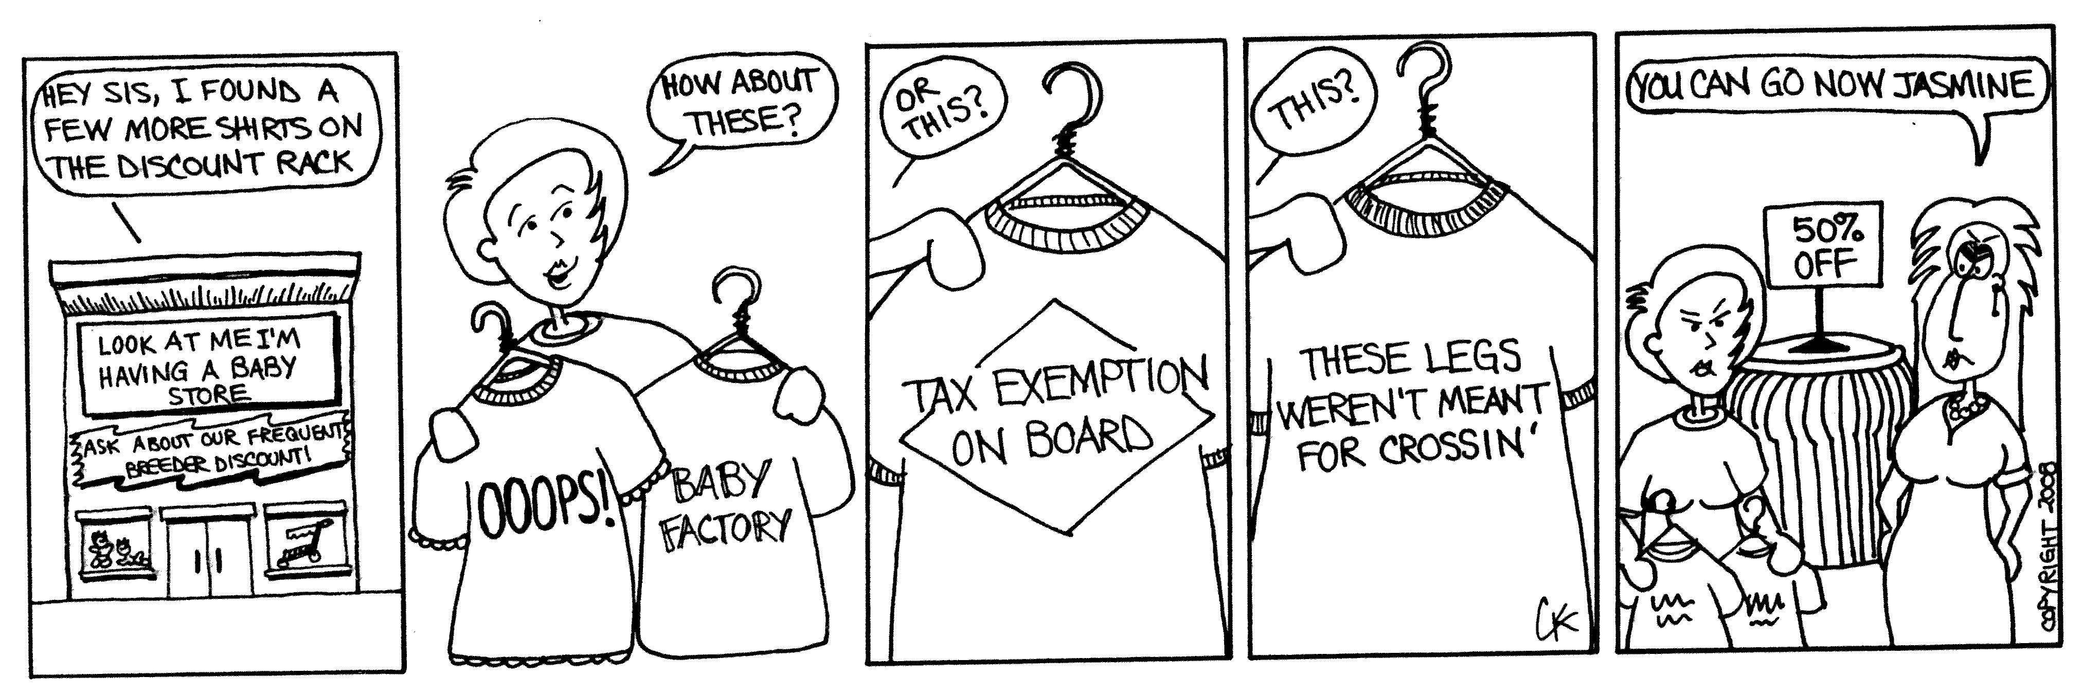
Apple Pi by Carrie Kinnison



