TOM DUCK & HARRY by David Mudrick
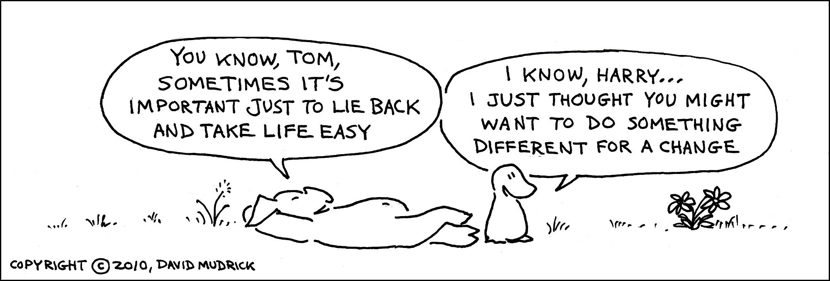

TOM DUCK & HARRY by David Mudrick
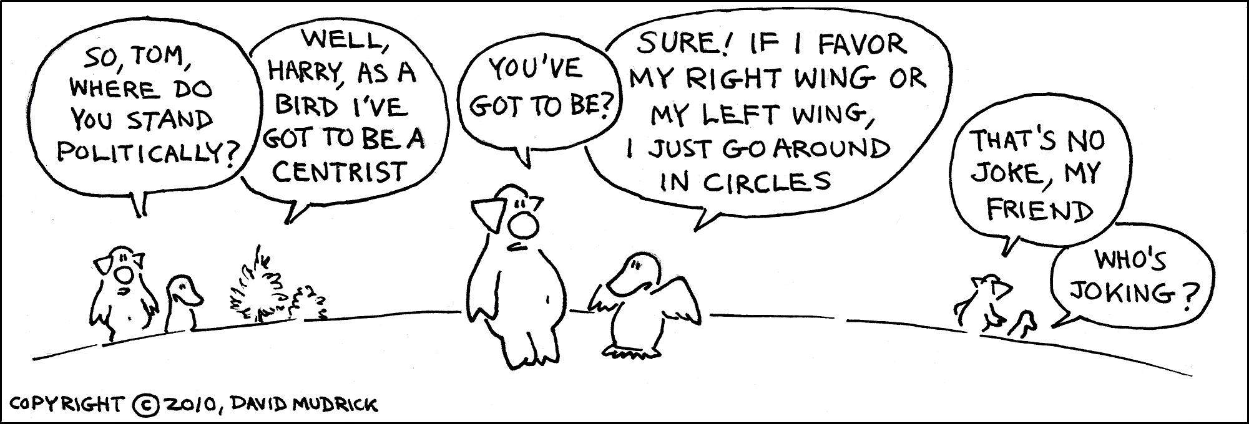

TOM DUCK & HARRY by David Mudrick
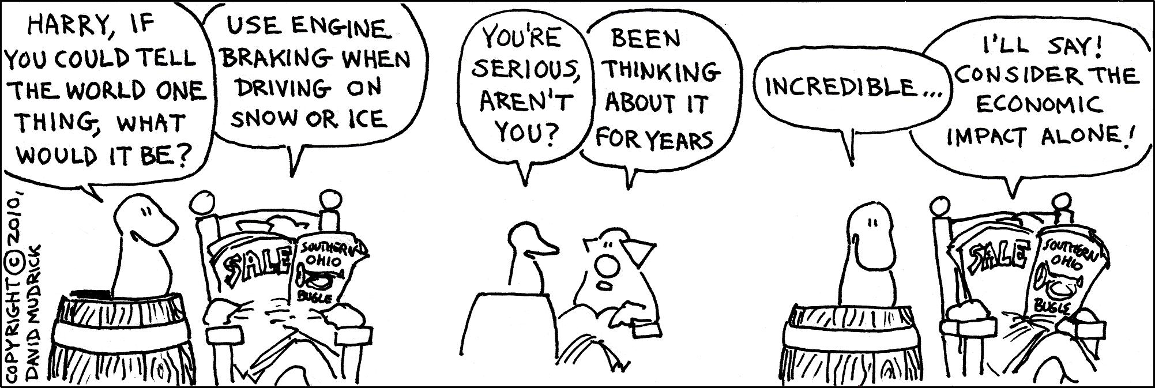

TOM DUCK & HARRY by David Mudrick
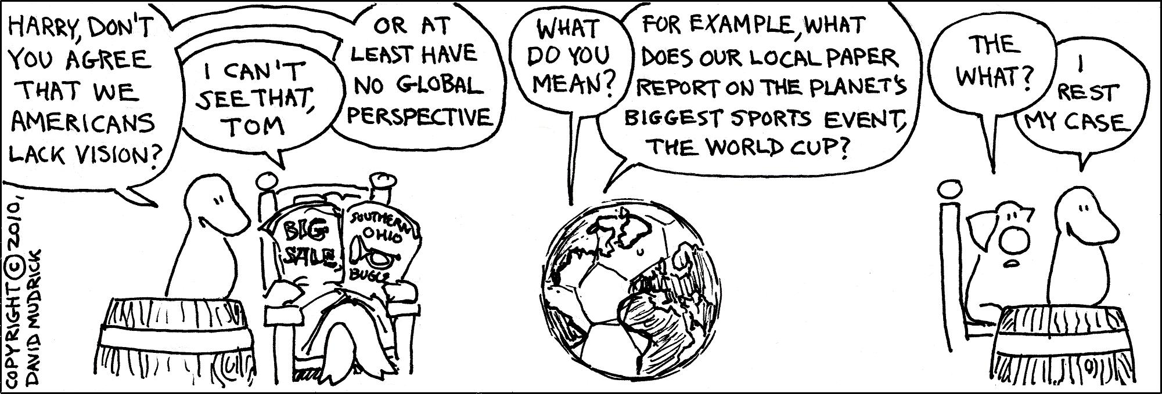

TOM DUCK & HARRY by David Mudrick
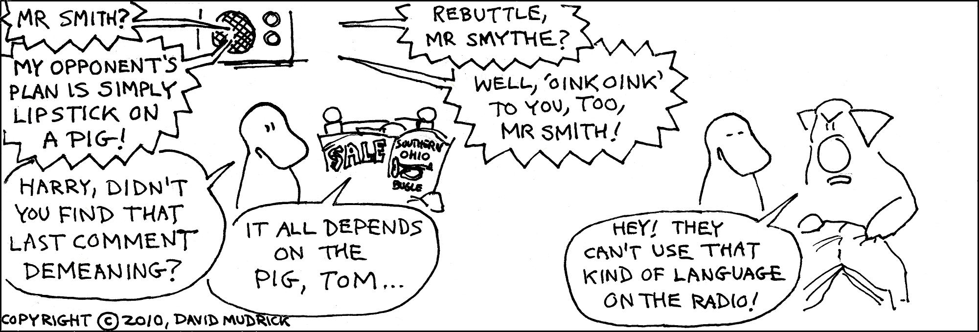

TOM DUCK & HARRY by David Mudrick
