America’s Next Great Cartoonist
“Whirled”, a Single Panel comic strip
File Name: JasonCampbell.doc
Jason Campbell, age 42
45 Clementi Lane, Methuen, MA 01844 781-799-0457
jason@campbellgraphics.com

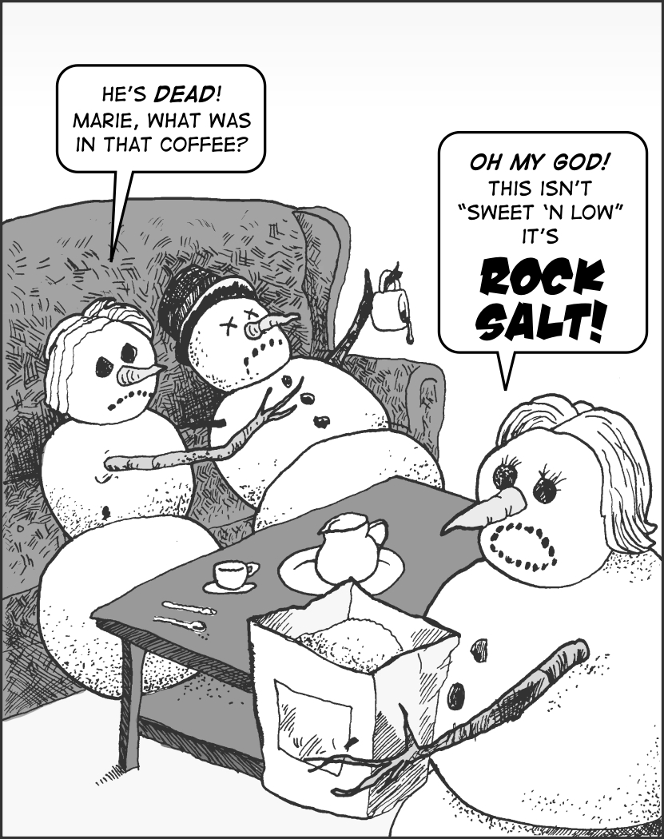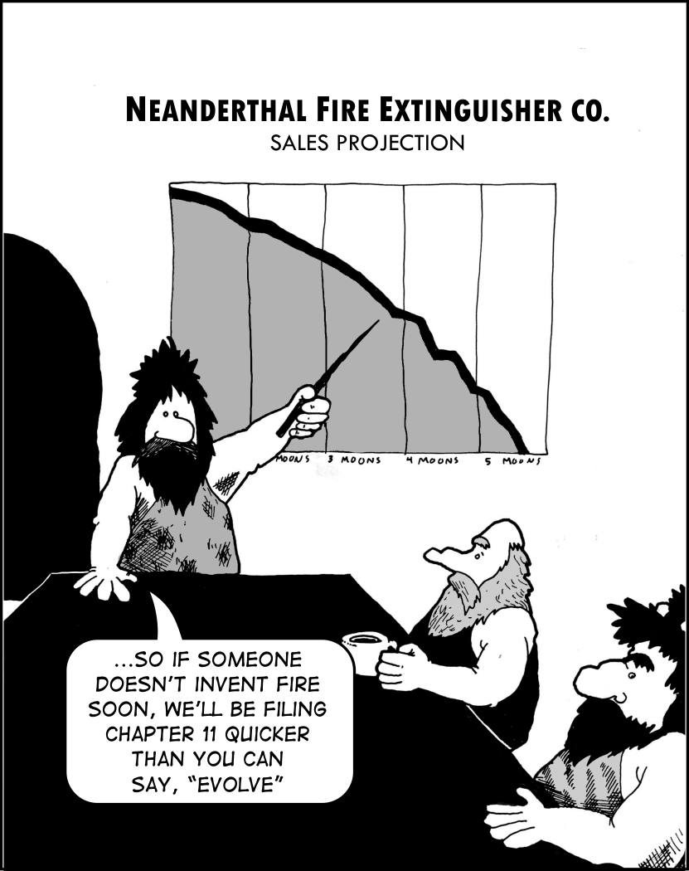
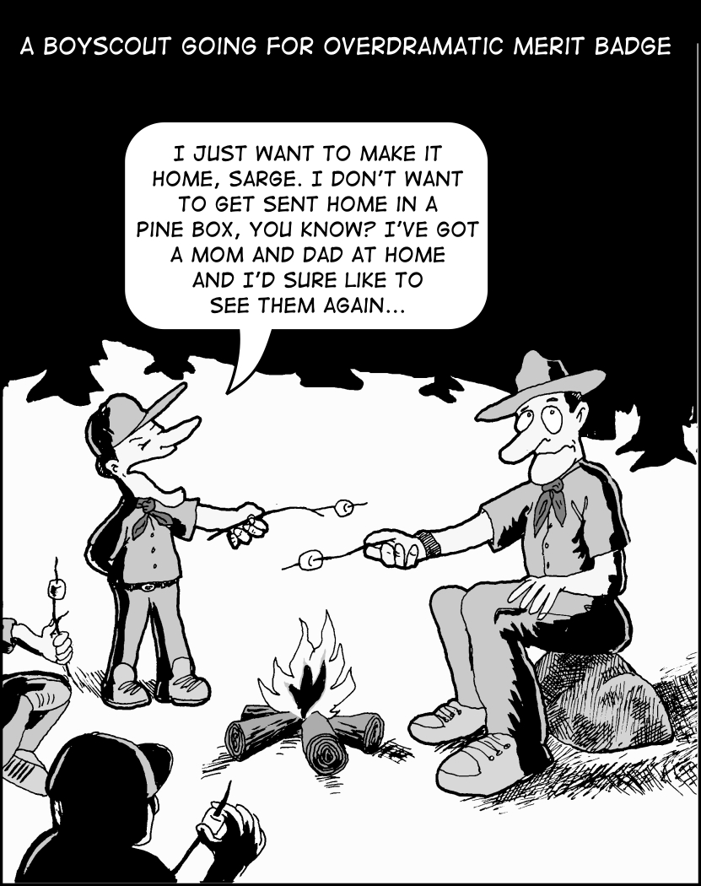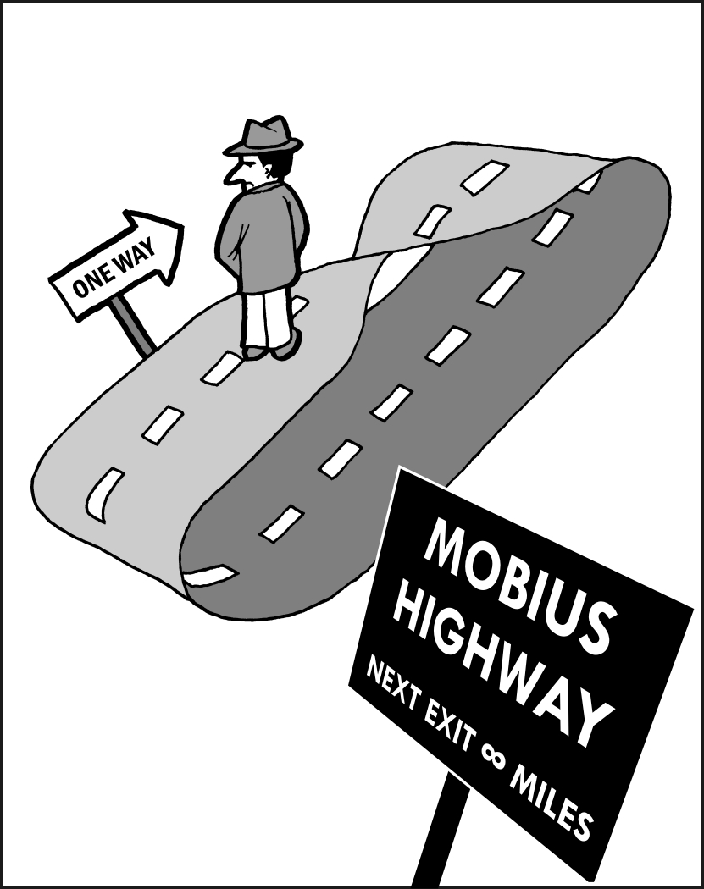
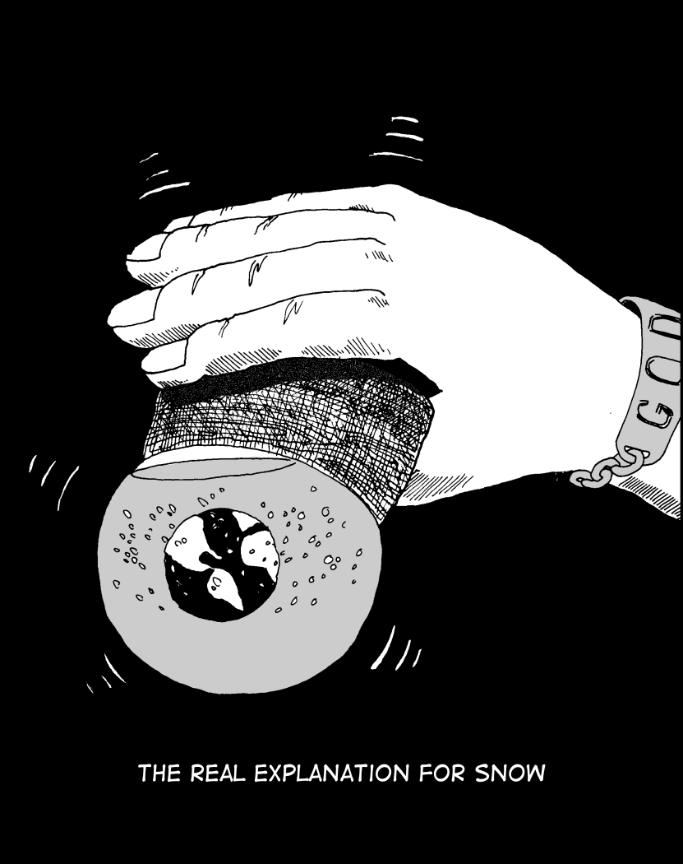

Jason Campbell, age 42
45 Clementi Lane, Methuen, MA 01844 781-799-0457
jason@campbellgraphics.com

