AMERICA’S NEXT GREAT CARTOONIST CONTEST
The Washington Post, June 2010

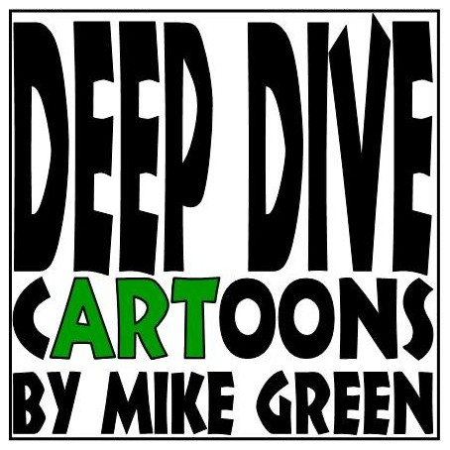
MIKE GREEN
DEEP DIVE cARToons
1128 Centennial Drive
Fort Washington, Maryland 20744
mykgreen@gmail.com
703-597-6861 / 301-265-0014

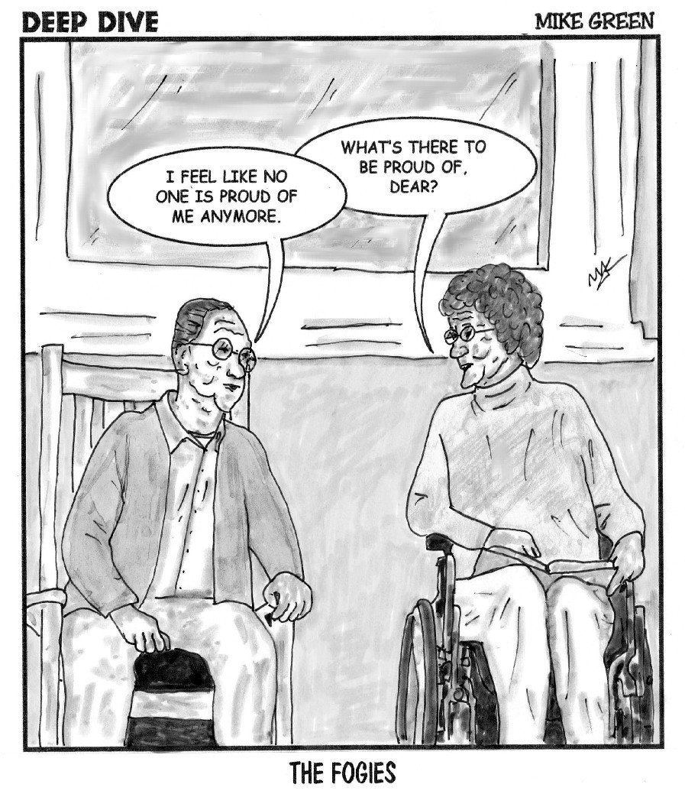

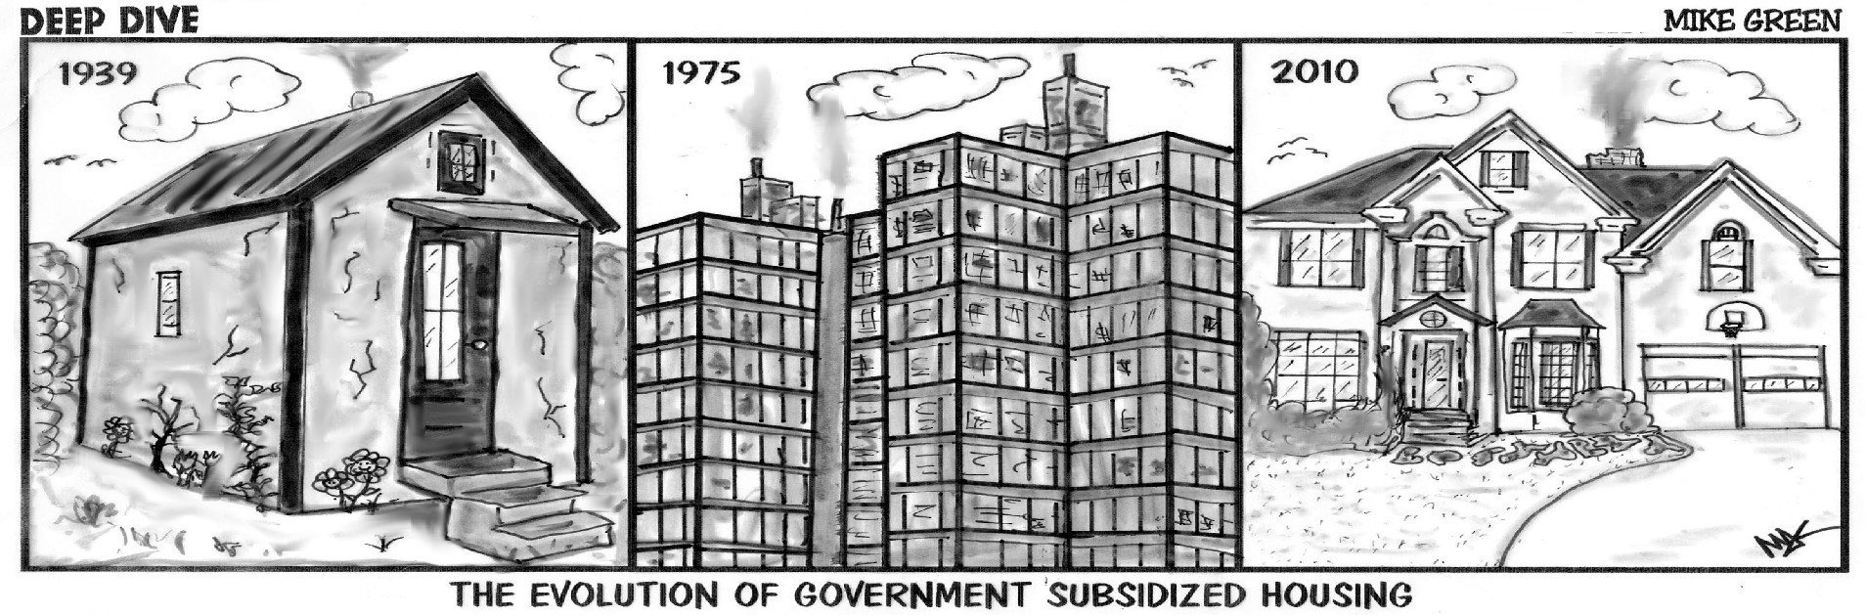

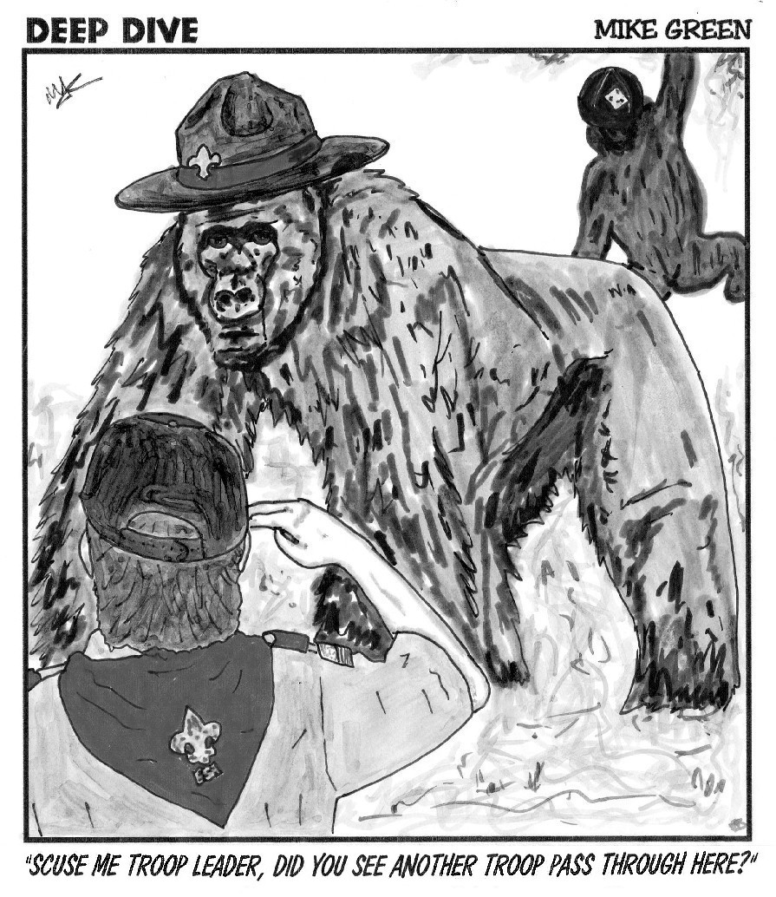
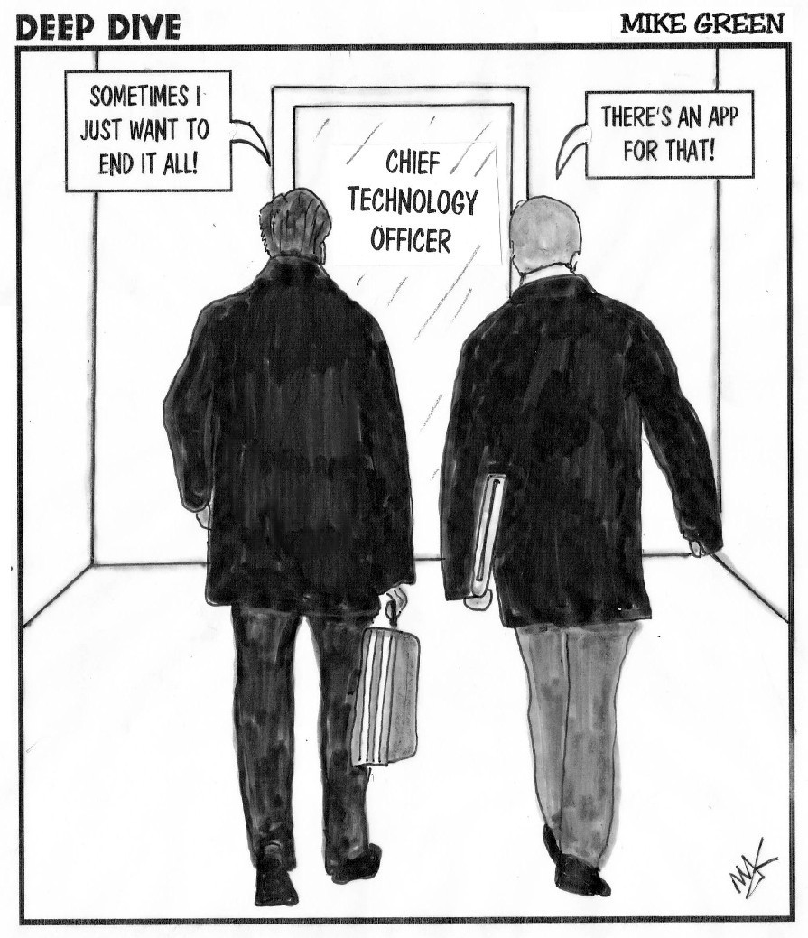

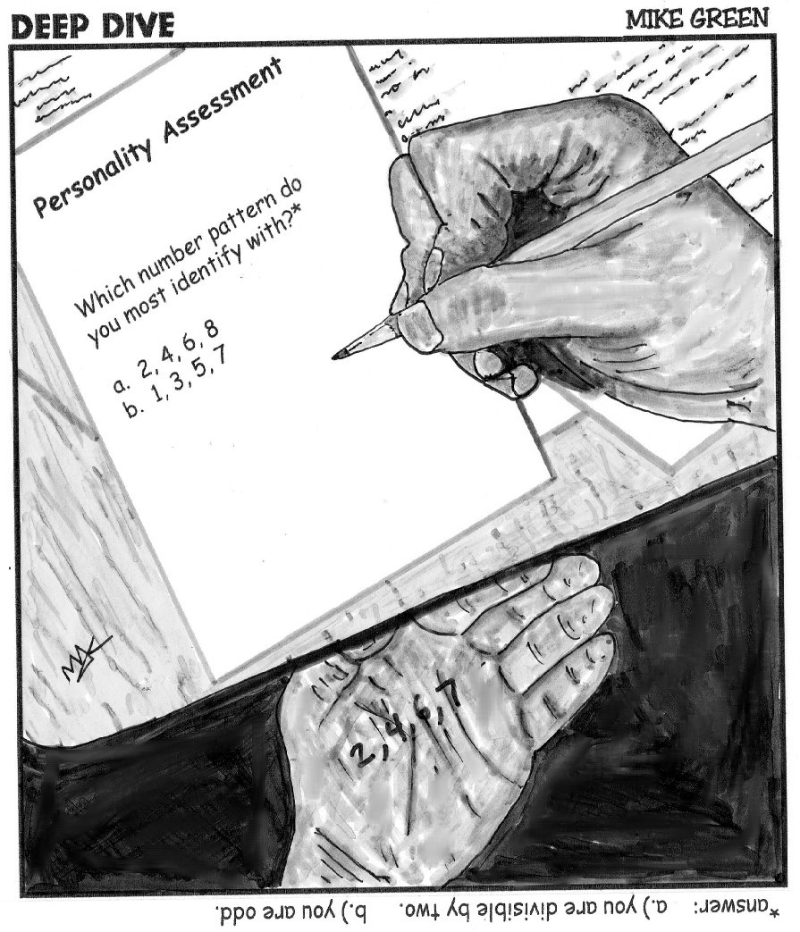
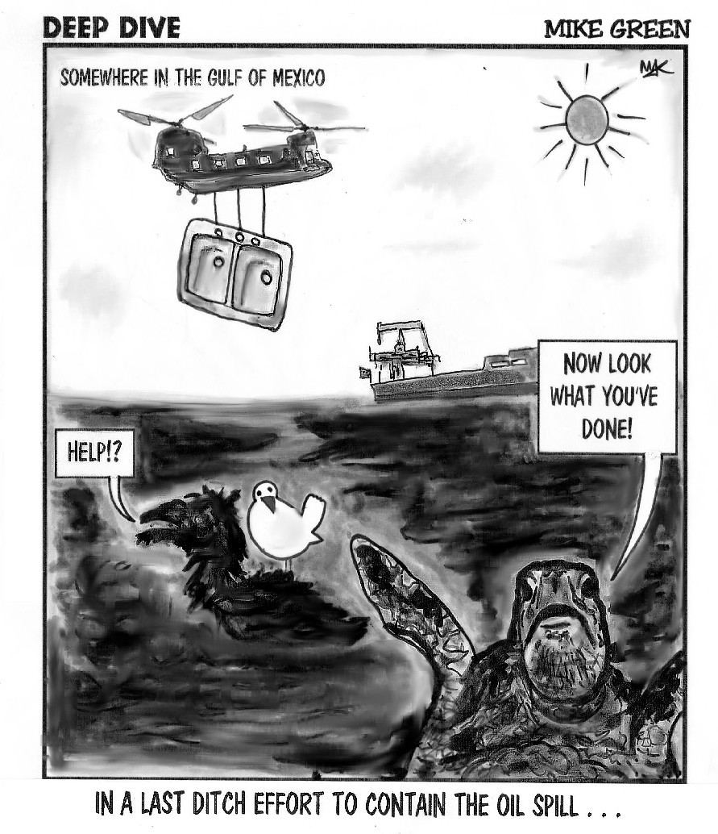

MIKE GREEN
DEEP DIVE cARToons
1128 Centennial Drive
Fort Washington, Maryland 20744
mykgreen@gmail.com
703-597-6861 / 301-265-0014

