Stupid Inventor by Zachary Snyder - StupidInventor@gmail.com – http://www.StupidInventor.com

Stupid Inventor by Zachary Snyder - StupidInventor@gmail.com – http://www.StupidInventor.com
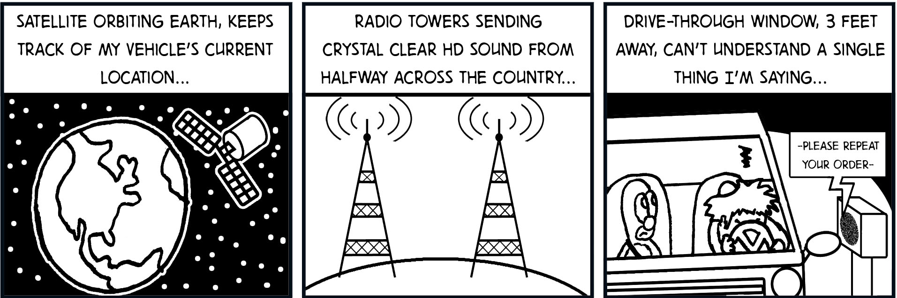
Stupid Inventor by Zachary Snyder - StupidInventor@gmail.com – http://www.StupidInventor.com

Stupid Inventor by Zachary Snyder - StupidInventor@gmail.com – http://www.StupidInventor.com

Stupid Inventor by Zachary Snyder - StupidInventor@gmail.com – http://www.StupidInventor.com
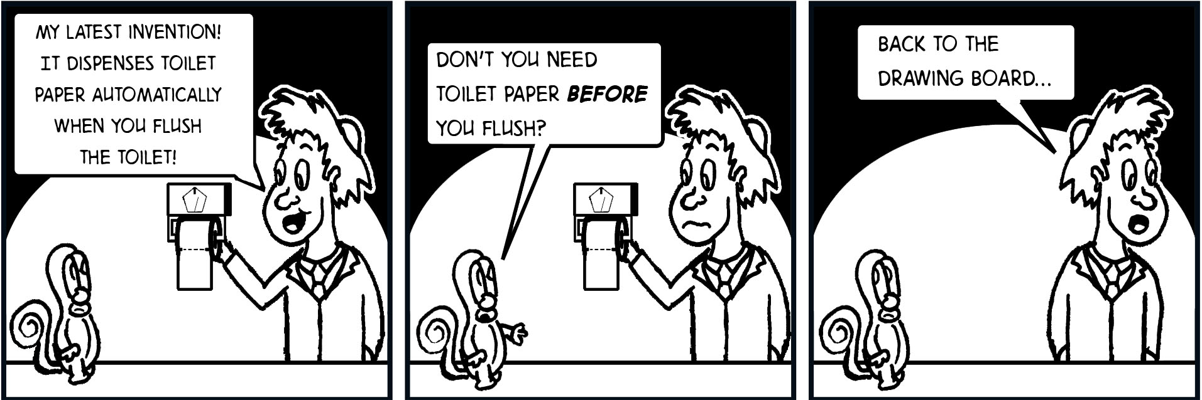
Stupid Inventor by Zachary Snyder - StupidInventor@gmail.com – http://www.StupidInventor.com
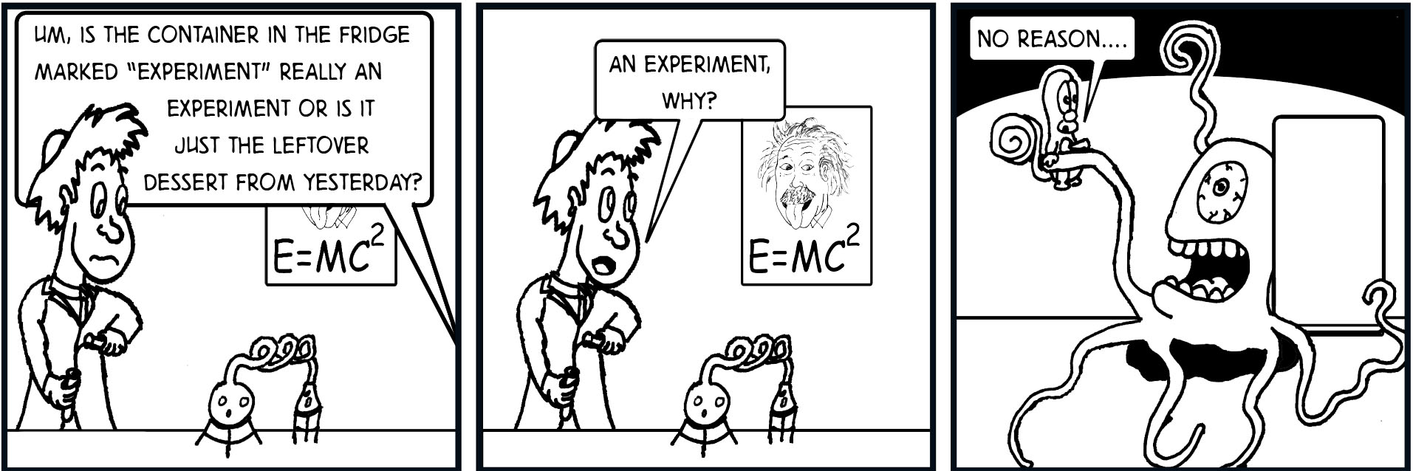
Stupid Inventor by Zachary Snyder - StupidInventor@gmail.com – http://www.StupidInventor.com

Stupid Inventor by Zachary Snyder - StupidInventor@gmail.com – http://www.StupidInventor.com

