America's Great Cartoonist Contest
Mary Rosebrock & Shannon Bouknight
Page 1/3

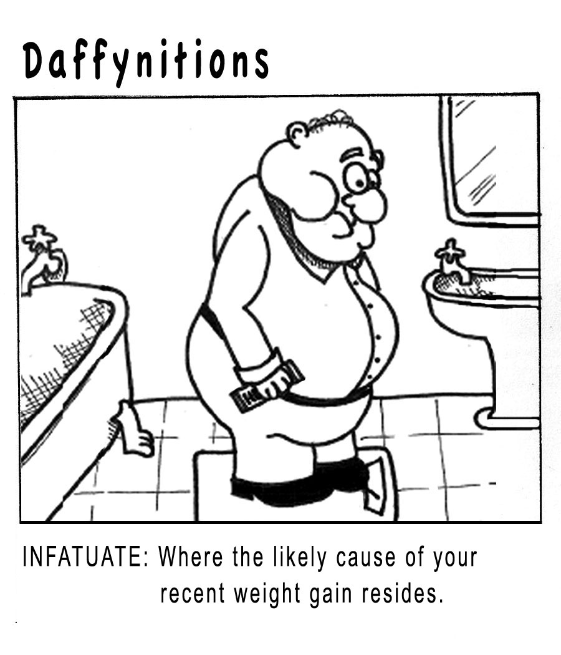

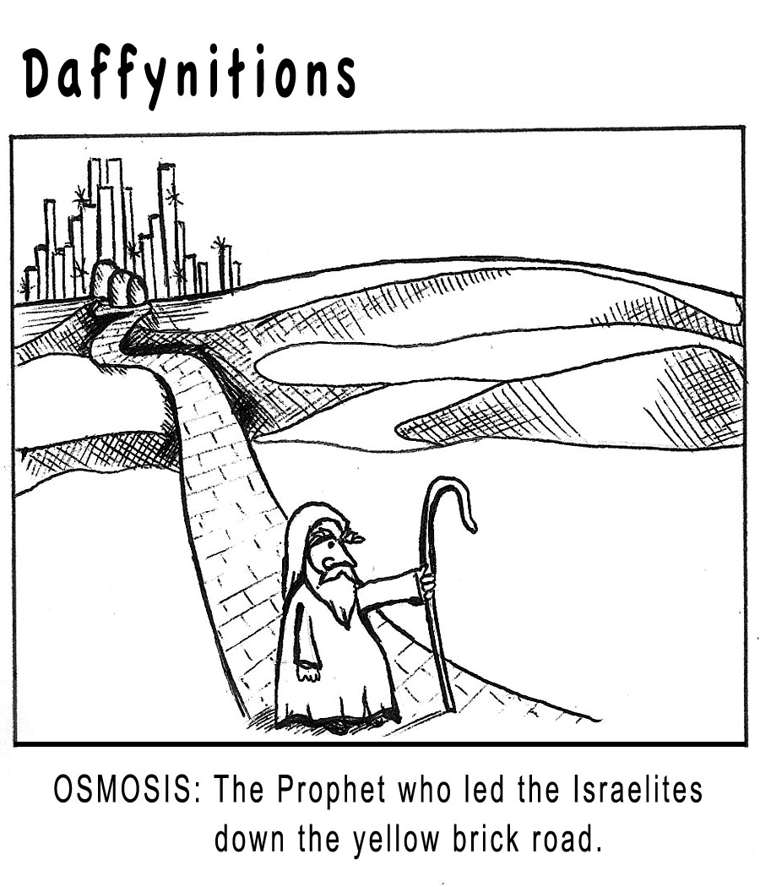

(Please continue to page 2)

America's Great Cartoonist Contest
Mary Rosebrock & Shannon Bouknight
Page 2/3

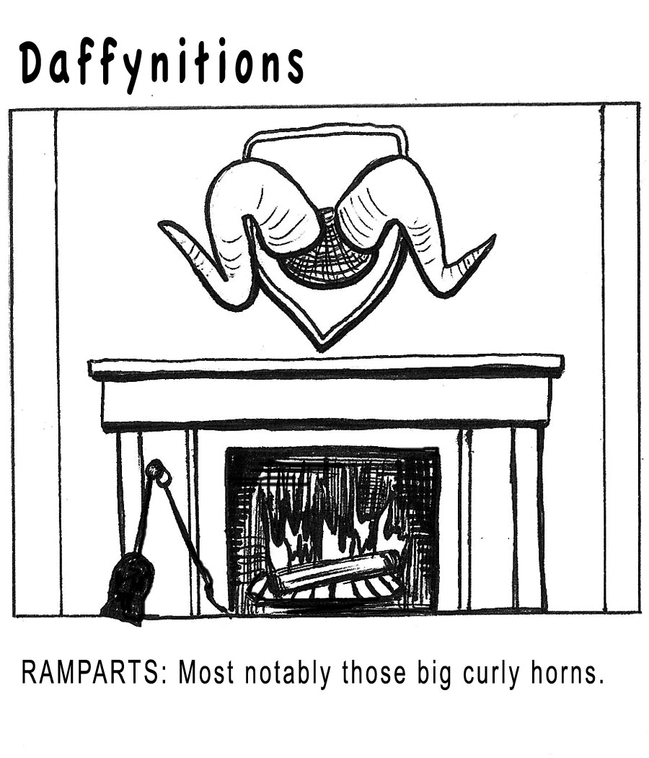

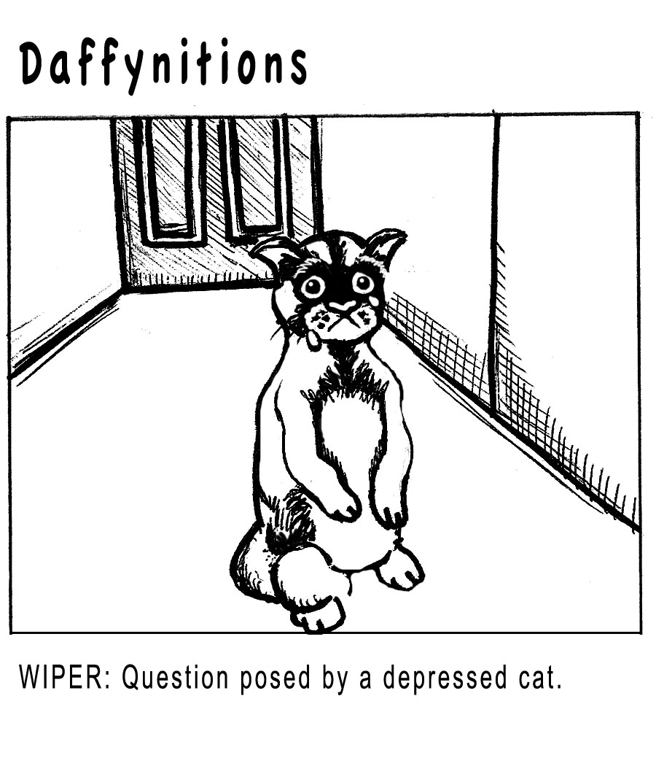

(Please continue to page 3)

America's Great Cartoonist Contest
Mary Rosebrock & Shannon Bouknight
Page 3/3

