**Functional Requirement Documents**

Table of Contents

1. Scope 2

2. System(s) Impacted 2

3. Assumption(s)/Dependencies 3

4. As-Is Business Process (via activity diagram) 3

5. T0- Be Business Process (via activity diagram) 3

6. Requirements 3

6.1 Requirements: ‘Home’ Page 3

6.2 Requirements: ‘Online Banking’ Page 4

6.2.1 ‘Online Banking’ page data fields 4

6.3 Requirements: ‘New User Registration’ Page 6

6.3.1 ‘New User Registration’ page data fields 6

6.3.2 ‘New User Registration’ page data validations 7

6.3.2.1 ‘New User Registration’ page data validation= Pass 8

6.3.2.2 ‘New User Registration’ page data validation= Fail 8

6.3.3 Cancel Registration 8

6.4 Requirements: ‘Password’ Page 9

6.4.1 ‘Password Page’ page data fields 9

6.4.2 Validate Password 9

7. Issues/Open Questions 10

# Scope

The goal of the project is to implement ‘Online Banking’ capability so that the customers can manage their account 24X7. This will also result in a significant decrease in call center volume, which not only provide a better customer experience but will also reduce call center expenses.

1. System(s) Impacted

‘Online Banking’ capabilities shall be added as an enhancement to

‘https://sbi.co.in/’

# Assumption(s)/Dependencies

N/A

# As-Is Business Process (via activity diagram)

1. T0- Be Business Process (via activity diagram)

# **6. Requirements**

## **6.1 Requirements: ‘Home’ Page**

6.1.1 Display ‘Online Banking’ Hyperlink

System shall display ‘Online Banking’ hyperlink, which shall be located to the left of ‘SBI in the news’ hyperlink.

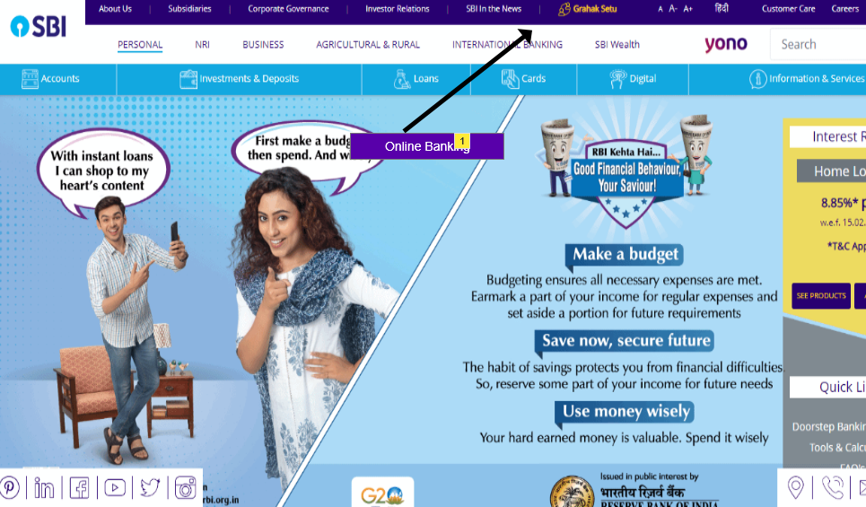

## 6.1.2 ‘Online Banking’ Hyperlink Navigation

On clicking ‘Online Banking’ hyperlink, system shall display ‘Online Banking’ page in the same window.

## **6.2 Requirements: ‘Online Banking’ Page**

## 6.2.1 ‘Online Banking’ page data fields

System shall display the following data fields on ‘Online Banking’ page:

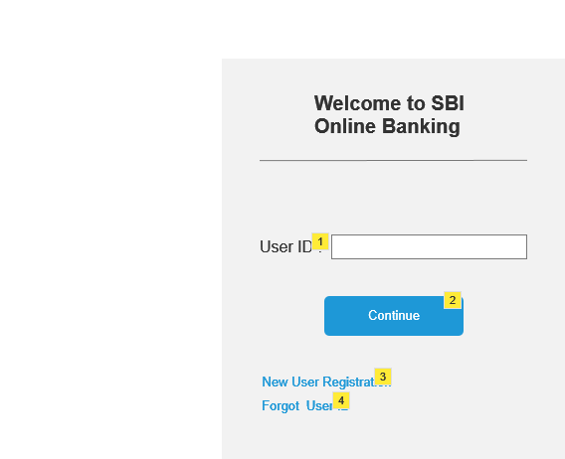

|  |  |  |  |  |  |  |
| --- | --- | --- | --- | --- | --- | --- |
| **Field Name** | **Field Type** | **Content** | **Required**  **Field?** | **Min. Char.** | **Max**  **Char.** | **Notes** |
| User ID | Text Box | Alpha-Numeric | No | 8 | 16 |  |
| Continue | Command Button | N/A | N/A | N/A | N/A | On click, if validation passes, display ‘Password’ page else display error message |
| New User Registration | Hyperlink | N/A | N/A | N/A | N/A | On click, display ‘New User Registration’ page in the same window. |
| Forgot User ID? | Hyperlink | N/A | N/A | N/A | N/A | On click, send an email to the registered mail id to reset the user id. |

**6.2.2 Validate User ID**

In the event of the user clicking the ‘Continue’ command button, system shall validate the entered user id.

6.2.2.1 if the entered User ID is valid, display ‘Password’ page in the same window.

6.2.2.2 if the entered User ID is invalid, display the following error message: Invalid User ID. “Please re-enter a valid value.”

## **6.3 Requirements: ‘New User Registration’ Page**

## 6.3.1 ‘New User Registration’ page data fields

System shall display the following data fields on ‘New User Registration’ page:

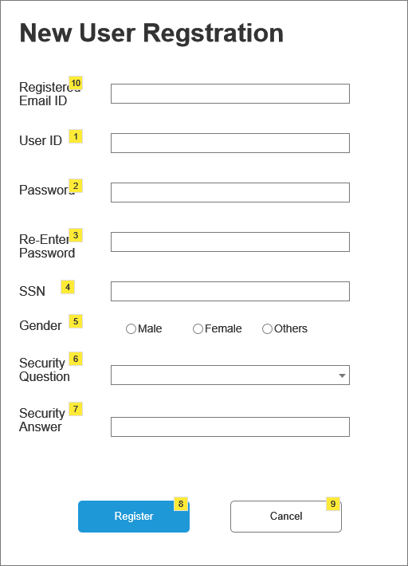

|  |  |  |  |  |  |  |
| --- | --- | --- | --- | --- | --- | --- |
| **Field Name** | **Field Type** | **Content** | **Required**  **Field?** | **Min. Char.** | **Max**  **Char.** | **Notes** |
| User ID | Text Box | Alpha-Numeric | Yes | 8 | 16 | Must be uniwue |
| Password | Text Box | Alpha-Numeric | Yes | 8 | 16 | Data is encrypted |
| Re-enter Password | Text Box | Alpha-Numeric | Yes | 8 | 16 | Data is encrypted |
| SSN | Text Box | Numeric | Yes | 9 | 9 | Encrypt the first 5 numbers |
| Gender | Radio Button | Male, Female | No | N/A | N/A | No default selection |
|  |  |  |  |  |  |  |
| Security Question | Dropdown | What is your best friend’s name?  What is your mother’s maiden name?  What is the make of your first car?  What city were you born?  What is your favorite movie? | Yes | N/A | N/A | Sort the options alphabetically.  No default selection |
| Security Answer | Text Box | Alpha-Numeric | Yes | 2 | 56 |  |
| Register | Command Button | N/A | N/A | N/A | N/A | On click, if all validations pass, display ‘Account Summary’ page, else display error messages |
| Cancel | Command Button | N/A | N/A | N/A | N/A | On click, discard the entered data and display ‘Online Banking’ page. |

## 6.3.2 ‘New User Registration’ page data validations

On click of ‘Register’ command button, system shall perform following validations:

1. All required data is entered
2. All the entered data is valid
3. User ID is unique
4. Re-entered password matches with the entered password
5. Entered SSN is associated with an active account
6. Entered SSN is NOT associated with an active User ID

## 6.3.2.1 ‘New User Registration’ page data validation= Pass

In the event of passing of all the validations, display ‘Account Summary’ page in the same window.

## 6.3.2.2 ‘New User Registration’ page data validation= Fail

In the event of the failure of one or more validations, display the error messages as shown below

|  |  |
| --- | --- |
| **Failed Validation** | **Error Message Displayed** |
| All required data is entered | <Data Field> is a required field. Please enter a value for <Data Field> |
| All the entered data is valid | Value for <Data Field> is invalid. Please enter a valid value for <Data Field> |
| User ID is unique | <User ID> is already taken. Please enter a different user id. |
| Re-entered password matches with the entered password | The entered password and the re-entered password do not match. Please try again. |
| Entered SSN is associated with an active account | The entered SSN does not have an active account in the bank. Please re-enter the SSN. |
| Entered SSN is NOT associated with an active User ID | The entered SSN is already associated with an active User ID. You are not allowed to create multiple User ID’s. |

## 6.3.3 Cancel Registration

On click of ‘Cancel’ command button, system shall discard the entered data and display ‘Online Banking’ page in the same window.

## **6.4 Requirements: ‘Password’ Page**

## 6.4.1 ‘Password Page’ page data fields

System shall display the following data fields on ‘password’ page:

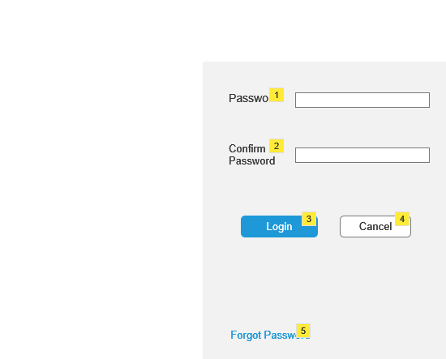

|  |  |  |  |  |  |  |
| --- | --- | --- | --- | --- | --- | --- |
| **Field Name** | **Field Type** | **Content** | **Required**  **Field?** | **Min. Char.** | **Max**  **Char.** | **Notes** |
| Password | Text Box | Alpha-Numeric | No | 8 | 16 | Data is encrypted |
| Login | Command Button | N/A | N/A | N/A | N/A | On click, if validation passes, display ‘Account Summary’ page else display error message |
| Forgot Password? | Hyperlink | N/A | N/A | N/A | N/A | On click, send an email to the registered mail id. |

## 6.4.2 Validate Password

In the event of the user clicking the ‘Login’ command button, system shall validate the entered Password.

6.2.2.1 if the entered Password is valid, display ‘Account Summary’ page in the same window.

6.2.2.2 if the entered Password is invalid, system shall calculate the password failure count.

6.2.2.2.1 If the Password failure count is <3, display the following error message: Invalid password. Please re-enter a valid password.

6.2.2.2.2 if the Password failure count= 3, system shall lock the account and display the following error message: Your account is locked. Please call 1-800-XXX-XXXX to unlock your account,

# ***6.5 Requirements : Password Reset Mail :***

Clicking on the “Forgot Password” button, Reset password mail will be sent to the user’s registered email id and a message will pop up saying “Reset Password mail has been sent to <registered mail id>”

|  |  |  |
| --- | --- | --- |
| **Field Name** | **Field Type** | **Notes** |
| **Reset Password** | **Command Button** | **On clicking the button, Password Reset page will open.** |

System shall display the Reset Password button in following manner.

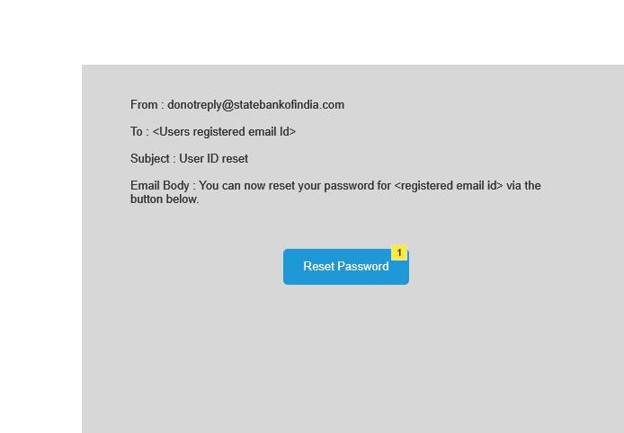

# 

# ***6.5 Requirements : User ID Reset Mail :***

Clicking on the “Forgot User ID” button, Reset User ID mail will be sent to the user’s registered email id and a message will pop up saying “Reset User ID mail has been sent to <registered mail id>”

|  |  |  |
| --- | --- | --- |
| **Field Name** | **Field Type** | **Notes** |
| **Reset User ID** | **Command Button** | **On clicking the button, User ID Reset page will open.** |

System shall display the Reset Password button in following manner.

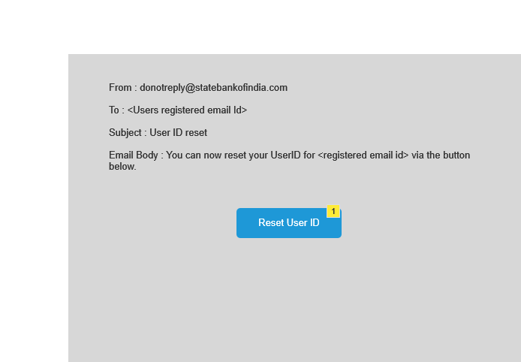

# ***6.6 Requirements : Password Reset page :***

The user interface will look like below.

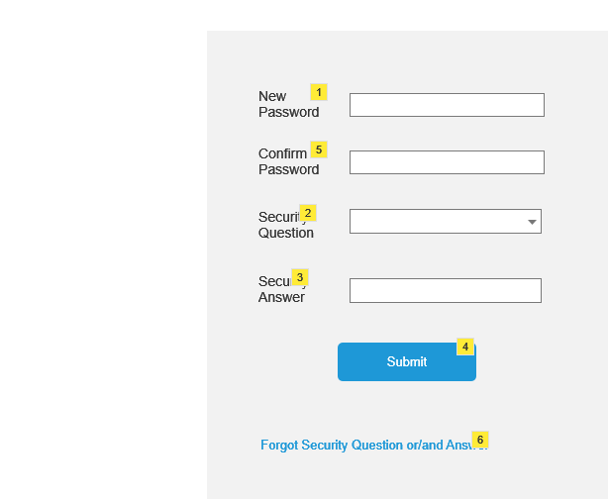

|  |  |  |  |  |  |  |
| --- | --- | --- | --- | --- | --- | --- |
| **Field Name** | **Field Type** | **Content** | **Required**  **Field?** | **Min. Char.** | **Max**  **Char.** | **Notes** |
| New Password | Text Box | Alpha-Numeric | Yes | 8 | 16 | Data is encrypted |
| Confirm Password | Text Box | Alpha-Numeric | Yes | 8 | 16 | Data is encrypted |
| Security Question | Dropdown | Options | Yes | N/A | N/A | On clicking the the dropdown, 5 options will be displayed. Selected question should match with the previously registered question.  If not matched, error message should pop up saying “Security question does not match” |
| Security Answer | Text Box | Alpha Numeric | Yes | 2 | 60 | Answer should match with the previously registered answer.If not matched, error message should pop up saying “Security question does not match” |
| Submit | Command Button | N/A | N/A | N/A | N/A | On clicking the button, “Online Bankng” page will open. |
| Forgot Security Q&A | Hyperlink | N/A | N/a | N/A | N/A | Open Helpline Page. A message will pop up saying "Please contact with the helpline" |

# ***6.7 Requirements : User ID Reset page :***

# The user interface will look like below.

# 

|  |  |  |  |  |  |  |
| --- | --- | --- | --- | --- | --- | --- |
| **Field Name** | **Field Type** | **Content** | **Required**  **Field?** | **Min. Char.** | **Max**  **Char.** | **Notes** |
|  |  |  |  |  |  |  |
| User ID | Text Box | Alpha Numeric | Yes | 5 | 16 | Must be Unique |
| Security Question | Dropdown | Options | Yes | N/A | N/A | On clicking the the dropdown, 5 options will be displayed. Selected question should match with the previously registered question.  If not matched, error message should pop up saying “Security question does not match” |
| Security Answer | Text Box | Alpha Numeric | Yes | 2 | 60 | Answer should match with the previously registered answer.If not matched, error message should pop up saying “Security question does not match” |

|  |  |  |  |  |  |  |
| --- | --- | --- | --- | --- | --- | --- |
| Submit | Command Button | N/A | N/A | N/A | N/A | On clicking the button, “Online Bankng” page will open. |
| Forgot Security Q&A | Hyperlink | N/A | N/a | N/A | N/A | Open Helpline Page. A message will pop up saying "Please contact with the helpline" |

# 7. Issues/Open Questions