|  |
| --- |
|  |
| The Documentation |
| [Type the document subtitle] |
|  |
| **[Your Name]** |
| **[Pick the date]** |

[Type the abstract of the document here. The abstract is typically a short summary of the contents of the document. Type the abstract of the document here. The abstract is typically a short summary of the contents of the document.]

Table of Contents

[To update the table of contents, right click the message below and select Update Field (F9 on PC, ⌥⌘U on Mac).]

**No table of contents entries found.**

1. Pages
   1. Page Tree

Home  
NewUserReg  
OnlineBanking  
Password  
Password_reset_mail  
UserID_reset_mail  
UserID reset  
Password reset

* 1. Home
     1. User Interface

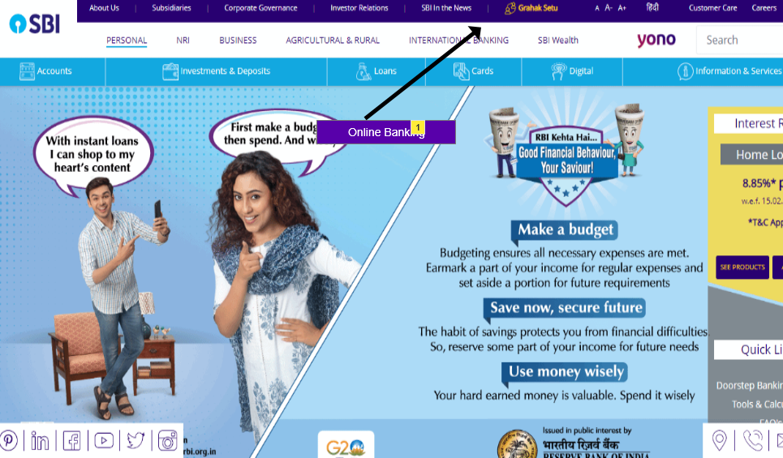

* + 1. Widget Table

| Note number | Name | Note |
| --- | --- | --- |
| 1 | Online Banking | Hyperlink :  On Clicking it, system will display the 'Online Banking' page on the same window. |

* 1. NewUserReg
     1. User Interface

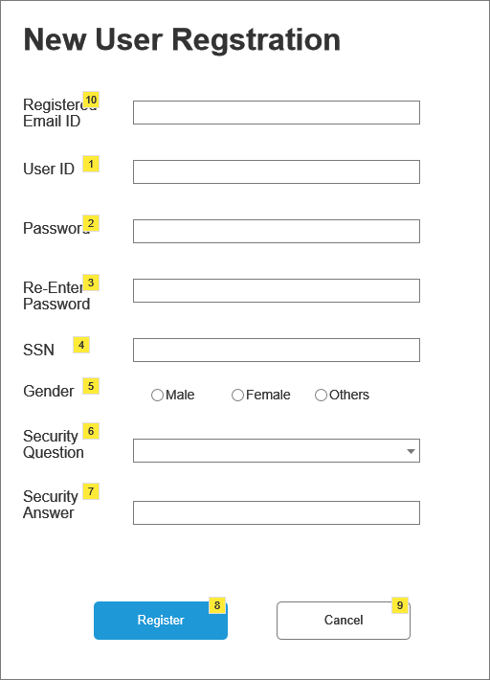

* + 1. Widget Table

| Note number | Name | Note |
| --- | --- | --- |
| 1 | UserID-Text Box | Required Fields :  Alphanumeric Data  Min. Char : 8  Max. Char. : 16 |
| 2 | Password-Textbox | Required Fields :  Alphanumeric Data  Min. Char : 8  Max. Char. : 16  Data is Encrypted |
| 3 | Re-Enter Password-Textbox | Required Fields :  Alphanumeric Data  Min. Char : 8  Max. Char. : 16  Data is Encrypted |
| 4 | SSN-Textbox | Required Fields :  Numeric Data  Min. Char : 8  Max. Char. : 16  First 5 numbers Data is Encrypted |
| 5 | Gender-Radio Button | Optional Field  Options are Male, Female, Others  No default Select |
| 6 | Security Question - Dropdown | Reqired Field  Options :  Sort Options Alphabatically  No default Select |
| 7 | Security Answer - Text Box | Required Field  Alphanumeric Data  Min. Char. 2  Max Char. 60 |
| 8 | Register - Submit Button | On click if all validations pass, display login page else display error mesage |
| 9 | Cancel - Command Button | Discard the entered data and display online banking page. |
| 10 | UserID-Text Box | Required Fields :  Alphanumeric Data  Min. Char : 8  Max. Char. : 16 |

* 1. OnlineBanking
     1. User Interface

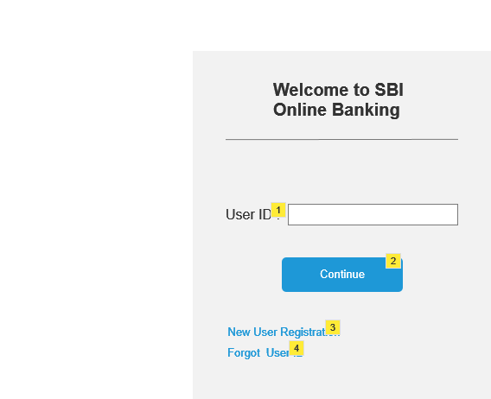

* + 1. Widget Table

| Note number | Name | Note |
| --- | --- | --- |
| 1 | User ID - Textbox | Required Field :  Alphaneumeric Data  Must be Unique |
| 2 | Continue - Command Button | Command Button :  On clicking this Password page will open |
| 3 | New User Registration - Hyperlink | Hyperlink :  On clicking this, "New User Registration" page will open. |
| 4 | Forgot User ID | Hyperlink :  On clicking this, email will be sent to the user to reset the userID.  A message will pop up "User ID reset email is sent to mail id <User's registered email-id>" |

* 1. Password
     1. User Interface

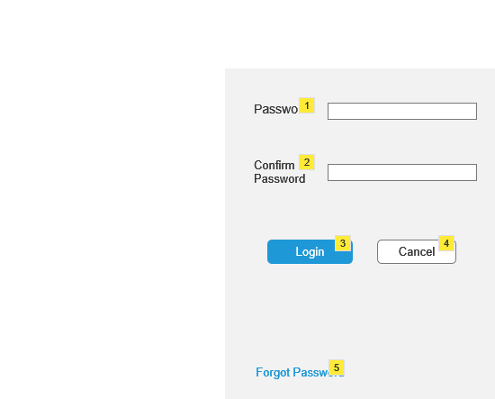

* + 1. Widget Table

| Note number | Name | Note |
| --- | --- | --- |
| 1 | Password - Textbox | Textbox :  Alphanumeric  User will enter previously created password |
| 2 | Confirm Password - Textbox | Textbox :  Alphanumeric  User will enter same password |
| 3 | Login - Command Button | Command Button:  On clicking this "Account Summary" Page will open after validation of the password. |
| 4 | Cancel - Command Button | Command Button :  On clicking this all the entered credentials will be discarded and "Online Banking" page will open. |
| 5 | Forgot Password - Hyperlink | Hyperlink :  Clicking this user will recieve an email to reset their Password.  A message will pop up "Password Reset Mail has been sent to <registered emailID>" |

* 1. Password_reset_mail
     1. User Interface

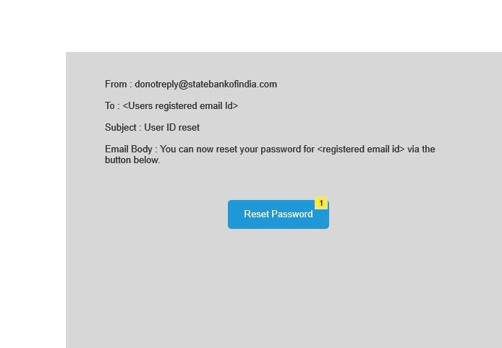

* + 1. Widget Table

| Note number | Name | Note |
| --- | --- | --- |
| 1 | Reset Password | Command Button :  On clicking this, reset password page will open. |

* 1. UserID_reset_mail
     1. User Interface

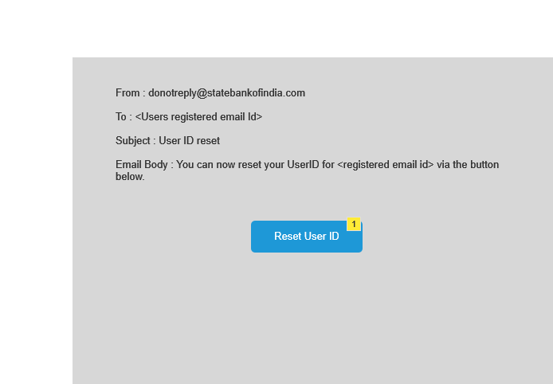

* + 1. Widget Table

| Note number | Name | Note |
| --- | --- | --- |
| 1 | Reset Password | Command Button :  On clicking this, reset UserID page will open. |

* 1. UserID reset
     1. User Interface

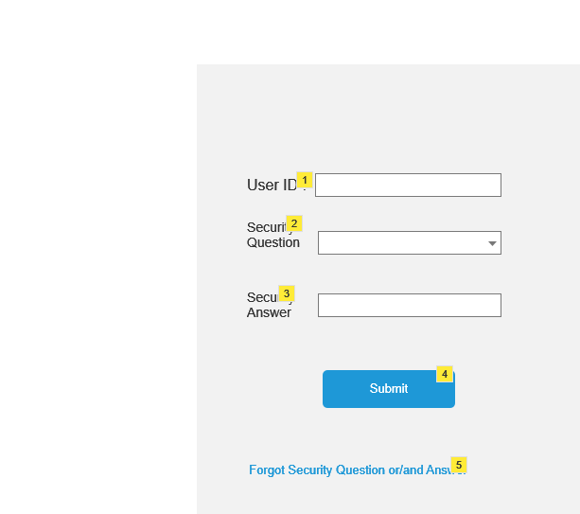

* + 1. Widget Table

| Note number | Name | Note |
| --- | --- | --- |
| 1 | User ID - Textbox | Required Field :  Alphaneumeric Data  Must be Unique |
| 2 | Security Question - Dropdown | Reqired Field  Options :  Sort Options Alphabatically  No default Select |
| 3 | Security Answer - Text Box | Required Field  Alphanumeric Data  Min. Char. 2  Max Char. 60 |
| 4 | Submit - Command Button | After validating all the credentials On clicking this, "Online Banking" page will open |
| 5 | Forgot Security Q&A | Hyperlink :  Open helpline page  A message will pop up saying "Please contact with the helpline" |

* 1. Password reset
     1. User Interface

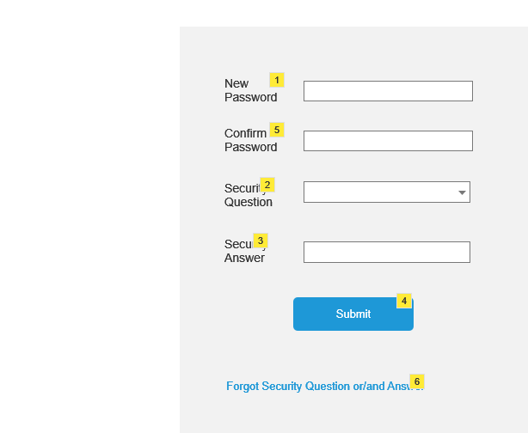

* + 1. Widget Table

| Note number | Name | Note |
| --- | --- | --- |
| 1 | New Password - Textbox | Required Field :  Alphaneumeric Data  Must be Unique  Min. Char. 8  Max. Char. 16 |
| 2 | Security Question - Dropdown | Reqired Field  Options :  Sort Options Alphabatically  No default Select |
| 3 | Security Answer - Text Box | Required Field  Alphanumeric Data  Min. Char. 2  Max Char. 60 |
| 4 | Submit - Command Button | After validating all the credentials On clicking this, "Online Banking" page will open. |
| 5 | Confirm Password - Textbox | Required Field :  Alphaneumeric Data  Must be Unique  Min. Char. 8  Max. Char. 16 |
| 6 | Forgot Security Q&A | Hyperlink :  Open helpline page  A message will pop up saying "Please contact with the helpline" |