GAMEPLAY COMBAT ENGINEERING

MORGOTT, THE OMEN KING
  - 82-point combat behavior & Unreal Engine implementation reference
Adapted from the existing 83-point boss checklist • Network item BOSS-QA-008 excluded
Research basis: public encounter observation and detailed community combat analysis. Does not claim access to FromSoftware’s private AI code.
30 October 2026 | UE 5.5 / 5.5.4
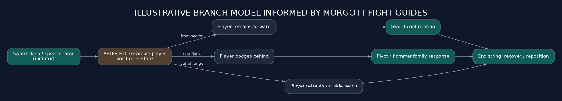
Original conceptual diagram: when the player moves, a legal combo gate may choose a different follow-up.
RESEARCH STATUS
12 observable mechanics • 17 community-reported patterns • 18 reasoned interpretations • 35 internal-engine details unverified

Reading guide
Purpose Use Morgott as an evidence-led reference while improving your existing Unreal boss. This is a separate benchmark, not the current boss audit.
Evidence O Clearly visible encounter mechanic described by fight sources.
Evidence R Community-documented behavior that should be verified with footage or repeated testing.
Evidence I Engineering inference from observable gameplay; not verified internal implementation.
Evidence U Hidden AI, data or event-lifecycle behavior not established publicly.
How to use each requirement Read the original checklist rule, the Morgott evidence, the suggested Unreal translation, and the measurable test. Do not assume Unreal uses Elden Ring’s internal architecture.

Summary: why his combat works
- Weapon families carry tactical meaning: dagger for close pressure, sword for varied strings, spear for distance, hammer for heavy punish, tail for rear defense and bloodflame for delayed hazards.
- Position near the boss when a combo gate resolves can change its next move; spacing is part of the fight’s decision-making language.
- The player learns both release timing and commitment: delayed slashes punish panic dodges, while whiffed charges or finishers can be punishable.
- Holy sword rain and later geysers constrain sections of the arena; the player must plan escape routes, not simply react to the boss’s hands.
- Fight progression is reported as roughly 80% HP holy rain unlock, 60% cursed-blood transition, 30% extended armament-string availability. These are approximate and may be affected by interruption.
- The boss can be stance-broken and parried, letting sustained skilled offense counter his pressure.

Core attack catalogue
Attack family | Function / phase | Collision family | Counterplay
Curved sword slash / delayed overhead | Melee front | Swept blade / narrow downward arc | Attack on actual release, not first lift; dodge flank; punish only confirmed finisher.
Holy dagger double slash | Close anti-greed | Two short narrow active windows | Move around flank and avoid immediate greedy extra attack.
Holy dagger throw | Medium / far pressure | Several narrow projectile lanes | Sidestep or dodge after projectile launch; keep approach option.
Holy spear throw | Ranged precision | Fast narrow projectile / lane | Side dodge later in wind-up; avoid linear backward running.
Holy spear charge | Medium-to-long gap closer | Moving thrust volume across root-motion path | Commit to lateral escape; dodge behind for flank punish.
Holy hammer overhead slam | Close/mid heavy follow-up | Impact volume plus possible local shockwave | Dodge to side/back and identify whether ender follows.
Sword + hammer spin | Close area denial | Sequential moving sweep volumes | Leave immediate radius or time successive dodges.
Helicopter: holy sword spin finisher | Melee combo finisher | Multiple blade arcs with separate windows | Stay outside repeated swings or evade around; retaliate after ender.
Rear tail sweep | Player behind | Rear sweeping capsule / angular arc | Avoid persistent rear camping; jump/dodge with timing.
Holy swords rain | Arena zoning; scripted ~80% | Initial circle + repeated falling sword hazard lanes | Identify lane pattern, move through safe spaces; exploit long setup cautiously.
Omen curse burst and geysers | Scripted ~60% transition | AOE burst + discrete localized eruptions | Disengage for burst; watch local geyser positions.
Bloodflame slam | Phase 2 | Heavy impact + localized erupting AOE | Circle toward safe flank; retaliate after commitment if no geyser underfoot.
Bloodflame chase / two slashes | Phase 2 | Two swept arcs + delayed hazard trail volumes | Avoid direct blade and delayed trail as distinct threats.
Bloodflame grab / skewer | Phase 2 | Narrow moving grab capsule + paired animation | Dodge at thrust release and take punish on whiff from side.
Rapid weapon-change barrage | Below ~30% unlock | Sequence of short weapon hits + broad heavy finisher | Survive string and identify true terminal recovery.

Original engineering diagrams
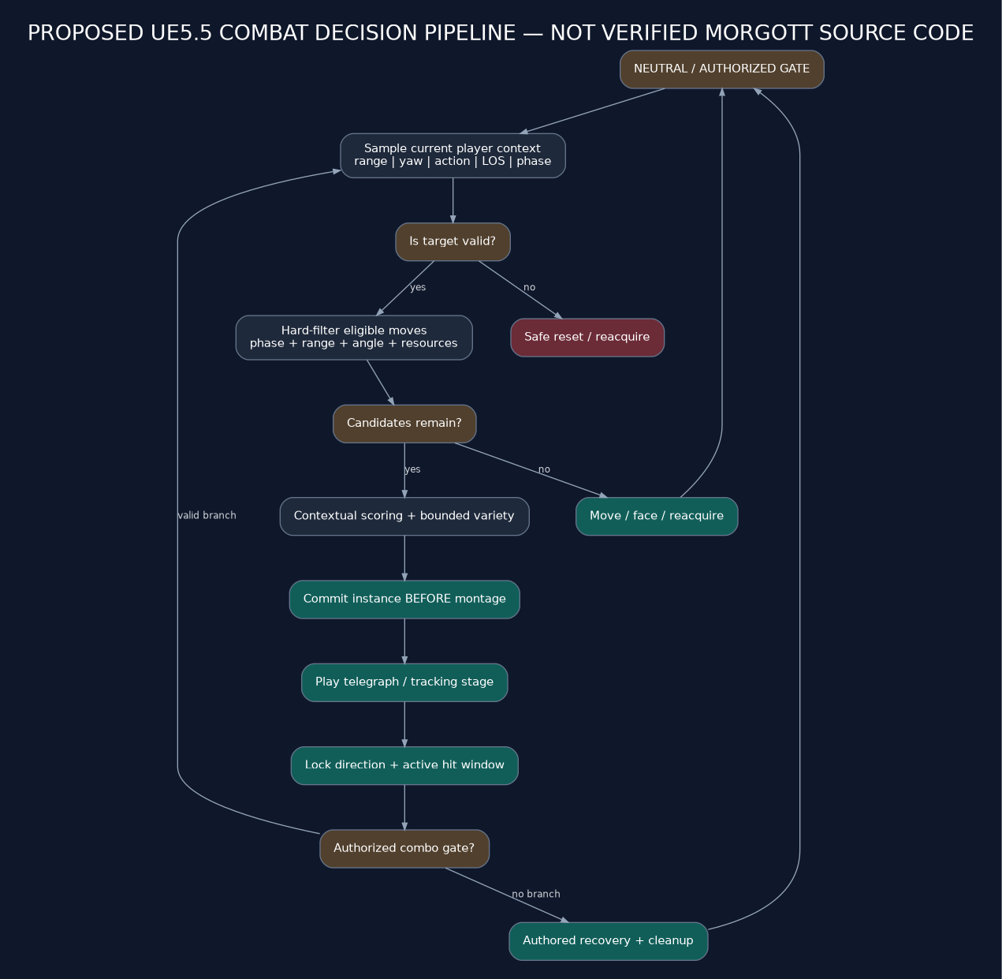
Figure 1. Proposed Unreal decision and execution pipeline (not confirmed Elden Ring internals).
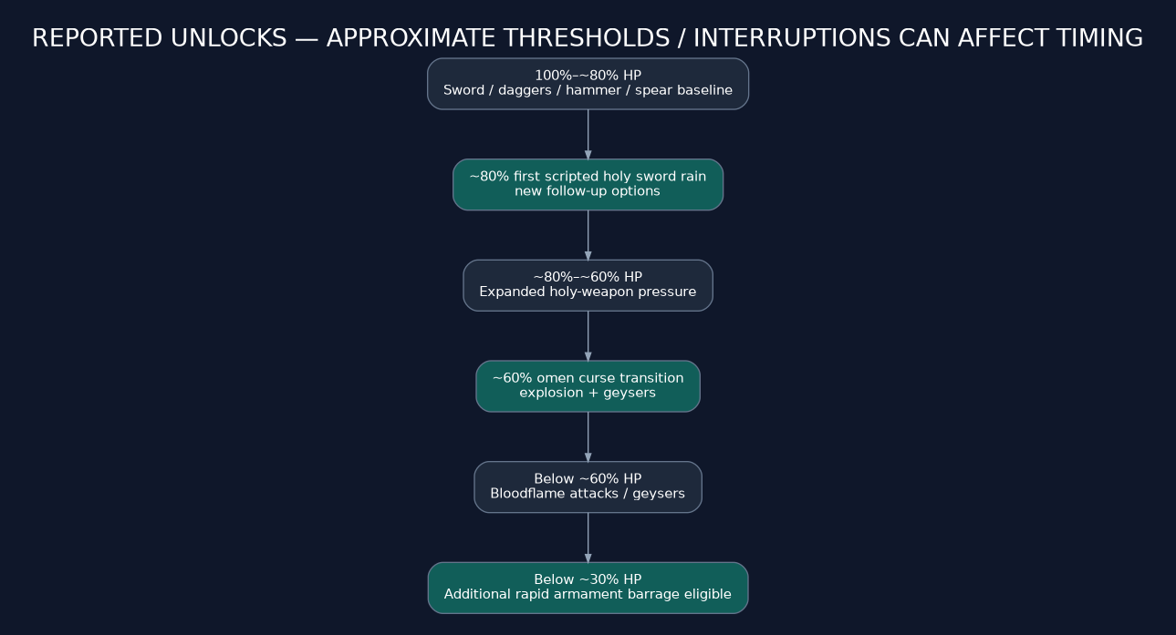
Figure 2. Reported health-based unlocks; thresholds are approximate.
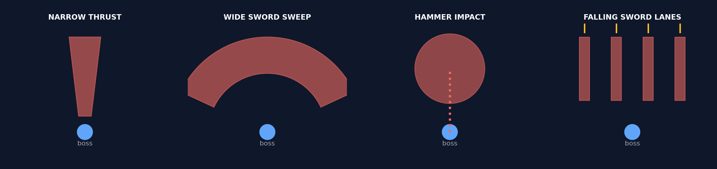
Figure 3. Simplified sword thrust, sweep, impact and falling-sword hit geometry.
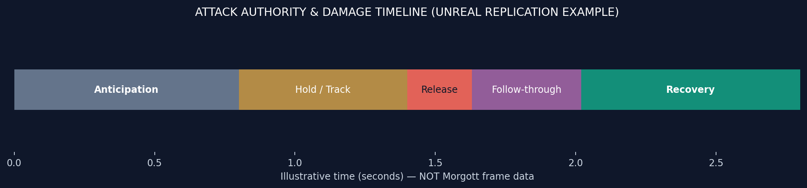
Figure 4. Sample attack time authority. All seconds are illustrative, not Morgott measured timings.

Awareness and observable context

BOSS-AWR-001 — Target validity [I]
Requirement Every decision rejects dead, destroyed, invalid, out-of-arena or otherwise non-targetable actors.
Morgott Morgott engages a valid opponent and stops offensive behavior at encounter termination. How his internal target-object validity and leash checks are encoded is unknown.
Unreal 5.5 Before every neutral or follow-up decision, reject dead/destroyed/non-targetable or off-arena targets; abandon an attack gracefully when a target becomes invalid.
Acceptance test Kill/despawn the player, break encounter boundaries and interrupt a queued follow-up; expect safe reacquisition/reset.
Evidence: S1,S2 | O=observed • R=reported • I=inferred • U=unverified

BOSS-AWR-002 — Gate-time snapshot [U]
Requirement A timestamped combat context is rebuilt atomically at every neutral, combo or reaction gate.
Morgott Morgott visibly changes follow-ups based on where the player finishes a dodge, suggesting fresh situation evaluation, but no public proof establishes atomic snapshots or timestamps.
Unreal 5.5 At every neutral, combo or reaction gate capture target location, action tags, facing, distance, LOS, boss phase and clock time in one immutable FCombatContext.
Acceptance test Move behind Morgott during one combo; debug logs must show a fresh gate snapshot and the corresponding branch.
Evidence: S1,S2 | O=observed • R=reported • I=inferred • U=unverified

BOSS-AWR-003 — Distance convention [I]
Requirement Each attack declares whether range means root, capsule-surface or attack-origin distance.
Morgott The spear has long reach, dagger pressure is strongest up close, and the sword/hammer cover different extents; exact range measurement convention is not published.
Unreal 5.5 Document root-to-root versus capsule edge versus attack-origin distance in each MoveData; avoid inconsistent range checks between selectors and traces.
Acceptance test Place target on min/max range thresholds and repeat from different capsule sizes; compare eligibility with actual reach.
Evidence: S1,S2 | O=observed • R=reported • I=inferred • U=unverified

BOSS-AWR-004 — Signed angle and hysteresis [R]
Requirement Relative yaw is planar, boss-facing and stable near sector boundaries.
Morgott Tail swipes answer positions behind him, and frontal or flank positioning changes certain sword/hammer continuations in detailed player observations.
Unreal 5.5 Compute signed planar target yaw relative to boss forward; add enter/leave thresholds around rear and side sectors to prevent flicker.
Acceptance test Orbit across front/side/rear boundaries while an attack finishes; verify stable branch selection without oscillation.
Evidence: S1,S4 | O=observed • R=reported • I=inferred • U=unverified

BOSS-AWR-005 — Vertical separation [U]
Requirement Melee and ground actions enforce a documented Z tolerance.
Morgott The fight mostly takes place on a relatively flat arena; no evidence establishes Morgott’s internal Z-difference gates.
Unreal 5.5 Apply vertical tolerance to sword, hammer, ground shockwaves and spear charge; define airborne exceptions for projectiles and leap attacks.
Acceptance test Raise the player on test platforms; verify no ground sweep or melee attack hits vertically impossible targets.
Evidence: S1,S2 | O=observed • R=reported • I=inferred • U=unverified

BOSS-AWR-006 — Observable player activity [R]
Requirement Reactions use public committed action state, not raw future input.
Morgott Players report Morgott responding to committed healing, long casts, and guard-break states; this should not be interpreted as knowledge of future button presses.
Unreal 5.5 Expose player action tags only after the animation/ability actually starts; gate reaction by commitment, LOS, feasible distance and reaction delay.
Acceptance test Heal inside and outside reach; cancel during startup; ensure reaction never fires on input before an action is visible.
Evidence: S1,S4 | O=observed • R=reported • I=inferred • U=unverified

BOSS-AWR-007 — LOS and memory [U]
Requirement Precision reactions require current LOS; lost targets use timestamped last-seen state and reacquire.
Morgott The arena is open and line-of-sight is generally unobstructed, but last-seen timers and LOS handling are not documented.
Unreal 5.5 Require current LOS for precision throws; store last-seen position/time and use a reacquire or search fallback after LOS loss.
Acceptance test Introduce an occluding temporary wall and loss/reacquisition conditions; verify response is not omniscient.
Evidence: S1,S2 | O=observed • R=reported • I=inferred • U=unverified

BOSS-AWR-008 — Soft adaptation memory [U]
Requirement Pattern features decay, are capped and bias rather than force choices.
Morgott Repeated-position pressure may result from fixed positional rules; evidence does not establish a decaying memory or player-pattern model.
Unreal 5.5 If adaptation is desired, track short-lived capped recent heal/roll/rear-camping metrics; bias preferences rather than guarantee a hard counter.
Acceptance test Repeat backward rolls then vary behavior; ensure reactions shift probabilistically and decay after the pattern stops.
Evidence: S1,S2 | O=observed • R=reported • I=inferred • U=unverified

Eligibility, utility and selection

BOSS-SEL-001 — Legal decision gates [I]
Requirement Full attack selection runs only in neutral or an explicitly authorized gate.
Morgott Morgott’s attacks visibly commit and branch rather than instantly switching on every player movement; the exact internal selection-gate topology is unknown.
Unreal 5.5 Call selection in neutral or authored combo/reaction windows only; keep active committed motion under a single executor.
Acceptance test Move player rapidly during active attack; ensure no illegal attack change until the next legal gate.
Evidence: S1,S2 | O=observed • R=reported • I=inferred • U=unverified

BOSS-SEL-002 — Hard-filter precedence [I]
Requirement Phase, state, range, angle, LOS, cooldown, resource, asset and path constraints reject before scoring.
Morgott His weapon choices are context-sensitive: dagger at closer spacing, spear throws at range, tail response from behind, and health-gated moves.
Unreal 5.5 Hard-filter by phase, state, attack range, angle, LOS, cooldown and asset readiness; score only passing candidates.
Acceptance test At each position/phase enumerate rejected candidates and reasons; no impossible move should be selected.
Evidence: S1,S2 | O=observed • R=reported • I=inferred • U=unverified

BOSS-SEL-003 — Executable asset gate [U]
Requirement A move with a missing montage/socket/required resource is never selected.
Morgott The shipped boss of course has working animations; a data/asset validity gate inside FromSoftware’s runtime is not observable.
Unreal 5.5 Validate montage, sockets, curves, reaction ability and VFX references during content audit and at runtime before committing.
Acceptance test Delete an attack montage reference in a dev copy; attack should be skipped with diagnostics, not leave boss frozen.
Evidence: S1,S2 | O=observed • R=reported • I=inferred • U=unverified

BOSS-SEL-004 — Normalized utility [U]
Requirement Eligible moves receive comparable documented range, angle, opportunity, spacing, phase and variety terms.
Morgott Morgott creates the impression of contextual selection, but neither a utility-scoring equation nor its weights are established publicly.
Unreal 5.5 Use normalized scores for geometry, target commitment, phase, spacing, combo intent, variety and hazards; tune from recorded fights.
Acceptance test Replay identical contexts with debug scoring; highest eligible utility should dominate without deterministic repetition.
Evidence: S1,S2 | O=observed • R=reported • I=inferred • U=unverified

BOSS-SEL-005 — Bounded randomness [U]
Requirement Variation is limited to near-best candidates, with deterministic seeded RNG.
Morgott Different choices occur in comparable situations, but we cannot verify seeded RNG, near-best sampling, or exact randomness limits.
Unreal 5.5 Randomly choose among near-best legal attacks with reproducible local seed for tests; keep deterministic cooldown and rule enforcement.
Acceptance test Run 1000 seeded neutral gates; confirm diversity, no invalid moves, and reproducible outputs.
Evidence: S1,S2 | O=observed • R=reported • I=inferred • U=unverified

BOSS-SEL-006 — Cooldown semantics [R]
Requirement Cooldown commits on an attack start, not on rejected or failed choice attempts.
Morgott Community moveset analysis identifies attack-specific cooldown behavior, but not the engine’s precise commit semantics.
Unreal 5.5 Start cooldown only when the montage successfully enters the committed attack; failed selection or montage playback must not consume it.
Acceptance test Force montage-start failure then retry; confirm cooldown was not consumed.
Evidence: S1 | O=observed • R=reported • I=inferred • U=unverified

BOSS-SEL-007 — Anti-repeat memory [U]
Requirement Recent move and family repetition lower preference with time decay; hard spacing may protect signature moves.
Morgott The moveset contains numerous attacks and reported cooldowns, but explicit anti-repeat memory and decay are not publicly verified.
Unreal 5.5 Add recent attack-family penalties and optional minimum separation for signature rain/hammer spins; store expiring history on committed starts.
Acceptance test Fight at one fixed range for 5 minutes; histogram short-loop repeats and long-form variety.
Evidence: S1,S2 | O=observed • R=reported • I=inferred • U=unverified

BOSS-SEL-008 — No-candidate fallback [I]
Requirement Empty eligible sets choose purposeful wait, reorientation, approach/retreat, EQS positioning or reset.
Morgott Morgott uses idle, approach, hops, and repositioning between attacks; no-candidate implementation is not disclosed.
Unreal 5.5 If no attack is eligible, intentionally face, approach, retreat, strafe, reset, or search, with bounded durations; never spin in a retry loop.
Acceptance test Disable all valid attacks; watch boss choose visible purposeful neutral action without CPU spikes.
Evidence: S1,S2 | O=observed • R=reported • I=inferred • U=unverified

BOSS-SEL-009 — Reaction latency and budget [I]
Requirement Defensive/heal reactions require nonzero latency, cooldown/budget and ordinary feasibility.
Morgott A flask or cast may invite quick projectiles and gap closing, but exact reaction latency or budget cannot be established by observation alone.
Unreal 5.5 Add nonzero reaction latency, cooldown, animation free-state, LOS and travel-time rules; never interrupt committed motion to cheat.
Acceptance test Use healing at several ranges and just after attack commit; measure realistic response latency and valid interruptions.
Evidence: S1,S4 | O=observed • R=reported • I=inferred • U=unverified

BOSS-SEL-010 — Decision trace [U]
Requirement Each gate logs context, all candidate eligibility/reasons/scores, winner and RNG seed.
Morgott No public view exposes Morgott’s internal attack scoring trace or seed values.
Unreal 5.5 Log gate ID, player state, all filtered candidates and reasons, selected move, RNG seed and phase in a development-only ring buffer.
Acceptance test Recreate any test run from trace and seed; compare selected sequence to recorded animation events.
Evidence: S1,S2 | O=observed • R=reported • I=inferred • U=unverified

Attack executor and state safety

BOSS-EXE-001 — Single execution authority [U]
Requirement One executor owns current attack, instance, section, state, target snapshot and victim sets.
Morgott Only one coherent attack appears to own each active weapon/action, but internal executor ownership is unknown.
Unreal 5.5 Use one UBossAttackExecutorComponent as authority for attack instance, montage/section, phase, victim records, hit windows and cleanup.
Acceptance test Trigger combo, stagger and phase transition on the same frame; one authoritative final state remains.
Evidence: S1,S2 | O=observed • R=reported • I=inferred • U=unverified

BOSS-EXE-002 — Instance before montage [U]
Requirement A unique ID and wind-up state are set before montage playback.
Morgott There is no public evidence of Morgott’s internal attack instance creation order.
Unreal 5.5 Create unique FAttackInstanceId and set wind-up state before Montage_Play and Notify activation; carry ID through effects and damage.
Acceptance test Add immediate startup notify and forced montage failure; verify events map to the correct instance.
Evidence: S1,S2 | O=observed • R=reported • I=inferred • U=unverified

BOSS-EXE-003 — Start rollback [U]
Requirement Montage play failure restores neutral/movement and does not consume a live attack.
Morgott Montage startup rollback is a hidden engine implementation detail.
Unreal 5.5 Check playback handle; on failure atomically reset movement/rotation/temporary states and do not consume attack cooldown.
Acceptance test Provide missing Montage in a test Data Asset; boss resumes neutral and chooses a fallback.
Evidence: S1,S2 | O=observed • R=reported • I=inferred • U=unverified

BOSS-EXE-004 — Stale event rejection [U]
Requirement Notify/callback instance, montage, section and expected state are validated.
Morgott Stale animation callback rejection is not externally observable.
Unreal 5.5 Every callback validates instance ID, montage, section and expected state; reject old timelines after interruption or phase change.
Acceptance test Interrupt and immediately start a new attack; late Notify must not damage or trigger an old branch.
Evidence: S1,S2 | O=observed • R=reported • I=inferred • U=unverified

BOSS-EXE-005 — Explicit priority [I]
Requirement Death, phase, stance, special, combo and completion conflicts follow a documented order.
Morgott Morgott can be staggered and phase-transition mid-fight; these are visible priorities, though the exact arbitration table is unknown.
Unreal 5.5 Declare priority: death > forced phase > stance break > unavoidable transition > attack abort > legal combo > recovery, with design exceptions.
Acceptance test Hit stance threshold as phase threshold is crossed; verify a single valid transition and no overlapping offense.
Evidence: S1,S2 | O=observed • R=reported • I=inferred • U=unverified

BOSS-EXE-006 — Idempotent abort [U]
Requirement Abort closes collision, warping, gates, armor and latent work, then restores motion once.
Morgott Disappearing active attacks after stagger/death imply cleanup, but idempotent abort internals are hidden.
Unreal 5.5 Abort exactly once: stop traces, cancel spawned persistent actors when required, release warp, clear armor and reset gate state.
Acceptance test Call Abort twice during active grab/AoE; expect no extra hit or leaked animation state.
Evidence: S1,S2 | O=observed • R=reported • I=inferred • U=unverified

BOSS-EXE-007 — Watchdog [U]
Requirement Every live attack has maximum expected duration plus margin and a safe timeout path.
Morgott No public information documents an attack watchdog or duration margin.
Unreal 5.5 Track max expected montage duration plus bounded margin; if state is still live, close damage and transition to safe recovery.
Acceptance test Suppress Montage End/Notify End in a controlled dev test; verify no permanent attack lock.
Evidence: S1,S2 | O=observed • R=reported • I=inferred • U=unverified

BOSS-EXE-008 — Cleanup-before-unlock [U]
Requirement Trace and temporary state are closed before any next selection can occur.
Morgott It cannot be established whether hit volumes are torn down before the next selection gate internally.
Unreal 5.5 Close active attack collision and temporary invulnerability/warp state before clearing busy flag or choosing follow-up.
Acceptance test Spam branching and interrupt at edge frames; no hit from a previous attack may land after next start.
Evidence: S1,S2 | O=observed • R=reported • I=inferred • U=unverified

Conditional combos

BOSS-COM-001 — Authored graph [R]
Requirement Combo nodes and allowed outgoing edges are data-authored, not arbitrary full-pool selections.
Morgott Community flowcharts document opening moves and restricted follow-up families: e.g. spear charge can lead to different sword/hammer continuations depending on position.
Unreal 5.5 Author move nodes, legal next-edge lists, gate timing, hit/guard/whiff prerequisites and cooldowns as Data Assets.
Acceptance test Render attack graph from assets; all observed branches must appear; no unrelated attack may enter a combo gate.
Evidence: S1,S2 | O=observed • R=reported • I=inferred • U=unverified

BOSS-COM-002 — Gate after damage [R]
Requirement A branch gate occurs only at its authored time, normally after the prior hit window closes.
Morgott Many follow-ups occur after a slash, charge or slam has reached a recognizable completed-hit stage; exact internal event marker is undisclosed.
Unreal 5.5 Place combo-gate Notifies after active hit window closes, unless move card explicitly allows overlapping multi-weapon hits.
Acceptance test Slow animation to 0.25x; prove hitbox closes before branch gate for representative combos.
Evidence: S1 | O=observed • R=reported • I=inferred • U=unverified

BOSS-COM-003 — Fresh branch context [R]
Requirement The gate evaluates current target state, not only the first move's snapshot.
Morgott Changing position during a spear charge or dodge can alter whether a frontal sword continuation or an angled hammer response follows.
Unreal 5.5 At each gate resample player range/yaw/action; never reuse only the initiating attack snapshot.
Acceptance test Dodge behind vs remain in front during spear charge; record two different eligible follow-up families.
Evidence: S1 | O=observed • R=reported • I=inferred • U=unverified

BOSS-COM-004 — Explicit hit-confirm policy [R]
Requirement Each edge states whether contact, damage, guard or whiff is required.
Morgott Reported guard-break interactions can change Morgott’s follow-up behavior; source notes some equipment-dependent exceptions.
Unreal 5.5 Every edge declares hit confirm / blocked / guard-broken / whiff / location conditions; separate confirmed hit from raw overlap.
Acceptance test Compare clean whiff, guarded strike, parry and guard break; follow-up branches must match configured conditions.
Evidence: S1 | O=observed • R=reported • I=inferred • U=unverified

BOSS-COM-005 — Single-use gate [U]
Requirement A gate is consumed once per matching instance.
Morgott Repeated follow-up transition callbacks cannot be inspected externally.
Unreal 5.5 Consume a combo gate exactly once per attack instance and gate ID, even if Notify fires twice or the montage scrubs.
Acceptance test Emit duplicate gate events and validate only one follow-up is committed.
Evidence: S1,S2 | O=observed • R=reported • I=inferred • U=unverified

BOSS-COM-006 — Finite pressure [R]
Requirement Combo depth, edge use/cooldown and maximum pressure duration enforce eventual recovery.
Morgott He has long multi-weapon strings but also finishers such as the spinning sword/hammer sequence, allowing counterattacks after the sequence ends.
Unreal 5.5 Bound graph depth, number of repeat edges and pressure time; finishers always reach recovery unless special scripted phase behavior intervenes.
Acceptance test Force max-depth combos in 100 fights; none should loop forever or prevent all offense from the player.
Evidence: S1,S5 | O=observed • R=reported • I=inferred • U=unverified

BOSS-COM-007 — Default recovery [I]
Requirement A missing/invalid target, edge or montage routes to declared recovery.
Morgott When the player escapes range, Morgott may end a sequence, hop away, or reacquire rather than continuing every attack without a target.
Unreal 5.5 Missing edge/invalid target/failed Montage resolves to an authored recovery pose and intentional neutral movement.
Acceptance test Remove target during gate; verify no frozen animation or instantaneous neutral bypass.
Evidence: S1,S2 | O=observed • R=reported • I=inferred • U=unverified

Animation, tracking and motion

BOSS-ANM-001 — Montage timeline authority [U]
Requirement Commit, active, gate, armor and recovery derive from montage events/position rather than duplicate delays.
Morgott Weapon release and impact visibly follow authored animation; exact animation-notify pipeline and engine event authority are not public.
Unreal 5.5 Drive attack hit windows, commit points, warp permissions and recovery transitions from Montage Notifies and montage-position checks; avoid unrelated timers.
Acceptance test Play at 0.5x and during hitches; hit events should follow authored frame positions.
Evidence: S1,S2 | O=observed • R=reported • I=inferred • U=unverified

BOSS-ANM-002 — Telegraph phases [O]
Requirement Pose/direction/release cues precede damage and identify geometry.
Morgott Morgott uses readable wind-ups, summoned holy weapon silhouettes, sword rain setup, and bloodflame infusion cues before distinctive attacks.
Unreal 5.5 Build attack telegraph design per move: pose, left/right weapon, floor cue, audio onset, release cue, camera framing and active hit shape.
Acceptance test Blindplay tester identifies thrust/sweep/hammer/rain/grab from their cues without looking at debug labels.
Evidence: S1,S2,S4 | O=observed • R=reported • I=inferred • U=unverified

BOSS-ANM-003 — Bounded holds [R]
Requirement Variable delay has declared min/max and is chosen before commitment with a reliable release cue.
Morgott Delayed sword/hammer releases are perceptible, but precise variable random hold durations are not proven.
Unreal 5.5 If adding variable hold, define min/max chosen at wind-up start and make release animation readable; do not assume Morgott randomizes every hold.
Acceptance test Record 30 repetitions; ensure no zero-warning release and all delays stay within authored bounds.
Evidence: S1,S5 | O=observed • R=reported • I=inferred • U=unverified

BOSS-ANM-004 — Staged rotation cap [R]
Requirement Early/late/active/recovery stages enforce per-move turn limits.
Morgott Positioning can make a committed leap or spear charge pass the player, creating rear-flank punish windows; exact turn-rate curves remain unverified.
Unreal 5.5 Use explicit early/late wind-up tracking, release lock and limited recovery-turn rates on each move; never 180-degree auto-snap mid strike.
Acceptance test Circle behind during wind-up and after commit; plot yaw per stage and test dodge consistency.
Evidence: S1,S4 | O=observed • R=reported • I=inferred • U=unverified

BOSS-ANM-005 — Exclusive motion authority [U]
Requirement Navigation/manual movement stops while root-motion/warp attack owns motion.
Morgott Dashes, leaps and cartwheels are visible, but the game’s locomotion/root-motion ownership internals are unknown.
Unreal 5.5 Suspend AI MoveTo/CharacterMovement steering while an attack owns root motion or Motion Warping; restore cleanly at exit.
Acceptance test Start a lunge while AI is chasing; detect no Nav/RootMotion tug-of-war or foot sliding.
Evidence: S1,S2 | O=observed • R=reported • I=inferred • U=unverified

BOSS-ANM-006 — Bounded Motion Warping [U]
Requirement Warp target updates only in an authorized early window and obeys translation/rotation/Z/path caps.
Morgott Morgott changes displacement across leaps and charges; it is not established whether or how Souls game internals use a UE-style motion-warp system.
Unreal 5.5 For a UE imitation, restrict motion-warp target updates to early preparation, clamp reach and yaw and prevent collision crossing.
Acceptance test Jump sideways after warp lock; attack should miss rather than unnaturally curve into target.
Evidence: S1,S2 | O=observed • R=reported • I=inferred • U=unverified

BOSS-ANM-007 — Notify-end independence [U]
Requirement Blend-out, interruption and watchdog all close any window even if Notify End is skipped.
Morgott No external source establishes whether his hit windows rely on notify-end callbacks or fail-safe lifecycle logic.
Unreal 5.5 On Montage End, blend-out, interruption, phase transition and watchdog, always force all hit windows closed.
Acceptance test Skip Notify End in a test asset or interrupt on active frame; verify trace stops immediately.
Evidence: S1,S2 | O=observed • R=reported • I=inferred • U=unverified

BOSS-ANM-008 — MoveCard handoff [I]
Requirement Every move records axes, scale/FPS, timing, displacement, sockets, warp, cues, cancels and branches.
Morgott Morgott’s distinctive armament and geometry imply each move needs different animation specifications; his own studio asset documentation is private.
Unreal 5.5 Create MoveCard for each sword, dagger, hammer, spear, tail, rain and bloodflame action: FPS, startup, contacts, root motion, sockets, cues and branches.
Acceptance test Content review rejects any active attack without its MoveCard and montage-based timing sheet.
Evidence: S1,S2 | O=observed • R=reported • I=inferred • U=unverified

Hit detection and damage

BOSS-HIT-001 — Geometry fidelity [O]
Requirement Collision family and volume match the visible thrust, sweep, slam, ring, lane or grab.
Morgott Morgott uses narrow sword/spear thrusts, broad spinning blade arcs, heavy hammer impacts, tail sweeps, falling blades, bloodflame trails and bloodflame grab.
Unreal 5.5 Use separate hit-volume families matching visible geometry: moving sword capsule, spear lane, sweep volumes, impact sphere, rain blades, persistent flame and grab capture.
Acceptance test Capture synchronized weapon/hitbox overlays; each visible threat corresponds to a plausible collision volume.
Evidence: S1,S2,S4 | O=observed • R=reported • I=inferred • U=unverified

BOSS-HIT-002 — Swept temporal sampling [U]
Requirement Weapon samples sweep previous-to-current positions during active windows.
Morgott Visible blades move rapidly; exact Elden Ring collision sampling strategy is not publicly documented.
Unreal 5.5 During active animation frames sweep each weapon sample from previous to current world transform rather than relying only on instantaneous overlap.
Acceptance test Test 30 FPS, 120 FPS and deliberate frame spikes; a blade passing through a target registers once.
Evidence: S1,S2 | O=observed • R=reported • I=inferred • U=unverified

BOSS-HIT-003 — Blade interior samples [U]
Requirement Long rotating weapons sample multiple points, not endpoints only.
Morgott Long sweeping weapon arcs would benefit from interior sampling; public observation does not prove internal sample count.
Unreal 5.5 Add blade base, mid and tip samples (or contact segments) to the sword and spectral spear to cover interior trajectory.
Acceptance test Put small test capsules at multiple places along blade; all should produce consistent contact.
Evidence: S1,S2 | O=observed • R=reported • I=inferred • U=unverified

BOSS-HIT-004 — Adaptive substeps [U]
Requirement Excessive sample translation/angular delta creates bounded substeps.
Morgott Adaptive weapon trace subdivision is an engineering proposal, not a verified Morgott mechanic.
Unreal 5.5 If angular or positional delta between frames exceeds budget, subdivide swept segments with a strict maximum work cap.
Acceptance test Inject 100 ms frame hitch into fast spin attack; compare missed hit count and CPU cost.
Evidence: S1,S2 | O=observed • R=reported • I=inferred • U=unverified

BOSS-HIT-005 — Query filtering [U]
Requirement Traces ignore owner/allies and use query-only channels with valid target/team checks.
Morgott The boss attacks opponents rather than itself, but underlying object channels and filters are unavailable.
Unreal 5.5 Ignore attacker, attached weapon, friendly allied actors and non-targetables; use query-only physics channels and target classification.
Acceptance test Spawn ally, summon and destructible prop between sword and target; verify correct candidates only.
Evidence: S1,S2 | O=observed • R=reported • I=inferred • U=unverified

BOSS-HIT-006 — Logical-victim dedupe [U]
Requirement Multiple components/bones of one actor count once according to hit policy.
Morgott An ordinary sword swing should not multiply damage because it intersects multiple player bones; dedupe internals not visible.
Unreal 5.5 Key hit victims by logical actor/character and attack-window ID, not individual mesh primitive or bone.
Acceptance test Hit multiple skeletal bodies with one sweep; exactly one configured contact is applied.
Evidence: S1,S2 | O=observed • R=reported • I=inferred • U=unverified

BOSS-HIT-007 — Explicit hit policy [O]
Requirement Once-per-attack, once-per-window, periodic and impact-plus-splash policies behave distinctly.
Morgott Multi-weapon strings contain separate strikes; holy sword rain and bloodflame ground effects can produce distinct successive hazards.
Unreal 5.5 Define policy per attack window: once per strike, per impact, per projectile, periodic hazard, or separately flagged direct/splash.
Acceptance test Stand in same AoE; verify hit frequency and knockback match each attack card.
Evidence: S1,S2 | O=observed • R=reported • I=inferred • U=unverified

BOSS-HIT-008 — Central defense order [I]
Requirement Validity/dedupe, iframe, parry, guard, posture/armor, health and feedback resolve in one documented order.
Morgott Morgott’s fight supports dodge iframes, blocking, guard-break reactions and parryable physical sword attacks; internal resolution order is private.
Unreal 5.5 Centralize defense resolution: valid target -> dedupe -> iframe -> parry -> guard -> armor/stance -> health -> feedback, with per-attack exceptions.
Acceptance test Use same target in sword/spear/hammer/rain trials while blocking, dodging and parrying; record consistent rule application.
Evidence: S1,S3 | O=observed • R=reported • I=inferred • U=unverified

BOSS-HIT-009 — Iframe completeness [I]
Requirement An invulnerable contact applies neither unintended health nor posture effects.
Morgott Well-timed rolls can avoid sword, hammer, spear and many AoE hits; exact secondary posture handling requires engine-level inspection.
Unreal 5.5 When iframe succeeds, reject health, status and stance effects unless design explicitly says otherwise; handle undodgeable lingering mechanics separately.
Acceptance test Roll through two contact windows and verify both direct and secondary effects behave per attack specification.
Evidence: S1,S2 | O=observed • R=reported • I=inferred • U=unverified

BOSS-HIT-010 — Direct/splash precedence [I]
Requirement Direct and AoE overlap cannot double-dip unless the data explicitly permits it.
Morgott A hammer slam, bloodflame trail or geyser can overlap with its originating weapon impact; visible footage does not reveal dedupe policy.
Unreal 5.5 Tag direct strike and splash actor with one logical AttackID; designate direct-hit priority and explicitly permit independent secondary explosion only when intended.
Acceptance test Stand at impact center vs nearby ring; verify no accidental direct+splash double damage.
Evidence: S1,S2 | O=observed • R=reported • I=inferred • U=unverified

BOSS-HIT-011 — Swept annulus [I]
Requirement Radial waves test the previous-to-current radius band and damage each victim once.
Morgott Morgott’s phase transition spawns localized eruptions/geysers, and holy rain occupies targeted lanes; it is not one uniform continuously expanding ring.
Unreal 5.5 For the transition use timed geyser zones/overlap volumes; implement swept annulus only if a separate shockwave move explicitly needs an outward ring.
Acceptance test Map impact zones and timing across the arena; ensure no invisible damage band or frame-step gap.
Evidence: S1,S4 | O=observed • R=reported • I=inferred • U=unverified

BOSS-HIT-012 — Grab fail-safe [O]
Requirement Grab capture, defense, alignment, control lock, damage and release are explicit and restore on interrupt/death.
Morgott Phase-two Bloodflame Skewer/Grab impales a struck player, lifts them and throws them; it requires an authored capture/release lifecycle.
Unreal 5.5 Implement capture validity, iframe/guard behavior, paired attacker-victim Montages, motion alignment, damage event, interruption/death release and control restoration.
Acceptance test Interrupt the grab at startup, after capture, during lift, and at death; player always regains control.
Evidence: S1,S2,S4 | O=observed • R=reported • I=inferred • U=unverified

Movement and arena

BOSS-MOV-001 — Range-band policy [R]
Requirement Close, ideal, approach and reacquire bands produce distinct movement/action preferences.
Morgott Morgott alternates close sword pressure, midrange spear threat and long-range dagger/spear actions; the player can influence his available moves through spacing.
Unreal 5.5 Define close, ideal, chase and reacquire bands and choose movement based on the attack families available in each.
Acceptance test Hold target at 1, 3, 7 and 12 meters; log qualitatively different movement and legal attack sets.
Evidence: S1,S4 | O=observed • R=reported • I=inferred • U=unverified

BOSS-MOV-002 — Combat positioning [I]
Requirement Candidate positions score reachability, distance, LOS, wall/hazard clearance, flank and variety.
Morgott Morgott performs hops, sidesteps, cartwheels, approach and retreat; whether he uses numerical candidate-position scoring is unknown.
Unreal 5.5 For UE, evaluate few reachable strafe/reposition points for distance, visibility, wall clearance and follow-up opportunities.
Acceptance test Test backpedaling and wall proximity; boss chooses reachable non-clipping approach/reposition destinations.
Evidence: S1,S2 | O=observed • R=reported • I=inferred • U=unverified

BOSS-MOV-003 — Movement commitment [U]
Requirement Strafe/approach choices have minimum duration and are not restarted every frame.
Morgott Movement feels deliberate, but there is no evidence of internal minimum commitment timers.
Unreal 5.5 Give strafe/retreat choices minimum dwell time and interruption reasons, avoiding per-tick path change oscillation.
Acceptance test Record move requests under moving target; no rapidly flipping left/right direction.
Evidence: S1,S2 | O=observed • R=reported • I=inferred • U=unverified

BOSS-MOV-004 — Wall-safe attacks [I]
Requirement Root-motion/warp paths predict walls and use correction, fallback or decline.
Morgott Players report awkward fight patterns near the arena perimeter; leap and charge moves may be constrained by wall geometry.
Unreal 5.5 Predict root-motion path sweep; decline or adjust risky attacks near walls rather than letting the capsule clip into arena props.
Acceptance test Bait spear charge against walls at all headings and review penetration and animation displacement.
Evidence: S1 | O=observed • R=reported • I=inferred • U=unverified

BOSS-MOV-005 — Arena-valid responses [U]
Requirement Unreachable/elevated/outside targets cause reposition, search, leash or reset.
Morgott The shipped encounter uses a bounded arena, but elevated/outside/leash target response policy is not known.
Unreal 5.5 If unreachable, fall back to seek, face, reacquire or reset; never throw a melee-only move at a target outside navmesh.
Acceptance test Teleport test player beyond arena, above floor and behind blockers; boss exits invalid attack loop safely.
Evidence: S1,S2 | O=observed • R=reported • I=inferred • U=unverified

BOSS-MOV-006 — Arena/attack fit [O]
Requirement Escape requirements and camera visibility are valid from every legal arena position.
Morgott The open Elden Throne arena supports lateral dodging and sightlines; holy swords rain creates lanes that constrain usable paths.
Unreal 5.5 Ensure every attack has dodge paths from legal arena positions and camera can show weapon release; avoid spawning impossible hazard overlaps.
Acceptance test Spawn player at center and every edge point; capture dodge-space coverage for rain, hammer and geysers.
Evidence: S1,S2 | O=observed • R=reported • I=inferred • U=unverified

Pacing and punishability

BOSS-PAC-001 — Explicit attack segments [O]
Requirement Every move declares anticipation, hold, commit, active, follow-through, recovery and neutral boundaries as applicable.
Morgott Morgott shows dramatic anticipation, fast active slashes, chained follow-through and enders with identifiable recovery; exact timeline boundaries require frame study.
Unreal 5.5 For each MoveCard annotate anticipation, delayed hold, last tracking frame, active sub-windows, combo gate, recovery and neutral unlock.
Acceptance test Export montage timeline for 12+ representative moves and compare to capture at slow playback.
Evidence: S1,S5 | O=observed • R=reported • I=inferred • U=unverified

BOSS-PAC-002 — Pressure variation [O]
Requirement Offense rises and falls; neutral/recovery periodically reset pressure.
Morgott Sequences alternate explosive multi-hit offense, slow overhead anticipation, repositioning, and recognizable windows after specific enders.
Unreal 5.5 Manage combo-pressure budget, slow/heavy versus fast attacks, and neutral reset probabilities without forcing unnatural pauses.
Acceptance test Chart 20 consecutive fights: longest unbroken pressure, waits and punish frequency must meet authored combat targets.
Evidence: S1,S5 | O=observed • R=reported • I=inferred • U=unverified

BOSS-PAC-003 — Guaranteed openings [R]
Requirement Some high-commitment moves have unconditionally meaningful recovery.
Morgott Players can punish holy sword rain setup, helicopter finisher, missed spear charge and many bloodflame enders; safety depends on position and weapon speed.
Unreal 5.5 Mark actual guaranteed opening only after proving a chosen player weapon can start and exit safely from a defined position.
Acceptance test For each claimed guaranteed opening, test light/heavy from close and flank distances with 30/60 FPS.
Evidence: S1,S4,S5 | O=observed • R=reported • I=inferred • U=unverified

BOSS-PAC-004 — Conditional opening cues [R]
Requirement Follow-up-capable recoveries reveal the gate/outcome consistently.
Morgott A hammer or sword continuation can be conditional on where the player rolls, so an apparent gap may not be a safe ender.
Unreal 5.5 Make potential follow-up readable via animation stance, armament spawn, pause or audible cue; separate conditional recovery from true ender.
Acceptance test Test players blind: can they recognize whether the boss has a pending branch?
Evidence: S1 | O=observed • R=reported • I=inferred • U=unverified

BOSS-PAC-005 — Punish-margin calculation [I]
Requirement Opening classification includes travel, player startup and safety buffer, not montage recovery alone.
Morgott Morgott’s openings depend strongly on dodge destination and weapon speed; a single recovery-animation length cannot describe punish safety.
Unreal 5.5 Compute usable window = boss lock remaining − player approach − player attack startup − safety margin, for position/weapon variants.
Acceptance test Measure actual travel/startup for light, heavy and flask; label guaranteed/conditional based on empirical margin.
Evidence: S1,S5 | O=observed • R=reported • I=inferred • U=unverified

BOSS-PAC-006 — Neutral is purposeful [O]
Requirement Non-attacking time may face, strafe, observe or reset without hidden damage pressure.
Morgott Morgott may hop away, move, watch, or approach between strings; these intervals change positioning and open small decisions for the player.
Unreal 5.5 Create neutral states with visible facing/footwork and bounded pacing controls; never allow invisible damage during neutral.
Acceptance test Measure idle durations and confirm no hidden active traces between attacks.
Evidence: S1 | O=observed • R=reported • I=inferred • U=unverified

Defense, posture and interruption

BOSS-DEF-001 — Separate health/reaction/posture [O]
Requirement Health, immediate flinch and posture accumulation have independent state and rules.
Morgott Morgott has health, staggerable attacks, and a separate stance/critical-opening system; successful parries also build toward a critical opening.
Unreal 5.5 Separate health, one-hit reaction and cumulative stance resources; prevent incidental animation flinches from resetting stance unless authored.
Acceptance test Compare chip damage, high-stagger attack and parry; confirm distinct health/reaction/posture outcomes.
Evidence: S1,S3 | O=observed • R=reported • I=inferred • U=unverified

BOSS-DEF-002 — Posture regeneration [R]
Requirement Regeneration starts only after a documented quiet delay and rate, then resets correctly.
Morgott Community combat research reports a stance value of 80 and delayed reset behavior; exact patch-specific decay timing requires verification before treating it as a target.
Unreal 5.5 Expose posture maximum, quiet timer and regeneration curve in boss data; tune to desired fight pacing rather than copying unseen internals.
Acceptance test After a controlled stance hit, wait different delays and log posture regeneration transition.
Evidence: S1,S3 | O=observed • R=reported • I=inferred • U=unverified

BOSS-DEF-003 — Single stance break [O]
Requirement Threshold produces one break, closes current offense and exposes a bounded critical window.
Morgott Once stance is depleted Morgott can fall into a critical-hit opportunity; parry chains also lead to riposte availability.
Unreal 5.5 Fire stance break once at threshold, cancel offense, close active weapon windows and expose a timed critical socket state.
Acceptance test Strike threshold during active combo and phase threshold; no duplicate breaks or stale active hit damage.
Evidence: S1,S3 | O=observed • R=reported • I=inferred • U=unverified

BOSS-DEF-004 — Windowed hyperarmor [I]
Requirement Interruption resistance exists only for named moves/windows; health/posture policy is explicit.
Morgott Some moves are interruptible via stance pressure while others visibly continue through smaller hits; per-animation hyperarmor windows are not published.
Unreal 5.5 Author hyperarmor windows per Montage section; specify effects on flinch and stance damage separately.
Acceptance test Apply same stagger attack at startup, active and recovery for hammer, spear and bloodflame attacks.
Evidence: S1,S2 | O=observed • R=reported • I=inferred • U=unverified

BOSS-DEF-005 — Fair boss defense [U]
Requirement Boss block/parry/dodge has facing/timing, startup, cooldown, cost and recovery constraints.
Morgott Morgott is not typically depicted using a shield-block/parry/dodge system like a humanoid duelist; his defensive repertoire is mainly repositioning, mobility and retaliatory threats.
Unreal 5.5 Treat active boss block/parry as optional, not as a required copy of Morgott; if implemented, impose startup, angle, cooldown and recovery.
Acceptance test Never claim this is a documented Morgott feature; prove fair reaction timings for any added defensive action.
Evidence: S1,S2 | O=observed • R=reported • I=inferred • U=unverified

Phases and anti-cheese reactions

BOSS-PHS-001 — Phase rule set [O]
Requirement A phase defines move pool, utility modifiers, combo cap, movement, pressure, recovery and presentation.
Morgott Detailed moveset analysis describes an early sword-rain unlock around 80% HP, a dramatic cursed-blood transition around 60%, and an additional rapid armament barrage becoming eligible around 30%.
Unreal 5.5 Represent threshold unlocks as data-driven event/phase flags; change attack pool, geyser hazard rule, pressure and follow-up families, not merely HP damage scale.
Acceptance test Reduce HP slowly across thresholds; record first-time events, legal attacks before/after and late-fight move availability.
Evidence: S1,S3 | O=observed • R=reported • I=inferred • U=unverified

BOSS-PHS-002 — Safe transition policy [R]
Requirement Threshold queues/delegates interruption according to one declared policy; first version should defer to a safe gate.
Morgott The transition visibly interrupts or supersedes current combat with sword-plant/cough and curse eruption; community analysis notes stagger can shift its actual activation point.
Unreal 5.5 Queue one protected phase action at a documented safe/preemptive gate, cancel stale attack traces and do not transition into an invalid state.
Acceptance test Cross threshold while staggered, grabbing and during combo branch; transition occurs once without stray damage.
Evidence: S1,S3 | O=observed • R=reported • I=inferred • U=unverified

BOSS-PHS-003 — Phase monotonicity [I]
Requirement Healing and repeated threshold events do not oscillate or duplicate the transition.
Morgott Morgott does not visibly revert to an earlier move set after entering cursed-blood phase, and threshold events are one-time.
Unreal 5.5 Monotonic phase state and one-shot transition flags; heals cannot rearm 80/60/30% unlock events.
Acceptance test Artificially heal boss above a prior threshold; verify no duplicated sword-rain intro or phase transition.
Evidence: S1,S2 | O=observed • R=reported • I=inferred • U=unverified

BOSS-PHS-004 — Fair heal punish [R]
Requirement Heal reaction requires committed heal, latency, LOS, range, travel feasibility, cooldown and free executor.
Morgott Healing or lengthy casts at vulnerable distances can provoke fast ranged or advancing pressure, but he is not guaranteed to react every time.
Unreal 5.5 Only consider committed flask/cast after observable startup; add positive latency, LOS, range, travel and cooldown, and defer until executor free.
Acceptance test Test instant/long heal at each range with and without LOS and while boss is mid-combo; report probabilities.
Evidence: S1,S4 | O=observed • R=reported • I=inferred • U=unverified

BOSS-PHS-005 — Anti-cheese with counterplay [R]
Requirement Kiting, rear camping, guard, terrain and wall traps receive bounded readable responses or reset.
Morgott Tail whip addresses rear positioning; spears/daggers address distance; rain and geysers reshape arena movement, giving counterplay for overly safe habits.
Unreal 5.5 Use bounded, telegraphed counters to rear camping, kiting, repeated guard and terrain abuse; never auto-correct strike trajectory into player.
Acceptance test Repeat each exploit attempt 20 times; counters must be visible, avoidable and not force an infinite punish chain.
Evidence: S1,S4 | O=observed • R=reported • I=inferred • U=unverified

Debugging, QA, presentation and optional networking

BOSS-QA-001 — Runtime overlay [U]
Requirement Debug view exposes phase/state/instance/context/attack/montage/tracking/window/gate/cooldown/pressure.
Morgott Morgott’s actual game does not expose a developer overlay of combat state to players.
Unreal 5.5 Add optional debug HUD of target distance, sector, phase flags, attack instance, montage, active hit windows, cooldowns and recovery.
Acceptance test During fights compare HUD values against ground truth traces and events.
Evidence: S1,S2 | O=observed • R=reported • I=inferred • U=unverified

BOSS-QA-002 — Structured event log [U]
Requirement Decisions, commits, windows, contacts, defenses, branches, interrupts and transitions use stable IDs/times.
Morgott No public structured runtime event log reveals private AI state.
Unreal 5.5 Emit event logs keyed by encounter/attack/branch ID with monotonic timestamps, contextual inputs, collision hits and aborts.
Acceptance test Correlate a single multi-hit string from selection to attack end across serverless runtime logs.
Evidence: S1,S2 | O=observed • R=reported • I=inferred • U=unverified

BOSS-QA-003 — Reproducible scenarios [U]
Requirement Seed, starts, player script, time, phase and IDs are recorded.
Morgott Player recordings can show repeated fight patterns, but they are not deterministic seeds of FromSoftware AI.
Unreal 5.5 Record seeded decision RNG, player replay scripts, starting phase/position, cooldowns and version; support deterministic automation trials.
Acceptance test Replay same scripted player trajectory twice and compare selected action sequence.
Evidence: S1,S2 | O=observed • R=reported • I=inferred • U=unverified

BOSS-QA-004 — FPS and time-scale parity [U]
Requirement 30/60/120 FPS and supported time scales do not change hit count, cleanup or legal decisions.
Morgott No reliable public test proves Morgott’s internal 30/60/120 FPS parity or time-dilation safety.
Unreal 5.5 Run frame-rate capped automated cases for charge, sweep, grab, rain, phase transition and stance break; compare hit counts and decision legality.
Acceptance test Execute 30/60/120 FPS plus induced hitch; no unjustified duplicate/missed damage or orphaned state.
Evidence: S1,S2 | O=observed • R=reported • I=inferred • U=unverified

BOSS-QA-005 — Performance bounds [U]
Requirement Utility is gate-driven; traces run only while active with bounded samples; packaged frame cost is profiled.
Morgott Exact CPU cost of Morgott’s combat decision evaluator and collision system is not public.
Unreal 5.5 Evaluate utility at events, not every tick; trace only while hit active; bounded substeps and pooled projectile/hazard effects.
Acceptance test Unreal Insights packaged runs across low/high frame settings and demanding Phase 2 hazards.
Evidence: S1,S2 | O=observed • R=reported • I=inferred • U=unverified

BOSS-QA-006 — Camera/readability [O]
Requirement Boss target point, camera collision and framing keep release cues/weapon threats visible.
Morgott Long weapon swings and overhead attacks require readable camera framing; even this polished encounter can sometimes crowd the camera at close range.
Unreal 5.5 Ensure lock-on point, camera collision and arena edge positioning keep release cues in frame; adjust own boss scale and effects as needed.
Acceptance test Capture camera from 8 compass bearings at near/far distances during huge hammer and bloodflame effects.
Evidence: S1,S4 | O=observed • R=reported • I=inferred • U=unverified

BOSS-QA-007 — Accessible feedback [U]
Requirement Shake/effect reduction and non-color-only audiovisual cues preserve attack distinctions.
Morgott Accessibility settings and non-color-only cue completeness cannot be inferred from Morgott gameplay guides alone.
Unreal 5.5 Provide distinctive poses/audio/shape cues separate from holy-gold vs blood-red colors, with optional camera-shake/effect reductions.
Acceptance test Test color-blind filters, low VFX, no audio and constrained camera; moves remain distinguishable.
Evidence: S1,S2 | O=observed • R=reported • I=inferred • U=unverified

P0–P8 adoption sequence
Stage | Objective | Work package / review focus
P0 | Evidence capture and active system audit | Claude: inspect active C++/BT/Blueprint execution, real Montage gates, attack data and damage paths. Antigravity: visual timing, silhouettes and animation-hit alignment. Astra: reconcile observed behavior with requirements; mark hidden internals unverified.
P1 | Telegraph and hazard readability | Prioritize visible shockwaves/ground hazards, readable thrust-versus-sweep cues, material visibility and packaged build evidence.
P2 | Attack lifetime and event reliability | Unique instance assigned before Montage play; validated Notify lifecycle; hitch, cancel, death and timeout tests.
P3 | Damage defense consistency | Separate strike, sweep, burst, persistent hazard and grab policies with consistent iframe, guard, posture and dedupe rules.
P4 | Attack geometry and coverage | Validate true weapon trajectory, interior traces, projectile lanes, stagger opportunities and attack eligibility.
P5 | Contextual combos and punish windows | Codify legal branches and gates, locked strike direction, whiff/follow-up recovery and testable safe counterattacks.
P6 | Movement and smart selection | Improve range bands, action awareness, anti-repeat, reaction latency, purposeful spacing and no-candidate fallback.
P7 | Pressure and threshold escalation | Use purposeful late-fight unlocks, active hazard management and readable aggression changes, while preserving the project design freeze.
P8 | Package/build/runtime QA | Validate 30/60/120 fps behavior, recorded fight scripts, camera/readability, packaged performance and owner gameplay evaluation.

Reproducible test scenarios
Test | Scenario | Expected evidence
T01 | Frontal close attack | Frontal legal follow-ups only; log gate and valid choices.
T02 | Rear escape during charge | Committed charge does not curve unnaturally; rear branch/recovery chosen at gate.
T03 | Heal punish feasibility | Reaction only after action visibly commits, with delay and feasible follow-up.
T04 | Dagger anti-greed | Dagger can appear when eligible, but does not guarantee an unfair instant counter.
T05 | Tail anti-rear-camping | Tail/reorient counters occur with readable cues and real recoveries.
T06 | Hammer finisher | After known ender player can land an intended punish, no hidden cancel.
T07 | Swords rain lanes | Fixed lane cue is consistent with the damage volumes and remaining safe ground.
T08 | Blood transition | One legal phase transition; no overlapping hits or repeat transition.
T09 | Geyser locality | Local eruptions only damage their displayed areas, cleanup after finish.
T10 | Bloodflame grab release | Player regains controls; capture identity and damage are consistent.
T11 | Late rapid string | Late attack becomes eligible but does not need to fire immediately.
T12 | Stance-break authority | Attack traces close, one stance break, valid critical window.
T13 | Frame-time hitch | No skipped required hits, duplicate contacts, stale Notify callbacks.
T14 | No-candidate fallback | Purposeful face/approach/reacquire/reset, no infinite reevaluation.
T15 | Camera readability | Attack release remains visible enough to support dodge choice.
T16 | Recovery vs weapon speed | Document actual valid punish window by starting distance and startup.

Implementation cautions
- The user’s original 83-point audit statuses belong to the existing Unreal boss, not to Morgott. They should never be copied into this reference as a Morgott score.
- Morgott has an actual Bloodflame grab. BOSS-HIT-012 is therefore applicable here even though the original current-project audit marked it not applicable.
- Delayed release animation is observed; randomized hold duration is not confirmed. Do not invent animation-specific frame counts.
- Morgott’s local geysers and falling sword lanes are distinct from a mathematically expanding annular shockwave. Use the correct shape for the right attack.
- Player parries Morgott; that does not establish Morgott himself as a block/parry AI specialist.
- Where knowledge is internal to Elden Ring’s engine (RNG, timestamp snapshots, rollback, watchdog, trace substeps, event priorities), treat this document as an engineering recommendation rather than a factual reverse-engineering result.
- Exact gameplay timing, startup and recovery should be measured in recorded footage or controlled test sessions before selecting target values for your own move cards.

Sources & reproducibility
S1 — Recycle, “Morgott – The Omen King | A Comprehensive Guide” (Steam Community, detailed community combat observations, updated 2026).
https://steamcommunity.com/sharedfiles/filedetails/?id=2982878937
S2 — Eldenpedia / wiki.gg, “Morgott, the Omen King” (community moveset, phases, arena).
https://eldenring.wiki.gg/wiki/Morgott,_the_Omen_King
S3 — tarnished.app, “Morgott, the Omen King” (combat stats, parries, stagger, thresholds).
https://tarnished.app/enemies/morgott--the-omen-king
S4 — Neoseeker, “Morgott, the Omen King – Elden Ring Walkthrough” (moves, counterplay, phase two).
https://www.neoseeker.com/elden-ring/Bosses/Morgott_the_Omen_King
S5 — EIP Gaming, “How to Beat Morgott, the Omen King” (move lists and punishability examples).
https://eip.gg/elden-ring/guides/how-to-beat-morgott-the-omen-king/
S6 — Original project checklist: Boss_83_Combat_Requirements_Audit.md (user-provided; source for the 83 IDs and criteria, network omitted).
Boss_83_Combat_Requirements_Audit.md
Source and diagrams notice: All diagrams in this document are newly created conceptual engineering illustrations; they do not contain Elden Ring game assets.

