CHUNGUZA GROWTH PLATFORM
Architecture Plan
Agency operating system: multi-workspace lead generation, outreach, retention and analytics
Version 3.0 (refines v2.0 of 17 Sep 2026) · Date 25 September 2026
Companion documents Product Requirements Document · OOAD Specification v3

Contents

(In Word: right-click the table above → Update Field to refresh page numbers.)

1. Executive summary
Version 2 was a multi-tenant SaaS where each company ran its own growth tooling. Version 3 re-centres the product on Chunguza as an AI lead-generation agency. One agency workspace finds and signs clients. Each client gets its own workspace where the agency (and the client) finds leads, contacts them through ranked methods, books CPS meetings, follows up non-responders on a cadence, and tracks customer churn. The agency sees every client's health and churn in one place.

1.1 What changed from v2
Area | v2 | v3
Tenancy | Flat: one company = one tenant | Hierarchical: agency → client workspaces, switched per request with the X-Workspace-Id header
Lead model | Company leads with one email/phone | Company or person leads. Unlimited labelled contacts per lead (owner, reception, WhatsApp, socials, …)
Outreach | Email campaigns + call scripts | Four ranked methods (door to door → cold call → digital → email/DM). Every attempt recorded with result and standards
Follow-up | Manual tasks | Policy-driven cadence engine with method rotation and anti-spam caps, run by a scheduler
Replies | None (send only) | IMAP/webhook inbound, lead matching, classification, AI draft or auto reply, live SSE notifications
Meetings | Date + .ics | CPS brief generation, outcome and notes capture, quoted price
Retention | None | Customers (import/lost with reason), customer churn, client health score, client churn, MRR
Strategy | AI company profile | + business-profile document analysis, value pyramid (local currency), growth plan per funnel step
AI calls | Direct calls, with a temperature parameter that the current models reject | One gateway (llm.js), effort per task, refusal fallback, shape-guarded JSON
Integrations | Lead-data providers | + HighLevel contact upsert, Appointwise webhook, inbound ad-lead webhooks

2. Goals and design principles

2.1 Functional goals
- Run the agency's three stages (find, sign, get results) and each client's four-step funnel in one tool.
- Make every lead actionable from one drawer: all contacts, method preparation, result logging, meetings, outcome and follow-up state.
- Record every touch as structured data so method effectiveness, standards adherence and loss reasons can be measured and fed back into the AI.
- Notify people the moment a lead replies, and never let a non-responder be forgotten or spammed.

2.2 Design principles
Principle | How it shows up
Playbook as configuration | src/config/playbook.js is the single source of truth for methods, results, standards, CPS, funnel, loss reasons and cadence. The UI, rules and AI prompts all read it.
Works without AI | Every AI feature has a deterministic fallback. Model output is merged over the fallback shape (withFallback).
Server-side tenancy | The workspace is resolved and authorised in middleware. Services always receive a companyId and never trust the client.
Humans in the loop for outbound | Nothing leaves the platform without a human action, except email follow-ups and auto-replies that a workspace setting explicitly enables.
No build step | Vanilla ES-module frontend and a single Node process, so deployment stays a single Render web service.
Additive migrations | The v2 database upgrades in place on start (idempotent ALTERs, one safe table rebuild, backfills).

3. Architectural views

3.1 System context
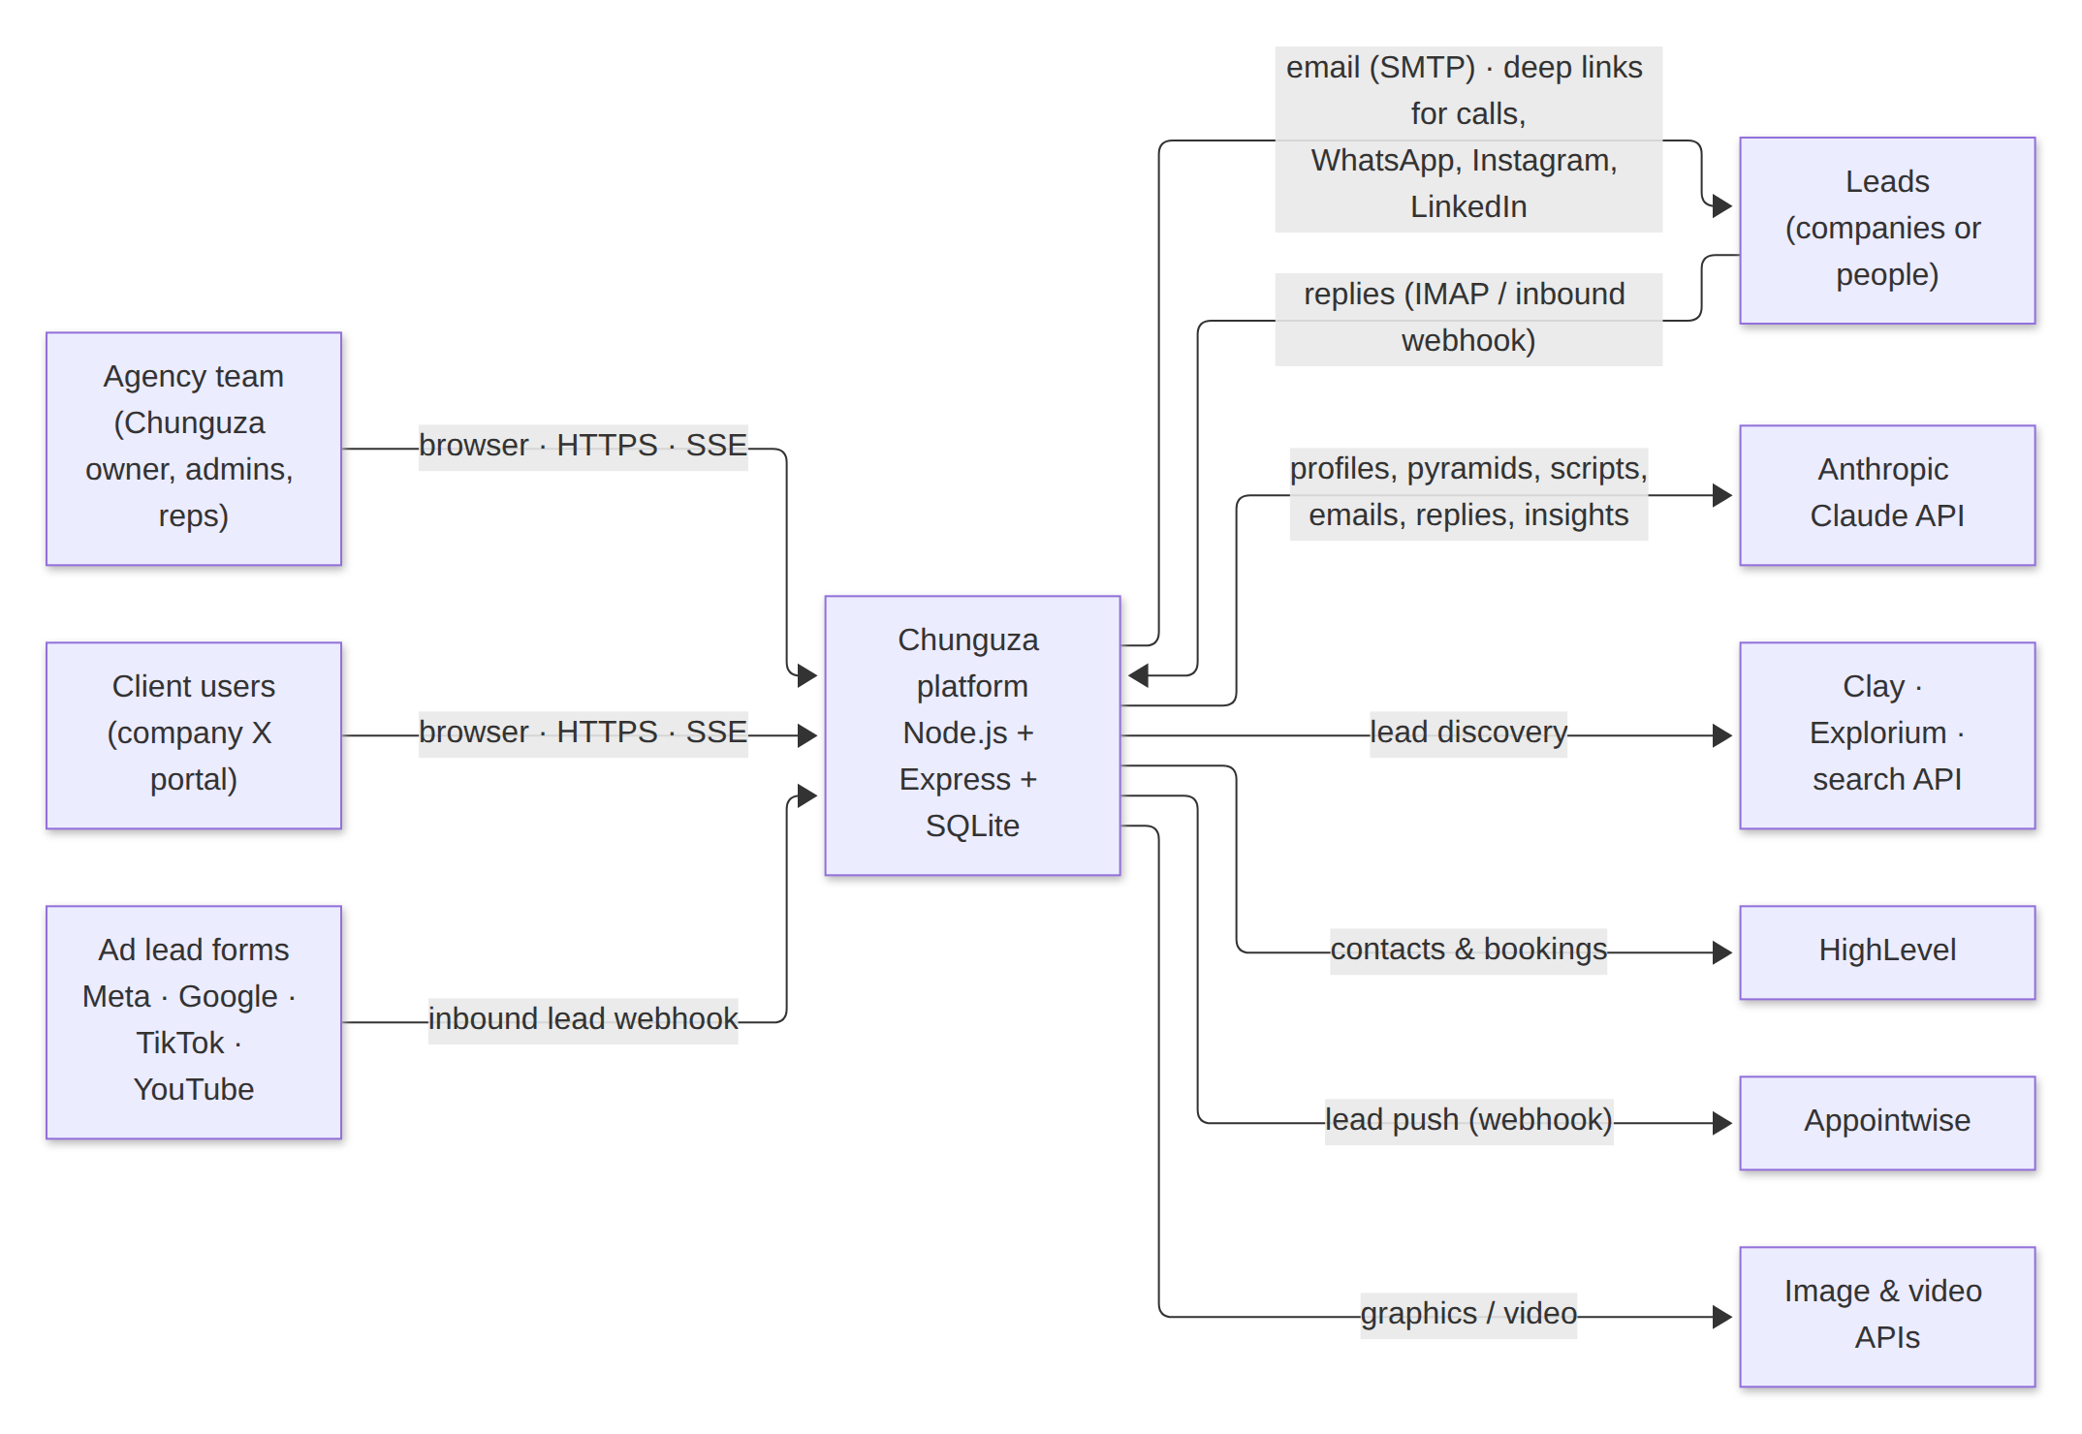
Figure 1. System context: users, Chunguza platform and external services

3.2 Layered module architecture
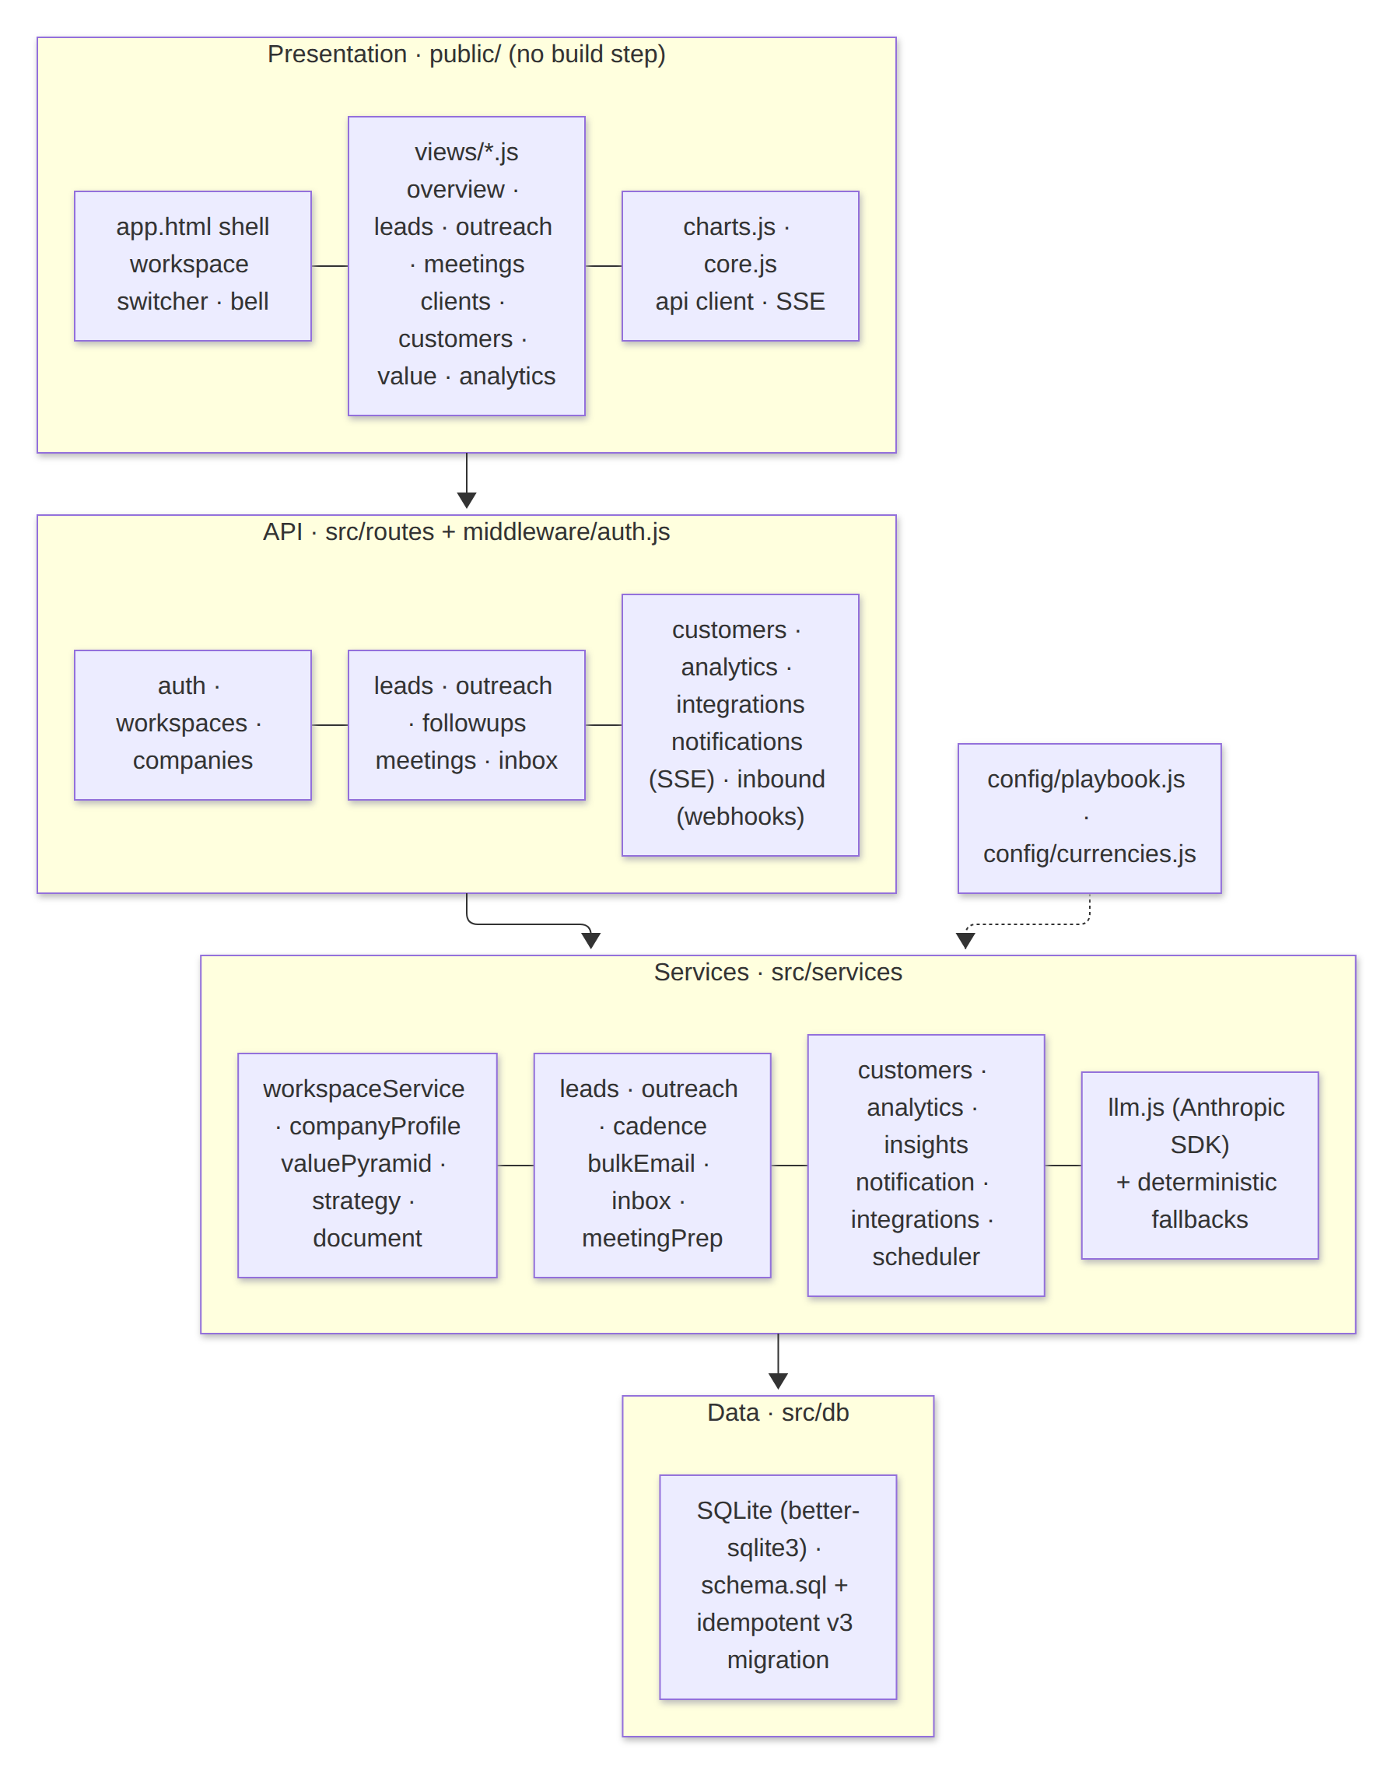
Figure 2. Layers: browser SPA → Express routes → domain services → gateways → SQLite

3.3 Deployment
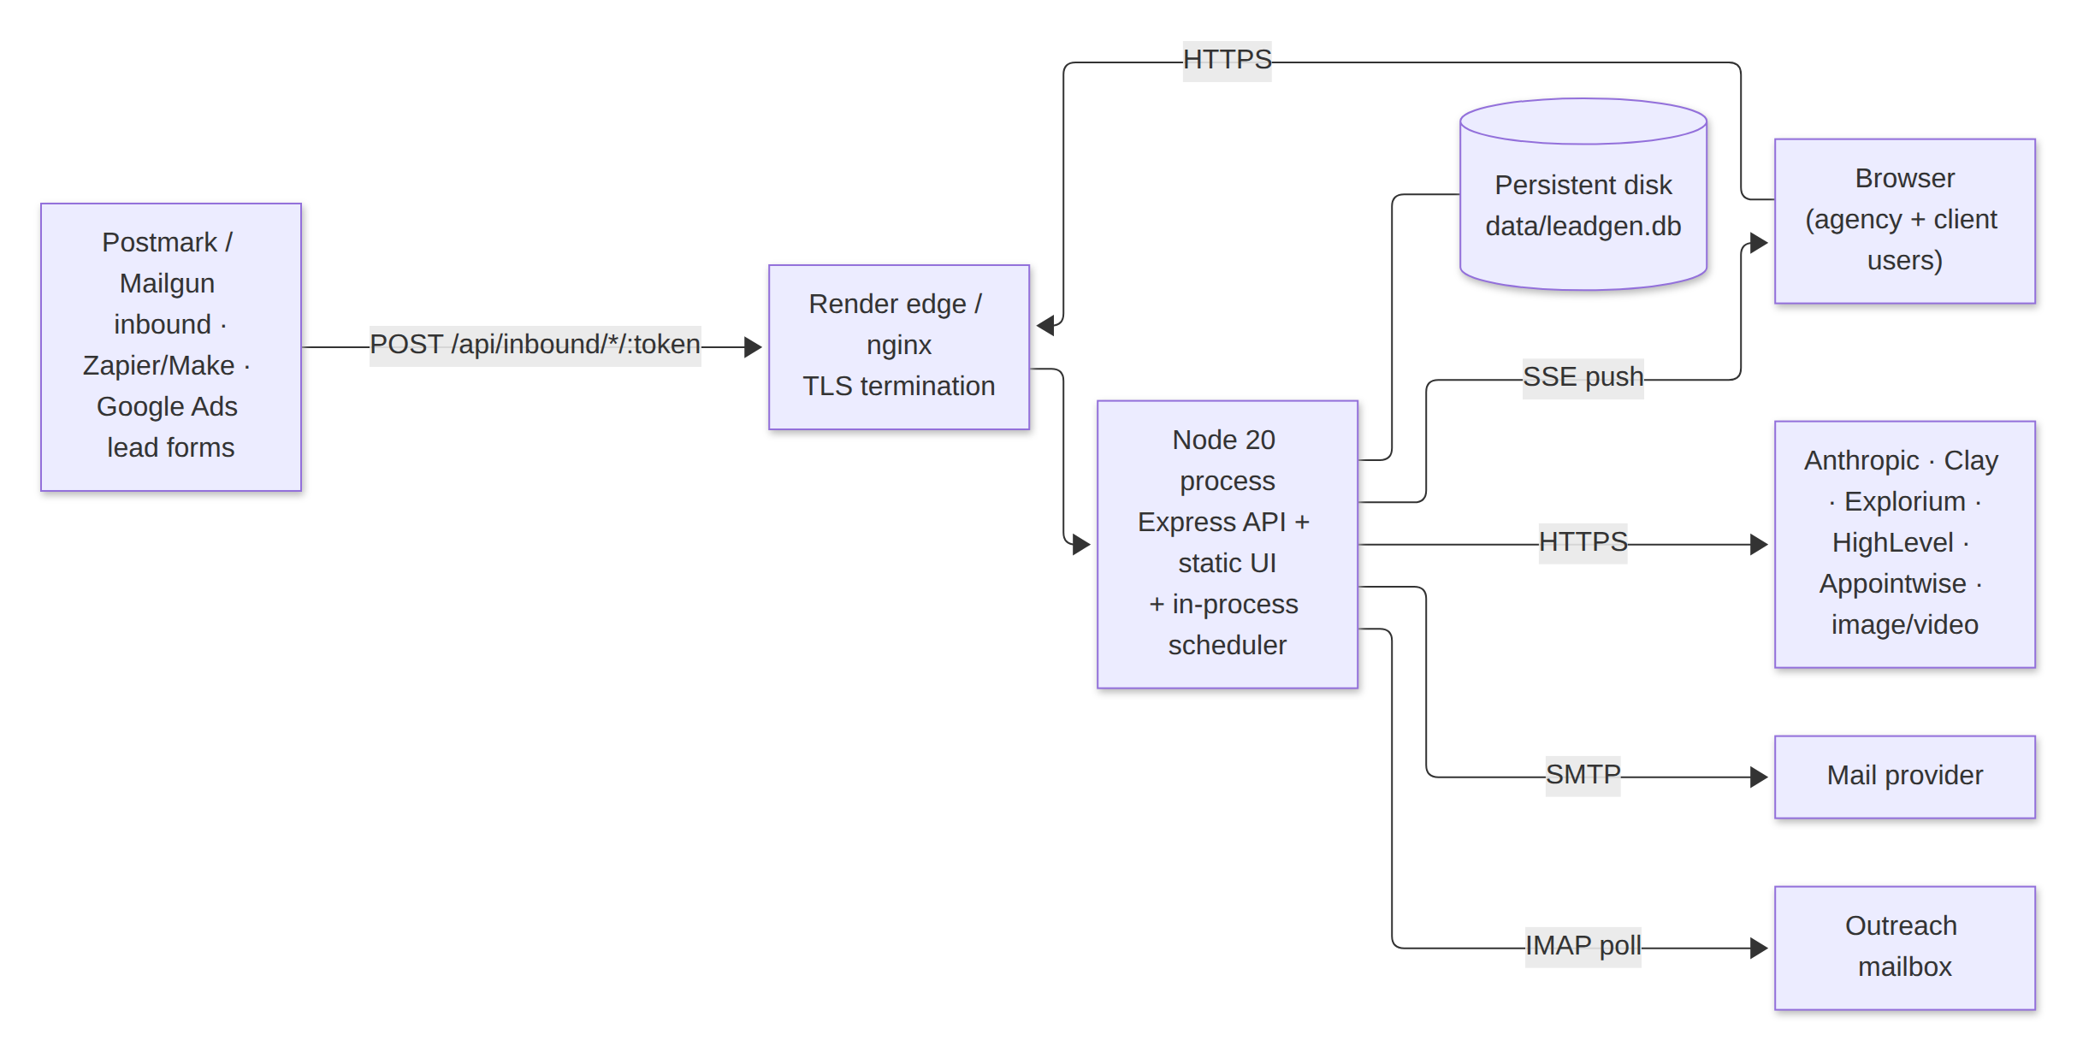
Figure 3. Deployment on Render: one web service, persistent disk, in-process scheduler

3.4 Lead flow (sourcing → outreach → outcome)
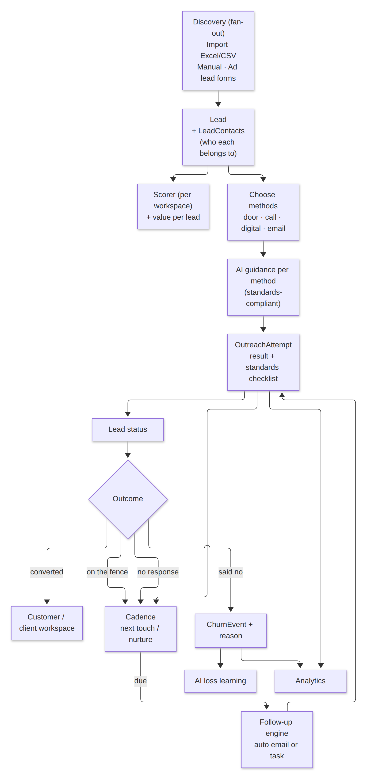
Figure 4. Lead flow through discovery, merge, contacts, outreach, cadence and outcome

3.5 Reply pipeline
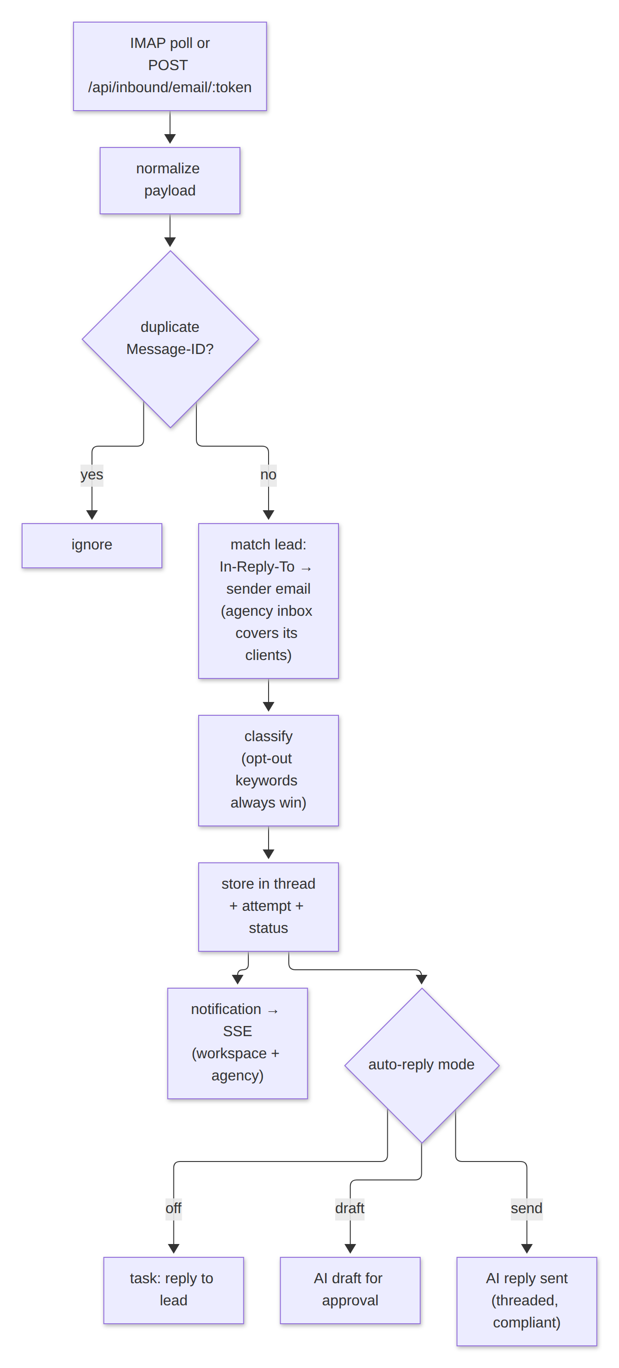
Figure 5. Inbound reply pipeline: receive → match → classify → act → notify

4. Tenancy and data model
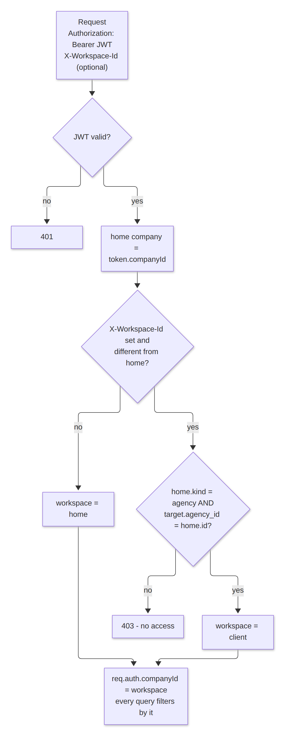
Figure 6. Workspace hierarchy and access rules

4.1 Access rules
- Each request carries a JWT with the user's home company. The optional X-Workspace-Id header selects the working workspace.
- Access is allowed when the workspace is the home company, or when the home company is an agency and the workspace's agency_id equals it. Anything else returns 403.
- req.auth = { userId, companyId (working workspace), homeCompanyId, role, isAgencyUser, workspaceKind }. Every query is filtered by companyId.
- The SSE stream authenticates with a token in the query string (EventSource cannot set headers). This is limited to that single route.

4.2 New tables in v3
Table | Purpose | Key columns
lead_contacts | Every contact means per lead | channel, value, person_name, person_role, is_decision_maker, is_primary, source
outreach_attempts | Each touch (in or out) | method, channel, contact_id, direction, result, spoke_to_decision_maker, standards_json, automated, occurred_at
email_messages | Outbound and inbound email, drafts | direction, status, mode, message_id, in_reply_to, classification, auto_generated
notifications | In-app alerts (bell + SSE) | company_id, agency_id, type, title, body, lead_id, read_at
customers | The client's customers | status, tier, total_value, monthly_value, source, lead_id, lost_at, lost_reason_category
churn_events | Lost customers, count-only losses and churned clients | subject_kind (customer|client), count, reason_category, reason_text, occurred_at
ai_insights | Cached learning and period summaries | kind, period_key, content_json, generated_by
integration_events | HighLevel / Appointwise push log | provider, action, lead_id, status, detail
companies gains kind, agency_id, currency, target_market, client status/since/churn, monthly_retainer, services, ad_platform, value_pyramid_json, funnel_json, business profile text, baseline customer count, settings_json and inbound_token. leads gains lead_type, website, address, preferred methods, follow-up state, loss reason, estimated value and conversion links. meetings gains meeting_type, the CPS brief and notes, outcome and quoted price.

4.3 Upgrade path from v2
- The migration runs on every start (`node src/db/migrate.js && node src/server.js`) in four steps: upgrade guard → schema (CREATE IF NOT EXISTS) → add missing columns → relax leads.company_name → backfills.
- Making company_name nullable needs a table rebuild. It runs once, inside a transaction with foreign keys off, and recreates the indexes.
- Backfills cover the currency from the country, a unique inbound token per workspace, and lead_contacts from the legacy email/phone/linkedin columns.
- Existing v2 companies stay usable as stand-alone workspaces (kind = client with no agency). No data is dropped.

5. Technology stack
Concern | Choice | Why
Runtime | Node 20 LTS, Express 4 | Already in use. better-sqlite3 is pinned to Node 20 and rebuilt from source on install.
Database | SQLite (better-sqlite3), WAL mode, on a Render disk | Zero-ops and fast for a single instance. Postgres is the scale-out path (section 9).
AI | @anthropic-ai/sdk, default model claude-opus-5 | Official SDK, adaptive effort, server-side refusal fallback
Email out | nodemailer (SMTP) | Works with any provider; Ethereal preview in development
Email in | imapflow + mailparser, or a webhook | Polling for any mailbox; webhooks for Postmark/Mailgun
Documents | fflate (docx/xlsx XML), unpdf (PDF text), Claude document input for scanned PDFs | Pure JS with no native dependencies
Realtime | Server-Sent Events | One-way, proxy-friendly, no extra dependency
Auth | JWT (jsonwebtoken), bcryptjs | Stateless and simple
Frontend | Vanilla ES modules, the ds.css design system, SVG charts | No build step. Charts are accessible and checked against the palette validator.

6. Module breakdown

Identity, workspaces and onboarding
Module | Responsibility
middleware/auth.js | JWT verification, workspace resolution and authorisation, role guards
routes/auth.js | Agency or client registration (agency code / invite), login, me with workspaces
workspaceService | Create/list/update clients, invites, health score, churn events, lead → client conversion
companyProfileService, documentService | AI company profile and business-profile extraction (docx/pdf/txt/xlsx/csv)
valuePyramidService, strategyService | Value pyramid in local currency, growth plan per funnel step

Leads and outreach
Module | Responsibility
leadSourceRegistry + providers | Fan-out discovery (Clay, Explorium, web research, mock) and merge by domain/email
leadsService | Lead shape, contacts (dedupe, labels), detail view, status advance, learning events
outreachService | Prepare per method (brief, script, DM + deep link, email), record attempts, set outcomes
callsService, emailGenerationService, meetingPrepService | Playbook-grounded call scripts, bespoke emails and CPS briefs
bulkEmailService, emailService | Template or bespoke compose, merge fields, rate-limited send, unsubscribe
cadenceService, followUpService, scheduler | Next-touch policy, due queue, automatic email follow-ups, tasks for manual methods

Replies, retention and insight
Module | Responsibility
inboxService, imapPoller, routes/inbound | Receive, normalise, match, classify, draft or auto reply, opt-out handling
notificationService | Persist and publish notifications; SSE subscribers per workspace; the agency channel gets client events
customersService | Customer CRUD, import, lost/reactivate, baseline, count-only losses, monthly stats
analyticsService | Workspace and agency metrics, time series, method and standards stats (julianday ranges)
insightsService | Loss learning (AI + rules), daily and monthly summaries (cached)
integrationsService | HighLevel upsert, Appointwise webhook, SSRF guard, event log
assistantService | Tool-using AI agent scoped to the workspace

7. AI integration strategy

7.1 One gateway: src/services/llm.js
- Uses the official Anthropic SDK. The model comes from ANTHROPIC_MODEL (default claude-opus-5). No temperature is sent: the current models reject it. In v2 that meant every call failed silently and fell back to templates.
- Sets output_config.effort per task: low for extraction, classification, emails, scripts and outreach prep; medium for profiles, value pyramids, growth plans, CPS briefs, learning and the assistant.
- Server-side refusal fallback (beta server-side-fallback-2026-07-01, fallbacks: "default") is enabled for claude-opus-5 and claude-fable-5-1. Set ANTHROPIC_FALLBACKS=off to disable it. echoableContent() strips pre-fallback blocks before a tool loop echoes them back.
- completeJson() parses loosely (code fences, leading text). withFallback() merges the output over the deterministic fallback, so missing keys never break the UI.

7.2 Playbook-grounded prompts
playbookPromptBlock() injects the method ranking, meeting standards, the CPS stages, "never pitch before the meeting", the scarcity line and the workspace booking link into every outreach prompt. The fallback templates follow the same rules, so the behaviour is consistent with or without a model.

7.3 Per-task usage
Task | Input | Output | Effort
Company profile | Description + business-profile text | ICP, geo, scoring, outreach tone | medium
Value pyramid | Industry, currency, services | Tiers with price and take rate | medium
Growth plan | Profile, pyramid, ad platform | Funnel actions, ad plan, AI systems | medium
Outreach prep / email | Lead, contacts, history, playbook | Brief, script, DM, email | low
CPS brief | Lead, client offer, pyramid | Attention/Identify/Solve/Cost + objections | medium
Reply classify + draft | Inbound email + thread | Intent, draft answer | low
Loss learning, summaries | Loss reasons, method stats, metrics | Suggestions, playbook fixes | medium / low
Assistant | Chat + tools | Actions via tools (max 8 rounds) | medium

7.4 Learning loop
Outcomes and loss reasons update the v2 online scoring weights (learnFromEvent). insightsService groups losses by reason and method, applies rule-based fixes (for example "price" leads to "anchor with the free tier first"), and asks the model for richer suggestions when a key is present.

8. Security and compliance
Concern | Control
Authentication | JWT with JWT_SECRET (generated on Render); bcrypt password hashes
Authorisation | Workspace check on every request; owner/admin for settings, invites and client changes; agency sign-up can be closed (ALLOW_AGENCY_SIGNUP=false)
Inbound webhooks | Per-workspace random token, timing-safe compare, payload size limit (18 MB JSON)
Outbound webhooks | isPublicHttpsUrl: HTTPS only, blocks private, loopback and link-local hosts (SSRF)
Email | HTML-escaped bodies, validated From address, unsubscribe link and List-Unsubscribe header, suppression list, warm-up and caps
Messaging platforms | No automated DMs. The message is prepared and a deep link opens the platform, per platform terms.
Data protection | Kenya DPA 2019: register with the ODPC, record a lawful basis (legitimate interest for B2B, consent for B2C marketing), honour access and deletion requests, keep data in the workspace only
Secrets | Environment variables only; .env is git-ignored; nothing secret goes to the browser

9. Scalability and evolution
Pressure | Now | Next step
Write concurrency | SQLite WAL, one instance | Postgres (same SQL shape); move scheduler jobs to a worker
Realtime fan-out | In-memory pub/sub | Redis pub/sub when running more than one instance
Inbound email | IMAP polling every 2 min | Provider webhooks (already supported) for instant delivery
AI cost | Effort per task, cached summaries | Prompt caching of the playbook block; Batch API for nightly summaries
Follow-up volume | Tick every 30 min, rate-limited send | Queue with per-domain throttles

10. Deployment and operations
Render Blueprint (render.yaml). One web service on Node 20 with a persistent disk at /opt/render/project/src/data. The build runs `npm ci` (with a postinstall rebuild of better-sqlite3). Start runs the migration, then the server. Health check: /api/health. It auto-deploys on every push to main.

Environment variables added in v3
Variable | Purpose | Default
ANTHROPIC_MODEL / ANTHROPIC_FALLBACKS | Model id; set "off" to disable the refusal fallback | claude-opus-5 / on
IMAP_HOST, IMAP_PORT, IMAP_SECURE, IMAP_USER, IMAP_PASS, IMAP_MAILBOX | Reply mailbox to poll | unset (off), 993, true, INBOX
IMAP_WORKSPACE_ID, IMAP_POLL_MINUTES | Which workspace owns the mailbox (an agency inbox also matches its clients' leads); poll interval | first agency workspace; 2
FOLLOWUP_ENGINE_ENABLED, FOLLOWUP_ENGINE_INTERVAL_MINUTES | Automatic cadence runner | true, 30
HIGHLEVEL_API_KEY, HIGHLEVEL_LOCATION_ID, HIGHLEVEL_API_BASE | HighLevel contact upsert | unset; services.leadconnectorhq.com
APPOINTWISE_WEBHOOK_URL | Appointwise hand-off (a per-workspace setting overrides it) | unset
ALLOW_AGENCY_SIGNUP | Set false to block further agency sign-ups once one agency exists | allowed

11. API surface (v3)
All routes are under /api and require a Bearer token unless marked public. The X-Workspace-Id header selects the workspace.
Router | Endpoints
auth | POST /register, POST /login, GET /me, GET /agency/:code (public)
workspaces | GET /, GET /current, GET|POST /clients, PATCH /clients/:id, GET /clients/:id/health, POST /clients/:id/invite
companies | GET|PUT /me, POST /me/regenerate, POST /me/regenerate-profile, POST /me/business-profile, GET|PUT /me/value-pyramid, GET|PUT /me/settings, GET|PUT /me/directions
leads | POST /discover, GET /, GET /sources, POST /, POST /import, GET /:id, POST /:id/contacts, DELETE /:id/contacts/:contactId, POST /:id/outcome, POST /:id/convert-to-client, POST /:id/follow-up, POST /:id/feedback, PATCH /:id
outreach | POST /prepare, POST|GET /attempts, POST /email/compose, POST /email/send, POST /meeting-brief
followups | GET /due, POST /run
inbox | GET /, POST /:emailId/send, DELETE /:emailId, POST /simulate-reply, POST /poll
inbound (public, token) | POST /email/:token, POST /lead/:token
notifications | GET /stream (SSE), GET /, POST /read
customers | GET /, GET /stats, POST /, POST /import, PUT /baseline, POST /lost-count, POST /:id/lost, POST /:id/reactivate
analytics | GET /overview, GET /timeseries, GET /summary, GET /agency, GET|POST /learning
integrations, playbook | GET /, POST /:provider/push · GET /
meetings | GET /, POST /, GET /:id/ics, POST /:id/brief, PATCH /:id
v2 (kept) | campaigns, calls, tasks, assistant, content

