CHUNGUZA
Product Requirements Document
AI lead-generation agency platform: find clients, sign clients, get results
Version 3.0 · Date 25 September 2026
Status Implemented (release 3.0) with open items listed in section 12
Companion documents Architecture Plan v3 · OOAD Specification v3

Contents

(In Word: right-click the table above → Update Field to refresh page numbers.)

1. Summary
Chunguza is an AI lead-generation agency. A business (Company X) hires Chunguza to grow its sales. Chunguza finds leads for X (other companies, or people such as dental patients), contacts them through the channels that actually work, books meetings with decision makers, and keeps X's customers from leaving.
This platform is the operating system for that agency. It runs two kinds of workspace on one deployment:
- The agency workspace (Chunguza itself) for finding and signing its own clients, and for watching every client's health and churn.
- A client workspace for each company Chunguza serves. It holds the client's leads, outreach, meetings, customers, value pyramid and analytics.
Design rule: every lead is a person or a business with all of its contact means attached. Each contact is labelled with who it belongs to. Every touch is recorded against a ranked outreach method and follows the meeting standards, so results can be measured and learned from.

2. Background and business model

2.1 Services sold
Service | What the client gets | Where it lives in the platform
Paid advertising | One ad platform run around the client's offer (Meta, Google Ads, YouTube or TikTok) | Growth plan → ad plan; inbound lead webhook (Google Ads lead forms)
Appointment setting | Leads contacted and booked into meetings or appointments | Lead drawer, outreach, follow-up cadence, meetings, HighLevel/Appointwise hand-off
AI automation | Bespoke AI systems that raise sales and streamline the business | Growth plan → AI systems; reply bot; AI assistant

2.2 The three agency stages
Stage | Goal | How
1. Find clients | Fill the agency pipeline | Scattergun on high-demand niches (dentists first), Google sweeps, scraping and data providers
2. Sign clients | Get a yes | Meetings with the decision maker using the CPS structure (Attention → Identify → Solve → Cost)
3. Get results | Deliver and retain | Strategy build per client: the four-step AI funnel, value pyramid, health monitoring

2.3 The AI funnel run for every client
- Create interest: ads on one platform, scraping tools, Google sweeps, social media and LinkedIn.
- Generate leads: a targeted offer (the free-value tier), or leads pulled directly by the platform.
- Book appointments: cadenced follow-ups, AI replies, calls, plus HighLevel and Appointwise.
- Implement AI systems: bespoke systems per industry once the client is getting results.

3. Goals and success metrics
Goal | Metric | Target (initial, per client)
Consistent lead flow | New leads per month | ≥ 50 (setting: monthlyLeadTarget)
Meetings booked | Meetings per month | ≥ 10 (setting: monthlyMeetingTarget)
Outreach quality | Meeting-standards adherence (share of attempts that meet all 5 standards) | ≥ 80%
Responsiveness | Reply notification latency | < 5 s with the SSE stream open; ≤ 2 min via IMAP polling
Retention (client's customers) | Monthly customer churn | Trending down month on month
Retention (agency's clients) | Client health score / monthly client churn | Every client "healthy" (≥ 70) by day 60
Learning loop | Loss reasons captured | 100% of lost leads/customers have a reason category

4. Users and roles
Persona | Workspace | Role | Can do
Agency owner / manager | Agency | owner / admin | Everything: clients, invites, all client workspaces, agency analytics, settings
Agency rep / appointment setter | Agency | member | Work leads and outreach in agency and client workspaces; cannot change settings
Client owner (Company X) | Client (own only) | owner | See own leads, meetings, customers and analytics; upload profile and customers; edit value pyramid
Client staff | Client (own only) | member | Work leads and record outcomes
Lead / customer | None | None | Receives outreach; can reply or unsubscribe via a signed link
Agency users can open their own clients only. Client users are locked to their own workspace. Both rules are enforced server-side on every request (see the Architecture Plan, section 4).

5. Operating model
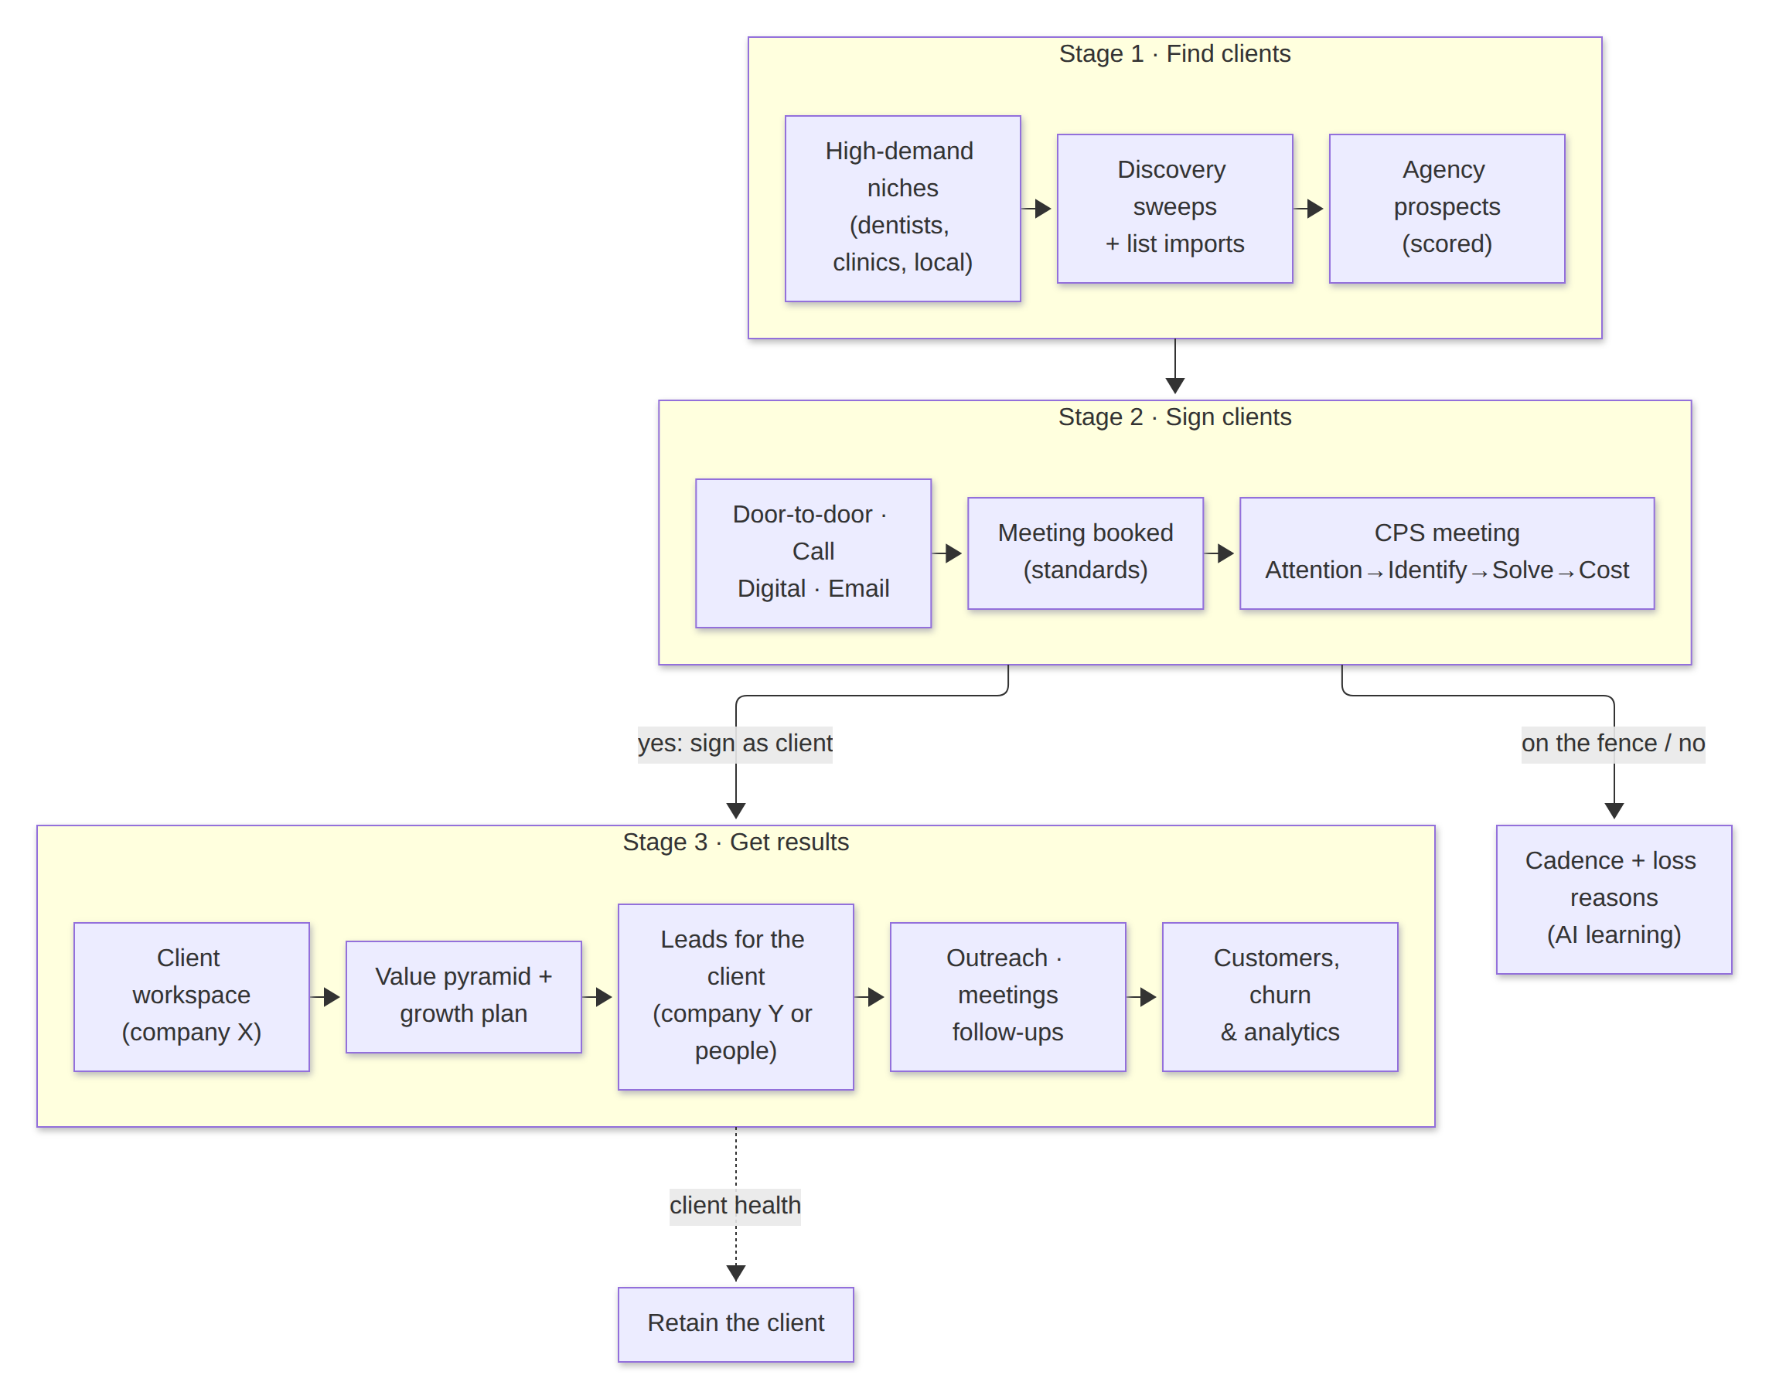
Figure 1. Operating model: agency stages, the client funnel and the ranked outreach methods

5.1 Outreach methods (ranked)
Rank | Method | Use | Automated?
1 (best) | Door to door | Local businesses; a walk-in brief with hook, scarcity line and meeting ask | No: brief + result log
2 | Cold calling | Decision-maker call script with gatekeeper handling | No: script + result log
3 | Multi-platform digital | WhatsApp, Instagram, Facebook, LinkedIn, TikTok, X with a short, personal DM | Deep links only (platform terms)
4 | Emails & DMs (auto) | Bespoke AI or bulk email, with an unsubscribe link | Yes: rate-limited

5.2 Meeting standards (applied to every script, brief and email)
- Always the decision maker. Do not pitch the gatekeeper.
- Straight to the point with a hook specific to the business.
- Scarcity and exclusivity ("one business like yours per area"), and make them feel cared about.
- Never pitch before the meeting. The only goal is the meeting.
- It is fine to get a no before a yes. Log the reason and keep the door open.

5.3 CPS meeting structure
Step | Purpose | Platform output
Attention | Earn the first minute | Opening hook drawn from the lead's business and niche
Identify | Find the real problem | Diagnostic questions plus a "listen for" list
Solve | Show the path | Solution tied to the client's services and value pyramid
Cost | Anchor and ask | Cost of inaction versus the price anchor from the core-offer tier; objection answers

6. Functional requirements
Priority: M = must, S = should, C = could. Status reflects release 3.0.

6.1 Tenancy, onboarding and strategy
ID | Requirement | Priority | Status
FR-1 | Workspaces. One agency workspace plus one client workspace per client, switchable from the top bar. Client users see only their own workspace. | M | Done
FR-2 | Onboarding. Register as the agency or as a client (agency code or invite link). Capture B2B/B2C, target market, services, one ad platform, country (sets the currency) and current customer count. | M | Done
FR-3 | Business profile upload. Word (.docx), PDF (including scanned) or text. AI turns it into an ICP, geo scope, scoring and outreach profile. | M | Done
FR-4 | Value pyramid. Tiers from free value to lifetime value in the local currency, with a take rate per tier. Computes value per customer and value per lead. Editable. The AI draft is based on industry templates. | M | Done
FR-5 | Growth plan. Four-step funnel actions, an ad plan for the single chosen platform, the lead magnet (free tier) and bespoke AI systems for the industry. | S | Done

6.2 Leads and outreach
ID | Requirement | Priority | Status
FR-6 | Lead sourcing. Discovery by niche and geography (high-demand niches suggested), plus CSV/Excel import, manual add and inbound webhooks (Google Ads lead forms, generic JSON). Deduplicated by domain or email. | M | Done
FR-7 | Lead record. Each lead is clickable and opens a drawer. It holds all contact means (phone, email, WhatsApp, socials, LinkedIn, website, address), each labelled with who it belongs to (owner, reception, main line). | M | Done
FR-8 | Multi-method outreach. Pick one or more methods. The platform prepares each (door-to-door brief, call script, DM with deep link, email), then records the result per attempt. | M | Done
FR-9 | Meeting standards. Every recorded attempt ticks the 5 standards, and adherence is reported. Prompts and templates enforce them. | M | Done
FR-10 | CPS meetings. Booking a meeting generates a CPS brief. The meeting outcome, CPS notes and quoted price are recorded. Includes an .ics download. | M | Done
FR-11 | Outcomes. Converted / on the fence / said no (with a reason) / not responded. A converted agency lead can be signed as a client in one click. | M | Done
FR-12 | Email. Bulk (one email, lightly customised with merge fields) or bespoke AI email per lead. Unsubscribe link and header, suppression list, warm-up and rate limits. | M | Done
FR-13 | Follow-up cadence. Non-responders are followed up on days 2, 4, 7, 14 and 21 (max 6 attempts, ≥ 48 h apart, ≤ 4 touches in 30 days), then nurtured every 60 days. Each touch rotates to the strongest method not used last. Can be paused per lead. | M | Done

6.3 Replies, customers, retention and analytics
ID | Requirement | Priority | Status
FR-14 | Real-time replies. Inbound email arrives via IMAP polling or a webhook (Postmark, Mailgun, JSON). The reply is matched to its lead and classified, and the team is notified live (bell and toast over SSE). | M | Done
FR-15 | Reply bot. For generic questions the AI drafts an answer that follows "never pitch, book the meeting". Mode is draft (default) or auto-send. Opt-out keywords always unsubscribe. | M | Done
FR-16 | Customers. Enter the count, import Excel/CSV or add one at a time. Register lost customers or lost counts with a reason. Converted leads become customers. | M | Done
FR-17 | Client monitoring. Health score per client (leads, meetings, activity, engagement), bands, a daily sweep with alerts, client churn events with reason, and MRR. | M | Done
FR-18 | Analytics. Lead, sales, method and standards analytics. Customer churn, client churn, time series, and daily and monthly summaries. | M | Done
FR-19 | AI learning. From loss reasons and method results, the AI suggests better methods and playbook fixes. Falls back to rules when there is no AI. | S | Done
FR-20 | Integrations. Push a lead to HighLevel (contact upsert) or Appointwise (webhook). Event log per push. | S | Done (API specifics to confirm)
FR-21 | AI assistant. A chat agent with tools: find leads, log attempts, set outcomes, list due follow-ups, read analytics. | S | Done
FR-22 | Content studio. Sales pitch, ad copy, social plan, graphics and video ad (carried over from v2). | C | Done

7. Key user journeys

J1. Agency finds and signs a client
- Search the "dentists" niche in Nairobi, then open a lead: 10 labelled contacts are shown.
- Select door to door and cold call, then Prepare: the brief and the call script follow the standards.
- Record "gatekeeper". The next follow-up is scheduled automatically (day 2, rotated to the next method).
- Book a meeting: a CPS brief is generated. Record the outcome as converted, then Sign as client.

J2. Client workspace goes live
- The client uploads their business profile (.docx or PDF). The AI profile and value pyramid are drafted in KES.
- Leads are discovered or imported. The bulk email is composed and sent within the warm-up cap.
- A lead replies. The bell and toast fire, and the AI drafts a reply. A rep sends it and books the meeting.

J3. Retention
- The client imports its customer list and marks lost customers with reasons.
- Analytics shows customer churn by month. AI learning suggests fixes, and the agency sees the client's health band.

8. Non-functional requirements
Area | Requirement
Security and tenancy | JWT auth. Workspace access is checked server-side on every request. Role checks cover settings and invites. Inbound webhooks use per-workspace tokens compared in constant time. The SSRF guard allows only public HTTPS URLs for outgoing webhooks.
Privacy and compliance | Kenya Data Protection Act 2019 (ODPC registration, lawful basis, data-subject rights), CAN-SPAM/GDPR-style unsubscribe and suppression, and HTML-escaped email bodies. No automated DMs: social platforms forbid bulk automation, so the platform prepares the message and opens a deep link only.
Deliverability | Per-workspace warm-up (20/day rising to the cap over 21 days), hourly and daily caps, and bounce/spam statuses stop the cadence.
Reliability | Every AI feature has a deterministic fallback, so the product works with no key or in MOCK_MODE. Model output is merged over the fallback shape so partial JSON never breaks a page. Server-side refusal fallback is on for supported models.
Localisation | Currency comes from the country (KES, NGN, ZAR, UGX, TZS, GBP, EUR, USD, …). Prices are rounded to "nice" local amounts.
Performance | Target: analytics responses under 500 ms for 10k leads per workspace (indexed SQLite). One SSE connection per tab with a 25 s keep-alive.
Accessibility | Status is never shown by colour alone (icon + label). Every chart has a table view. Keyboard access to chart points. Palette validated for colour-vision deficiency on the dark surface.
Mobile | All views have zero horizontal overflow at 390 px width. The top bar and grids reflow.

9. Metric definitions
Metric | Definition
Response rate | Leads with a reply ÷ leads contacted, in the period
Meeting rate | Meetings booked ÷ leads contacted
Win rate | Converted ÷ (converted + said no)
Customer churn (monthly) | Customers lost in the month ÷ customers active at the start of the month. Active = listed active + (baseline count − count-only losses).
Client churn (agency) | Clients churned in the month ÷ active clients at the start of the month. MRR = Σ monthly retainers of active clients.
Value per customer | Σ (tier price × take rate) across the pyramid tiers
Value per lead | Value per customer × lead-to-customer rate
Pipeline value | Σ estimated value of open leads (defaults to value per lead)
Health score (0–100) | Last 30 days: 30% new leads ÷ lead target + 35% meetings ÷ meeting target + 20% activity (last touch ≤ 3 days = full, ≤ 7 = 0.6, ≤ 14 = 0.3) + 15% engagement (reply rate × 5, capped), +5 if any conversion. Healthy ≥ 70, watch 40–69, below that "ramping up" for the first 14 days after signing, otherwise "at risk".
Standards adherence | Attempts that meet all five standards ÷ attempts with standards recorded

10. AI behaviour and guardrails
- One gateway (the official Anthropic SDK). The default model is claude-opus-5, set by the ANTHROPIC_MODEL environment variable. Effort is set per task: low for extraction, higher for plans and briefs.
- Every prompt embeds the playbook: method ranking, meeting standards, the CPS structure, never pitch before the meeting, scarcity phrasing and the booking link.
- Outputs are structured JSON, merged over a deterministic fallback. The AI never sends an outbound message without either a human action or an explicit auto-send setting.
- Opt-out and unsubscribe keywords override the AI classification.
- The AI assistant can only call registered tools scoped to the current workspace, with at most 8 tool rounds per request.

11. Release scope and roadmap
Release | Scope
3.0 (this release) | FR-1 to FR-22, agency and client workspaces, v2→v3 automatic data migration
3.1 | Sales-funnel workflow template (pending from the founder), per-rep assignment and leaderboards, WhatsApp Business API (template messages, opt-in only)
3.2 | Two-way HighLevel sync (pipelines and calendar), Appointwise booking callbacks, Postgres option for multi-instance hosting

12. Open questions
# | Question | Owner
Q1 | The sales-funnel workflow "from dad": the stage names and exit criteria to load as the default pipeline template | Founder
Q2 | Appointwise: confirm the webhook payload and whether a booking callback is available | Ops
Q3 | HighLevel: private integration token vs. OAuth app, and the location per client | Ops
Q4 | Pricing of Chunguza retainers per service (feeds MRR and the client value pyramid) | Founder
Q5 | Which markets beyond Kenya launch first (currency and compliance text) | Founder

13. Acceptance and verification
- 75 automated API checks pass covering tenancy, discovery, contacts, outreach, cadence, email, inbox, notifications, customers, churn, analytics, integrations and the legacy v2 endpoints.
- A browser journey (J1–J3) passes end to end, including document upload, bulk email under the warm-up cap, a simulated reply with a live notification, and the customer import.
- The mobile check at 390 px shows zero horizontal overflow on every view.
- The v2 database upgrades in place and is idempotent (checked on both v2 and fresh databases).

14. Glossary
Term | Meaning
Agency workspace | Chunguza's own workspace: its leads are prospective clients
Client workspace | A workspace per company that hired Chunguza: its leads are that company's prospects
CPS | Meeting structure: Attention → Identify → Solve → Cost
Cadence | The follow-up schedule for leads that have not responded
Value pyramid | The client's offers from free value to lifetime value, with prices and take rates
Health score | A 0–100 indicator of whether a client is getting results
SSE | Server-Sent Events: the live notification stream to the browser

