CHUNGUZA GROWTH PLATFORM
OOAD Specification
Object-oriented analysis and design for the agency platform
Version 3.0 (refines v2.0 of 17 Sep 2026) · Date 25 September 2026
Companion documents Product Requirements Document · Architecture Plan v3

Contents

(In Word: right-click the table above → Update Field to refresh page numbers.)

1. Introduction and approach
This specification models the domain objects and behaviour of release 3.0. The code is written in plain JavaScript with services and SQLite tables rather than ORM classes, so each class below maps to a table (its state) plus a service module (its behaviour). Section 8 gives that mapping for every requirement.
Diagram | Purpose | Section
Class | Tenancy and strategy; leads and outreach; retention, insight and integrations | 2
Object | A concrete agency with one dental client, one lead and its touches | 3
State machine | The lead lifecycle driven by attempt results and outcomes | 4
Sequence | Registration, outreach, bulk email, replies, meetings, cadence, assistant | 5
Activity | Cadence decision, client health sweep, value pyramid computation | 6
Changes from v2: Company became hierarchical (agency → clients). Lead gained LeadContact, OutreachAttempt and EmailMessage. New classes: Cadence, Playbook, Customer, ChurnEvent, ValuePyramid, GrowthPlan, Notification, AIInsight and the IntegrationAdapter family. All model calls go through one LLM gateway.

2. Class diagrams

2.1 Tenancy and strategy
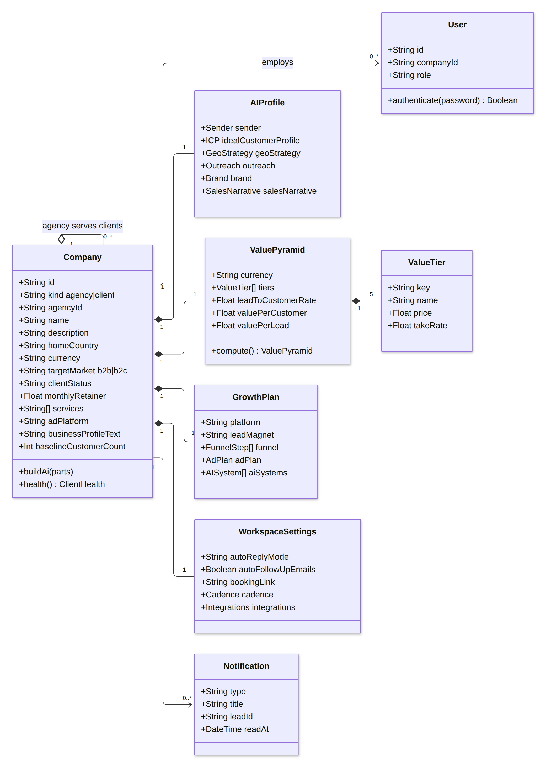
Figure 1. Company hierarchy, users and per-workspace strategy objects

2.2 Leads and outreach
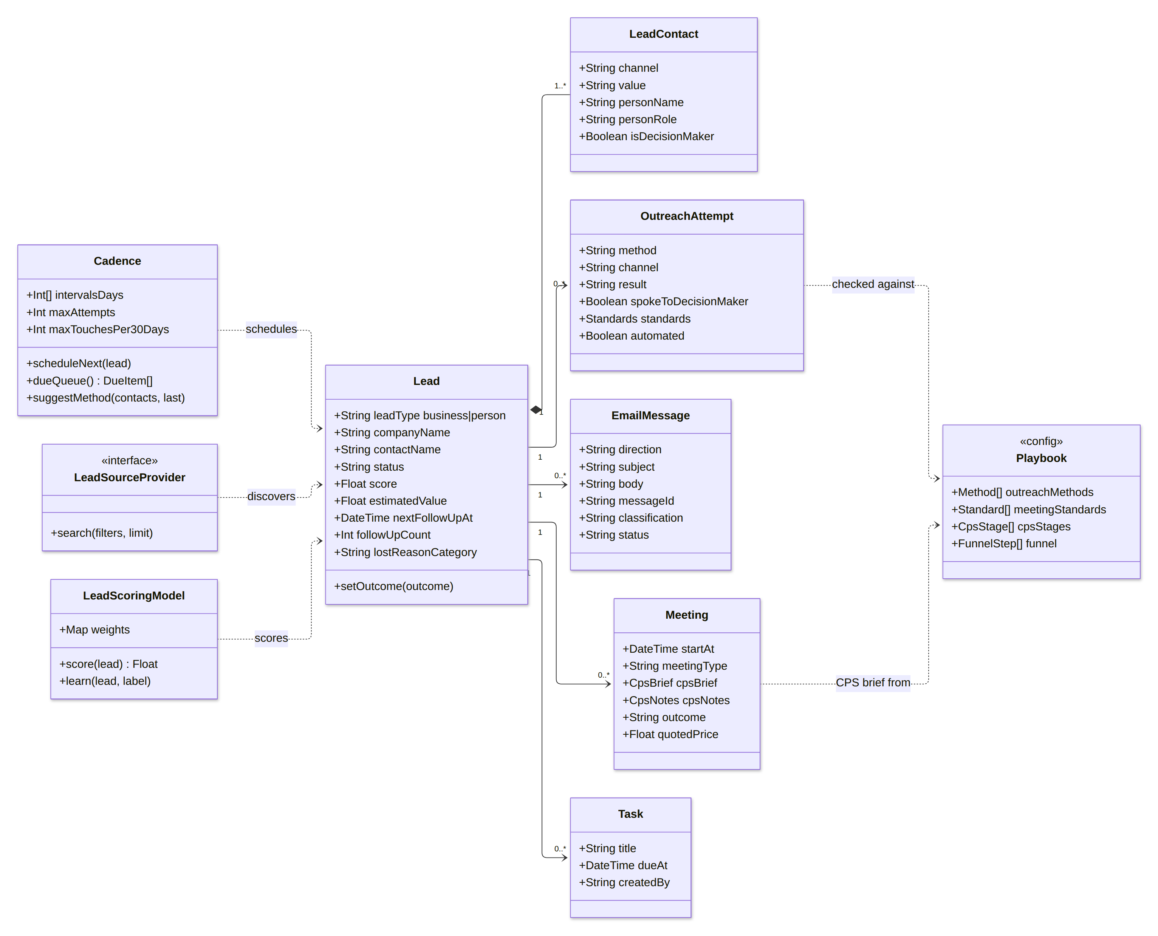
Figure 2. Lead aggregate, outreach, meetings, cadence and playbook

2.3 Retention, insight and integrations
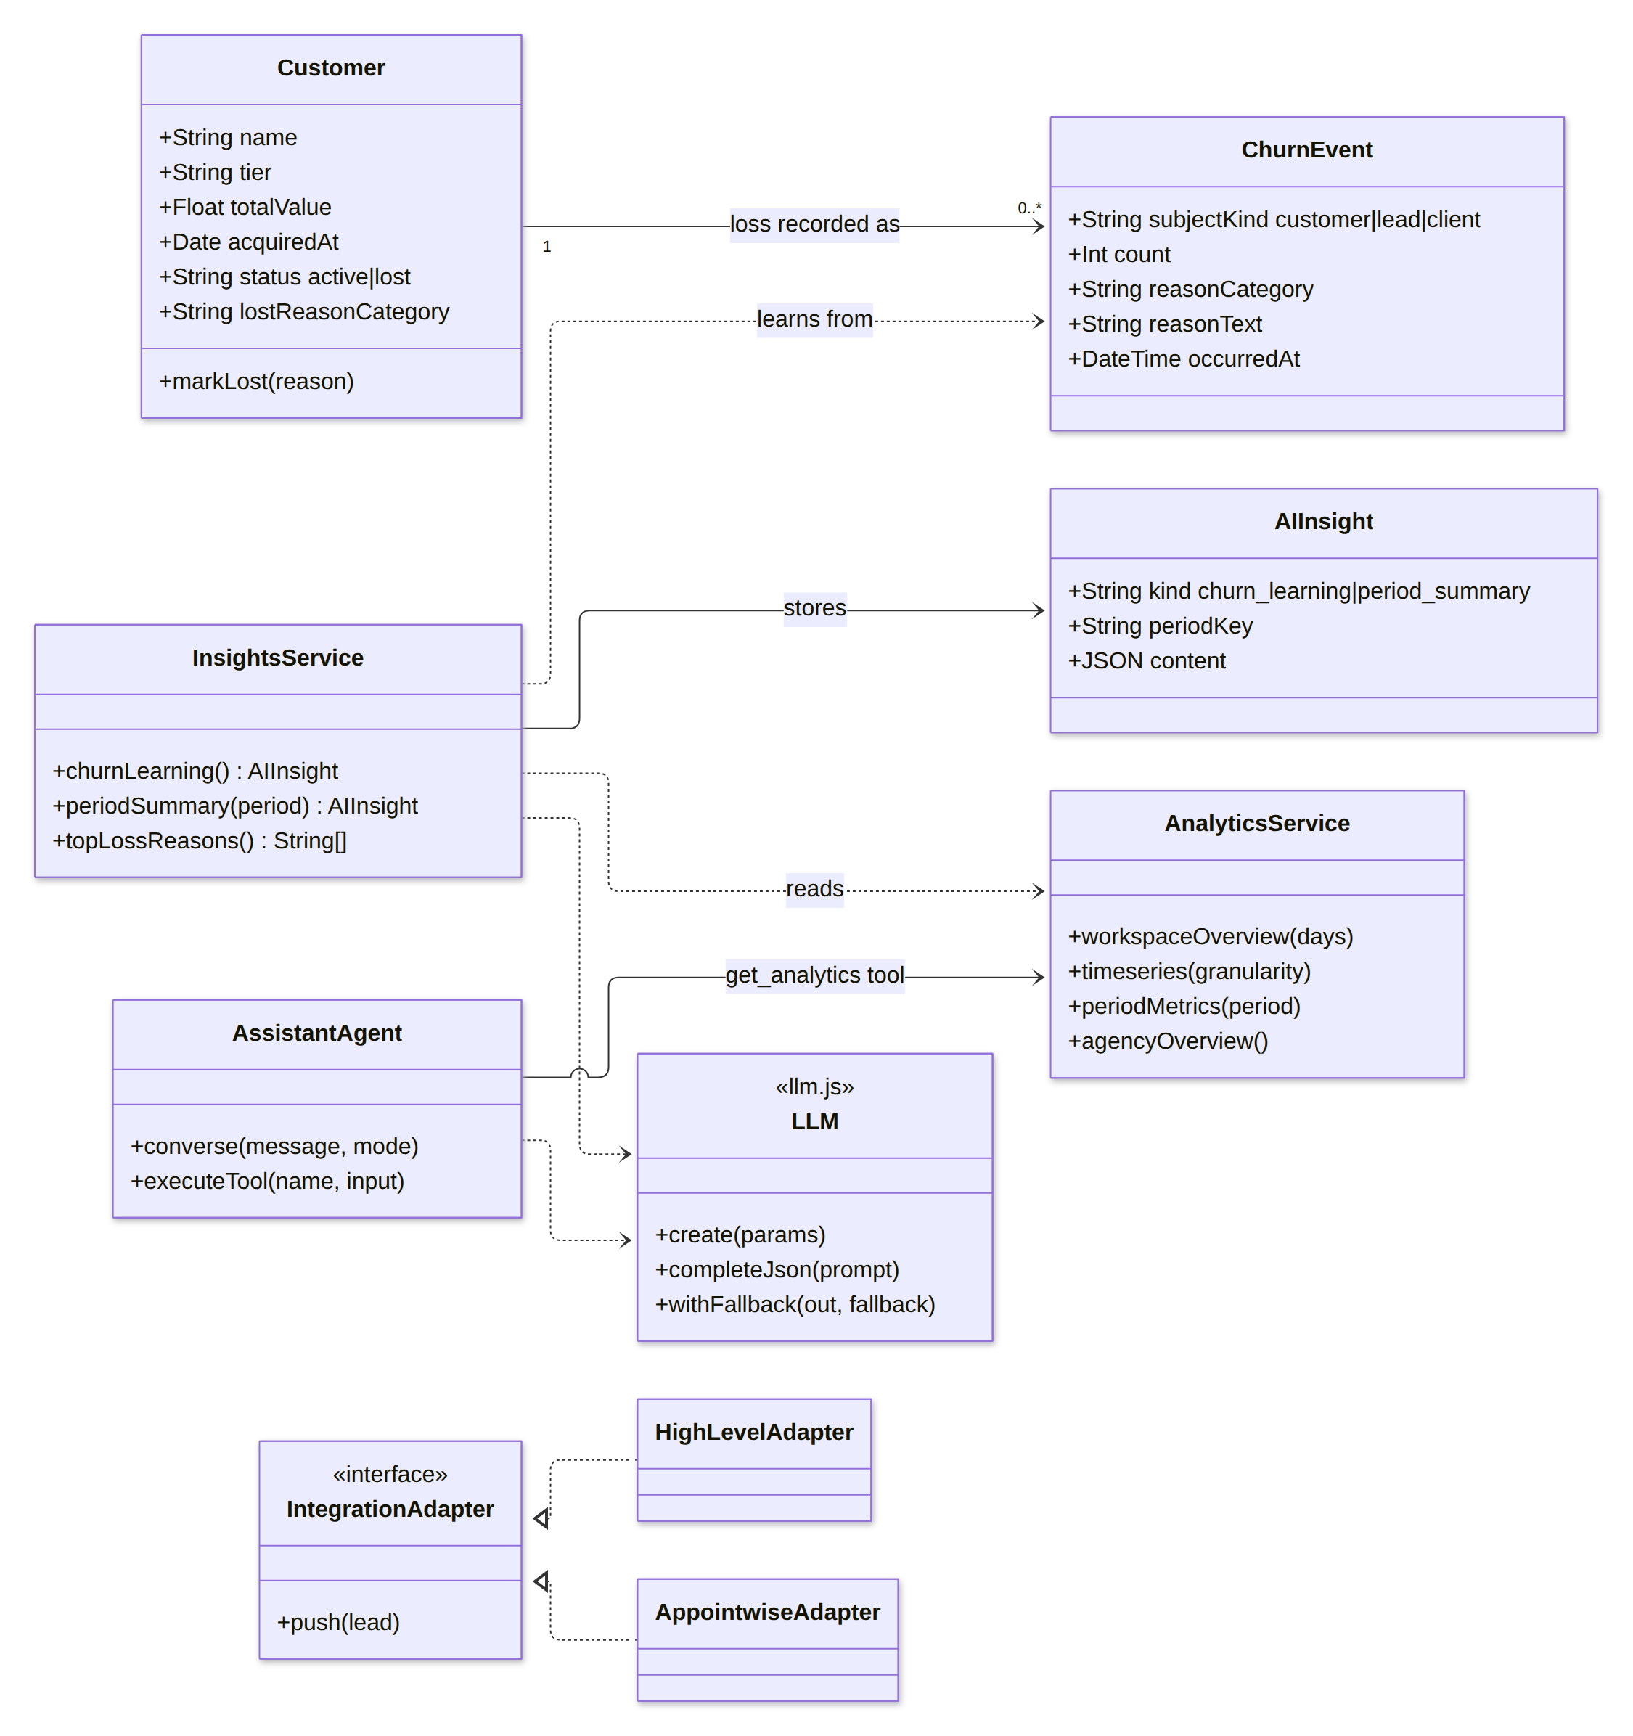
Figure 3. Customers, churn, analytics, AI insight, assistant and integration adapters

2.4 Class descriptions
Class | Responsibility | Persistence / module
Company | A workspace. kind = agency or client; a client refers to its agency. Holds currency, services, ad platform and client status. | companies · workspaceService
User | A person who logs in to one home company, with a role (owner, admin, member) | users · routes/auth
AIProfile | ICP, geo scope, scoring and outreach tone derived from the description and business profile | companies.ai_* · companyProfileService
ValuePyramid / ValueTier | Offers from free to lifetime value with price and take rate; computes value per customer and per lead | value_pyramid_json · valuePyramidService
GrowthPlan | Actions per funnel step, ad plan, lead magnet, AI systems | funnel_json · strategyService
WorkspaceSettings | Reply mode, auto follow-ups, booking link, targets, cadence, integration settings | settings_json · directionsService
Lead | A business or person being pursued. Holds its status, follow-up state, outcome and loss reason. | leads · leadsService
LeadContact | One contact means (phone, email, WhatsApp, social, …) and the person it belongs to | lead_contacts · leadsService
OutreachAttempt | One touch: method, channel, result, the standards met, notes | outreach_attempts · outreachService
EmailMessage | Outbound, inbound or draft email with threading and classification | email_messages · bulkEmailService, inboxService
Meeting | A booked meeting with its CPS brief, notes, outcome and quoted price | meetings · meetingsService, meetingPrepService
Task | A manual follow-up (door to door, call, DM) for a rep | tasks · followUpService
Cadence | Policy that decides when the next touch happens and with which method | cadenceService (config in settings)
Playbook | Static configuration: methods, results, standards, CPS, funnel, loss reasons | src/config/playbook.js
Customer | A customer of a client, active or lost with a reason | customers · customersService
ChurnEvent | A loss of a customer (or a count of customers) or of a client | churn_events · customersService, workspaceService
Notification | An alert delivered to the bell and pushed over SSE | notifications · notificationService
AIInsight | Cached learning output or period summary | ai_insights · insightsService
IntegrationAdapter | Pushes a lead to HighLevel or Appointwise and logs the result | integration_events · integrationsService
LLM | Gateway to Claude with a fallback-aware JSON helper | src/services/llm.js

3. Object diagram: instance snapshot
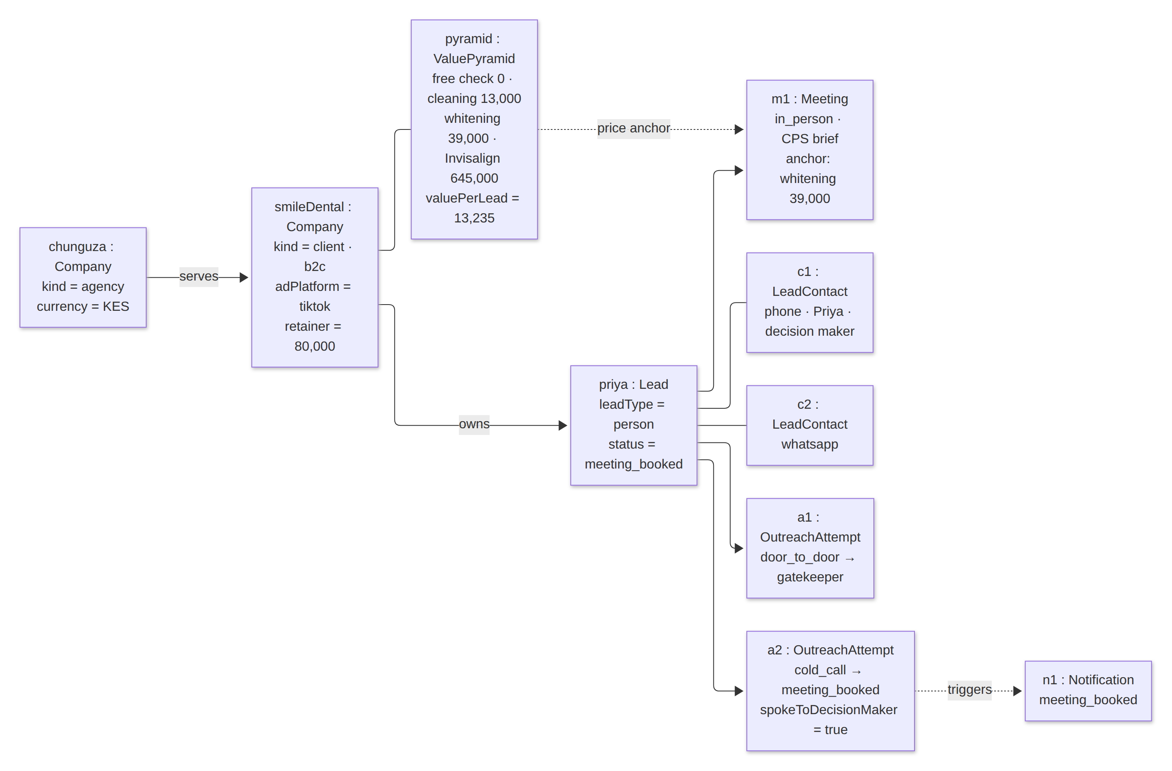
Figure 4. Chunguza agency, a dental client and one lead with contacts, attempts and a meeting
The snapshot shows the key rule of the model: the lead belongs to the client workspace. The agency sees it only by opening that workspace, while the agency's notification channel also receives the client's reply events.

4. Lead state model
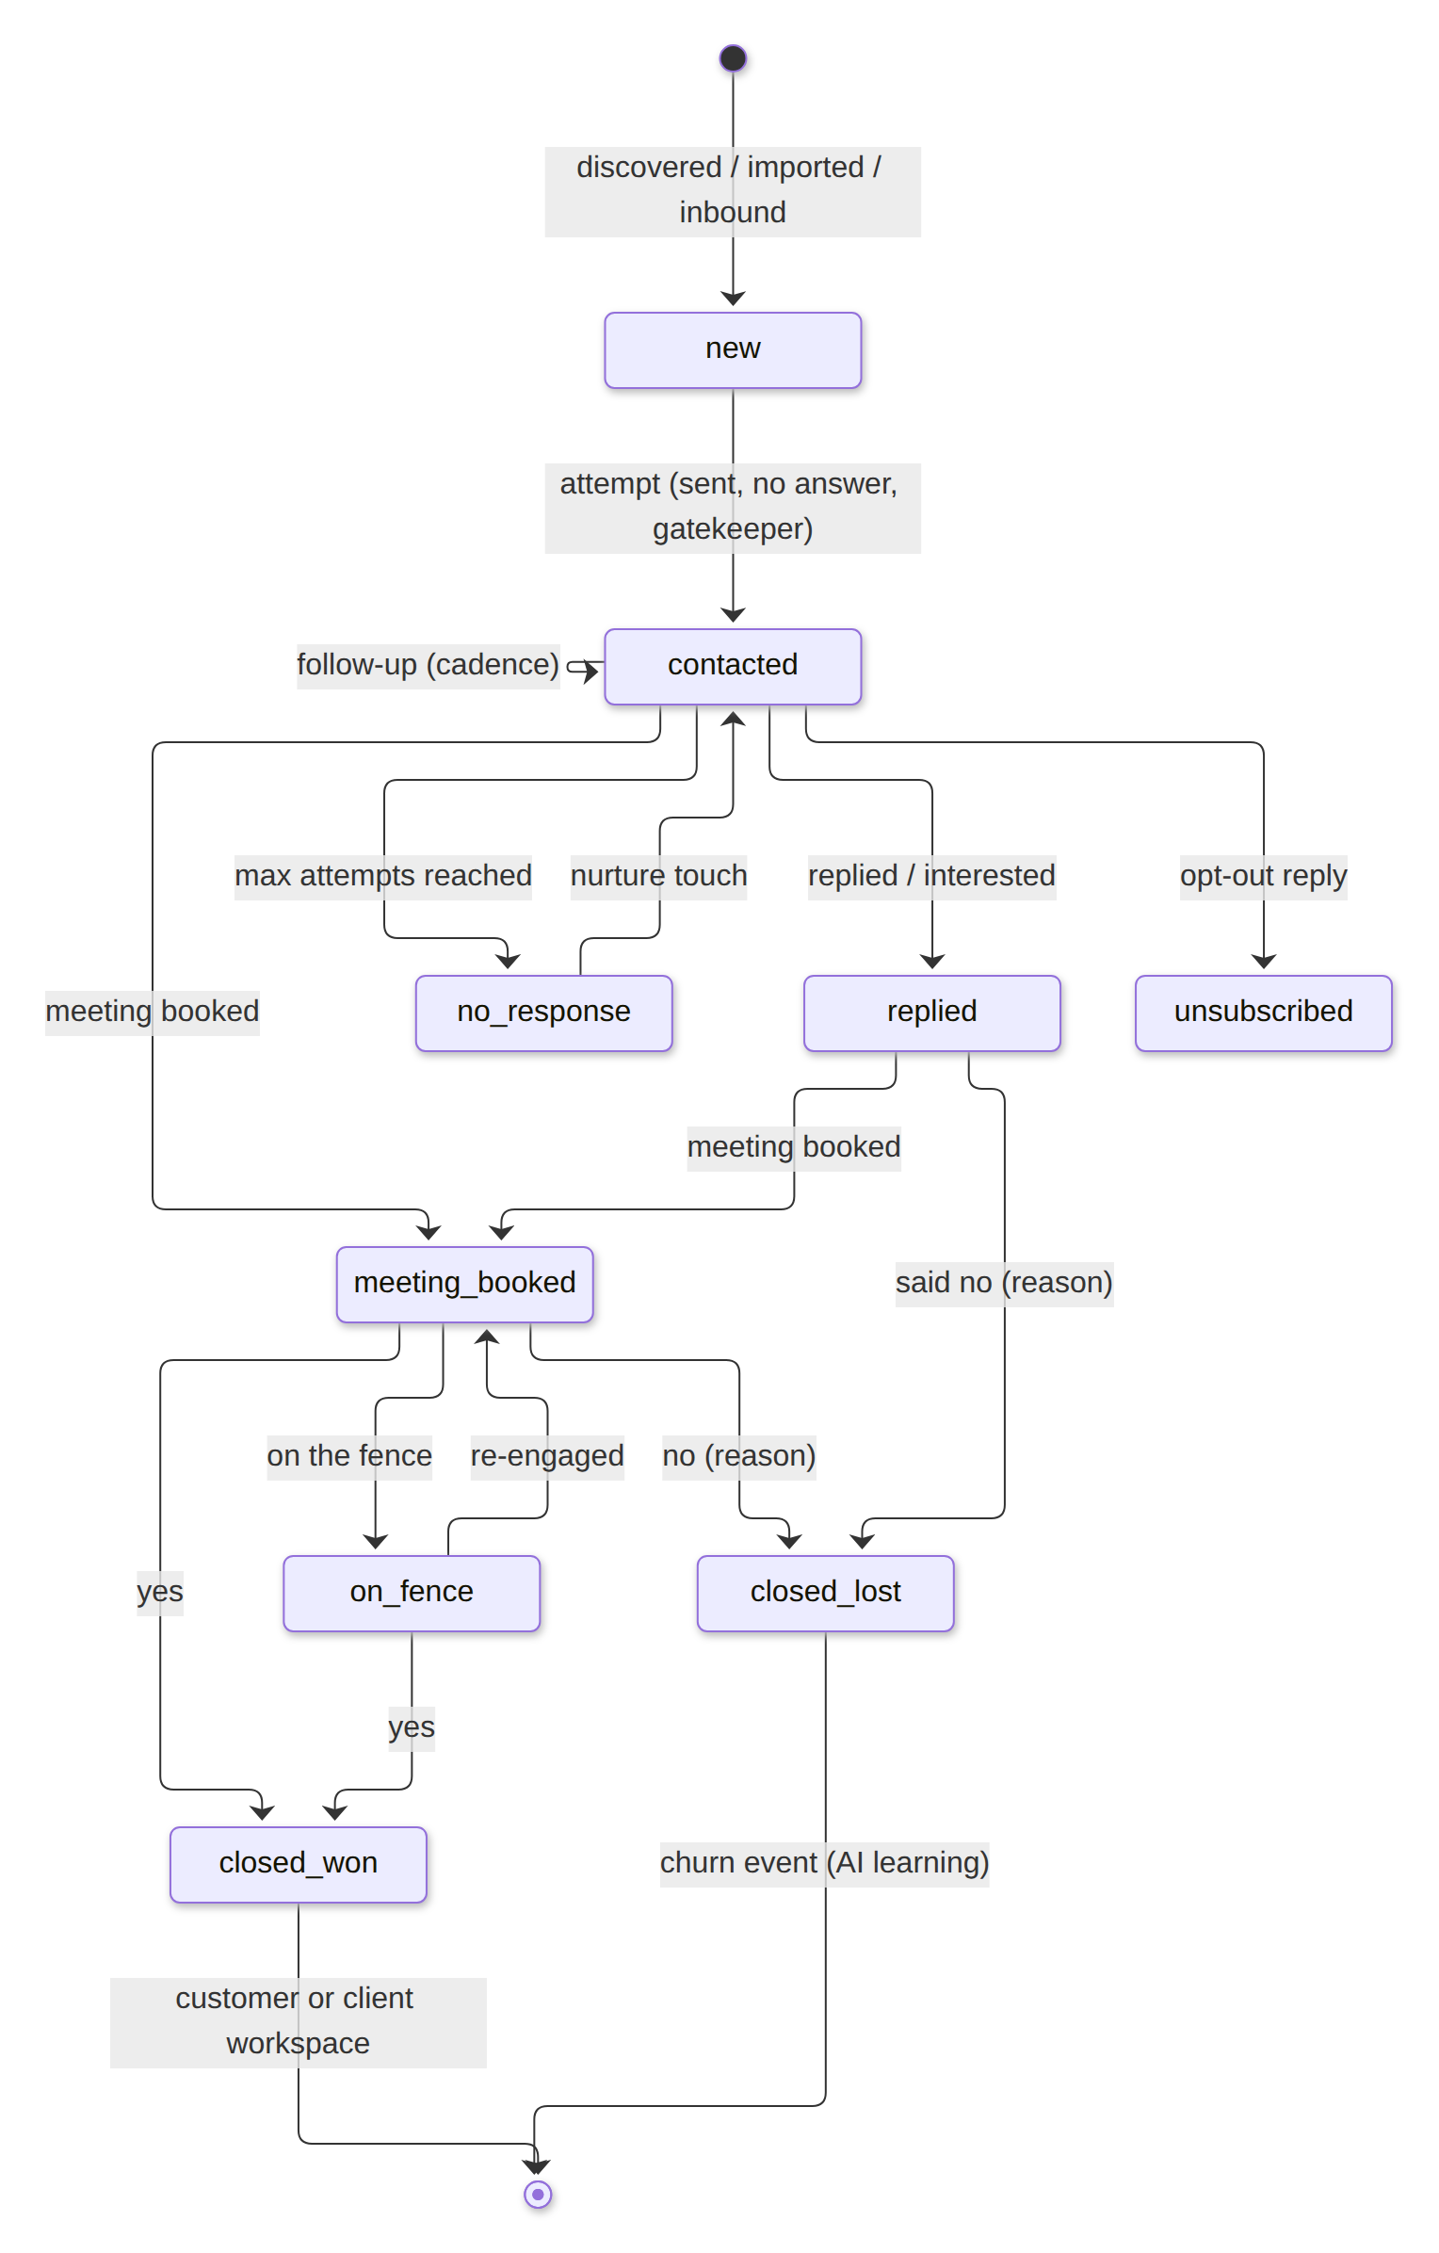
Figure 5. Lead lifecycle
Trigger | From → To | Side effects
Attempt: sent / no answer / gatekeeper / callback | new → contacted | Schedule next touch (cadence), last_contacted_at set
Attempt: replied / interested, or an inbound email | contacted → replied | Notification, AI reply draft (or auto-send), cadence continues
Attempt: meeting booked, or a meeting created | * → meeting_booked | Cadence stops; CPS brief generated
Cadence: 6 attempts with no response | contacted → no_response | Switches to nurture every 60 days
Outcome: converted | * → closed_won | Customer created (client workspace) or "Sign as client" (agency); scoring update
Outcome: on the fence | * → on_fence | Cadence continues at the normal intervals
Outcome: said no + reason | * → closed_lost | Loss reason recorded; learning input; cadence stops
Opt-out reply, bounce, spam | * → unsubscribed / bounced / spam | Suppression list; all sending stops

5. Sequence diagrams

5.1 Registration and workspace creation
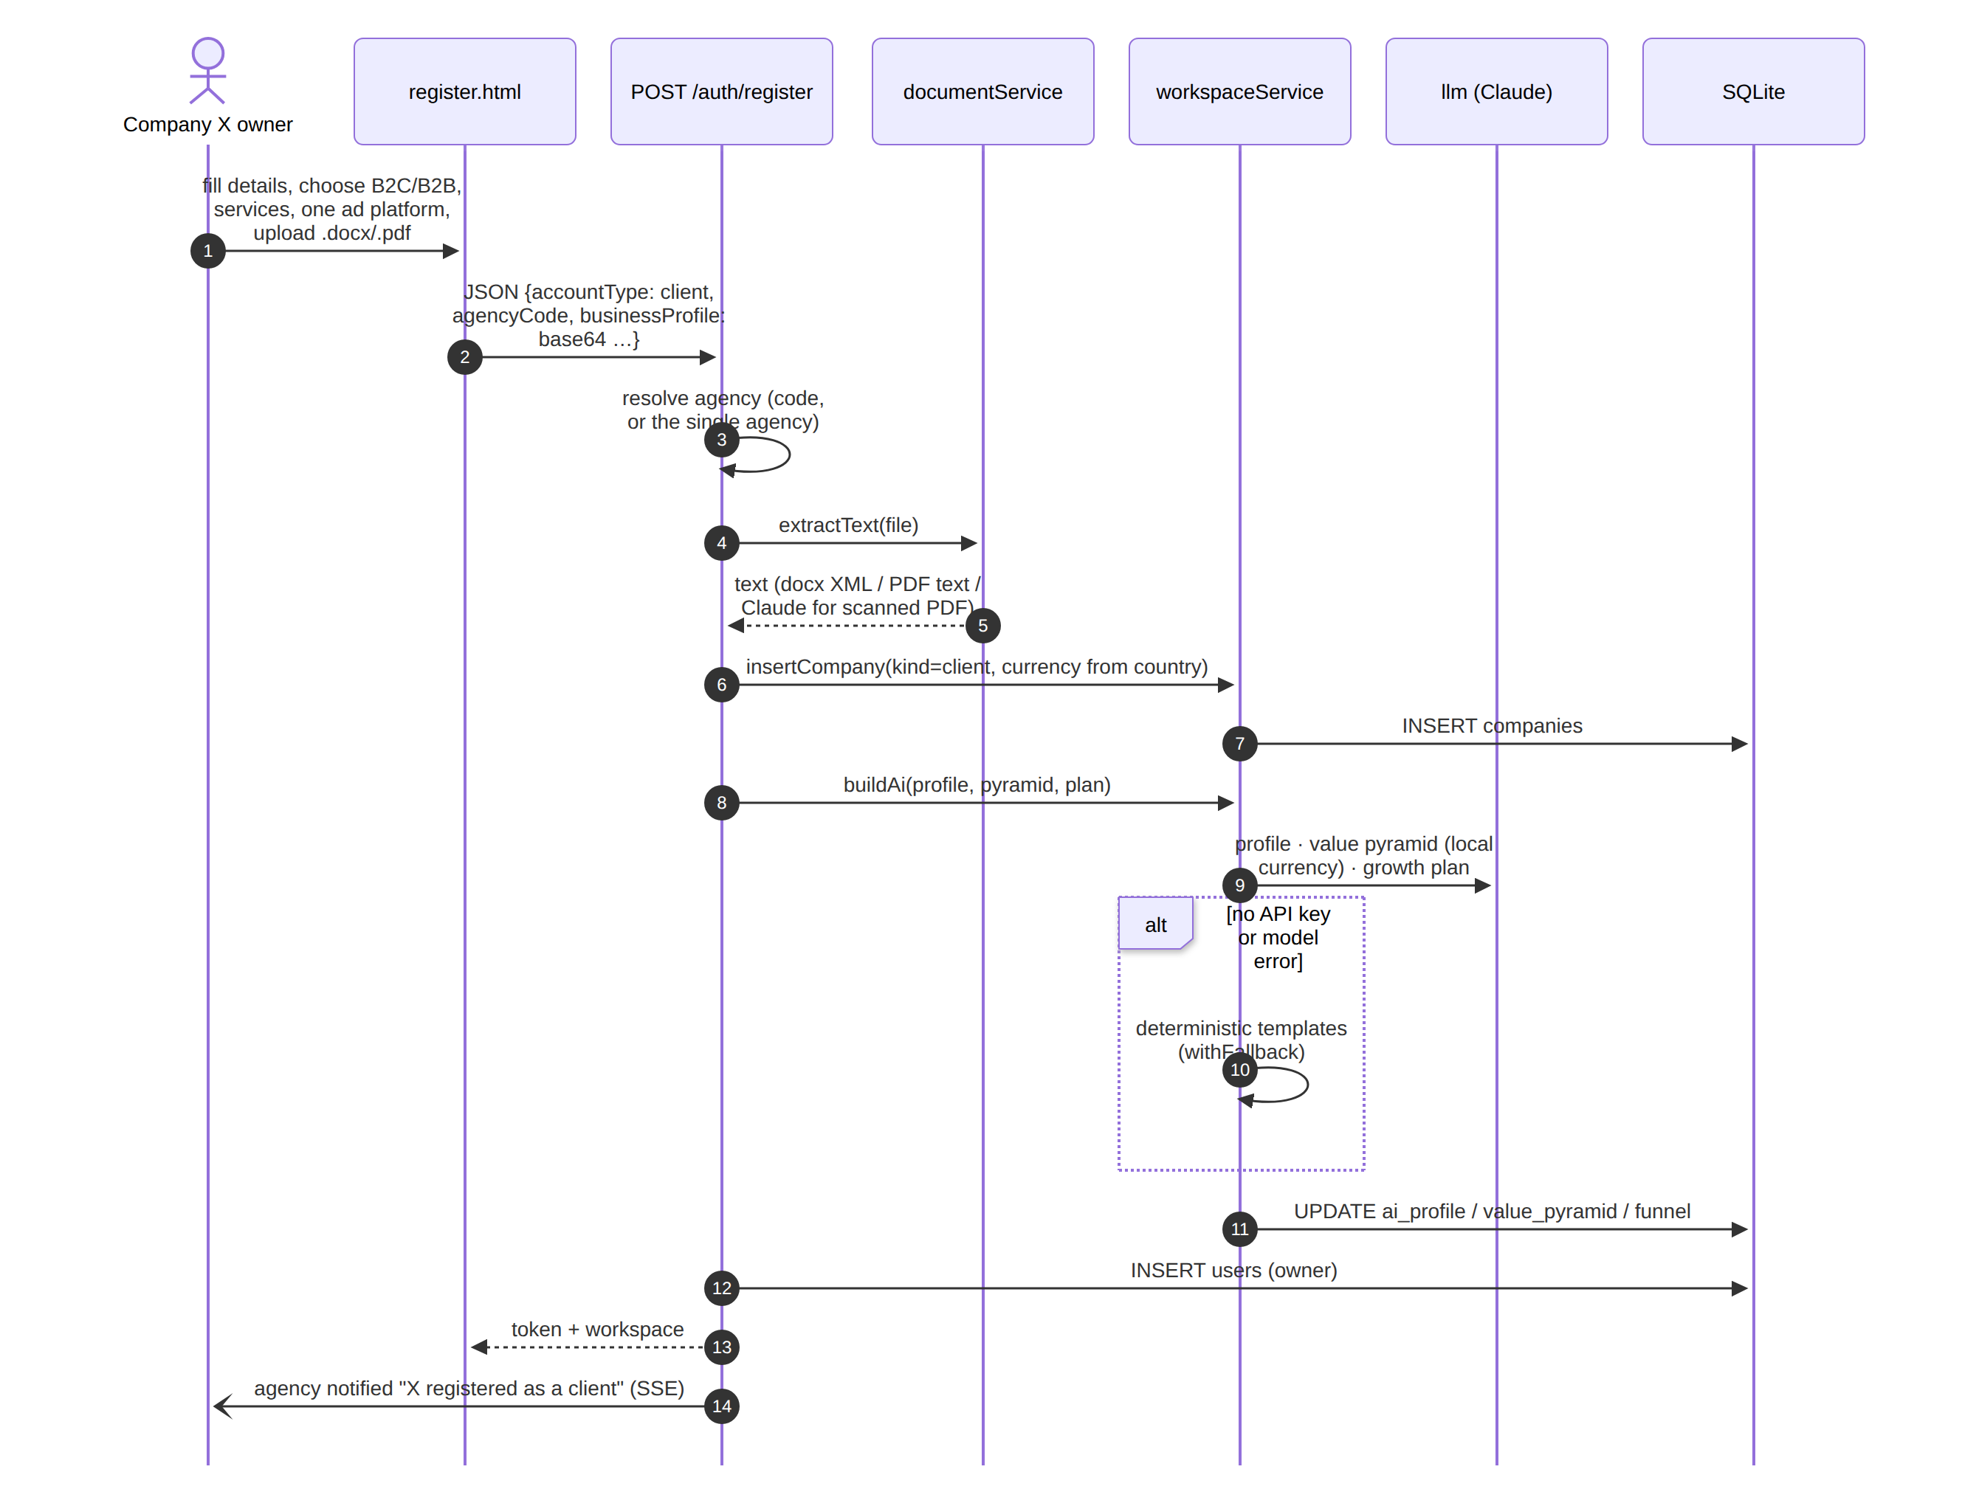
Figure 6. Agency or client registration, profile extraction and AI onboarding

5.2 Multi-method outreach on one lead
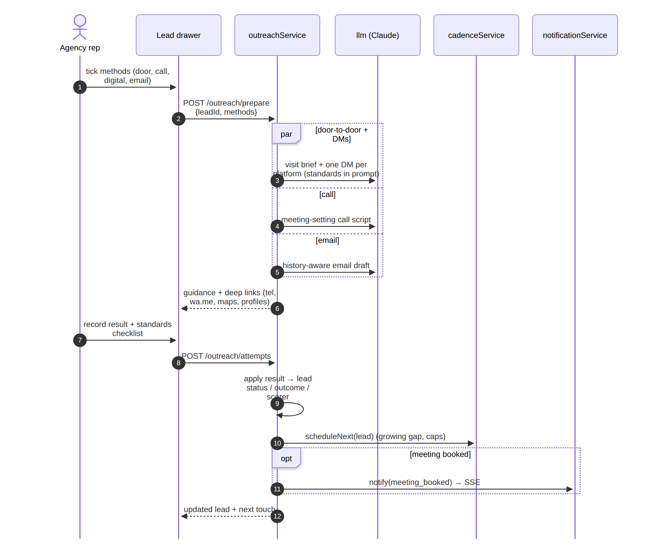
Figure 7. Prepare the selected methods, record the result and schedule the follow-up

5.3 Bulk or bespoke email
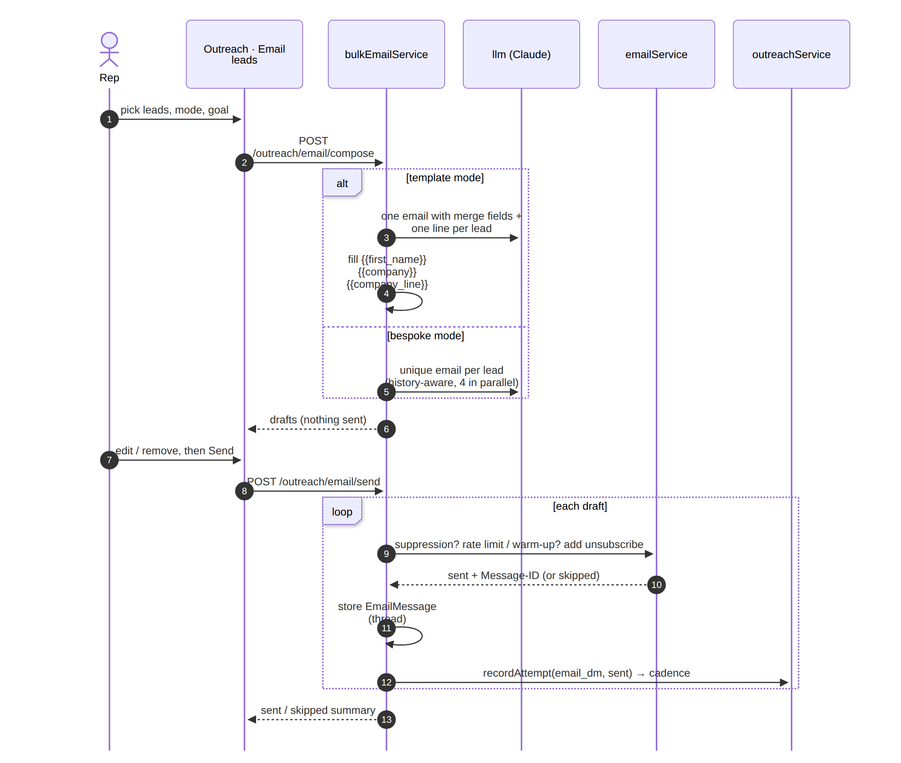
Figure 8. Compose (template or bespoke), gate checks, send and record

5.4 Reply handling and live notification
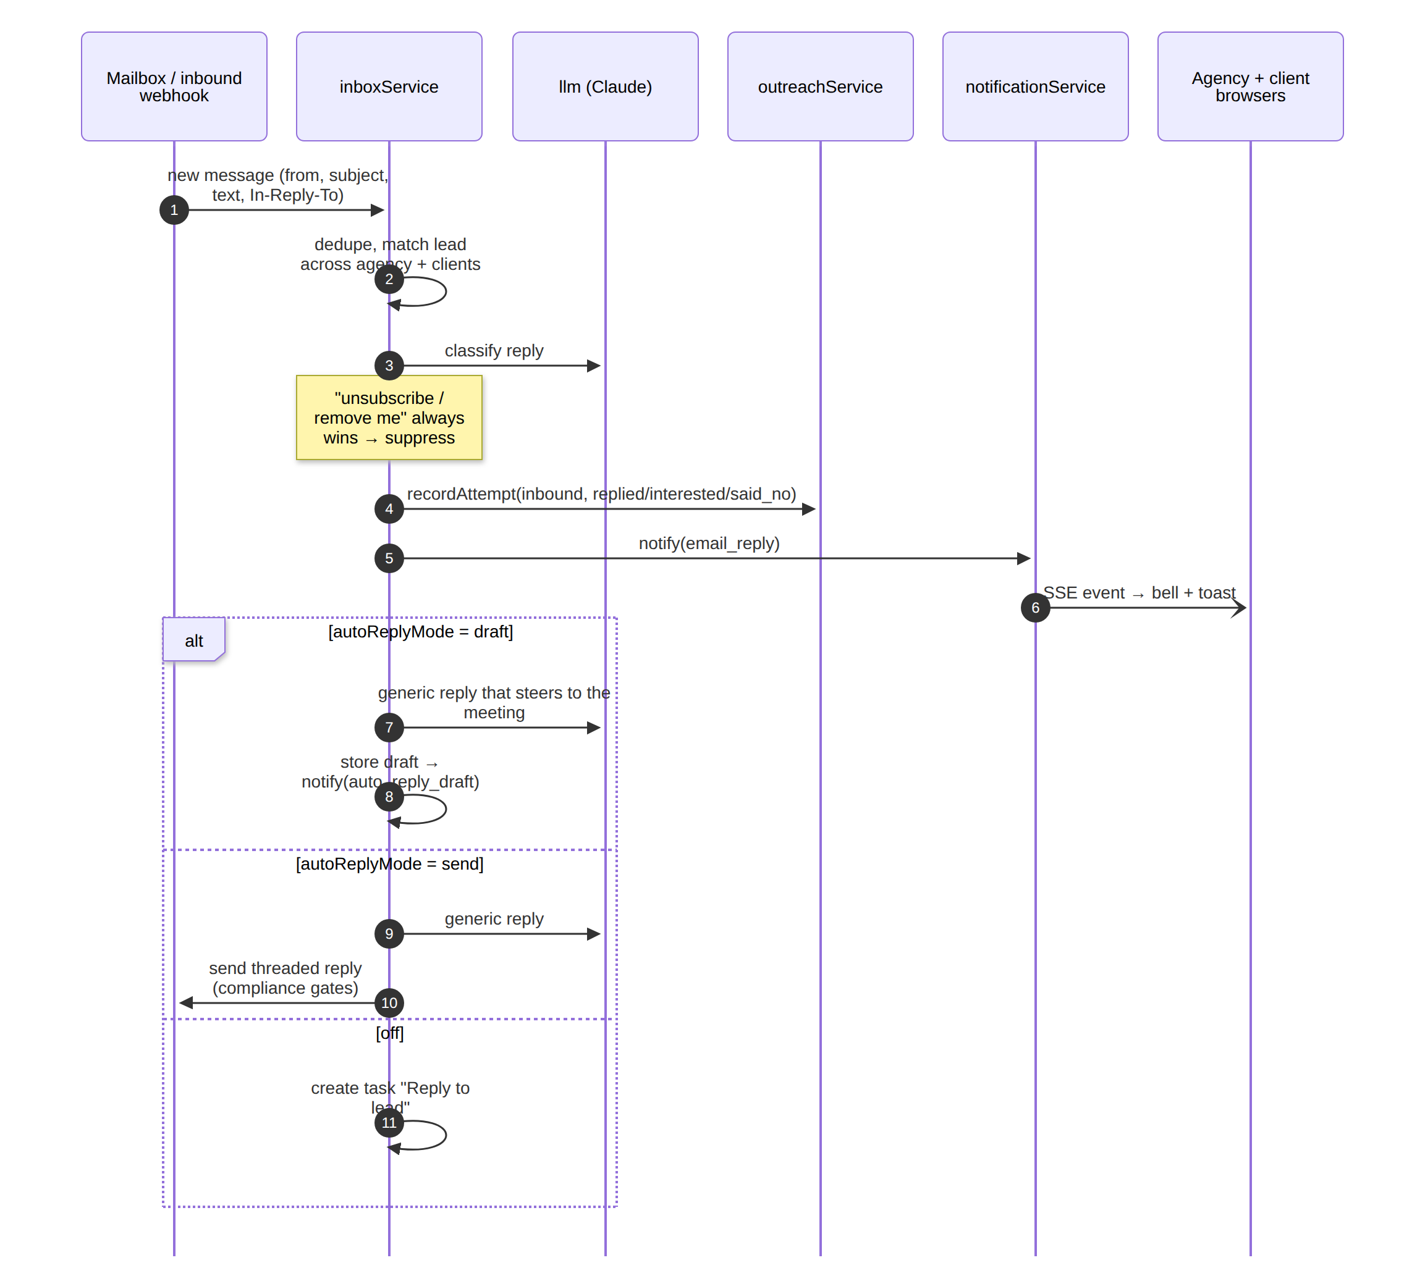
Figure 9. Inbound email → match → classify → draft or auto reply → SSE notification

5.5 CPS meeting
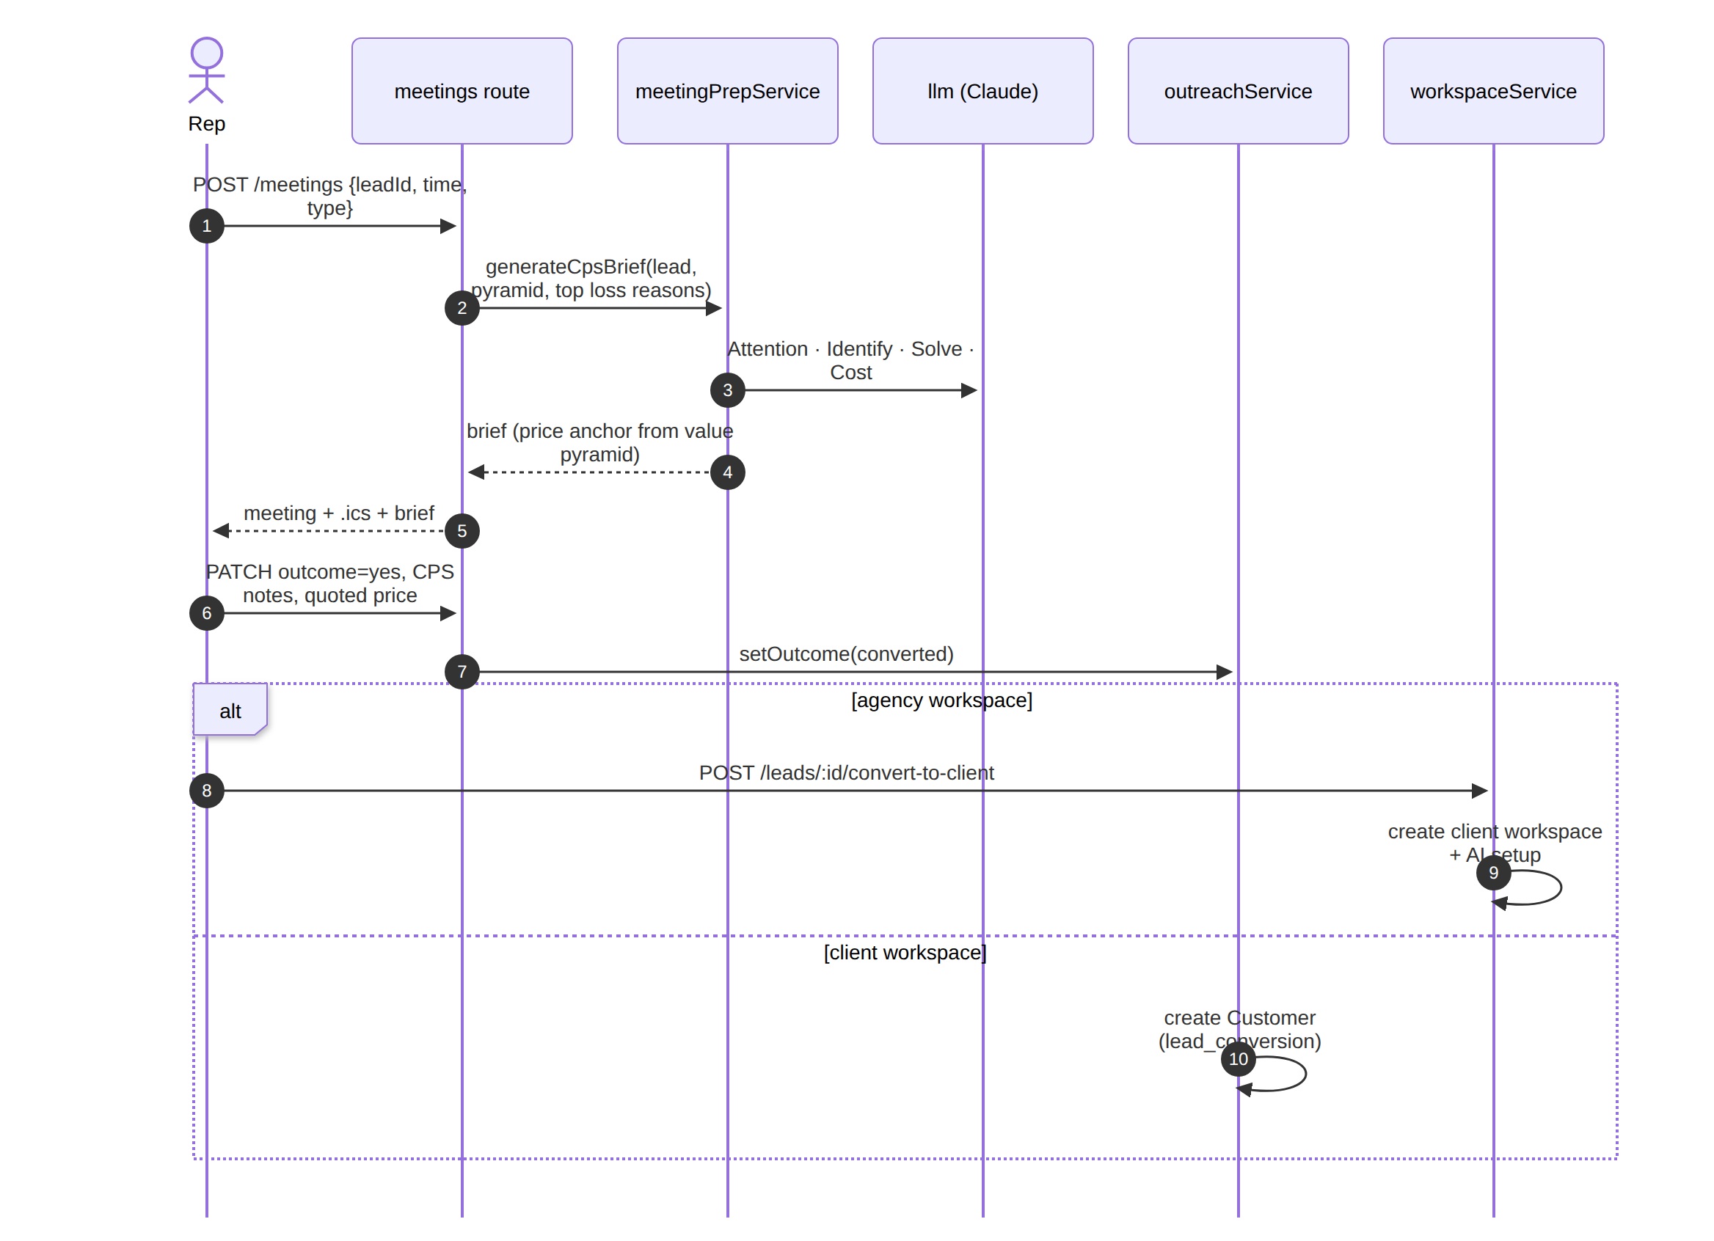
Figure 10. Book a meeting, generate the CPS brief, record the outcome

5.6 Follow-up cadence run
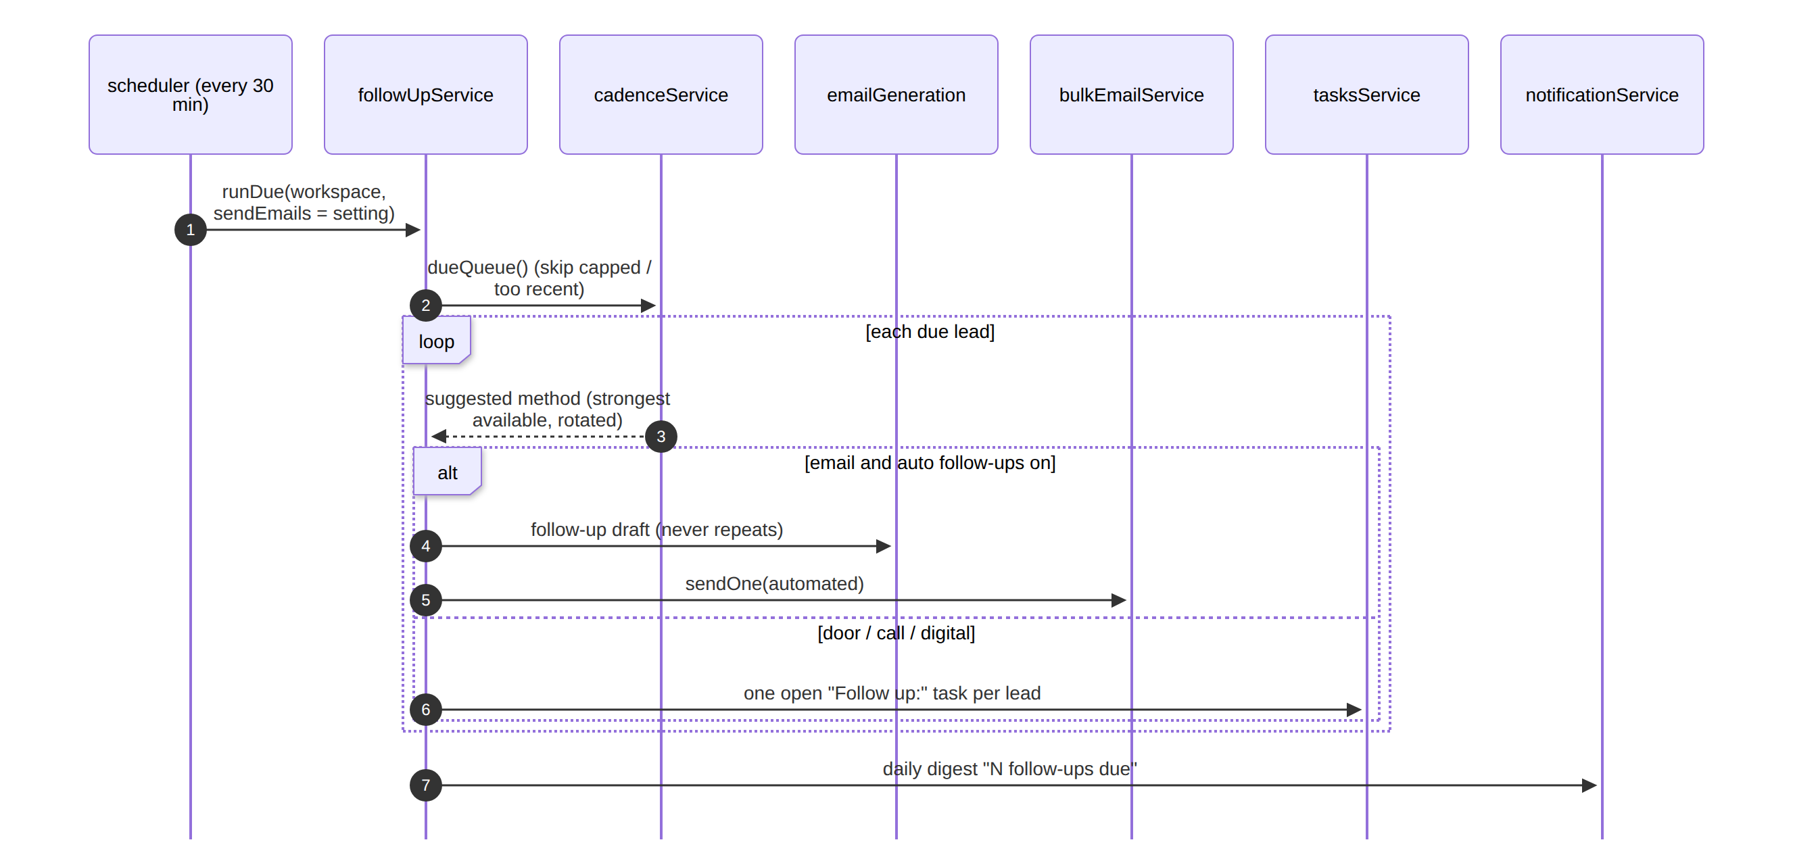
Figure 11. Scheduler tick: due queue, email follow-ups and tasks for manual methods

5.7 AI assistant tool loop
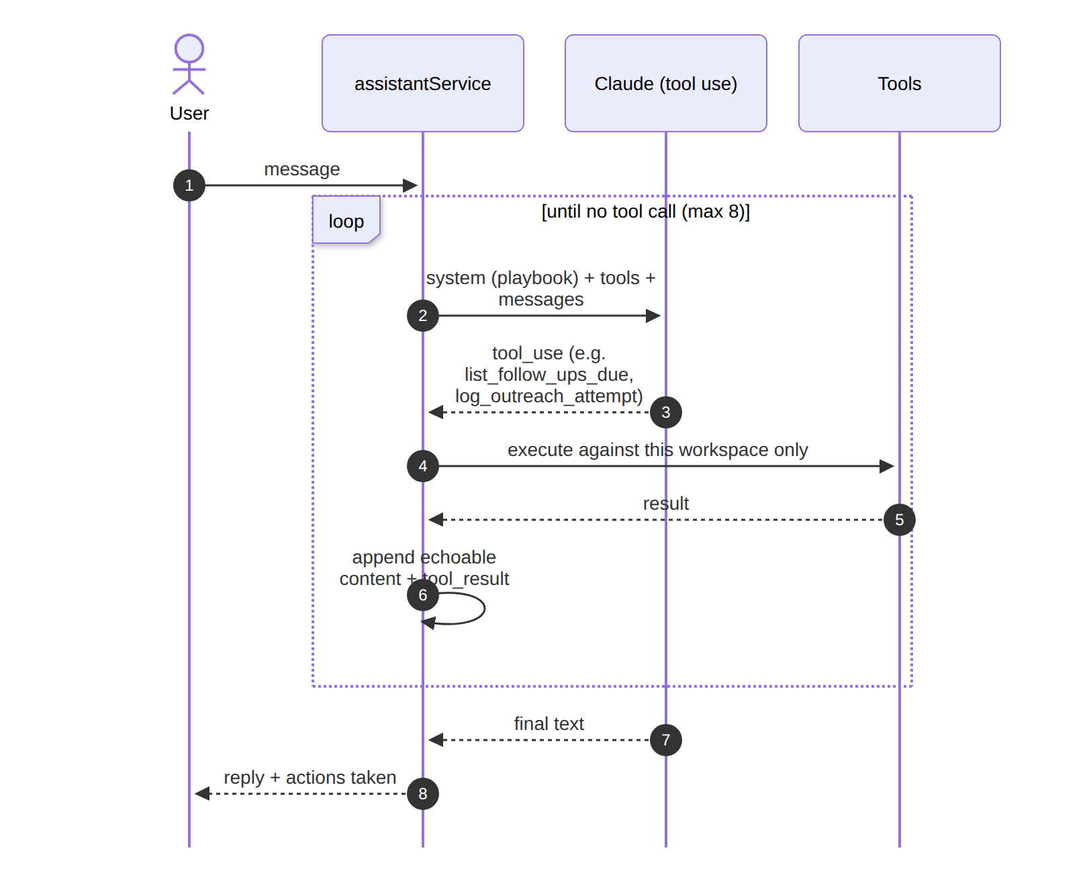
Figure 12. Assistant with workspace-scoped tools (max 8 rounds)

6. Activity diagrams

6.1 Cadence decision
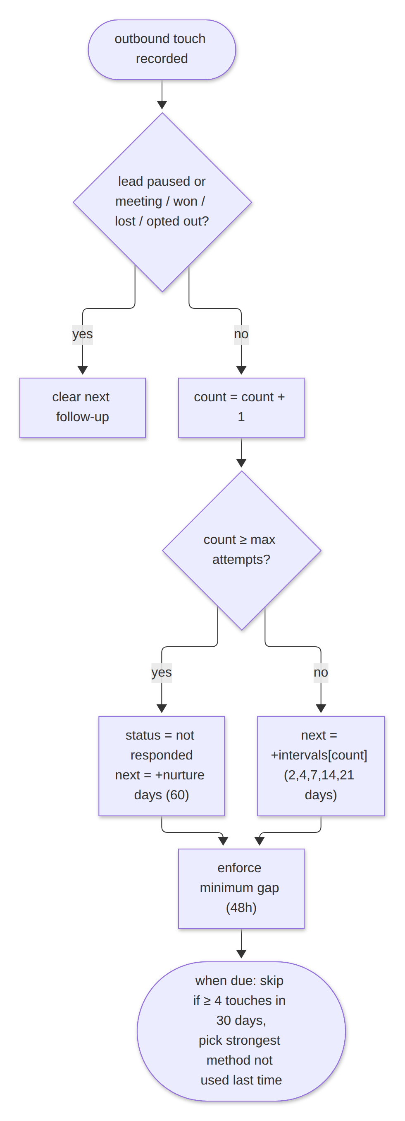
Figure 13. Deciding whether, when and how to follow up

6.2 Daily client health sweep
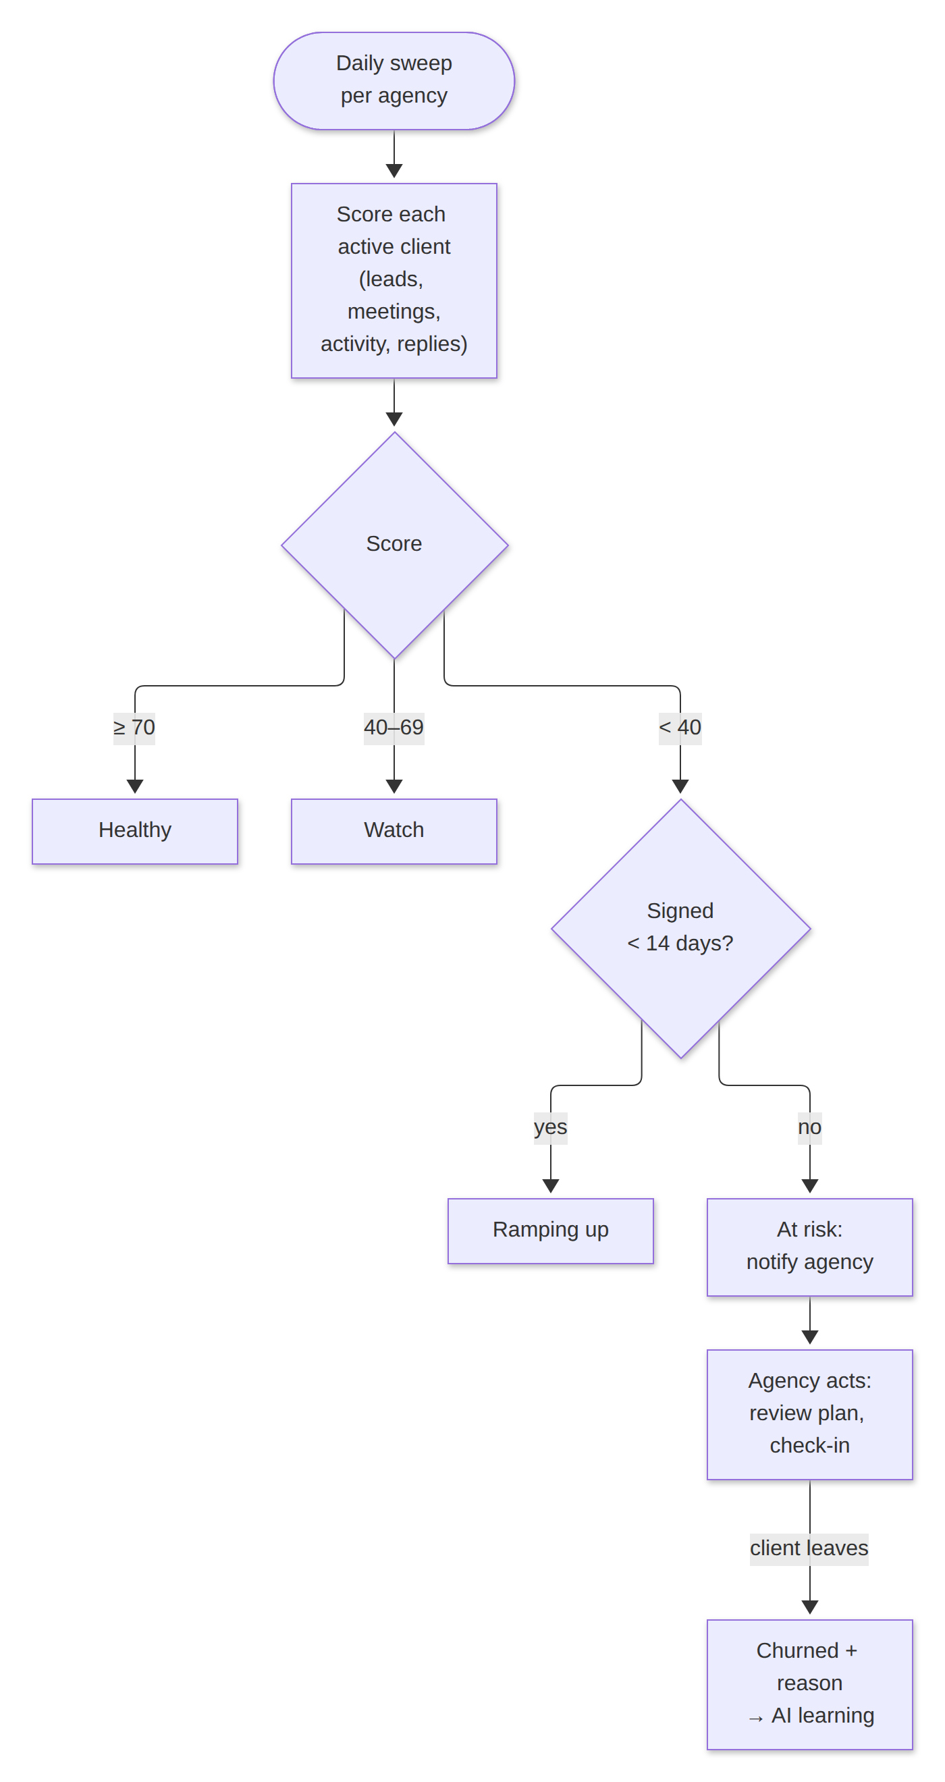
Figure 14. Score each client, band it and alert the agency

6.3 Value pyramid computation
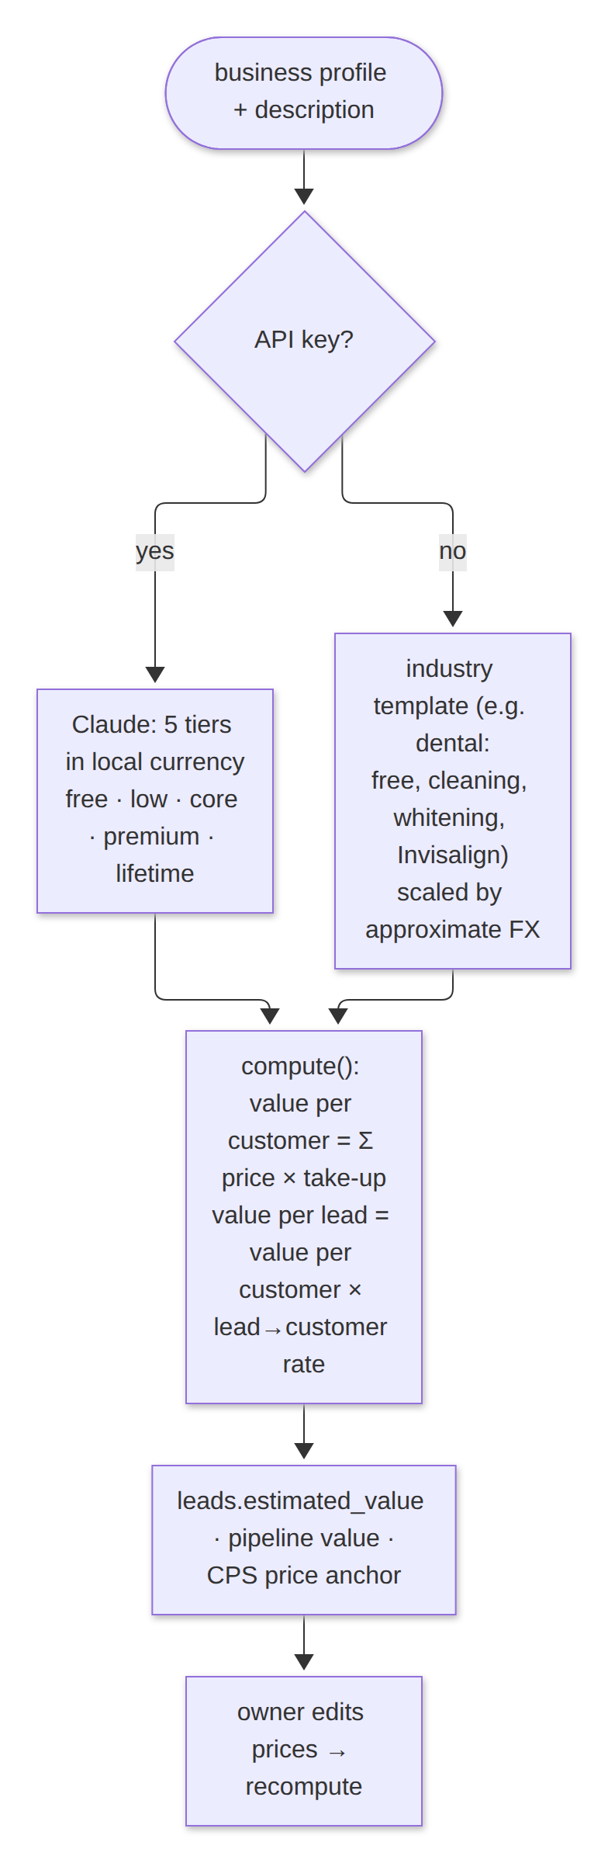
Figure 15. From industry template (or AI draft) to value per lead

7. Design patterns and implementation mapping
Pattern | Where | Why
Gateway | llm.js wraps the Anthropic SDK | One place for the model, effort, refusal fallback and parsing
Template Method + Null Object | Each AI service: prompt → model → withFallback(local template) | The same shape with or without AI; partial output is safe
Observer (pub/sub) | notificationService.publish → SSE subscribers per workspace and agency | Live replies without polling
Strategy | Lead sources (Clay, Explorium, web, mock); outreach methods | Pluggable sources; method-specific preparation
Adapter | normalizeWebhookPayload (Postmark, Mailgun, JSON); HighLevel/Appointwise adapters | External shapes become one internal shape
Policy object | cadenceService with settings.cadence | Timing and anti-spam rules in one place, configurable per workspace
Configuration as code | playbook.js | The same rules drive the UI, validation and prompts
Chain of responsibility | Send gates: suppression → opt-out → rate limit → warm-up → send | Each check can stop the send and say why
Middleware / decorator | requireAuth → authenticate (workspace) → requireRole | Tenancy enforced before any handler runs
Command | Assistant tools (find_leads, log_outreach_attempt, set_lead_outcome, …) | The model issues named commands that are validated and scoped
Repository | Service modules own their tables' SQL | Routes never write SQL directly for the v3 domains

8. Requirement → object traceability
Requirement (PRD) | Classes | Main modules
FR-1 Workspaces | Company, User | middleware/auth, workspaceService, routes/workspaces
FR-2 Onboarding | Company, User, AIProfile | routes/auth, companyProfileService
FR-3 Business profile | AIProfile | documentService, companyProfileService
FR-4 Value pyramid | ValuePyramid, ValueTier | valuePyramidService
FR-5 Growth plan | GrowthPlan | strategyService
FR-6 Lead sourcing | Lead, LeadContact, LeadSourceProvider | routes/leads, leadSourceRegistry, csvImportService, routes/inbound
FR-7 Lead record | Lead, LeadContact | leadsService
FR-8 / FR-9 Outreach & standards | OutreachAttempt, Playbook | outreachService, callsService
FR-10 CPS meetings | Meeting | meetingsService, meetingPrepService
FR-11 Outcomes | Lead, Customer, Company | outreachService.setOutcome, workspaceService.convertLeadToClient
FR-12 Email | EmailMessage | bulkEmailService, emailService, emailGenerationService
FR-13 Cadence | Cadence, Task | cadenceService, followUpService, scheduler
FR-14 / FR-15 Replies & bot | EmailMessage, Notification | inboxService, imapPoller, notificationService
FR-16 Customers | Customer, ChurnEvent | customersService
FR-17 Client monitoring | Company, ChurnEvent, Notification | workspaceService.clientHealth, scheduler
FR-18 Analytics | n/a (read model) | analyticsService
FR-19 AI learning | AIInsight | insightsService
FR-20 Integrations | IntegrationAdapter | integrationsService
FR-21 Assistant | AssistantAgent | assistantService

