National Cheng Kung University
Department of Electrical Engineering

Introduction to VLSI CAD (Spring 2016)

Lab Session 5

ALU and Register Files

Name |  | Student ID
Practical Sections | Points |  | Marks
Prob A | 24
Prob B | 12
Prob C | 14
Prob D | 50
Notes:

Due Date: 15:00, April 08, 2016 @ moodle

Deliverables
- All Verilog codes including testbenches for each problem should be uploaded.
NOTE: Please DO NOT include source code in the paper report!
- Important! TA will use the command in Appendix A to check your design under SoC Lab environment, if your code can not be recompiled by TA successfully using the commands, you will not get full credit.
- If you upload a dead body which we can’t even compile you will get NO credit!
- All homework requirements should be uploaded in this file hierarchy or you will not get full credit.
NOTE: Please DO NOT upload waveforms!
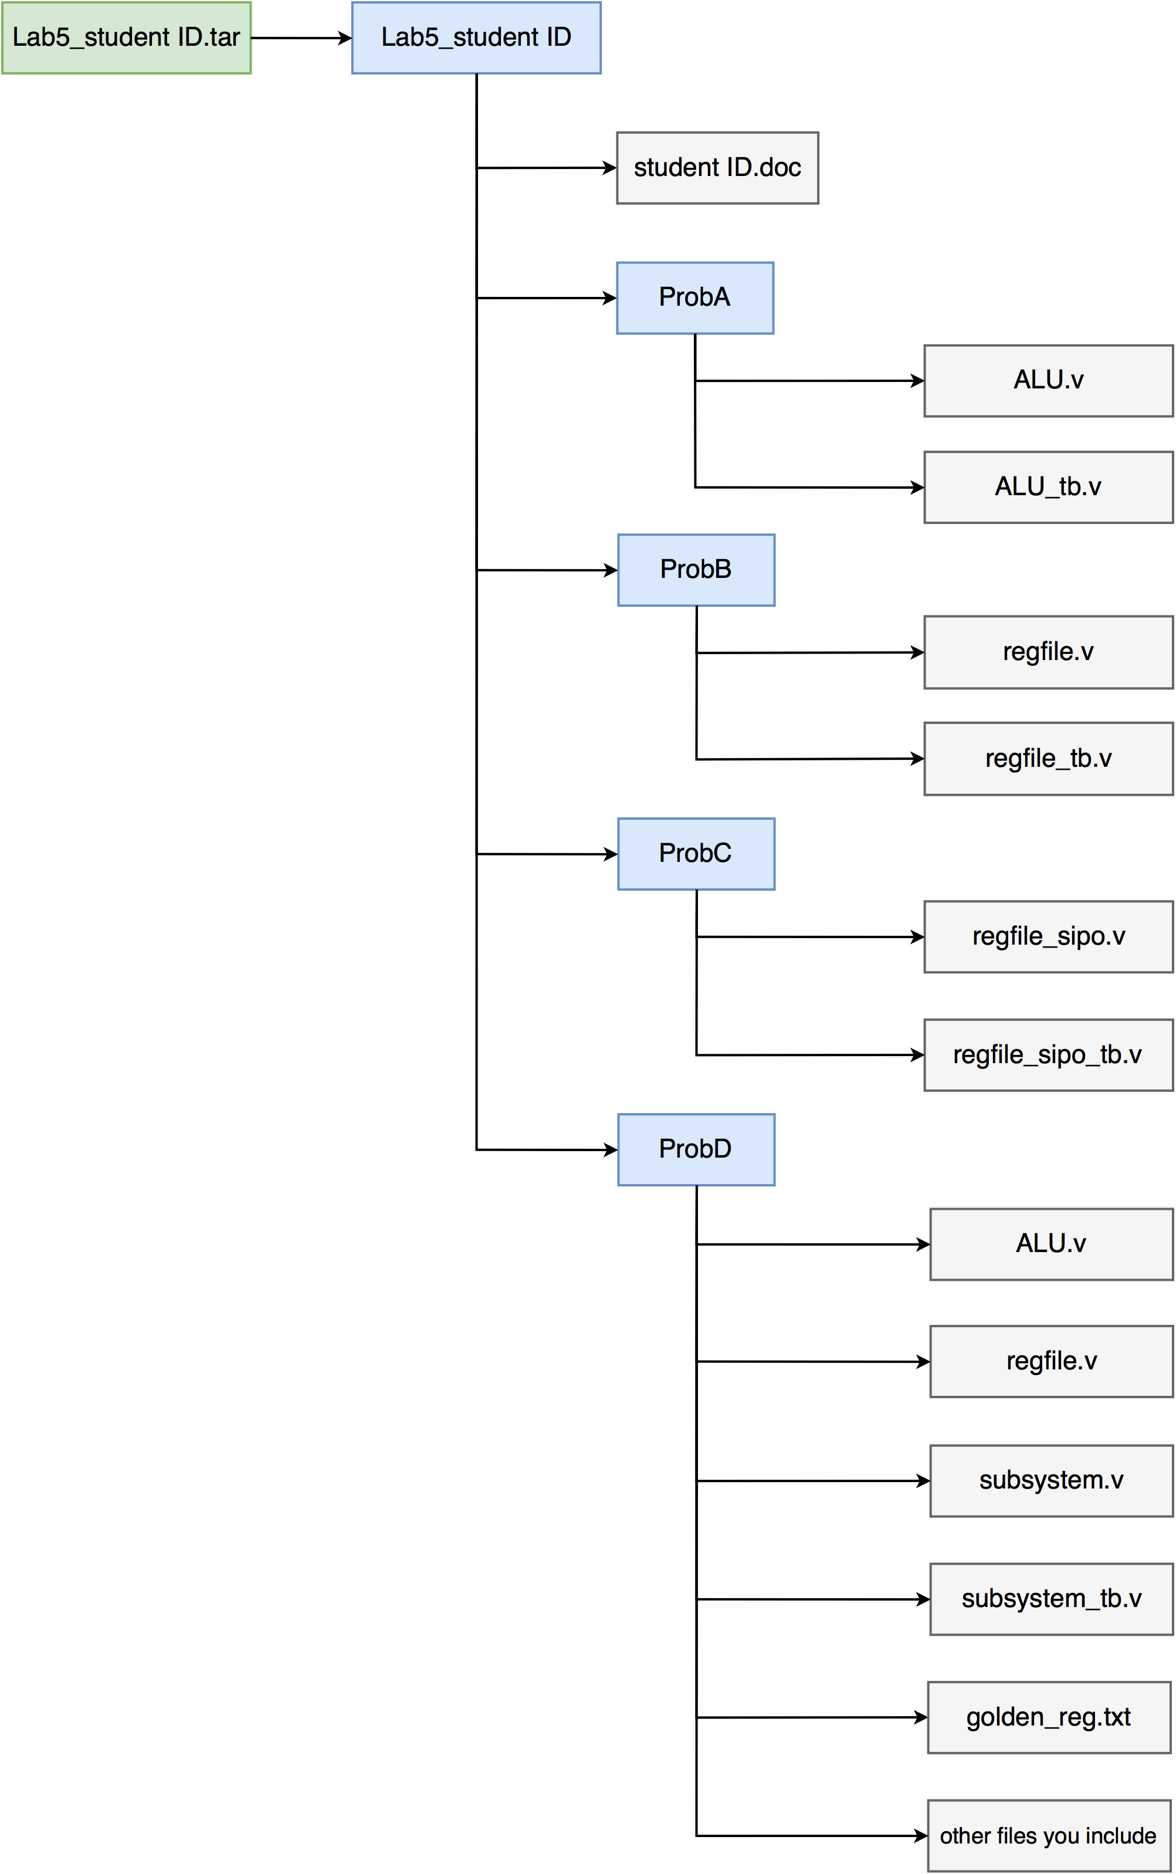
Fig.1 File hierarchy for Homework submission
Objectives:
Learn how to design an ALU and Register file which are two main components in CPU. Homework 5 you are allowed to use behavioral description to speed up your design process.
Prob A: Arithmetic Logic Unit
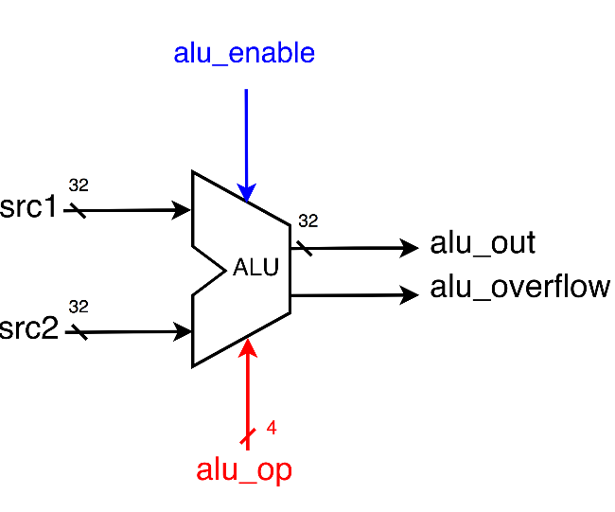

- Based on LabA and the reference code we gave you, please implement another 8 operations which are listed as bellow.
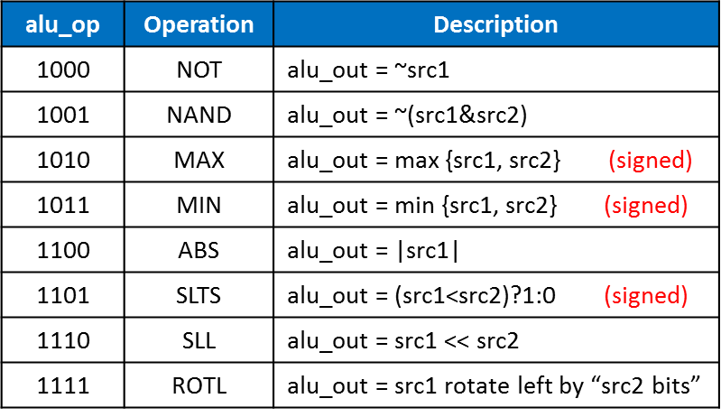
- Port list
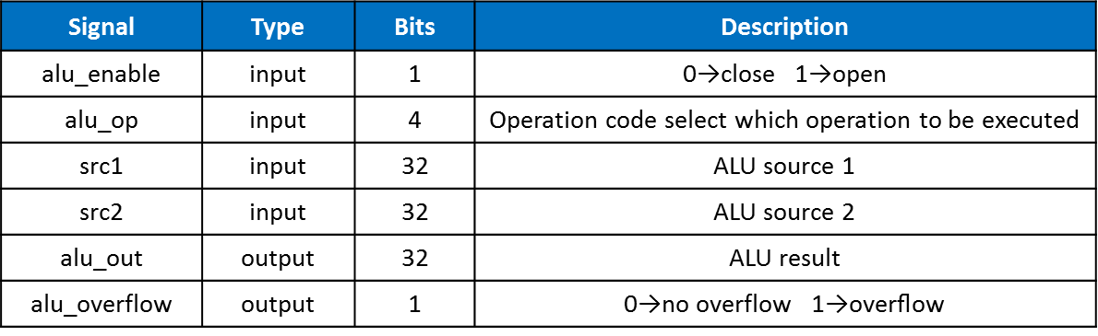
- You should follow the file name rules as follow.
- ALU (provided!)
  - File name: ALU.v
  - Module name: ALU
- ALU testbench
  - File name: ALU_tb.v
  - Module name: ALU_tb
- You should verify your code by the following test patterns.
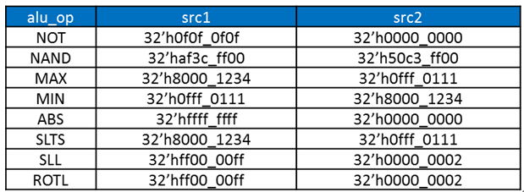
- You need to snapshot the waveform of the 8 operations you implemented and explain why they are correct. If you didn’t explain you will get no credit!

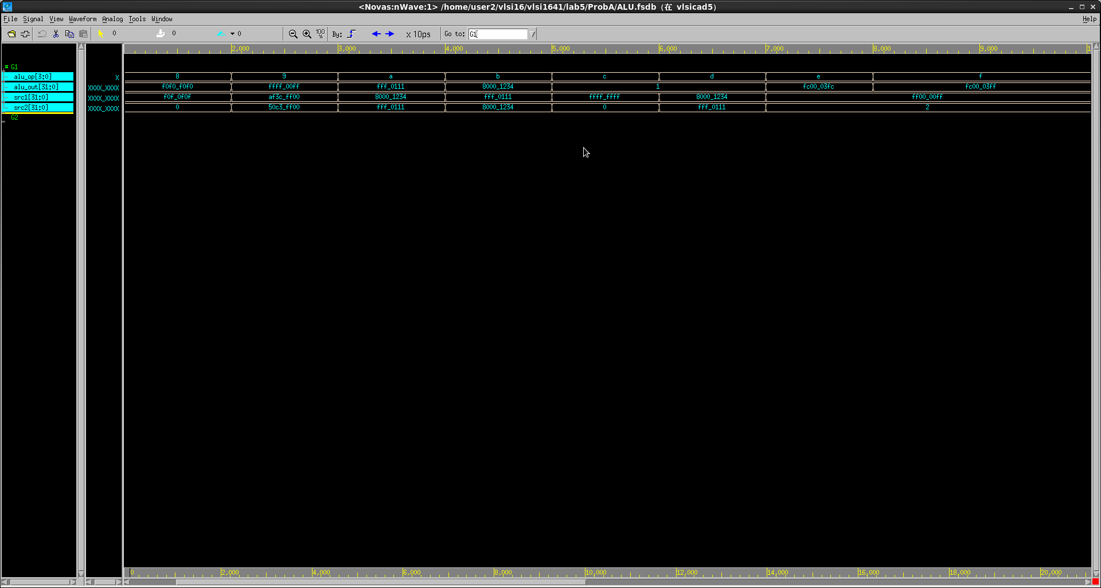
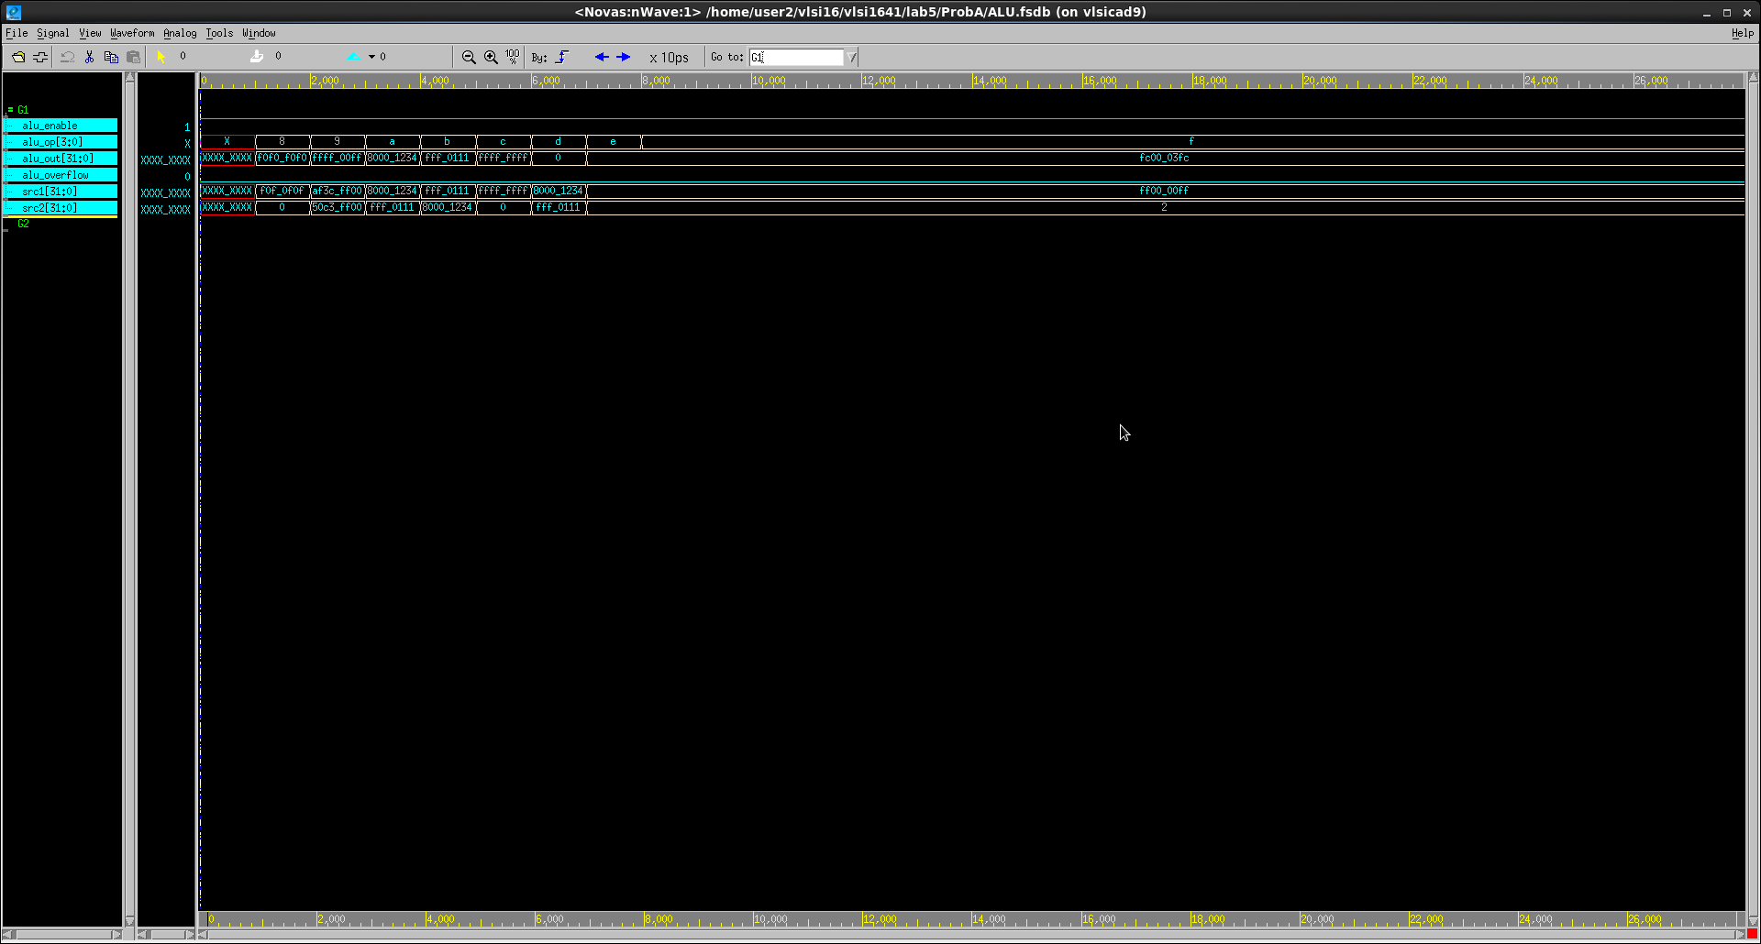

ALU是一個運算的東西,先輸入兩個數值分別為src1和src2,之後運用op去控制我們所要對這兩個值所作運算,但必須在enable為1的情形下才能使用,之後經過各種運算後,就可以得出alu的輸出

Prob B: Register File
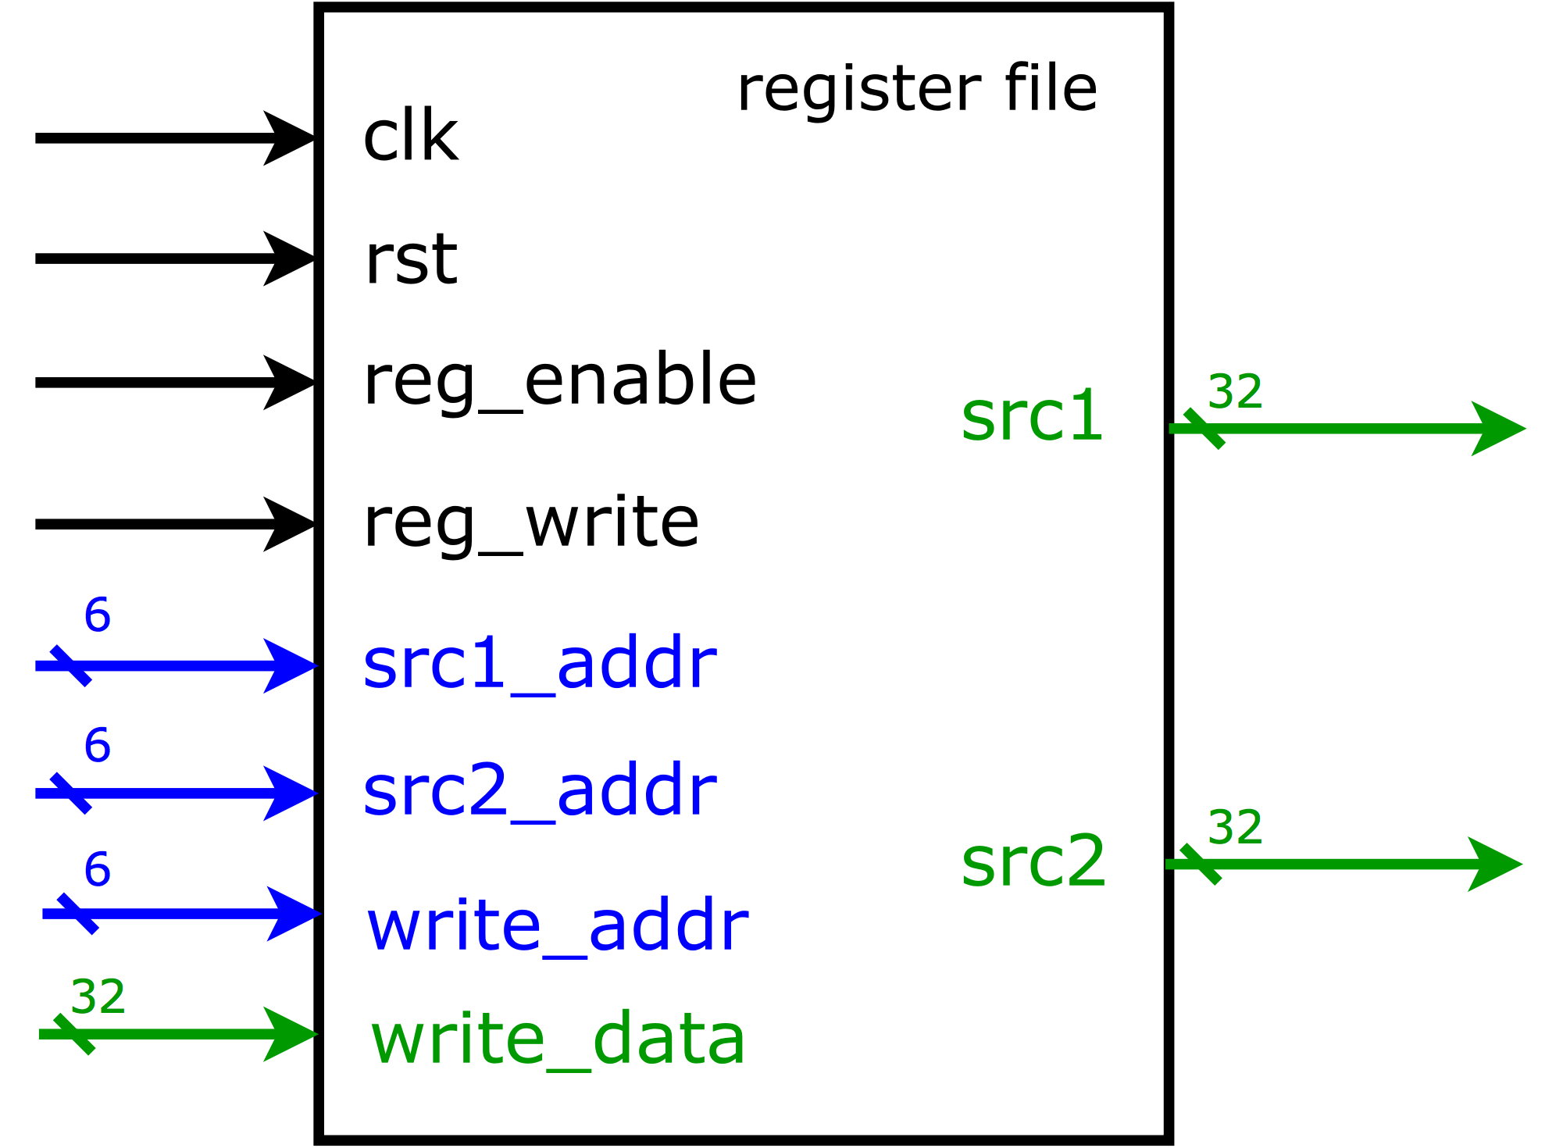
- Based on the register file structure in LabB, please design a 64 x 32 register file by yourself. We did not provide you any reference code but you may reference the code in the tutorial Lab5’s PDF.
- Port list
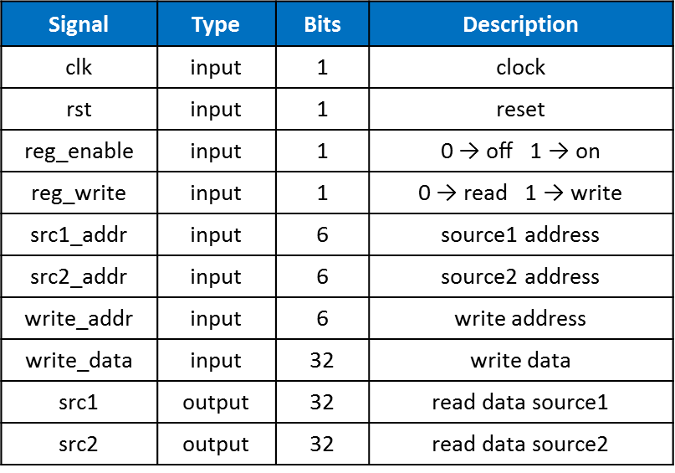
- You should follow the file name rules as follow.
- Register file
  - File name: regfile.v
  - Module name: regfile
- Register file testbench (provided!)
  - File name: regfile_tb.v
  - Module name: regfile_tb
- You should verify your code by the following test patterns.
- Write data into register file
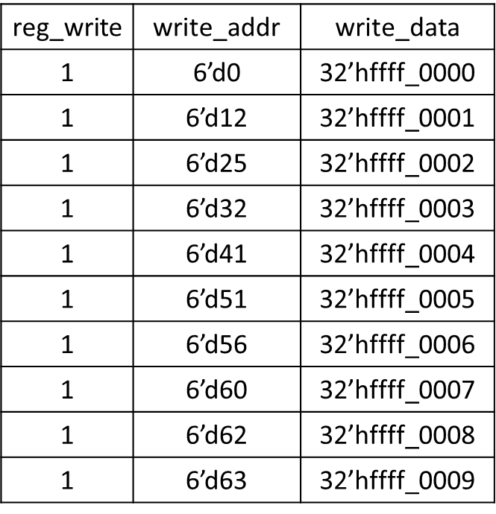
- Read data from register file
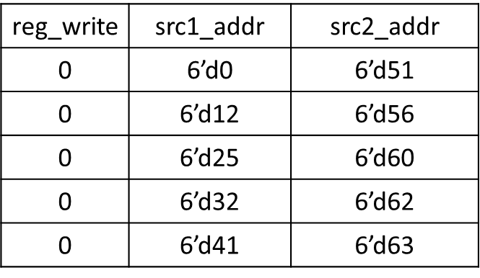
- You need to snapshot the waveform and show that your register file can read and write correctly.

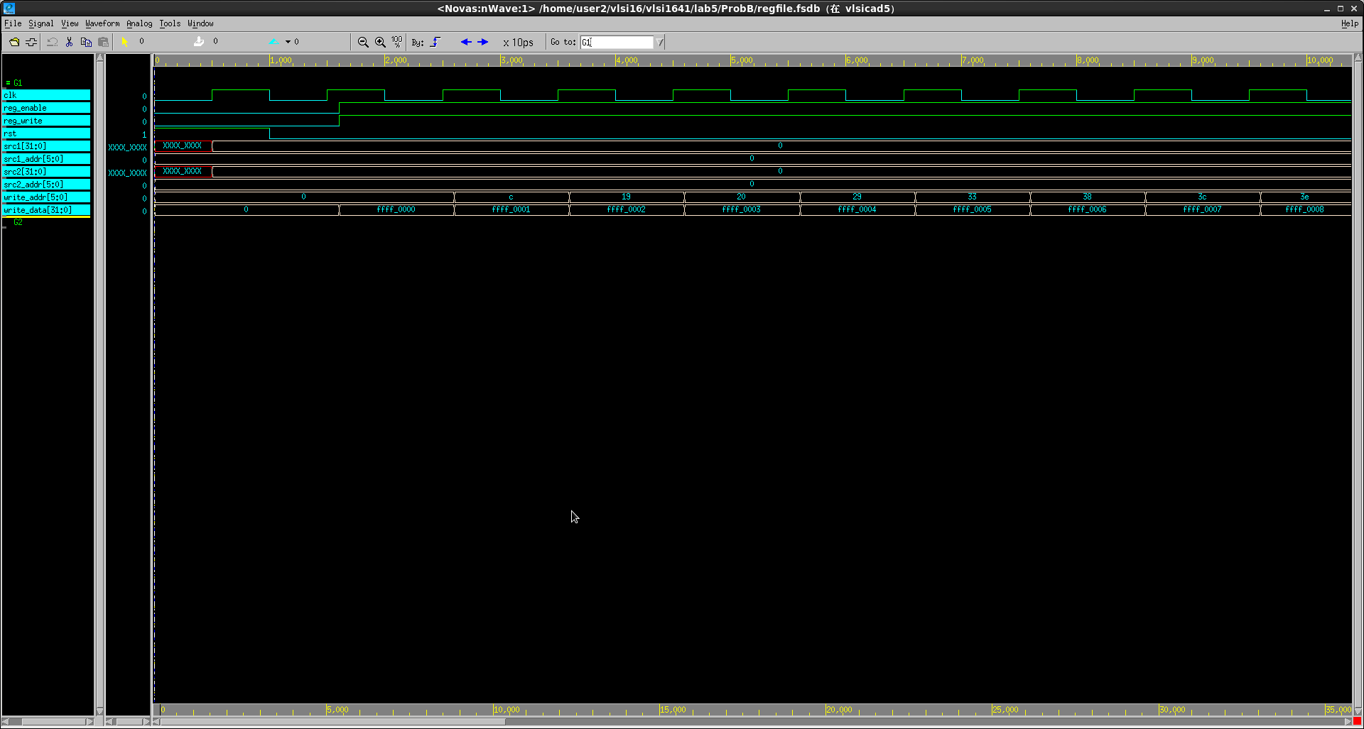
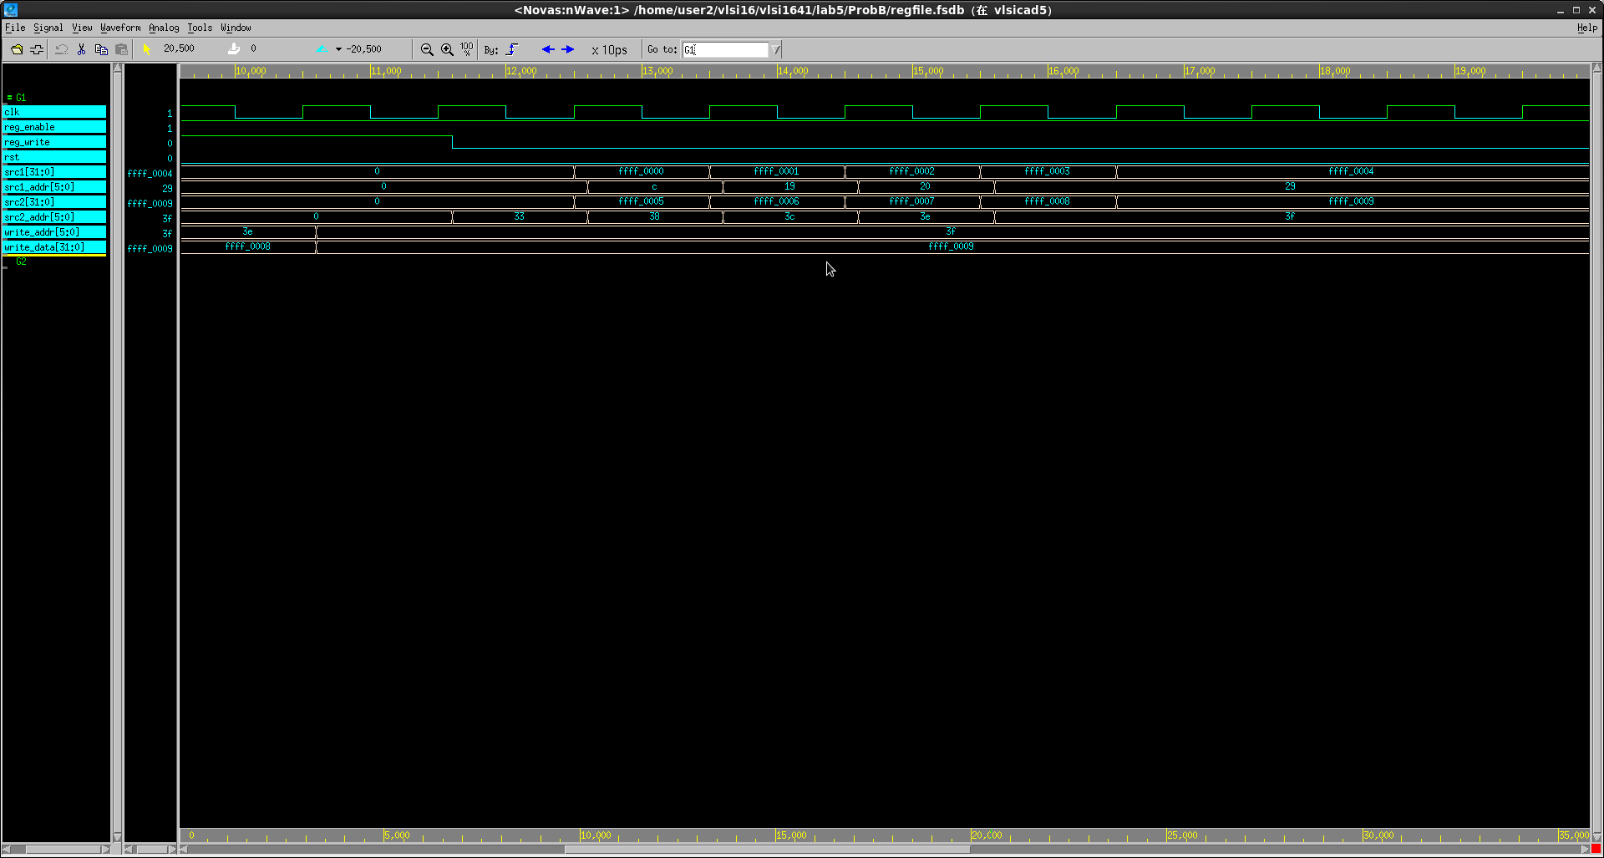

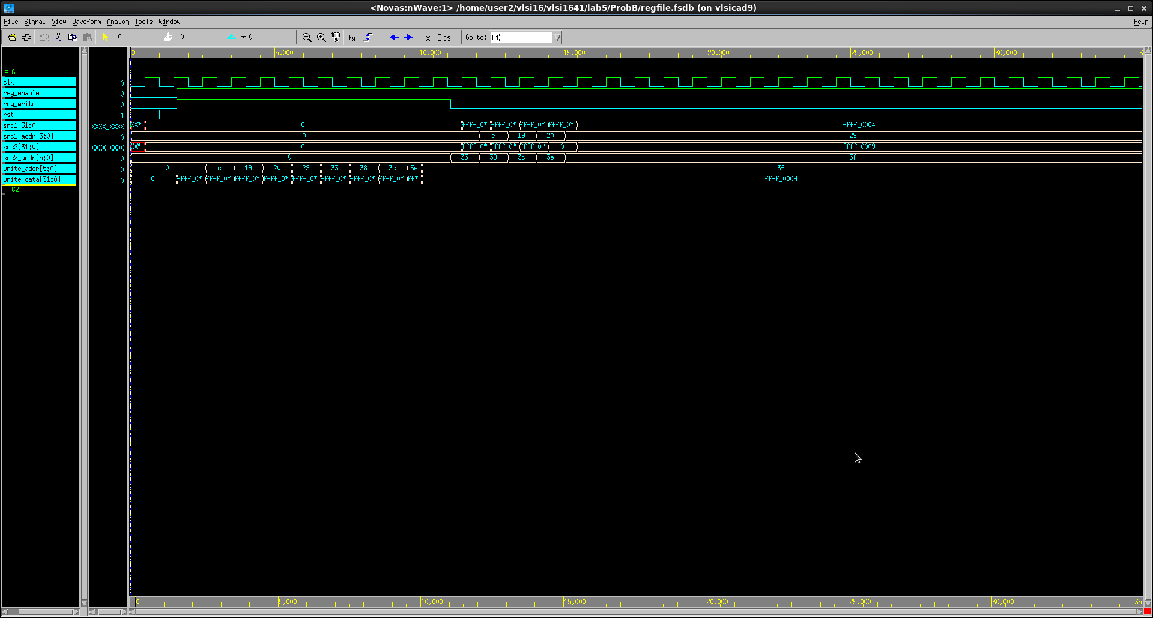

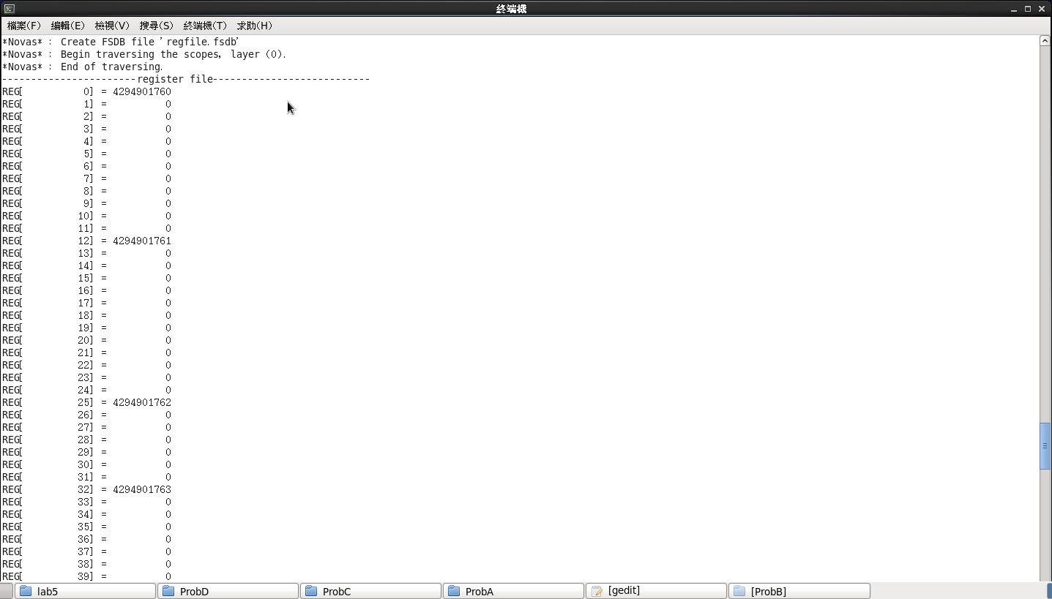
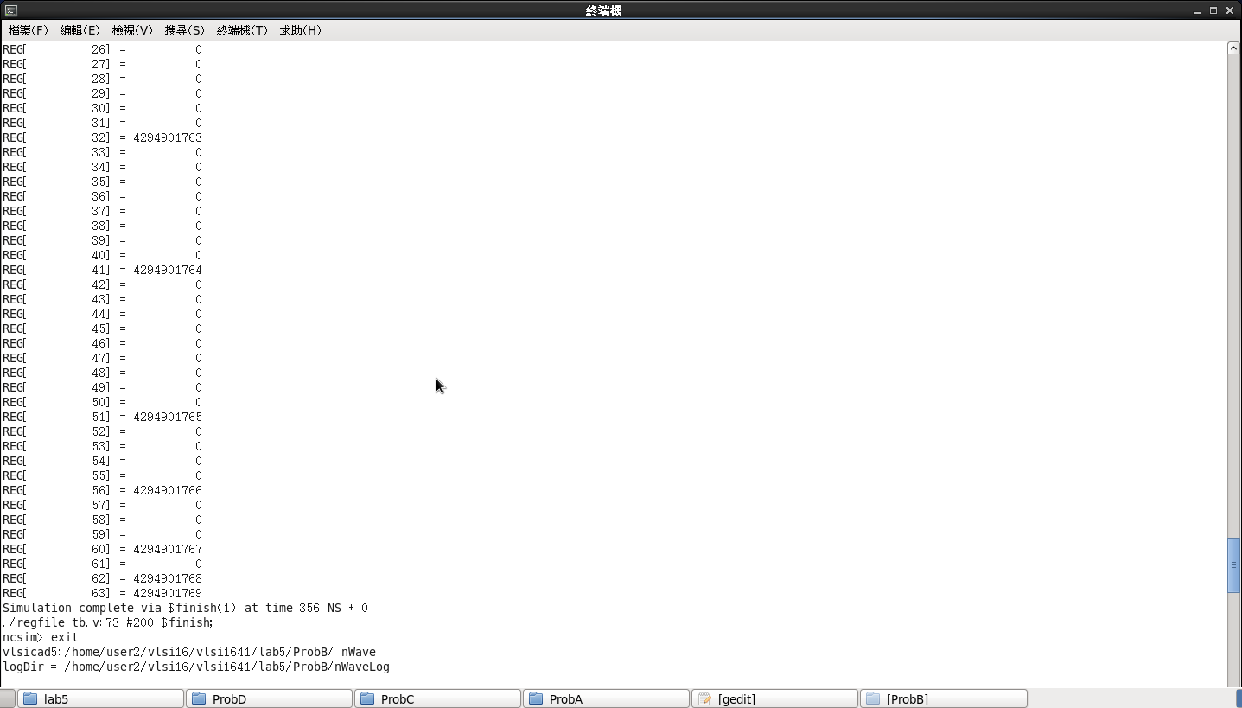

這是register file,將數值寫入其中後儲存在其中 ,當clk為正緣上升時 ,才會執行其中的運算,當reg_write為1時 ,我們將其中之一的write_addr取出 ,將其寫write_data ,把它存入其中,之後當reg_write為0時,就會讀取出數值 ,呼叫scr1_addr或是scr2_addr ,寫出其記憶體位置就可以讀出數值

Prob C: Serial-In Parallel-Out Register File
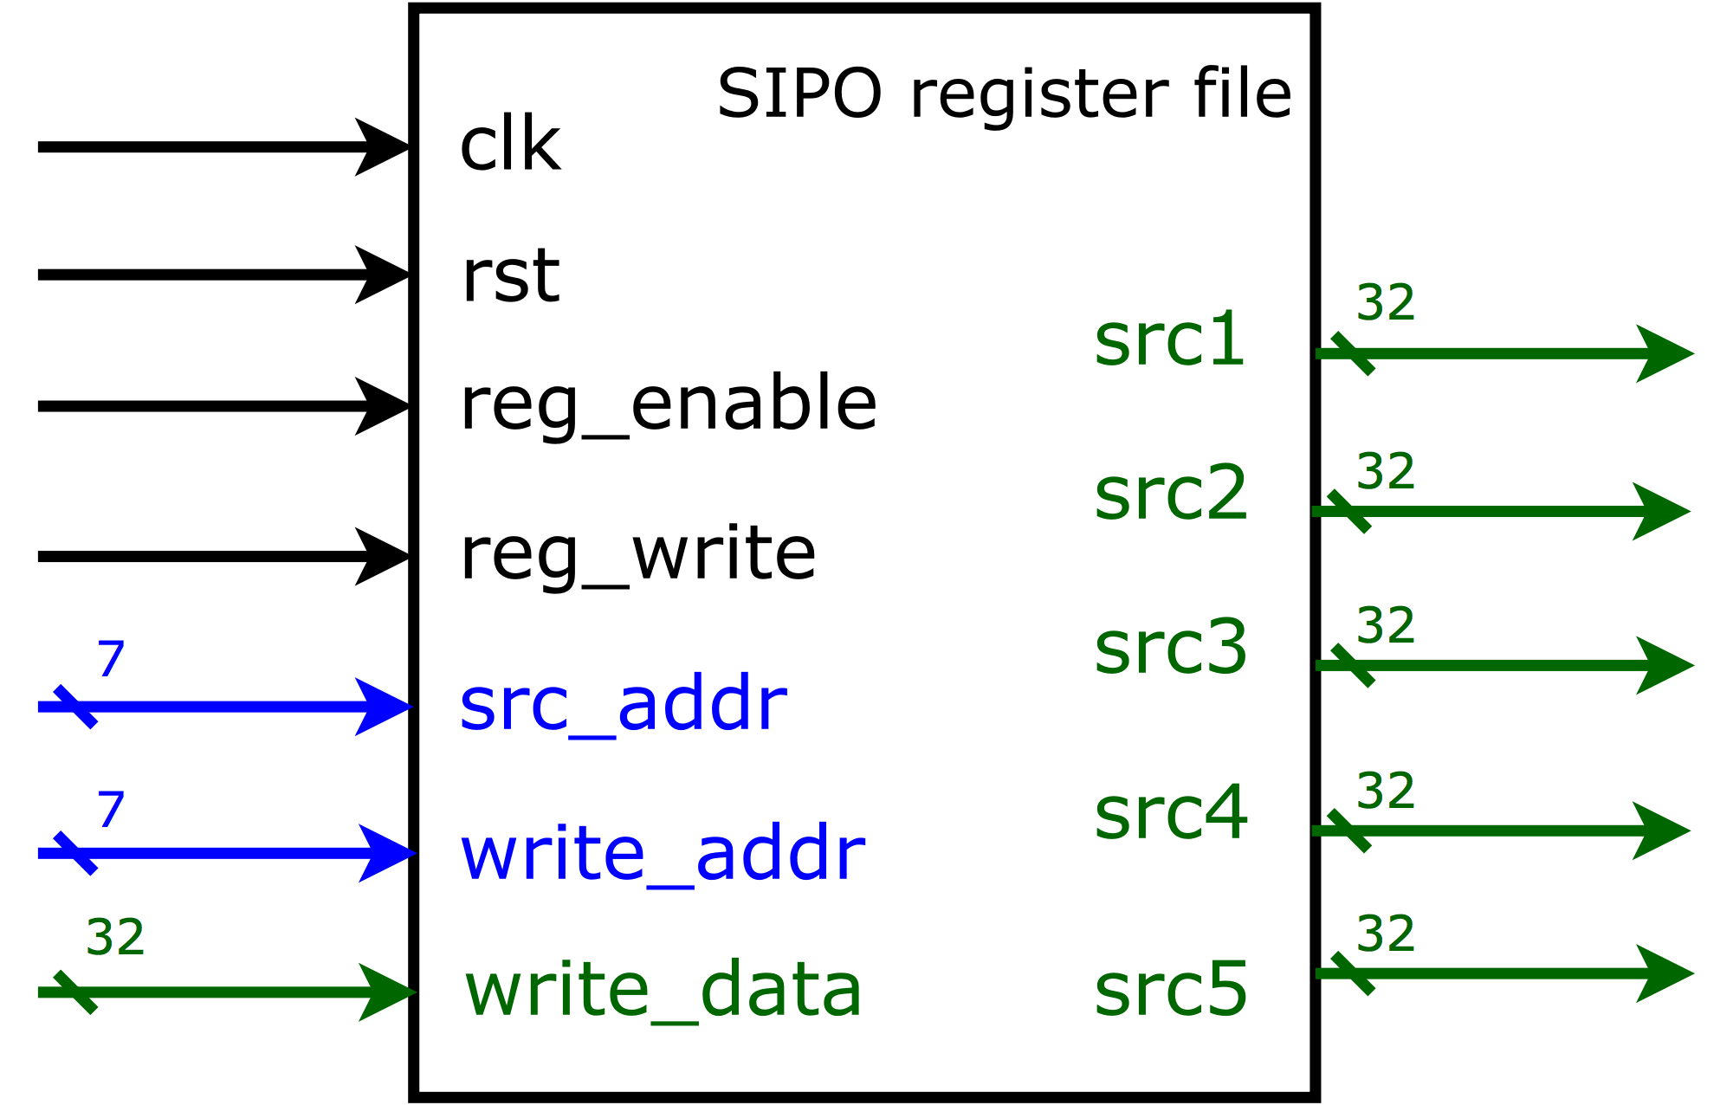
- Based on the SIPO register file in LabC, please design a 128 x 32 SIPO register file by yourself. We did not provide you any reference code but you may reference the code in the tutorial Lab5’s PDF.
- Port list
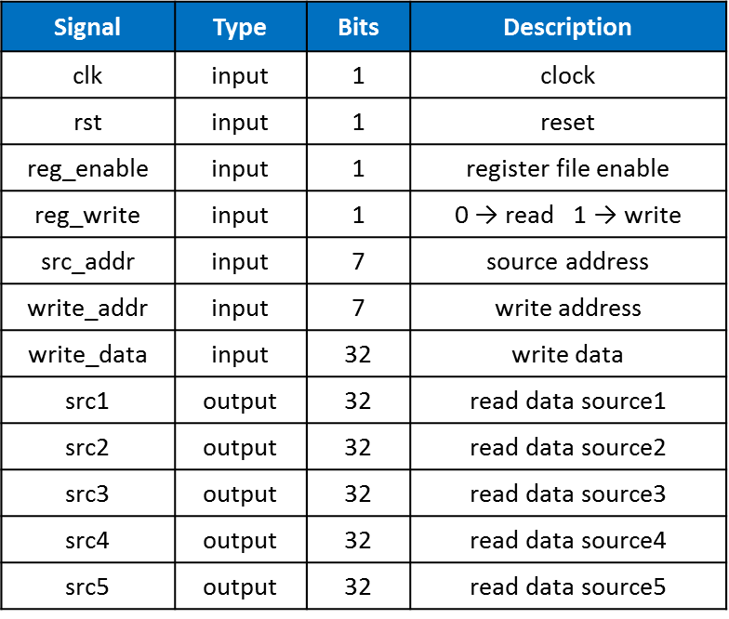
- You should follow the file name rules as follow.
- SIPO Register file
  - File name: regfile_sipo.v
  - Module name: regfile_sipo
- SIPO Register file testbench
  - File name: regfile_sipo_tb.v
  - Module name: regfile_sipo_tb
- You should verify your code by the following test patterns.
- Write data into register file
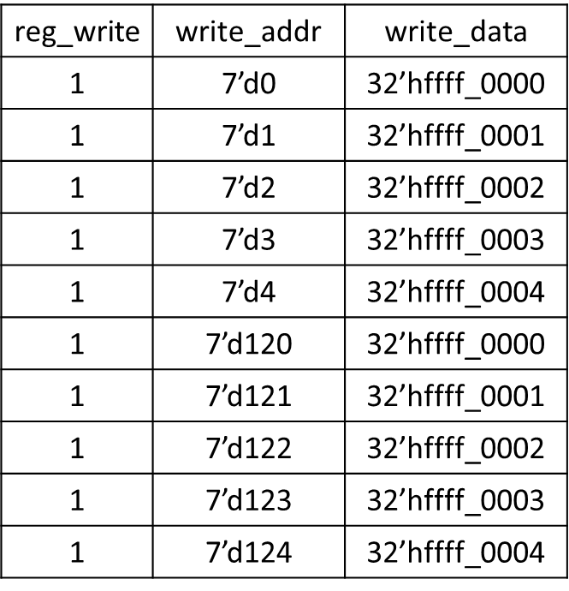
- Read data from register file
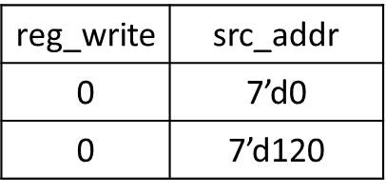
- You need to snapshot the waveform and show that your SIPO register file can read and write correctly.
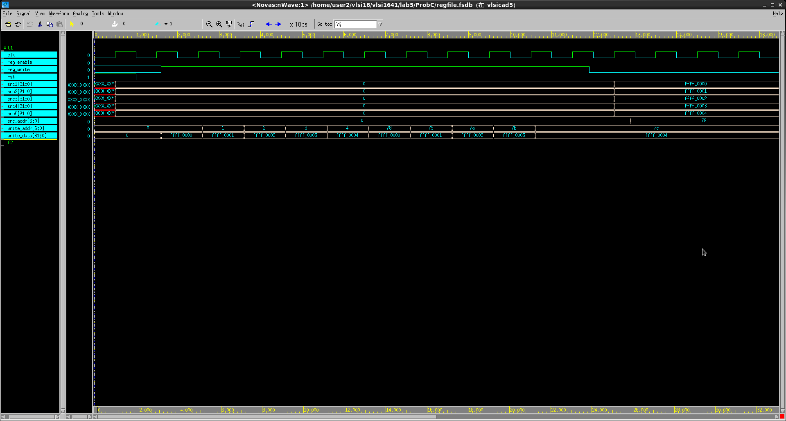

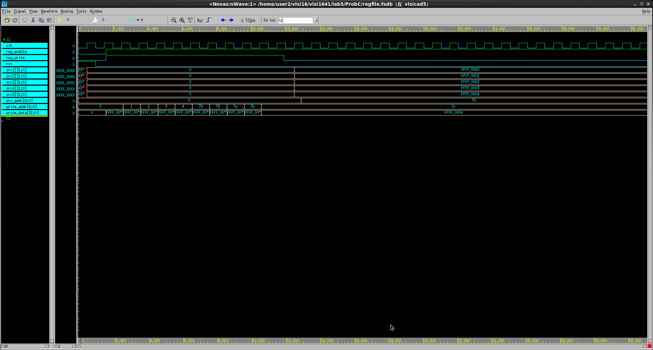

跟前一個有點像,但是是一次產生出許多數值出來,在程式中用for迴圈讓當data在讀取時可以一次能有許多數值一次顯示出來

Prob D: Register File + ALU
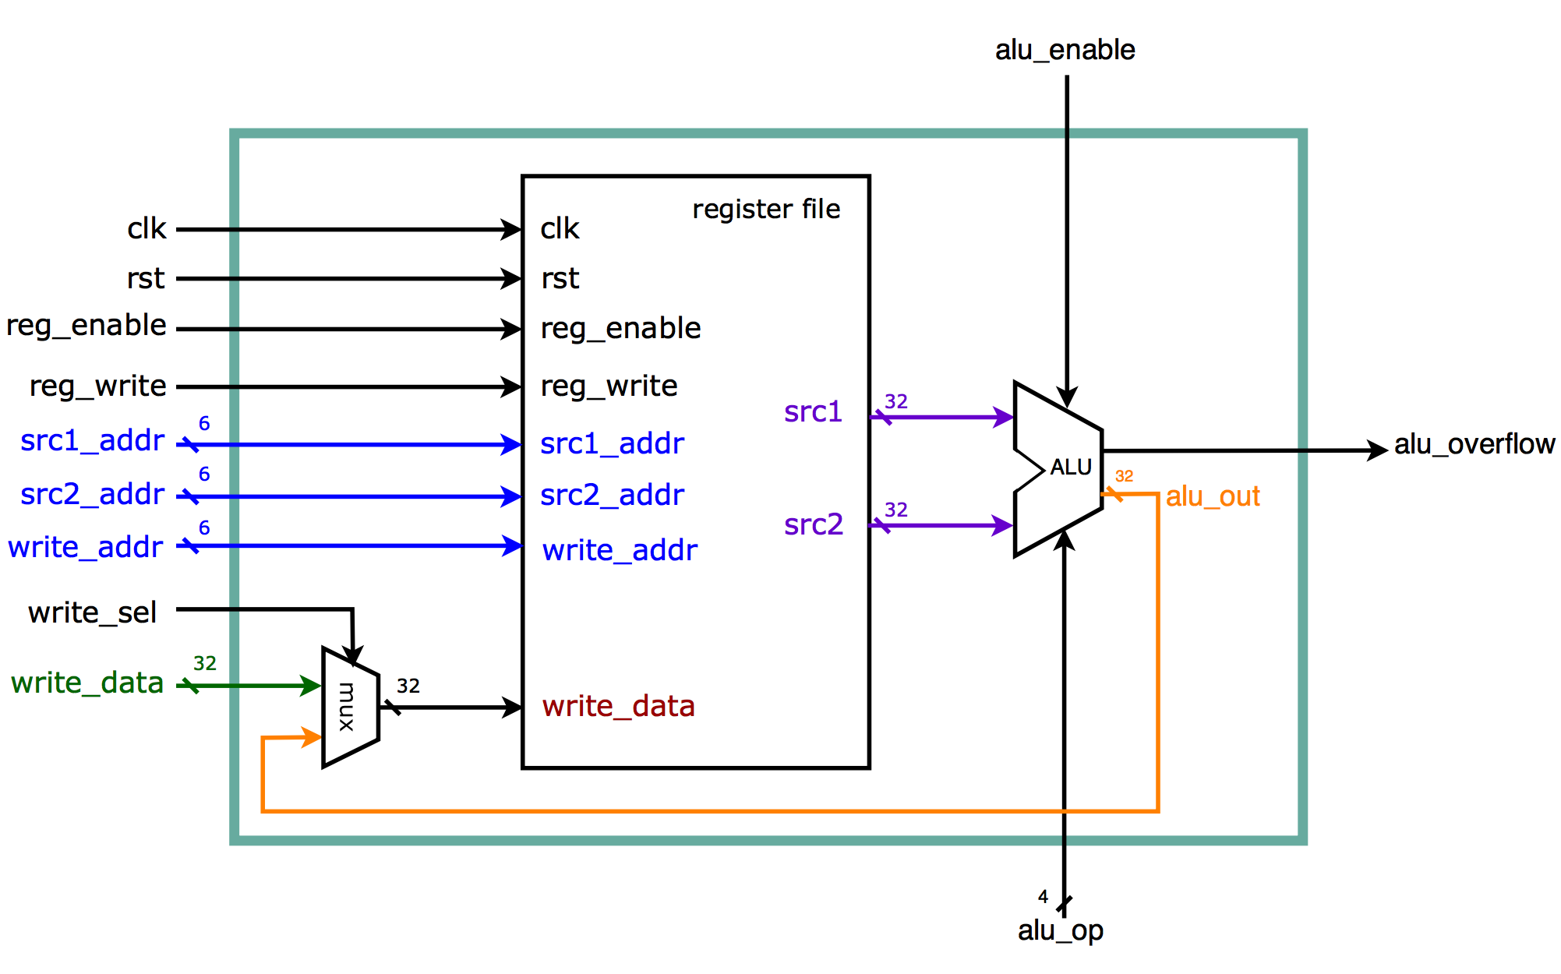
- Please implement the structure in LabD by combining the 64 x 32 Register File (Prob B) and the ALU (ProbA) to form a subsystem that could carry out the basic operation of a single processer.
- You must follow the write/read timing we taught in LabD (page 26 to page 29).
- Port list
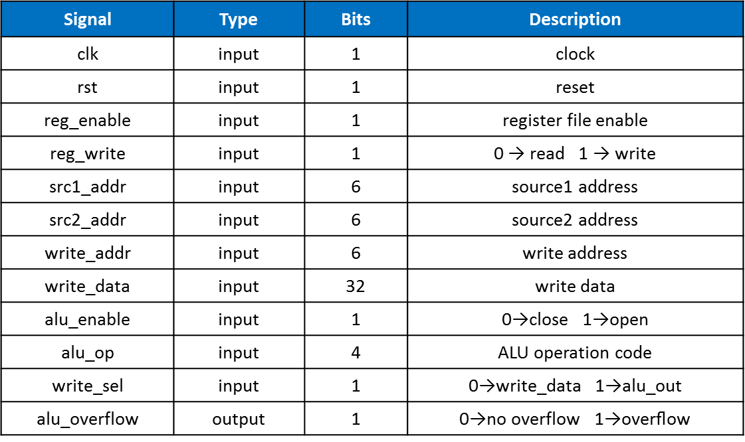
- Your subsystem should be able to do the following tasks :
- Write data into the register file
- Read data from the register file
- Execute 16 ALU operations using data which are read from the 64 x 32 register file
- Store (Write) the ALU result back into register file
- You should follow the file name rules as follow.
- Subsystem
  - File name: subsystem.v
  - Module name: subsystem
- Subsystem testbench (provided!)
  - File name: subsystem_tb.v
  - Module name: subsystem_tb
- ProbD we provide you a testbench. Your goal is to pass the testbench we provide. Do not modify the testbench!!! You should modify your code to satisfy our testbench or you will get no credit.
- If your design has errors, you will see something like this on your terminal.
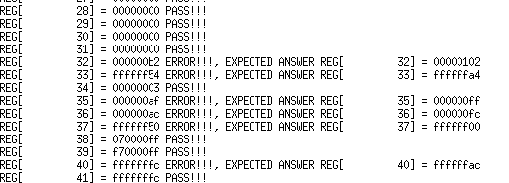
- If your design has no error, you will see this on your terminal.
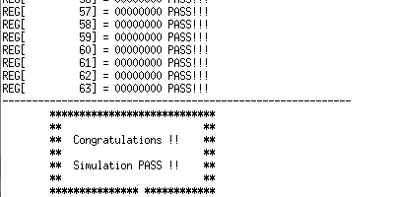
- You only need to snapshot the PASS message on the terminal.

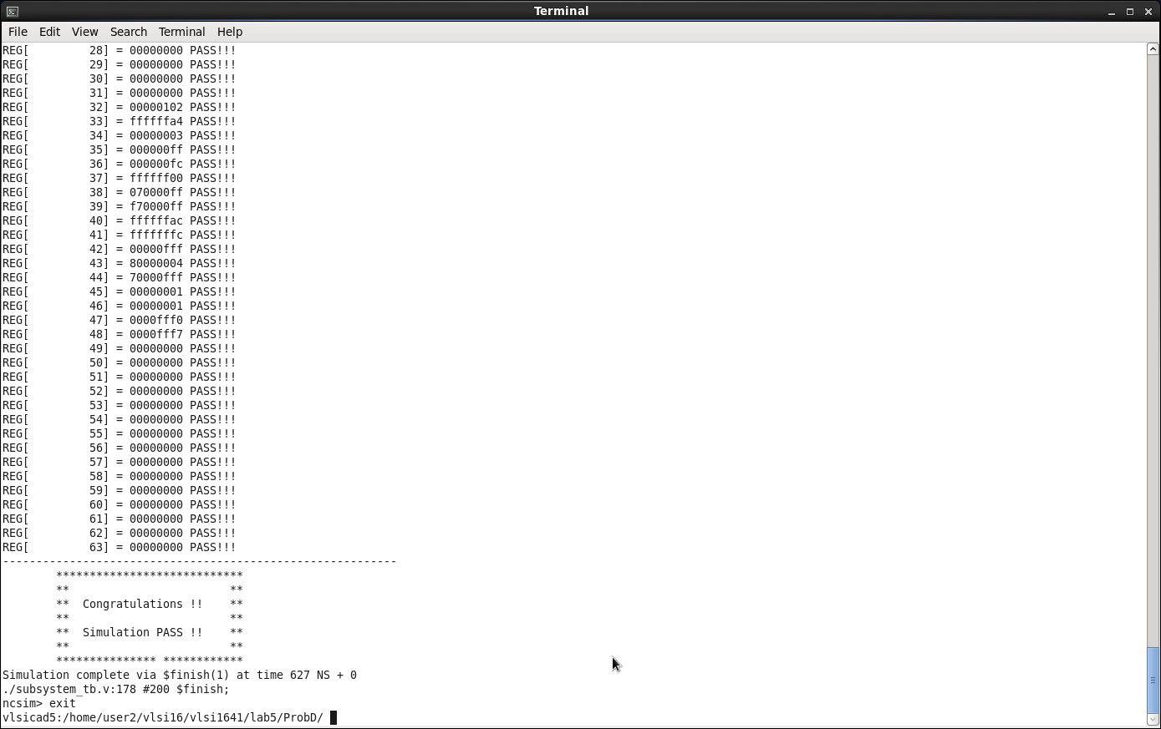
Appendix A : Commands we will use to check your homework
