National Cheng Kung University
Department of Electrical Engineering

Introduction to VLSI CAD (Spring 2016)

Lab Session 3

Design and Simulation of MUXes

Name | Student ID
林韋儒 | E24039122
Practical Sections: |  | Points | Marks
Prob A |  | 25
Prob B |  | 25
Prob C |  | 50
Notes

Due Date: 15:00, March 16, 2016 @ moodle

Deliverables
- All Verilog codes including testbenches for each problem should be uploaded.
NOTE: Please DO NOT include source code in the paper report!
- All homework requirements should be uploaded in this file hierarchy or you will not get the full credit.
NOTE: Please DO NOT upload waveforms!
- Important! TA will use the command in Appendix B to check your design under SoC Lab environment, if your code can not be recompiled by TA successfully using the commands, you will not get the full credit.
- If you upload a dead body which we can’t even compile you will get NO credit!
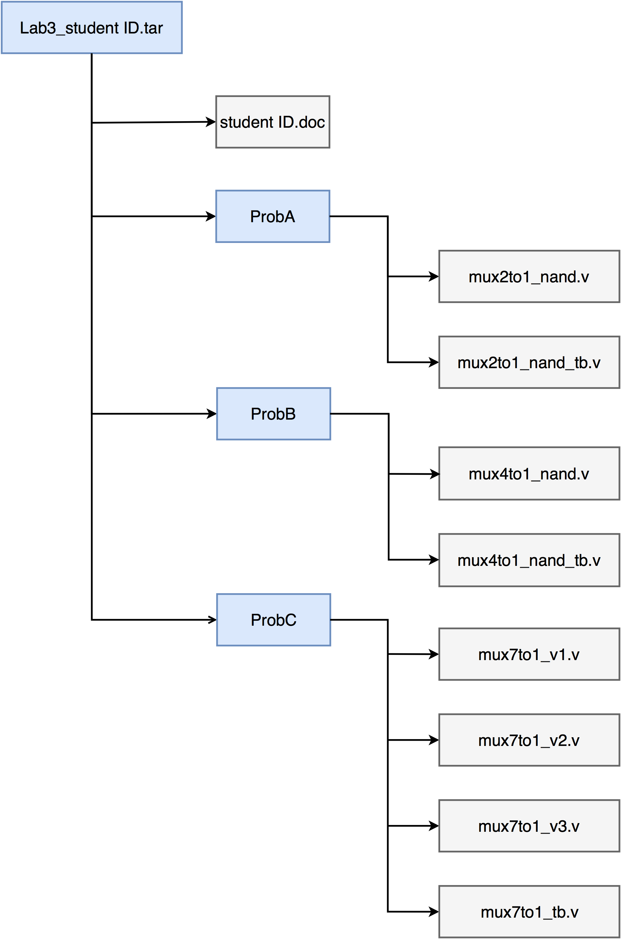
Fig.1 File hierarchy for Homework submission
Objectives:
Help students get familiar with the CAD tools (NC-Verilog & Debussy) for digital logic design. Please go through the hands-on exercise step-by-step.
Prob A: Design Steps
- Understand the function of the target component.
A multiplexer is a combinational circuit that selects binary information from one of many input lines and directs the information to a single output.

Exercise 1-1: Hand draw the symbol of a 4-to-1 MUX.
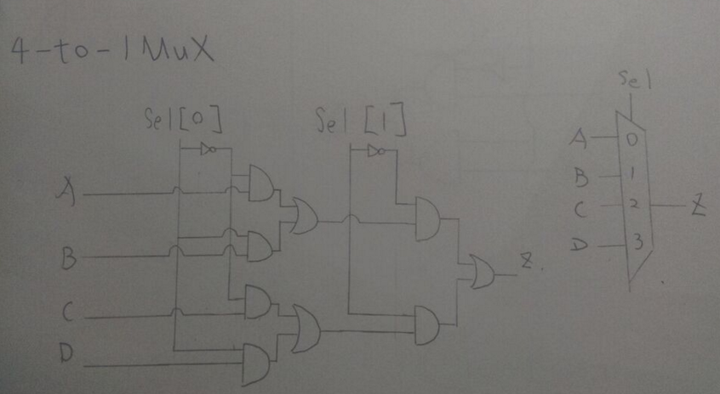
Exercise 1-2: Hand draw the data flow from one of 4 inputs to the output.
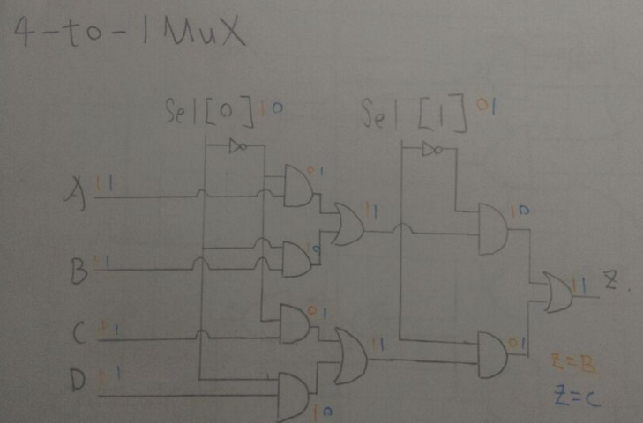
- Describe in digital logic manner for a simple component. Please fill the blank cells in the truth table and correct the Boolean equation of a 2-to-1 MUX.

Truth Table of a 2-to-1 MUX
Sel | A | B | Z
0 | 0 | 0 | 0
0 | 0 | 1 | 0
0 | 1 | 0 | 1
0 | 1 | 0 | 1
1 | 0 | 0 | 0
1 | 0 | 1 | 1
1 | 1 | 0 | 0
1 | 1 | 1 | 1

Boolean Equation of 2-to-1 MUX
Z = Sel A + Sel B

- Derive a gate-level implementation

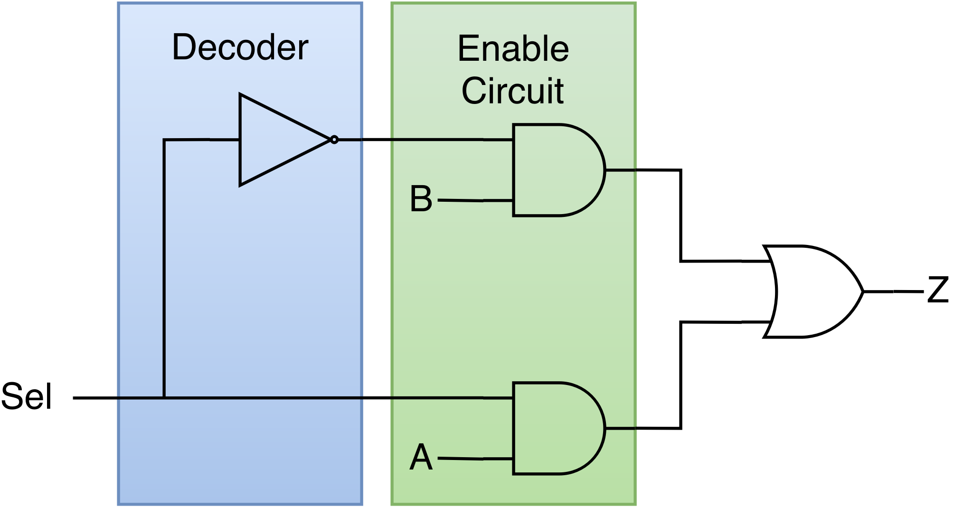
Redraw the gate-level diagram by using 2-input NAND gate.
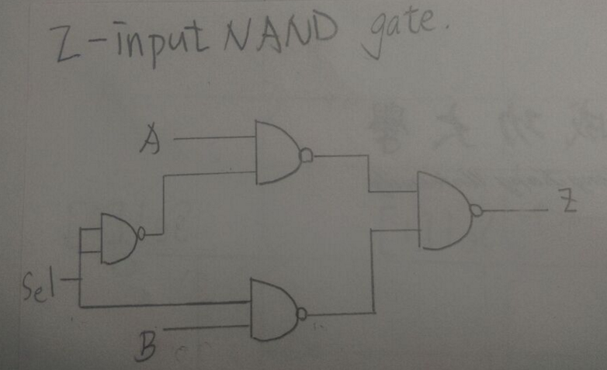
- Implement 2-to-1 MUX based on the gate-level diagram you drawn in 3) by verilog code. (The module name should be mux2to1_nand)
- You only need to upload your v-code file to moodle, do not paste your code here.

- Write a testbench for 2-to-1 MUX you implemented in 4). (You must write a new TB which is different from Lab3 example source code. The module name should be mux2to1_nand_tb)
- You only need to upload your v-code to moodle, do not paste your code here.

- Compile the code you implemented in 4) using NC-Verilog. If there are errors, please go back to 4) to debug your code and re-compile again. (Hint : The command for compiling is % ncverilog mux2to1_nand.v)

- Simulate your design in 4) with your own testbench in 5).
(Hint: The command for simulation is
% ncverilog mux2to1_nand_tb.v +define+FSDB +access+r)

- Verify your design by comparing the simulation results with the results you predicted. If the results are not the same, please go back to 4) and revise your code. If the simulation results are correct please snapshot the simulation result on the terminal and the waveform you dumped and explain your waveform. (Hint : The command to open nWave is % nWave &)

Your simulation result on the terminal. ( You should $monitor the I/O port like the example TB code does! )
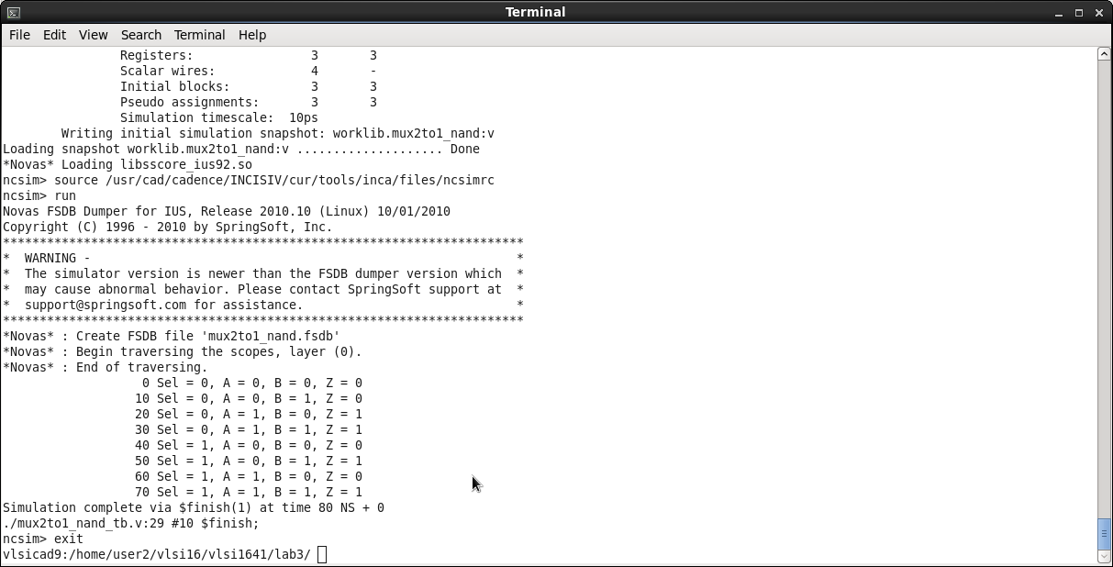
Your waveform :
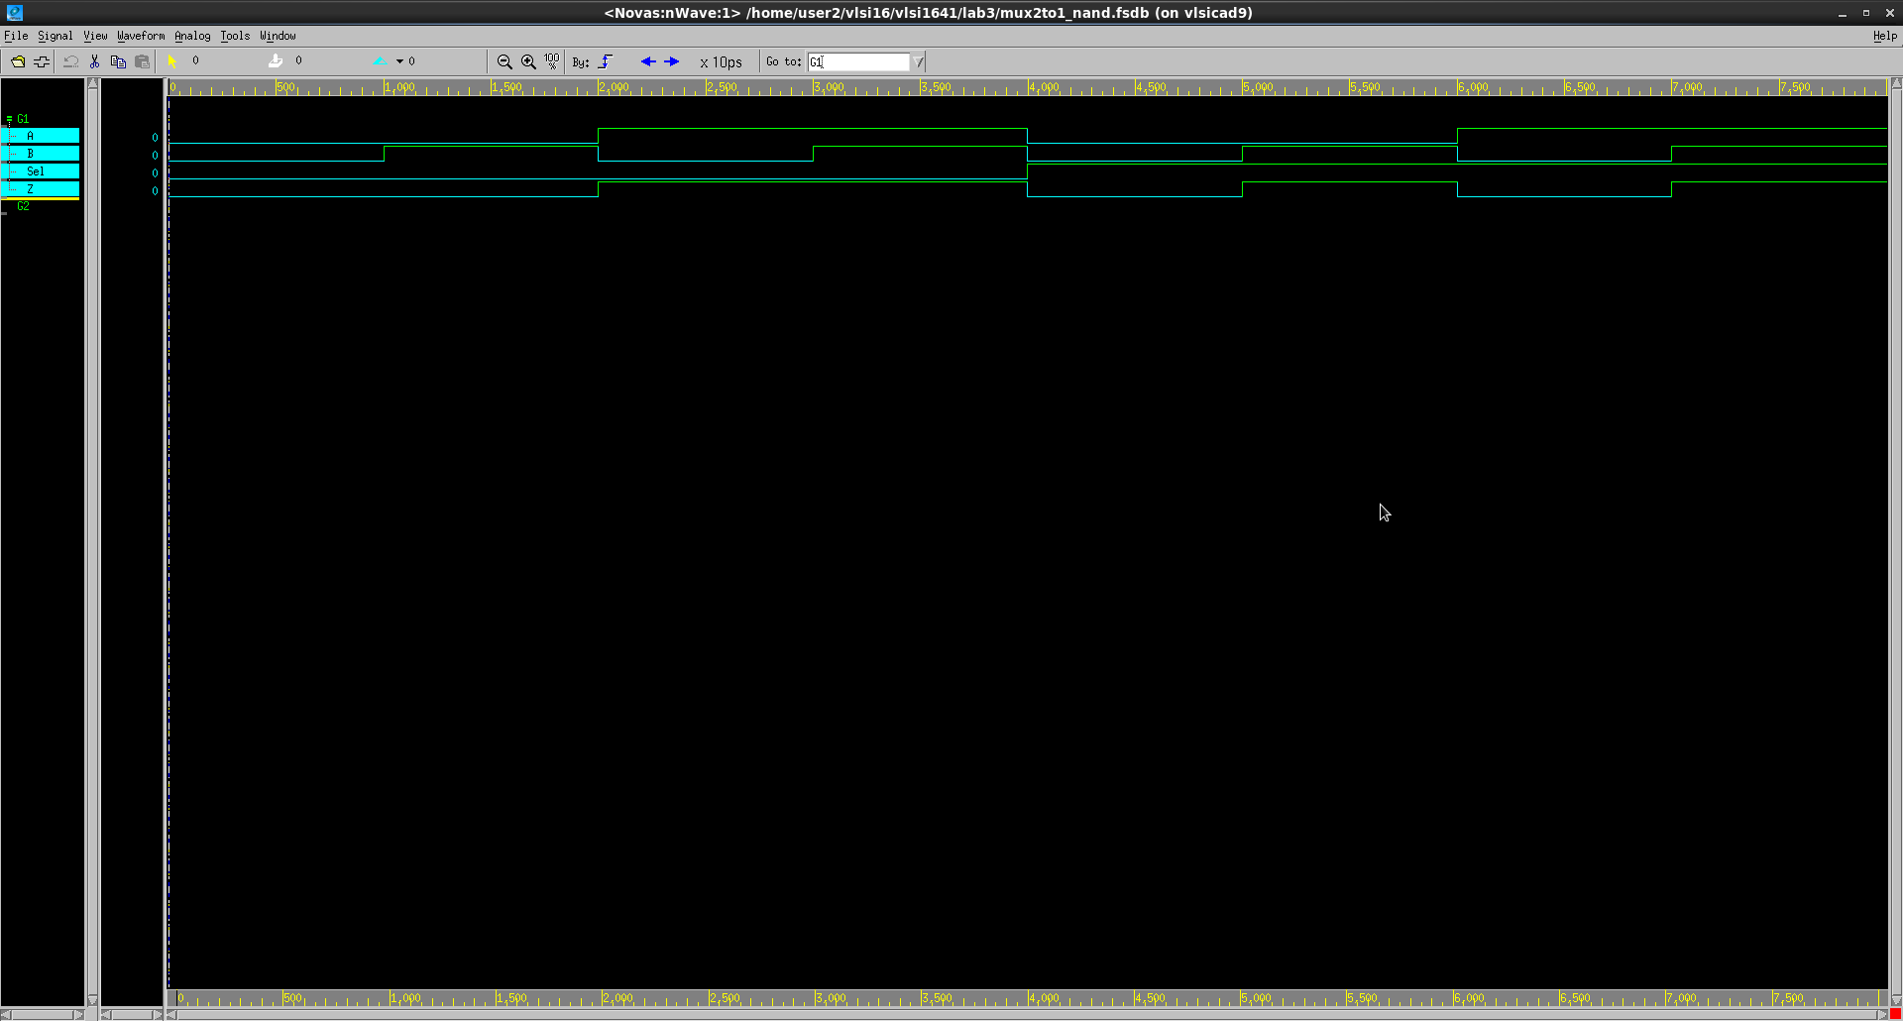
Explanation of your waveform :
當Sel選擇0時,Z的Output=A的Output
當Sel選擇1時,Z的Output=B的Output

Prob B: Hierarchical Coding
- Hand draw a 4-to-1 MUX using three 2-to-1 MUXes.
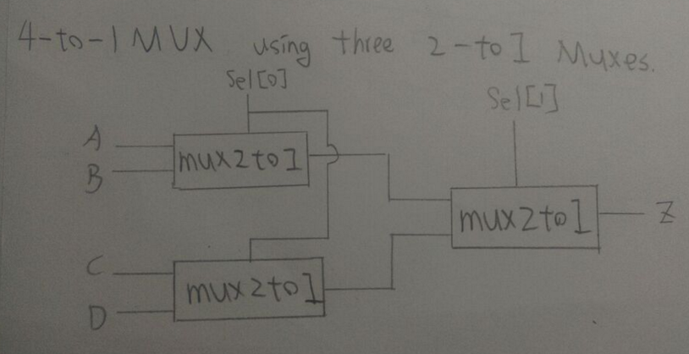
- Implement 4-to-1 MUX based on the diagram you drawn in 1) by verilog code. You should use the 2-to-1 MUX you designed in Prob A. (The module name should be mux4to1_nand. And the file you include should be mux2to1_nand.v)
- You only need to upload your v-code to moodle, do not paste your code here.

- Write a testbench for 4-to-1 MUX you implemented in 2). (You must write a new TB which is different from Lab3 example source code. The module name should be mux4to1_nand_tb)
- You only need to upload your v-code to moodle, do not paste your code here.

- Compile the code you implemented in 2) using NC-Verilog. If there are errors, please go back to 2) to debug your code and re-compile again. (Hint: The command for compiling is % ncverilog mux4to1_nand.v)

- Simulate your design in 3) with your own testbench in 4).
(Hint: The command for simulation is
% ncverilog mux4to1_nand_tb.v +define+FSDB +access+r)

- Verify your design by comparing the simulation results with the results you predicted. If the results are not the same, please go back to 2) and revise your code. If the simulation results are correct please snapshot the simulation result on the terminal and the waveform you dumped and explain your waveform. (Hint : The command to open nWave is % nWave &)

Your simulation result on the terminal. (You should $monitor the I/O port like the example TB code does!)
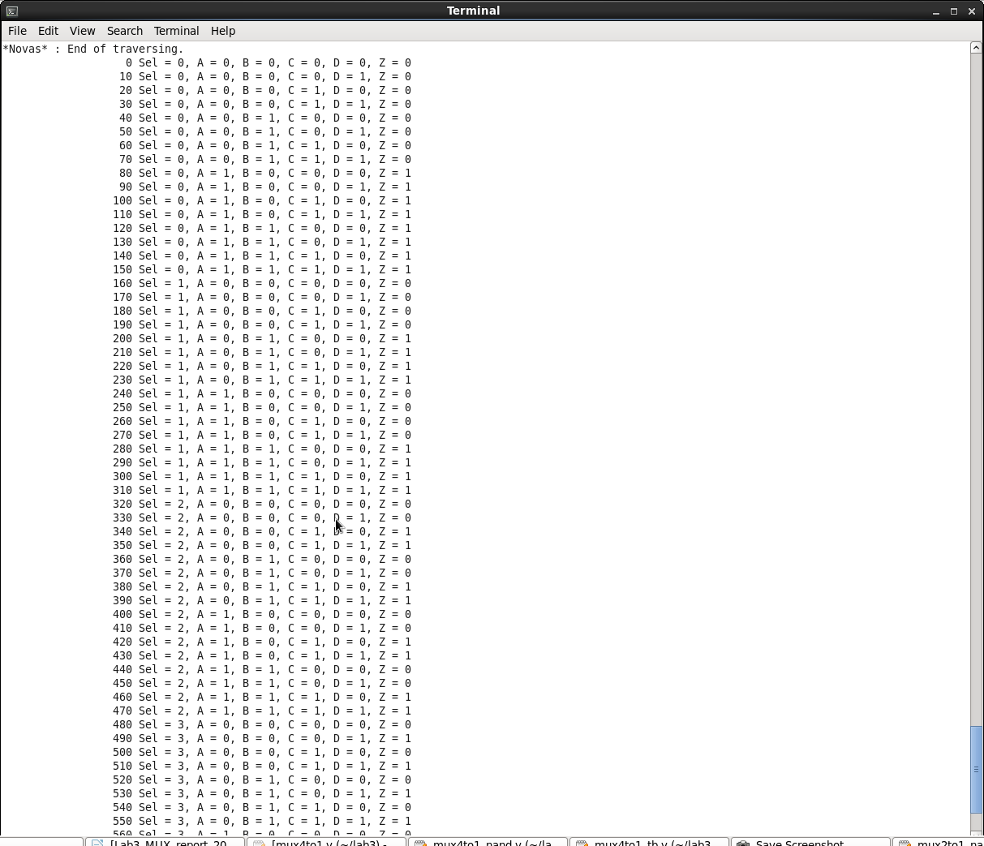
Your waveform :
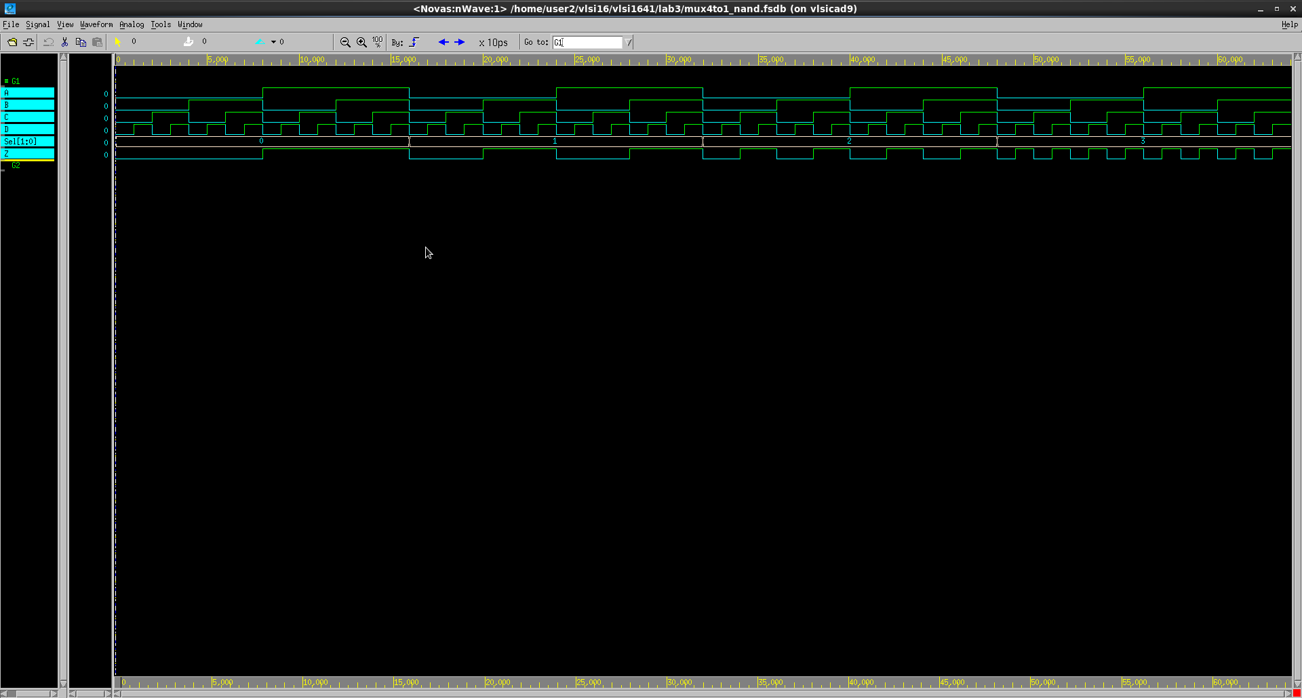
Explanation of your waveform :
當Sel選擇00時,Z的Output=A的Output
當Sel選擇01時,Z的Output=B的Output
當Sel選擇10時,Z的Output=C的Output
當Sel選擇11時,Z的Output=D的Output
Prob C: 7-to-1 MUX Implementation
- Design a 7-to-1 MUX in three ways under gate level. You can use any primitive instantiation, for example, the NOT gate, AND gate, OR gate, XOR gate and etc. You can use hierarchical coding, too.
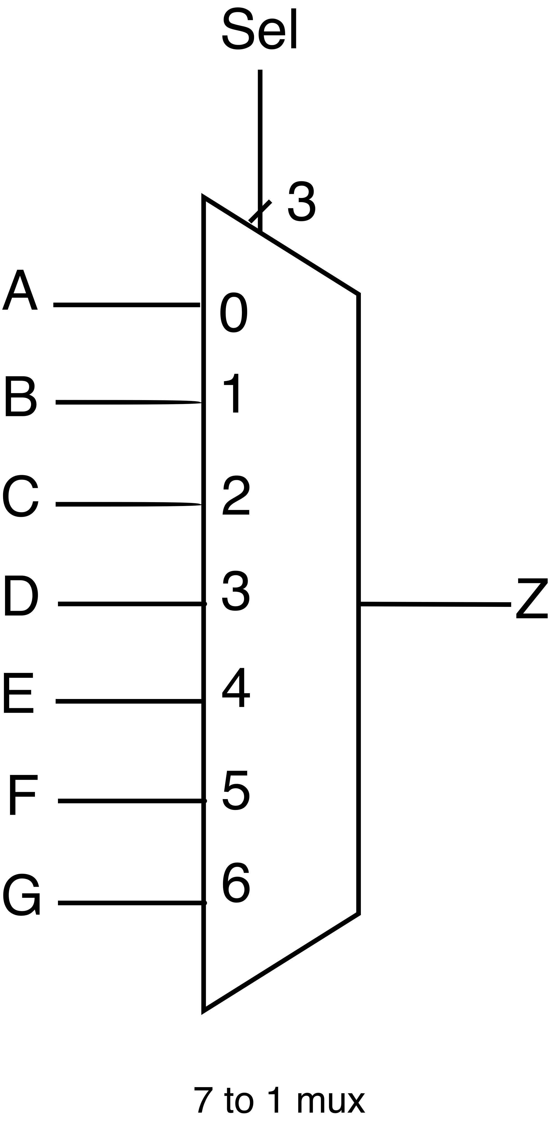
- This time we provide a mux7to1_tb skeleton for you to use. To implement the missing test patterns please look at the table in Appendix A.
- Please follow these rules or you might have trouble using the provided testbench.
- File names of your design should be named as mux7to1_v1.v, mux7to1_v2.v, mux7to1_v3.v
- Module names in those three files should all be named as mux7to1
- You must follow the port names in the testbench
- Compile command
% ncverilog mux7to1_v1.v (or mux7to1_v2.v or mux7to1_v3.v)
- Simulation command
# For first version of your design
% ncverilog mux7to1_tb.v +define+v1+FSDB +access+r
# For second version of your design
% ncverilog mux7to1_tb.v +define+v2+FSDB +access+r
# For third version of your design
% ncverilog mux7to1_tb.v +define+v3+FSDB +access+r
- In each design, please report:
- The schematic of the design.

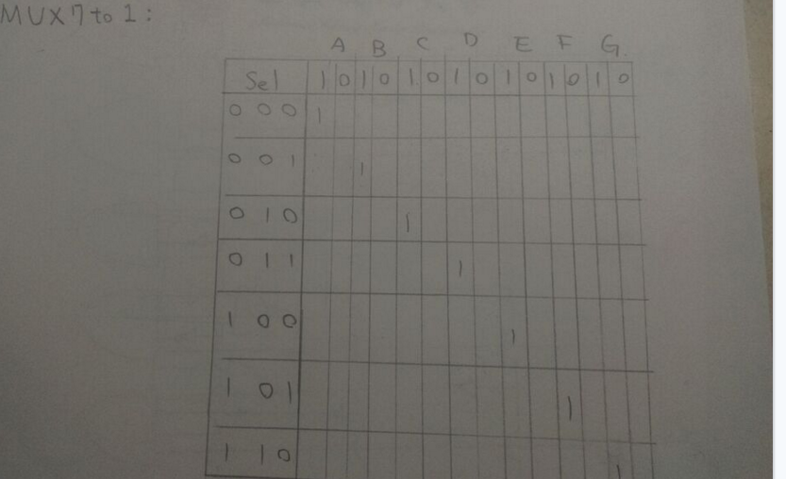

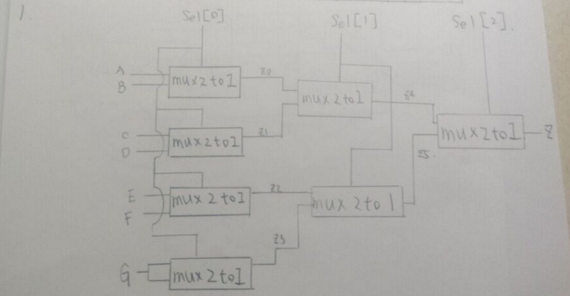
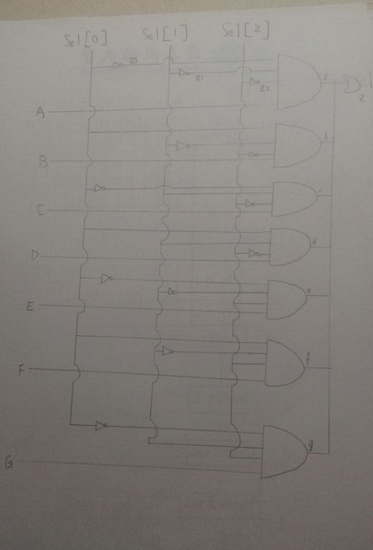
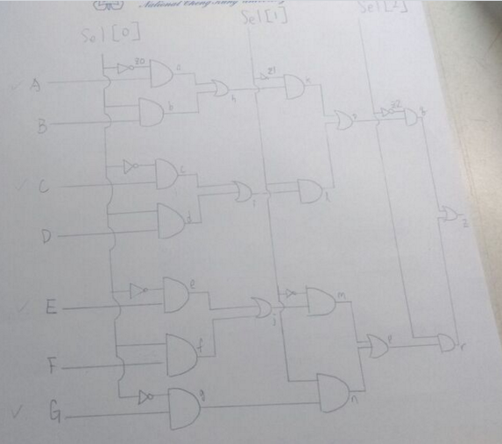
- The Verilog code of the design.
(You only need to upload your v-code to moodle, do not paste your code here.)
- The simulation result of the design. Please snapshot the terminal result and the simulation waveform.
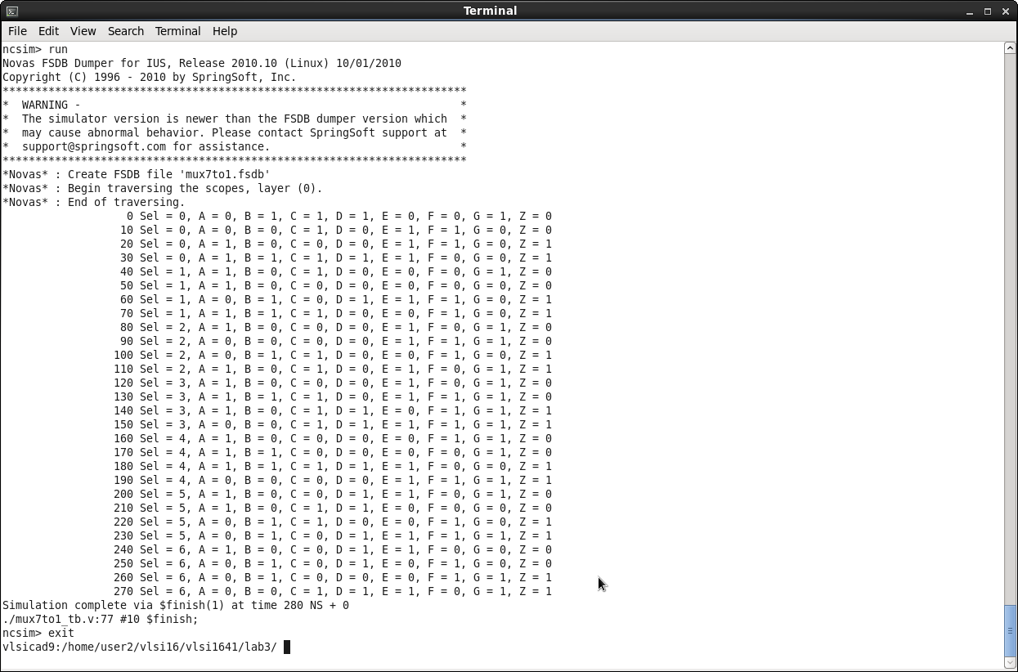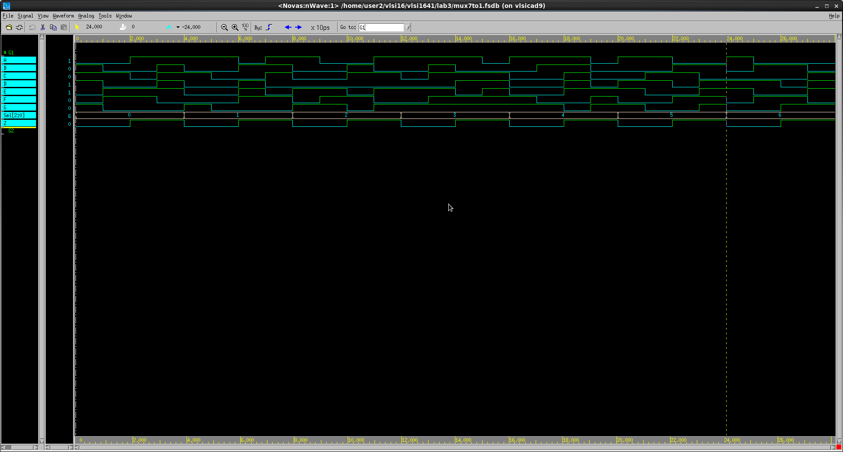
- At last, please write the lesson you learned from Lab 3.
這次實驗讓我學到很多東西,從老師上課精彩且詳細的介紹,還有助教詳細的解說實驗,讓我收穫許多,雖然之前有學過如何寫, 但是沒有這次講解的詳細,而且之前也有許多沒注意到的地方,這次就很清楚地避免,二對一多工器和四對一之前有聽過,但是沒用VERILOG寫出來,這次特別在實驗中執行出來,還用NAND GATE顯示,我覺得很棒,最後還有七對一多工器,自己想出三種以上的方法去解, 讓我獲益良多,也感謝助教和教授的指導,讓我抓出許多盲點以及缺失,覺得開心

Appendix A : Test Patterns for ProbC 7-to-1 MUX
select signal | Input |  |  |  |  |  |  | Output
Sel [ 2:0 ] | A | B | C | D | E | F | G | Z
3b’000 | 0 | 1 | 1 | 1 | 0 | 0 | 1 | 0
3b’000 | 0 | 0 | 1 | 0 | 1 | 1 | 0 | 0
3b’000 | 1 | 0 | 0 | 0 | 1 | 1 | 0 | 1
3b’000 | 1 | 1 | 1 | 1 | 1 | 0 | 0 | 1
3b’001 | 1 | 0 | 1 | 1 | 0 | 0 | 1 | 0
3b’001 | 1 | 0 | 0 | 0 | 0 | 0 | 0 | 0
3b’001 | 0 | 1 | 0 | 0 | 1 | 1 | 0 | 1
3b’001 | 1 | 1 | 1 | 1 | 0 | 1 | 0 | 1
3b’010 | 1 | 0 | 0 | 0 | 1 | 0 | 1 | 0
3b’010 | 0 | 0 | 0 | 0 | 1 | 1 | 1 | 0
3b’010 | 0 | 1 | 1 | 0 | 0 | 1 | 0 | 1
3b’010 | 1 | 0 | 1 | 0 | 1 | 0 | 1 | 1
3b’011 | 1 | 0 | 0 | 0 | 1 | 0 | 1 | 0
3b’011 | 1 | 1 | 1 | 0 | 1 | 1 | 1 | 0
3b’011 | 1 | 0 | 1 | 1 | 0 | 1 | 1 | 1
3b’011 | 0 | 0 | 1 | 1 | 1 | 1 | 1 | 1
3b’100 | 1 | 0 | 0 | 0 | 0 | 1 | 1 | 0
3b’100 | 1 | 1 | 0 | 0 | 0 | 0 | 1 | 0
3b’100 | 1 | 1 | 1 | 1 | 1 | 0 | 0 | 1
3b’100 | 0 | 0 | 0 | 0 | 1 | 1 | 1 | 1
3b’101 | 1 | 0 | 0 | 1 | 1 | 0 | 1 | 0
3b’101 | 1 | 0 | 1 | 1 | 0 | 0 | 0 | 0
3b’101 | 0 | 1 | 1 | 0 | 0 | 1 | 0 | 1
3b’101 | 0 | 1 | 0 | 1 | 1 | 1 | 1 | 1
3b’110 | 1 | 0 | 0 | 1 | 1 | 0 | 0 | 0
3b’110 | 0 | 1 | 0 | 1 | 0 | 1 | 0 | 0
3b’110 | 0 | 1 | 0 | 0 | 0 | 1 | 1 | 1
3b’110 | 0 | 0 | 1 | 1 | 1 | 0 | 1 | 1

Appendix B : Commands we will use to check your homework
Problem |  | Command
ProbA | Compile | % ncverilog mux2to1_nand.v
ProbA | Simulate | % ncverilog mux2to1_nand_tb.v +define+FSDB +access+r
ProbB | Compile | % ncverilog mux4to1_nand.v
ProbB | Simulate | % ncverilog mux4to1_nand_tb.v +define+FSDB +access+r
ProbC | Compile | % ncverilog mux7to1_v1.v
ProbC | Simulate | % ncverilog mux7to1_tb.v +define+v1+FSDB +access+r

