***Stages of making a SAESER***

ENG.AHMAD

HISHAM

MAJD

KANAAN

**Introduction**

**WRO Future Engineers -Selft Driving car**

**selft driving car**

**When we talk about competitions that are concerned with the field of robotics, we must talk about The** World Robot Olympiad (WRO) **, which was launched for the youth category. China, Japan and Singapore, and these four countries are the founding countries of this Olympiad (now known as the WRO Advisory Board).**

**Problems**

Our Competition:

We are competing in this competition in the Future Engineers category It revolves around designing a self-driving robot that can overcome the obstacles and problems it encounters in the least possible time, based on artificial intelligence and machine learning.

Contest idea:

The environment of this competition consists of a circuit surrounded by an external wall, inside which there is an internal wall. As for the competition, it consists of one stage in which the robot runs at a rate of 3 laps that it must complete in 3 minutes as a maximum.

**STAGE**

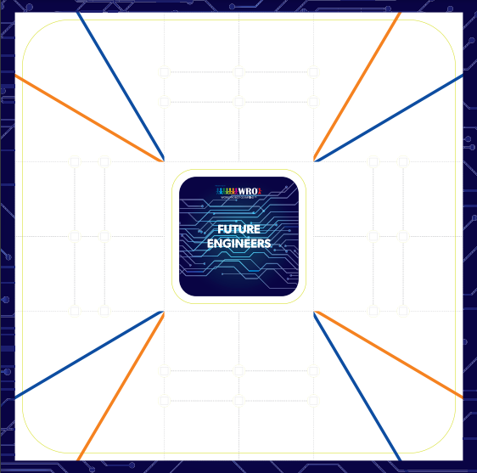

**Hypotheses**

During our work and the manufacture of the robot, we encountered many problems, and it is normal for such matters to happen in this field. They must be resolved with patience, effort, research, and the use of time to find an accurate solution.

**Hypotheses and questions:**

How to identify the appropriate electronics and employ them properly?

How can machine learning be employed in the work of a robot?

How can you complete the race and avoid mistakes?

How can a software algorithm be found to make the performance professional?

How to find solutions to all possible possibilities?

Methodology

The design phase of the robot was divided into 2 parts

namely:

. Hardware 1

. Software2

First, the electronics were selected according to the "WRO" competition.

Secondly, we start creating 3D designs to be placed on most electronic pieces to install or otherwise.

Thirdly, we start installing the 3D designs of electronics on the robot and conducting a preliminary test for it.

Finally, we start writing the software code and employing these electronics in it.

**The Electronics:**

**Use Electronics:**

**• Arduino Mega 2560**

**• L298N Motor Driver**

**• Ultrasonic Distance sensor x(4)**

**• DC gear motor 12v 60 RPM**

**• s3003 servo motor**

**• Power Supply**

**• Wires**

**• Wheels**

**Arduino Mega 2560:**

**• Microcontroller: ATmega2560.**

**• INPUT VOLTAGE (LIMIT): 6-20V**

**• Flash Memory: 256 KB** of which 8 KB used by bootloader**.**

**• Analog In Pin: 16.**

**• Digital I/O Pins: 54** (of which 15 provide PWM output).

**• Weight: 37g.**

**صورة تحتوي على نص, لقطة شاشة, برمجيات, دائرة كهربائية

تم إنشاء الوصف تلقائياً**