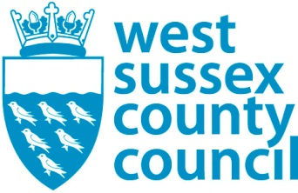

Self-harm in West Sussex – a rapid needs analysis

Author: Rachel Jevons - Public Health Lead for Mental Health, WSCC

Contents

Key recommendations

Chapter 1: What is self-harm and what do we know about self-harm in West Sussex?
  - What is self-harm?
  - What is the extent of self-harm in West Sussex?

Chapter 2: Who is most likely to self-harm?
2.1 Who is at highest risk?
2.2 Demographics and identity
2.3 Sex
2.4 Ethnicity
2.5 Sexual orientation and gender identity
2.6 Deprivation

Chapter 3: What causes a person to self-harm and what factors help reduce the risk?
3.1 Relationships
3.2 External stressors
3.3 Financial and economic circumstances
3.4 Diagnosed mental illness
3.5 Internet use

Chapter 4: What can we do and what are we doing?
4.1 Opportunities for intervention and prevention
4.2 Interventions and preventions

Chapter 5: What strategies do we have to identify, co-ordinate and inform these
interventions and prevention opportunities?

5.1 West Sussex Suicide Prevention Strategy 2017-2020
5.2 West Sussex Plan 2017-2022
5.3 Sustainability and Transformation Programme (STP)

Key recommendations

Oversight and strategy
There is a large and wide ranging amount of activity taking place in West Sussex that impacts on this area, but it is important that it is delivered in a coordinated and strategic way, which recognises that this is a related but separate area to suicide prevention.

Recommended actions
Although there is service provision and sources of support for all ages, there are clear opportunities for improvement. Given what we know about the people at risk and the West Sussex context, we have formed the following recommendations against which we can assess progress.

- Establish a multi-agency self-harm oversight group, as a sub-group of the West Sussex suicide prevention steering group.
- Continue the joined up and strategic approach to children and young people’s mental and emotional health and wellbeing in educational settings
- Commission focussed rapid research / data gathering on community self-harm activity ( ie which does not result in emergency admission), including in educational settings
- Deliver a systematic programme to increase skills and awareness amongst relevant professional groups
- Ensure that when targeting interventions for self-harm prevention, data for deprivation is used to identify where those most at risk groups are.
- Set out a plan for working with acute trust partners to assess the quality and coordination of secondary care to prevent readmission
- Establish an agreed West Sussex pathway to support people through bereavement – for end of life and planned/expected deaths as well as suicide/ sudden and unexpected death.
- Deliver a campaign focussed on messaging and interventions promoting middle aged men’s mental and emotional health and wellbeing
- Establish what additional support is available for LGBTQI people’s emotional and mental health and wellbeing and identify gaps, partnership working and training opportunities
- Develop a plan for working with CCGs, SPFT and community pharmacists as well as parents/families to identify opportunities for reducing incidences of self-poisoning
- Strategic activity around safe internet use in the county to explicitly support self-harm prevention, through the new self-harm prevention Programme Manager role.
- Assess optimal digital approaches supporting self-harm prevention interventions.
- Develop a plan to work with CVS organisations who work with high risk groups, to develop nuanced and suitable messages around self-harm and good mental health.

Chapter 1: What is self-harm and what do we know about self-harm in West Sussex?

What is self-harm?
This needs analysis looks at self-harm across the life course and considers risks and protective factors and drivers for self-harm in all age groups. It frames the issue in West Sussex and looks at opportunities and existing provision for prevention. It outlines a number of priority areas where further work is needed to address this issue.
There are a number of definitions of self-harm; some of these consider the intent of the self-harm, some exclude certain ‘self-destructive behaviours’ such as excessive drinking, eating disorders and drug misuse and therefore may lead to an underestimation of the drivers and intent, as well as excluding some behaviours predominantly associated with males.
Although there are significant issues with alcohol and substance related admissions and deaths, we will not be including these within this needs assessment. There is currently a public health programme to reduce alcohol and substance misuse where there are opportunities for joint working.
We will follow the example from our neighbours in Brighton & Hove Council and Brighton & Hove Clinical Commissioning Group (CCG)( 1) and take a pragmatic approach, using the more inclusive definition provided by the National Self-Harm Network:
“Self-harm can take many different forms and as an individual act is hard to define. However, in general self-harm (also known as self-injury or self-mutilation) is the act of deliberately causing harm to oneself either by causing a physical injury, by putting oneself in dangerous situations and / or self-neglect.”

What is the extent of self-harm in West Sussex?
Defining the extent of self-harm in the county is made problematic by the available data, which relates to hospital emergency admissions. Assumptions can be made on the basis of national data, but there is little local information on self-harm which does not result in a hospital admission which is likely to be most cases.

All ages
Most recent data show that in 2017/18 there were 1,743 emergency admissions for self-harm in West Sussex (2). Represented as a rate per 100,000 this is significantly higher than the England average. Adur and Worthing have highest incidence. Looking over a five year period from 2013/14 to 2017/18, there were 9,254 emergency hospital admissions for self-harm in West Sussex, an age-standardised rate of 236.1 per 100,000 persons. The estimated rate of admissions for self-harm was highest in an MSOA in Worthing, at 481.5 per 100,000 (Figure 1).

Across West Sussex, rates of self-harm vary; Adur, Arun and Worthing have exceeded the national rate since 2010/11 (to 2017/18), whilst Horsham and Mid Sussex tend to be more comparable to the England average. There are marked inequalities in self-harm, with higher rates among areas with greater deprivation.
Figure 1: Directly age-standardised rate of emergency hospital admissions for self-harm (2013/14 to 2017/18 data aggregated)
Colours reflect comparison with West Sussex. Areas in red are significantly higher, green are significantly lower and yellow are similar to West Sussex.
(PHSRU WSCC, 2019)
In terms of trends, over the five year period from 2013/14 to 2017/18, while emergency admissions in the county are consistently higher than for England, they do not show a significant increase or decrease (Table 1). The numbers of admissions for 2016/17 and 2017/18 are lower than those for the previous three years.
Table 1: West Sussex emergency hospital admissions for intentional self-harm - number and rate per 100,000 population from 2013/14 to 2017/18
Period | Number | Rate | Lower CI | Upper CI
2013/14 | 1,936 | 247.6 | 236.6 | 258.9
2014/15 | 1,810 | 230.3 | 219.8 | 241.2
2015/16 | 2,051 | 261.5 | 250.3 | 273.1
2016/17 | 1,714 | 218.8 | 208.5 | 229.5
2017/18 | 1,743 | 222.2 | 211.8 | 232.9
Source : Public Health Outcomes Framework

Methods of self-harm
In the five years from 2013/14 to 2017/18, 88% of admissions were due to self-poisoning and the majority of those were from widely available over the counter medicines, such as paracetamol. Of these:
- 38% were self-poisoning through non-opioid medication (such as paracetamol, ibuprofen and other over the counter medicines);
- 30% self-poisoned through prescription drugs such as antiepileptic, sedative-hypnotic, anti parkinsonism and psychotropic drugs;
Self-harm through use of sharp objects, accounted for some 9% of all admissions for this period.
While self-poisoning was associated the majority of admissions in West Sussex, national data suggests that self-cutting is the most common form of self-harm overall. The Adult Psychiatric Morbidity Survey (APMS) 2014 (3) found that three-quarters of people who self-harmed had cut themselves (73.1%); around one in ten had burned themselves (10.2%); a similar proportion swallowed something (13.8%); and nearly a third had used some other method (29.1%). While women were more likely than men to report cutting (77.0%, compared with 66.2% of men), men were more likely than women to have burned themselves (16.8%, compared with 6.5% of women). (

Young people
In 2017/18, young people aged 15-19 accounted for a fifth of all emergency hospital admissions for self-harm in West Sussex, at around 350 admissions (Figure 2). The proportion of emergency admissions for self-harm is highest among young people and generally decreases with age thereafter. In total, young people aged 10-24 account for 39% of all admissions for self-harm in West Sussex.

Data continues to show that differences by sex are most pronounced at younger ages. Among 10-24 year olds, 80% of emergency admissions for self-harm in West Sussex were females (2017/18 - Figure 2)

Figure 2: Proportion of emergency admissions for self-harm in West Sussex by 5-year age bands and sex (2017/18)
Note. * denotes where counts in any age-sex group were small (fewer than 8) and have been suppressed. Proportions are calculated using total emergency admissions for self-harm. (PHSRU, WSCC, 2019).
Females (all ages) are more likely than males (all ages) to be admitted for self-harm (68.5% v 31.5%). Across the local authorities within West Sussex, Arun had the highest rate of emergency admissions for self-harm among males in 2017/18 whilst Adur was highest for females. Apart from Horsham, all local authorities in the county had a significantly higher rate of self-harm admissions for females than England, whereas only Arun and Worthing exceeded England for males.

During 2010/11 to 2017/18, there were 14,114 hospital admissions for self-harm in West Sussex. These admissions were accounted for by 8,235 individuals.
Whilst three-quarters (74.5%) of people admitted for self-harm during this time were admitted once, single admissions represent fewer than half (43.5%) of all self-harm admissions that occurred.

Readmissions

During 2016/17 to 2017/18, there were 3,457 emergency admissions for self-harm in West Sussex. These admissions were accounted for by 2,624 individuals. Whilst 84% of people admitted for self-harm during this time were admitted once, single admissions represent less than two-thirds (63.6%) of all self-harm admissions that occurred. Around 2% of individuals accounted for 10% of self-harm admissions that occurred in 2016/17 to 2017/18. These persons were admitted for self-harm 5 or more times during the 2 year period.

Figures suggest that every admission for self-harm through self-poisoning costs £806, with self-injury costing £753). (4) Based on these costs, 1.4 the current burden for West Sussex is in the order of £1.3m to £1.4m. When the broader costs to society are taken into account this rises to £6.2m - £6.6m per annum.
Alcohol-harm admissions numbered 4,940 in West Sussex in 2017/18. Although subject to a different public health indicator, many of the drivers for high alcohol consumption are the same as those for self-harm. (5)
As noted at the beginning of this section, not all people who self-harm will present at hospital and be counted as part of the statistics. Only the most serious cases are admitted to acute care and these form the ‘tip of the iceberg’, so understanding the incidence of ‘community based self-harm’ within the population is useful. A recent study from The Children’s Society (6) suggests that 20% of their female study participants had reported self-harming in the last year – this highlights that the incidence is much larger than admissions data would suggest.
The Adult Psychiatric Morbidity Survey (APMS) 2014 (7) found that one in five 16 to 24 year old women reported having self-harmed at some point in their life when asked face-to-face and one in four reported this in the self-completion section of the survey. The overall rate of self-harm in the adult population (7.3%) is broadly similar to that for suicide attempt (6.7%). Rates were higher in females (8.9%) than in males (5.7%). Individuals who start to self-harm when young might adopt the behaviour as a long-term strategy for coping; there is a risk that the behaviour will spread to others; and also that greater engagement with the behaviour may lead in time to a higher suicide rate.
Comparing APMS survey responses from 2000, 2007 and 2014 (8) shows an increase in the prevalence of self-harm over time. Overall, this increase may be due in some measure to changes in reporting behaviour. A number of factors may be at play:
- minor self-injury which people may not have thought of as self-harm in previous surveys, may now be recognised as self-harm;
- a person may feel more able to disclose self-harm.
- it may reflect a higher level of normalcy and understanding in communities around self-harm; or
- increased reporting of self-harm reflects a real increase in the behaviour.
The likelihood is that each of these factors contribute in some way

Figure 3: Self-harm without suicidal intent ever in England 2014, by age and sex (all adults)
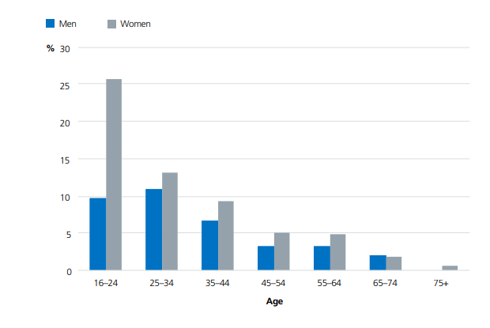
Source: APMS, 2014

Most evidence shows that self-harm increases the risk of suicide. The West Sussex suicide audit (2017) found that 34% of suicides had a history of self-harm, and this increased to over 50% of under 24-year olds. (10)

After an episode of self-harm, older people were more likely than younger people to obtain medical or psychological help. It should be noted that this relates to self-harming and help received at any point; some younger people may go on to receive support in the future.

Chapter 2: Who is most likely to self-harm?

2.1 High risk groups
There are groups of people within our community in West Sussex who are at particular risk of self-harm. Some of these risk factors are modifiable, however there are some which are not.
Risk factors which are generalisable across all age groups include:
- Demographics and identity
- Mental illness and wellbeing
- Physical health and health behaviours
- Relationships
- Acute and chronic environmental/social stressors
- Deprivation
- Formal service contact
Specific groups most likely to self-harm are: young people, women, people who identify as LGBTQI, people who misuse drugs and alcohol, prisoners, people who have a mental illness, South Asian women, people with individual factors associated with higher risk.
2.2 Demographics and identity
There are nuances to these risk factors, and the effects of each factor may be cumulative; with both modifiable and unmodifiable risks persisting across the life course.

2.2.1 Young people and younger age groups
Risk factors include but are not limited to: poor mental health; people who identify as LGBTQI; low familial socio-economic and/or education status; adverse childhood experiences; poor relationships with family or peers; experience of suicide/self-harm; looked after children; psychological challenges (such as low emotional intelligence, low self-esteem); and being part of a subculture. (11) In this age group there is a higher proportion of females self-harming.

2.2.2 Midlife age groups
Risk factors include but are not limited to: Being aged 35-59; female; identifying other than heterosexual; poor mental health; substance dependence; physical illness (especially those that preclude/limit work); debt, unemployment and housing issues; lacking a close or supportive relationship; living alone; abuse (including bullying and violence); and stressful life events such as relationship breakdown; contact with criminal justice system; and being attacked). (12)

2.2.3 Older age group 65+
Risk factors include but are not limited to: Decline in function due to frailty and/or multiple health conditions; diagnosis of mental illness (as with any stage of life); experience of social isolation or loneliness; and experience of bereavement. (13)

2.3 Sex
2.3.1 In children and young people and younger age groups, females are more likely to self-harm. It is likely that self-harm among young males is under reported for this group and may largely be a result of alcohol or substance misuse, which are not included in self-harm statistics. (14)
2.3.2 In midlife, females are over represented when compared to their male counter parts. At particular risk are those aged 35-59.
2.3.3 In the 65 and older age group there is no appreciable difference between males and females. (15)

2.4 Ethnicity
The available evidence around risk and ethnicity is lacking. One recent review suggests that women of South Asian origin are over-represented in self-harming samples compared to the proportion of white women and men. There is some evidence that those of South Asian origin and aged under 35 are at higher risk than those over 35. There is also evidence of increasing risk in those of Caribbean origin aged less than 35 years. (16) There is no breakdown available by ethnicity for West Sussex.

2.5 Sexual orientation and gender identity
In both sexes, self-harm rates are upwards of five times greater in people who report same sex attraction, compared with their heterosexual counterparts. In addition, the risk of self-harm in people who do not identify as their gender assigned at birth is 5.8 times greater risk of self-harm than those who do. (17, 18, 19)

2.6 Deprivation
There is wealth of evidence linking self-harm to socio-economic deprivation and self-harm. (20, 21, 22). The data below (Figure 4 and Table 1) shows this association is true for West Sussex.
Figure 4: Directly age-standardised rate of emergency admissions for self-harm (aggregated 2013/14 to 2017/18) in West Sussex by Indices of Multiple Deprivation 2015 countywide deciles
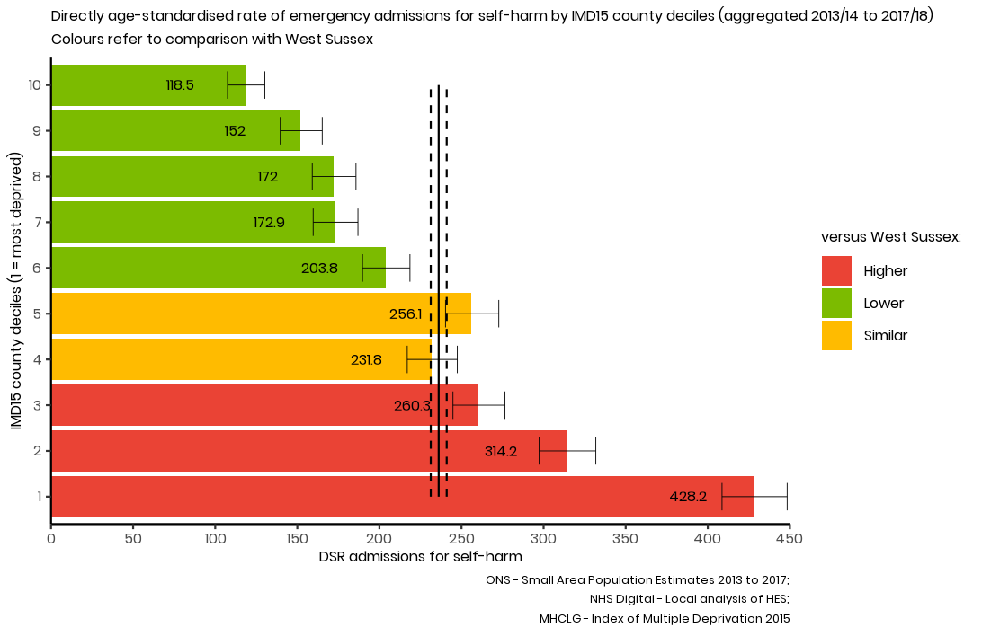
Table 2: Age-standardised rate of emergency hospital admissions for self-harm (all ages) in West Sussex (2013/14 to 2017/18) by countywide deprivation deciles
County Deprivation Decile | 2013/14 to 2017/18
County Deprivation Decile | Number of admissions for self-harm | DSR | 95% Confidence intervals
County Deprivation Decile | Number of admissions for self-harm | DSR | Lower | Upper
1 (most deprived) | 1,832 | 428.2 | 408.7 | 448.3
2 | 1,302 | 314.2 | 297.3 | 331.8
3 | 1,058 | 260.3 | 244.8 | 276.5
4 | 913 | 231.8 | 217.0 | 247.5
5 | 986 | 256.1 | 240.2 | 272.7
6 | 805 | 203.8 | 189.7 | 218.6
7 | 660 | 172.9 | 159.7 | 186.9
8 | 670 | 172.0 | 159.1 | 185.7
9 | 577 | 152.0 | 139.6 | 165.2
10 (least deprived) | 451 | 118.5 | 107.5 | 130.2
West Sussex: | 9,254 | 236.1 | 231.3 | 241.0
Source: NHS Digital - Local analysis on HES data
Chapter 3: What causes a person to self-harm and what factors help reduce the risk?
There are a number of risk factors which can increase the likelihood of a person self-harming or act as a protective factor to decrease this likelihood, depending on their presence in the person’s life.

3.1 Relationships
Quantity and quality of relationships are crucial, with different emphasis across the life course. Evidence shows that younger people value quantity of social contact and networks; whereas older people favour enduring and more profound relationships. (23) Positive attachment or ‘closeness’ to at least one adult during childhood is a protective factor against mental illness, self-harm and suicide. Where no such relationship exists, or there is insecure parent/carer or peer attachment, the risk of self-harm and particularly repetition of these behaviours, is significantly increased. (24) Emotional regulation or the ability and opportunity to process those emotions, also impact on the risk of self-harming. Having an outlet for people to process these feelings is one of the elements found to protect against this (for example where that is a strong friendship group, a hobby or activity) (25). Participants in a recent study indicated that a significant protective factor was a feeling of being ‘accepted’. (26)
Relationship breakdown and bereavement are risk factors in self-harm and suicide. This may be due to a complex interplay of issues, such as loneliness, isolation as well as grief, estrangement from family and other external stressors.
While a lack of positive relationships can increase risk, harmful and negative relationships and social interactions also contribute to the risk factors for self-harm and suicide. These can in turn compound the effects of lack of attachment in childhood, into adult years. Past and ongoing traumatic events such as bullying, violence and sexual abuse are major predictors for self-harm and suicide. There is less acknowledgement of the role of ongoing abuse by a partner in the adult population in predicting a deliberate self-harm event.
Strong social attachments and positive family relationships are positive protective factors, which increase a person’s resilience.

3.2 External stressors
Sudden or unexpected events such as bereavement (especially through suicide), serious illness or disability, a traumatic event (assault, for example) contact with the criminal justice system and a change in economic circumstances were identified as significant contributors to deliberate self-harm (with or without intent).
Multiple trauma is a stronger predictor than a single event with people who are constantly experiencing stress, such as homeless people, prisoners, people living in or who have lived in care, experience of armed conflict, and carers. (25)

3.3 Financial and economic circumstances
3.3.1 Debt
Debt is likely to be a greater factor in self harm and suicide, as opposed to income levels alone. There appears to be a linear increase in the risk of suicide and self-harm, the greater the debt. (26)
3.3.2 Employment and housing
Having a secure home and a job are major influencers of suicidal and self-harm behaviour. (27)
Unemployment and the length of time without a job are drivers for suicidal thoughts, mostly in males. This is in turn affected by other indicators associated with economic instability such as debt, health problems and disability impacting on ability to work or limiting types of jobs, and job insecurity. Bullying in the workplace can exacerbate any of these additional factors.
Suicidal thoughts are particularly prevalent in the homeless population. When considering the definition of homelessness, there are nuances to the risks. Those who had a consistent base - such as long-term B&B accommodation – experienced fewer thoughts of this nature than those who sleep in the open or in night shelters. Renting, affordability, housing benefits also impact on suicidal behaviours. (28)

3.4 Diagnosed mental illness
Having a diagnosis of a mental illness such as (but not limited to) anxiety, depression, personality disorders, substance misuse and bi-polar disorder is a risk factor for self-harm. (29) Prompt diagnosis and good mental health care and treatment, either in the community or within a specialist team are protective factors. (30)

3.5 Internet use
A review of the literature found that there is significant potential for harm from online behaviour in relation to self-harm and suicidal behaviour in terms of triggering, normalisation and competition between users, a source of contagion and harmful information for vulnerable individuals. At the same time there is the potential to exploit the benefits of the internet including a sense of community, crisis support, delivery of therapy and outreach. (31,32)

Chapter 4: What can we do and what are we doing?

4.1 Opportunities for intervention and prevention
The recent West Sussex Annual Public Health Report (34) provides some examples of different actions at individual, community and population levels that can help to reduce self-harm and suicide
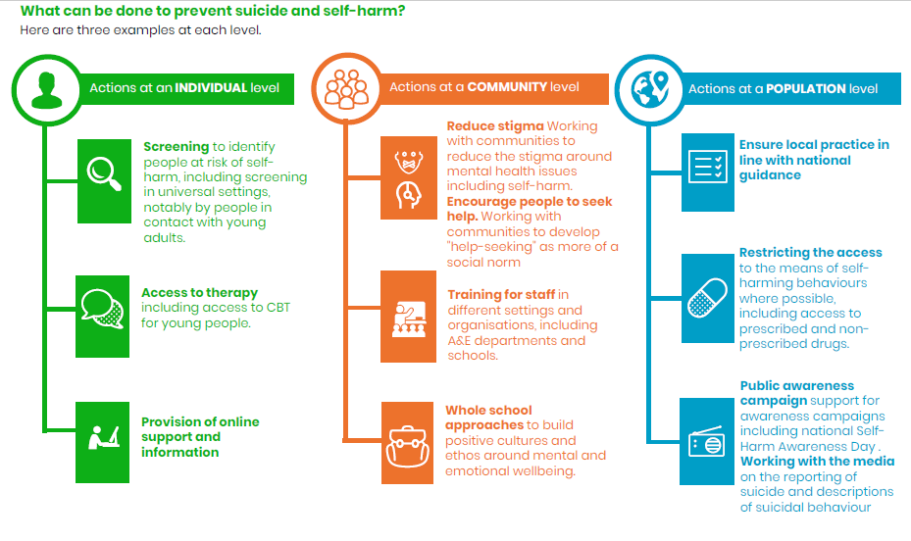

4.1.1 Primary prevention opportunities
We know that primary prevention is about early intervention and modifying and influencing individual risk factors; through ‘starting well’ initiatives, whole school approaches to emotional and mental wellbeing, Making Every Contact Count and the five ways to wellbeing. Although given there is much primary prevention activity already taking place (see 4.2) it is often difficult to demonstrate impact due the lack of data as mentioned above, the presence of multiple risk factors, the fact that community based self-harm is the most prevalent form and may often go undisclosed makes this difficult to measure; and the multi-agency approach required to tackle the causes of self-harm increases the challenge of being able to demonstrate the effectiveness of interventions in the round.
From a public health perspective, there are clear opportunities for interventions at a population health level based on the general population and for those with particular risk factors which are outlined above.
For children and young people, developing mental and emotional wellbeing and resilience through whole school approaches and specific activity around screening, psychological skills and training are most effective.
For the general public at risk, public awareness campaigns, encouraging help seeking behaviour, reducing stigma, improving media reporting and portrayal of self-harm and suicide are all population-level tools able to reduce prevalence of self-harming behaviour.

4.1.2 Secondary prevention opportunities
Of the reported admissions for self-harm, some 36% of these were re-admissions, with around 2% of all admissions admitted five times or more.
A recent systematic review in this area found that cognitive behavioural therapy (CBT) seems to be effective in reducing the number of patients who recurrently self-harm. Dialectical behaviour therapy did not reduce the proportion of patients repeating self-harm but did reduce the frequency of self-harm. However, aside from CBT, there were few trials of other promising interventions, precluding firm conclusions as to their effectiveness.
There are two National Institute for Health and Social Care Clinical Guidelines related to self-harm and one quality standard. (36)

Self-harm in over 8s: short-term management and prevention of recurrence (CG16) published in 2004.

Self-harm in over 8s: long-term management (CG133) published in 2011.

Self Harm Quality Standard (QS34) published in 2013. This contains a number of statements as follows:
Statement 1. People who have self-harmed are cared for with compassion and the same respect and dignity as any service user.
Statement 2. People who have self-harmed have an initial assessment of physical health, mental state, safeguarding concerns, social circumstances and risks of repetition or suicide.
Statement 3. People who have self-harmed receive a comprehensive psychosocial assessment.
Statement 4. People who have self-harmed receive the monitoring they need while in the healthcare setting, in order to reduce the risk of further self-harm.
Statement 5. People who have self-harmed are cared for in a safe physical environment while in the healthcare setting, in order to reduce the risk of further self-harm.
Statement 6. People receiving continuing support for self-harm have a collaboratively developed risk management plan.
Statement 7. People receiving continuing support for self-harm have a discussion with their lead healthcare professional about the potential benefits of psychological interventions specifically structured for people who self-harm.
Statement 8. People receiving continuing support for self-harm and moving between mental health services have a collaboratively developed plan describing how support will be provided during the transition
When older people self-harm, treatments will be much the same as for younger adults, but the risk of further self-harm and suicide are substantially higher and must be considered. In fact, people over 65 years of age are more likely to complete suicide in a self-harm attempt.
In the recent West Sussex Suicide Audit (37) it was found that one third of all those who died through suicide had a history of self-harm:
“One in three files described a history of self-harm. For the audit, incidences of self-harm included all physical bodily damage as well as previous suicide attempts and overdoses believed to be intentional. Some were unknown to service providers and professionals and were only discerned from case notes or testimony from friends/relatives. Over half of under-25s had known to be self-harming at some point and this prevalence tended to decrease with age. Counts from the older individuals were mainly failed suicide attempts.”

Table 2, Suicides and open verdicts completed in West Sussex audit (2013-15 cases)
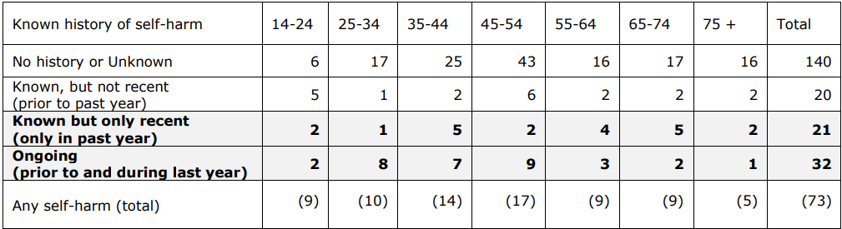
Therefore, once people have been identified as having self-harmed, there are opportunities to provide interventions at a number of levels: individually as part of an ongoing care plan, as well as within their home/work/educational/community setting. It should be understood that people who self-harm are not a homogenous group and interventions which are effective for one at risk group or person, may not be suitable for another.

4.2 Services in West Sussex
Although there are clinical guidelines for secondary prevention, there is little robust evidence around public health interventions for preventing self-harm. Much of the evidence around self-harms relates to the wider determinants of health and wellbeing. Early years and starting well programmes are focused around tackling the risk factors for self-harm such as reducing incidence and impact of adverse childhood experiences, drug and alcohol use and wellbeing and resilience. For older people, there is a focus on the impact of social isolation and loneliness – it is likely that these will all impact in the longer term. Interventions should be targeted and appropriate to risk group and demographics.
Across West Sussex, there are number of programmes (some of which are commissioned or co-commissioned by West Sussex County Council) which aim to address the causes of self-harm from universal approaches to targeted activity.

4.2.1 Universal services
Local Maternity System – all women are entitled to maternity care free at point of delivery. This provides support for women and families with access to specialist provision for many specific needs, such as perinatal mental health and chronic health conditions, and lifestyle behaviours to ensure the best start in life.
Healthy Child Programme – care, support and health visitor service from -9 months to 19 (25 for people with learning disabilities) focusing on the best start in life.
GPs and primary care services - GPs are often the first point of contact for anyone with a health issue and they manage mental illness in the community for common mental disorders. They are also able to refer into specialist secondary care support and treatment services. In addition, pharmacists are a crucial contact point – with self-poisoning being the most common reason for admission here in West Sussex – opportunities exist for working more closely with pharmacists to educate their communities and encourage people to return unused medication, through awareness raising.

4.2.2 Services for specific families needing support
Adult Social Care and Children’s Services – additional support for people and families with specific social care needs.
Family Nurse Partnership – targeted and intensive parenting support for young parents to give the family the best start.
Integrated Prevention and Early Help – a step up/step down service for families who need support which may fall below the threshold for children’s services. This includes the Multi Agency Safeguarding Hub (MASH), Family Support Hubs, specialist key workers for complex needs, and strong local community partnerships to ensure ongoing support.

4.2.3 Education based programmes
The whole school approaches to wellbeing and resilience tackles the risk factors and promotes those protective factors by supporting children to become resilient and access help when needed.
School nurse – designated nurses who responsibility for specific health and wellbeing roles (immunisation, weight measurement etc) in a number of schools.
Educational Psychology - All schools have a named contact EP who will conduct a School and EP Planning Meeting where schools are able to discuss either whole school issues or individual pupils, with parental permission. Special schools receive termly planning meetings. The Educational Psychology Service provides advice to the local authority (LA) to support assessments of children’s SEN and disability.
Safeguarding in education – oversee practice and police development, safe guarding audits and training. Local Authority Designated Officer manages safeguarding allegations.

4.2.4 For young people (see also Education based programmes)
CAMHS – The following services are available for families in West Sussex:

- Assessment and treatment service: work directly with children and young people who have displayed worrying or harmful sexual behaviours. Where appropriate, they also work with the families of children and young people in a support and advisory role.

- Child disability and complex behaviour support: We provide a service in West Sussex for young people with moderate/severe learning disabilities and behaviours which present a challenge to their families, carers and education teams.

- Community teams - West Sussex: specialist teams offering assessment and treatment to children and young people up to age 18 who have emotional, behavioural or mental health problems. Part of this is the Free Your Mind project. Free Your Mind is a social action project run by young people for young people, which aims to challenge stigma, taboo and stereotypes and improve mental health services for their peers. The project has been awarded the Community Impact Award for the most sustainable project.
- Early intervention in psychosis: community-based support to people aged up to 65 years old including children and adolescents) who are experiencing their first episode of psychosis.

- Looked after and adopted children: supporting children who are being looked after or who have been adopted in West Sussex, and experiencing complex emotional and psychological difficulties.

- Pan-Sussex children and young people and family eating disorder service: working with children, young people and their families to treat eating disorders. The service looks at physical health as well as mental health. Providing support are through a multi-disciplinary team of clinicians, experienced in working with children, young people and families effected by an eating disorder; including psychologists, psychiatrists, psychotherapists, nurses, dieticians, a paediatrician and systemic family therapists/practitioners.

- Perinatal service: A community-based service supports mothers who are experiencing, or who have previously experienced, severe mental health difficulties during pregnancy or up to a year after birth.

- West Sussex community mental health liaison service: The Community Mental Health Liaison Service (CMHL) provides an early intervention and prevention service for professionals who are working with young people under the age of 18, and are concerned about a young persons mental health and wellbeing. This may include professionals such as GPs, teachers, public health nurses, Emotional Wellbeing Leads (EWB), support workers.
- A+E Liaison Service: The service conducts mental health assessments, risk assessments, offers one-off follow-up appointments and provides self-harm training to A&E medical staff. The CAMHS A&E Liaison Team will also offer consultation and advice to GPs and Paramedics when they are unsure how to proceed with a young person, and whether A&E would be appropriate.

Mind the Gap - provides intensive support and advocacy for 16-25 year olds in supported housing whose mental health or emotional wellbeing needs put them at high risk of self-harm or suicide and/or losing their tenancy.
Youth Emotional Support (YES) - a free service for young people aged 11-18 looking for support with their wellbeing, including self-harm, mood, anxiety, relationships, unhelpful thoughts and self-esteem. Referrals can come from GPs, Child and Adolescent Mental Health Services, the School Nurse Service and self-referral via Find It Out Centres. They provide one-to-one support and group working and give information about other support that is available.
Find it Out Centres There are 8 WSCC Find It Out Centres across West Sussex providing advice, information, support and signposting for children and young people aged 13-25 years.
YMCA Downslink - offers telephone and face to face counselling within the centres, and also leisure centres and libraries providing on-line counselling and support. The main issues young people present with are self-harm and suicidal thoughts, isolation, bullying, arguments at home and alcohol/drug use.
There are a number of services and sources of support across the statutory and voluntary sector and within communities. However, with commissioning cycles being limited to a few years, there remains a need for oversight of these programmes from a self-harm (and suicide prevention) perspective and a strategic view of self-harm prevention.

4.2.5 Other programmes
Carers support - help carers access equipment to assist them in their caring role or provide funds so that carers can do something for themselves. Helping carers access counselling and call back services, and wellbeing (physical and mental) support.
Pause - Pause works with women who have experienced, or are at risk of, repeat removals of children from their care. Through an intense programme of support, it aims to break this cycle and give women the opportunity to reflect, tackle destructive patterns of behaviour, and to develop new skills and responses that can help them create a more positive future.
Social prescribing – a number of social prescribing programmes exist in West Sussex. These target those who use GP services for non-clinical issues, giving the clinicians a way of meeting their psycho-social needs alongside ongoing treatment and care. Examples of most common issues include unemployment, debt, insecure housing and homelessness, and social isolation.
Homelessness services – a number of homelessness services are commissioned in West Sussex. These range from night shelters, day centres, hostels and outreach. Supporting people who are homeless or require support to maintain their housing.
Drugs and alcohol services – There are a number of interventions being delivered in West Sussex. From Water Angels to encourage people to enjoy alcohol responsibly; advice from Wellbeing Hubs and a specialist drugs and alcohol service provided through CGL. (Holly to check)
Social support contracts – there are a number of social support services for older people including day activities aimed at reducing loneliness and social isolation.

4.2.6 Mental Health focused services (all ages)
Sussex Partnership Foundation Trust (SPFT) community and secondary care – SPFT are the NHS providers of both Children and Adolescent Mental Health Service (CAMHS) and adult metal health services. There is a broad provision, from psychiatric units to community crisis support. WSCC work closely with SPFT across many of the services as a commissioning body and partner.
Pathfinder – Alliance of local mental health focused organisations providing support and advice for people who have or are affected by a mental health disorder. Support for all ages and a directory of support for issues which impact on mental health.
Coastal West Sussex MIND has been commissioned (in partnership with Grassroots, YMCA Downslink, SPFT, Lifecentre and Allsorts) to provide 108 training courses, including suicide prevention, young people living with self-harm and self-injury for all ages.
Sussex Partnerships Foundation Trust – providing specialist outpatient and inpatient healthcare, treatment and support for people with mental illness.

4.2.7 Community initiatives
There are a number of community-based initiatives, groups and informal networks which help work towards a community-based approach to improving the lives of residents. Some of these received funding from WSCC or District and Borough Councils. From local branches of large national organisations (eg Age UK, Citizens Advice) to small church led organisations (Worthing Churches Homeless Project).
Formal community and voluntary sector (CVS) organisations are supported by Community Works, the over-arching body for West Sussex.

4.2.8 Bereavement support
Cruse - offer support, advice and information to children, young people and adults when someone dies and to enhance society’s care of bereaved people. Cruse offers face-to-face, telephone, email and website support. There are freephone national helpline and local services, and a website (hopeagain.org.uk) specifically for children and young people
Survivors of Bereavement by Suicide (SoBS) – a charity which aims to meet the needs of, and overcome the isolation experienced by, people over 18 who have been bereaved by suicide.
Child bereavement service – An intensive support service for families who are bereaved through the death of a child.
Death registry – we have identified an opportunity to work more closely with the registrar of births and deaths to address social isolation and loneliness through bereavement.

Chapter 5: What strategies do we have to identify, co-ordinate and inform these interventions and prevention opportunities?
There are a number of strategic plans which feed into this particular work-stream – however, there is no single self-harm specific strategic document, despite a reduction in self-harm admissions being one of the corporate objectives for West Sussex County Council.

5.1 West Sussex Suicide Prevention Strategy 2017-2020
The plan, informed by the West Sussex Suicide Audit (33), acknowledges the importance of addressing the wider determinants of mental health and wellbeing in preventing suicide and self-harm behaviours. This strategy is the key document from the West Sussex Suicide Prevention Steering Group – a multi-agency group to coordinate implementation of the national suicide prevention strategy ‘Preventing Suicide in England’ (34).
Of the nine priority action points one specifically relates to self-harm: “Point 4: focus on reducing self-harm, particularly in young people”. This needs analysis is part of that focus.

5.2 West Sussex Plan 2017-2022
The West Sussex Plan sets out WSCC’s commitment to making our communities strong, safe and sustainable.
The ‘A strong Safe and Sustainable Place’ is one of five priorities set out in the plan. The healthy place indicator will be measured by emergency hospital admissions for intentional self-harm. This may not take into account any impact on community based self-harm where no admission takes place.
However, the remaining priorities; best start in life; a prosperous place; independence for later life; and a council that works for the community, all address the wider determinants of our mental health, wellbeing and resilience.
These performance data are updated on a quarterly to annual basis (depending on the data set) and published.

5.3 Surrey and East Sussex Sustainability and Transformation Programme (STP)
The Sussex and East Surrey STP have produced a plan ‘Mental health in Sussex and East Surrey: strategic framework and delivery roadmap’.
The plan used national policy, local data and workshops to identify four mental health improvement areas. These are:
- common mental health conditions;
- psychosis;
- dementia and cognitive impairment; and
- youth service
Suicide prevention is a priority area for the STP and this includes self-harm as part of its remit. A suicide prevention steering group has been set up to oversee work in this area.

5.4 NHS Long Term Plan
The NHS Long Term plan outlines a commitment for all acute hospitals to have an all-age mental health liaison service in A&E departments and inpatient wards by 2020/21, to expand the Improved Access to Psychological Therapies programme and to increase children and young people’s access to mental health support including via new mental health teams in schools.

References

- Brighton Hove Clinical Commissioning Group and Brighton & Hove Council (2018) Self-harm needs assessment for children & young people February 2018. Available at: http://www.bhconnected.org.uk/sites/bhconnected/files/280318%20Self-harm%20needs%20assessment.pdf
- Public Health England, 2019: Local Authority Health Profiles. Available at https://fingertips.phe.org.uk/profile/health-profiles

- McManus S, Bebbington P, Jenkins R, Brugha T. (eds.) (2016) Mental health and wellbeing in England: Adult Psychiatric Morbidity Survey 2014. Leeds: NHS Digital. https://assets.publishing.service.gov.uk/government/uploads/system/uploads/attachment_data/file/556596/apms-2014-full-rpt.pdf

- Tsiachristas, A., McDaid, D., Casey, D., Brand, F., Leal, J., Park, A-L., Geulayov, G., & Hawton, G., 2017: General hospital costs in England of medical and psychiatric care for patients who self-harm: a retrospective analysis. Lancet Psychiatry 2017;4: 759–67. Available at: https://www.ncbi.nlm.nih.gov/pubmed/28890321

- Griffin, E., Arensman, E., Perry, IJ., Bonner, B., O'Hagan, D., Daly, C. and Corcoran, P., 2018: The involvement of alcohol in hospital-treated self-harm and associated factors: findings from two national registries. J Public Health (Oxf). 2018 Jun 1;40(2):e157-e163. Available at: https://www.ncbi.nlm.nih.gov/pubmed/28498968

- The Children’s Society, 2018: The Good Childhood Report 2018. Available at: https://www.childrenssociety.org.uk/good-childhood-report

- Ibid 3
- Ibid 7

- Whitehead, R., Public Health and Social Research Unit (PHSRU) West Sussex County Council, 2017: West Sussex Suicides Audit 2013-2015. Available at: https://jsna.westsussex.gov.uk/assets/core/West-Sussex-Suicide-Audit-2017.pdf

- Ibid 9

- Ibid 1

- McManus S, Lubian K, Bennett C, Turley C, Porter L, Gill V, with Gunnell D, Weich S. (2019) Suicide and self-harm in Britain: researching risk and resilience using UK surveys. NatCen: London. Available at: http://natcen.ac.uk/media/1704167/Suicide-and-self-harm-in-Britain-Main-report.pdf

- Morgan, C., Webb, R.T., Carr, M.J., Kontopantelis, E., Chew-Graham, C.A., Kapur, N., and Ashcroft, D.M., 2018: Self-harm in a primary care cohort of older people: incidence, clinical management, and risk of suicide and other causes of death. Lancet Psychiatry 2018; 5: 905–12. Available at: https://www.thelancet.com/journals/lanpsy/article/PIIS2215-0366(18)30348-1/fulltext

- Ibid 6

- Briskman, I., Shelef, A., Berger, U., Baruch, Y., Bar, G., Asherov, J., Lvovski, A., Apter, A. and Barak, Y., 2017: Deliberate Self-Harm in Older Adults: A General Hospital Emergency Department Survey. Israeli Medical Association Journal, Mar;19(3):160-163. Available at: https://www.ncbi.nlm.nih.gov/pubmed/28457093

- Bhui, K., McKenzie, K. and Rasul, F., 2007: Rates, risk factors & methods of self harm among minority ethnic groups in the UK: a systematic review. BMC Public Health 7:336. Available at: http://www.biomedcentral.com/1471-2458/7/336

- King, M., Semlyen, J., Tai, S.S., Killaspy, H., Osborn, D., Popelyuk, D. and Nazareth, I., 2008. A systematic review of mental disorder, suicide, and deliberate self harm in lesbian, gay and bisexual people. BMC Psychiatry. 2008; 8:70. Available at: https://bmcpsychiatry.biomedcentral.com/articles/10.1186/1471-244X-8-70

- Skegg, K., Nada-Raja, S., Dickson, N., Paul, C. and Williams, S., 2003: Sexual orientation andself-harm in men and women. American Journal of Psychiatry; 2003; 160(3):pp541-6. https://ajp.psychiatryonline.org/doi/full/10.1176/appi.ajp.160.3.541?url_ver=Z39.88-2003&rfr_id=ori:rid:crossref.org&rfr_dat=cr_pub%3dpubmed

- Fergusson, D.M., Horwood, L.J. and Beautrais AL, 1999: Is sexual orientation related to mental health problems and suicidality in young people? Archives of General Psychiatry. 1999; 56(10):pp876-80. Available at: https://www.ncbi.nlm.nih.gov/pubmed/10530626

- Ibid 15

- Brooks F., Chester, K., Klemera, E. and Magnusson, J., 2017: Intentional self-harm in adolescence: An analysis of data from the Health Behaviour in School-aged Children (HBSC) survey for England,2014. Public Health England; 2017. 22p. Available at: https://assets.publishing.service.gov.uk/government/uploads/system/uploads/attachment_data/file/621069/Health_behaviour_in_school_age_children_wellbeing_of_adolescent_girls.pdf

- Brunner, R., Parzer, P., Haffner, J., Steen, R., Roos, J., Kle, M. and Resch, F., 2007: Prevalence and psychological correlates of occasional and repetitive deliberate self-harm in adolescents. Archives of Pediatric Adolescent Medicine. 2007; 161(7):pp641-9. Available at: https://www.ncbi.nlm.nih.gov/pubmed/17606826

- Charles, S. and Carstensen,L.L., 2010: Social and Emotional Aging. Annual Review of Psychology. 2010; 61: pp383–409. Available at: https://www.ncbi.nlm.nih.gov/pmc/articles/PMC3950961/

- Glazebrook, K., Townsend, E. and Sayal, K., 2015: The Role of Attachment Style in Predicting Repetition of Adolescent Self‐Harm: A Longitudinal Study. Suicide and Life Threatening Behaviour. Volume 45, Issue 6. pp 664-678. Available at: https://onlinelibrary.wiley.com/doi/full/10.1111/sltb.12159

- Kharsati, N. and Bhola, P., 2016: Self-injurious behavior, emotion regulation, and attachment styles among college students in India. Industrial Psychiatry Journal; 25(1): pp 23–28. Available at: https://www.ncbi.nlm.nih.gov/pmc/articles/PMC5248415/
- Ibid 12
- Ibid 26
- Ibid 27
- The Samaritans, 2017: Socioeconomic disadvantage and suicidal behaviour. Available at: https://www.samaritans.org/documents/266/Socioeconomic_disadvantage_and_suicidal_behaviour_-_Full.pdf

- Ibid 28
- Doyle, L., Treacy, M.P. and Sheridan, A., 2015: Self-harm in young people: Prevalence, associated factors, and help-seeking in school-going adolescents. International Journal of Mental Health Nursing, 24 (6), 485-495. Available at: https://www.researchgate.net/journal/1447-0349_International_journal_of_mental_health_nursing
- Marchant A, Hawton K, Stewart A, Montgomery P, Singaravelu V, Lloyd K, et al 2017: A systematic review of the relationship between internet use, self-harm and suicidal behaviour in young people: the good, the bad and the unknown. PLoS ONE. 12(8) e:0181722.
- Hawton, K., Rodham, K. and Evans, E., 2002: Deliberate self harm in adolescents: self report survey in schools in England. BMJ 2002; 325:1207. Available at: https://www.bmj.com/content/325/7374/1207.short
- Public Health and Social Research Unit, West Sussex County Council, 2018: West Sussex County Council Annual Public Health Report 2018. Available at: https://jsna.westsussex.gov.uk/updates/annual-public-health-report-2018/

- Hawton, K., Witt, K.G., Salisbury, T.L.T., Arensman, E., Gunnell, D., Hazell, P., et al Psychosocial interventions following self-harm in adults: a systematic review and meta-analysis. Volume 3, issue 8, p740-750, august 01, 2016. Available at: https://www.thelancet.com/journals/lanpsy/article/PIIS2215-0366(16)30070-0/fulltext

- NICE, 2004: Self-harm in over 8s: short-term management and prevention of recurrence. Available at: https://www.nice.org.uk/guidance/cg16/chapter/Key-priorities-for-implementation#

- Ibid 10

- HM Government, 2012: Preventing suicide in England A cross-government outcomes strategy to save lives. Available at: https://www.gov.uk/government/publications/suicide-prevention-strategy-for-england

