Ethnic Composition 2011
- Numbers

2011 | Arun | Chichester | West Sussex | SOUTH EAST | ENGLAND
ALL | 149,518 | 113,794 | 806,892 | 8,634,750 | 53,012,456
White: English/Welsh/Scottish/Northern Irish/British | 137,024 | 105,841 | 717,551 | 7,358,998 | 42,279,236
White: Irish | 889 | 743 | 5,979 | 73,571 | 517,001
White: Gypsy or Irish Traveller | 162 | 238 | 1,073 | 14,542 | 54,895
White: Other White | 7,043 | 3,500 | 31,896 | 380,709 | 2,430,010
Mixed/multiple ethnic group: White and Black Caribbean | 426 | 269 | 2,886 | 45,980 | 415,616
Mixed/multiple ethnic group: White and Black African | 221 | 158 | 2,061 | 22,825 | 161,550
Mixed/multiple ethnic group: White and Asian | 532 | 361 | 4,269 | 58,764 | 332,708
Mixed/multiple ethnic group: Other Mixed | 323 | 304 | 2,939 | 40,195 | 283,005
Asian/Asian British: Indian | 498 | 470 | 9,659 | 152,132 | 1,395,702
Asian/Asian British: Pakistani | 107 | 36 | 5,236 | 99,246 | 1,112,282
Asian/Asian British: Bangladeshi | 367 | 131 | 2,346 | 27,951 | 436,514
Asian/Asian British: Chinese | 412 | 339 | 2,960 | 53,061 | 379,503
Asian/Asian British: Other Asian | 732 | 641 | 8,133 | 119,652 | 819,402
Black/African/Caribbean/Black British: African | 313 | 319 | 4,569 | 87,345 | 977,741
Black/African/Caribbean/Black British: Caribbean | 160 | 129 | 1,339 | 34,225 | 591,016
Black/African/Caribbean/Black British: Other Black | 65 | 70 | 1,238 | 14,443 | 277,857
Other ethnic group: Arab | 72 | 102 | 1,081 | 19,363 | 220,985
Other ethnic group: Any other ethnic group | 172 | 143 | 1,677 | 31,748 | 327,433

Ethnic Composition 2011
- Percentage

2011 | Arun | Chichester | West Sussex | SOUTH EAST | ENGLAND
White: English/Welsh/Scottish/Northern Irish/British | 91.6% | 93.0% | 88.9% | 85.2% | 79.8%
White: Irish | 0.6% | 0.7% | 0.7% | 0.9% | 1.0%
White: Gypsy or Irish Traveller | 0.1% | 0.2% | 0.1% | 0.2% | 0.1%
White: Other White | 4.7% | 3.1% | 4.0% | 4.4% | 4.6%
Mixed/multiple ethnic group: White and Black Caribbean | 0.3% | 0.2% | 0.4% | 0.5% | 0.8%
Mixed/multiple ethnic group: White and Black African | 0.1% | 0.1% | 0.3% | 0.3% | 0.3%
Mixed/multiple ethnic group: White and Asian | 0.4% | 0.3% | 0.5% | 0.7% | 0.6%
Mixed/multiple ethnic group: Other Mixed | 0.2% | 0.3% | 0.4% | 0.5% | 0.5%
Asian/Asian British: Indian | 0.3% | 0.4% | 1.2% | 1.8% | 2.6%
Asian/Asian British: Pakistani | 0.1% | 0.0% | 0.6% | 1.1% | 2.1%
Asian/Asian British: Bangladeshi | 0.2% | 0.1% | 0.3% | 0.3% | 0.8%
Asian/Asian British: Chinese | 0.3% | 0.3% | 0.4% | 0.6% | 0.7%
Asian/Asian British: Other Asian | 0.5% | 0.6% | 1.0% | 1.4% | 1.5%
Black/African/Caribbean/Black British: African | 0.2% | 0.3% | 0.6% | 1.0% | 1.8%
Black/African/Caribbean/Black British: Caribbean | 0.1% | 0.1% | 0.2% | 0.4% | 1.1%
Black/African/Caribbean/Black British: Other Black | 0.0% | 0.1% | 0.2% | 0.2% | 0.5%
Other ethnic group: Arab | 0.0% | 0.1% | 0.1% | 0.2% | 0.4%
Other ethnic group: Any other ethnic group | 0.1% | 0.1% | 0.2% | 0.4% | 0.6%

Change in White British Group – 2001 and 2011
Percentage of Population - White British*
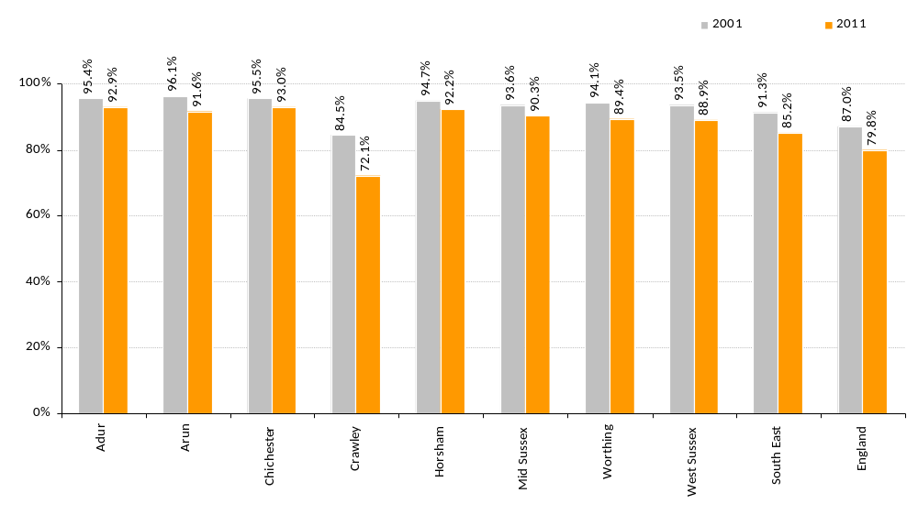

*White British - ‘White English/Welsh/Scottish/Northern Irish/British

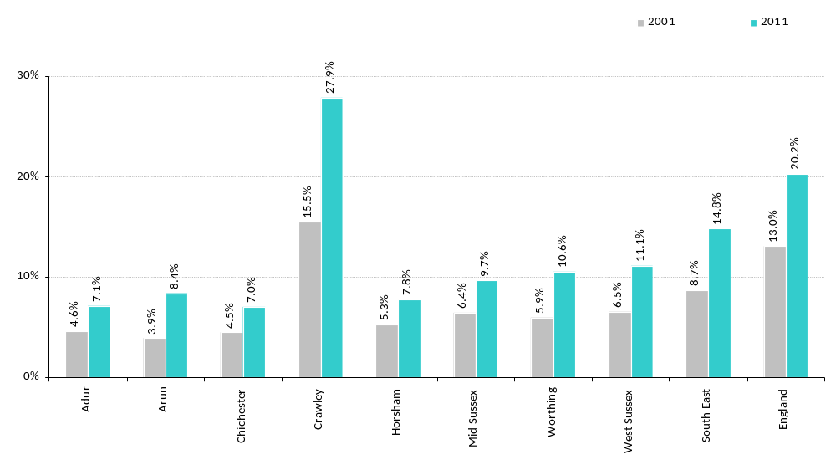
Percentage of Population From Ethnic Minority Groups**

**Includes White Irish, White Other and Gypsy and Irish Traveller

ETHNIC GROUPS - 2001 AND 2011 DATA COMPARED – ARUN
Percentage of the Resident Population
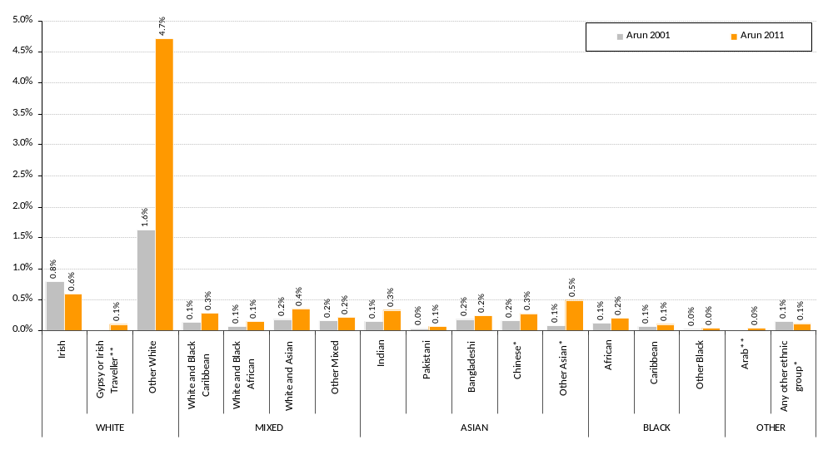

* No comparable group in 2001, introduced in 2011
** ONS have stated there are issues relating to the comparability of these specific groups between 2001 and 2011

ETHNIC GROUPS - 2001 AND 2011 DATA COMPARED – CHICHESTER
Percentage of the Resident Population
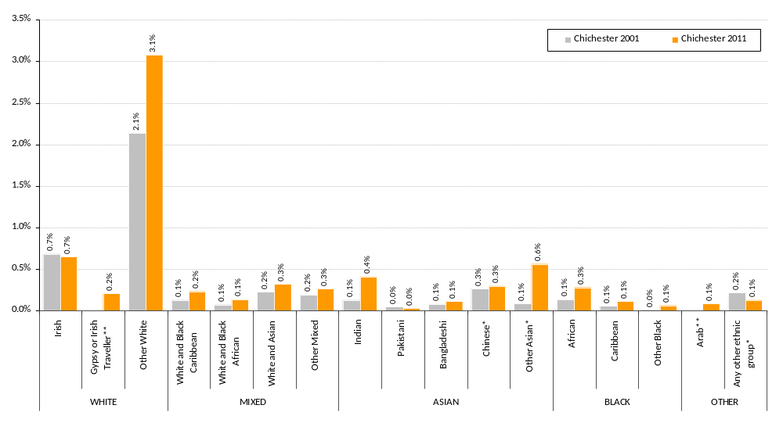

* No comparable group in 2001, introduced in 2011
** ONS have stated there are issues relating to the comparability of these specific groups between 2001 and 2011

