Family Link Worker Service Evaluation 2012/2013

Tim Martin and Sue d’Authreau

December 2013

Social Research Unit, West Sussex County Council
October 2009


Public Health
Research Unit

Contents

Summary of key findings  1 Background  1.1 Number of responses  2 Family Link Worker evaluation forms  2.1 Characteristics of the children referred to the service  2.2 Referral to the Family Link Worker Service  2.3 Family link workers’ ratings of effectiveness  3 Parent/carer evaluation forms  3.1 Parental rating of the family’s situation and how this changed  4 Children’s evaluation forms  4.1 The extent to which the FLW helped children and families  4.2 How the FLW helped  5 Schools’ evaluation forms  5.1 The extent to which barriers to learning changed  5.2 The extent to which other family-related problems changed  6 School’s view about the effectiveness of the Family Link Worker Service  6.1 Effectiveness of the FLWS in meeting needs  6.2 Effectiveness of the FLWS in improving links between parents and schools  6.3 Referral procedure  6.4 Overall experience of working with the FLWS  6.5 Suggested improvements to the service  6.6 Other comments made by schools  7 Conclusion and discussion  7.1 The evaluation  7.2 Service overview  7.3 Effectiveness of the service | 3  5  5  7  7  8  13  15  15  16  16  16  17  17  17  18  18  18  18  19  19  20  21  21  21  21

Acknowledgements

We would like to acknowledge Jane Bridgeman for supporting this evaluation, family link workers and practice leads for completing and following up outstanding questionnaires, and schools for completing and returning their questionnaires.

We would also like to acknowledge the children and young people, and the parents and carers who took the time to complete and return questionnaires and tell us about their experiences of using the service.

Evaluation of the Family Link Worker Service (FLWS) 2012/2013

Summary of key findings

Background and aims

This project had two main aims. Firstly, to evaluate the impact of the Family Link Worker Service over the 2012-2013 academic year and, secondly, to develop and refine the methodology used to record and hold service data in the future (Frameworki).

Four different evaluation forms could be completed for each individual child/case (FLW, parent/carer, child and school).

Overall, at least one of the four evaluation forms was returned for 340 children/cases. These children attended 125 different schools. The number of children referred from these schools ranged from between one to ten.

Characteristics of the children referred to the Family Link Worker Service

The average age of the children referred to the FLWS was 7 years and 9 months.

Around twice as many boys than girls were referred to the service.

Around a third of the children referred to the service had a special educational need, around double the proportion found in the population of West Sussex primary schools.

The majority of children referred to the service were of White British ethnic origin (93%).

Referral to the Family Link Worker Service

Around three-quarters of cases were referred to the FLWS by schools.

For 89% of families, this was their first referral to the service.

The service provided an average of three sessions for parents; two for children; and one for both parents and their children together.

The average number of sessions provided per family has fallen between 2010/2011 and 2012/2013.

Most children were referred for behaviour and this was more likely to be associated with boys than girls. Meanwhile, girls were more likely to be referred for self-esteem than boys.

- Younger children tended to be referred for reasons of behaviour, whilst younger children tended to be referred for self-esteem and attendance.

- One quarter of cases referred did not engage with the service.

FLW ratings of families’ situations

- Family link workers rated the family’s situation between one and ten depending on the severity of issues, where one equated to the highest level of problems and ten no problems at all. This was done at the start of their involvement with families and at the end.

- On average, FLWs reported a three point positive change in their ratings of families’ situations.

- A high level of both family participation and parental response to strategies was reported (71% and 66% respectively).

- In six out of ten cases, FLW input was considered to have been effective.

- Effectiveness was found to be associated with both family participation and response to strategies.

Parents’ ratings of their situation

Parents rated their situation between one and ten depending on the severity of issues, where one equated to the highest level of problems and ten no problems at all. This was done at the start of the service’s involvement with families and at the end.

On average, parents reported a three point positive change in their ratings of their situations, closely reflecting the ratings of FLWs.

- Using the same rating scale, parents rated changes across self-defined targets. On average, parents reported a positive change of between three and four points in their ratings of the self-defined targets.

Children’s views on service effectiveness

- In eight out of ten cases, children said that their FLW had helped them and their families a lot.

- Children said that the FLW had helped most at home (74%).

Schools’ views on service effectiveness

- In two-thirds of cases schools said that barriers to learning had been lessened.

- In 55% of cases schools said that other family-related problems has lessened.

School’s views about working with the service

- 86% of schools thought that the service was effective in meeting children’s needs.

- 95% of schools thought that the referral procedure worked well.

- Nine out of ten schools rated their overall experience of working with the service as good.

- 92% of schools felt that the service had been effective at improving links between schools and parents.

- Schools highlighted areas where they felt improvements might be made. Broadly speaking, they said that they would like to see improvements in the areas of capacity.

Evaluation of the Family Link Worker Service (FLWS) 2010/2011

1 Background

This project had two main aims. Firstly, to evaluate the impact of the Family Link Worker Service over the 2012-2013 academic year and, secondly, to develop and refine the methodology used to record and hold service data in the future (Frameworki).

1.1 Number of responses

1.1.1 All forms returned

As part of this evaluation, four different evaluation forms could be completed for each individual child/case (FLW, parent/carer, child and school). However, few cases had all four forms completed and returned. Overall, at least one of the four evaluation forms was returned for 340 children/cases. These children attended 125 different schools, representing around half of all West Sussex primaries. The number of children referred from these schools ranged from between one to ten.

1.1.2 Response by FLWS area

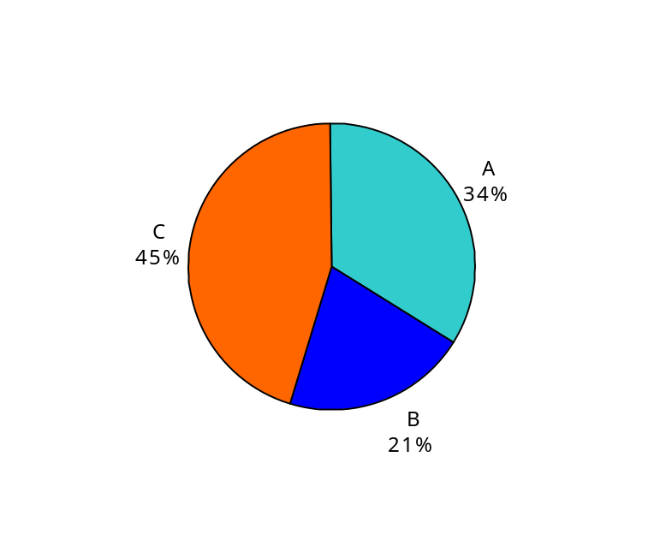The chart below illustrates where at least one form was returned from each FLWS area. As can be seen, Area C achieved the highest response.

Chart 1: Responses by FLWS area

Area | Number
A | 115
B | 70
C | 155
All | 340

1.1.3 Number of forms returned for each FLW

The number of cases (where at least one form was returned) for each family link worker ranged from between 2 to 57.

1.1.4 Number of forms returned by each stakeholder

Chart 2, on the following page, shows the response from each stakeholder. Most forms came from FLWs; least forms came from schools.

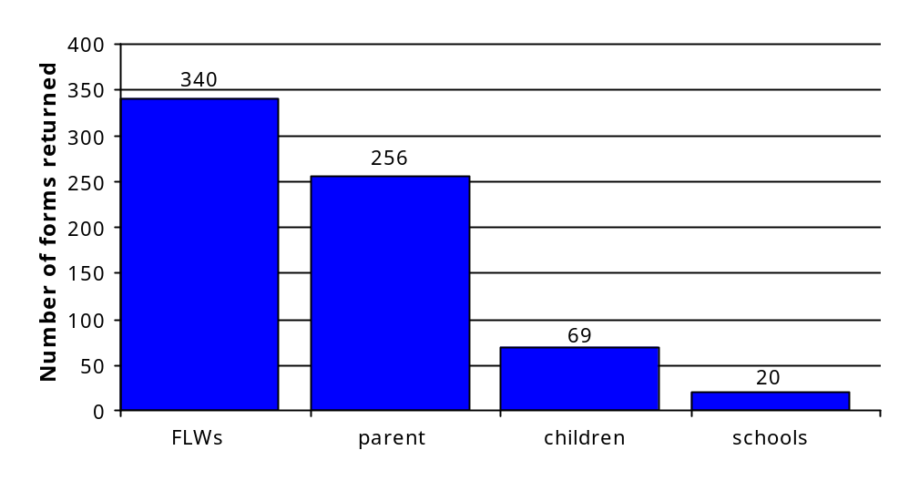Chart 2: Number of forms returned by each stakeholder

Overall, at least one form was returned for 340 cases. For 75% of cases parents/carers completed forms (compared with 65% in 2010/2011). For 20% of cases children completed forms (compared with 18% in 2010/2011).

2 Family Link Worker evaluation forms

2.1 Characteristics of the children referred to the service

The characteristics of the children described in this section are based on the information provided on the FLW evaluation forms (340).

2.1.1 Age and sex of children

The age and sex of the children that the service worked with in 2012/2013 were almost exactly the same as 2010/2011.

In 2012/2013 the age of the children ranged from 4 to 12 years. On average, the children referred were 7 years and 9 months.

Around twice as many boys than girls were referred to the service (224 v 111; not recorded in 5 cases).
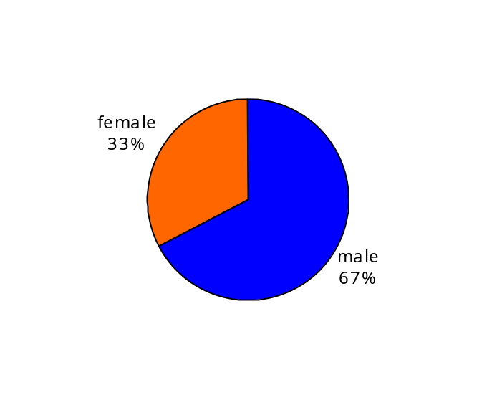
Chart 3: Proportion of male to female children referred to service

2.1.2 Special educational needs

Special educational needs in West Sussex

The figures for special educational needs in West Sussex’s state-funded primary schools show that the county has a slightly higher proportion of children with special educational needs than the national average, but a slightly lower proportion with a statement. This is illustrated in the following table.

Table 1: Proportion of children with special educational needs in West Sussex compared with England (state-funded primary schools)

 | Children with SEN without statements | Children with statements | All children with SEN
West Sussex | 16.7% | 1.1% | 17.8%
England | 16.0% | 1.4% | 17.4%

Source: DfE. (2013). Special Educational Needs in England: January 2013. London: DfE.

Family Link Worker Service evaluation

Around a third of children (115 or 34%) referred to the service had some level of special educational need, a much higher proportion than those in West Sussex primaries overall (17.8%). Of the 115 children, the largest proportion (56 or 49%) was identified as SEN Action Plus. The next largest group was identified as SEN Action (52 or 45%). Seven children (6%) had a statement.

2.1.3 Ethnicity

As can be seen from the table below, the vast majority of children referred to the service were of a White British ethnic origin.

Since the 2010/2011 evaluation, the recording of ethnicity has significantly improved. In 2010/2011 ethnicity was not recorded in 20% of cases. In 2012/2013 this figure dropped to 4% (13 cases).

Table 2: Ethnicity

 | number | percentage
White British | 303 | 92.7%
White other | 3 | 0.9%
White Irish | 1 | 0.3%
White and Black Caribbean | 2 | 0.6%
White and Black African | 4 | 1.2%
White and Asian | 3 | 0.9%
Other mixed background | 5 | 1.5%
Pakistani | 1 | 0.3%
Chinese | 1 | 0.3%
Other Asian | 1 | 0.3%
Spanish | 1 | 0.3%
Any other ethnic background | 1 | 0.3%
Prefer not to say | 1 | 0.3%
Total recorded | 327 | 100.0%
Not recorded | 13
Total | 340

2.2 Referral to the Family Link Worker Service

The figures in this section are based on the number of FLW evaluation forms completed and returned (340).

2.2.1 Number of referrals

The number of referrals was recorded for 307 cases. Of these, the vast majority who were referred to the service (89%) during the 2012/2013 period were referred for the first time.

Table 3: Number of referrals

 | number | percentage
First | 272 | 89%
Second | 35 | 11%

2.2.2 Referral requester

Around three-quarters of cases were referred to the FLWS by schools either alone or with parents or others (245 cases or 76%). Of these, 51 referrals were made by both the school and parent (16%); the school and other agencies made 11 (4%). A total of 31 other agencies also made referrals (10%).

Chart 4: Referral requester

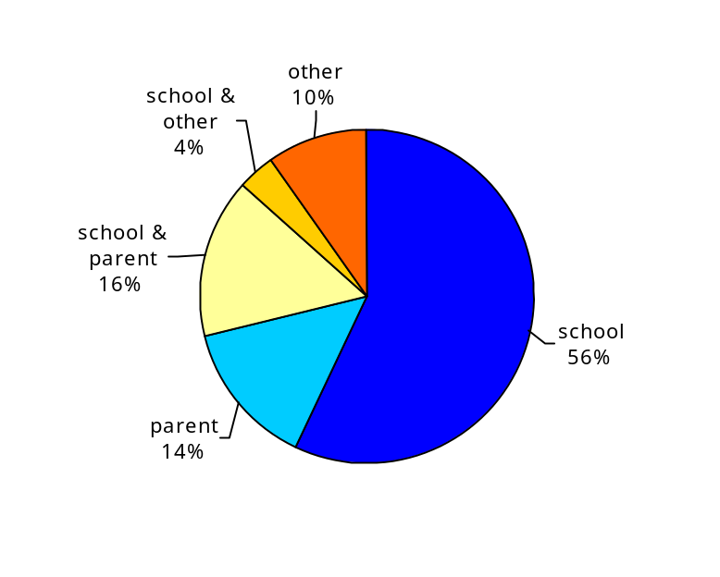

2.2.3 Number of sessions provided

Up to 11 sessions were provided for parents; up to eight were provided for children and up to five for both parents and children. As can be seen from the chart below, the average number of sessions provided has fallen between 2010/2011 and 2012/2013.

Chart 5: Average number of sessions with parents and children

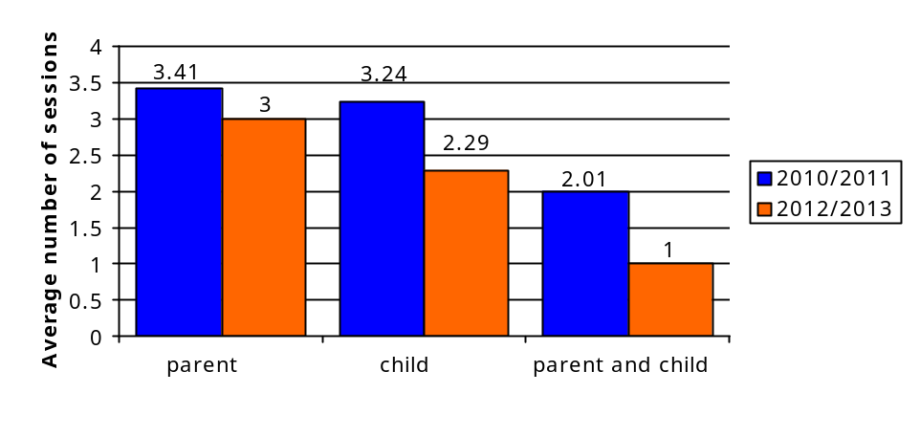
2.2.4 Reasons for referral to the Family Link Worker Service

As can be seen from the chart below, nearly eight in ten cases were referred for behaviour (266 or 78%); a third (110 or 32%) due to parenting skills; and 12% (40) due to family change.

Chart 6: Reasons for referral to the Family Link Worker Service

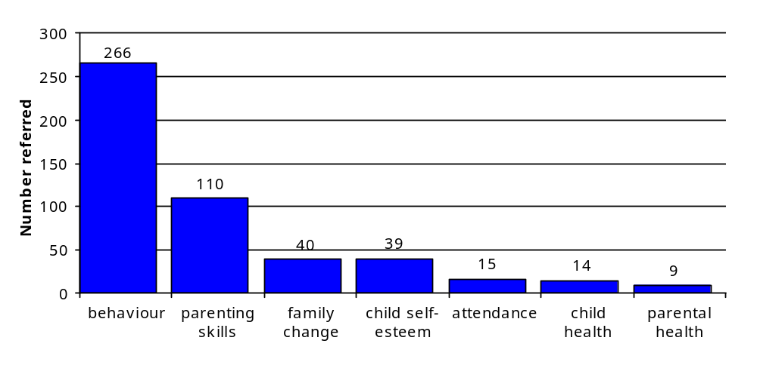
Lower number/percentage reasons for referral (under 9 or 3%) included: domestic violence (7); transition (7); friendship issues (3); mental health of parent/carer (4); young carer (2); housing (1); new to area (1); school refuser (1).

No referrals were made for the following reasons: substance misuse; victim of crime.

A final group – ‘other’ – accounted for 17 (5%) referrals. Where these were defined, they tended to be case-specific.

2.2.5 Referral by sex

Boys were more likely to be referred for behaviour than girls (82% of boys v 71% of girls). However, girls were more likely to be referred for issues related to self-esteem than boys (19% v 8%). This is demonstrated in the following chart.

Chart 7: Reasons for referral to the service by the child’s sex

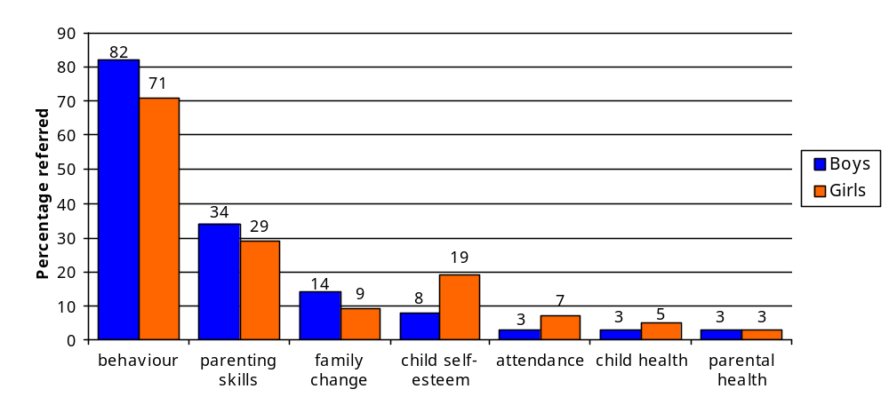
2.2.6 Referral by age range

The following chart shows that younger children tend to be referred for behaviour reasons, while older children tend to be referred for self-esteem and attendance.

Chart 8: Referral by age range
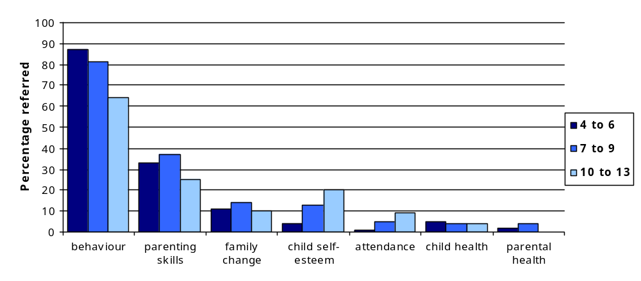

2.2.7 Non-engagement

Of the 340 cases, around a quarter (25% or 84) did not engage with the service. Of these, 26% were referred elsewhere after little work taking place. In eight cases (10%), families engaged at first, but then disengaged later. This is illustrated in Chart 9.

Chart 9: Non-engagement
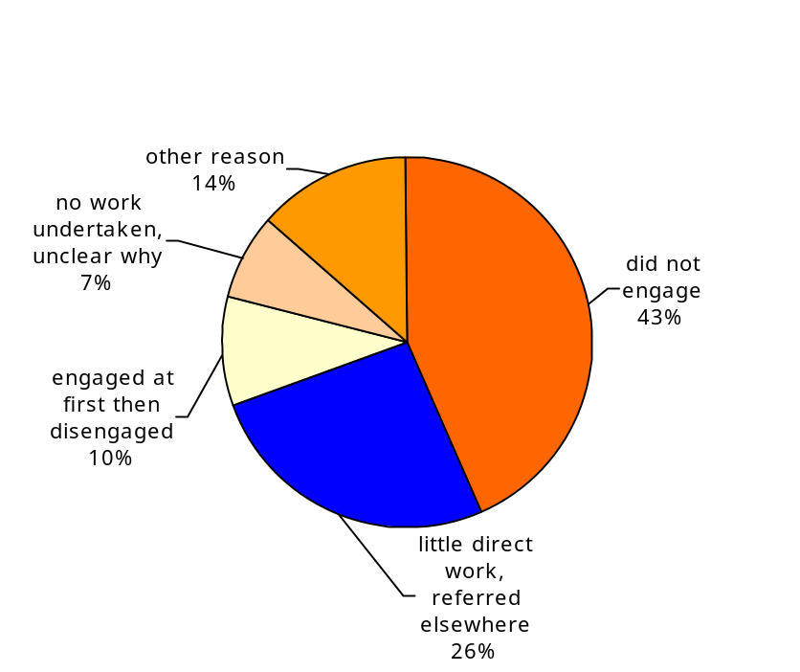

2.2.8 Casework undertaken

In some areas the casework undertaken reflected the reason for referral as can be seen from the following chart.

The chart also illustrates that, although the main reason for referral is behaviour, a high level of casework is focused on parenting skills. To a lesser extent, a similar pattern exists for family change, child self-esteem and child/parental health.

Chart 10: Comparison between reason for referral and the casework undertaken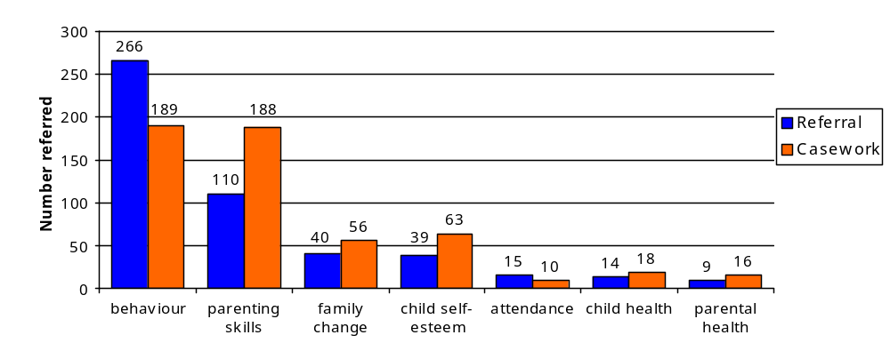

2.2.9 Liaison with other services

The number of other services that the FLW liaised with on individual cases was recorded. In 63% of cases no other service was recorded. Of those who did liaise with other services, most liaised with more than one. In 16 cases the FLW liaised with more than four, as illustrated in the table below.

Table 4: Liaison with other services

 | number | percentage
One | 58 | 17%
Two | 30 | 9%
Three | 20 | 6%
Four or more | 16 | 5%
Total | 124 | 37%
No other service recorded | 216 | 63%
All cases | 340 | 100%

2.2.10 Common Assessment Framework (CAF)

There was much less involvement in CAF recorded for cases in 2012/2013 than in 2010/2011. In ten cases (3%) the FLW said they had initiated a CAF (compared with 15% in 2010/2011), whilst six had been a lead professional for the case (2% in 2010/2011 compared with 12% in 2012/2013). This is shown in Table 5 on the following page.

Table 5: CAF involvement

 | 2012/2013 |  |  | 2010/2011
 | number | percentage |  | number | percentage
CAF initiated | 10 | 3% |  | 73 | 15%
CAF recommended | 10 | 3% |  | 44 | 9%
CAF contributed | 22 | 6% |  | 68 | 14%
CAF lead professional | 6 | 2% |  | 60 | 12%
CAF TAC attended | 29 | 8% |  | 86 | 17%

2.3 Family link workers’ ratings of effectiveness

FLW ratings of families’ situations

Family link workers rated the family’s situation between one and ten depending on the severity of issues, where one equated to the highest level of problems and ten no problems at all. This was done at the start of their involvement with families and at the end.

The table below shows that, on average, FLWs reported a positive three point change between the start and end of their work with families.

Table 6: FLW ratings – first and last meetings

Start | End | Change | Number of cases
3.3 | 6.4 | + 3.1 | 246

Extent of family participation

The majority of families were thought to have participated well – 71% reported that families either participated ‘a lot’ or ‘totally’. This is shown in the following table.

Table 7: Family participation

 | number | percentage
Totally | 93 | 38%
A lot | 81 | 33%
A little | 67 | 27%
Not at all | 5 | 2%
Total | 246 | 100%

Parental response to strategies suggested

Two-thirds of parents (66%) were reported as responding either ‘a lot’ or ‘totally’ to the strategies suggested.

Table 8: Parental response to strategies suggested

 | number | percentage
Totally | 72 | 30%
A lot | 86 | 36%
A little | 69 | 29%
Not at all | 11 | 5%
Total | 238 | 100%

Effectiveness of FLW input

In six out of ten cases (61%) FLWs felt that their input had been effective.

Table 9: Effectiveness of FLW input

 | number | percentage
Totally | 40 | 17%
A lot | 105 | 44%
A little | 86 | 36%
Not at all | 8 | 3%
Total | 239 | 100%

What was associated with effectiveness?

Further analysis found no difference between whether the input had been more effective for boys or girls. Similarly, the input was equally effective across all age ranges.

However, there was an association between effectiveness and both parental participation and their response to strategies, as follows:

- Higher level of parental participation = higher level of effectiveness
- Higher level of parental response to strategies = higher level of effectiveness

In other words, the service was more likely to be effective in cases where there was a higher level of participation from parents and in cases where they engaged with the suggested strategies.
3 Parent/carer evaluation forms

A total of 256 parents’ evaluation forms were completed and returned.

3.1 Parental rating of the family’s situation and how this changed

Parents were asked to rate, on a scale of one to ten, where their family started from and, later, where they ended up (ten being the most positive and one being the least).

Where parents started from and where they finished

On average, there was a positive shift of around three points in parents’ rating of their situation by the end of the FLW’s involvement. As can be seen from the table below, this was consistent with how FLWs rated their situation over the same time period.

Table 10: Parents’ and FLWs’ ratings of where families started from and where they finished

 | Start | End | Change | Number of cases
Parents’ rating | 3.31 | 6.59 | + 3.28 | 223
FLWs’ rating | 3.3 | 6.4 | +3.1 | 246

Parental rating of targets set

Parents rated their family’s situation across self-defined targets. As can be seen from the table below, each target, on average, had shifted by around three to four points on the rating scale over the period of the FLW’s involvement with the family.

Table 11: Parental rating of targets set

Target | Start | End | Change | Number of cases
1 | 2.69 | 6.26 | + 3.57 | 206
2 | 2.43 | 5.88 | + 3.45 | 141
3 | 1.99 | 5.92 | + 3.93 | 60

4 Children’s evaluation forms

A total of 69 children’s evaluation forms were completed and returned.

4.1 The extent to which the FLW helped children and their families

All children felt that the FLW had helped to some extent, eight out of ten of whom said the FLW helped ‘a lot’.

Table 12: The extent to which the FLW helped children and their families

 | number | percentage
A lot | 55 | 80%
A little | 14 | 20%
Not at all | - | -
Total | 69 | 100%

4.2 How the FLW helped

Children rated the extent to which the FLW had helped across a range of areas. As can be seen from Table 13 below, children were generally positive in their ratings of the help they had in the listed areas. They were most positive about the FLW’s help at home with 74% reporting that the worker had helped ‘a lot’.

Table 13: How the FLW helped at home, at school with friends and in some other way

FLW help: | A lot | A little | Not at all
At home | 74% | 26% | 0%
At school | 62% | 26% | 12%
With friends | 40% | 40% | 19%
Some other way | 64% | 18% | 18%

5 Schools’ evaluation forms

Schools’ evaluation forms contained two questions relating to specific pupils with whom the FLWS was working. Forms were returned for 20 children.

5.1 The extent to which barriers to learning changed

In 13 of the 20 cases (65%), schools felt that barriers to learning had at least been lessened.

Table 14: The extent to which barriers to learning changed

 | number | percentage
Totally removed | 2 | 10%
Been lessened | 11 | 55%
Remained the same | 7 | 35%
Became worse | 0 | 0%
Became a lot worse | 0 | 0%
Total | 20 | 100%

5.2 The extent to which other family-related problems changed

Schools said that family-related problems had been either removed or lessened in 11 of the 20 (55%) cases.

Table 15: The extent to which other family-related problems changed

 | number | percentage
Totally removed | 2 | 10%
Been lessened | 9 | 45%
Remained the same | 6 | 30%
Became worse | 2 | 10%
Became a lot worse | 1 | 5%
Total | 20 | 100%

6 Schools’ views about the effectiveness of the Family Link Worker Service

Schools were asked about their experiences of working with the Family Link Worker Service. A total of 40 schools gave their views.

6.1 Effectiveness of FLWS in meeting needs

The majority of schools (86%) reported the FLWS as being either effective or very effective in meeting needs. Five schools felt that service had not been effective in this respect.

Table 16: Effectiveness of FLWS in meeting needs

 | Number | %
Very effective | 19 | 51%
Effective | 13 | 35%
Not very effective | 4 | 11%
Not at all effective | 1 | 3%
Total | 37 | 100%

6.2 Effectiveness of FLWS in improving links between parents and schools

As can be seen from the table below, the majority of schools felt the FLWS was effective or very effective at improving links between parents and schools (92%).

Table 17: Effectiveness of FLWS in improving links between parents and schools

 | Number | %
Very effective | 18 | 49%
Effective | 16 | 43%
Not very effective | 2 | 5%
Not at all effective | 1 | 3%
Total | 37 | 100%

6.3 Referral procedure

All in all, schools thought the referral procedure worked well. Only two schools felt this was not the case.

Table 18: How well does the referral procedure work?

 | Number | %
Very well | 27 | 73%
Quite well | 8 | 22%
Poorly | 2 | 5%
Very poorly | 0 | 0%
Total | 37 | 100
6.4 Overall experience of working with the FLWS

Overall, around nine out of ten schools rated their experience of working with the FLWS as either good or very good (92%).

Table 19: Overall rating of schools’ experience of working with the FLWS

 | Number | %
Very good | 27 | 71%
Good | 8 | 21%
Adequate | 1 | 3%
Poor | 2 | 5%
Total | 38 | 100%

6.5 Suggested improvements to the service

Schools were asked an open-ended question to find out how they felt the service might be improved. Broadly speaking, the most suggested areas where improvements might be made were associated with the service’s capacity, as illustrated in the table and following comments.

Table 20: How could the service be improved?

 | Number | %
More FLW time/more FLWs | 13 | 32%
Reduce waiting times | 4 | 10%
Other specific suggestions | 9 | 22%

6.5.1 More FLW time/more FLWs

Typical comments included:

‘More availability – longer periods of involvement.’

‘We are in constant need of this service, so more hours would be useful.’

‘The obvious answer is increase the capacity of the service so we can refer more children.’

6.5.2 Reducing waiting times

Typical comments included:

‘That referrals are picked up more quickly, but I know this is because of the impact of staffing and funding.’

‘It would be good if there wasn’t such a waiting time, time that we had to wait after a referral.’

‘More FLWs in place to cut down waiting times, but I know this is a budget issue.’

6.6 Other comments made by schools

Schools were invited to make any other comments they wished about the service. These tended to be highly complementary and supportive of the service. A full list of these comments can be found below:

‘Amazed at how skilled and experienced, wise and knowledgeable [FLW] is.’

‘Our FLW is fantastic. She is always happy to discuss concerns and queries and offers productive solutions and advice. For a new SENCo working in West Sussex for the first time, I have been very impressed with the service.’

‘[FLW] always makes effective links/communication with parents and school. She responds quickly to each referral.’

‘As many cases are being ‘referred on’ by GPs etc., the workload is increasing and often the cases that are seen by FLW are the more ‘extreme’, rather than those where intervention can be more effective. [FLW] is great!’

‘Very grateful for the support.’

‘We made a good start with [FLW] and the service is very good, but has declined over the last two years. I am not sure the reasons why it has deteriorated.’

‘This is an excellent service which is being offered to schools. [FLW] has had significant success with the children and their families. But most important she has been able to bridge the gap between home and school. She has been able to inform the school of issues/concerns from home and we have been able to work together to resolve these. I would like to say a massive thank you to [FLW] from all the staff at [school].’

‘I have worked and had good communication with [FLW] and previous link workers. We have networked and worked as a team, which makes the service a joy to work with.’

‘Feel the family link worker service plays a vital part in our school provision. It has been very successful on a number of occasions and we have a good working relationship which means parents trust everyone involved. [FLW] is great to work with and I would like a similar format to be still available.’

‘Please may it continue. We find this service so valuable to support families in ways we cannot. It also provides a great link between home and school.’

‘[FLW] is excellent! The needs of the child required FRT support and were beyond what [FLW] could achieve alone.’

‘We support the need for more FLWs to enable greater, more timely access to them when they are needed.’

‘It works very well!’

‘We have been fortunate to receive the support of two FLWs this term and for this we are really grateful. The service is much needed and essential for providing family support.’

‘Overall very supportive and easily accessible and a much needed resource. Thank you!’
7 Conclusion

7.1 The evaluation

This project had two main aims. Firstly, to evaluate the impact of the Family Link Worker Service over the 2012-2013 academic year and, secondly, to help inform ongoing data collection and the development of fields and output for Frameworki.

In order to gain a balanced perspective, all key stakeholders completed forms asking how effective they thought the service had been in improving families’ situations. The stakeholders involved were parents, children, FLWs and schools. All forms that were completed by stakeholders were returned to the Public Health Research Unit where they were compiled, organised, aggregated and analysed.

7.2 Service overview

The results of the project provided an overview of the characteristics of the children and families referred to the service. As this report was a follow up to the earlier evaluation comparisons with the earlier data could be made where appropriate.

Forms were returned for 340 cases. The children that these forms related to attended 125 different primary schools, meaning that the service worked with children from around half of all primaries in the county.

The children referred to the service in the 2012-2013 academic year had almost identical characteristics to those referred to the service in 2010-2011. The children referred to the service were twice as likely to be boys as girls. The average age of the children referred was just under eight years old. Additionally, they had much higher levels of special educational needs compared with those in the general population. Meanwhile, whilst the ethnicity of those referred was similar between 2010-2011 and 2012-2013, the recording of ethnicity significantly improved for the latter academic year.

Overall, lower numbers of sessions were provided in the 2012-2013 year than in 2010-2011. In 2012-2013 up to eight sessions were undertaken with the children (average around 2); up to 11 with parents (average around 3); and up to five sessions with both together (average around 1).

Most referrals came from schools. Behaviour was the main reason for most referrals with this featuring in more than three-quarters of cases. Boys were more likely than girls to be referred for this reason. Meanwhile, girls were more likely to be referred for issues related to self-esteem. Although casework broadly reflected referrals, parenting skills, in particular, stood out as a major area of casework with families.

Around a quarter of the cases referred to the service were non-engagers.

7.3 Effectiveness of the service

In around seven out of ten cases, FLWs said that families had participated well and responded to the suggested strategies. In six out of ten cases FLWs rated their input as effective. Effectiveness was found to be associated with both parents’ participation and their response to the suggested strategies.

FLWs and parents used rating scales to assess any changes in families’ situations over time alongside changes in parents’ self-defined targets. On average, all of these scales showed a positive change between the start and the end of FLWs’ work with the families.
Children were similarly positive about the extent to which the FLW helped them and their families. The area in which children felt the FLW had helped most was at home.

Schools generally felt that both barriers to learning and problems at home had been lessened during the period of FLW involvement with cases.

Overall, 86% of schools thought the service was effective at meeting needs. Meanwhile, more than nine out of ten schools reported that the service had been both effective in improving links between parents and schools and that the referral procedure had worked well.

Schools also highlighted areas where they felt improvements might be made. In general, they said that they would like to see improvements in the area of capacity. In particular, they felt there could be more FLW time and/or more FLWs and that waiting times could be reduced.

Public Health
Research Unit

West Sussex Public Health Research Unit
West Sussex County Council
The Grange
County Hall Campus
Chichester
West Sussex PO19 1QT

Phone: 033022 28673
Email: researchandconsultation@westsussex.gov.uk

There are 240 primary schools in West Sussex in total.
Martin, T. (2011). Family Link Worker Service Evaluation 2010-2011. West Sussex County Council.

