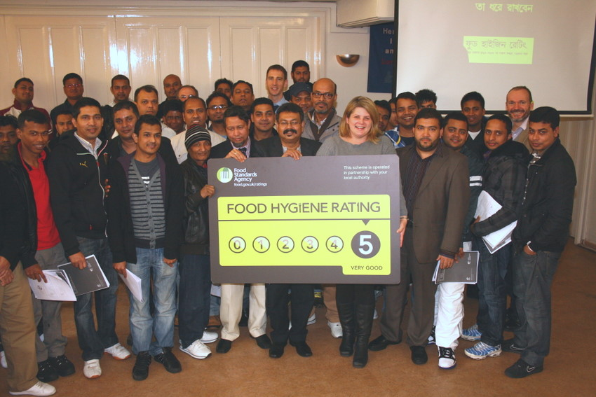

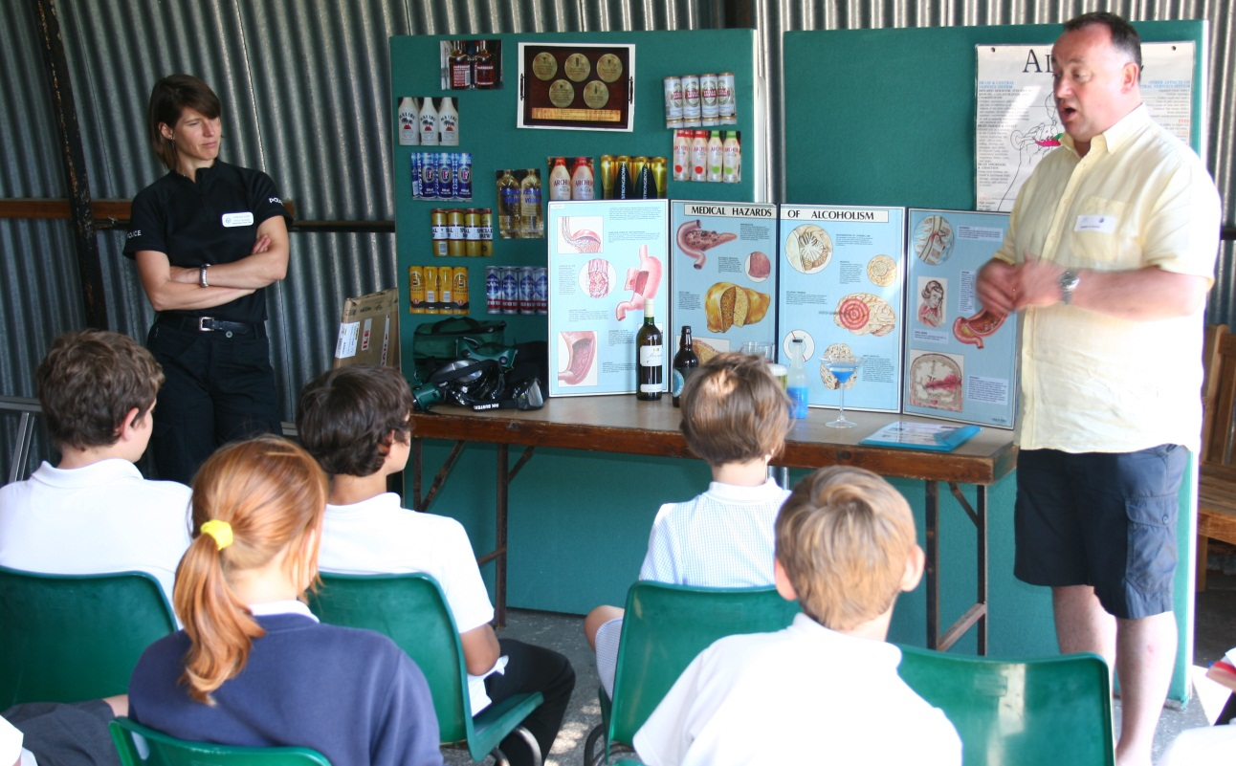


Environmental Health Services
Reconnecting Public Health


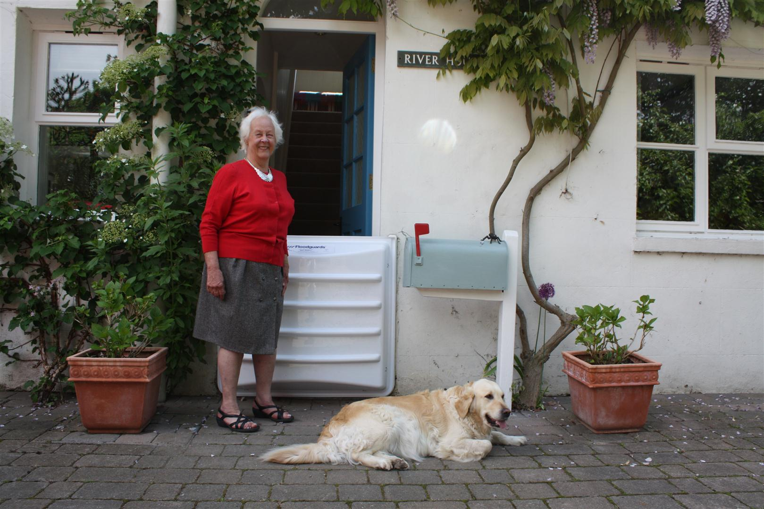
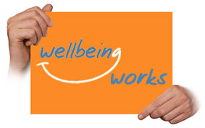
Environmental Health Services: Reconnecting Public Health

Foreword

Over the last year, we have seen significant changes in the way that work to protect and improve Public Health is carried out, as duties in respect of Health and Wellbeing moved from the NHS to West Sussex County Council. This new way of working presents challenges in providing a joined-up approach across the agencies providing these services.

However, all of these agencies share a goal: to offer the best service for the community of West Sussex. In a time of reducing resources, this means targeting and aligning our services effectively. It is, therefore, essential to have an objective understanding of the needs of our community and this requires the collection and analysis of evidence relating to public health issues in West Sussex.

As Local Authorities, we have access to a range of tools to address public health issues, both on an individual and community wide level. These include promotion of positive behavioural changes before individual ill health develops, a regulatory function to enable enforcement of certain standards designed to maintain the health of the public and provision of services to assist individuals who wish to improve their health and well being. As we carry out this work, we monitor and collate information, which is used locally and nationally for horizon scanning and planning risk based interventions.

The transfer of a range of Public Health duties from the NHS to West Sussex County Council offers new ways for all of the Local Authorities within West Sussex to work together: County, Boroughs and Districts across the county will have the opportunity to forge better and more effective working relationships. This report represents the first step in creating a joint evidence base to inform the interventions that we need to carry out to support a happier and healthier community in West Sussex.

CONTENTS

Page(s)
Introduction

Subject Reviews
- Air Quality
- Fuel Poverty
- Water Quality
- Alcohol Control
- Noise Control
Emergent Issue

Raising Awareness of Food Hygiene Standards

Core Issue Briefings

- Workplace safety and accidents
- Natural environment
- Tobacco control
- Pest control
- Housing
-Climate Change
- Sites of specific risks: Cooling Towers

Appendices
Appendix 1 Core datasets to be sustained within JSNA framework

Appendix 2 Environmental Health contacts in West Sussex

INTRODUCTION

Environmental Health Services have a long history as one of the key contributors to the delivery of public health work. The service is located solely within the Boroughs and Districts. Officers in these authorities, the original ‘public health inspectors’, play an active role in population wide interventions through advice, regulation and education. Their day to day work provides unique access to information regarding live Public Health issues in West Sussex and the role they play as part of the ‘Public Health Workforce’ for West Sussex is illustrated in Figure 1.

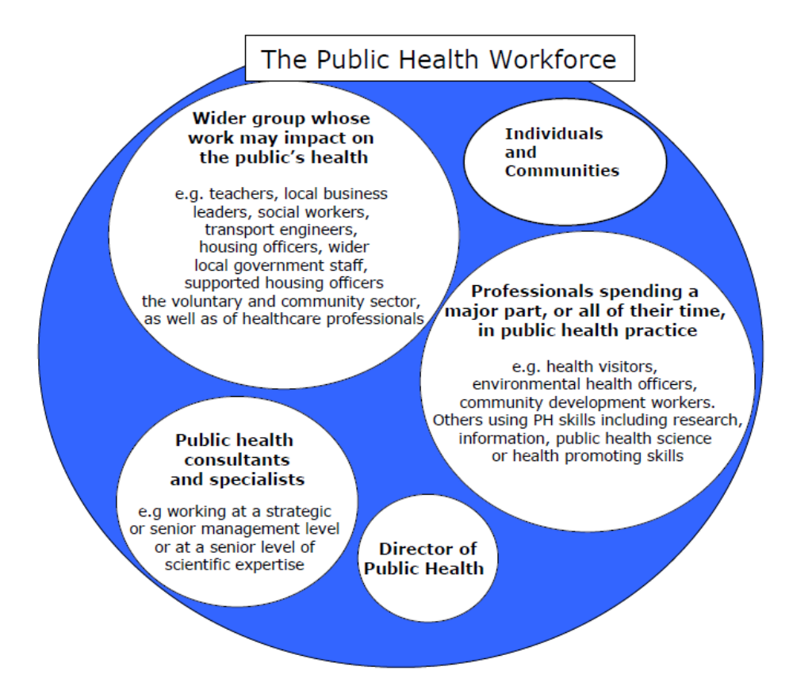
Figure1. West Sussex County Council Public Health Plan 2012-2017.
The scope of Environmental Health Services is considerable, as shown in Figure 2 below.
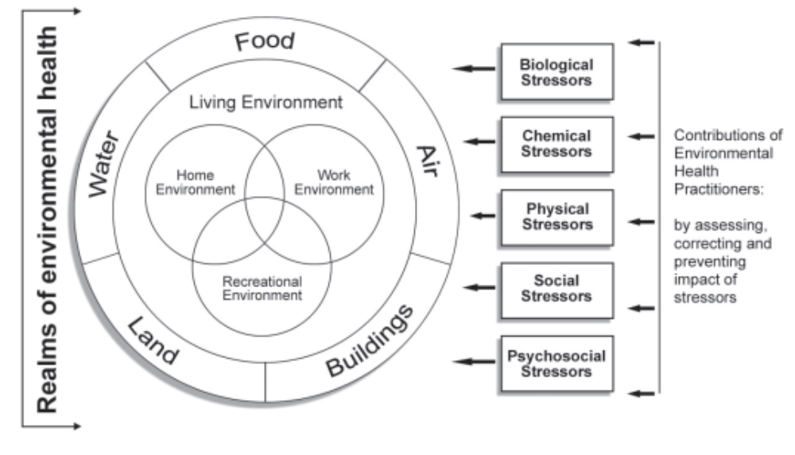
Figure 2. The Scope of Environmental Health Services
Burke, S., Gray, I., Paterson, K., and Meyrick, J. (2002), Environmental Health 2012 – A Key Partner in Delivering the Public Health Agenda, Health Development Agency, London.

In order to deliver an effective service it will be necessary to build on existing good practice within this scope, in order to integrate the diversity of the interventions currently available through Environmental Health Services. Our aim is to actively create and participate in an holistic ‘Public Health Service.’

It will also be necessary to align the current strategies and plans which have been developed to address local needs, as perceived by the Public Health services within West Sussex. Figure 3 shows an overview of some of the key players with strategies for delivering ‘Public Health’.

West Sussex County Council

West Sussex Public Health Plan 2012-2017
District and Borough Councils
Environmental Health Services (EHS), supported by
Sussex CEHOs ‘Spanning the Gap’ Public Health Strategy
Health and Wellbeing
Partnerships
Non- Local Authority Regulatory Agencies e.g. Environment Protection Agency, Health and Safety Executive, Health Protection Agency.
Sussex Regulatory Services Public Health Strategy
Police
Fire Authority
Trading Standards

Environmental Health Regulatory Services
Public Health
Figure 3. An Overview of Key Players in Public Health

Over the last year for Environmental Health Services across West Sussex, our focus has been on:
- The proportionate and transparent enforcement of public health legislation
- Protection of the human environment
- Ensuring food safety standards are being maintained and improved
- Ensuring workplace health, safety and wellbeing standards are maintained and improved
- Improving homes to make them decent.
- Eliminating vectors of disease and public health nuisance and
- Working with others to improve public health and protect public health rights

Our objective in collating and presenting the information in this report is to give a sense of the range of evidence which could be developed and provided to create priorities for Public Health interventions in West Sussex which accurately reflect local needs. The majority of the data described has the advantage of being timely and ‘live’ in that it can usually be made available annually, quarterly and in some cases monthly. It can also, being sourced from local districts and boroughs, identify specific needs in specific areas, sometimes down to Ward level. This is invaluable when looking to target limited resources in a county as diverse as West Sussex.

This is the first report of its kind for West Sussex and the sheer breadth of public health work covered by Districts and Boroughs means that it has not been possible to present all of the data relating to Environmental Health Services in this initial document. Instead, the report presents in the first section five key subjects which affect Public Health in West Sussex:

- Air Quality
- Fuel Poverty
- Water Quality
- Alcohol Control
- Noise Control

Each Subject Review explains the significance of the subject in respect of Public Health, with an example of local data for West Sussex and recommendations for the future, based on current trends.

The second section focuses on the emergent issue of increasing public awareness of Food Hygiene standards when eating out: an excellent example of public pressure improving commercial standards, which in turn improves public health.

The final section contains a series of briefings on core Environmental Health issues, as examples that could be developed into Subject Reviews in the future.

WHY IS AIR QUALITY IMPORTANT?
SUBJECT REVIEW – AIR QUALITY
Air pollution has major environmental and health implications.

The WHO has estimated that air pollution causes 800,000 premature deaths from respiratory and cardiovascular disease worldwide. It also increases the incidence of chronic disease, impairs lung function and exacerbates asthma.

In the UK, life expectancy is estimated to reduce by an average of 6 months from long-term exposure to poor air quality. Furthermore, poorer air quality is associated with deprived areas due to the proximity to busy roads and areas of industry. It is estimated that the societal cost from the impact of air pollution is about £9 to £19 billion every year in the UK (£120-£250m for West Sussex based on population).

WHAT IS THE IMPACT OF AIR QUALITY ON HEALTH?

Key Pollutants and their Impact on Health

Table 1 Key Air Pollutants and Their Sources

KEY POLLUTANTS | SOURCES
Nitrous oxides (NOx) | - Relevant nitrous oxides are NO and NO2  - Main source is road traffic and burning of fossil fuels
Particulate Matter (PM) | - PM10 and PM_{2.5} (fine particles smaller than 10 and 2.5 micrometres respectively)  - Main source is car and fuel combustion. Other sources include mining processes, particles from brake and tyre wear, dust from construction work  - Natural sources of particular include wind blown dust, sea salt, pollen and salt particles
Carbon Monoxide (CO) | - Formed when gas and fossil fuels are burned without an adequate supply of oxygen  - Other sources include road traffic – levels have decreased due to catalytic converters
Ozone (O₃) | - Secondary pollutant formed by photochemical reactions between primary pollutants in the lower atmosphere  - Main source for primary pollutants is motor vehicles  - Precursor pollutants like ozone are able to travel long distances where they accumulate and reach high concentrations in areas further from the source  - Higher levels of ozone are found in rural areas as a result of this and higher levels of chemical reaction between ozone and NO_{x} in urban areas.

Health Impact of Key Pollutants

For the most part, air pollutant levels have continued to decrease and the resulting health effects from exposure to air pollutants are based on exposure to high levels and prolonged exposure to air pollutants.

Nitrous oxides - The health impact of nitrous oxides at ambient levels (levels in outside air) is still unclear as it is difficult to separate the effect of nitrous oxides from the other pollutants released. At high concentration, it causes inflammation of the lungs and increases the likelihood if lung infections.

Particulate Matter – health effects of PM are associated with respiratory and cardiovascular disease. Long term exposure to particles has been found to increase the risk of death, while daily and long term exposure is associated with cardiovascular disease. PM2.5 are smaller particles, which can be carried deeper into the lungs and can worsen lung disease.

Carbon Monoxide – Carbon monoxide reduces the transport of oxygen in the blood and its delivery to tissues. Higher exposure to carbon monoxide is from indoor sources, which can cause symptoms such as tiredness, nausea and headaches.

Ozone – Ozone is an irritant and high levels of ozone can cause breathing discomfort and damage to the lining of the airways. The inflammatory response in asthmatics is prolonged and studies have shown higher hospital admissions among asthmatics. This is an issue for West Sussex because of the county’s rurality and it’s proximity to Europe. High levels are recorded when anti-cyclonic conditions prevail on the continent, causing air carrying a cocktail of pollutants to travel to the UK. The sun heats this polluted air, causing the creation of Ozone, which is unable to be broken down in the same way that it is in urban areas. As we would expect, Ozone has a greater presence in the atmosphere on high temperature days, and is expected to become more prominent in the rural areas of the south of England as the planet’s climate changes over the next few decades.

Monitoring of Air Pollution at National and Local Level

Air pollution has decreased for the past four decades due to measures taken to improve industrial processes, emissions from motor vehicles and domestic sources. However, there are indications that the reduction is levelling off for a number of pollutants including nitrous oxides (NOx) and sulphur dioxide (SO2).

The health impact of air pollution is receiving further recognition and the recent Public Health Outcomes Framework has included air pollution as an indicator to improve the population’s health.

The National Air Quality Strategy introduced standards and objectives for eight pollutants, which are the maximum concentration acceptable to public exposure. In addition, the strategy also introduced air pollution monitoring at more local area levels through the Local Air Quality Management (LAQM) scheme. Under the LAQM scheme, local authorities have to monitor air pollution levels and take action if they breach the objective targets.

If an area is likely to exceed maximum concentration levels, it must be declared an Air Quality Management Area (AQMA). Sussex currently (June 2012) has 12 AQMA areas, which have produced action plans to reduce air pollution.

Table 2 AQMAs in West Sussex

Local Authority | AQMAs | Description | Pollutant
ADUR | Shoreham AQMA | Area encompassing the High Street, Shoreham-by-Sea between the Ropetackle Roundabout and Surry Street. | Nitrogen dioxide
ADUR | Southwick AQMA | Area encompassing the Old Shoreham Road, Southwick between Kinston Lane and Lower Drive. | Nitrogen dioxide
ARUN | Currently, there are no Air Quality Management Areas in Arun.
CHICHESTER | Chichester St Pancras (AQMA) | Area along St Pancras Road, Chichester between Eastgate Square and New Park Road. | Nitrogen dioxide
CHICHESTER | Chichester Orchard St (AQMA) | Area along Orchard Street, Chichester at the eastern end of the street where it meets Northgate | Nitrogen dioxide
CHICHESTER | Chichester Stockbridge Roundabout (AQMA) | Area encompassing the Stockbridge Roundabout at the junction of the Chichester bypass and Stockbridge Road. | Nitrogen dioxide
CRAWLEY | Currently, there are no Air Quality Management Areas in Crawley
HORSHAM | Horsham AQMA No1 | West Street, the High Street, and part of School Hill and Manleys Hill, Storrington. | Nitrogen dioxide
HORSHAM | Horsham Cowfold AQMA | Incorporating The Street, part of Station Road and Bolney Road | Nitrogen dioxide
MID SUSSEX | Currently, there are no Air Quality Management Areas in Mid Sussex
WORTHING | Currently, there are no Air Quality Management Areas in Worthing
Source: DEFRA

AIR QUALITY - Local Data Example - Crawley

In 2011, Crawley published their Progress Report on air quality, an update on air pollutant levels and information on monitoring sites within the district. The information below is taken from the report unless otherwise noted.

There are no AQMAs within Crawley, but 11 permanent diffusion tube sites and one automatic monitoring site. The automatic monitoring site measures NO2 and PM10 while the diffusion tubes monitor NO2 concentrations. In addition to the automatic site in the Gatwick East site, four other sites managed only by British Airport Authority (BAA) and Reigate and Banstead Local Authority have been included in the report for pollution concentration comparisons.

The results from all monitoring sites show that NO2 levels have increased although there were variations based on distance to the airport and the level of road traffic in residential areas.

The results from all automatic monitoring sites in Gatwick have found that NO2 levels have fluctuated since 2004 but all sites showed higher NO2 concentrations in 2010 than in 2009, with an average increase of 15%. Overall, NO2 levels have shown slight improvement over the past 7 years in Horley and Gatwick Airport. However NO2 levels have increased slightly in Gatwick East and Poles Lane (site close to the airport) since 2004.

Results from the diffusion tube in the Gatwick East area reported an increase in NO2 levels by 7 to 11 µg/m3 between 2009 and 2010. While previous analysis indicates a decrease in NO2 levels between 2004 and 2009, the 2010 NO2 levels have resulted in a reversal of that trend.

Figure 1 Annual Mean Nitrogen Dioxide Concentration 2004-2010
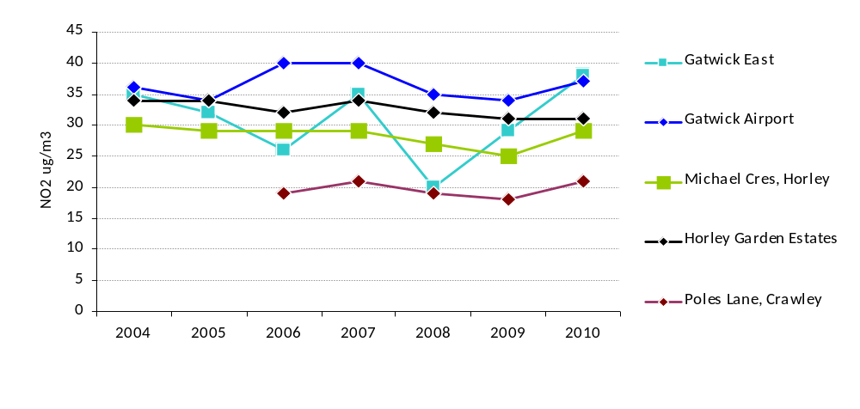

Source: Crawley Borough Council

NO2 levels from diffusion tubes in other areas also reported increases. NO2 levels from the diffusion tubes at background roads were up by 34%, roadside sites by 37% and airport sites by 40%.

The higher NO2 concentrations in 2010 were a major contributing factor in the reversal of the downward trend. Although passenger volume to Gatwick has reduced by a million people, the likely sources for the increase in NO2 concentrations are a result of variations in pollution emission and changes in wind direction, which would have brought in air pollution from the airport and M23.

The location of the permanent monitoring sites is shown in Figure 2.1 below. Additional diffusion tube sites are set up as necessary to monitor areas of potential exceedence identified by the review and assessment process.

Figure 2 Permanent NO2 Monitoring Sites In Crawley
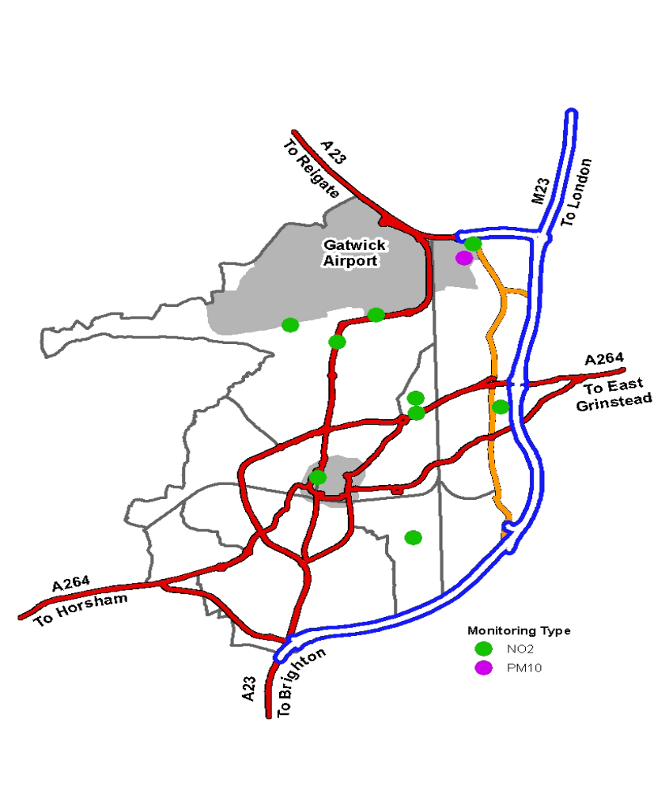

Hazelwick Roundabout

During 2010 the diffusion tubes placed at the Tinsley Close and Woodfield Lodge sites (located on either side of the Hazelwick Roundabout) exhibited mean NO2 readings of 51, 51, 55 and 69, exceeding the 40µg/m3 level. These areas are close to several residential roads, commercial buildings and Hazelwick primary school but there is quite a lot of open space nearby enabling gas dispersion. Three other tubes placed in Crawley town centre also had mean readings exceeding 40µg/m3. Crawley town centre has a high pedestrian traffic throughout the day and includes a large number of workplaces, the buildings here may be creating a “canyoning effect” by not allowing the gases to disperse from the roadside.

Traffic

NO₂ is produced primarily via vehicle emissions, which is a big problem in congested towns and cities with high buildings that abut the road. In these conditions the buildings create a canyoning effect. Other environmental conditions such as natural environment, wind speed and direction and land contours can also have an effect on NO₂ levels. This combination of factors makes the correlation between traffic volume and NO₂ a complex one. We have received data on traffic volume and waiting times at junctions but have not used the data to conduct any public health analysis due to these issues. An example traffic volume map is shown below for reference.

Figure 3 Rush Hour Traffic Flows in Crawley
(Passenger Car Unit per hour)

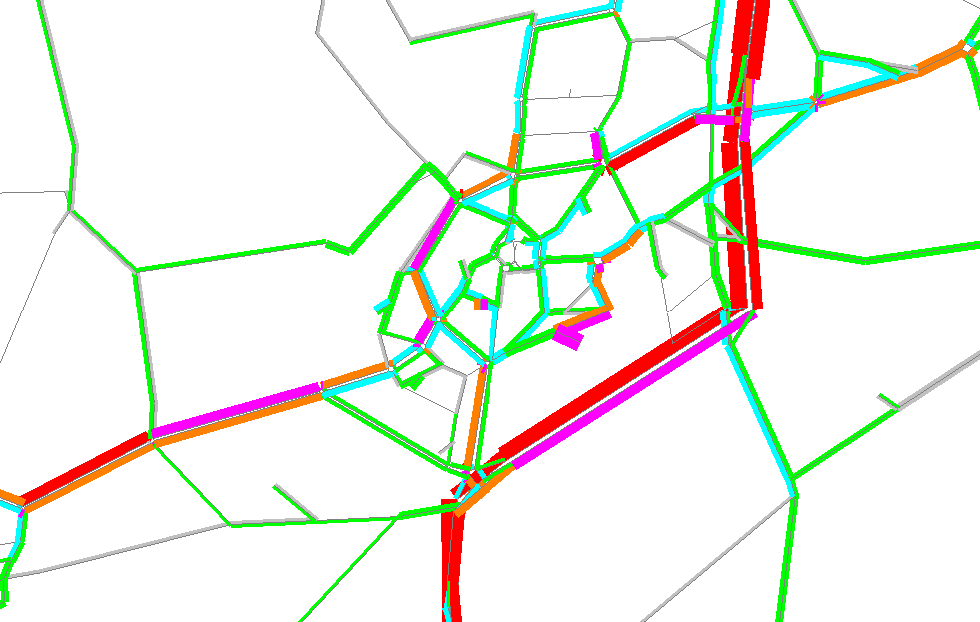

Legend
> 2250
1750 – 2250
1250 – 1750
750 – 1250
250 – 750
< 250

Source: WSCC

PM10

Table 3 below shows that PM10 annual mean concentrations in 2010 have increased by 6% in monitoring sites in Gatwick. However, the overall change in PM10 concentration from 2004 to 2010 shows a downward trend line despite the increase in 2010.

Table 3 Annual Mean Concentrations of PM10 at Gatwick Airport

Monitoring Sites | 2010 PM10
Monitoring Sites | Annual mean concentrations (µg/m3).  Objective = 40µg/m3 | Number of exceedences of daily  Mean objective (50µg/m3)
Gatwick East | 22 | 3
Gatwick Airport | 22 | 3
Horley, AQMA | 19 | 1
Source: Crawley Borough Council

Figure 4 2004-2010 Annual Mean of PM10 at Gatwick Sites
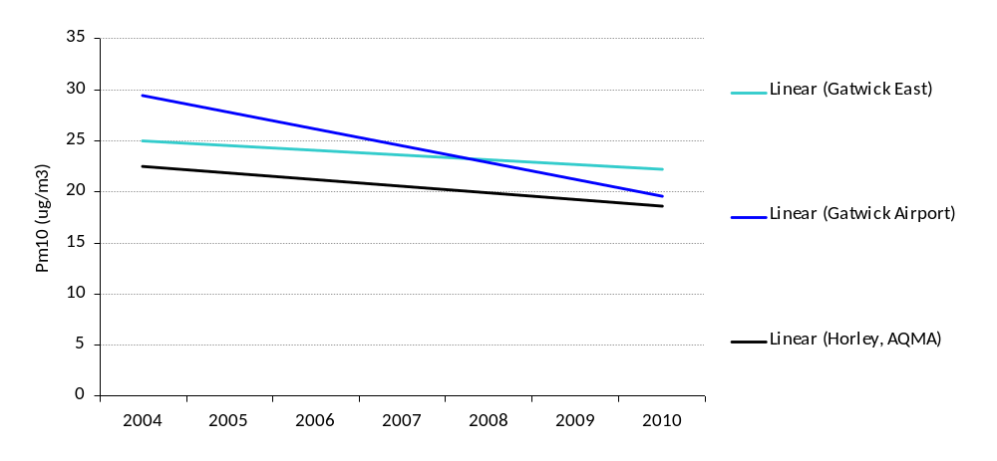

Sulphur Dioxide, Benzene, Carbon Monoxide and Lead

Within Crawley, these air pollutants do not appear to have much of an impact on overall air quality compared to NO2 and PM10. The report found there were no significant or harmful sources of all these air pollutants from industrial, domestic or transport sources. Previous monitoring of these air pollutants did not exceed the air quality objectives and were unlikely to exceed the 2010 objectives.

Indices of Multiple Deprivation 2010 (IMD 2010)
A model was developed by Staffordshire University (2008) and used in the IMD 2010. This modelled air quality measures at small area level and showed some areas of Crawley, Chichester and Burgess Hill being among the 20% worst areas in the country. Due to the effects of the built and natural environment on pollution dispersion, however, modelling air quality at such small areas is problematic and should be treated with caution.
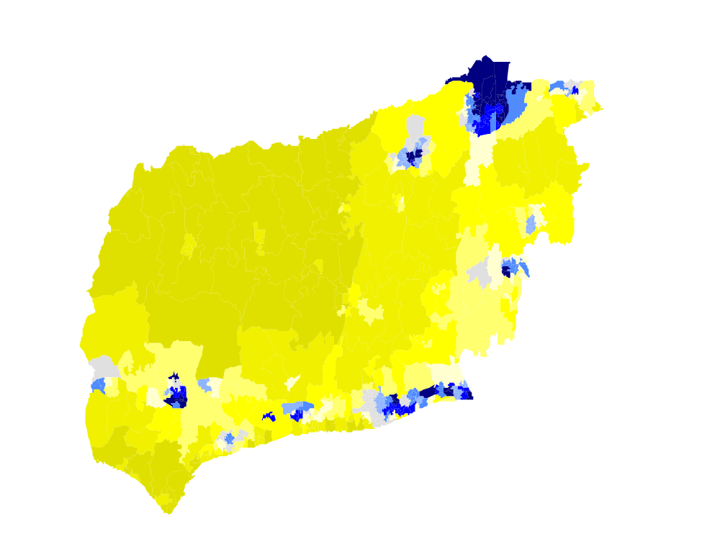
Figure 5 Small Area Rankings from ID20910

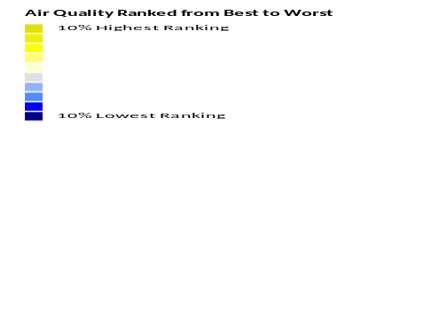

ACTIVE INTERVENTIONS

- airAlert is a service, provided by the Sussex Air Quality Partnership (SAQP), that sends alert messages to vulnerable people in Sussex informing them that poor air quality is predicted in their area. The alerts are sent to home phones via voice message, to mobile phones via text and via email to a total cohort of around 500 people suffering from COPD. The SAQP are aiming to provide a similar service to people vulnerable to atmospheric conditions other than pollution in the near future (high levels of ozone, pollen or heat for example).

- A review of the effectiveness collected as part of the Air Alert system is currently being undertaken by Kings College, London.

- A Cold Alert pilot will also start this winter (2012/13), providing warnings on particularly cold days, something that is currently primarily aimed at sufferers of COPD but may be of interest to other people with chronic conditions and mobility problems. This may be of interest to policymakers/commissioners concerned with excess winter deaths.

- Environmental health departments also work in conjunction with WSCC to provide safe routes to school and promote cycling into both school and work. Further data are available on these topics.

- Another initiative has been to install electric vehicle charging points to disincentives the use of petrol and diesel cars across the county. There are two in each district.

RECOMMENDATIONS

- When complete, to consider findings of the Kings College study into the impact of the AirAlert system on hospital admissions and carry out a cost effectiveness analysis on system.

- To ensure that the new Public Health outcome on air quality incorporated into the JSNA.

WHY IS FUEL POVERTY IMPORTANT?
SUBJECT REVIEW - FUEL POVERTY AND COLD HOMES

Not being able to adequately heat living and sleeping space can affect physical and mental well being in a number of ways, and these may require different interventions, summarised below:-

Increased blood pressure and risk of heart attacks and strokes
Worsening arthritis

Increased respiratory illness

Symptoms of arthritis, particularly pain, become worse among people who live in cold, damp homes.
Worsening asthma and COPD (chronic obstructive pulmonary disease).
Blood pressure rises in older people with exposure to temperatures below 12ºC.

Increased accidents
at home
Adverse effects
on nutrition
EFFECT OF COLD HOMES ON HEALTH RISKS

Having a cold home increases the risk of falls in the elderly, and the risk of accidents due to loss of strength and dexterity in the hands and due to open or free-standing heating.
Homes in fuel poverty have a choice between keeping warm and spending money on other essentials.

Adverse effects on children’s education
Impaired mental health

Increased social isolation

Damp housing is associated with increased mental health problems.
People may become more socially isolated due to economising and reluctance to invite friends into a cold home. Increased social isolation is a risk factor for depression and coronary heart disease.
In many cold homes, only one room is heated, which causes difficulties for children doing homework.

Source : Summary of Fuel Poverty And Health : A Guide For Primary Care Organisations, And Public Health And Primary Care Professionals (National Heart Forum, the Eaga Partnership Charitable Trust, the Faculty of Public Health Medicine, Help the Aged and the Met Office)

WHAT IS THE IMPACT OF FUEL POVERTY ON HEALTH?

Definition of Fuel Poverty
The Government definition of fuel poverty is:-

“A household is in fuel poverty if, in order to maintain a satisfactory heating regime and cover other normal fuel costs, it would be required to spend more than 10% of its income on all household fuel use.”

In 2001 the UK Government published the first UK Fuel Poverty Strategy. This first strategy sets a target of 2010 for ending fuel poverty in “vulnerable” households in England; these were defined as households where people are particularly at risk of ill health – the elderly, those with young children, the long term sick and disabled.

Causes of Fuel Poverty
Fuel poverty is the interplay of several factors:-
- household income
- home energy efficiency
- household size and occupancy levels
- household fuel costs
- the external environment

This interplay means different types of households can be affected by fuel poverty for different reasons, for example people living in social rented housing may have central heating and more energy efficient homes but low incomes may mean they do not use the heating available, whilst people living in detached rural houses, on higher incomes, may have much higher fuel costs due to a lack of access to mainstream gas and living in less energy efficient homes not suited to some efficiency measures.

This means that action to tackle fuel poverty needs a three pronged approach, increasing incomes, particularly of vulnerable households, improving energy efficiency and addressing rising fuel costs.

National Context

The Marmot Review Team commissioned Friends of the Earth to examine the evidence of the direct and indirect health impacts of fuel poverty and cold homes. The report “The Health Impacts of Cold Homes and Fuel Poverty” was published in May 2011.

This report has six policy recommendations for action at a national and local level: -
- That programmes set up to tackle fuel poverty and improve energy efficiency remain in place, and that low income and vulnerable groups are able to take up programmes irrespective of cost.
- The Warm Front Scheme should be renewed and its eligibility criteria expanded.
- Funding mechanisms should be in place to enable households across all tenures to upgrade their homes. Beyond supporting low income households in all areas, further more intensive intervention should be targeted through programmes and poor quality housing should be tackled through a renewed energy-focused Decent Homes Standard.
- Legislation should be developed to support tenants in private rented accommodation to be make energy efficiency improvements to their homes.
- National indicators relating to fuel poverty and energy efficiency should remain, and a new national indicator of housing quality, focussed on energy efficiency, and specifically related to the private rented sector, should be developed for local authority areas.
- Energy standards and guidelines should be coupled with quality standards for adequate ventilation when sealing homes. In major refurbishment and regeneration projects, consideration should be given to using solar heat gain, while at the same time avoiding summer overheating.

Recent Government initiatives

Green Deal
- The Energy Act 2011 introduced a new financing framework to enable homes improvements to the energy efficiency of households and non-domestic properties, improvements to be funded via on going charges in energy bills to avoid the need for upfront costs.

Private rented sector
- The Energy Act 2011 also introduces measures to ensure that from April 2016, private landlords will be unable to refuse a reasonable request for consent to energy efficiency improvements where a finance package, such as the Green Deal and/or the Energy Company Obligation (ECO), is available.

- From April 2018 it will be unlawful to rent out a residential (or business premise) that does not reach a minimum energy efficiency standard.

Energy Efficiency of Homes of Older People

By improving the energy efficiency of homes, households become more resilient to the fluctuations in fuel costs, it has been estimated that raising the all properties to an energy efficiency rating to SAP 81 or above would lift 83% of households out of fuel poverty.
A sample of energy efficiency surveys were sent out with the 2006 lifestyle survey, this was done in part to collect data for a target agreed within the West Sussex Local Area Agreement. Older people aged between 65-68 years were sampled and 4,754 surveys were completed. Hestia Ltd analysed the efficiency forms to examine the SAP rating of homes.
Definition: Standard Assessment Procedure (SAP) rating

This is the primary measure used in England to measure the energy efficiency of homes, it takes into account factors such as property type, construction materials, insulation and the efficiency of heating systems. The SAP rating is out of 100, with very inefficient homes being rated 30 or below and very efficient homes 70+.

Energy Performance Certificate (EPC) bands are based on the SAP scores, ranging from a low grading (G) to a high performance (A) Current building regulations require a SAP rating of between 65 and 81 as a base-line.

SAP Rating | EPC Band | % of Households  (England)
81+ | A/B | 0.3%
69 – 80 | C | 10.0%
55 -68 | D | 35.4%
39 – 54 | E | 37.4%
21 – 38 | F | 13.4%
1 - 20 | G | 3.5%

From a sample of 4,658 respondents with full postcodes provided the average SAP rating was 56, this is higher than the latest available (2007) UK estimate average rating of 51. although, 10% of households sampled had very low SAP ratings of 30 or below.

FUEL POVERTY – Local Data Example – West Sussex

At national and regional level data collated as part of the English Housing Survey (EHS) are used to estimate fuel poverty, but given small sample sizes different models were developed for small areas geographies. DECC commissioned the Building Research Establishment (BRE) to produce estimates for both private sector housing and social housing stock. Figures released by the Department of Energy and Climate Change (DECC) estimates that in 2009 12.6% of households in West Sussex were in fuel poverty; this represents approximately 42,200 households.

Table 4 Estimated Number of Fuel Poor Households in West Sussex

 | Fuel Poor Households | % of All Households
Adur | 3,590 | 13.6%
Arun | 9,295 | 14.1%
Chichester | 7,485 | 15.4%
Crawley | 3,860 | 9.2%
Horsham | 6,010 | 11.3%
Mid Sussex | 5,940 | 10.9%
Worthing | 6,035 | 13.3%
West Sussex | 42,215 | 12.6%
South East | 410,930 | 11.8%
England | 3,964,000 | 18.4%
Source : DECC

Figure 6 Estimating Fuel Poverty at a Small Area Level (2009)
% of Households who are Estimated to be Fuel Poor
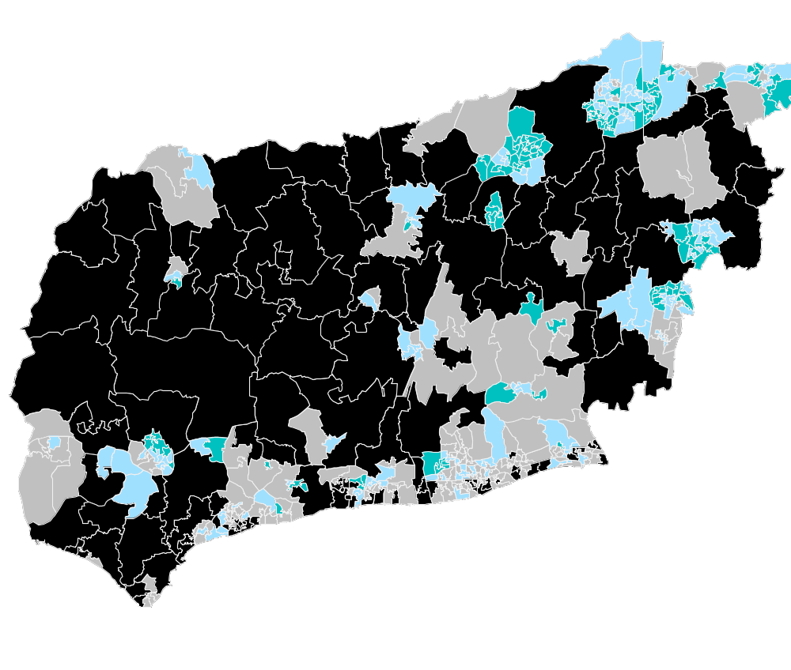

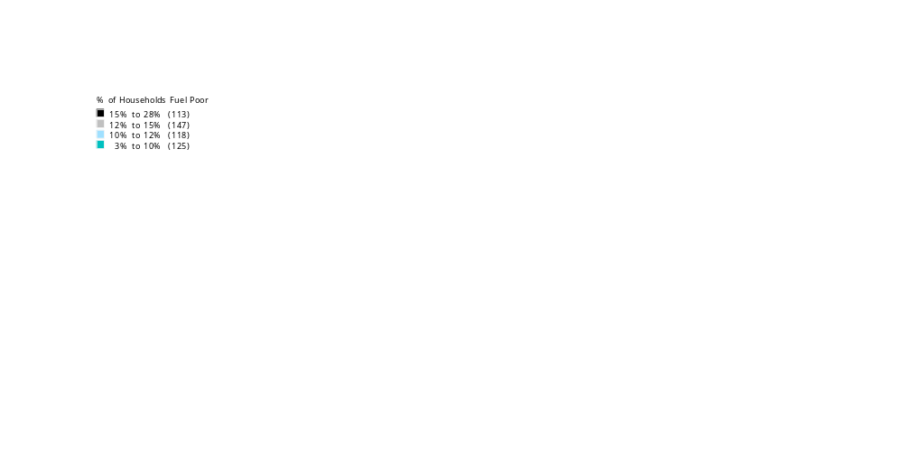

Fuel Poverty and Older People

In the winter of 2005/6 NHS West Sussex and West Sussex County Council carried out a survey of older people in West Sussex. The survey asked a range of questions relating to health and well being.

Two specific questions relating to winter warmth were included:-
- Do you worry about keeping warm in your home in winter?
- Do you ever turn off your heating / fire in winter because it is too expensive?

This survey found that overall in West Sussex 17.5% of older people surveyed said they did worry about keeping warm in winter and 14.9% said they did turn off heating due to expense. This shows that even with more energy efficient housing stock and better access to mainstream, Crawley had significantly higher numbers of older people who said they were worried and turned off heating.

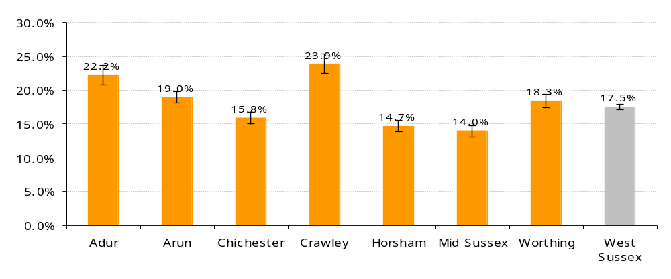
Figure 7 % Of Older People Who Said They Worried About Keeping Warm In Winter

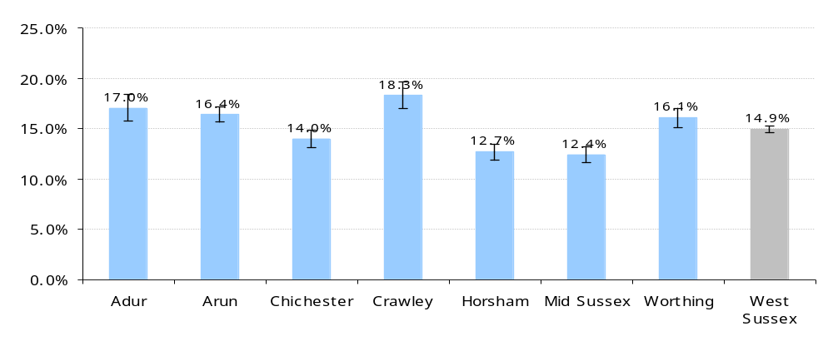
Figure 8 % Of Older People Who Said They Turned Off Their Heating Due to Expense

Source : Lifestyle Survey of Older People (NHS West Sussex, West Sussex County Council 2006)

Cross referencing answers to questions on winter warmth with self-reported health, the survey results showed that older people with the worst health were twice as likely as those in good health to turn off their heating due to expense.

Of people who said their health was poor over 20% said they sometimes turned off their heating due to the expense, this was significantly higher than other respondents.

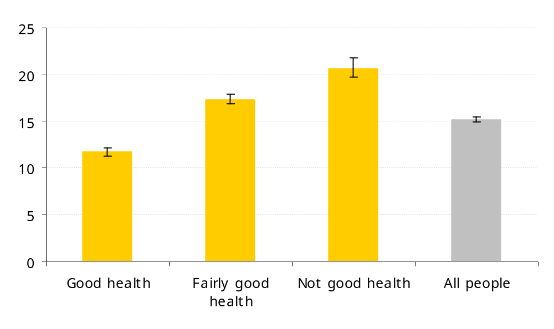
Figure 9 % of People (65 years+) Who Turn Off Heating Due to Cost by Health Status

Source : Lifestyle Survey of Older People (NHS West Sussex, West Sussex County Council 2006)

RECOMMENDATIONS
- Given the range of measures being introduced to support energy efficiency and reduce fuel poverty, continuing to implement a West Sussex Fuel Poverty Strategy would ensure that specific actions required for different areas and groups across the county are delivered effectively.
- Many of the existing new Government programmes are targeting energy efficiency and have specific targets relating to CO² emissions. These may or may not target those in fuel poverty and indeed may, without intervention, be unlikely to be taken up by those in fuel poor households, additional support is required to ensure those in fuel poverty are able to benefit from the programmes such as the Green Deal.

SUBJECT REVIEW – WATER QUALITY
WHY IS WATER QUALITY IMPORTANT?

Safe clean drinking water is fundamental to our daily lives. A failure of the quality or quantity of water risks causing outbreaks of infectious disease and can seriously affect commercial activities and everyday living.

A risk based approach to regulating the supply of safe clean drinking water has been developed. The European Union Drinking Water Directive recommendations continue to be implemented.

WHAT IS THE IMPACT OF WATER QUALITY ON HEALTH?

The following sections summarise key information and recommendations from the last two reports of the Drinking Water Inspectorate (DWI) and seek to put these in a local context. Due acknowledgement is given to the DWI as the main source.

Southern region is served by five water companies delivering water supplies to over five million consumers. Some consumers are supplied by private water supplies and by private distribution systems. This has been a focus of recent concern and enforcement action by the DWI. The EU recognises this important issue and is committed to developing a best practice framework.

The Drinking Water Inspectorate (DWI)
The DWI is the drinking water quality regulator for England and Wales. It is part of the Department for the Environment, food and Rural Affairs (DEFRA).

The DWI provides expert technical advice to local authorities ensuring consistency of interpretation of drinking water legislation. DWI collects information from public water companies and from local authorities about private water supplies.

The DWI maintains public confidence in the safety and quality of public water supplies through the exercise of its powers of reporting, audit, inspection, enforcement and prosecution. The regulatory framework for water supplies in England and Wales is set out in the Water Industry Act 1991, amended by the Water Act 2003. These Acts define the powers and duties under which the DWI operates and also the duties of water companies and licensees.

Public Water Supplies
A public water supply is one provided for the purposes of drinking, washing, cooking or food production by a statutorily appointed water company. Licenses are controlled by OFWAT. OFWAT regulates water prices and ensures that water companies are adequately financed to meet their duties. The quality of water resources (groundwater, rivers, streams, lakes, raw water reservoirs) is regulated by the Environment Agency (EA). The three water regulators (DWI, OFWAT and EA) co-operate over matters of common interest.

Private Water Supplies
The 1991 Act defines supplies of water not provided by a statutorily appointed water companies as private water supplies. These are highly variable in their characteristics and size. Most are in rural areas. Many more people are exposed to the risks of private water supplies when travelling through or taking a holiday in rural areas. Private water supplies can be used in making foods and drinks, and can supply public buildings, hotels, B&Bs, campsites and leisure parks. This includes temporary events where short term water supplies are purchased from the public supply and then linked to a network of stand pipes, tanks and pipes serving mobile toilets, washbasins and catering outlets. The main risks are of poor hygiene when in use.
A private distribution system is type of private water supply where the source water is mains water but this is then distributed over a private network of tanks and pipes.

Small private or community supplies are more often of poor quality and linked to illness than public water supplies. Owners/users of private supplies may lack access to the appropriate technical knowledge and consequently have insufficient understanding of the hazards and how best to manage these risks.

Private water supplies are the responsibility of local authorities, through implementation of the Private Water Supplies Regulations 2009. The drinking water standards which apply to private water supplies are the same as for public supplies.

The DWI report there is a continuing and substantive risk to public health that remains to be mitigated by local authorities through implementation of the risk assessment element of the private supply regulations by 2014. The DWI concluded that many local authorities should and could do more to provide complete and accurate information to private supply owners and the general public.
Environmental health departments of local authorities have an important role in identifying where private supplies are in their area and by undertaking these risk assessments, including ongoing risk monitoring and management. The regulations subdivide the sources as follows:

Regulation 9 supplies:

- More than 1000 m³ of water per day, or more than 5000 people. These supplies are reportable under the EU Drinking Water Directive in the same way as public water supplies.
- Supplying from 10m³ to 1000m³ of water per day, or from 50 to 5000 people. These supplies are reportable regardless of the use to which the water is put.
- Supplying less than 10m³of water per day or fewer than 50 people. These supplies are reportable where water is used for a commercial or public activity, including food production.

Regulation 10 supplies: refers to small domestic supplies-supplying less than 10m³ water per day and less than 50 people. Some information is reportable where water is used only for domestic purposes in two or more premises .

Exempt supplies: this is where the supply serves a single domestic dwelling. Exempt supplies may only be known about because the owner has requested that the quality of the supply is checked, or has come to the attention of the local environmental health department because of insufficient supply, a change of ownership or use, land development and planning permission, or notification of a water-related infectious disease.

Risk Management:
Risk management is the decisions and actions that local authorities are required to take when they become aware, through risk assessment, that a supply may pose a potential danger to human health or is insufficient, or unwholesome.

Risk management involves interpreting the results of water quality tests in the context of a particular water supply (source, infrastructure, treatment and management arrangements). If there is a danger to human health, local authorities can issue a Regulation 18 Notice, or where the supply is insufficient or not wholesome, a Section 80 Notice. Consumers must be appropriately informed.

Drinking Water Testing:
Public water companies have a duty to collect samples and test these for each of the substances and organisms (known as parameters) in the regulations. Tests are carried out each year at a sample of consumers’ taps, and from service reservoirs and treatment works. Companies must make the results of this testing available to their customers on request. The DWI role is to carry out independent checks to ensure this testing is being carried out to a high standard of quality control.
Public water companies are required to provide the DWI with full details of their annual monitoring programme.

Local authorities must have in place robust arrangements for taking and analysing samples from private water supplies. Local authorities are able to charge private water supply owners and users for the monitoring of their water supply.

Water Safety Plans
The DWI requires public water companies to implement a water safety plan. This is a systematic assessment of hazards along the whole supply chain (from water production to distribution).This quality assurance process includes the measures to mitigate each risk when identified. Risks are evaluated daily. This approach is recommended by the World Health Organisation (2004 WHO Guidelines for Drinking Water Quality).

Water companies are required to have adequate water treatment in place, informed by a raw water monitoring programme. They must disinfect all water before supplying it and, where necessary, subject the water to sufficient preliminary treatment to prepare it for disinfection. The DWI require water companies to document their disinfection policy generally and to define this in the procedures for each treatment works.

Potential danger to human health means a potential risk to public health generally. It is not a consideration of the medical needs of a particular individual. Risk assessment is concerned with the human population. There is no requirement to assess the risk to pets, livestock or fish.

Regulatory risk assessments also cover other physical and organisational hazards which may result in a failure of the water supply (no water) or consumers rejecting the water for aesthetic reasons. Where an unacceptable risk is identified, water companies must put in place an urgent programme for mitigation and control, including, where necessary, short, medium and long‐term improvement measures.

The DWI requires water companies to communicate effectively about their risk assessments with key stakeholders. This means that consultants in communicable disease control (CsCDC) and local authorities will be briefed on, and consulted about, each specific risk assessment for water supplies in their areas. The DWI has the power to issue notices directing a water company to take certain actions in respect of its risk assessments. These notices are copied to the CCDC and local authority.

Water companies must treat water to make it less aggressive towards lead and copper plumbing where this has been shown to be a problem with a specific water supply. There are also regulatory controls over the chemicals and materials of construction that water companies are permitted to use. The DWI operates a national approvals system for chemicals and materials of construction.

DWI Inspectors carry out independent technical audits of water company records and sites to ensure that operational and management procedures are robust. If deficiencies are identified, DWI has the power to take enforcement action to require improvements to be made. DWI will notify the relevant local authority and CCDC.

A drinking water quality problem may be due to the condition of water systems in buildings, rather than the part of the distribution system owned and operated by the water company. Water companies have powers (the Water Fittings Regulations 1999) to inspect premises to ensure the public water mains are protected by backflow devices or other means from any possibility of contamination from water used in industrial processes, wastewater or any private supply.

Water companies have a programme of regular inspections of high risk building water systems in place and will carry out inspections in response to unexplained consumer complaints.

Drought Management Plans
New powers have been introduced under the Water Act restricting the use of water e.g. hosepipe bans when necessary. There will be concessions to some members of the public with a disability to permit the use of a hose. They will potentially benefit from being on a register for vulnerable customers.

Water disconnections
A water supplier, whether a public or private supplier, cannot lawfully disconnect a domestic water supply in the event of non-payment of bills by the user.

PRIVATE WATER SUPPLIES - Local Data Example - West Sussex

Local authorities have until December 2014 to identify and risk assess all relevant private supplies in their area. This is to determine whether a supply poses a potential danger to human health, to take action to safeguard public health in the short term and to improve supply in the long term. Action is required under the EU Drinking Water Directive.

The following table briefly summarises the assessment of risks in private water supplies in West Sussex local authorities to date. Local authorities are expected to prioritise the risk assessment process according to the degree of risk and public health importance.

Table 5 Assessment of risks in private water supplies in West Sussex

Local authority | Number of premises to be assessed | Risks assessment completed | To be completed | Population at risk
Adur | 3 | Under old regulations | 3 | One farm:12 properties  One farm:5 properties-members of public visit farm
Arun | 7 private supplies | All 7 assessed | Private distribution systems
Chichester | 65 private supplies. Of these 9 are high risk large and/or commercial  29 are multiple domestics  (Regulation 10) | All 9 high risk have been assessed  Assessments ongoing | 300-400 private distribution networks.  Temporary private distribution networks | 3500  000s at large public events
Horsham | 6 high risk | All 6 assessed | Private distribution systems  Medium and low risk premises
Mid Sussex | 2 of which  1 commercial  1 domestic | Assessed
Sources: PWS lead officer for each LA. There are no PWS in Worthing or Crawley BC

WATER FOR RECREATIONAL PURPOSES

Bathing Water Quality at EU designated Bathing Beaches:
http://europa.eu/legislation_summaries/consumers/consumer_safety/l28007_en.htm
The Environment Agency sample the water quality at all EU Designated Bathing Beaches, The District Council’s has a duty to inform the general public about the water quality at the 3 designated beaches. The Environment Agency hold the sampling data.
Storm Water Discharges:
The district council monitors the frequency of Storm Water Discharges (discharges of only primary treated sewage effluent to the harbour, that occur when the sewage works are unable to cope with the incoming flow rates) from various Southern Water owned/operated waste water treatment works. The council publishes notifications of such events on their website and this information is also passed to local sailing clubs by Chichester Harbour Conservancy.
Swimming Pool Water Quality:
All swimming pools that are open to the public should undertake monthly water quality sampling to check that the treatment systems that they have in place are operating correctly. The District Council offers a sampling service to pool operators. The district council also investigates complaints about swimming pools and outbreaks that are thought to be related to a given pool.

WATER QUALITY - Local Data Example - Chichester
Recreational Sea Water Quality:
Chichester Harbour does not fit the criteria to become an EU designated bathing water, but a huge number of people use this water body for recreational purposes. Additionally there have been problems related to Storm Water Discharges into the Harbour from Chichester Waste Water Treatment Works, therefore the council decided that it would be useful to monitor the water quality at several points around the harbour to help the public make informed decisions about their use of the Harbour. http://www.chichester.gov.uk/index.cfm?articleid=5765
Similar information about recreational water quality can be obtained from the websites of Adur, Arun District and Worthing Borough Councils.
RECOMMENDATIONS

- Complete the assessment of all high risk private water supplies and private distribution systems by all local authorities in West Sussex, in collaboration with the DWI and implement a responsive action plan.
- Introduce a uniform, transparent system of charges by local authorities for assessing and monitoring risks of private water supplies across West Sussex.
- Evaluate the costs to the health care system of outbreaks of water borne disease as part of any outbreak investigation involving the water supply.
SUBJECT REVIEW - ALCOHOL CONTROL AND LICENSING

WHY IS ALCOHOL CONTROL IMPORTANT ?

Alcohol misuse has been associated with an increased risk of liver problems, various cancers, diabetes and mental health problems. It is estimated that 33,000 deaths in the UK are alcohol-related while the cost of alcohol harm to the NHS in England is estimated to be £2.7 billion. Of this, £646 million was attributed to accident and emergency visits caused by alcohol misuse.

Excessive alcohol drinking is also associated with loss of employment as a result of repeated absence or poor productivity at work, crime and breakdown of relationships. Over the last couple of years, there have been higher levels of alcohol consumption and hospital admissions among middle-class professionals. As these individuals function well and tend to drink at home, there has been increasing concern over this as goes undetected.

WHAT IS THE IMPACT OF ALCOHOL ON HEALTH?

Illegally Produced Alcohol
It is illegal to distil alcohol in the UK without a license from the HMRC. This includes alcohol produced in unlicensed distilleries and people’s own homes. Since 2005, HMRC has seized more than 15million litres of illegally produced alcohol and the Trading Standards Institute has reported an increase in fake or illegally produced alcohol being sold.

In most cases, ethanol is substituted with cheaper and alternative forms of alcohol including cleaning fluids, nail polish remover and automobile screen wash. As a result, fake alcohol can have a serious adverse affect on health including nausea, vomiting and in serious cases, kidney problems and coma.

National Legislation and Regulation
Businesses or organisations that intend to sell alcohol require a license from a licensing authority. Since April 2012, sale and supply of alcohol is regulated by responsible authorities at a local level under the updated Licensing Act 2003 (Order 2010). Under this act, Public Health is recognised as a responsible authority, and therefore responsible for issuing licenses and enforcement activity. Under this role, Public Health can:

- Make representations to the Licensing Authority relating to licence applications or variations to sell alcohol, provide late night refreshment and/or regulated entertainment;
- Request that the Licensing Authority review an existing licence;
- Support a review application submitted by another Responsible Authority
- Make representations to the Licensing Authority regarding the potential cumulative impact of an application in an area where there is a Cumulative Impact Policy

Recent updates to the Licensing Act brought in October 2010, apply to all licensing and clubbing premises and include:-
- A ban on irresponsible promotion
- A ban on dispensing alcohol directly into the customer’s mouth
- Mandatory provision of free water
- Age verification policy – premises must ask anyone that appears to be younger than 18 to produce identification
- Smaller measures – offering alcohol in smaller measures i.e. beer or cider is available in half pints

There are three types of licenses available, depending on the nature of the organisation or individual requiring it. These are:-

- Premises licence – Businesses or organisations that sell or supply alcohol on a permanent basis
- Personal licence – Anyone who plans to sell or authorise the sale/supply of alcohol
- Club premises certificate – members clubs (such as rugby clubs) that plan to sell or supply alcohol

A temporary events notice (TEN) is required for the sale of alcohol at temporary small scaled events attracting fewer than 500 people.

Alcohol Misuse and Cost In West Sussex

West Sussex is significantly better than the national average on a number of indicators including alcohol attributable mortality, hospital admission and alcohol-related crime However, alcohol misuse is still an issue in West Sussex, 23.5% of adults in West Sussex drink more than the recommended guidelines while 17.4% of adults binge drink. Furthermore, alcohol-related hospital admission in West Sussex has been on the rise over the last couple of years, increasing NHS expenditure in dealing with alcohol-related events and admissions.

The table below shows the total cost of treating emergency admissions for patients with alcohol-related conditions as well as the rate of admissions by CCG localities. The total cost for Coastal is much higher than Crawley and Mid Sussex and Horsham, however this reflects the larger population within the Coastal CCG compared the other localities.

Table 6 Alcohol-related emergency admissions (Rate per 1,000 population) and cost of emergency admissions (2011-2012)

CCG | Total cost | Rate per 1,000 population | Cost per 1,000 population
Coastal | £1,453,533 | 2.62 | £3,329
Crawley | £263,051 | 1.92 | £2,397
Mid Sussex & Horsham | £322,997 | 1.65 | £1,624
West Sussex | £2,039,581 | 2.26 | £2,737

Figure 10 Alcohol-related emergency admissions (Rate per 1,000 population)
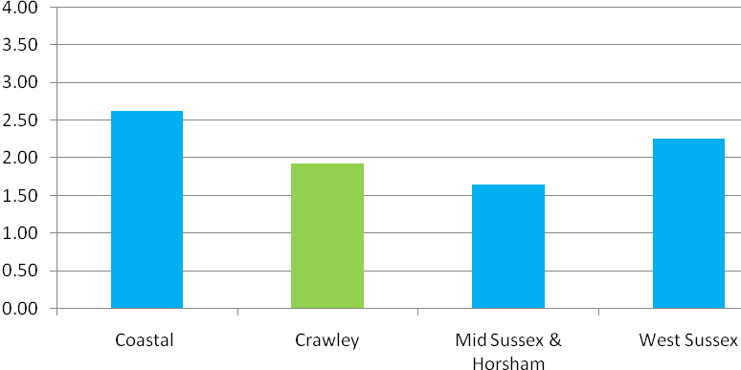

Based on the national figure, it is estimated that the cost of alcohol-related harm in West Sussex is approximately £300 million. The following shows the breakdown of the figure:-
- £109.5m spent on Law and Order costs
- £96m spent on workplace productivity losses
- £70.5 spent on non-specific domestic and social costs
- £25.5m spent on NHS resourcing such as hospital admissions, GP services, premature deaths and suicides

The association between alcohol and crime is well established. In 2011-12, 3,242 offences in West Sussex (6.8% of total offences) occurred when the suspect was under the influence of alcohol. In that time, 2,564 violent crimes (26.3% of total violent crimes) occurred when the suspect was under the influence of alcohol.

In West Sussex, the Drug and Alcohol Action Team (DAAT) commissions a range of alcohol and drug services for adults and young people. In 2011-12, there were 1047 people in treatment for alcohol misuse, of which 644 were new presentations (62%). For those exiting treatment, 391 people were successful in overcoming their alcohol problems.

ACTIVE INTERVENTIONS
A variety of actions and measures can be used at a local level to address – examples are outlined below.

- Alcohol action in West Sussex – West Sussex County Council has identified alcohol consumption as an area for improvement under the Public Health Plan. Among the actions outlined include implementing alcohol misuse pathways and services in acute hospitals, reduce the inappropriate availability of alcohol to children and young people and providing training to medical and social care staff in identifying individuals with alcohol misuse problems.

- Alcohol-free Zones or Designated Public Place Orders (DPPO) was introduced in 2003 to enable local authorities to designate places where it is illegal to drink. DPPOs cover highways, privately owned lands and spaces in public ownership. The main aim of this measure was to tackle anti-social drinking in public places. Police officers are able to control the consumption of alcohol in the designated areas by ensuring individuals stop drinking or by confiscating alcohol.

- As part of the recent consultation on dealing with problems with late-night drinking, the government has implemented Early Morning Restriction Orders (EMRO) and Late Night Levy. EMROs are an extension of the Licensing Act 2003, which enables local authorities to restrict the sale of alcohol between 12am and 6am in their areas. If licensing authorities decide to introduce an EMRO in a specified area, this will apply to all types of licenses within the area.

- Late Night Levy allows licensing authorities to charge premises with a late night license (12am to 6am). This charge will contribute towards policing costs associated with alcohol related crime.

EMROs and Late Night Levy were introduced by the government at the end of 2012.

ALCOHOL CONTROL - Local Data Example - Crawley

Figure 11 Location of all premises in Crawley with an alcohol license

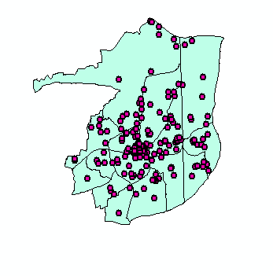
Off-license premises
Over the past 30 years, there has been a 25% increase in the number of off-licensed premises including supermarkets and convenience stores. Sales from off-licensed premises account for 50% of all alcohol consumption while the volume of alcohol consumed has also increased over the last 14 years⁴.

The increased density of off-licenses and competitive prices of alcohol suggests an increased risk of alcohol consumed by those who are dependent on it. In addition, off-license premises acts as a direct source of alcohol for people under the age of 18 through greater availability of alcohol at home and through family, friends or passers-by. The test purchase of alcohol scheme carried out by the police is used to identify licensed premises that are selling alcohol to under 18 year-olds.

Table 7 Test Purchases carried out by Sussex police Neighbourhood Licensing Team in Crawley since February 2012

Type of premise | Number of test purchases | Number of premises failing test purchase (sale of alcohol to under 18 year-olds)
Off-licensed premises | 16 | 4
Licensed premises (pubs) | 3 | 0

RECOMMENDATIONS

- West Sussex to continue the work done to reduce high levels of alcohol consumption and implement services to identify individuals with alcohol misuse problems.
- Public Health as a responsible authority for licensing, to strengthen local evidence available on premises and alcohol misuse. This would include improving data collection on alcohol-related emergency admissions

WHY IS NOISE CONTROL IMPORTANT?
SUBJECT REVIEW – NOISE CONTROL

Noise is defined as “unwanted sound”. Sources of noise include occupational (in the workplace), neighbourhood (including noise related to antisocial behaviour), and environmental (including road traffic).
The health effects of noise can include:
- Annoyance
- Sleep disruption
- A small increase in risk factors associated with cardiovascular disease
- Negative impact on children’s learning and cognitive performance.

Noise is often neglected when considering pollution at macro level giving way to topics such as air pollution and contaminated land for which well established cause and health effect models exist. Noise is nevertheless an extremely insidious pollutant giving rise to extreme discomfort and serious neighbour disputes effecting large numbers of people year on year. Noise is commonly defined as unwanted sound clearly defining the unpleasantness of exposure to sounds which human beings do not find attractive. Noise disputes between neighbours have also in several extreme cases lead to violence and in one case even murder.

Exposure to constant or very loud noise can cause temporary or permanent damage to hearing.

Exposure to extreme noise events, or continued exposure to high noise levels is known to give rise to defined pathological changes to the inner ear resulting in deafness. As a consequence statutory controls have been created to limit exposure in industrial of commercial situations. However, it is not possible to demonstrate direct otto pathogenic effect as a result of noise exposure at low levels although it is claimed continued low level noise energy may give rise to socioacousis and may be an important factor together with occupational exposure and age related changes as regards hearing loss in the general population.

Whilst the direct damage to aural health which may occur from noise exposure such as the playing of loud music in a neighbouring property is not easy to establish, such continued disturbance may result in significant detrimental health consequences due to the deprivation of sleep and general hyper tension caused to the person or persons effected.

WHAT IS THE IMPACT OF NOISE ON HEALTH?

Local Authorities in England are obliged to investigate noise complaints made by persons living within its area by way of sec. [79] Environmental Protection Act 1990. Whilst many Local Authorities to provide a 24 hour noise service there is no legal duty imposed on them to do so. This may be seen as rather short sighted when it is considered the vast majority of noise complaints relate to incidents that happen outside normal office hours.

Whilst a large number of noise complaints investigated by officers from the Environmental Health Service relate to domestic dwellings significant issues are also encountered concerning noise emanating from commercial premises such as pubs, clubs and general commercial activities.

The provision of an effective service to investigate noise nuisance is a crucial component as regards protecting residents in Crawley therefore. This service is an extremely important contributor to protecting local house-holders general amenity from being detrimentally effected through noise through close working relationships with both Development Control and Licensing colleagues.

Key evidence and national policies
Health Protection Agency (2010) Environmental Noise and Health in the UK http://www.hpa.org.uk/ProductsServices/ChemicalsPoisons/Environment/Noise/
DEFRA webpages, including national policy and legislation. http://www.defra.gov.uk/environment/quality/noise/
National Environment White Paper (2011)
http://www.defra.gov.uk/environment/natural/whitepaper/
Various legislation and guidance exists to manage noise in the environment, homes and workplaces:
- The statutory nuisance provision under the Environmental Protection Act 1990 is a primary tool for preventing and abating noise nuisance. Where a noise nuisance exists, or is likely to exist, there is a statutory duty to serve a noise abatement notice on the person responsible, owner and/or occupier.
- The Noise Act 1996 introduced the concept of the night time noise offence, and a fixed penalty provision that enables fixed penalties to be issued to domestic and licensed premises.
- The Control of Pollution Act 1974 has always provided specific provisions to manage noise from construction sites and has been a valuable tool when preventing noise from major construction sites around the City.
- The Licensing Act 2003 defines one of the licensing objectives as ‘prevention of public nuisance’. Noise from city centre licensed premises is a factor in our special licensing policy covering the cumulative impact zone. Assessment and review of noise complaints received in relation to licensed premises is carried out whenever licensing policy is reviewed.
The planning regime provides an opportunity to prevent and manage noise where new developments are proposed. Local and national planning policy helps influence the statutory decision making process on whether a development goes ahead, the character and design of a development, and/or any planning conditions that can be imposed to minimise noise, and thereby minimise the impact. The National Planning Policy Framework published in March 2012 removed guidance specific to managing noise, including Guidance Note PPG24. This has been a key tool for protecting new residential developments proposed near significant noise sources.

Key outcomes
The National Noise Policy Statement1 states the long-term vision to promote good health and quality of life through the management of noise.
Local inequalities
There are limited local data on the impact of noise on different population groups. Groups who may be particularly vulnerable to the effects of noise include children, older people and people with hearing impairments.
Unsurprisingly the DEFRA mapping predicts that households most affected by traffic noise are those closest to major roads such as the A23 and M23.
National research has reported that noise problems are worse in areas of high density housing, rented accommodation (both social and private sectors), areas of deprivation and areas which are highly urbanised.

NOISE CONTROL - Local Data Example - Crawley

In 2011 -2012 Crawley Borough Council received over 1010 noise complaints, relating to noise from both domestic and commercial sources including construction sites, dogs units, plant and machinery, pubs and clubs, neighbours and parties. The number of complaints has increased since 2007 peaking in 2009 but has been relatively stable since.
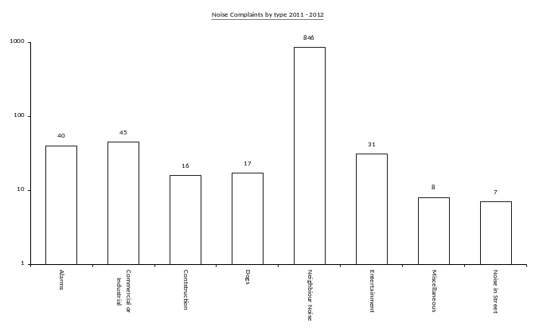
The major source of complaints is due to neighbour noise complaints as can be seen from the graph above. A Nuisance and Anti Social Behaviour Team was created in 2011 and the Environmental Health Service works closely with this team to address serious noise problems.

The introduction of the Nuisance and Anti Social Behaviour Team has lead to an apparent increase in reporting of noise in the 2011 – 2012.

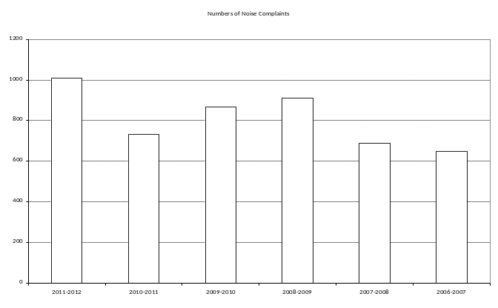

The graph above shows the number of complaints received for the last 6 years.

The EU Environmental Noise Directive requires Member States to draw up action plans designed to manage noise. A rolling programme for noise mitigation is set out, starting with agglomerations with more than 250,000 inhabitants. No noise mapping has yet been undertaken in Crawley but the presence of the M23 and London Gatwick Airport will require such an exercise to be completed sometime in the future. Officers and Elected Members are active participants in noise matters concerning London Gatwick Airport providing expert input into a number of specialist forums concerning aviation noise.
Influencing Development Control in Respect of Building New Dwellings
Despite expert witness evidence being provided to a Planning Public Enquiry concerning the residential development adjacent to London Gatwick Airport to the North East of Crawley, permission to build over 1500 new homes was granted upon appeal to the Planning Inspectorate.
Not withstanding this fact, Environmental Health Officers will continue to work closely with Planning colleagues to ensure residential premises and other vulnerable use classes such as schools are adequately protected against noise in keeping with World Health Organisation guidelines.

RECOMMENDATIONS

Ensure the continuation of work to protect and enhance the soundscape of West Sussex to prevent adverse impact from industrial, commercial, transportation, domestic and leisure type noise sources.

Promote the use by Districts, Borough and County Councils of planning controls based upon World Health Organisations recommendations and local intervention in acute cases.

Bearing in mind the active building programme being carried out in West Sussex, lobby Central Government to implement previous plans to undertake a large scale noise mapping of major housing conurbations subject to high noise levels to create a base level national noise survey and enable strategic planning debates to be properly informed. The need for economic growth is fully recognised but such growth must be balanced with a need to prevent potential harmful effects of sleep disturbance and high noise levels in sensitive locations such as educational establishments. The prevent of background noise levels creep is a priority for protecting health as far as is possible

Where noise levels are high due to existing noise sources such as major roads or transportation hubs, Districts, Borough and County Councils should use their planning policies to encourage developers to ensure design principles include treatment to the building envelope to enhance the overall sound reduction index values.

WHY IS INCREASING PUBLIC AWARENESS OF FOOD HYGIENE STANDARDS IMPORTANT?
EMERGING ISSUE – Increased Public Awareness of Food Hygiene Standards
Safe, good quality food is vital for good health. Local authorities have a number of duties, and powers, to protect the general public by maintaining and promoting good hygiene and food safety standards.

WHAT IS THE IMPACT OF FOOD HYGIENE?

Food Poisoning
The Food Safety Act 1990 defines food poisoning as ‘Any disease of an infectious or toxic nature caused by or thought to be caused by the consumption of food or water’. Food poisoning is caused by eating food which has been contaminated by bacteria, e.g. salmonella, by virus e.g. the norovirus, or by a chemical.

Symptoms include nausea, vomiting and diarrhoea. Although most people who suffer food poisoning get better without seeking any medical treatment, some cases can be very serious; food poisoning can be particularly harmful for people vulnerable to the effects of infection, for example older people or people with weakened immune systems.

There are some foods which are particularly susceptible to contamination, if not handled, stored or cooked correctly, including:-
- raw meat and poultry
- sliced meats, pate, soft cheeses and pre-packaged sandwiches
- dairy products, including eggs and milk

Causes of food poisoning include:-
- Campylobacter bacteria is the most common cause of bacterial food poisoning. In 2009 there were an estimated 350,000 estimated cases in England and Wales, 17,500 hospitalisations and 88 deaths attributed to campylobacter bacteria. The bacteria are found naturally in the gut of various farm, wild and domestic animals including pets and birds.
- Listeria, food poisoning as result of eating food contaminated by the listeria bacteria, although relatively rare can be very dangerous to people with reduced immunity and pregnant women.
- Salmonella – sometimes found in unpasteurised milk, raw meat, poultry and perhaps most notably, in terms of press reporting, in eggs,
- E-coli 0157 – e-coli are common bacteria which live in the intestines of animals, including humans. However specific strains of e-coli pose a considerable risk to health. E coli 0157 is the most important strain in terms of risks to health in the UK and is found in the intestine of healthy farm animals. People become infected when they consume food or water that has become contaminated by faeces from infected animals.
- Norovirus – the norovirus (sometimes called the “winter vomiting virus”) is the most common cause of diarrhoea and vomiting in England and Wales. It is highly infectious and is of specific concern to “semi-closed environments” such as residential care homes, schools and hospitals.
- Giardia - Giardia are a group of protozoans (single-celled, microscopic parasites). These grow in the intestines of infected humans or animals and can cause diarrhoea in humans.
- Cryptosporidium – is parasite that causes an infection called cryptosporidiosis found in contaminated food, water, soil or human or animal faeces, characterised by watery diarrhoea.
FOOD POISONING - Local Data Example - Food Poisoning Cases in West Sussex

Notified and Other Ascertained Cases of Food Poisoning
Doctors are legally required to notify the “Proper Officer” of the local authority (the Consultant in Communicable Disease Control) should they suspect a diagnosis of food poisoning. Notifications are collated weekly by the Health Protection Agency. Not all cases notified are formally diagnosed via stool samples but are based on clinical diagnosis.

As most people who suffer a bout of food poisoning do not seek medical help, the majority of cases will not be formally notified. These are described as otherwise ascertained.

Table 8 Number of Notifications of Food Poisoning Per 100,000 Population
 | 2008 | 2009 | 2010
Adur | 162.0 | 191.9 | 105.5
Arun | 163.5 | 168.7 | 124.3
Chichester | 259.0 | 240.3 | 147.0
Crawley | 150.0 | 151.6 | 114.3
Horsham | 164.1 | 204.0 | 134.5
Mid Sussex | 176.7 | 176.4 | 84.8
Worthing | 138.4 | 137.0 | 75.8

The HPA state that the notification rate per 100,000 will vary in relation to the make up of the population at risk. Decreases in recent years may be due to a change in legislation where GPs are no longer paid for notification, resulting in fewer notifications.

Table 9 Lab Confirmed Cases of Gastrointestinal diseases
 | 2008 | 2009 | 2010  In 2010, areas with a rate of over 330 cases per 100,000 population were higher than the national average.
Adur | 23.8 | 9.5 | 161.8
Arun | 5.6 | 43.7 | 205.8
Chichester | 593.9 | 495.3 | 406.7
Crawley | 325.4 | 352.4 | 378.5
Horsham | 81.5 | 94.6 | 210.5
Mid Sussex | 176.4 | 137.0 | 200.3
Worthing | 387.6 | 375.7 | 207.8
Source : HPA

There may be several reasons why the rate of laboratory confirmed cases vary from area to area, including whether healthcare professionals take samples, whether people go to their GP, as well as an actual higher incidence of disease. Rates rate of infection also vary due to weather, the season and food hygiene practices.

Regulation and Enforcement - Legal Framework
The safe management and handling of food is key to reducing the risks of food poisoning. Under food hygiene regulations, each local authority in West Sussex maintains a database of food “premises”. The term “premises” covers a range of sites including restaurants, importers, distributors etc. An inspection plan is maintained by each local authority to ensure that inspections of the premises assessed as high or medium risk are inspected frequently (at least every 2 years). Local authorities will also undertake inspections where an increased food safety risk has been identified .
Food Hygiene Inspections
Local authorities inspect a variety of food premises including caterers, restaurants, distributors, manufacturers and importers. Each area reports annually to the Food Standards Agency (FSA) the number of establishments in their area subject to inspection.
Table 10 Food Inspections
2010-2011 | Total No of Establishments (inc unrated) | No of Establishments not yet rated for intervention | Total % of broadly compliant premises (excluding unrated and outside) | Total % of broadly compliant premises (including unrated and outside)
Adur | 475 | 13 | 89.4 | 87.0
Arun | 1,125 | 0 | 86.9 | 86.9
Chichester | 1,461 | 64 | 81.9 | 76.7
Crawley | 764 | 15 | 93.1 | 91.2
Horsham | 1,017 | 99 | 92.5 | 83.5
Mid Sussex | 1,326 | 146 | 74.2 | 66.0
Worthing | 912 | 84 | 80.6 | 73.1
Source : FSA

Food Hygiene Rating System – “Scores on the Door”
Premises are rated on a scale of 0 to 5, with 5 meaning that standards are very good.

5 | VERY GOOD | Very high standards of food safety management - Fully compliant with food safety legislation.
4 | GOOD | Good food safety management - High standard of compliance with food safety legislation.
3 | GENERALLY SATISFACTORY | Good level of legal compliance - Some more effort might be required.
2 | IMPROVEMENT NECESSARY | Broadly compliant with food safety legislation - More effort required to meet all legal requirements.
1 | MAJOR IMPROVEMENT NECESSARY | Poor level of compliance with food safety legislation – much more effort required.
0 | URGENT IMPROVEMENT NECESSARY

The food hygiene rating reflects the hygiene standards found on the date of inspection

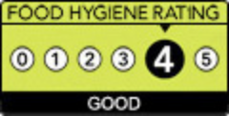
Once awarded, premises are provided with a food hygiene rating certificate. Display is at the discretion of the owner

Hygiene Ratings - West Sussex premises
Approximately 4,790 premises are currently (March 2012) rated across West Sussex, of these over 70% rated 4 or 5.

Figure 12 Ratings in West Sussex (March 2012)
(Source : (data accessed from Food Standards Agency website March 22nd 2012)
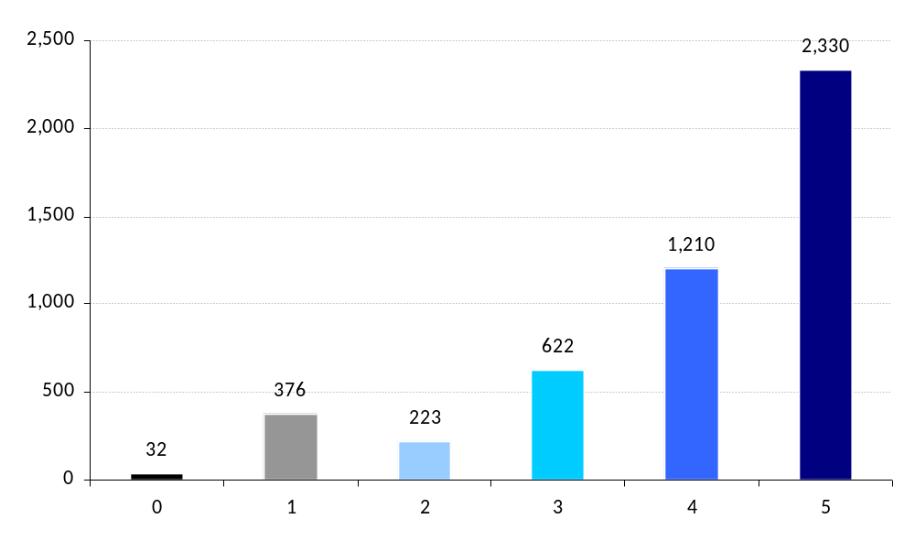

In individual local authority areas there is some variation, more premises are rated at 0, 1 or 2 in Adur and Worthing.

Figure 13 Food Hygiene Rating System by Local Authority Area - % at Each Grade (All Premises)
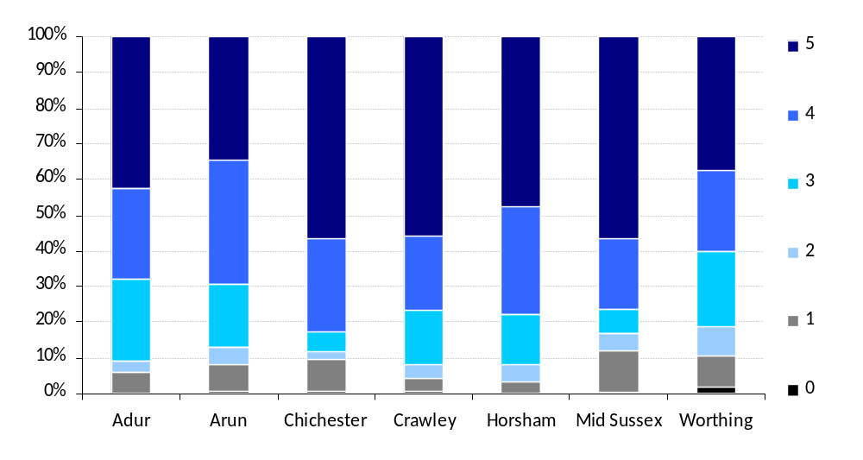

RECOMMENDATIONS
- Maintain County level analysis and monitoring of the food hygiene ratings, with specific analysis of health and care premises.
- Continue the risk based interventions programmes provided in each Local Authority.

SECTION 3 CORE ISSUES BRIEFINGS

Briefing 1 - HEALTH AND SAFETY AT WORK

Reporting of Injuries, Diseases and Dangerous Occurrences Regulations (RIDDOR)

Information on injury and deaths at work is collated into three groups:-

- Deaths (although note road accident deaths involving people travelling in the course of their work Deaths of people in the Armed Forces and other deaths are subject to separate reporting
- Major injury – this include bone fractures, injuries which require 24 hour hospital stay or more, injuries where the person has required resuscitation
- Over 3 – Day injuries - injuries that cause an absence from work of over 3 days

In addition to employee reporting, any member of the public sustaining an injury (non-fatal) in a workplace is reportable if the person has been taken from the workplace to hospital.

RIDDOR injury data for counties and local authorities (LA) are presented as rates per 100,000 employees. These rates allow comparisons to be made between different areas. However, the Health and Safety Executive (HSE) have stated that the following points should be taken into account:

- Research shows that differences between reported injury rates at regional / local level are strongly influenced by variations in the mix of industries and occupations; for example, some LAs contain large employers in riskier industries.

- The local area data will also be affected by different levels of reporting of RIDDOR (this effect is reduced by looking at data for employed persons only, i.e. excluding the self employed).

The data only relate to injuries reported under RIDDOR. Other sources - e.g. the Labour Force Survey - do not generally permit examination at this level of detail.

RIDDOR Reporting – Incidences West Sussex 2006/7 to 2010/11 (Employees)

 | Incidences |  |  | Rate per 100,000 Employees
 | Fatal and Major Injuries* | 3 Day Injuries | Total injuries | Fatal and Major Injuries | 3 Day Injuries | Total injuries
2006/07 | 339 | 1,157 | 1,496 | 105.5 | 360.2 | 465.8
2007/08 | 350 | 1,217 | 1,567 | 112.0 | 389.4 | 501.4
2008/09 | 320 | 1,245 | 1,565 | 102.4 | 398.3 | 500.6
2009/10 | 314 | 1,163 | 1,477 | 104.1 | 385.7 | 489.9
2010/11p | 321 | 1,053 | 1,374 | 105.0 | 344.3 | 449.3
Source : HSE

* in terms of fatalities, there are a very small number of deaths per year, in 2010/11 there was one recorded fatality

The level of overall reported incidents has fallen over the last ten years although the reporting of major injuries across West Sussex has remained around 320-350 per annum, in 2010/11 this was a rate of 105 fatal or major injuries per 100,000 employees.

In the past five years, reported “over 3 day injury” rates have been falling across England; in 2010/11 the West Sussex rate was 344 per 100,000 employees, compared with the England rate of 362.7 per 100,000.

Briefing 2 - THE NATURAL ENVIRONMENT AND GREEN SPACES

Between 2009 and 2011, the population in England made 5.4 billion visits to natural environments in the UK. Of this, 2.1 billion visits to green spaces were in urban areas. Green spaces have important health benefits and are associated with positive mental and physical health outcomes. It is estimated that the health benefits of living close to green spaces is worth up to £300 per person, per year (DEFRA 2011). Among the health benefits:-

- Encourages ‘green exercise’ leading to better health –Green spaces, including urban parks, and the countryside are routinely used for physical activity. There is evidence to suggest that people who have access to green spaces are three times more likely to exercise and therefore less likely to become overweight or obese. Green spaces have also been associated with decreased health complaints, better perceived general health.
- Reduces stress levels and improves mood – greater improvements in mood were found for people who exercised in green spaces. Similarly, greater health improvements were
- found in people with mental health problems suggesting that exercise in green spaces for people with mental health problems may have therapeutic benefits.
- Utilisation of green spaces for social engagement – areas with green spaces, particularly in urban areas encourage social engagement with families and communities.

Access to green spaces may be an issue in deprived areas; people living in poor housing and deprived neighbourhoods with a lack of access to green spaces may not benefit from the physical and mental benefits associated with green spaces. The Government White Paper ‘Natural Choice: Securing the Value of Nature’ outlines the plan to improve the quality and use of the natural environment over the next 50 years. This paper defines the natural environment as “living things in all their diversity: wildlife, rivers and streams, lakes and seas, urban green space and open countryside, forests and farmed land.” Proposals in the White Paper cover improvements to wildlife areas and urban green spaces, as well as strengthening local public health activities, connecting people with nature for better health

MENE Survey Information for West Sussex
The Monitor of Engagement with the Natural Environment (MENE) survey is commissioned jointly by Natural England, the Forestry Commission and DEFRA. The survey started in 2009 and is a continuous survey with people being interviewed in weekly “waves”; in 2010/11 over 46,000 were surveyed nationally. Over 1,000 people living in West Sussex have been questioned since 2009. The aim of the survey is to understand how people use, enjoy and “are motivated to protect the Natural Environment”.

This survey will be the source for the new DoH Public Health Outcome, the percentage of people using green space for exercise or health reasons. This will be measured by the number of people surveyed who say they have taken a visit in previous seven days to a green space for health / exercise reasons.

Results are available at county level and some of the main findings for West Sussex have been summarised below.

- For West Sussex, 26% of the population visited green spaces for exercise/health reasons, which is lower than the national average of 38%.

- The main reasons given for visiting green spaces are for recreational purposes and relaxation. More than 50% of people visited green spaces to exercise their dog.

- It is estimated that 48% of green spaces visited by adults in West Sussex are in the countryside. This would reflect the high proportion of rural areas within the county but may also include adults in towns that are in close proximity to the countryside.

- In terms of access to green spaces, more than 41% of people travelled less than 0.5 miles to these areas, although it is unclear what proportion of people were from urban or rural areas.

- Differences in age group, socio-economic group or disability did not make an impact on the distance travelled to visit green spaces.

- However, the number of visits to green spaces in a week does vary by age groups and socio-economic group. It was found that with increasing deprivation, the number of visits to green spaces dropped.

Briefing 3 – TOBACCO CONTROL

WHY THIS IS IMPORTANT
Smoking is the largest preventable cause of death in the UK and is a risk factor for many diseases including lung and heart disease. In 2009, Over 80,000 people die from smoking related illnesses. (Statistics on Smoking: England, 2010. NHS Information Centre). West Sussex in general has a lower level of tobacco use and smoking attributable deaths compared to the national average. Smoking prevalence is estimated at 18.3% for 2010/11, while the number of ex-smokers is estimated at 39.5%. However, there is considerable variation in West Sussex; Crawley has an estimated current smoking prevalence of over 28%, and Mid Sussex an estimated prevalence less than 15%.

Benefits of Tobacco Free Environments
There is increasing evidence that smoke free environments are beneficial to an individual’s health.
One of the biggest outcomes of the smoke-free legislation is the reduction in second hand smoking (SHS) and the adverse health effects as a result of exposure to tobacco smoke. Non-smokers are exposed to the same substances as active smokers and have raised levels of tobacco related substances and carcinogens. Implementation of smoke free environments reduces the exposure to tobacco smoke and reduces the ill effects caused by it.

National Regulation and Legislation
  - Regulations came into force from 1 July 2007 prohibiting smoking in virtually all enclosed public places and workplaces in England.
  - In October 2007 it became illegal to sell tobacco products to anyone under the age of 18, previously this had been 16.
  - In October 2011 a ban on vending machines selling cigarettes was also introduced. More than 1 in 10 11-15 year olds get their cigarettes from vending machines. Removing vending machines will reduce access to cigarettes particularly for these children and young people.
  - Point of Sale legislation, banning the display of tobacco products at the point of sale, came into effect for large stores in April 2012. This will be extended to small stores in April 2015.
  - At present (April 2012) the Government is consulting on plain packaging for cigarettes.

Under the Tobacco Plan for England, released in 2011, local authorities have been given a greater role in tobacco control, working in partnerships. The Tobacco Control Alliance is a partnership between NHS Sussex, Sussex Community NHS Trust, West Sussex County Council, district and borough councils and West Sussex Trading Standards. The aim of the alliance is to reduce smoking rates, eradicate death and disease caused by tobacco and to reduce health inequalities associated with tobacco.

Illegal Tobacco
With increasing prices in cigarettes, the market has shifted towards increasing number of people using hand-rolling cigarettes (HRT) and illegal cigarettes. Cigarettes, from any source, are harmful to health, however the ingredients used in illegal cigarettes are of low quality such as higher amounts of lead and arsenic than in ordinary cigarettes. This therefore poses a more detrimental effect to health. Illegal cigarettes are increasingly used by more people irrespective of socio-economic status. However, due to the accessibility, cheap cost and unregulated sales, illegal cigarettes disproportionately impact low income and younger individuals making it more difficult to quit smoking. Aside from the ill-effects associated with low quality illegal cigarettes, illegal cigarettes are linked to organised small and large scale crime.

Illegal cigarettes are HRT or cigarettes that have been bootlegged, smuggled or counterfeit:-
- Bootlegged – foreign imports that individuals have been brought in cigarettes more than their legal allowance and resold
- Smuggled – foreign brands illegally brought into the UK. They are illegal due to non-payment of duty and brought in specifically for the UK illegal tobacco market
- Counterfeit – fake packaging of usually low quality tobacco designed to look like premium brands in the UK

The majority of illegal cigarettes come from Eastern Europe; however, the end-user sales occur in local communities. Sources of illegal tobacco include under the counter sale at tobacco retailers and non-tobacco retailers, friends/colleagues and outdoor markets. Her Majesty’s Revenue and Custom (HMRC) is the main agency responsible for the tackling illegal trade of tobacco products while the UK Border Agency (UKBA) is responsible for the enforcement and seizures at UK borders. The Trading Standards sets the legislations regarding pricing of tobacco products as well as seizures of illegal tobacco trade at local levels.

Briefing 4 – PEST CONTROL
There are a wide range of pests which can impact on health and living environments. In addition to a direct impact on health, through the transmission of diseases, pests can affect the quality of the living and general community environment and some can even damage building structures.

Environmental Health departments deal with a range of pests.

- Rodents – rats and mice
- Rats and mice can carry a wide range of diseases, some can be passed to humans. A specific risk with rats is Leptospirosis, which can lead to Weil’s disease, a serious liver and kidney disease. This can be fatal to humans.
- Rats can also be very destructive to buildings, eating through materials including electrical cables increasing fire risk.
- Under the Prevention of Damage by Pests Act 1949, local authorities are not legally required to provide a pest control service, but have a duty to “take such steps as may be necessary to secure, as far as practicable, that their district is kept free from rats and mice,”. Notably, they are required to keep the local authority’s own land free from rats and mice and also to enforce the duties of owners and occupiers of land. If an owner does not take steps to deal with an infestation a local authority can undertake the work and recover the costs.
- A national survey of environmental health departments found that leaving out food for wild birds in gardens, defective drainage and sewers and poorly managed domestic waste disposals were identified as the main causes of rodent infestations.

- Cockroaches
- Cockroaches pose a range of health risks, not only in the carrying of bacteria and pathogens but there is increasing evidence linking cockroach infestation with asthma.
- Unlike some household pests, infestations of cockroaches are strongly associated with poor housing conditions.

- Bed bugs
- In recent years the media, overseas and in the UK, have reported a great increase in bedbugs. Bedbugs are small blood sucking insects, attracted at night to bodily warmth. Not everyone reacts to the bites, but some people will develop itchy inflamed bites. Often mistaken for mosquito bites, the bites of a bed bug are characteristically in a straight line rather than a random pattern.

- As bed bugs do not need to feed for a year, they can be present for a long period prior to becoming evident. Bed bugs can be easily and rapidly spread within buildings and passed on the surfaces materials, for example in luggage, furniture etc.

Briefing 5 – HOUSING CONDITIONS

Monitoring Housing Conditions

English Housing Survey
The Department for Communities and Local Government (DCLG) commissions a continuous housing survey, the English Housing Survey (EHS), to monitor housing conditions. This survey was introduced in 2008 and replaced two existing surveys, the English Housing Condition Survey (EHCS) and Survey of English Housing (SHE). EHS has similar components to the previous surveys; a household interview, and, for some of the properties, a physical inspection and market value survey. The survey is across all types of tenure and households, with a national sample each year of approximately 17,000 for the interview components and then a sub sample of approximately 8,000 for physical inspections (by qualified surveyors) and market evaluation. There is also a follow up survey of private landlords, examining their motivation for becoming a landlord, experiences and type of properties owned.

Information from the English Housing Survey is provided at national and regional level, no local data are available. The survey collects a wide variety of data on housing stock and household, including information relating to housing condition.

The DCLG definition of a decent home is detailed below, although it should be noted that some local authorities set additional standards and requirements.

Definition: Decent Home (DCLG definition)

A decent home is one that meets all of the following four criteria:

a) meets the statutory minimum standard for housing. From April 2006 the Fitness Standard was replaced by the Housing Health and Safety Rating System (HHSRS).
b) it is in a reasonable state of repair (assessed from the age and condition of a range of building components including walls, roofs, windows, doors, chimneys, electrics and heating systems).
c) it has reasonably modern facilities and services (assessed according to the age, size and layout/location of the kitchen, bathroom and WC and any common areas for blocks of flats, and to noise insulation).
d) it provides a reasonable degree of thermal comfort (adequate heating and effective thermal insulation).

Source : DCLG

Of the local authorities in West Sussex who still own their own social housing stock, a provisional figure for the percentage of their stock not meeting the decent homes standard and a forecasted number of properties is shown below

Decent Homes – Local Authority Stock
 | Dwellings becoming non decent in2009/10 | Number of non decent dwelling as of 1/4/2010 | Proportion of LA homes that are non-decent (%) | Forecast number of non-decent homes for each of the next five years as at 1st April:
 |  |  |  | 2011 | 2012 | 2013 | 2014 | 2015
Adur | 80 | 105 | 4 | 120 | 140 | 160 | 180 | 200
Arun | 0 | 355 | 10 | 166 | 335 | 287 | 508 | 65
Crawley | 187 | 2174 | 26 | 61 | 85 | 90 | 85 | 95
Source : DCLG

The Housing Health and Safety Rating System (HHSRS)
The Housing Health and Safety Rating System (HHSRS) is a risk assessment tool used to assess potential risks to the health and safety of occupants in residential properties in England and Wales. It was introduced in the Housing Act 2004, came into effect in April 2006, and replaced the Housing Fitness Standard.

Hazards are scored in relation to the seriousness of their potential impact on health and safety. Overall twenty-nine specific hazards are evaluated against four categories of harm, physiological, accident, psychological and infection.

Councils have a duty to take some enforcement action where Category 1 hazards exist.

Data collected for the 2008 English Housing Survey found that, overall, 22.7% of dwellings had a category 1 hazard, and this rose to almost 31% of private rented property.

English Housing Survey Properties Identified with a HHSRS Category 1 Hazard

Tenure | % HHSRS category 1 hazard
Tenure | Any Hazard | Excess Cold | Any Falls* | Any Other Hazards
Owner Occupied | 23.0 | 9.2 | 13.2 | 4.4
Private Rented | 30.7 | 13.1 | 16.2 | 9.9
Local Authority | 16.4 | 4.0 | 9.1 | 5.1
Housing Association | 12.7 | 3.5 | 6.7 | 4.2
All Private | 24.4 | 9.9 | 13.7 | 5.4
All Social | 14.6 | 3.7 | 7.9 | 4.6
All Dwellings | 22.7 | 8.8 | 12.7 | 5.2
* 'Any falls' includes those related to stairs, on the level, between levels and those associated with baths.
Source: English Housing Survey 2008, dwelling sample
Briefing 6 – CLIMATE CHANGE

Over the past century, the average global temperature has increased by 0.75°C and is increasing at a higher rate over the past few decades. In the UK, the average temperature has been between 0.5 and 1°C warmer than the 1961-1990 average. We have seen summers becoming warmer and drier while winters are milder and wetter.

It is predicted that by the end of this century, the average global temperature will increase by between 1°C and 6°C. This will have a significant impact on the environmental, health, agriculture and wildlife among other things.

The UK government has also introduced measures to reduce the country’s carbon footprint. This includes ensuring 40% of electricity comes from low carbon sources such as renewable sources and setting a ‘carbon budget’ to cap the overall carbon dioxide (CO₂) emissions.

There are a number of organisations involved in reducing and preparing for climate change. The Environmental Agency is responsible for implementing climate change adaptation in England by supporting businesses and communities respond to climate change. This includes providing guidance in infrastructure and emergency services address climate change risks as well as ensuring that government policies address climate change risks.

At a local level, local authorities are responsible for planning and preparation of the impact of climate change. Climate change has regional differences due to geographical characteristics, which presents different challenges for local authorities.

Locally, the WSCC Sustainability Team have identified specific risks and mitigations in relation to climate change:-

- In West Sussex by the 2050s, we are likely to see an increase in summer temperatures of 3 degrees, and a quarter less rain than at present (in summer and winter).

- Sea levels along our stretch of coast are likely to rise as much as 21 cm, and in the winter, we may see 13% more rain.

Note : The Team use figures NOT from the most extreme projections for the county but a likely average of conditions by the 2050s.

As a response to the challenge of climate change WSCC have stated 4 Corporate Priorities (as stated in “Building A
Sustainable A Strategy For Delivering The Corporate Priority”)

“1. Reduce carbon emissions
We recognise that carbon represents not only a threat to then environment, but a significant financial cost to the County Council. We will make sure that we fully understand the carbon emissions of West Sussex, take action to manage and reduce our contribution to these emissions, as well as seeking to inform and influence others to do the same.
2. Adapt to a changing climate
A changing climate poses significant challenges to the way we deliver Council services. We must prepare to meet these challenges to reduce the impact of a changing climate on the communities we serve, especially the more vulnerable in our society.
3. Use resources efficiently and effectively
The natural resources we consume and how we deal with the waste we generate present key challenges for us. The County Council has in place many plans for addressing these. Our focus here is on ensuring the resources we require for our internal operations are used as efficiently and effectively as possible, and always in a way which provides value for money.
4. Make sustainability ‘business as usual’ Everyone in the Council has a role to play in delivering corporate priorities and ensuring the delivery of sustainable services. We will increase the knowledge, skills, and resources of services to embed sustainability into our culture and all our activities.”

Briefing – CLIMATE CHANGE
In relation to adapting to climate change specific actions which may be useful to support health have been identified by the WSCC Sustainability Team
(Drafted by Margaret Enstone and Catherine Cannon Sustainability Team WSCC)

- Ensure all care homes, residences, managers, carers and landlords sign up to Floodline if in a flood risk area and identify properties to which people could be evacuated.

- Think about working practices to care for people affected by the heat. Alert staff and carers about conditions with increased risk. Provide training for staff - signs and treatment of strokes etc.

- Investigate wider use of Telecare – could the system be promoted to provide water level data and inform central point (e.g. during flooding). Packages can already alert for extreme temperatures, another includes a reminder for drinking sufficient fluids.

- Collect and monitor information on customers who have been affected by an increase in temperature, which has resulted in them having an increase in health problems. Report back to Adult Services.

- Make all staff aware that an increase in temperature is likely to increase cases of hay fever and asthma. Ensure they are appropriately trained and can access relevant guidance.

- Update first aid courses to include insect-borne diseases

- Install simple solar shading (e.g. blinds, awnings) as low impact measures to alleviate overheating due to predicted future increase in temperature. Provide outside spaces in the shade (with canopies or tree planting) so young people can still access outside.

- Encourage tree planting around residences/care homes. This will help provide cool shading during heatwaves, reduces urban heat island effect, help absorb pollution (reducing health impacts from poor air quality), reduce impact of flooding, proven link to well-being. Consider planting fruit trees for home-grown benefits.

- Ensure all residential properties and office spaces install and use water saving devices to include e.g. flow restrictors on taps and showers, cistern displacement devices, water butts in outside areas, and encourage water saving behaviour (not just during drought but routinely).

- Include more robust training on effects of extreme weather for staff and young people working on outdoor activities such as Duke of Edinburgh Award.

- Write and implement long term strategy to develop local services for Day Services - reducing high dependency on transport, enabling people to stay locally, and support local businesses.

- Initiate research into how those taking drugs/alcohol will be affected by the extremes of hot and cold weather and what are the implications on their health (not long term but immediate e.g. hypothermia). What steps could be taken to minimise the impacts? What advice can youth workers give or what should they be aware of?

- When re-designing spaces in care homes, consider retro-fitting (improving the insulation of a property, installing more energy efficient appliances and boilers and improving water consumption) as well as reducing bills these measures can increase comfort in differing climate conditions.

Cooling Towers In West Sussex Local Authorities
Notification of Cooling Tower and Evaporative Condenser Regulations 1992
Registration
All premises where cooling towers and evaporative condensers are situated must register with the local authority under The Notification of Cooling Towers and Evaporative Condensers Regulations 1992. This is because, without proper treatment, cooling towers can be the source for the development and dispersion of bacteria, especially Legionella pneumophila the bacteria that causes Legionnaires' Disease.
Registration will provide the information to enable any outbreak to be properly investigated. All changes and alterations should also be notified to the Local Authority.
Enforcement
Whilst the task of maintaining records of wet cooling systems under the regulations rests with local authorities, responsibility for enforcement in respect of standards of assessment and control is split between the Health & Safety Executive and local authorities, depending on the main activity of the premises.
Operators of installations should be aware that both the local authority and HSE will undertake a number of visits to their premises to ensure standards are met and will take enforcement action where appropriate.
The following Cooling Towers are Registered in West Sussex:

Arun DC:
None identified.

Chichester DC:
Teknoflex Ltd

Princes Ltd

Natures Way Foods Ltd

Crawley BC:

Gatwick Airport Ltd (Global Investment Partnership Ltd)
2 cooling towers North Terminal and 2 cooling towers South Terminal

Standard Life (County Mall)
2 at North Car Park and 2 at South Car Park

Afriso Euogauge
1 cooling tower

Delphax Technology Ltd.
1 cooling tower

CNC Vacuum Processes Ltd
3 cooling towers.

British Airways (Hanger 6 LGW)
1 cooling tower hanger six.

Airbase Interiors Ltd
1 cooling tower

Eskimo Ice
1 Evaporative Condenser

Horsham DC:

Aqua Hydraulics Ltd.

Plysolene Ltd.

Burwill Moulds Wienerbergers Ltd

C.T. Moulds Ltd.

Royal Sun Alliance Insurance

E Insurance

Creightons PLX

Hughes Pumps Led

Ibstock Brick Laybrook

Schnectady Europe Ltd.

Mid Sussex DC:

Johnsons Dry Cleaners
1 Cooling Tower

Trek Diagnostics Ltd
2 Cooling Towers

Halifax Building Society
3 Cooling Towers

London Underwriters Group
2 Cooling Towers

Goldman Sachs
3 Cooling Towers

Worthing and Adur Councils:

BOC Edwards
1 Tower

Ricardo Consulting Engineers
9 Towers

Pyroban Ltd
1 Tower

Appendix 1 – JSNA Core Dataset – Additions – Related to Environment and Health
Subject | Dataset / Report | National Outcome measure
Air | AQMA - Locations and Pollutants - Map | No
Air | Annual reports -specific reports from LAs on their Air Quality | No
Air | The mortality effect of anthropogenic particulate air pollution (measured as fine particulate matter, PM2.5*) per 100,000 population. | Public Health Outcome
Fuel Poverty | Numbers of Fuel Poor Households | Public Health Outcome
Water | Private water supply assessment | No
Alcohol | Licenses map - split by type of license | No
Alcohol | Alcohol-related admissions to hospital | No
Noise and ASB | Number of complaints per year per local authority about noise per thousand population (according to statistics collected by CIEH). | Public Health Outcome
Noise and ASB | The proportion of the population exposed to transport noise (primarily road) of more than x dB(A) per local authority. | Public Health Outcome
Green Space | Percentage of people using green space for exercise/health reasons. | Public Health Outcome
Excess winter deaths | Excess Winter Deaths Index: The ratio of extra deaths from all causes that occur in the winter months compared to the expected number of deaths, based on the average of the number of non-winter deaths. | Public Health Outcome
Food Poisoning | Notifications per 100,000 Population | No
Food Poisoning | Lab confirmed cases | No
Food | Food Safety Inspection - summary on inspected premises | No
Food | Food Hygiene Rating Systems - Overall Score / Scores for care and nursing premises | No
Notifiable Diseases | HPA Summary data for LAs in West Sussex - broken down by specific diseases | No
Housing Condition | Housing Health and Safety Rating System (HHSRS) | No
Housing Condition | Decent Homes - Local Authority Stock | No
Safety at Work | RIDDOR Statistics - Fatal/3 Day/Total Injuries | No
Specific Risk sites | Notifiable premises - Cooling Towers and Condensing Units - map of sites | No

- END-
This information has been produced by the Sussex Chief Environmental Health Officers and the
West Sussex Research Unit of West Sussex County Council, with the help of Dr. Farhang Tahzib, Consultant in Public Health.

For further information, please contact
Angela Tanner, Single Point of Contact for Public Health for the Sussex Chief Environmental Health Officers.
angela.tanner@crawley.gov.uk Tel. 01293 438567.

The Cost of Alcohol Harm to the NHS, Department of Health,2006-07
Local Alcohol Profile for England, LAPE 2010
Alcohol Strategy West Sussex, 2010
1 Health Protection Agency (2010) Environmental Noise and Health in the UK
Cited in Royal Commission on Environmental Pollution (2007)
Health Protection Agency. Metadata Number of notifications of food poisonings per 100,000 population. http://hpa.org.uk (accessed 23rd March 2012)

