



Date | September 2011
Contact | jacqueline.clay@westsussex.gov.uk
HOUSING
REVIEW OF DATA
Supported Housing Needs Review of Data

This is a review of the evidence relating to the need for housing and supported housing in West Sussex.

It collates current evidence, identifies “known knowledge gaps” and provides a high-level summary of the assumptions underpinning housing and supported housing needs strategies and service reviews.

Data collected as apart of this review will be incorporated into the wider West Sussex Joint Strategic Needs Assessment (JSNA), providing an expanded core dataset to incorporate housing and housing related data.

Supported housing needs cannot be isolated from “wider” housing needs, therefore information on wider housing need and supply is also included. In relation to supported housing, West Sussex County Council has undertaken (as of summer 2011) a series of strategic reviews, examining the provision for the following client groups:-

- younger people
- older people
- offenders and ex-offenders
- people who have experienced domestic violence
- people with mental health problems

In addition to examining existing provision, these reviews have also considered wider issues and unmet need. Further strategic reviews are planned for homeless people and families, and people with substance misuse problems.

CONTENTS

 |  | Page(s)
SUMMARY OF KEY POINTS |  | 3-5
INTRODUCTION |  | 6
DEMOGRAPHIC CONTEXT | - Population  - Population Change  - Socio-economic background – deprivation  - Households and household formation | 7-17  18-21
HOUSING | - Housing stock  - Housing Condition and suitability to meet needs  - Adult Residential Care  - Tenure  - Access to Tenure  - Homelessness | 22-48  49-65
SUPPORTED HOUSING | - Supported Housing Needs  - Health and Social Care Needs  - Specific Client Groups | 66-84
APPENDICES

Summary of Key Points
Housing and Health and Well-being

- Good quality housing is an important determinant of health, poor housing has a negative impact on physical and mental well-being.

Demographics

- There are growing numbers of older people, and, using current projections, this growth is expected to accelerate over the next 20 years. The 85+ age group is projected to have significant growth, with increases of over 10% for each five-year period to 2026. West Sussex remains an attractive retirement destination; there is net inward migration of older people.

- There are an estimated 342,000 households in West Sussex.

- Households headed by someone 85+ are expected to be the fastest growing household type; provision for such households should be considered the “mainstream” not specialist.

Housing Supply

- Housing supply is not keeping up with household formation, nationally or locally; this is placing increased pressures on existing housing supply.

- Overall there are relatively few vacant or second homes in West Sussex; 4% compared to 5.4% in the South East region; a notable exception being Chichester, where approximately 8% of household spaces were not occupied, 5% of all homes being second homes.

    - In 2009/10 fewer than 2,000 new dwellings were added to the housing stock in West Sussex, over 900 fewer than the previous two years.

    - “Specialist” housing for older people and vulnerable adults is limited in West Sussex. There are a large number of sheltered housing units, although the popularity of some studio or one bedroom provision is unknown. West Sussex has a low level of extra care provision.

- As of June 2011, there were almost 400 residential and nursing homes, for adults, in West Sussex, with approximately 10,500 bed spaces.

- Outside of the decennial census there is little information relating to the occupancy level of care homes. In 2001 8.8% of people aged 75+ lived in a communal medical or care establishment, this was higher than the South East (7.6%) or England (7.1%). In Worthing almost 13% of the 75+ population lived in a care home.

- Almost 3,300 people in 2009/10 were supported (i.e. wholly or part funded) by WSCC or the NHS to live in residential care. In relation to people supported by the County Council, a snapshot study found that approximately 18% of people who enter care homes did so as “self-funders” and required support following their money running out.

Housing Condition and Suitability

- Between 80% and 90% of people who responded to local Housing Needs Surveys stated that their current home was adequate to meet their current needs. There was however considerable variation across tenures and areas; only 64% to 72% of people in private sector housing felt their housing was adequate.

- The Housing Needs Surveys found that between 31% (in Adur) to almost 52% (in Mid Sussex) of households were under-occupied.

- Over 9% of households have had adaptations to address a limiting long term illness or disability.

- National housing condition surveys show that houses in the private rented sector tend to be in poorer condition than owner-occupied housing or socially rented housing stock. With rising numbers of people entering private rented accommodation, increased consideration should be placed on the condition of the stock and its impact on health and well-being.

- The links between fuel poverty and health and well-being are well established. Concerns relating to fuel poverty are increasing. The Centre for Sustainable Energy estimated that, in 2007, approximately 17,500 households in West Sussex lived in fuel poverty.

- A lifestyle survey of older people in West Sussex, carried out in 2006, found that older people in poorer health were more likely to turn off heating than older people in good health.

Tenure and Access to Tenure

- Most households in West Sussex are owner-occupied, 77% of households compared with 74% in the South East and 69% in England. Crawley is very different from the rest of the county, over 23% of housing is socially rented.

- Locally there is evidence of increased pressures on all tenures:-

  - There are rising waiting lists for social housing,

  - Although house prices have fallen in recent years, the ratio of house prices to earnings, coupled with poorer access to finance, means that home ownership remains out of reach for many households.

  - Changes in the benefits system mean that low income households will have a restricted access to private rented accommodation.

Needs of Specific Groups

- Large numbers of young people approach local authority housing departments for support to prevent homelessness. Such approaches and preventative work is not reflected in the “official homeless” figures.

- Currently, specialist provision for young adults is not meeting demand; a survey of local providers found demand outstripping supply by 3:1.

Needs of Specific Groups continued

- In relation to vulnerable young adults, including care leavers and older looked after children, there is some evidence of an increase, although small, in the use of bed and breakfast accommodation.

- An ageing population means there will be significantly higher numbers of people living with physical and sensory impairment, mobility problems and dementia. Support for older people to remain independent in their own homes and/or specialist housing will need to increase accordingly.

- At present the level of extra care housing in West Sussex is well below the guideline levels issued by DCLG. The choice of supported housing appears polarised, with sheltered schemes for lower level needs and residential care for highest level of need with little between.

- An audit of the housing needs of working-age adults with a learning disability found an additional 150 people likely to need supported housing over the next 3-5 years. It is difficult using existing social care databases to monitor and track housing needs of individuals.

- In relation to gypsies and travellers, there is a basic lack of sites, including transit sites. There is evidence of a lack of understanding or access to social care, supportive aids and adaptations.

  - Where there is available information on housing support needs for specific groups, including ex-offenders, people with mental health problems and vulnerable young adults, demand is greater than supply.
Introduction

Housing and Health and Well-Being

The relationship between housing and health is a complex one.

At a very basic level, not having a roof over your head has serious implications to physical and mental well-being. Beyond this basic need, good quality, secure housing supports health and well-being; this is especially true for vulnerable individuals, young and old, who are more susceptible to problems of poor housing, including cold, damp or overcrowded conditions.

The National Institute of Clinical Excellence (NICE) summarised the interplay between housing and health into four key areas:-

- Clearly it is vital that the indoor environment does not contain agents which are harmful to health, for example asbestos, lead etc.

- Poor housing design and layout can adversely impact health, for example layout which can restrict accessibility or usability of housing, transmission of noise between households etc.

- Wider social and environmental factors play an important part in supporting health and well being, including neighhourhood quality and services, parks, community safety and cohesion.

- “Macro-level” factors which ultimately affect individuals in their access to affordable, good quality housing, for example housing allocation, affordability, housing supply.

One, or the interplay of a number of these factors, factors can have a negative impact on health and increase health inequalities.

A summary of recent key reports on housing and health is provided in Appendix 1.

SECTION 1 BACKGROUND CONTEXT
Demographics

Current Population

In 2010, the resident population was estimated at 799,700. This was an increase of approx 7,000 from 2009. Since 2002, the overall population in West Sussex is estimated to have increased by 42,400 (5.6%).

Mid Year Estimates (MYE) of population are published every June by the Office for National Statistics.

Individual year MYEs for West Sussex, for the period 2002 to 2010, are shown on Table 1 below.

Table 1 West Sussex – Mid-Year Estimates of Population 2002 – 2010
Figures are rounded so may not sum

Year | 2002 | 2003 | 2004 | 2005 | 2006 | 2007 | 2008 | 2009 | 2010
0-4 | 41,500 | 41,100 | 40,900 | 40,800 | 41,400 | 42,700 | 43,600 | 44,300 | 45,300
5-14 | 93,800 | 93,900 | 94,300 | 93,800 | 93,000 | 91,700 | 91,200 | 90,700 | 90,600
15-24 | 77,600 | 78,400 | 79,700 | 80,600 | 82,000 | 84,000 | 85,200 | 85,700 | 86,100
25-44 | 201,000 | 200,500 | 200,700 | 200,700 | 200,700 | 199,800 | 198,000 | 195,800 | 194,200
45-64 | 190,200 | 192,900 | 195,900 | 199,000 | 203,400 | 207,400 | 210,600 | 214,000 | 217,500
65-74 | 74,100 | 74,300 | 74,500 | 74,700 | 74,300 | 74,800 | 76,600 | 78,600 | 81,100
75-84 | 56,400 | 57,500 | 58,300 | 57,900 | 57,700 | 57,700 | 57,800 | 57,900 | 58,400
85+ | 22,900 | 22,200 | 22,000 | 23,000 | 24,400 | 25,100 | 25,600 | 26,000 | 26,500
All Ages | 757,300 | 760,600 | 766,400 | 770,600 | 776,700 | 783,100 | 788,600 | 792,900 | 799,700
Source : ONS Revised Estimates of MYE Population 2002 – 2010

Table 2 Mid-Year Estimates of Population 2010 – Local Authority Level
Figures are rounded so may not sum

Year | Adur | Arun | Chichester | Crawley | Horsham | Mid Sussex | Worthing
0-4 | 3,400 | 7,300 | 5,800 | 7,500 | 7,100 | 8,200 | 6,000
5-14 | 6,600 | 15,000 | 12,300 | 12,300 | 16,500 | 16,900 | 11,100
15-24 | 7,100 | 15,500 | 12,100 | 13,600 | 13,400 | 13,600 | 10,800
25-44 | 14,400 | 31,700 | 24,100 | 34,100 | 30,800 | 32,100 | 27,100
45-64 | 16,600 | 40,800 | 32,000 | 25,400 | 38,300 | 37,700 | 26,600
65-74 | 6,700 | 19,500 | 13,600 | 6,600 | 12,700 | 12,300 | 9,900
75-84 | 4,700 | 13,800 | 9,600 | 5,800 | 8,500 | 8,300 | 7,800
85+ | 2,100 | 6,800 | 4,000 | 2,400 | 3,600 | 3,500 | 4,200
All Ages | 61,600 | 150,400 | 113,500 | 107,700 | 130,900 | 132,600 | 103,500
Source : ONS Revised Estimates of MYE Population 2010
The percentage change in population between 2002 and 2010, for West Sussex, is shown on the graph below. This shows that the increase in the number of people aged 85+ has increased by almost 16% compared to an overall increase in population of 5.5%. There were fewer 5-14 year olds and 25-44 year olds in 2010 than 2002.

Figure 1 Percentage Change In Population 2002 to 2010
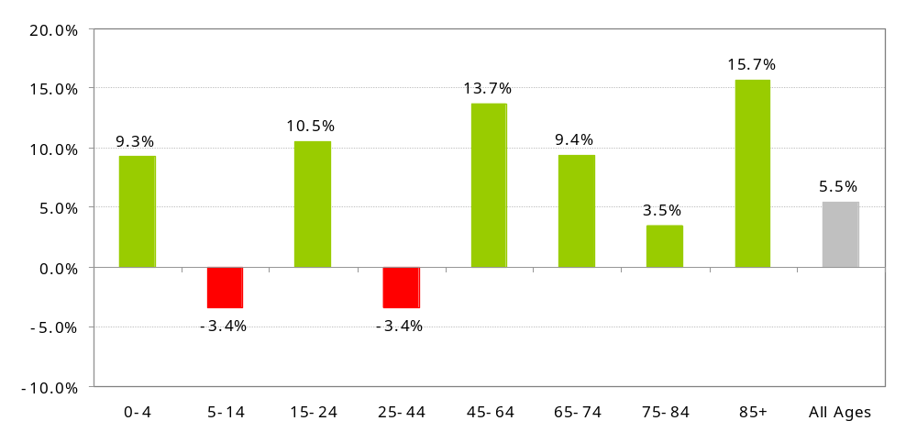

Source : ONS Revised Estimates of MYE Population 2002 – 2009 (June 2010)

Supported Housing
- Key Age Groups West Sussex, the South East and England

In relation to supported housing, some age groups are more likely to require support than others, notably young people under 24 and older people aged 75+.

Overall, West Sussex has a higher proportion of people aged over 75 than the South East region or England. In 2010, in West Sussex, 10.6% of residents were aged 75 or over compared with 8.5% in the South East region and 7.9% nationally.

Table 3 Key Supported Housing Age Groups

 | West Sussex |  | SOUTH EAST |  | ENGLAND
 | Number | % | Number | % | Number | %
16/17 | 19,000 | 2.4 | 217,160 | 2.5 | 1,306,560 | 2.5
18-24 | 57,600 | 7.2 | 748,360 | 8.8 | 4,912,260 | 9.4
75-84 | 58,400 | 7.3 | 498,800 | 5.9 | 2,921,600 | 5.6
85+ | 26,500 | 3.3 | 219,800 | 2.6 | 1,197,800 | 2.3
Source: ONS Mid-Year Estimates 2010
Population Projections


West Sussex County Council produces its own population projections; projections are simply trends, for example, in fertility rates, death rates, migration etc which are projected forward; they reflect current policies and migration patterns. All projections should be treated with caution.

The current West Sussex projections take into account the housing numbers adopted under the South East Plan 2009. Following the General Election in 2010, this plan was revoked by the Secretary of State. Projections will be revised in 2011.

West Sussex County Council uses a “dwelling-based” model called POPGROUP; this is different from the model used for sub-national projections by the ONS.

Table 4 West Sussex County Council Population Projections

Year | 2016 | 2021 | 2026
0-4 | 44,200 | 47,600 | 48,500
5-14 | 91,600 | 92,900 | 93,300
15-24 | 101,800 | 96,400 | 93,400
25-44 | 187,800 | 202,900 | 208,100
45-64 | 222,300 | 220,700 | 208,600
65-74 | 94,500 | 95,400 | 94,700
75-84 | 59,400 | 67,100 | 77,400
85+ | 31,100 | 34,900 | 39,100
All Ages | 832,700 | 857,900 | 863,100

(Source : WSCC Projections June 2010)

Change Projected to 2026

Figure 2 overleaf shows the projected change in:-

- the total population,
- people aged 16-24 years,
- and people aged 85+ years.

WSCC projections indicate that whilst population growth is expected to be maintained in the 16-24 year age group in the initial 5-year period (2011-2016), this growth is not expected to be sustained.

For the 85+ age group growth in excess of 10% over each 5 year period is projected.

Figure 2 Projected Change in Population by Age Groups to 2026
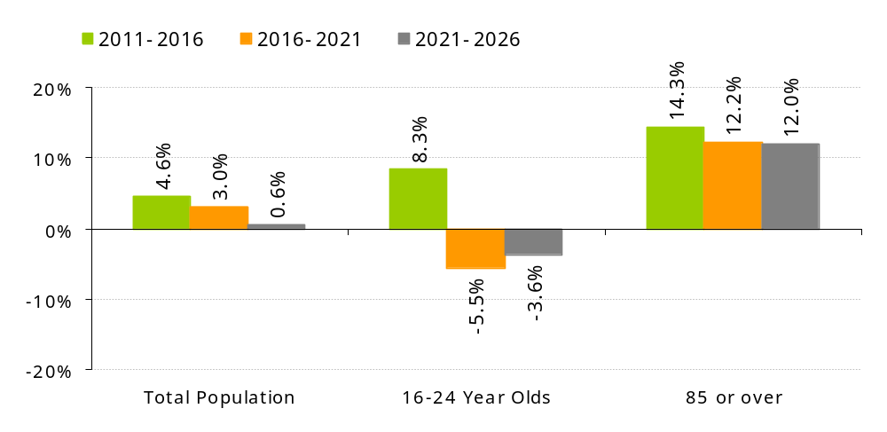

(Source : WSCC)

ETHNIC COMPOSITION OF RESIDENT POPULATION
Note: Although the decennial census provides comprehensive and robust data, it is acknowledged this information is somewhat dated.

Data from the 2011 census will not be available until late 2012.

The Office for National Statistics released estimates of ethnic group populations with a caveat that these should be considered “experimental” statistics.

Data shown overleaf detail the groups for each of the local authority area in West Sussex.

It is estimated that approximately 89.8% of the population of West Sussex was of the ethnic background “white British”.

There are considerable variations across the county, notably in Crawley where 81% of people were white British, to 92.4% in Arun.

Table 5 Percentage of Black and Minority Ethnic Population

 | All Groups | White: British | % White British | % BME
Adur | 60,600 | 55,500 | 91.6 | 8.4
Arun | 146,400 | 135,800 | 92.8 | 7.2
Chichester | 109,400 | 101,100 | 92.4 | 7.6
Crawley | 100,100 | 81,100 | 81.0 | 19.0
Horsham | 129,900 | 117,400 | 90.4 | 9.6
Mid Sussex | 130,300 | 116,500 | 89.4 | 10.6
Worthing | 99,600 | 90,100 | 90.5 | 9.5
West Sussex | 776,300 | 697,600 | 89.9 | 10.1
SOUTH EAST | 8,308,700 | 7,246,700 | 87.2 | 12.8
ENGLAND | 51,092,000 | 42,736,000 | 83.6 | 16.4
Source : ONS 2007

Figure 3 Breakdown of Non-White British Groups
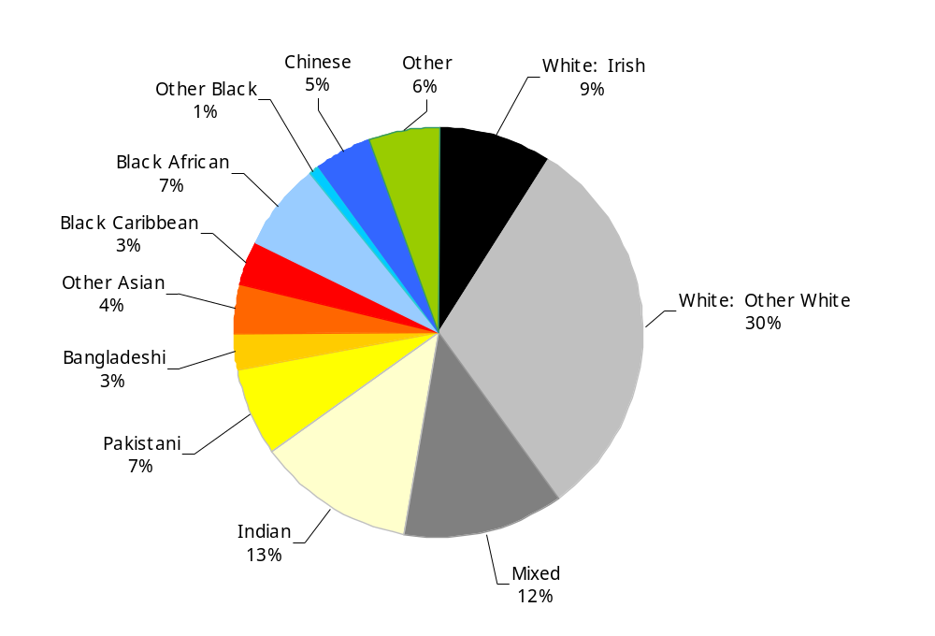
(% of People Non – White British)

(Source : ONS)

Table 6 Ethnic Breakdown of Population – By Local Authority Area
This data is the experimental Population Estimates by Ethnic Group for 2007, published by ONS

 | White: Irish | White: Other White | Mixed | Indian | Pakistani | Bangladeshi | Other Asian | Black Caribbean | Black African | Other Black | Chinese | Other
Adur | 500 | 1,500 | 900 | 500 | 100 | 200 | 200 | 100 | 300 | 0 | 300 | 400
Adur | 10.0% | 30.0% | 18.0% | 10.0% | 2.0% | 4.0% | 4.0% | 2.0% | 6.0% | 0.0% | 6.0% | 8.0%
Arun | 1,300 | 3,400 | 1,500 | 900 | 400 | 400 | 400 | 500 | 800 | 100 | 500 | 600
Arun | 12.0% | 31.5% | 13.9% | 8.3% | 3.7% | 3.7% | 3.7% | 4.6% | 7.4% | 0.9% | 4.6% | 5.6%
Chichester | 900 | 2,900 | 1,100 | 700 | 300 | 200 | 300 | 300 | 600 | 100 | 500 | 600
Chichester | 10.6% | 34.1% | 12.9% | 8.2% | 3.5% | 2.4% | 3.5% | 3.5% | 7.1% | 1.2% | 5.9% | 7.1%
Crawley | 1,200 | 3,800 | 1,800 | 4,400 | 3,400 | 300 | 1,000 | 600 | 1,300 | 100 | 600 | 500
Crawley | 6.3% | 20.0% | 9.5% | 23.2% | 17.9% | 1.6% | 5.3% | 3.2% | 6.8% | 0.5% | 3.2% | 2.6%
Horsham | 1,000 | 4,800 | 1,400 | 1,000 | 400 | 300 | 400 | 400 | 900 | 100 | 600 | 900
Horsham | 8.2% | 39.3% | 11.5% | 8.2% | 3.3% | 2.5% | 3.3% | 3.3% | 7.4% | 0.8% | 4.9% | 7.4%
Mid Sussex | 1,200 | 5,200 | 1,900 | 1,200 | 400 | 500 | 500 | 500 | 900 | 100 | 700 | 800
Mid Sussex | 8.6% | 37.4% | 13.7% | 8.6% | 2.9% | 3.6% | 3.6% | 3.6% | 6.5% | 0.7% | 5.0% | 5.8%
Worthing | 900 | 2,900 | 1,400 | 1,200 | 400 | 400 | 300 | 300 | 600 | 100 | 400 | 600
Worthing | 9.5% | 30.5% | 14.7% | 12.6% | 4.2% | 4.2% | 3.2% | 3.2% | 6.3% | 1.1% | 4.2% | 6.3%
West Sussex | 7,000 | 24,400 | 10,100 | 9,800 | 5,400 | 2,300 | 3,100 | 2,700 | 5,400 | 600 | 3,500 | 4,300
West Sussex | 8.9% | 31.0% | 12.8% | 12.5% | 6.9% | 2.9% | 3.9% | 3.4% | 6.9% | 0.8% | 4.5% | 5.5%
SOUTH EAST | 82,700 | 318,400 | 126,700 | 140,800 | 80,200 | 25,800 | 41,600 | 47,000 | 73,200 | 9,900 | 58,900 | 57,000
SOUTH EAST | 7.8% | 30.0% | 11.9% | 13.3% | 7.6% | 2.4% | 3.9% | 4.4% | 6.9% | 0.9% | 5.5% | 5.4%
ENGLAND | 570,500 | 1,776,300 | 870,100 | 1,316,000 | 905,700 | 353,900 | 339,200 | 599,700 | 730,600 | 117,600 | 400,300 | 376,100
ENGLAND | 6.8% | 21.3% | 10.4% | 15.7% | 10.8% | 4.2% | 4.1% | 7.2% | 8.7% | 1.4% | 4.8% | 4.5%

Table 7 Diversity of Older People

 | % of Older Pop. White British | BME* Population (Men 65+ / Women 60+)
Adur | 96.0% | 4.0%
Arun | 95.0% | 5.0%
Chichester | 95.3% | 4.7%
Crawley | 89.1% | 10.9%
Horsham | 94.8% | 5.2%
Mid Sussex | 94.7% | 5.3%
Worthing | 94.3% | 5.7%
West Sussex | 94.4% | 5.6%
SOUTH EAST | 93.5% | 6.5%
ENGLAND | 91.8% | 8.2%
* BME includes White Other and White Irish groups
(Source : ONS)

SOCIO-ECONOMIC BACKGROUND INFORMATION
Deprivation in West Sussex

The Indices of Deprivation 2010 (ID2010) ranks all areas of England according to their relative deprivation. In 2010 West Sussex was ranked 130th out of 152 upper tier authorities, Brighton and Hove ranked 53rd and East Sussex 90th, relatively more deprived than West Sussex, Hampshire and Surrey 141st and 150th respectively.

Table 8 Indices of Deprivation 2010 County and Unitary Rankings
- 2004, 2007 and 2010

 | Rank 2004 | Rank 2007 | Rank 2010
West Sussex | 135 | 132 | 130
Brighton and Hove | 62 | 59 | 53
East Sussex | 103 | 95 | 90
Hampshire | 142 | 141 | 141
Surrey | 150 | 150 | 150
Source : DCLG

West Sussex - Lower Tier Local Authorities

The most deprived lower tier authority in West Sussex is Adur (ranked 145th out of 326 local authorities), the least deprived Mid Sussex (ranked 315th).

Table 9 overleaf shows rankings for 2004, 2007 and 2010.

Between the 2007 and 2010 indices, Crawley had the largest “fall” (-18 places) on the index (i.e. has become relatively more deprived than other areas), with large falls also in Arun and Chichester. Adur’s relative position improved between 2007 and 2010, from 129th to 145th.

Table 9 Indices of Deprivation 2010 Local Authority Rankings
- 2004, 2007 and 2010

Rankings Based on CURRENT LA Boundaries
(out of 326 LAs)
 | Locally Calculated Rank 2004 | Locally Calculated Rank 2007 | Published  Rank 2010
Adur | 163 | 129 | 145
Arun | 184 | 170 | 154
Chichester | 253 | 237 | 222
Crawley | 193 | 188 | 170
Horsham | 314 | 310 | 304
Mid Sussex | 318 | 318 | 315
Worthing | 178 | 160 | 160

In relation to neighbourhood level deprivation, West Sussex now has three small areas (within River and Ham wards in Littlehampton) falling in the 10% most deprived areas in England. This was not the case in 2004 or 2007.

At ward level River and Ham wards are within the most deprived 10% in England, a further seven wards are within the most deprived 20% in England .

Considerable inequalities remain evident, across the county as a whole and within local authority areas.

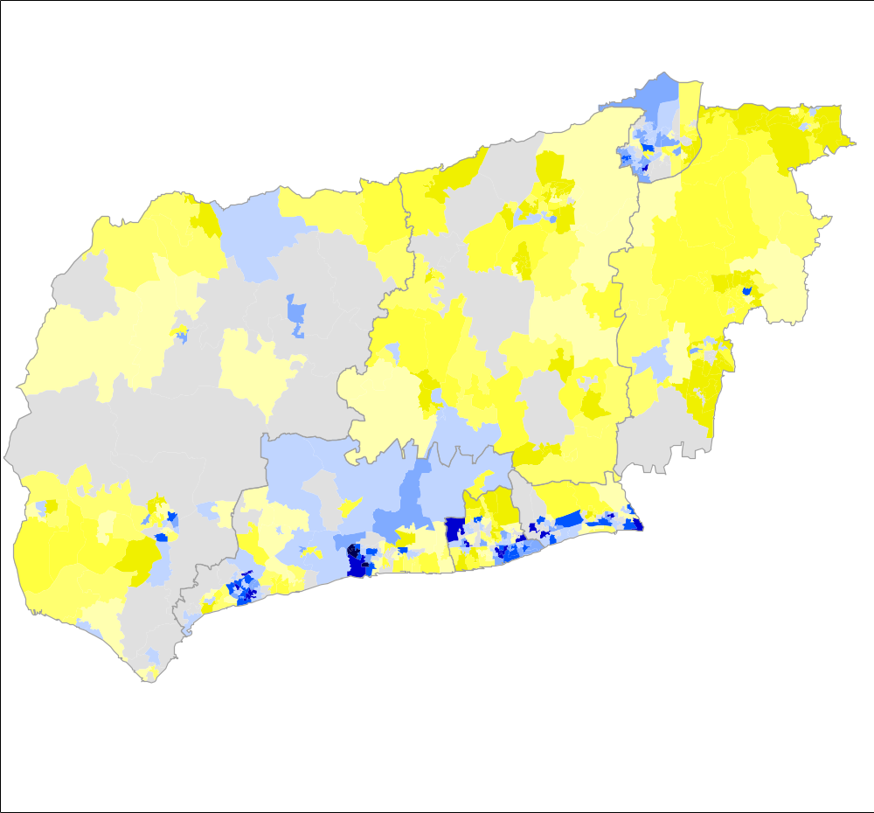
Figure 4 Small Area Deprivation

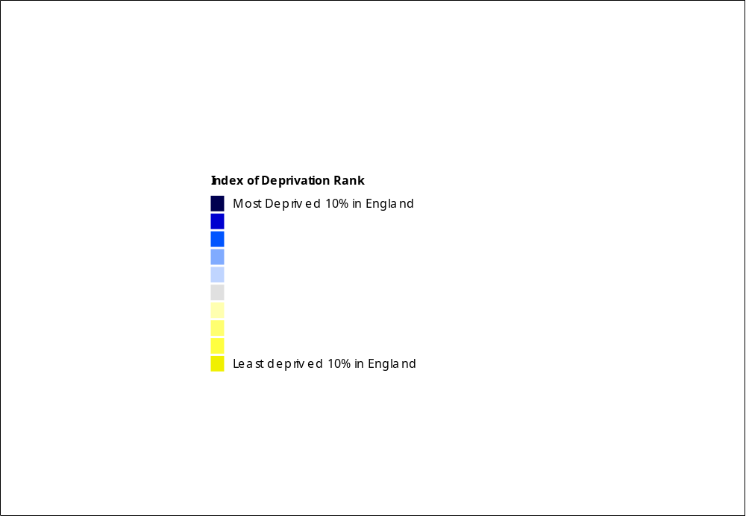

Income Deprivation

Income deprivation examines the number of people who are living on a household income which is 60% or below median household income. Using data from the ID2010, approximately 74,300 people in West Sussex are income-deprived; this is approximately 9.5% of the population (based on MYE 2008 population).

Table 10 Number of People Income-Deprived
Calculated from LSOA Aggregation (rounded to nearest 100)

 | Number | %
Adur | 7,300 | 12.0%
Arun | 17,100 | 11.4%
Chichester | 9,900 | 8.9%
Crawley | 12,100 | 11.6%
Horsham | 8,300 | 6.4%
Mid Sussex | 8,100 | 6.2%
Worthing | 11,500 | 11.3%
Total | 74,300 | 9.5%

Across the county there are considerable differences. Figure 5 shows the percentage of people income-deprived at Lower Super Output Area (LSOA) level.

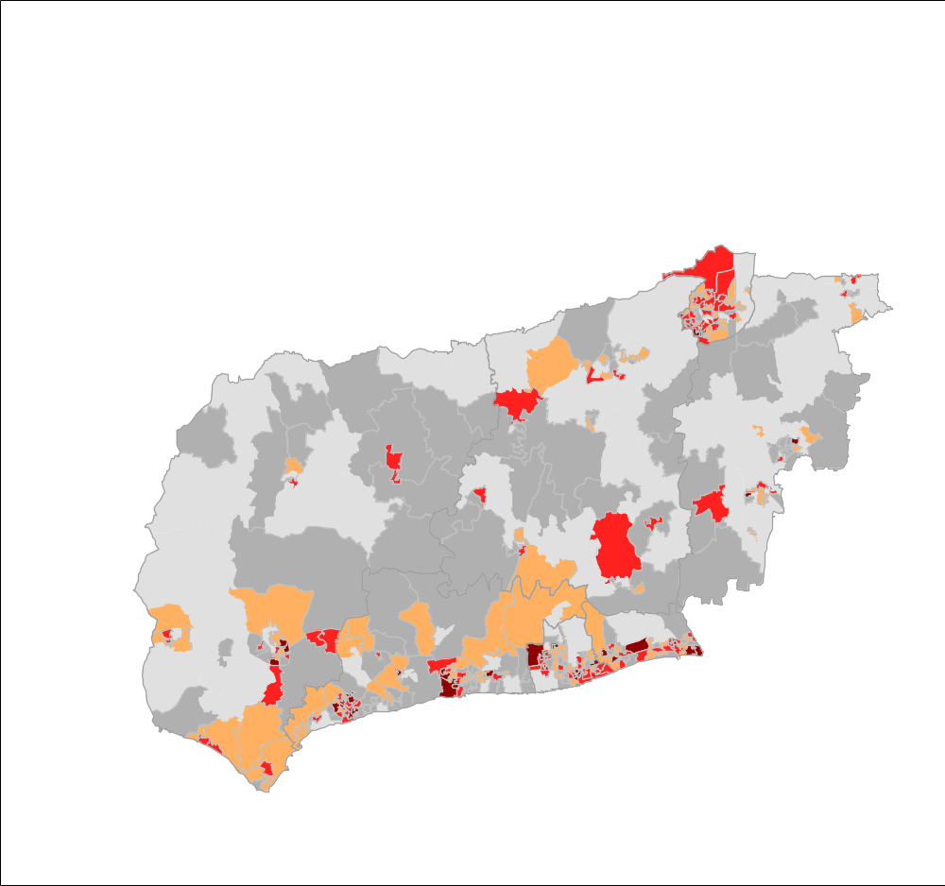
Figure 5 Percentage of People Income-Deprived

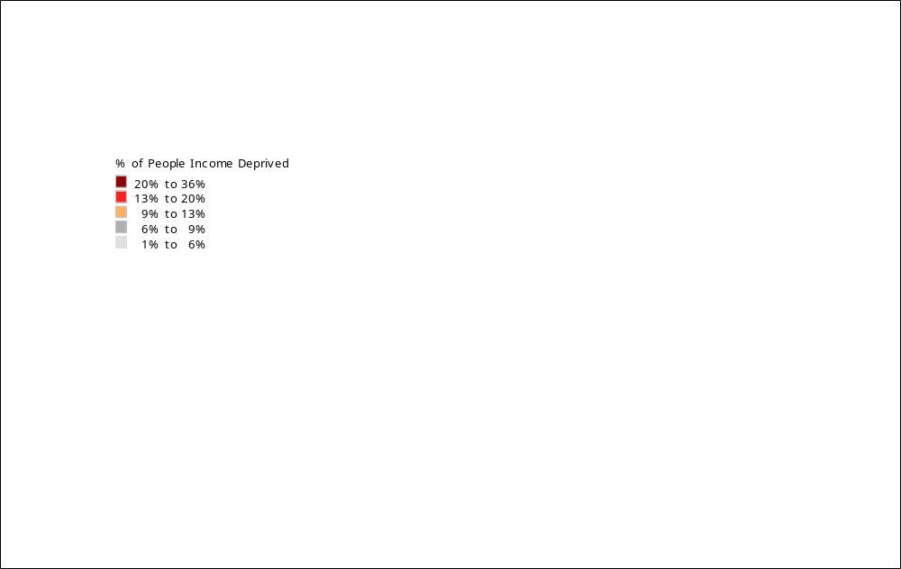

Older People Living in Low Income Households

Overall approximately 12% of older people (23,000 people) in West Sussex are living in low income households.

There is considerable variation across West Sussex, with over 15% of older people in Adur and Crawley living in low income households, and less than 10% in Horsham and Mid Sussex.

Table 11 Older People Living in Low Income Households

 | Older People in Low Income Households ID2010
 | Number | %
Adur | 2,320 | 15.1%
Arun | 6,060 | 13.4%
Chichester | 3,400 | 11.1%
Crawley | 2,560 | 15.2%
Horsham | 2,490 | 8.9%
Mid Sussex | 2,480 | 9.0%
Worthing | 3,510 | 14.3%
West Sussex | 22,810 | 12.1%

Source : DCLG

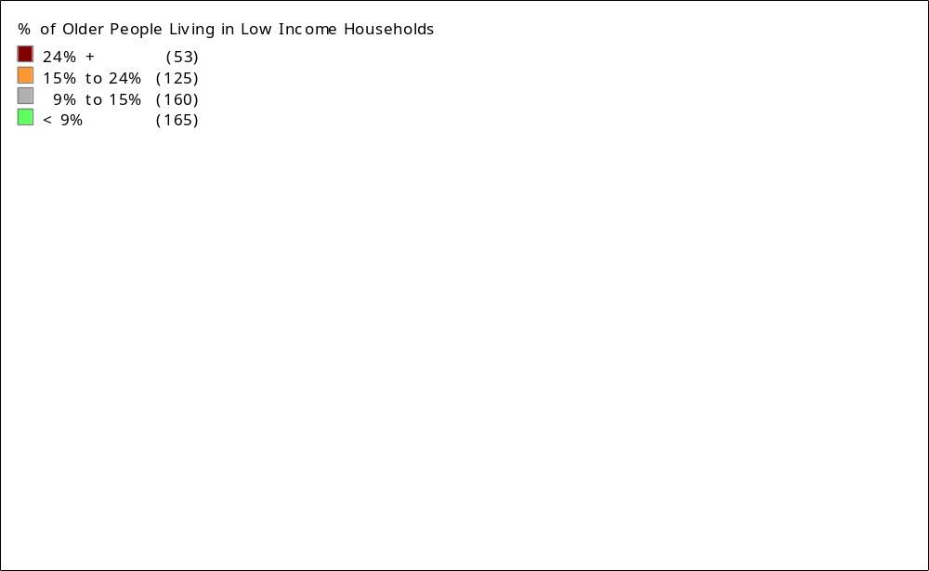
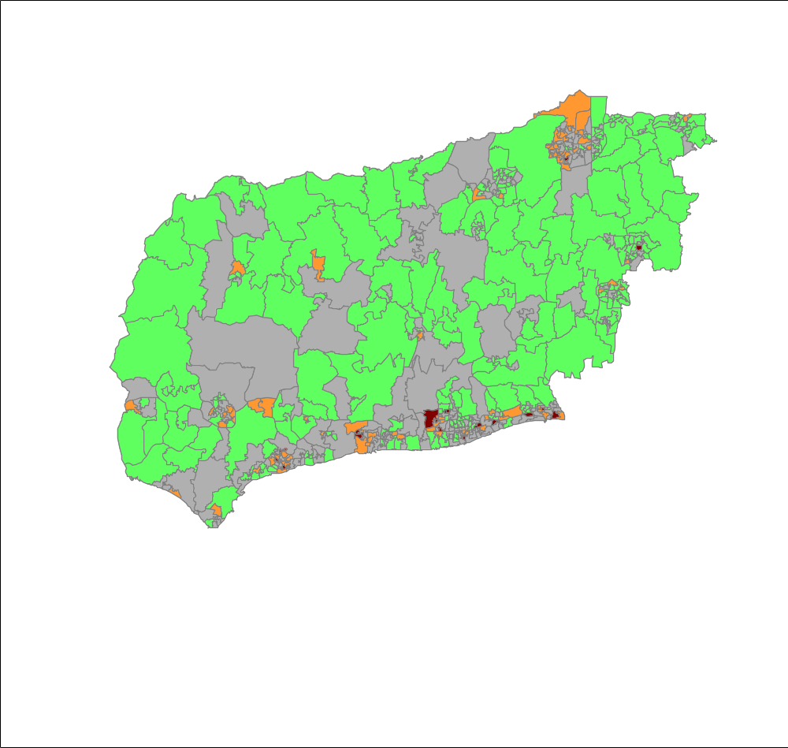
Figure 6 Percentage of Older People Living in Low Income Households
Job Seekers Allowance (JSA) Claimant Rate

Figure 7 below shows the JSA claimant rate for people aged 16-64 in West Sussex, South East and Great Britain.

The graph shows that West Sussex has continued to have a lower JSA rate than national levels.

Figure 7 % of Population 16-64+ Claiming Job Seekers Allowance
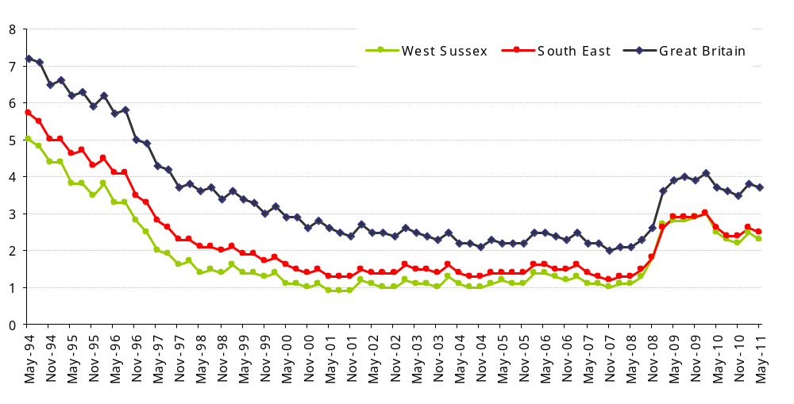

Figure 8 below shows the JSA claimant rate for young adults 16-24 years in West Sussex, South East and Great Britain.

Figure 8 % of Population 16-24 year olds Claiming Job Seekers Allowance
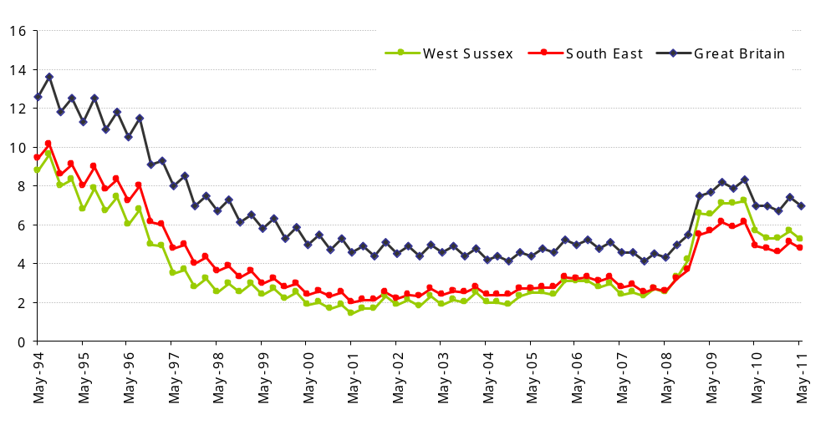
HOUSEHOLDS AND HOUSEHOLD FORMATION
Definition of a household (2001 Census definition)

One person living alone, or a group of people living at the same address with common housekeeping, that is, sharing either a living room or at least one meal a day.

ONS household estimates for West Sussex are shown on the table below. In 2001, there were an estimated 321,000 households; this was estimated to have risen to approximately 342,000 in 2008. On average, ONS estimated that the household numbers grew by an additional 3,000 to 4,000 each year.

Table 12 Estimated Numbers of Households – West Sussex

 | 2001 | 2002 | 2003 | 2004 | 2005 | 2006 | 2007 | 2008
Adur | 26,000 | 26,000 | 26,000 | 26,000 | 26,000 | 27,000 | 27,000 | 27,000
Arun | 63,000 | 64,000 | 65,000 | 65,000 | 66,000 | 67,000 | 67,000 | 68,000
Chichester | 46,000 | 46,000 | 47,000 | 47,000 | 48,000 | 48,000 | 48,000 | 49,000
Crawley | 40,000 | 40,000 | 40,000 | 40,000 | 41,000 | 41,000 | 42,000 | 43,000
Horsham | 50,000 | 51,000 | 51,000 | 52,000 | 52,000 | 53,000 | 54,000 | 54,000
Mid Sussex | 52,000 | 52,000 | 52,000 | 53,000 | 53,000 | 53,000 | 54,000 | 54,000
Worthing | 44,000 | 44,000 | 45,000 | 45,000 | 45,000 | 46,000 | 46,000 | 47,000
Total | 321,000 | 323,000 | 326,000 | 328,000 | 331,000 | 335,000 | 338,000 | 342,000
(Source : ONS)

Given the older population age structure in West Sussex, it is not surprising that, in terms of household composition, the proportion of pensioner households is higher than the national average. In West Sussex, in 2001, over 17% of all households were lone pensioner households compared to 14% in England.

Table 13 Types of Household (2001 Census data)

 | Number | % of Households
Lone pensioner | 54,830 | 17.1%
All pensioner households (excluding lone pensioner) | 38,190 | 11.9%
Other lone person households | 41,790 | 13.0%
Couples with dependent children | 65,860 | 20.5%
Couples with children (all now non-dependent) | 18,060 | 5.6%
Lone parent families with dependent children | 15,780 | 4.9%
Lone parent families with children (all now non-dependent) | 8,160 | 2.5%
Couple households - no children | 61,130 | 19.0%
Other | 17,120 | 5.3%
Total | 320,920 | 100.0%
(Source : ONS Census 2001)

Figure 9 Household Composition – West Sussex compared to England

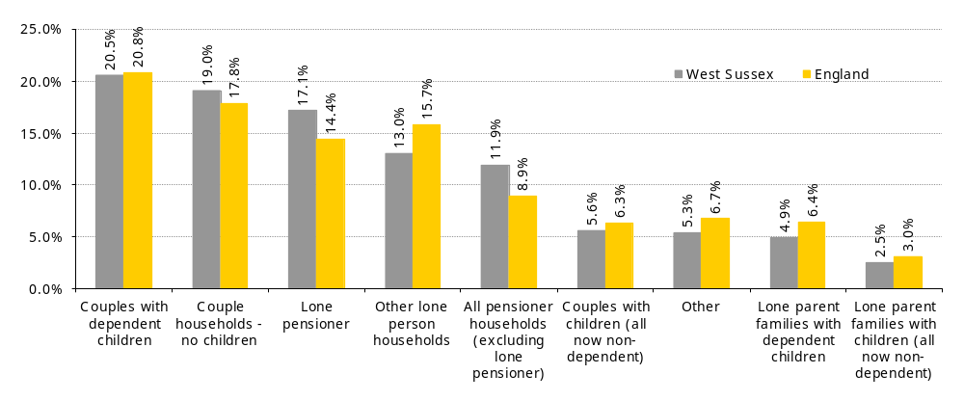

Source : ONS Census 2001

Future Household Formation

As with population, future household estimates are calculated by projecting forward trends and should be treated cautiously, and reviewed regularly.

Household projections are based on a number of factors:

- population age structure
- the current adult population living in private households
- marital status
- the likelihood that people (in particular age, gender and marital status group)s will be head of a household

Projections are published relating to type of household (e.g. lone person household) and by age of “reference” person (sometimes referred to as “head of household”. Actual numbers of households formed will be influenced by several factors including planning consent and rates of immigration.

There are five household types:-

- A couple with no other adults: with or without dependent children.
- A couple with other adults: with or without dependent children.
- Lone parent household: one or more lone parent families, but no married couple or cohabiting couple families.
- One person household: a person living alone who shares neither housekeeping nor a living room with anyone else.
- Other households
In relation to the type of household, ONS project that the largest growth in West Sussex, will be in lone parent and one-person households; this is in line with national projections.

Table 14 Projected Change in Household Type – West Sussex

 | One person | Couple and no other adult | Couple and one or more other adult | Lone parent | Other
2008 | 113,000 | 165,000 | 28,000 | 21,000 | 15,000
2033 | 180,000 | 201,000 | 19,000 | 35,000 | 11,000
Change between 2008 – 2033 | 59.3% | 21.8% | -32.1% | 66.7% | -26.7%

Of specific interest, in relation to supported housing needs, is the increase in households headed by an older person, a substantial increase is projected for households headed by someone aged 85 years or over. Figure 11 below shows the large increase projected for households headed by someone aged 85 years or over; an over 150% increase by 2033.

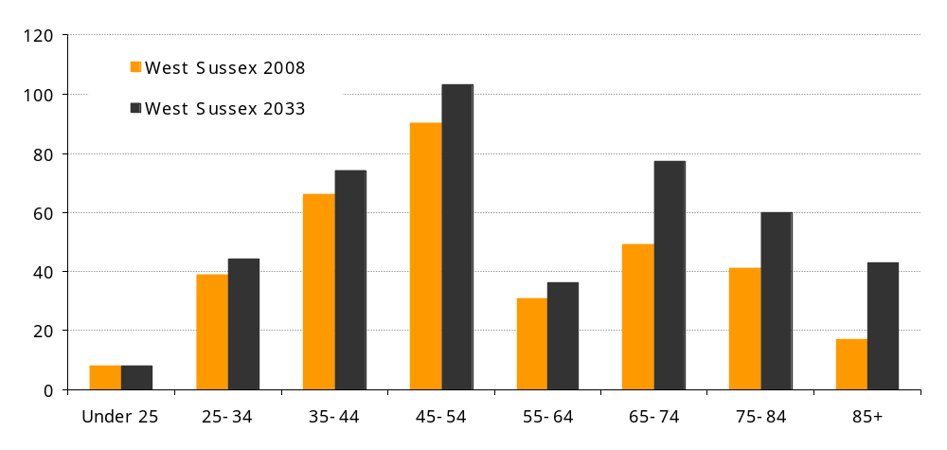
Figure 10 Number of Households by Age of Reference Person, 2008 and 2033

Source: ONS

Figure 11 Projected Percentage Change 2008 to 2033 Household Reference Person
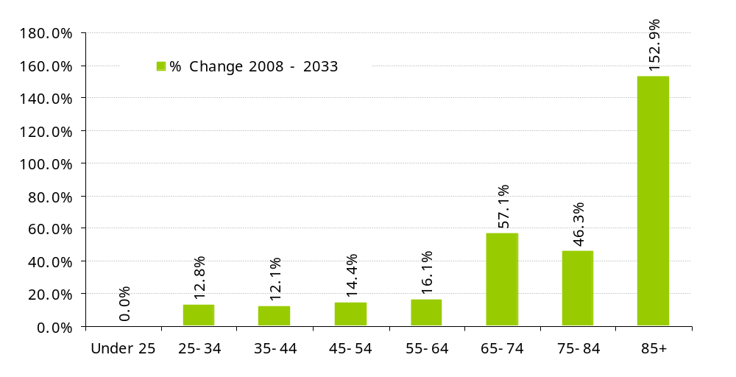

Household Formation and Older People – Local Authority Level
- Household Projection by Age

New household formation is dominated by older age groups across all local authority areas of West Sussex. In 2008 an estimated 31% of households in West Sussex were headed by someone aged 65 years or over, this is projected to increase to 40% by 2033.

Table 15 Households – Projected Change

 | Total Households |  | % of Households headed by someone aged 65 or over
 | 2008 Estimates | 2033 Projected | 2008 Estimates | 2033 Projected
Adur | 28,000 | 33,000 | 32.1% | 42.4%
Arun | 67,000 | 91,000 | 38.8% | 49.5%
Chichester | 49,000 | 66,000 | 36.7% | 43.9%
Crawley | 42,000 | 57,000 | 23.8% | 26.3%
Horsham | 55,000 | 71,000 | 27.3% | 40.8%
Mid Sussex | 55,000 | 68,000 | 27.3% | 38.2%
Worthing | 46,000 | 62,000 | 30.4% | 37.1%
West Sussex | 341,000 | 445,000 | 31.4% | 40.4%
South East |  |  | 26.3% | 33.3%
England |  |  | 27.2% | 35.8%

Fig 12 Percentage of Households Headed by Someone Aged 65 or Over
- 2008 Estimates and 2033 Projections

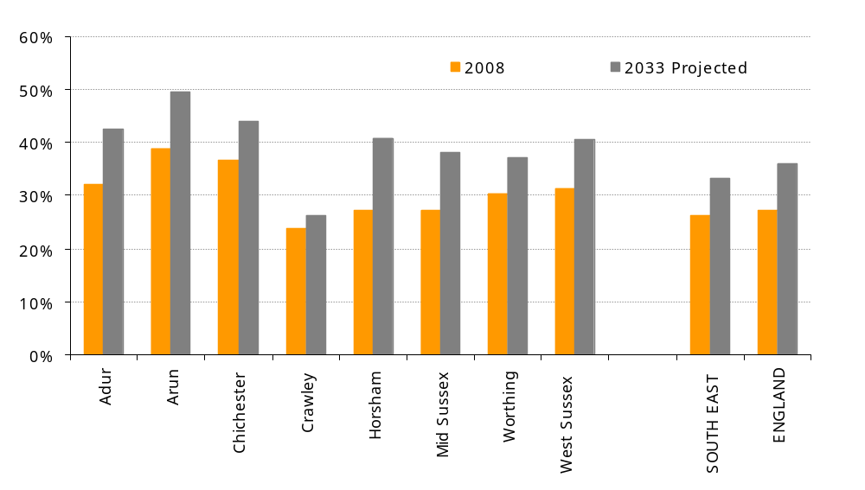

TYPES OF HOUSEHOLD SPACE

Across West Sussex there are approximately 346,500 household spaces. Of these 4% are vacant or second homes. Chichester has a higher percentage of second homes, 5% of all household spaces are second homes in the district.

Table 16 Household Spaces – With Residents/Vacant/Second Homes

 | All Dwellings on the Valuation List | All Vacant Dwellings and Second Homes | All Vacant Dwellings and Second Homes | Of Vacant Dwellings - the number of which are Second Homes | Second Homes
 | Count | Count | Percentage | Count | Percentage
Adur | 27,137 | 659 | 2.4 | 175 | 0.6
Arun | 68,228 | 3,142 | 4.6 | 1,599 | 2.3
Chichester | 52,200 | 4,027 | 7.7 | 2,641 | 5.1
Crawley | 40,685 | 1,106 | 2.7 | 323 | 0.8
Horsham | 55,003 | 1,684 | 3.1 | 381 | 0.7
Mid Sussex | 56,555 | 1,604 | 2.8 | 368 | 0.7
Worthing | 46,815 | 1,682 | 3.6 | 494 | 1.1
West Sussex | 346,623 | 13,904 | 4.0% | 5,981 | 1.8%
South East | 3,306,220 | 167,621 | 5.4% | 39,249 | 1.2%
England | 36,687,630 | 1,414,292 | 3.9% | 373,846 | 1.0%

Source : DCLG

Households in Multiple Occupation (HMO)
Definition: Household in Multiple Occupation
The Housing Act 2004 defines an HMO as a building, or part of a building, which includes more than one unit of accommodation, and in which the occupiers share basic amenities. The building must be the main residence of the occupiers and they must pay rent (or equivalent).

Table 17 Estimated Households in Multiple Occupation
(this is an estimate made by LAs which includes those known and verifiable)

 | 2002 | 2003 | 2004 | 2005 | 2006 | 2007 | 2008 | 2009
Adur | 20 | 110 | 110 | 110 | 120 | 120 | 120 | 120
Arun | 821 | 883 | 900 | 900 | 900 | 806 | 805 | 819
Chichester | 500 | 500 | 500 | 500 | 490 | 490 | 500 | 490
Crawley | 100 | 100 | 500 | 500 | Data not published | 110 | 220 | 500
Horsham | 70 | 71 | 79 | 79 | 79 | 79 | 79 | 79
Mid Sussex | 400 | 400 | 400 | 849 | 849 | 850 | 950 | 748
Worthing | 843 | 847 | 891 | 898 | 909 | 930 | 804 | 794
Total | 2,754 | 2,911 | 3,380 | 3,836 | 3,347 | 3,385 | 3,478 | 3,550
Source : DCLG

DWELLINGS IN WEST SUSSEX

Table 18 Dwelling Stock by Ownership (2010)

Data from HSSA returns April 2010. | Local Authority (incl. owned by other LAs) | Housing association | Other public sector | Private sector (P) | Total (P)
Adur | 2,660 | 811 | 0 | 23,920 | 27,390
Arun | 3,407 | 2,626 | 0 | 63,860 | 69,890
Chichester | 97 | 7,444 | 424 | 44,630 | 52,600
Crawley | 8,476 | 2,073 | 20 | 32,750 | 43,320
Horsham | 48 | 6,328 | 12 | 48,670 | 55,060
Mid Sussex | 17 | 6,105 | 1,338 | 49,610 | 57,070
Worthing | 4 | 4,520 | 0 | 42,970 | 47,500
Total | 14,709 | 29,907 | 1,794 | 306,410 | 352,830

Notes from DCLG on HSSA Dwelling Estimates

- Local Authority and other public sector were reported by local authorities through the HSSA as at 1 April 2010 and include non-permanent dwellings.

- "Housing association" refers only to registered providers of social housing (previously known as Registered Social Landlords). Figures include all self-contained units and bedspaces as at 31 March 2010 as collected in the Regulatory and Statistical Return.

- Total stock figures use the Census 2001 dwelling count as a baseline, with information on subsequent changes to the dwelling stock collected annually as at 31st March through the Housing Flows Reconciliation form.

- Private stock is calculated by the residual.

The Office for National Statistics has recommended that the most suitable method for producing estimates of total dwelling stock at the national and regional levels is to use the census count as a baseline and project this forward using information on annual net supply of housing.

Figures for the total dwelling stock and private sector are estimates and are therefore expressed to the nearest ten dwellings at district level and thousand dwellings at the England level because they should not be considered as accurate to the nearest dwelling.

Overall across West Sussex 87% of dwellings are privately owned, 8% in housing authority ownership, 4% local authority and 1% “other public sector”.

Figure 13
Dwelling Stock - Ownership
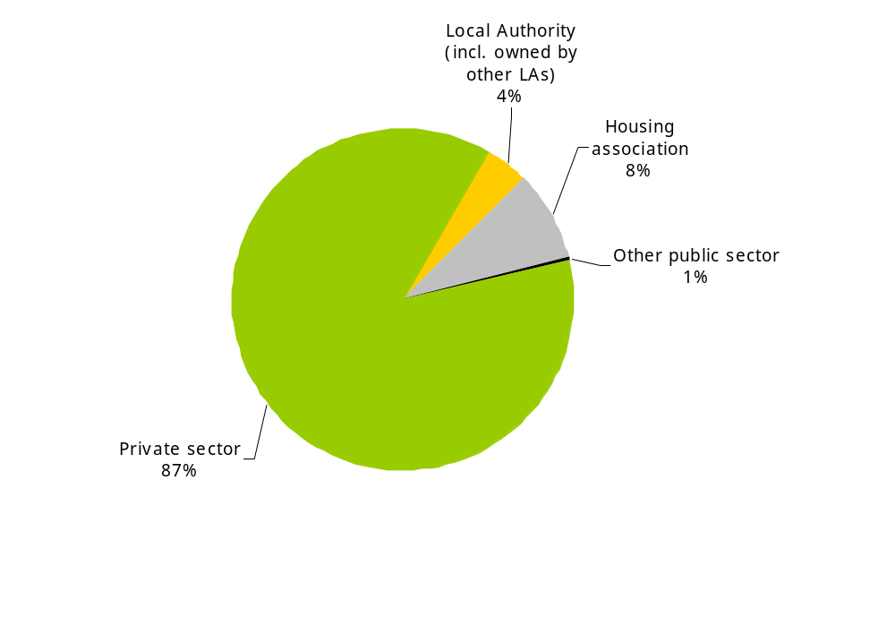

There are considerable differences across West Sussex, of note Crawley has a high level of social rented housing.

Figure 14 Type of Dwelling Stock (2010)

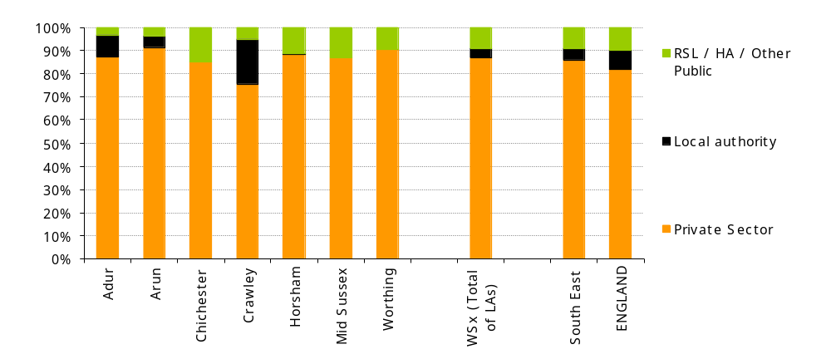

Source : DCLG HSSA Return
Note : Mid Sussex and Worthing transferred ownership of their own housing stock to RSLs.

Change in Socially Rented Housing Stock (Local Authority and RSL)

Table 19 Socially Rented Housing Stock
(rounded to nearest 5)

Dwelling stock: Registered Social Landlord Local authority stock (ROUNDED TO NEAREST 5)
 | 2002 | 2003 | 2004 | 2005 | 2006 | 2007 | 2008 | 2009 | 2010
Adur | 3,680 | 3,615 | 3,575 | 3,545 | 3,535 | 3,520 | 3,485 | 3,490 | 3,470
Arun | 5,810 | 5,835 | 5,865 | 5,850 | 6,000 | 5,815 | 5,890 | 6,005 | 6,035
Chichester | 7,040 | 7,130 | 7,070 | 7,235 | 7,235 | 7,305 | 7,340 | 7,480 | 7,965
Crawley | 10,485 | 10,045 | 9,890 | 10,010 | 10,005 | 9,875 | 9,830 | 10,025 | 10,570
Horsham | 6,105 | 6,015 | 6,085 | 6,190 | 6,325 | 6,300 | 6,340 | 6,340 | 6,390
Mid Sussex | 5,655 | 5,815 | 5,850 | 5,865 | 5,995 | 5,720 | 5,650 | 6,065 | 7,460
Worthing | 4,385 | 4,450 | 4,380 | 4,460 | 4,390 | 4,395 | 4,440 | 4,485 | 4,525
West Sussex | 43,155 | 42,905 | 41,925 | 43,145 | 43,490 | 42,930 | 42,980 | 43,885 | 46,410

Source : Combined figures
LA Stock - Housing Strategy Statistical Appendix (HSSA)
RSL Stock - Tenant Services Authority via the annual Regulatory and Statistical Return (RSR)

Overall Net Additional Housing Stock

The provision of new houses (of all tenures) has fallen in recent years. In relation to new builds, the impact of the recession can be clearly seen; in the South East region only 18,800 dwellings had started being built in 2009/10, compared to over 31,000 in 2005/6.

The table below shows the net increase in housing stock in West Sussex, this includes new dwellings and losses (including demolition, change of use and conversions).

Table 20 Net Additional Housing Stock 2004/5 to 2009/10

Authority | 2004/5 | 2005/6 | 2006/7 | 2007/8 | 2008/9 | 2009/10
Adur | 120 | 200 | 220 | 150 | 120 | 60
Arun | 350 | 240 | 320 | 590 | 550 | 420
Chichester | 450 | 480 | 350 | 430 | 590 | 320
Crawley | 180 | 190 | 470 | 680 | 370 | 410
Horsham | 330 | 650 | 390 | 220 | 310 | 230
Mid Sussex | 460 | 610 | 340 | 500 | 480 | 240
Worthing | 220 | 280 | 270 | 260 | 380 | 250
West Sussex | 2,110 | 2,650 | 2,360 | 2,830 | 2,800 | 1,930

Source : DCLG

Additional Affordable Housing - 1991/2 to 2010/11

Net additional “affordable” housing units in West Sussex are shown on the Figure 15. This includes social rented households, and low cost affordable home ownership.

Figure 15 Additional Affordable Housing - 1991/2 to 2010/11

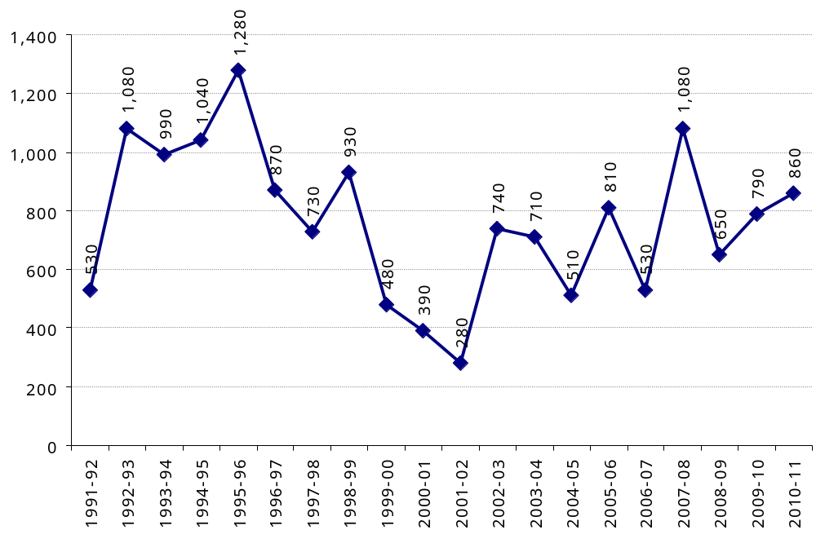

Source : DCLG
SPECIALIST HOUSING – SHELTERED HOUSING / EXTRA CARE HOUSING
Definitions:-
Sheltered housing usually refers to housing where the occupier has their own flat / or bungalow in a block, or on a small estate, where other residents are older people (usually over 55). This can include schemes which are owned or rented.
Extra Care housing refers to schemes where there is independent living with managed on-site care and support services.

Sheltered Housing and Extra Care Housing In West Sussex

The Future Direction for Extra Care Provision in South East England (March 2011). This review was commissioned by the Housing Learning and Improvement Network and the South East Joint Improvement Partnership and undertaken by specialist independent consultants, Ridgeway Associates; it examined the review into extra care housing in the South East.

This review included desktop research into provision and a consultation exercise to include the views and experiences of residents, providers and Local Authorities. The evidence from this review in relation to West Sussex:-

- there were 24 extra care housing schemes with 837 units of accommodation.

- there were 313 sheltered housing schemes in West Sussex with 9,886 units of accommodation.

Sheltered Housing Provision in West Sussex
- Popularity of Schemes by Numbers of Bedrooms

There are a large number of sheltered housing schemes in West Sussex, over 300, providing over 9,500 “units”. Many of these schemes are however are old, studio or one bedroom provision, accommodation which may now be less popular.

Many of the sheltered housing schemes in West Sussex can be directly bid for under the “Choice Based Lettings” scheme. Using a snapshot of some of the data relating to bids for specific properties the popularity of types of provision can be examined.

Local database (Locata) data for Adur, Arun, Chichester and Worthing were examined.

On the snapshot information relating to a total of 521 properties was provided. Of these
150 were sheltered schemes, 3 extra care schemes. Of the sheltered provision, 92 had bidding data provided. It is clear from this that studio type provision is the least popular, the average number of bids per studio is 5.9, compared with 38 bids per bungalow.

Table 21 Bids Per Type of Sheltered Housing Property
Caution this includes only a small amount of data relating to bungalows and studios.

 | Number of properties | Average number of bids per property
Bungalow | 10 | 38.0
Flat | 62 | 15.4
Studio | 20 | 5.9
Total | 92 | 13.7

Source : Locata snapshot data (April 2011)

This is consistent with research conducted by Centre for Housing Policy that older people preferred to have a spare room as a minimum.

Extra Care Housing Provision in West Sussex

“More Choice: Greater Voice” (CSIP/CLG, 2008) provides guidance as to the level of extra care housing provision required for an ageing population, suggesting that there should be 25 units per 1,000 of the population over 75 years.

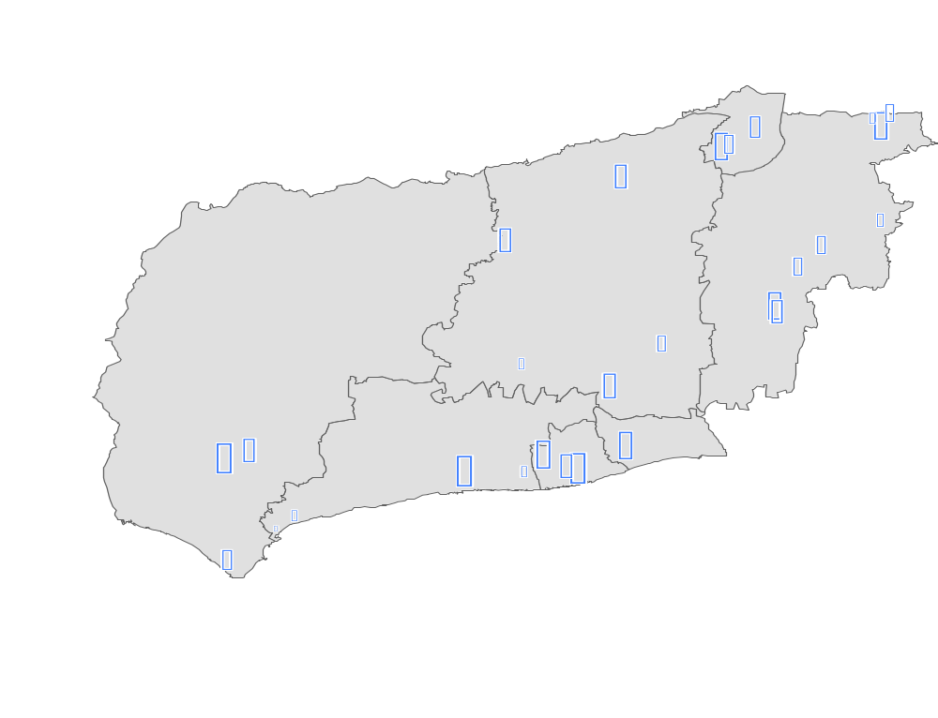
Using the latest data available from the Elderly Accommodation Council, there are approximately 900 units of extra care provision in West Sussex, this equates, at county level, to 11 units per 1,000 population aged 75+, well below the suggested level. The provision is patchy across the county, shown on the map below, of note Arun has only 4 units per 1,000 people aged 75 or over, and all areas have less than the recommended rate.

Figure 16 Extra Care Housing Provision

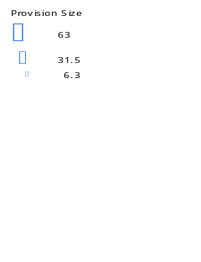

(Source : EAC Data April 2011)

Table 22 Extra Care Housing Provision

 | Population 75+ | Approx. Number of ECH units | Rate per 1,000
Adur | 6,700 | 50 | 7
Arun | 20,500 | 87 | 4
Chichester | 13,400 | 126 | 9
Crawley | 8,100 | 109 | 13
Horsham | 11,700 | 154 | 13
Mid Sussex | 11,500 | 237 | 21
Worthing | 11,900 | 157 | 13
West Sussex total | 83,800 | 920 | 11

RESIDENTIAL CARE – THIS RELATES TO RESIDENTIAL CARE FOR ADULTS

In total, there are almost 400 residential and nursing homes in West Sussex, with almost 10,500 bed spaces.

Table 23 Number and Types of Homes
Snapshot July 2010
Source : WSCC Care Guide

By Local Authority Area | Care Home | Care Home with Nursing | Total
Adur | 14 | 5 | 19
Arun | 90 | 26 | 116
Chichester | 35 | 17 | 52
Crawley | 17 | 5 | 22
Horsham | 16 | 22 | 38
Mid Sussex | 30 | 25 | 55
Worthing | 65 | 23 | 88
Total | 267 | 123 | 390
By Adult Services Locality Area (post 2010 localities) | Care Home | Care Home with Nursing | Total
Northern | 63 | 52 | 115
Southern | 111 | 39 | 150
Western | 93 | 32 | 125
Total | 267 | 123 | 390

Table 24 Bed Spaces
Snapshot July 2010
Source : WSCC Care Guide

By Local Authority Area | Care Home | Care Home with Nursing | Total | Bed Spaces per 1,000 resident population (post 18 years) | Bed Spaces per 1,000 resident population (75+ years
Adur | 349 | 240 | 589 | 12.0 | 87.9
Arun | 1,696 | 1,087 | 2,783 | 22.7 | 135.8
Chichester | 867 | 695 | 1,562 | 17.2 | 116.6
Crawley | 283 | 316 | 599 | 7.3 | 74.0
Horsham | 337 | 979 | 1,316 | 13.0 | 112.5
Mid Sussex | 646 | 970 | 1,616 | 15.9 | 140.5
Worthing | 1,156 | 858 | 2,014 | 24.5 | 169.2
Total | 5,334 | 5,145 | 10,479 | 16.6 | 124.9
By Adult Services Locality Area (post 2010 localities) | Care Home | Care Home with Nursing | Total
Northern | 1,266 | 2,265 | 3,531 | 12.4 | 112.8
Southern | 2,128 | 1,594 | 3,722 | 21.2 | 137.7
Western | 1,940 | 1,286 | 3,226 | 17.2 | 116.6
Total | 5,334 | 5,145 | 10,479 | 16.6 | 124.9

Snapshot Residential and Nursing Care West Sussex Bed Spaces July 2010

Table 25 Client Group - The West Sussex Care Guide provides a detailed description of specific homes and client groups. The table below breaks down data into broad groupings.

Broad Group Description | Northern | Southern | Western | Total
Dementia | 326 | 615 | 429 | 1,370
Drug or Alcohol Dependence | 0 | 0 | 21 | 21
Learning Disability | 365 | 286 | 276 | 927
Mental disorder | 13 | 191 | 123 | 327
Older People | 2,749 | 2,442 | 2,327 | 7,518
Physical Disability | 78 | 168 | 50 | 296
Respite | 0 | 20 | 0 | 20
Total | 3,531 | 3,722 | 3,226 | 10,479

Figure 17
Location of Care Homes – West Sussex (Snapshot of homes December 2010)
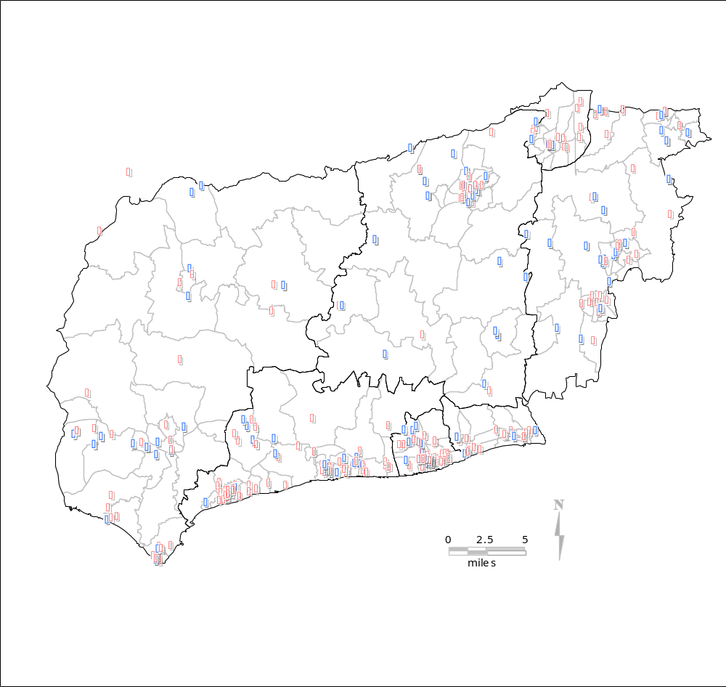

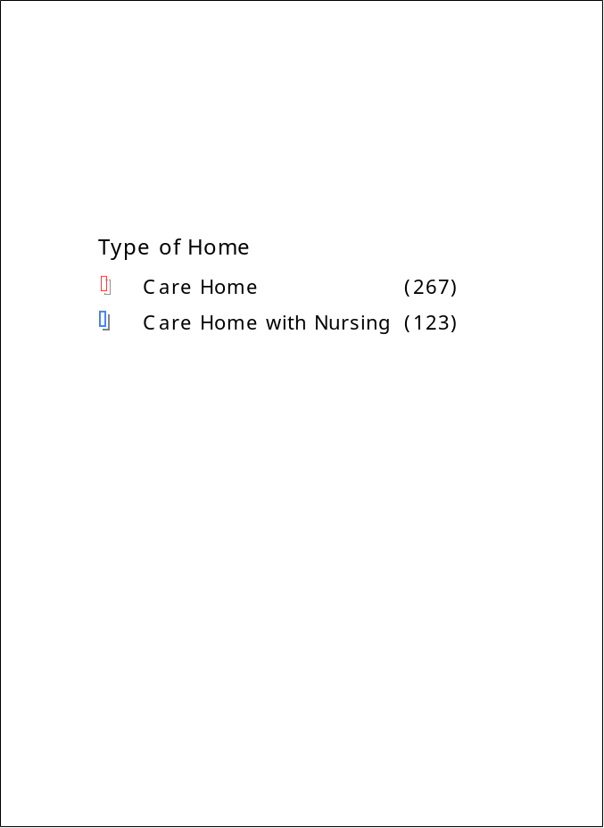

Figure 18
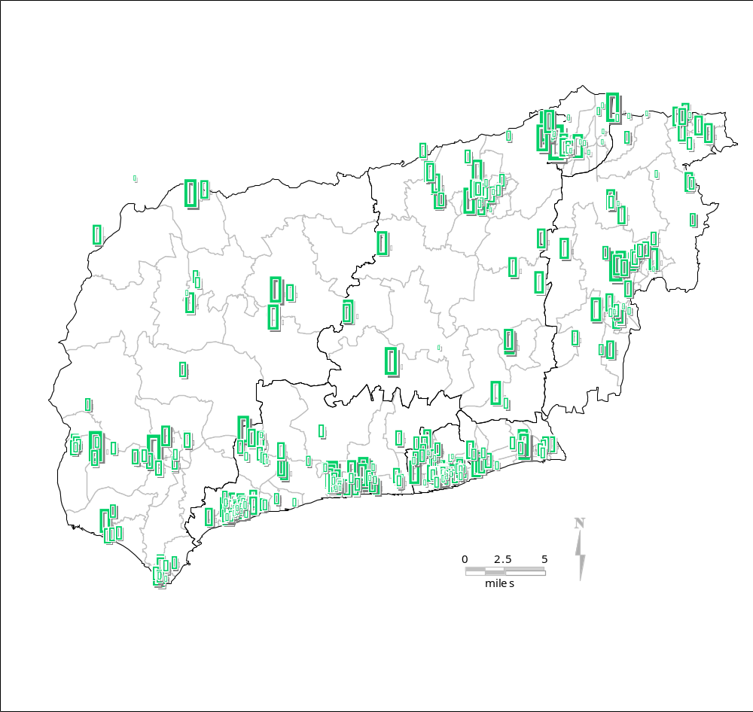
Number of Beds – West Sussex (Snapshot of homes December 2010

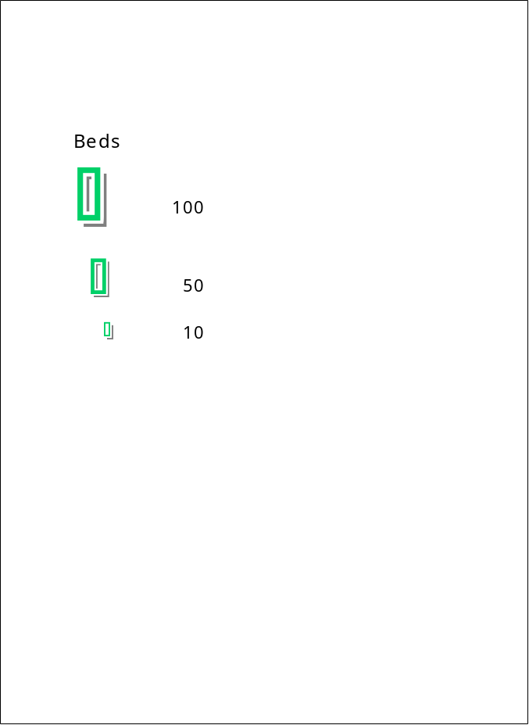

PEOPLE LIVING IN MEDICAL OR CARE COMMUNAL ESTABLISHMENTS
Definition:-
A communal establishment is defined as managed residential accommodation where there is full-time or part-time supervision of the accommodation.

Table 26 shows the overall residents in communal establishments and people aged 75+ in medical or care communal establishments as a percentage of the over 75 population.

Table 26 Residents In Communal Establishments (2001)
Figures rounded to nearest 5.

 | 75-84 | 85-89 | 90+ | 75+ | Population 75+ | % of 75+ Population Resident in Medical / Care Communal Establishment
Adur | 120 | 150 | 180 | 450 | 6,640 | 6.8%
Arun | 565 | 560 | 600 | 1,725 | 19,650 | 8.8%
Chichester | 320 | 305 | 380 | 1,005 | 12,335 | 8.1%
Crawley | 85 | 70 | 55 | 210 | 6,620 | 3.2%
Horsham | 265 | 225 | 305 | 795 | 10,035 | 7.9%
Mid Sussex | 330 | 325 | 420 | 1,075 | 10,390 | 10.3%
Worthing | 515 | 510 | 635 | 1,660 | 13,125 | 12.6%
West Sussex | 2,200 | 2,145 | 2,575 | 6,920 | 78,800 | 8.8%
South East | 16,775 | 14,795 | 16,895 | 48,465 | 640,120 | 7.6%
England | 99,585 | 78,990 | 84,235 | 262,810 | 3,705,160 | 7.1%

It is evident that in West Sussex, a high percentage of the resident population live in communal establishment. In Worthing, 13% of the over 75 population live in residential care, this is far higher than regional and national figures; in part this will reflect businesses serving a much larger geographic market, including Brighton and Hove.

With an ageing population and the increased emphasis of maintaining people in their “household” home the interface between “household” homes and communal homes needs more consideration and an understanding of why people move into residential care.

Although statutory agencies (social services and the NHS) hold information on people funded, or part-funded, who are living in residential and nursing homes, there is little information on people who are self-funders, outside of the census there is no maintained “count” of people living in care homes.

Using data from the census it is possible to note the health status of people living in communal establishments. Table 27 overleaf shows that, in West Sussex, of the people aged 65 or over living in care/or medical establishments 6.5% (approximately 500 people) did not have a limiting long term illness.

Table 27 Older People in Care Homes – By Limiting Long Term Illness

 |  | 65-74 | 75-84 | 85-89 | 90 years+ | Total 65+
Adur | Living in a care/medical establishment | 30 | 119 | 154 | 180 | 483
Adur | - With a limiting long term illness | 30 | 104 | 134 | 164 | 432
Adur | - Without a limiting long term illness | 0 | 15 | 20 | 16 | 51
Adur | % without a limiting long term illness | 0.0% | 12.6% | 13.0% | 8.9% | 10.6%
Arun | Living in a care/medical establishment | 203 | 575 | 558 | 604 | 1,940
Arun | - With a limiting long term illness | 180 | 536 | 520 | 570 | 1,806
Arun | - Without a limiting long term illness | 23 | 39 | 38 | 34 | 134
Arun | % without a limiting long term illness | 11.3% | 6.8% | 6.8% | 5.6% | 6.9%
Chichester | Living in a care/medical establishment | 98 | 326 | 309 | 380 | 1,113
Chichester | - With a limiting long term illness | 83 | 300 | 292 | 354 | 1,029
Chichester | - Without a limiting long term illness | 15 | 26 | 17 | 26 | 84
Chichester | % without a limiting long term illness | 18.1% | 8.7% | 5.8% | 7.3% | 7.5%
Crawley | Living in a care/medical establishment | 27 | 86 | 70 | 53 | 236
Crawley | - With a limiting long term illness | 27 | 80 | 67 | 45 | 219
Crawley | - Without a limiting long term illness | 0 | 6 | 3 | 8 | 17
Crawley | % without a limiting long term illness | 0.0% | 7.0% | 4.3% | 15.1% | 7.2%
Horsham | Living in a care/medical establishment | 71 | 266 | 226 | 310 | 873
Horsham | - With a limiting long term illness | 68 | 263 | 219 | 297 | 847
Horsham | - Without a limiting long term illness | 3 | 3 | 7 | 13 | 26
Horsham | % without a limiting long term illness | 4.2% | 1.1% | 3.1% | 4.2% | 3.0%
Mid Sussex | Living in a care/medical establishment | 102 | 328 | 324 | 413 | 1,167
Mid Sussex | - With a limiting long term illness | 102 | 302 | 307 | 398 | 1,109
Mid Sussex | - Without a limiting long term illness | 0 | 26 | 17 | 15 | 58
Mid Sussex | % without a limiting long term illness | 0.0% | 7.9% | 5.2% | 3.6% | 5.0%
Worthing | Living in a care/medical establishment | 16 | 516 | 507 | 636 | 1,675
Worthing | - With a limiting long term illness | 11 | 471 | 477 | 589 | 1,548
Worthing | - Without a limiting long term illness | 5 | 45 | 30 | 47 | 127
Worthing | % without a limiting long term illness | 31.3% | 8.7% | 5.9% | 7.4% | 7.6%
West Sussex | Living in a care/medical establishment | 661 | 2,208 | 2,146 | 2,575 | 7,590
West Sussex | - With a limiting long term illness | 612 | 2,053 | 2,012 | 2,418 | 7,095
West Sussex | - Without a limiting long term illness | 49 | 155 | 134 | 157 | 495
West Sussex | % without a limiting long term illness | 7.4% | 7.0% | 6.2% | 6.1% | 6.5%
SE England | Living in a care/medical establishment | 5,332 | 16,776 | 14,792 | 16,893 | 53,793
SE England | - With a limiting long term illness | 4,948 | 15,547 | 13,697 | 15,666 | 49,858
SE England | - Without a limiting long term illness | 384 | 1,229 | 1,095 | 1,227 | 3,935
SE England | % without a limiting long term illness | 7.2% | 7.3% | 7.4% | 7.3% | 7.3%
England | Living in a care/medical establishment | 32,270 | 99,585 | 83,987 | 84,204 | 300,046
England | - With a limiting long term illness | 30,447 | 94,174 | 74,530 | 79,354 | 278,505
England | - Without a limiting long term illness | 1,823 | 5,411 | 9,457 | 4,850 | 21,541
England | % without a limiting long term illness | 5.6% | 5.4% | 11.3% | 5.8% | 7.2%

People Living in Residential Care – Supported Residents

Table 28 Supported Residents in West Sussex

 | 18-64 yrs | 65+ yrs | Total
2005/06 | 1,090 | 2,985 | 4,075
2006/07 | 970 | 2,795 | 3,765
2007/08 | 920 | 2,550 | 3,475
2008/09 | 885 | 2,480 | 3,365
2009/10 | 880 | 2,450 | 3,300

Table 29 65+ Breakdown
- Residential Type

 | Residential Care | Nursing Care | Adult Placement | Total
2005/06 | 1,920 | 1,065 | 0 | 2,985
2006/07 | 1,810 | 985 | 0 | 2,795
2007/08 | 1,595 | 955 | 0 | 2,550
2008/09 | 1,585 | 885 | 10 | 2,480
2009/10 | 1,640 | 795 | 15 | 2,450

Table 30 Rates Per 10,000 population
– West Sussex compared to SE and National Rates

 | Rate Per 10,000 18-64 year olds |  |  | Rate Per 10,000 65+ years
 | West Sussex | South East | England | West Sussex | South East | England
2005/06 | 25 | 20 | 20 | 190 | 205 | 250
2006/07 | 20 | 20 | 20 | 180 | 205 | 235
2007/08 | 20 | 20 | 20 | 160 | 195 | 225
2008/09 | 20 | 20 | 15 | 155 | 185 | 215
2009/10 | 20 | 20 | 15 | 150 | 180 | 205

Table 31 Year on Year – Admissions to Residential and Nursing Care
– People Supported By Social Services

 | Residential Care | Nursing Care | Adult Placement | Total
2005/06 | 670 | 605 | 5 | 1,285
2006/07 | 705 | 380 | 15 | 1,100
2007/08 | 580 | 350 | 15 | 945
2008/09 | 740 | 385 | 15 | 1,145
2009/10 | 705 | 335 | 10 | 1,050
Figures rounded to nearest 5.
Source : DoH Information Centre

2010/2011 WSCC DATA – ADULTS SUPPORTED TO LIVE IN RESIDENTIAL CARE

For the period 2010/2011 comparator data have yet to be published.

- In West Sussex in March 2011 there were 2,232 residents supported to live in residential or nursing care; 1,459 in residential care, 773 in nursing care.

- Approximately 18% of people supported in residential care entered residential care as “self funders” and required financial support on depletion of capital.

“Run – Outs”

There is on-going work being developed by West Sussex County Council to address the number of people who become the financial responsibility of WSCC for funding residential/nursing care placements.

- A snapshot of data from November 2010, showed that there were there were 398 older people living in care homes in West Sussex who had previously been self funding, and who are now having the cost of their care met by the County Council (known as “capital depleters”).

- The annual cost to the Council based on the above resident number is £5.95 million per year (average cost per resident = £14,950).

Evidence gathered nationally suggests that the majority of older people who are funding their residential/nursing care themselves are highly unlikely to have sought specialist financial advice about the best means of funding of their long-term care - for many it will be their second largest purchase of their life. (Careless-Funding long term care for the elderly: Featherstone H & Whitham L (Policy Exchange 2010))

Note : there is no local data on people living in residential care in West Sussex funded by other local authorities.

HOUSING SUITABILITY AND CONDITION Monitoring Housing Conditions

- English Housing Survey

DCLG commissions a continuous housing survey, the English Housing Survey (EHS), to monitor housing conditions. This survey was introduced in 2008 and replaced two existing surveys, the English Housing Condition Survey (EHCS) and Survey of English Housing (SHE). EHS has similar components to the previous surveys; a household interview, and, for some of the properties, a physical inspection and market value survey.

The survey is across all types of tenure and households, with a national sample each year of approximately 17,000 for the interview components and then a sub sample of approximately 8,000 for physical inspections (by qualified surveyors) and market evaluation. There is also a follow up survey of private landlords, examining their motivation for becoming a landlord, experiences and type of properties owned.

Information from the English Housing Survey is provided at national and regional level, no local data are available. The survey collects a wide variety of data on housing stock and household, including information relating to housing condition.

The DCLG definition of a decent home is detailed in the box below, although it should be noted that some local authorities set additional standards and requirements.

Definition: Decent Home (DCLG definition)

A decent home is one that meets all of the following four criteria:

a) meets the statutory minimum standard for housing. From April 2006 the
Fitness Standard was replaced by the Housing Health and Safety Rating System
(HHSRS).

b) it is in a reasonable state of repair (assessed from the age and condition of a
range of building components including walls, roofs, windows, doors, chimneys,
electrics and heating systems).

c) it has reasonably modern facilities and services (assessed according to
the age, size and layout/location of the kitchen, bathroom and WC and any
common areas for blocks of flats, and to noise insulation).

d) it provides a reasonable degree of thermal comfort (adequate heating and
effective thermal insulation).

Source : DCLG

National level data shows that the private rented sector has the highest percentage of homes not of a decent standard. Figure 21 shows that, in 2008, 44% of the private rented housing stock was estimated to be non-decent, compared to 32.3% of owner occupied homes and 31.5% of housing association stock and 22.8% of housing still owned by councils. Of the local authorities in West Sussex who still own their own social housing stock, a provisional figure for the percentage of their stock not meeting the decent homes standard and a forecasted number of properties is shown on the Table 32 overleaf.

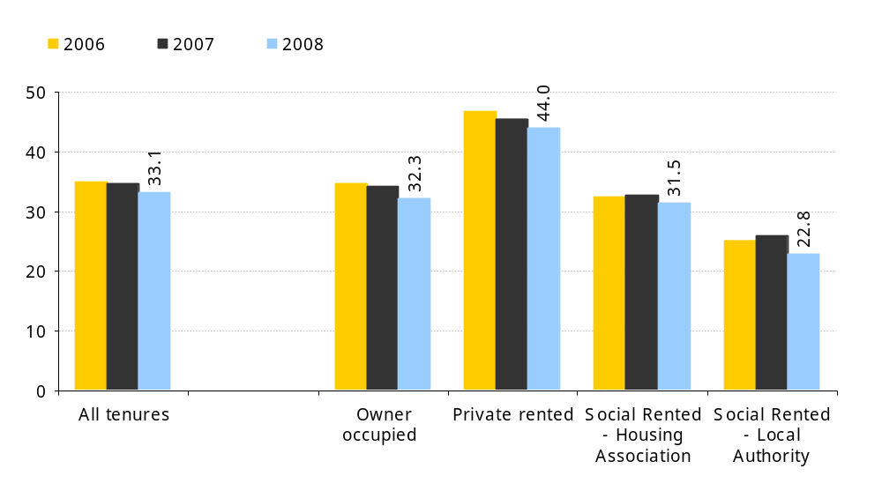
Figure 19 % of Housing Stock Not Meeting Decent Home Standards
- by Tenure

Source : English Housing Survey

Table 32 Decent Homes – LA Stock

 | Dwellings becoming non decent in2009/10 | Number of non decent dwelling as of 1/4/2010 | Proportion of LA homes that are non-decent (%) | Forecast number of non-decent homes for each of the next five years as at 1st April:
 |  |  |  | 2011 | 2012 | 2013 | 2014 | 2015
Adur | 80 | 105 | 4 | 120 | 140 | 160 | 180 | 200
Arun | 0 | 355 | 10 | 166 | 335 | 287 | 508 | 65
Crawley | 187 | 2174 | 26 | 61 | 85 | 90 | 85 | 95
Source : DCLG

THE HOUSING HEALTH AND SAFETY RATING SYSTEM (HHSRS)

The Housing Health and Safety Rating System (HHSRS) is a risk assessment tool used to assess potential risks to the health and safety of occupants in residential properties in England and Wales. It was introduced in the Housing Act 2004, came into effect in April 2006 and replaced the Housing Fitness Standard.

Hazards are scored in relation to the seriousness of their potential impact on health and safety. Overall twenty-nine specific hazards are evaluated against four categories of harm, physiological, accident, psychological and infection.

Detail on these hazard groups is provided in Appendix 2

Councils have a duty to take some enforcement action where Category 1 hazards exist.

Data collected for the 2008 English Housing Survey found that, overall, 22.7% of dwellings had a category 1 hazard, and this rose to almost 31% of private rented property.

Table 33 English Housing Survey Properties Identified with a HHSRS Category 1 Hazard

Tenure | % HHSRS category 1 hazard
Tenure | Any Hazard | Excess Cold | Any Falls* | Any Other Hazards
Owner Occupied | 23.0 | 9.2 | 13.2 | 4.4
Private Rented | 30.7 | 13.1 | 16.2 | 9.9
Local Authority | 16.4 | 4.0 | 9.1 | 5.1
Housing Association | 12.7 | 3.5 | 6.7 | 4.2
All Private | 24.4 | 9.9 | 13.7 | 5.4
All Social | 14.6 | 3.7 | 7.9 | 4.6
All Dwellings | 22.7 | 8.8 | 12.7 | 5.2

* 'Any falls' includes those related to stairs, on the level, between levels and those associated with baths.

Source: English Housing Survey 2008, dwelling sample

INFORMATION COLLECTED AS PART OF LOCAL HOUSING NEEDS SURVEYS.
In 2007 West Sussex County Council commissioned DCA to prepare a Housing Needs Assessment Summary Report for the seven local authorities. DCA was well positioned to do this as the consultancy had previously conducted individual Housing Needs Assessment for all the West Sussex local authorities between the years 2003 and 2004. Two local authorities updated their reports in 2005 and the updated information was included within the 2007 county level DCA report.

In the past Housing Needs Surveys assessed a number of issues relating to housing need including:-

- Access to tenures
- Identifying specific needs – for example wheelchair users
- Adequacy of current housing to meet current need;
- Over / under occupation levels

Across West Sussex as whole approximately 25,500 surveys were completed between 2003 and 2004. It should be noted that when analysing this information for some sub-groups, numbers can become quite small, so some caution is needed.

Some of the information can be updated from more recent published or local data, but other information gathered cannot be readily refreshed without re-surveying.

Adequacy to Meet Needs

Respondents were asked whether their current home was adequate to meet their current needs. The DCA report notes the variation across the county and by tenure. Between 80% and 90% of all respondents said their housing was adequate, but this was far lower in the private rented sector.

Table 34 Adequacy Of Housing By Tenure (%)

 | Adur | Arun | Chichester | Crawley | Horsham | Mid Sussex | Worthing
Owner occupied with mortgage | 88.7 | 86.9 | 88.0 | 81.5 | 87.9 | 84.3 | 87.1
Owner occupied no mortgage | 97.3 | 96.1 | 96.6 | 94.2 | 96.5 | 96.7 | 96.0
Private rented | 68.6 | 57.5 | 70.9 | 64.4 | 69.5 | 70.5 | 71.9
Council rented | 83.4 | 90.2 | - | 78.9 | - | - | -
HA rented | 71.8 | 89.6 | 84.8 | 78.2 | 80.4 | 83.9 | 81.9
Shared ownership | 100.0 | 84.1 | 80.8 | 62.3 | 89.5 | 65.8 | 86.2
Tied to employment / other | 99.4 | 88.5 | 88.2 | 54.3 | 90.1 | 93.0 | 88.1
All tenures | 89.7 | 88.4 | 89.1 | 82.5 | 88.7 | 87.5 | 88.1
Boxes shaded indicate small numbers.
Source : DCA

Over / Under Occupation
Definition:-
DCLG Bedroom standard refers to an indicator of occupation density.

A standard number of bedrooms is allocated to each household in accordance with its age/sex/marital status composition and the relationship of the members to one another.

Using the “DCLG Bedroom Standard”, the surveys collected data on levels of over occupancy (too many people for the allocation of bedrooms) and under occupancy (excess bedrooms for people in household).

In West Sussex local authority areas the percentage of households found to be under occupied ranged from 31% in Adur and Worthing to over 50% in Mid Sussex.

Table 35 Under/Over Occupation

 | Under occupied (%) | Over occupied (%)
Adur | 31.0 | 2.6
Arun | 36.5 | 2.0
Chichester | 42.0 | 2.4
Crawley | 44.3 | 3.3
Horsham | 44.9 | 1.8
Mid Sussex | 51.9 | 1.2
Worthing | 30.9 | 2.1

The census includes data on occupancy levels but uses a definition which relates to assumptions on number of “common” rooms per household – excluding bathrooms. This is not the same definition as used by DCLG.

Higher levels of under occupancy are associated with an ageing population, as older people continue to live in larger properties after children leave home and/or following a partner’s death.

It should be noted that while the bedroom standard is used to measure “need”, researchers are increasingly questioning it’s usefulness for planning purposes, arguing it does not reflect preference or rising expectations.

“In practice, other studies show that, given rising expectations, the formal bedroom standard no longer reflects household preferences; rather most households including older households now seek at least one spare room as a minimum and consequently, very few older people wish to move to one bedroomed accommodation.”
(Centre for Housing Policy 2008)

Although there is a relatively small percentage of total households in over occupied housing, when breaking this figures down by ethnic background, housing needs surveys found that BME households, in some areas, recorded a far higher level of overcrowding. For example in Crawley 9.6% of BME households were living in overcrowded accommodation, compared to 3.3% of households overall.

Supported / Adapted Housing

Housing Needs Surveys conducted in 2003/4 asked respondents whether they, or any household member, had a limiting long term illness or disability.

Excluding Crawley which used a slightly different question to other areas, between 12% and 22% of households contained someone with a LLTI or disability, in the main this was accounted for by older people. There were similar levels of adapted households, from 8.6% of households in Mid Sussex to 11.6% in Chichester.

Table 36 Households with Someone with a Disability or Limiting Long Term Illness and Households with Adaptations

 | Households with someone with a LLTI or disability (%) | Households with someone with a LLTI or disability (%) | Households with someone with a LLTI or disability (%) | % of all households adapted to meets the needs of person with LLTI or disability
 | Households with someone with a LLTI or disability (%) | % age 60+ | % age 75+
Adur | 21.9 | 61.0 | 33.9 | 10.0
Arun | 19.5 | 71.4 | 40.9 | 10.8
Chichester | 14.9 | 73.5 | 47.3 | 11.6
Crawley* | 26.4 | 46.1 | 24.6 | 10.1
Horsham | 14.6 | 68.6 | 37.9 | 9.1
Mid Sussex | 12.3 | 64.0 | 38.6 | 8.6
Worthing | 18.3 | 63.0 | 35.7 | 8.9
Source: Local Authority Housing Needs Surveys. *The survey Crawley used structured the question relating to disability differently, and included a wider range of conditions.

Adaptations

Adaptations to homes can maintain and improve health well being and independence, they can help reduce the need and cost for care, reduce specific concerns, for example in relation to falls or accidents, and improve well being by supporting people to remain in their own home.

The West Sussex Lifestyle Survey of Older People (2006) asked people, aged 65 years and over, to say whether they had had special equipment or adaptations within their home. Overall 13% of people said that they had special equipment / adaptations within their home, at District level the percentage ranged from 10% of older people in Mid Sussex to 15% of people in Adur.

Table 37 Percentage of Older People with Special Equipment or Adaptations

Adur | 15%
Arun | 14%
Chichester | 14%
Crawley | 17%
Horsham | 11%
Mid Sussex | 12%
Worthing | 14%
West Sussex | 13%

Source :West Sussex Lifestyle Survey of Older People (2006)

The use of equipment increases dramatically with age, men aged 85 or more are seven times more likely to have equipment than men aged 65-69 years. Men were found to be less likely than women, at all ages, to have equipment.

Given the large increase expected in the very elderly population (85+)e an increasing demand for adaptations and specialist equipment.

Figure 20
Percentage of Older People With Special Equipment Or Adaptations Within Their Home
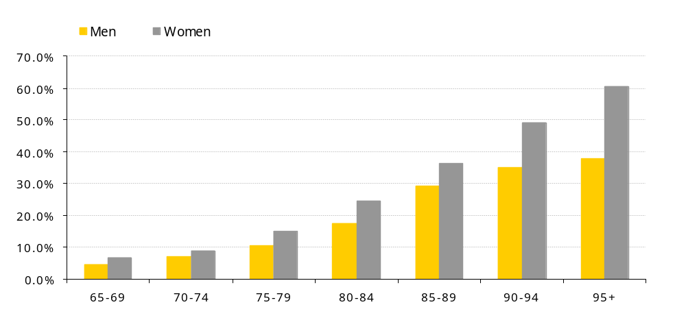

In terms of identifying need for support with mobility people were also asked whether they used a stick, wheelchair or walking frame to get about in their own home.

Figure 21
Percentage of People Who Said They Used A Stick, Walking Frame Or Wheelchair To Get Around In Their Home
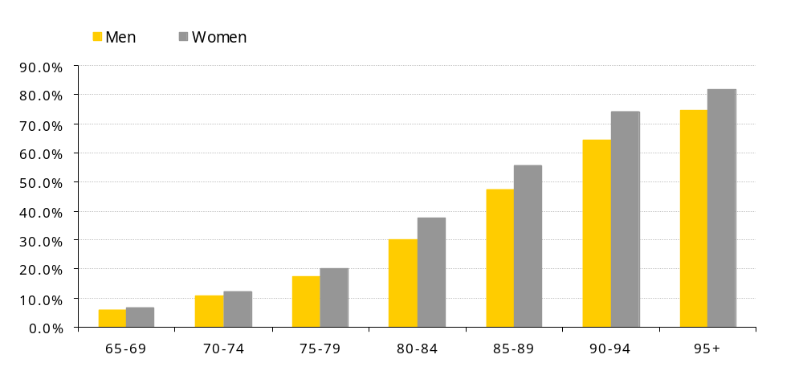

Source : Lifestyle Survey of Older People (NHS West Sussex, West Sussex County Council 2006)

FUEL POVERTY

The Government definition of fuel poverty is:-

“A household is in fuel poverty if, in order to maintain a satisfactory heating regime and cover other normal fuel costs, it would be required to spend more than 10% of its income on all household fuel use.”

Causes of Fuel Poverty

Fuel poverty is the interplay of several factors: -

- household income
- home energy efficiency
- household size and occupancy levels
- household fuel costs
- the external environment

This interplay means different types of households can be affected by fuel poverty for different reasons, for example people living in social rented housing may have central heating and more energy efficient homes but low incomes may mean they do not use the heating available, whilst people living in detached rural houses on higher incomes may have much higher fuel costs due to a lack of access to mainstream gas and living in homes less energy efficient and not suited to some efficiency measures.

In 2001 the UK Government published the first UK Fuel Poverty Strategy. This first strategy sets a target of 2010 for ending fuel poverty in “vulnerable” households in England; these were defined as households where people are particularly at risk of ill health – the elderly, those with young children, the long term sick and disabled. In 2011 the Government announced a review into fuel poverty, a final report is to be published in 2012.

The 2009 progress report on the UK Fuel Poverty Strategy estimated that from 1997 to 2003 the numbers of households in fuel poverty had been falling but since 2003/4 numbers had been rising again, primarily due to rising fuel costs. In 2009 it was estimated that 4 million households in the UK were in fuel poverty and that of these 3.25m were vulnerable households.

This means that action to tackle fuel poverty needs a three-pronged approach, increasing incomes, particularly of vulnerable households, improving energy efficiency and addressing rising fuel costs.

Impact on Health The 2003 publication “ Fuel Poverty And Health: A Guide For Primary Care Organisations, And Public Health And Primary Care Professionals” detailed the impact of cold housing on health risks, this is summarised in Appendix 3.

Estimating Fuel Poverty at a Small Area Level

The Department of Trade and Industry and Department of Health (with Eaga Partnership Charitable Trust, Energy Retail Association and Ofgem) commissioned The Centre for Sustainable Energy (CSE) and the University of Bristol to develop a small area fuel poverty indicator. This indicator was developed using the 2001 census, 2003 English House Condition Survey, and the national property database (RESIDATA).
The indicator relates to a satisfactory heating regime - the definition of a 'satisfactory standard of heating' varies according to household type and there are the temperature standards recommended by the World Health Organisation as necessary for maintaining good health:

- For households in work or full time education, it is considered to be 21°C in the living room and 18°C in the other occupied rooms for the whole house for 9 hours a day (morning & evening) - this is termed the Standard heating regime.

- For households likely to be at home all day, it is considered to be 21°C in the living room and 18°C in the other occupied rooms for the whole house for 16 hours a day (all day) - this is termed the Full heating regime.

- For under-occupied households, it is considered to be 21°C in the living room and 18°C in the other occupied rooms for half of the house for 16 hours a day (all day) - this is termed the Partial heating regime.

Fuel Poverty in West Sussex

The Fuel Poverty Indicator estimates the numbers and percentage of households down to Lower Super Output Area level who are estimated to be in fuel poverty. Across West Sussex overall approximately 17,500 households are estimated to be in fuel poverty using this data source and period; it is likely this figure has risen.

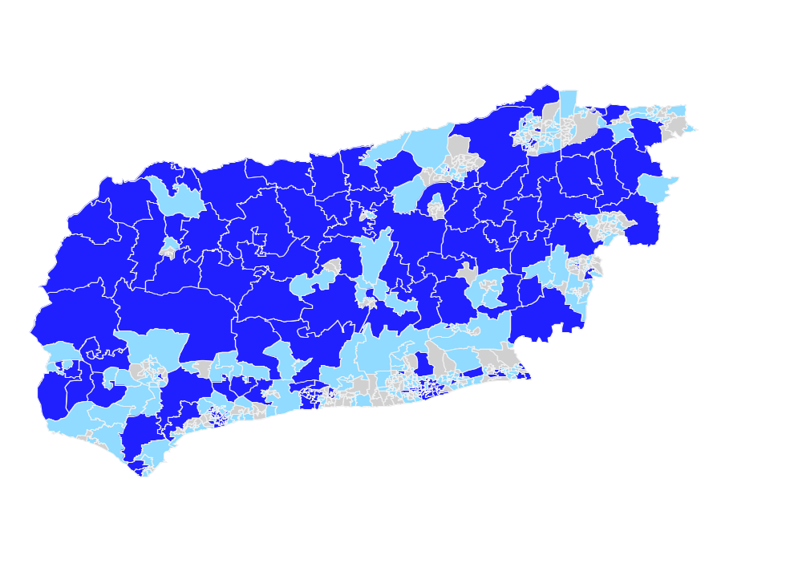
Figure 22 % of Households Estimated to be in Fuel Poverty
(Source : Centre for Sustainable Energy)

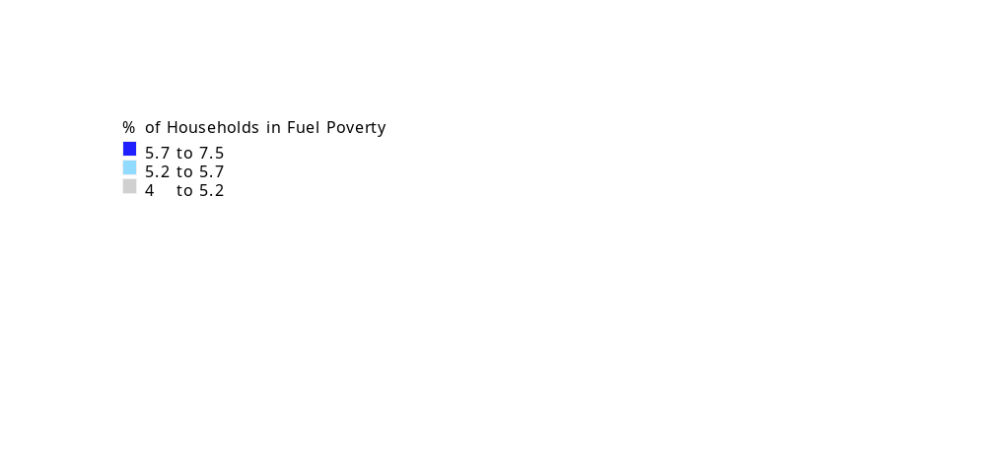

FUEL POVERTY AND OLDER PEOPLE

In the winter of 2005/6 NHS West Sussex and West Sussex County Council carried out a survey of older people in West Sussex. The survey asked a range of questions relating to health and well being.

Two specific questions relating to winter warmth were included:-

- Do you worry about keeping warm in your home in winter?
- Do you ever turn off your heating / fire in winter because it is too expensive?

This survey found that overall in West Sussex 17.5% of older people surveyed said they did worry about keeping warm in winter. 14.9% of respondents said they turned off heating due to expense. This shows that even with more energy efficient housing stock, and better access to mainstream gas, Crawley had significantly higher numbers of older people who said they were worried and turned off heating.

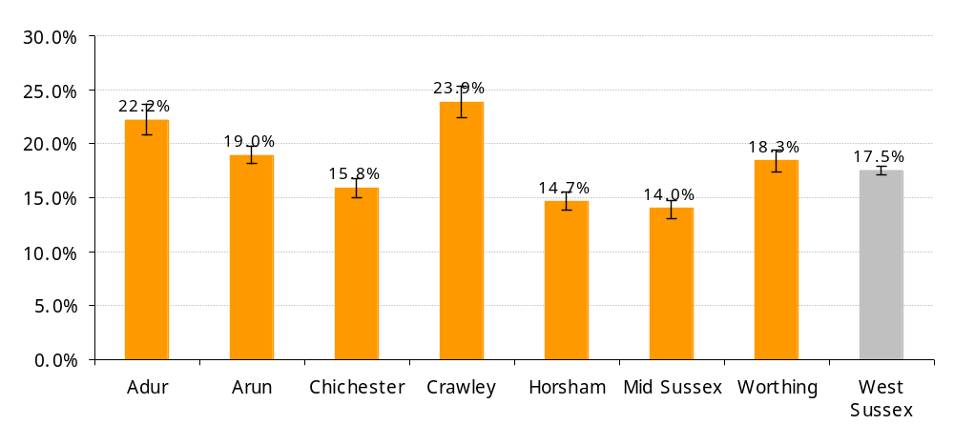
Figure 23 % Of Older People Who Said They Worried About Keeping Warm In Winter

Figure 24 % Of Older People Who Said They Turned Off Their Heating Due to Expense
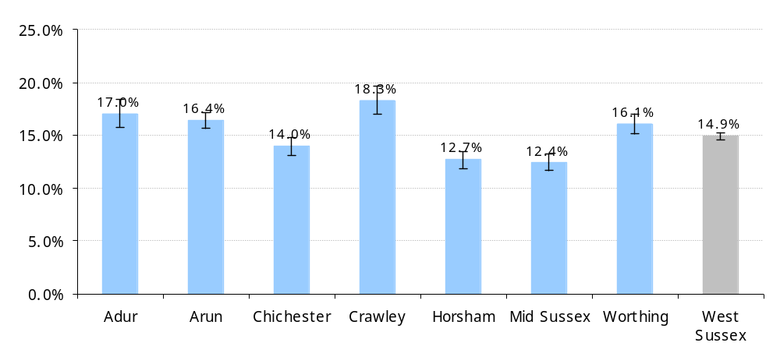

Cross referencing answers to questions on winter warmth with self-reported health, the survey results showed that older people with the worst health were twice as likely as those in good health to turn off their heating due to expense.

Of people who said their health was poor over 20% said they sometimes turned off their heating due to the expense, this was significantly higher than other respondents.

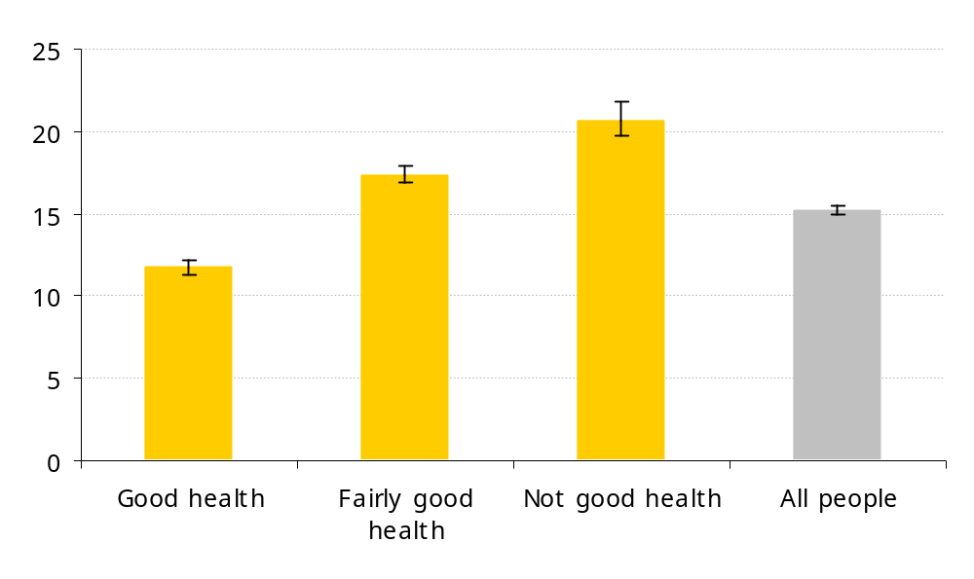
Figure 25 % of People (65 years+) Who Turn Off Heating Due to Cost by Health Status

Source : Lifestyle Survey of Older People (NHS West Sussex, West Sussex County Council 2006)

Energy Efficiency
Definition : Standard Assessment Procedure (SAP) rating

This is the primary measure used in England to measure the energy efficiency of homes, it takes into account factors such as property type, construction materials, insulation and the efficiency of heating systems. The SAP rating is out of 100, with very inefficient homes being rated 30 or below and very efficient homes 70+.

Energy Performance Certificate (EPC) bands are based on the SAP scores, ranging from a low grading (G) to a high performance (A) Current building regulations require a SAP rating of between 65 and 81 as a base-line.

SAP Rating | EPC Band | % of Households  (England)
81+ | A/B | 0.3%
69 – 80 | C | 10.0%
55 -68 | D | 35.4%
39 – 54 | E | 37.4%
21 – 38 | F | 13.4%
1 - 20 | G | 3.5%

By improving the energy efficiency of homes, households become more resilient to the fluctuations in fuel costs, it has been estimated that raising all properties to an energy efficiency rating to SAP 81 or above would lift 83% of households out of fuel poverty.
Energy Efficiency of Homes of Older People

A sample of energy efficiency surveys were sent out with the 2006 lifestyle survey of older people, this was done in part to collect data for a target agreed within the West Sussex Local Area Agreement. Older people aged between 65-68 years were sampled and Hestia Ltd analysed the efficiency forms to examine the SAP rating of homes. The average SAP rating from this sample was 56, this is higher than the latest available (2007) UK estimate average rating of 51, although, 10% of households sampled had very low SAP ratings of 30 or below.

TENURE

Overall West Sussex has a very high level of owner occupation, with over 76% of households (at the time of the last census in 2001) owner occupiers, this is far higher than the England average of approximately 69%.

There are clear differences within the county, Crawley having a high proportion of social renting. Chichester also had a lower owner occupation rate than the regional average.

Table 38 Tenure (Households)

 | Owns | Owns outright | Owns with a mortgage | Shared Owner. | Social Rent | Rent from a LA | Rent from social landlord | Rent - privately | Other
Adur | 20,320 | 9,640 | 10,600 | 80 | 3,560 | 2,830 | 730 | 1,320 | 670
Arun | 49,910 | 26,100 | 23,220 | 590 | 5,710 | 3,620 | 2,090 | 5,420 | 1,700
Chichester | 32,340 | 17,900 | 14,240 | 200 | 6,730 | 3,130 | 3,600 | 4,200 | 2,530
Crawley | 27,580 | 9,160 | 18,020 | 400 | 9,470 | 8,200 | 1,270 | 2,240 | 1,090
Horsham | 39,550 | 16,450 | 22,830 | 270 | 5,620 | 1,860 | 3,760 | 3,280 | 1,590
Mid Sussex | 41,710 | 17,620 | 23,700 | 390 | 5,280 | 270 | 5,010 | 3,520 | 1,470
Worthing | 33,990 | 16,260 | 17,540 | 190 | 4,300 | 1,320 | 2,980 | 4,860 | 970
West Sussex | 245,400 | 113,140 | 130,150 | 2,110 | 40,670 | 21,240 | 19,430 | 24,840 | 10,010
 | Owns | Owns outright | Owns with a mortgage | Shared Owner. | Social Rents | Rent from a LA | Rent from social landlord | Rent - privately | Other
Adur | 78.5% | 47.4% | 52.2% | 0.4% | 13.8% | 79.5% | 20.5% | 5.1% | 2.6%
Arun | 79.6% | 52.3% | 46.5% | 1.2% | 9.1% | 63.4% | 36.6% | 8.6% | 2.7%
Chichester | 70.6% | 55.3% | 44.0% | 0.6% | 14.7% | 46.5% | 53.5% | 9.2% | 5.5%
Crawley | 68.3% | 33.2% | 65.3% | 1.5% | 23.5% | 86.6% | 13.4% | 5.5% | 2.7%
Horsham | 79.0% | 41.6% | 57.7% | 0.7% | 11.2% | 33.1% | 66.9% | 6.6% | 3.2%
Mid Sussex | 80.3% | 42.2% | 56.8% | 0.9% | 10.2% | 5.1% | 94.9% | 6.8% | 2.8%
Worthing | 77.0% | 47.8% | 51.6% | 0.6% | 9.7% | 30.7% | 69.3% | 11.0% | 2.2%
West Sussex | 76.5% | 46.1% | 53.0% | 0.9% | 12.7% | 52.2% | 47.8% | 7.7% | 3.1%
SOUTH EAST | 74.0% | 42.3% | 56.7% | 1.1% | 14.0% | 52.7% | 47.3% | 8.8% | 3.3%
ENGLAND | 68.7% | 42.5% | 56.6% | 1.0% | 19.3% | 68.6% | 31.4% | 8.8% | 3.2%
Source : Census 2001

Tenure of Older People
Note this excludes people who live in residential care

Most older people in West Sussex live in “mainstream housing” and in West Sussex there is a high level of home ownership in the older age groups than regional and national figures. 83.7% of 65-74 year olds are owner occupiers, 78.1% of 75-84 year olds and 73.7% of 85+ year olds. There are however considerable differences across the county, Crawley having a far higher proportion of social renters than regional or national average. According to the 2001 census, in the 85+ age group over 42% were renting either from the council or a registered social landlord. Tables showing tenure in for Local Authority areas for these older age groups are shown overleaf.

Table 39 Tenure of People Aged 65-74 years

Local Authority | Owner Occupier | Rented from Council | Other Social Rented | Private Rented or Living Rent Free
Adur | 85.9% | 9.3% | 1.2% | 3.6%
Arun | 87.5% | 5.4% | 1.9% | 5.1%
Chichester | 79.6% | 5.8% | 7.3% | 7.3%
Crawley | 73.8% | 22.5% | 1.7% | 2.1%
Horsham | 83.8% | 3.0% | 8.3% | 4.9%
Mid Sussex | 86.6% | 0.5% | 9.0% | 3.9%
Worthing | 85.6% | 2.1% | 6.9% | 5.3%
West Sussex | 83.7% | 6.2% | 5.3% | 4.8%
SOUTH EAST | 81.1% | 7.8% | 6.1% | 5.0%
ENGLAND | 76.1% | 13.4% | 5.2% | 5.3%

Table 40 Tenure of People Aged 75-84 years

Local Authority | Owner Occupier | Rented from Council | Other Social Rented | Private Rented or Living Rent Free
Adur | 80.8% | 10.8% | 2.4% | 6.0%
Arun | 83.7% | 6.0% | 3.4% | 6.8%
Chichester | 75.7% | 6.9% | 8.8% | 8.7%
Crawley | 58.0% | 33.4% | 2.8% | 5.8%
Horsham | 75.7% | 4.7% | 12.6% | 7.0%
Mid Sussex | 79.4% | 0.7% | 13.8% | 6.1%
Worthing | 83.7% | 2.3% | 7.6% | 6.4%
West Sussex | 78.1% | 7.8% | 7.3% | 6.8%
SOUTH EAST | 74.1% | 10.2% | 8.7% | 7.0%
ENGLAND | 67.8% | 17.1% | 7.4% | 7.7%

Table 41 Tenure of People Aged 85 and Over

Local Authority | Owner Occupier | Rented from Council | Other Social Rented | Private Rented or Living Rent Free
Adur | 77.6% | 10.4% | 3.1% | 9.0%
Arun | 79.7% | 6.7% | 4.4% | 9.2%
Chichester | 72.5% | 5.4% | 9.6% | 12.4%
Crawley | 44.6% | 35.4% | 7.5% | 12.6%
Horsham | 68.0% | 4.8% | 16.2% | 11.0%
Mid Sussex | 70.8% | 0.6% | 19.5% | 9.1%
Worthing | 81.0% | 2.2% | 8.7% | 8.1%
West Sussex | 73.7% | 6.8% | 9.5% | 9.9%
SOUTH EAST | 68.3% | 10.4% | 10.9% | 10.3%
ENGLAND | 61.4% | 17.5% | 9.6% | 11.4%

“ACCESS TO TENURES”
Home Ownership – Getting a Foot on the Ladder

In the past mortgage lenders have allowed people to borrow a mortgage to the value of three times their income; so a person with an income of £20,000 could hope for a mortgage of £60,000. By considering the relationship between earnings and house prices at a local level, it is possible to assess the ability of people to get on the housing ladder. In terms of people buying their first home, it is important not to use the average in relation to house prices and incomes; the average is skewed by some very expensive properties and high earners. Lower quartile house prices as a ratio of lower quartile earnings provide a better indication of people getting their foot on the housing ladder. Table 42 below shows the ratio in West Sussex local authority areas over the last 10 years.

In 2009, lower quartile house prices were 8.6 times higher than lower quartile earnings across West Sussex as a whole. Although the ratio has come down in recent years, ownership still remains outside the 3:1 ratio standard used by mortgage providers. No area in West Sussex has a ratio less than 7. Of particular note is Chichester, with a ratio of 10 in 2009; using this indicator, this was the 4th least affordable area in the South East region, and less affordable than many London boroughs including Islington, Barnet and Ealing.

Table 42 House Prices and Ratio of Earnings to House Prices (Lower Quartile)
Lower Quartile House Prices (annual)
 | 2001 | 2002 | 2003 | 2004 | 2005 | 2006 | 2007 | 2008 | 2009
Adur | 89,950 | 108,500 | 129,000 | 145,000 | 155,000 | 162,838 | 179,950 | 170,000 | 154,988
Arun | 80,000 | 97,000 | 121,000 | 134,950 | 139,000 | 147,963 | 163,750 | 154,000 | 150,000
Chichester | 105,000 | 126,000 | 155,500 | 175,000 | 179,238 | 188,500 | 200,000 | 195,000 | 175,000
Crawley | 88,500 | 105,000 | 124,313 | 136,000 | 143,000 | 153,000 | 165,000 | 170,000 | 151,000
Horsham | 112,500 | 132,000 | 155,000 | 167,750 | 175,000 | 182,575 | 197,000 | 192,650 | 179,375
Mid Sussex | 112,000 | 128,950 | 152,000 | 167,500 | 173,000 | 180,000 | 195,000 | 195,000 | 180,000
Worthing | 74,659 | 91,500 | 115,000 | 126,000 | 128,500 | 138,000 | 150,000 | 145,000 | 139,950
West Sussex | 90,000 | 111,000 | 131,000 | 146,000 | 152,500 | 160,000 | 175,000 | 170,000 | 160,000
South East | 88,000 | 109,000 | 127,000 | 140,000 | 147,500 | 155,000 | 165,000 | 162,000 | 155,000
England | 59,950 | 70,000 | 85,000 | 105,000 | 115,000 | 122,000 | 127,000 | 124,000 | 123,000
Ratio Lower Quartile House Prices to Lower Quartile earnings
 | 2001 | 2002 | 2003 | 2004 | 2005 | 2006 | 2007 | 2008 | 2009
Adur | 7.5 | 7.1 | 7.7 | 9.1 | 9.4 | 10.7 | 9.9 | 10.3 | 8.7
Arun | 7.1 | 7.5 | 8.6 | 9.1 | 10.2 | 10.3 | 9.8 | 10.5 | 9.0
Chichester | 8.1 | 9.5 | 11.1 | 11.1 | 12.7 | 11.8 | 12.9 | 12.4 | 10.0
Crawley | 5.5 | 6.6 | 6.8 | 7.7 | 7.9 | 8.5 | 9.1 | 9.0 | 7.5
Horsham | 7.3 | 8.2 | 8.9 | 9.3 | 10.1 | 10.3 | 11.3 | 11.3 | 9.3
Mid Sussex | 7.2 | 8.6 | 9.4 | 10.4 | 10.3 | 10.6 | 11.4 | 10.4 | 9.8
Worthing | 5.8 | 6.4 | 8.0 | 8.5 | 8.9 | 9.3 | 9.3 | 9.4 | 7.8
West Sussex | 6.2 | 7.5 | 8.2 | 9.0 | 9.6 | 10.1 | 10.5 | 10.3 | 8.6
South East | 5.8 | 6.9 | 7.5 | 8.1 | 8.6 | 8.6 | 8.9 | 8.8 | 7.7
England | 4.2 | 4.7 | 5.2 | 6.3 | 6.8 | 7.2 | 7.3 | 7.0 | 6.3
Source: DCLG (Land Registry House Prices) ASHE (Earnings)
Note : as the number of housing transactions reduce, the volatility of the data below regional level increases.
Age and Home Ownership

From national figures, it is clear that while the average age of the first time buyer has not changed substantially over the last 10 years the percentage of first time buyers aged under 25 years has fallen significantly; 30% of first time buyers in 1990 were under 25, in 2010 that had fallen to less than 14%.

Figure 26 Average Age of First Time Buyer
and Percentage of First Time Buyers Aged Under 25 Years
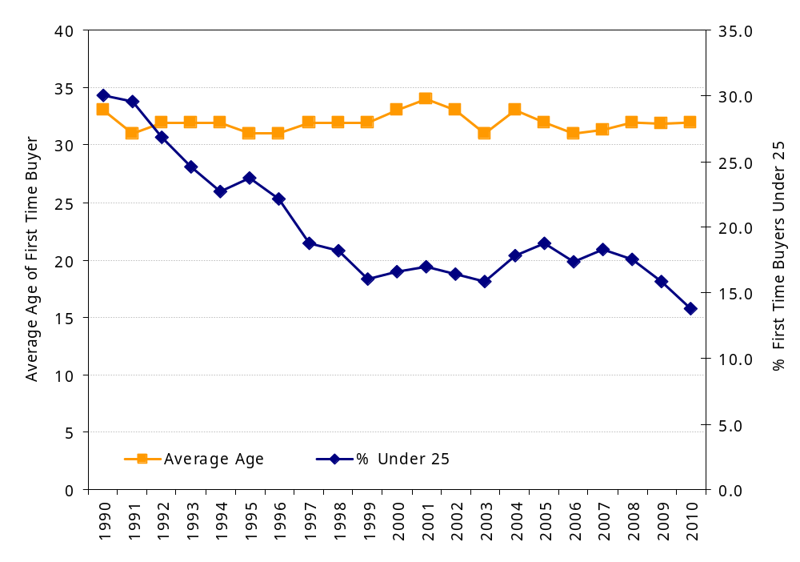
(National Data)

Source : DCLG

While the ratio of prices against earnings remains well above 3, the level of deposit by mortgage lenders has risen in the last 2 years to over 27%.

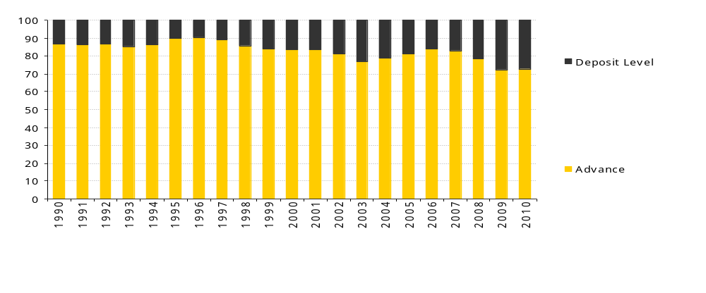
Figure 27 Level of Advance By Mortgage Lenders to First Time Buyers

Source : DCLG
Mortgage Possession Orders
– Local Authority Level 2000 to 2010 (full year data)

Information from the Ministry of Justice shows the number of possession orders served, broken down by local authority areas.

This is shown on Table 46 below for the last 10 years. Figure 28 shows the rate per 1,000 households.

There was a rise in possession awards between 2004 and 2008 but this has fallen back down. Crawley has the highest rate per 1,000 households in West Sussex and is the only area in west Sussex where the rate is higher than the England rate.

Table 43 Mortgage Possession Orders
Rounded to nearest 5

Local Authority | 2000 | 2001 | 2002 | 2003 | 2004 | 2005 | 2006 | 2007 | 2008 | 2009 | 2010
Adur | 80 | 50 | 65 | 70 | 85 | 135 | 125 | 105 | 145 | 105 | 70
Arun | 200 | 165 | 155 | 160 | 225 | 300 | 265 | 285 | 310 | 240 | 145
Chichester | 70 | 60 | 70 | 60 | 70 | 120 | 125 | 150 | 155 | 95 | 70
Crawley | 125 | 115 | 120 | 145 | 150 | 245 | 265 | 235 | 235 | 165 | 150
Horsham | 80 | 80 | 75 | 105 | 115 | 195 | 155 | 140 | 155 | 120 | 100
Mid Sussex | 80 | 80 | 95 | 80 | 110 | 165 | 210 | 155 | 160 | 125 | 105
Worthing | 120 | 120 | 130 | 105 | 130 | 210 | 210 | 200 | 220 | 145 | 125
Source : Ministry of Justice

Figure 28 Possession Orders Per 1,000 Households 2000-2010
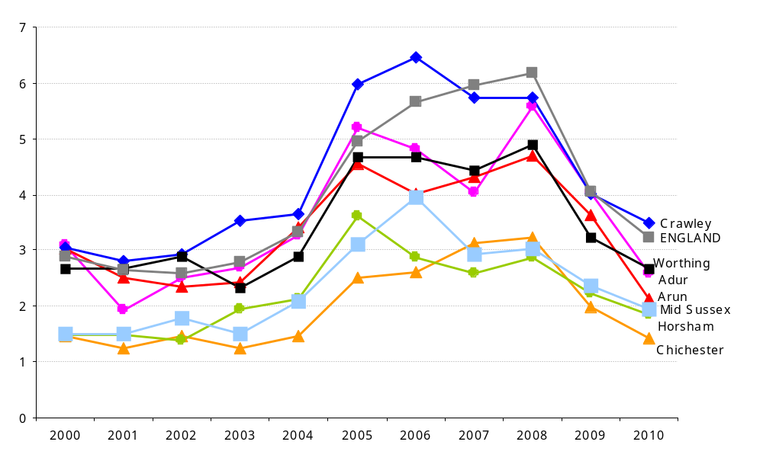

SOCIAL HOUSING - HOUSING WAITING LISTS

Almost 20,000 households are on social housing waiting lists in West Sussex.

The number has risen considerably in recent years; this, in part, reflects changes to the operation of housing lists. Provisional data for 2010 have been released by DCLG – these state that approximately 19,500 households are on social housing waiting lists.

Table 44 Waiting Lists for Social Housing

 | 2004 | 2005 | 2006 | 2007 | 2008 | 2009 | % change over 2004-2009
Adur | 1,551 | 1,888 | 1,711 | 1,520 | 1,548 | 1,681 | 8.4%
Arun | 1,385 | 2,309 | 2,389 | 3,882 | 3,318 | 3,566 | 157.5%
Chichester | 2,280 | 2,126 | 2,762 | 2,678 | 3,779 | 5,922 | 159.7%
Crawley | 2,250 | 2,208 | 2,562 | 2,445 | 2,599 | 2,459 | 9.3%
Horsham | 1,424 | 1,437 | 1,504 | 1,413 | 1,204 | 1,067 | -25.1%
Mid Sussex | 2,027 | 2,121 | 2,113 | 2,176 | 2,313 | 2,513 | 24.0%
Worthing | 1,648 | 2,216 | 2,662 | 2,361 | 2,465 | 2,532 | 53.6%
West Sussex | 12,565 | 14,305 | 15,703 | 16,475 | 17,226 | 19,740 | 57.1%

Source : DCLG

Figure 29 Numbers of Households on Social Housing Waiting Lists
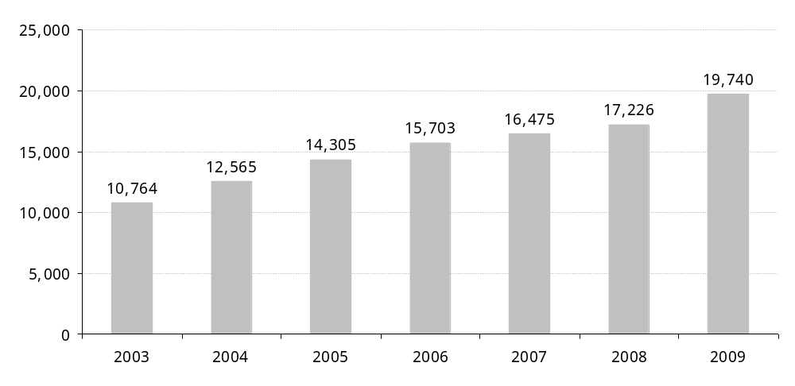

In 2009 there were almost 20,000 households on waiting lists for social housing, to accommodate this waiting list would require a 45% increase of social rented housing across the county (see Table 45 overleaf).

Table 45 Waiting Lists for Social Housing

 | 2003 | 2004 | 2005 | 2006 | 2007 | 2008 | 2009
Adur | 34.9% | 43.4% | 53.3% | 48.4% | 43.2% | 44.4% | 48.2%
Arun | 15.5% | 23.6% | 39.5% | 39.8% | 66.8% | 56.3% | 59.4%
Chichester | 30.4% | 32.2% | 29.4% | 38.2% | 36.7% | 51.5% | 79.2%
Crawley | 19.2% | 22.8% | 22.1% | 25.6% | 24.8% | 26.4% | 24.5%
Horsham | 24.1% | 23.4% | 23.2% | 23.8% | 22.4% | 19.0% | 16.8%
Mid Sussex | 25.4% | 34.6% | 36.2% | 35.2% | 38.0% | 40.9% | 41.4%
Worthing | 35.4% | 37.6% | 49.7% | 60.6% | 53.7% | 55.5% | 56.5%
West Sussex | 25.1% | 30.0% | 33.2% | 36.1% | 38.4% | 40.1% | 45.0%
Source : DCLG

This graph shows the waiting list as a percentage if the total social housing stock (RSL and LA) in each local authority area in West Sussex since 2003. Overall across West Sussex (the West Sussex line is shaded light blue), there has been a steady increase , of note is the considerable increase in the Chichester area, in 2009, the number of households on the waiting list was almost 80% of the total social stock.

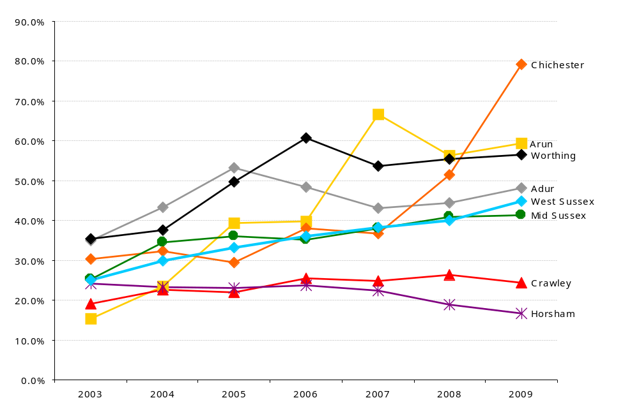
Figure 30 Waiting List as a Percentage of the Total Social Housing Stock (2003-2009)

PRIVATE RENTED ACCOMMODATION
Affordability

As part of the work undertaken for local Housing Needs Surveys in 2003 and 2004, research was undertaken to assess the level of income required to rent in the private rented sector in West Sussex. This research consisted of work with local estate agents to identify the level of income required to access “entry-level” properties. Table 49 below shows that entry level required an income of between £17,800 to over £25,000, these data relate to 2003/4.

Table 46 Private Rental Income Thresholds
(based on rent at 25% gross income, 30% net income)

 | 1 Bed Flat | 2 Bed Flat | 2 Bed Terrace
Adur* | 23,000 | 27,400 | 30,000
Arun | 17,800 | 22,800 | 27,000
Chichester | 20,900 | 25,500 | 27,000
Crawley | 25,500 | 29,800 | 31,500
Horsham* | 26,100 | 30,700 | 33,700
Mid Sussex | 23,800 | 28,000 | 33,400
Worthing | 20,600 | 25,100 | 28,700
* 2005 update information used.
Source : Housing Needs Surveys (DCA)

Housing Benefit

In February 2011, over 47,000 people received Housing Benefit in West Sussex, compared with fewer than 40,000 in November 2008; of the 47,000 approximately 29,000 people on Housing Benefit lived in the social rented sector and 18,400 were private rented sector tenants.

Figure 31 People in Receipt of Housing Benefit – West Sussex
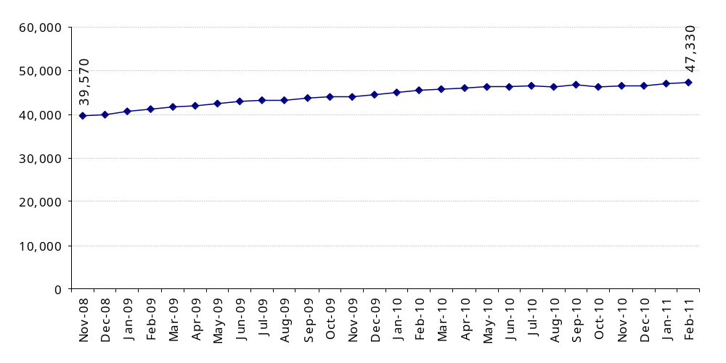

(Source : DWP)

Recent data published by the DWP show at local authority level on-flow and off-flow data. Figure below shows monthly figures from November 2008 to February 2011. The graph shows for only two periods (July-Aug 2010 and Sept-Oct 2010) were out- flows higher than on-flows, i.e. periods where there was a net fall in the total number of people in receipt of Housing Benefit.

Figure 32 Housing Benefit On and Off Flow Data

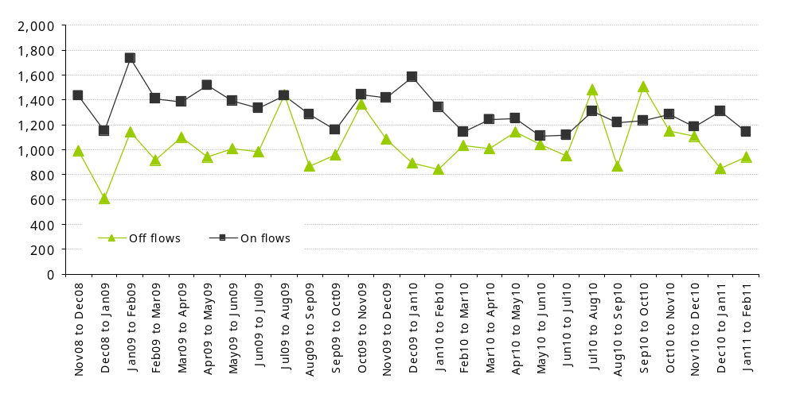

Source : DWP
Changes in Operation of Housing Benefit

In 2008 changes were introduced to the way Housing Benefit was calculated for people living in private rental accommodation. The Local Housing Allowance (LHA) was introduced. LHA rates set as the maximum amount of benefit that is paid in different local rental markets.

Up until April 2011 LHAs were set at the median of a sample of rents in a local area; an area defined as a broad market rental area.
Definition : Broad Market Rental Area (BMRA)

The BRMA is a geographical area used to determine the LHA rate.

It is an area where a person could reasonably be expected to live taking into account access to facilities and services for the purposes of health, education, recreation, personal banking and shopping.

The boundaries of a BRMA do not have to match the boundaries of a Local Authority and BMRAs will often fall across more than one Local Authority area. For West Sussex there are four relevant BMRAs, Crawley and Reigate, Chichester, Worthing and Brighton and Hove. LHA rates are regularly reviewed, the January 2011 rates are shown below

Table 47 Weekly LHA Levels of Broad Rental Market Areas

BRMA Area  LHA Rates (Jan 2011) | Shared | 1 Bedroom | 2 Bedroom | 3 Bedroom | 4 Bedroom | 5 Bedroom
Brighton and Hove | £84.46 | £150.00 | £196.15 | £253.85 | £333.31 | £424.62
Chichester | £71.54 | £134.43 | £167.31 | £206.54 | £286.15 | £392.31
Crawley & Reigate | £80.81 | £138.46 | £178.85 | £219.23 | £334.62 | £432.69
Worthing | £70.00 | £121.15 | £155.77 | £190.38 | £260.00 | £324.92

A new nationwide upper limit was introduced in April 2011:-

- 1 bed - £250
- 2 bed - £290
- 3 bed - £340
- 4 bed - £400

Changes Introduced by the Coalition Government

Considerable change has been planned / introduced to the welfare and housing benefit system.

A summary of changes is provided in Appendix 4

Changes will affect new and existing claimants; change is introduced for existing clients either following a change in circumstance, or move, or on the claim “anniversary”.
Numerous national and local studies have been undertaken to assess the possible impact of the changes:-

- National research undertaken by DWP,
- Local authorities’ projections
- Work undertaken by Shelter and the Chartered Institute of Housing

The work that has been undertaken to assess the potential impact of housing benefit (and wider benefit) change is based on the existing circumstances. Clearly, such large scale changes may alter some of the factors which have been used in the projections, for example rents may adjust downwards. All the analysis quoted should therefore be treated cautiously.

(i) Impacts of Housing Benefit proposals: Changes to the Local Housing Allowance to be introduced in 2011-12 (DWP 2010).The Department for Work and Pensions has modelled the impact of specific changes; a report was published in July 2010. The analysis was based on data available as of March 2010.

DWP assessed the number of people who would be affected by the changes introduced last year, and the 2011/12 change. DWP estimated the number of recipients who would be affected and their average weekly loss. For recipients in West Sussex, average loss was estimated from £7 per week to £37 per week.

Table 48 Estimated Average Reduction in Weekly Housing Benefit Following Changes Post April 2011 by District / Boroughs in West Sussex
- estimated level of loss in terms of £s per week

Estimated average loss per loser or notional loser, £ per week | Shared room | 1-bed | 2-bed | 3-bed | 4-bed | 5-bed
Adur | -7 | -10 | -14 | -14 | -17 | -
Arun | - | -9 | -11 | -12 | -17 | -24
Chichester | - | -10 | -12 | -15 | -17 | -37
Crawley | - | -11 | -9 | -16 | -17 | -30
Horsham | -10 | -8 | -10 | -16 | -18 | -
Mid Sussex | -10 | -7 | -9 | -16 | -18 | -
Worthing | -8 | -8 | -11 | -11 | -17 | -33

(ii) Local impact analysis has looked at longer-term issues, examining the effect of pegging the LHA rate to the 30th percentile and the use of CPI, and not RPI, to raise LHA in future years.

Work undertaken by Mid Sussex District Council projects that these measures will widen the gap between markets rents and LHA rates, they examined: -

- The relationship between the new LHA rents and market rents
- The relationship between actual rents and the universal credit caps

Their analysis projects a growing shortfall between LHA rates and market rents, shown on Figure 33 below. This shows that for larger properties the gap will widen considerably over the longer term, this will mean that Housing Benefit claimants will have a reduced access to private rental properties.

Figure 33 LHA Set By CPI and Relating to 30th Percentile Open Market Rents
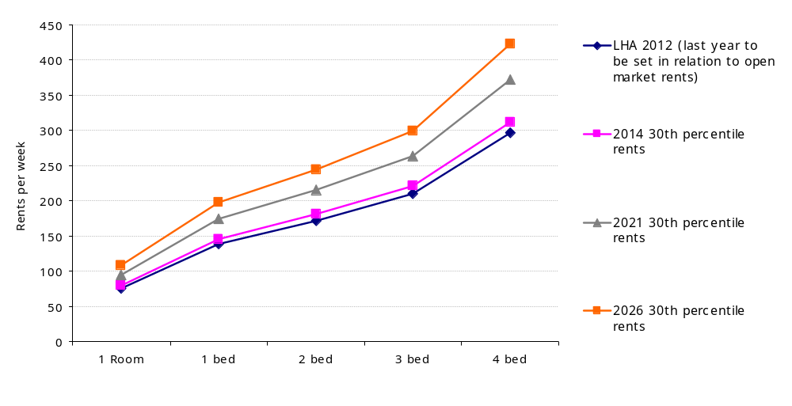

(iii) Neighbourhood Affordability.

Shelter, in conjunction with the Chartered Institute of Housing, examined five case-study areas in the UK, to assess affordability at small area level and consider what the changes might mean to local rental markets.

One of the case study areas was Brighton and Hove market rental area, this includes part of Adur District. The analysis identified areas in relation to whether they were or were likely to become “fairly unaffordable” or “very unaffordable” for people requiring 2 bedroom properties.

- Very unaffordable - areas where less than 10% of rental properties have rent at or below the maximum LHA rate.
- Fairly unaffordable - areas where less than 20% of rental properties have rent at or below the maximum LHA rate.

Of the rental area the analysis found that some of the area was already unaffordable. In the long-term, a switch to CPI, would leave only the rural north-western part of the BRMA, and the eastern coastal neighbourhoods affordable for families claiming Local Housing Allowance.

Note this does assume continuing increases in private rents.

Neighbourhood | Year becomes ‘fairly unaffordable’ | Year becomes ‘very  unaffordable’
Brighton city centre | Fairly unaffordable before CPI change 2013 | 2015
Hove | Fairly unaffordable before CPI change 2013 | 2019
East Brighton (Kemp town, Hanover, Marina) | 2015 | 2023
West Hove, Shoreham, Portslade | 2023 | 2027
Outer Brighton (Withdean, Preston) | 2023 | 2030
Lewes, Downs/rural | 2030 | Post 2030
East Coastal (Newhaven,  Peacehaven, Rottingdean) | Post 2030 | Post 2030

What the analysis highlighted that areas of high employment, central, accessible locations would be very unaffordable relatively quickly.
HOMELESSNESS
Statutory Figures

In relation to people statutorily homeless (accepted by the Local Authority as unintentionally homeless and in priority need), figures have fallen dramatically over the last ten years, from over 1,300 in 2002/3 to fewer than 400 in 2009/10. This reflects, in part, a greater emphasis authorities have placed on prevention.

Table 49 Total Numbers Accepted As Being Homeless And In Priority Need

 | 2002  /03 | 2003  /04 | 2004  /05 | 2005  06 | 2006  /07 | 2007  /08 | 2008  /09 | 2009  /10 | 2010  /11
Adur | 130 | 113 | 141 | 153 | 98 | 71 | 68 | 71 | 90
Arun | 178 | 183 | 148 | 112 | 105 | 59 | 87 | 52 | 79
Chichester | 128 | 36 | 62 | 82 | 81 | 53 | 65 | 44 | 47
Crawley | 282 | 184 | 250 | 163 | 82 | 105 | 67 | 83 | 130
Horsham | 171 | 140 | 130 | 92 | 72 | 57 | 81 | 91 | 125
Mid Sussex | 264 | 120 | 89 | 58 | 65 | 40 | 26 | 32 | 46
Worthing | 170 | 121 | 110 | 124 | 101 | 72 | 32 | 17 | 20
West Sussex | 1,323 | 897 | 930 | 784 | 604 | 457 | 426 | 390 | 537
South East | 14,630 | 15,290 | 12,420 | 9,330 | 6,660 | 5,510 | 4,730 | 3,870 | 4,520
England | 129,700 | 137,000 | 120,860 | 93,980 | 73,360 | 63,170 | 53,430 | 40,020 | 44,160

Looking at more recent figures, the number of people accepted as homeless has risen in 2010/2011, in the period October 2010 to December 2010 there were 145 acceptances in West Sussex.

Figure 34 Homeless Acceptances Quarter by Quarter Data – West Sussex Overall
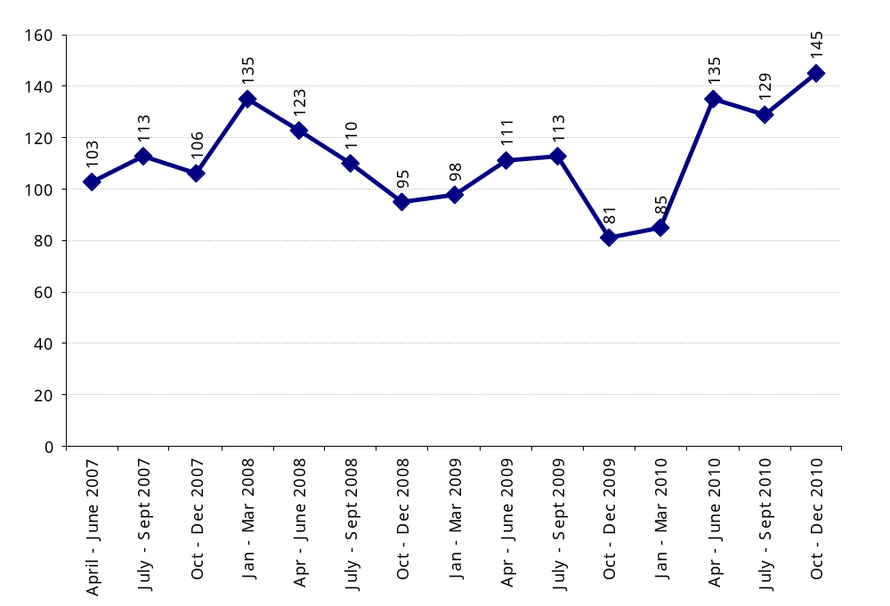
2007/8 to 3rd Quarter of 2010/11

Fig 35 shows the number of homeless households (accepted as homeless and in priority need) per 1,000 households at local authority level. The rate across England as w hole is 2.2 per 1,000 households. Birmingham has the highest rate of homeless acceptances per 1,000 households at 10.4. In West Sussex, for the financial year 2010/2011, Adur, Crawley and Horsham all had rates higher than the national rate.

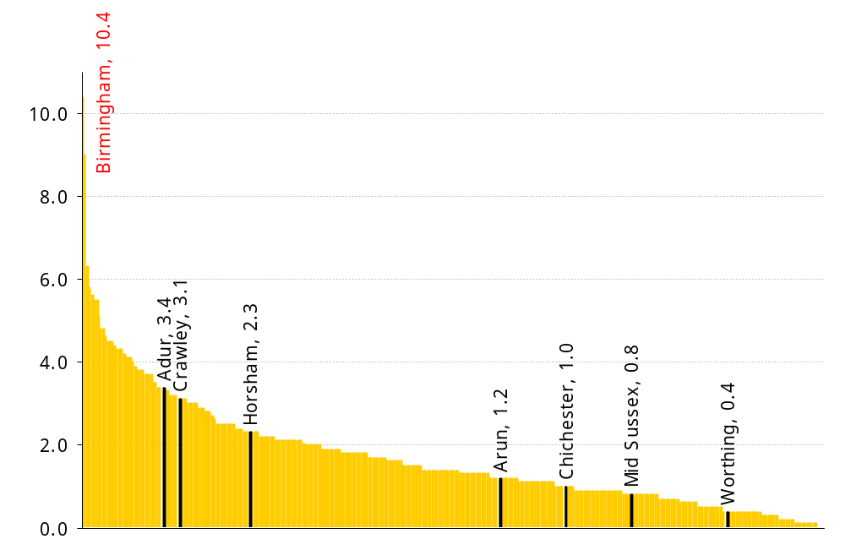
Fig 35 Homeless Households Per 1,000 Households (2010/2011)

Source : DCLG

Temporary Accommodation

Figure 34 below shows that, from the 3rd quarter of 2009/10 onwards, there has been a rise in the number of households in temporary accommodation in West Sussex, after a long period of reducing numbers.

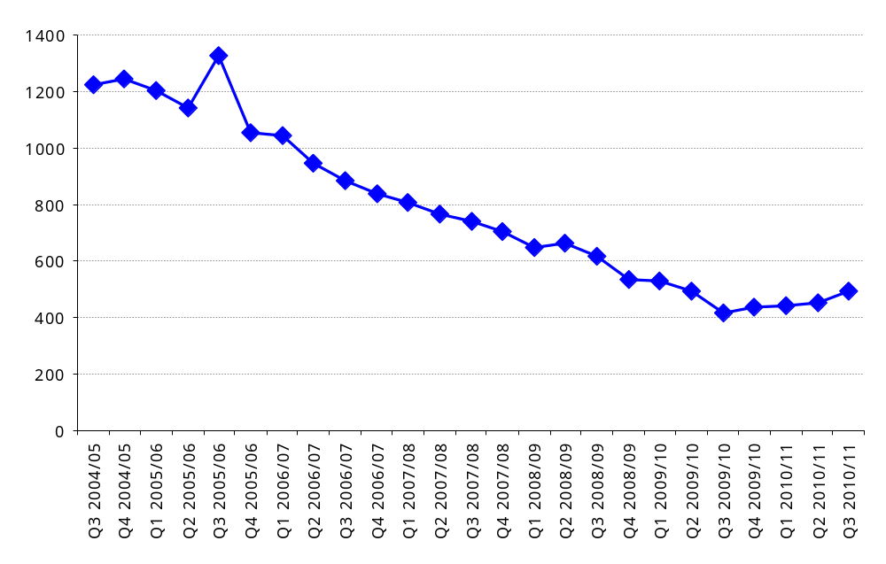
Figure 36 Households in Temporary Accommodation - West Sussex Overall

Prevention of Homelessness

Local authorities in recent years have placed a great emphasis on the prevention of homelessness.

Data relating to the prevention and relief of homelessness are now collected, this includes people being supported to stay in their existing homes or being supported to find alternative accommodation. Homelessness relief refers to situations where local authorities are unable to prevent homeless but have helped people to find other accommodation.

Table 54 below shows the number of people either preventing from becoming homeless, this shows that within West Sussex almost 2,000 households were supported.

Table 50 Prevention and Relief of Homelessness 2009/10 (DCLG)

 | Number of cases where positive action was successful in preventing homelessness of which household |  |  | Number of cases where positive action was successful in relieving homelessness | Total cases of prevention and relief
 | Able to remain in existing home | Assisted to obtain alternative accommodation | Total |  | Total cases of prevention and relief
Adur | 41 | 79 | 120 | 17 | 137
Arun | 555 | 0 | 555 | 152 | 707
Chichester | 54 | 96 | 150 | 0 | 150
Crawley | 37 | 106 | 143 | 0 | 143
Horsham | 144 | 116 | 260 | 25 | 285
Mid Sussex | 103 | 163 | 266 | 77 | 343
Worthing | 4 | 179 | 183 | 1 | 184

YOUTH HOMELESSNESS

Locally, a data collection exercise was undertaken to establish the levels of approaches to local authority housing departments by young people.

This information is shown in the table overleaf.
Not all local authorities could provide all the data requested, for all age groups.

Table 51 Prevention of Homelessness

2008/9
 | Approaches |  | Homelessness Applications |  |  | Accepted
 | Age Group 16/17 | Age Group 18-25 | Age Group 16/17 |  | Age Group 18-25 | Age Group 16/17 | Age Group 18-25 | 18-20 formerly in care
Adur | 32 |  |  |  | 12 | 2 |  | 0
Arun | 116 | 386 | 9 |  |  | 5 | 37 | 1
Chichester | - | - | - |  | - | 1 | 10 | 0
Crawley | 128 | 185 | 21 |  | 90 | 9 | 8 | 1
Horsham | 123 |  | 56 |  |  | 1 | 0 | 1
Mid Sussex | 87 | 296 | 8 | 23 |  | 2 | 11 | 1
Worthing | 140 | 700 | 0 | 14 |  | 0 | 0 | 1

Background and Risk Factors for Youth Homelessness

In 2007/8 DCLG published the results of a large scale survey into the background and experience of young people (16-17 year olds) and families who were accepted as statutorily homeless.

Statutory Homelessness in England: The experiences of families and 16-17 year olds (DCLG 2008)

Key findings relating to the backgrounds of 16-17 year olds, who were accepted as statutorily homeless were:-

- Many of the young people surveys had experienced violence at home and other forms of childhood trauma.

- Many of the young people had severe disruption to the education and 57% of the young people surveyed were NEET.

- Drug and alcohol misuse problems were common, 37% in the DCLG survey had existing, or previous, substance misuse problems.

- Over 50% had experienced depression, anxiety or other mental health problems; and 33% had current mental health problems (a rate approximately three times that of young people in the general population).
Perhaps not surprisingly many of the respondents were living on very low incomes with 35% per cent reported difficulties managing financially.

SUPPORTED HOUSING NEEDS

“The primary purpose of housing-related support is to develop and sustain an individual’s capacity to live independently in their accommodation…..a range of services and activities can be tailored to an individual’s specific needs.”

DCLG – Creating Sustainable Communities : Supporting Independence (2005)

Housing Related Support

There is no prescribed list of what constitutes “housing related support”, as many types of support and services may be used to help people living independently, examples include:-

- support to people to pay bills, manage finances
- assisting people develop life skills, cooking cleaning etc
- supporting people maximise income to maintain their home
- facilitate contact with other agencies

Broadly support can be:

- Accommodation based – supported housing provision ranging from self contained accommodation (for example extra care housing) to supported living schemes which may share communal living spaces to homeless hostels.

- Floating support – crudely this is support linked to the individual rather than the housing, for example supporting someone manage a tenancy.

- Housing adaptations – this can range from large capital projects, to basic physical aids, and assistance technology to improving insulation.

In developing the Supporting People programme, DCLG defined people requiring support into three broad groups:-

- People Who Need Support To Live Independently

This group may not need on-going care services but require support/assistance to maintain independence within their own accommodation. This will include people who need short term (perhaps as part of recovering from an illness) but also those requiring longer term provision. It includes older people with lower level support needs, people with moderate physical sensory disabilities.

- People In Receipt Of Care With Support

This group may need care from social and/or health services and many will also require housing related support to maintain their independence and quality of life. Some people in this group may already be living in supported or adapted housing in the community. The group includes the frail elderly, people with long term illness, severe physical or sensory problems and some people with learning disabilities.

- People at Risk of Social Exclusion

This covers a broad range of people, from people who may have a chaotic lifestyle, be experiencing a short term crisis, or for a period require support to obtain and sustain housing, with a view to becoming independent after a relatively short period (up to 2 years). This includes a broad range of client groups, many overlapping, including teenage parents, young people leaving care, people affected by domestic violence, homeless people and families, older people, people with substance misuse problems.

Clearly individuals do not necessarily fall into just one client group and people’s circumstances and conditions change; within each group the spectrum of needs may be very different for individuals.

HEALTH AND SOCIAL CARE NEEDS – ESTIMATING NUMBERS

- People Who Need Support To Live Independently
- People In Receipt Of Care With Support

The Department of Health and the Institute of Public Care have provided models which bring together researched prevalence assumptions. The model relating to older people is called POPPI (Projection Older People Population Information). There is a separate model for working-age adults called PANSI (Projecting Adult Needs and Service Information System).

In relation to working-age adults, it is estimated that currently approximately 38,000 adults have a “moderate” physical disability and 11,700 having a “severe” physical disability.
The definitions of “moderate” or “severe” are taken from the Health Survey for England, which adapted World Health Organisation classifications relating to various impairments, disabilities and handicaps; the survey grouped questions into five groups of physical and sensory disability.:-
- Locomotor (walking and using stairs)
- Seeing
- Hearing
- Communication
- Personal care (activities of daily living including getting in and out of bed or a chair, dressing, washing, feeding and toileting).
Table 52 Predicted Number of WORKING-AGE ADULTS with a Moderate to Serious Physical Disability - West Sussex 2009 to 2026

People aged 18-64 predicted to have a moderate or serious physical disability, projected to 2026.
All figures rounded to nearest 5
 | Age Group | Prevalence assumption | 2011 | 2016 | 2021 | 2026 | Current  MYE 2009
Moderate | 18-24 | 4.1% | 2,680 | 2,995 | 2,810 | 2,670 | 2,345
Moderate | 25-34 | 4.2% | 3,425 | 4,055 | 4,745 | 4,530 | 3,495
Moderate | 35-44 | 5.6% | 5,770 | 5,115 | 5,035 | 5,610 | 6,305
Moderate | 45-54 | 9.7% | 11,125 | 11,670 | 10,340 | 8,875 | 10,730
Moderate | 55-64 | 14.9% | 15,155 | 15,200 | 17,000 | 17,450 | 15,405
Moderate | Total |  | 38,155 | 39,035 | 39,930 | 39,135 | 38,280
 | Age Group | Prevalence assumption | 2011 | 2016 | 2021 | 2026 | Current  MYE 2009
Severe | 18-24 | 0.8% | 525 | 585 | 550 | 520 | 455
Severe | 25-34 | 0.4% | 325 | 385 | 450 | 430 | 335
Severe | 35-44 | 1.7% | 1,750 | 1,550 | 1,530 | 1,705 | 1,915
Severe | 45-54 | 2.7% | 3,095 | 3,250 | 2,880 | 2,470 | 2,985
Severe | 55-64 | 5.8% | 5,900 | 5,915 | 6,620 | 6,790 | 5,995
Severe | Total |  | 11,595 | 11,685 | 12,030 | 11,915 | 11,685

Again the PANSI prevalence model is based on data collected from the Health Survey for England and relates to people requiring personal care including:-

- getting in and out of bed
- getting in and out of a chair
- dressing
- washing
- feeding
- use of the toilet

A moderate personal care disability means the task can be performed with some difficulty; a severe personal care disability means that the task requires someone else to help.
It is estimated that currently 19,300 have a moderate level need for personal care; 4,200 having a severe need.

Table 53 Predicted Number of WORKING-AGE ADULTS with Personal Care Needs
West Sussex 2009 - 2026

People aged 18-64 predicted to have a moderate or serious personal care disability, projected to 2026
All figures rounded to nearest 5
 | Age Group | Prevalence assumptions | 2011 | 2016 | 2021 | 2026 | Current  MYE 2009
Moderate | 18-24 | 0.6% | 390 | 440 | 410 | 390 | 345
Moderate | 25-34 | 1.4% | 1,140 | 1,350 | 1,580 | 1,510 | 1,165
Moderate | 35-44 | 2.9% | 2,985 | 2,650 | 2,605 | 2,905 | 3,265
Moderate | 45-54 | 4.9% | 5,620 | 5,895 | 5,225 | 4,485 | 5,420
Moderate | 55-64 | 8.8% | 8,950 | 8,975 | 10,040 | 10,305 | 9,100
Moderate | Total |  | 19,085 | 19,310 | 19,860 | 19,595 | 19,295
 | Age Group | Prevalence assumptions | 2011 | 2016 | 2021 | 2026 | Current  MYE 2009
Severe | 18-24 | 0.4% | 260 | 290 | 275 | 260 | 230
Severe | 25-34 | 0.4% | 325 | 385 | 450 | 430 | 335
Severe | 35-44 | 0.6% | 620 | 550 | 540 | 600 | 675
Severe | 45-54 | 1.1% | 1,260 | 1,325 | 1,175 | 1,005 | 1,215
Severe | 55-64 | 1.7% | 1,730 | 1,735 | 1,940 | 1,990 | 1,760
Severe | Total |  | 4,195 | 4,285 | 4,380 | 4,285 | 4,215

Sources : Prevalence assumptions from PANSI (IPC / DoH model)
Population estimates (MYE) ONS
Population Projections WSCC 2009 projections

Older People with Limiting Long Term Illness

Using the census definition of “limiting long term illness” which refers to any illness, long-term condition or disability which affects a person’s ability to undertake daily activities or work, then at present, approximately 71,000 people aged 65 or over are living with a limiting long-term illness in West Sussex. Given the expected increase in the population of people aged 65 and over, this figure is projected to rise dramatically to almost 95,000 by 2026. This will pose considerable challenges for all services.

Table 54 Predicted Number of Older People with Limiting Long-Term Illness
West Sussex 2009 – 2026

People aged 65 and over with a limiting long-term illness, by age, projected to 2026. All figures rounded to nearest 5
Age Group | Prevalence assumption | 2011 | 2016 | 2021 | 2026 | Current  MYE 2009
65-69 | 29.3% | 13,275 | 15,090 | 13,685 | 14,855 | 12,245
70-74 | 35.4% | 12,850 | 15,220 | 17,240 | 15,575 | 13,025
75-79 | 45.7% | 14,580 | 15,035 | 17,915 | 20,155 | 14,855
80-84 | 54.3% | 14,120 | 14,390 | 15,150 | 18,080 | 13,790
85-89 | 63.8% | 10,780 | 11,805 | 12,440 | 13,335 | 11,035
90+ | 69.7% | 7,180 | 8,780 | 10,735 | 12,685 | 6,065
Total |  | 72,785 | 80,320 | 87,165 | 94,685 | 71,015

Sources : Prevalence assumptions from POPPI (IPC / DoH model) / Population estimates (MYE) ONS Population Projections WSCC 2009 projections

Life Expectancy and Disability-Free Life Expectancy

The report “A Fair Old Age” examined current estimates of life expectancy in West Sussex. In West Sussex male life expectancy at birth in 2006/8 was 79.1 years, and for women was 82.8 years, both over a year longer than the UK figures of 77.5 year and 81.7 years respectively. The report highlighted that, while life expectancy has steadily increased, disability-free life expectancy (DFLE), the years people live in good health, although increased, has increased more slowly. This means that people are living longer but are also living a greater proportion of their life with a disability. The need for housing-related support will increase, not just because the population is ageing and life expectancy increasing, but because people will be living for longer periods with a disability.

Table 55 Life Expectancy and Disability Free Life Expectancy
West Sussex 2009 - 2026

 | Male |  |  | Female
 | Life  expectancy  at birth  (years) | Disability-free  life  expectancy  at birth  (years) | Proportion of  life expectancy  without  disability at  birth | Life  expectancy  at birth  (years) | Disability-free  life  expectancy  at birth  (years) | Proportion of  life expectancy  without  disability at  birth
Adur | 77.4 | 71.5 | 92% | 81.9 | 74.6 | 91%
Arun | 77.8 | 71.7 | 92% | 81.5 | 74.5 | 92%
Chichester | 78.0 | 73.0 | 94% | 81.9 | 76.3 | 93%
Crawley | 78.6 | 72.4 | 92% | 80.6 | 73.0 | 91%
Horsham | 78.6 | 74.1 | 94% | 82.7 | 77.0 | 93%
Mid Sussex | 78.0 | 73.5 | 94% | 81.4 | 75.9 | 93%
Worthing | 76.0 | 69.9 | 92% | 81.1 | 74.9 | 91%
Source : A Fair Old Age (NHS West Sussex)
Older People Needing Support With Domestic Tasks

In trying to define what type of support may be required, two specific types of need are defined within the POPPI model:-

- support with domestic tasks
- support with personal care

Clearly many people will fall into both groups.

The need for support with domestic tasks, not surprisingly, increases fairly dramatically with age, so it is assumed that over 80% of women aged 85 or over will require some support with at least one domestic task. In West Sussex, as across the country, we should anticipate increased need for a range of domestic tasks and increased demand for low-level domestic support services.

Currently, an estimated 70,000 older people need some support with domestic tasks, clearly many of these needs will be met by a partner or families. The growth in population means that by 2026 this is expected to increase to 92,900 people.

Table 56 Predicted Number of Older People Needing Support With Domestic Tasks
West Sussex 2009 - 2026

People aged 65 and over unable to manage at least one domestic task on their own, by age and gender, projected to 2026. Tasks include: household shopping, wash and dry dishes, clean windows inside, jobs involving climbing, use a vacuum cleaner to clean floors, wash clothing by hand, open screw tops, deal with personal affairs, do practical activities. All figures rounded to nearest 5
Sex | Age Group |  | 2011 | 2016 | 2021 | 2026 | Current  MYE 2009
Males | 65-69 | 16.0% | 3,410 | 3,890 | 3,615 | 3,920 | 3,170
Males | 70-74 | 21.0% | 3,550 | 4,180 | 4,765 | 4,410 | 3,570
Males | 75-79 | 36.0% | 5,040 | 5,400 | 6,410 | 7,270 | 5,110
Males | 80-84 | 41.0% | 4,385 | 4,590 | 5,045 | 6,025 | 4,180
Males | 85+ | 68.0% | 6,255 | 7,685 | 9,110 | 10,675 | 5,850
Males | Total |  | 22,640 | 25,745 | 28,945 | 32,300 | 21,880
Females | 65-69 | 28.0% | 6,720 | 7,590 | 6,775 | 7,335 | 6,160
Females | 70-74 | 40.0% | 7,760 | 9,240 | 10,400 | 9,200 | 7,920
Females | 75-79 | 52.0% | 9,255 | 9,360 | 11,130 | 12,480 | 9,465
Females | 80-84 | 67.0% | 10,320 | 10,250 | 10,450 | 12,460 | 10,250
Females | 85+ | 82.0% | 14,760 | 16,235 | 17,550 | 19,105 | 14,350
Females | Total |  | 48,815 | 52,675 | 56,305 | 60,580 | 48,145
Total population aged 65 and over unable to manage at least one domestic task on their own |  |  | 71,455 | 78,420 | 85,250 | 92,880 | 70,025

As with domestic tasks, the need for support with self care/personal care tasks increases with age, over 50% of men are predicted to require support with one of the key personal tasks:- bathing, washing, dressing, taking medicines etc. In relation to personal self care needs (washing, getting dressed etc) currently nearly 57,400 people are estimated to have a self care need, with this projected to increase to almost 76,000 people by 2026.

Table 57 Predicted Number of Older People With Self-Care Needs
West Sussex 2009 - 2026

People aged 65 and over unable to manage at least one self-care activity on their own, by age and gender, projected to 2026. Activities include: bathe, shower or wash all over, dress and undress, wash their face and hands, feed, cut their toenails, take medicines. All figures rounded to nearest 5
Sex | Age Group |  | 2011 | 2016 | 2021 | 2026 | Current  MYE 2009
Males | 65-69 | 18.0% | 3,835 | 4,375 | 4,070 | 4,410 | 3,565
Males | 70-74 | 19.0% | 3,210 | 3,780 | 4,315 | 3,990 | 3,230
Males | 75-79 | 29.0% | 4,060 | 4,350 | 5,160 | 5,860 | 4,120
Males | 80-84 | 33.0% | 3,530 | 3,695 | 4,060 | 4,850 | 3,365
Males | 85+ | 51.0% | 4,690 | 5,765 | 6,835 | 8,005 | 4,385
Males | Total |  | 19,325 | 21,965 | 24,440 | 27,115 | 18,665
Females | 65-69 | 21.0% | 5,040 | 5,690 | 5,080 | 5,500 | 4,620
Females | 70-74 | 30.0% | 5,820 | 6,930 | 7,800 | 6,900 | 5,940
Females | 75-79 | 39.0% | 6,940 | 7,020 | 8,345 | 9,360 | 7,100
Females | 80-84 | 53.0% | 8,160 | 8,110 | 8,270 | 9,860 | 8,110
Females | 85+ | 74.0% | 13,320 | 14,650 | 15,835 | 17,240 | 12,950
Females | Total |  | 39,280 | 42,400 | 45,330 | 48,860 | 38,720
Total population aged 65 and over unable to manage at least one self-care activity on their own |  |  | 58,605 | 64,365 | 69,770 | 75,975 | 57,385
Sources : Prevalence assumptions from POPPI (IPC / DoH model) / Population estimates (MYE) ONS / Population Projections WSCC 2009 projections

Older People with Mobility Problems

Housing Needs Surveys, undertaken by Local Authorities, collect information on the use of wheelchairs and the need for housing which supports the use of wheelchairs.

However, it is recognised that, while some older people do not use wheelchairs or require housing which accommodates wheelchairs, people may have mobility problems, including use of stairs, walking to nearby amenities and moving around their home, which can affect their quality of life and their ability to maintain independence.

Table 58 Predicted Numbers of Older People with Mobility Problems
West Sussex 2009 - 2026

People aged 65 and over unable to manage at least one mobility activity on their own, by age and gender, projected to 2026. Activities include: going out of doors and walking down the road; getting up and down stairs; getting around the house on the level; getting to the toilet; getting in and out of bed
All figures rounded to nearest 5
Sex | Age Group |  | 2011 | 2016 | 2021 | 2026 | Current  MYE 2009
Males | 65-69 | 8.0% | 1,705 | 1,945 | 1,810 | 1,960 | 1,585
Males | 70-74 | 10.0% | 1,690 | 1,990 | 2,270 | 2,100 | 1,700
Males | 75-79 | 12.0% | 1,680 | 1,800 | 2,135 | 2,425 | 1,705
Males | 80-84 | 18.0% | 1,925 | 2,015 | 2,215 | 2,645 | 1,835
Males | 85+ | 35.0% | 3,220 | 3,955 | 4,690 | 5,495 | 3,010
Males | Total |  | 10,220 | 11,705 | 13,120 | 14,625 | 9,835
Sex | Age Group |  | 2011 | 2016 | 2021 | 2026 | Current  MYE 2009
Females | 65-69 | 9.0% | 2,160 | 2,440 | 2,180 | 2,360 | 1,980
Females | 70-74 | 16.0% | 3,105 | 3,695 | 4,160 | 3,680 | 3,170
Females | 75-79 | 21.0% | 3,740 | 3,780 | 4,495 | 5,040 | 3,820
Females | 80-84 | 29.0% | 4,465 | 4,435 | 4,525 | 5,395 | 4,435
Females | 85+ | 50.0% | 9,000 | 9,900 | 10,700 | 11,650 | 8,750
Females | Total |  | 22,470 | 24,250 | 26,060 | 28,125 | 22,155
People aged 65 and over unable to manage at least one mobility activity on their own |  |  | 32,690 | 35,955 | 39,180 | 42,750 | 31,990
Sources : Prevalence assumptions from POPPI (IPC / DoH model) / Population estimates (MYE) ONS / Population Projections WSCC 2009 projections

Older People with Dementia

Large increases in the number of people living with dementia are projected, in line with the growth in the population over the aged of 65, and notably over the age of 85.

The assumptions for West Sussex are shown below. Currently approx 13,000 people in West Sussex are assumed to be living with dementia, the majority aged 85 or over. The scale of change should be taken into account in planning provision.

It should be noted that many people living with dementia are unknown to services, especially in the early stages of the disease.

Table 59 Predicted Number of Older People with Mobility Problems
West Sussex 2009 - 2026

People aged 65 and over predicted to have dementia, by age and gender, projected to 2026
All figures rounded to nearest 5
Sex | Age Group |  | 2011 | 2016 | 2021 | 2026 | Current  MYE 2009
Males | 65-69 | 1.5% | 320 | 365 | 340 | 370 | 295
Males | 70-74 | 3.1% | 525 | 615 | 705 | 650 | 525
Males | 75-79 | 5.1% | 715 | 765 | 910 | 1,030 | 725
Males | 80-84 | 10.2% | 1,090 | 1,140 | 1,255 | 1,500 | 1,040
Males | 85+ | 19.7% | 1,810 | 2,225 | 2,640 | 3,095 | 1,695
Males | Total |  | 4,460 | 5,110 | 5,850 | 6,645 | 4,280
Sex | Age Group |  | 2011 | 2016 | 2021 | 2026 | Current  MYE 2009
Females | 65-69 | 1.0% | 240 | 270 | 240 | 260 | 220
Females | 70-74 | 2.4% | 465 | 555 | 625 | 550 | 475
Females | 75-79 | 6.5% | 1,155 | 1,170 | 1,390 | 1,560 | 1,185
Females | 80-84 | 13.3% | 2,050 | 2,035 | 2,075 | 2,475 | 2,035
Females | 85+ | 25.2% | 4,535 | 4,990 | 5,395 | 5,870 | 4,410
Females | Total |  | 8,445 | 9,020 | 9,725 | 10,715 | 8,325
People aged 65 and over predicted to have dementia. |  |  | 12,905 | 14,130 | 15,575 | 17,360 | 12,605
Sources : Prevalence assumptions from POPPI (IPC / DoH model) / Population estimates (MYE) ONS / Population Projections WSCC 2009 projections

Visual and Hearing Impairment

There are conditions and impairments which are associated with old age. For example in relation to visual and hearing impairment, both increase with age. At present 5,500 people are estimated to have a “registrable” eye condition, this is projected to increase to approximately 7,500 by 2026. Over 2,000 people, aged 65 or over, are estimated to be profoundly deaf, projected to rise to above 2,700 by 2026.

Table 60 Predicted Number of Older People with a Visual Impairment
West Sussex 2009 - 2026

Age Group | All figures rounded to nearest 5 |  | 2011 | 2016 | 2021 | 2026 | MYE 2009
65-74 | People aged 65-74 predicted to have a moderate or severe visual impairment | 5.6% | 4,570 | 5,290 | 5,340 | 5,305 | 4,400
75+ | People aged 75 and over predicted to have a moderate or severe visual impairment | 12.6% | 10,725 | 11,405 | 12,850 | 14,680 | 10,570
75+ | People aged 75 and over predicted to have registrable eye conditions | 6.4% | 5,445 | 5,790 | 6,530 | 7,455 | 5,370

Table 61 Predicted Number of Older People with a Hearing Impairment
West Sussex 2009 - 2026

People aged 65 and over predicted to have a moderate / severe, or profound, hearing impairment, by age and gender, projected to 2026 All figures rounded to nearest 5
 |  | Prevalence assumption
Men | Age Group | Moderate or severe | 2011 | 2016 | 2021 | 2026 | Current  MYE 2009
Men | 65-74 | 22.69% | 8,670 | 10,030 | 10,280 | 10,325 | 8,350
Men | 75-84 | 60.63% | 14,975 | 15,885 | 18,250 | 21,160 | 14,795
Men | 85+ | 85.05% | 7,825 | 9,610 | 11,395 | 13,355 | 7,315
Men | Total |  | 31,470 | 35,525 | 39,925 | 44,840 | 30,460
Women | Age Group | Moderate or severe | 2011 | 2016 | 2021 | 2026 | Current  MYE 2009
Women | 65-74 | 15.8% | 6,855 | 7,925 | 7,925 | 7,770 | 6,600
Women | 75-84 | 63.4% | 21,060 | 21,120 | 23,470 | 27,020 | 21,250
Women | 85+ | 84.8% | 15,265 | 16,790 | 18,145 | 19,760 | 14,840
Women | Total |  | 43,180 | 45,835 | 49,540 | 54,550 | 42,690
 |  | Moderate or severe total | 74,650 | 81,360 | 89,465 | 99,390 | 73,150
Men | Age Group | Profoundly Deaf | 2011 | 2016 | 2021 | 2026 | Current  MYE 2009
Men | 65-74 | 0.43% | 165 | 190 | 195 | 195 | 160
Men | 75-84 | 0.41% | 100 | 105 | 125 | 145 | 100
Men | 85+ | 3.45% | 315 | 390 | 460 | 540 | 295
Men | Total |  | 580 | 685 | 780 | 880 | 555
Women | Age Group | Profoundly Deaf | 2011 | 2016 | 2021 | 2026 | Current  MYE 2009
Women | 65-74 | 0.78% | 340 | 390 | 390 | 385 | 325
Women | 75-84 | 0.80% | 265 | 265 | 295 | 340 | 270
Women | 85+ | 4.73% | 850 | 935 | 1,010 | 1,100 | 830
Women | Total |  | 1,455 | 1,590 | 1,695 | 1,825 | 1,425
 |  | Profoundly Deaf total | 2,035 | 2,275 | 2,475 | 2,705 | 1,980

Sources : Prevalence assumptions from POPPI (IPC / DoH model) / Population estimates (MYE) ONS / Population Projections WSCC 2009 projections

PEOPLE WITH LEARNING DIFFICULTIES

To support the West Sussex Learning Disability Strategy; a review of available information was undertaken in 2009.

Key points from that review are summarised below:

- From both national models and a local mapping exercise, the number of people aged 18-64 with a moderate to severe learning disability in West Sussex is estimated at 2,500-3000 people.

- Of these people, the local mapping exercise estimated approximately 240 people had very challenging behaviour; this estimate was higher than the national model provided by the Department of Health.

- Data on specific numbers, and needs, of people with an autistic spectrum disorder, and notably people with Aspergers syndrome, is limited, both nationally and locally. No specific information was available on autism, from social care client records. Of the major studies into the prevalence of autism one relating to children and the other to adults, broadly the same prevalence level (1%) has been proposed.

- The numbers of people living with a learning disability is projected to increase over the next 10-20 years, and the increase is estimated to be higher than simple population increase, as more people will live longer with complex conditions and with learning disabilities.

- From local case analysis of existing social care clients, it was found that an additional 162 people would be in need of accommodation, or accommodation support, over the next 4 years.

In June 2010, a r review was undertaken of the housing status of existing social care clients, undertaken with meetings with social work teams. This review found approx 150-165 people with learning difficulties who would require housing in the next three years in the short to medium term (1-3 years). Below provides a summary of the findings of the review:-

Table 62 Age Profile of People with Learning Disabilities Likely to Need Supported Housing in Short to Medium Term

Age Group | Number
Under 18 | 6
18-24 | 71
25-34 | 29
35-44 | 20
45-54 | 15
55-64 | 7
65+ | 6

Table 63 Preferred Location of Provision

The table below sets out the towns or areas where the highest number of people expressed a preference to live, excluding places with very low numbers or a very specific location.

Town/Area | Number
Anywhere | 20
Horsham | 23
Crawley | 20
Chichester | 16
Bognor | 14
Western | 18
Coastal | 12
Worthing | 13
Northern | 5
East Grinstead | 5

Table 64 Specialist Needs

A wide variety of detailed needs were identified by social workers, specialist / high level issues shown below. The majority of the people placed on the housing list have more general learning difficulties.

Needs | Number
ASD | 23
Challenging behaviour | 11
Epilepsy (uncontrolled) | 6
Dual Diagnosis (MH) | 4

The table below sets out when it was considered likely that people will need to move. For some there isn’t any specific deadline whereas for others there is more urgency depending upon the circumstances or needs.

Table 65 When People Needed to Move

When? | Number
Anytime | 18
ASAP | 22
2009 | 29
2010 | 41
2011 | 28
2012 | 6

Table 66 Accommodation Status of Number of working-age learning disabled adults in receipt of support from social services

 | 2009/10
Rough sleeper/Squatting | 0
Night shelter/emergency hostel/direct access hostel (temporary accommodation accepting self referrals) | 0
Refuge | 0
Placed in temporary accommodation by Local Authority (including Homelessness resettlement) - e.g., Bed and Breakfast | 0
Staying with family/friends as a short term guest | 0
Acute/long stay healthcare residential facility or hospital (e.g. NHS or Independent general hospitals/clinics, long stay hospitals, specialist rehabilitation/recovery hospitals) | 10
Registered Care Home | 550
Registered Nursing Home | 15
Prison/Young Offenders Institution/Detention Centre | 0
Other temporary accommodation | 0
Total non-settled accommodation | 570
Owner Occupier/Shared ownership scheme (where tenant purchases percentage of home value from landlord) | 0
Tenant - Local Authority/Arms Length Management Organisation/Registered Social Landlord/Housing Association | 0
Tenant - Private Landlord | 0
Settled mainstream housing with family/friends (including flat-sharing) | 465
Supported accommodation/Supported lodgings/Supported group home (accommodation supported by staff or resident caretaker) | 665
Adult placement scheme | 160
Approved premises for offenders released from prison or under probation supervision (e.g., Probation Hostel) | 0
Sheltered Housing/Extra care sheltered housing/Other sheltered housing | 0
Mobile accommodation for Gypsy/Roma and Traveller community | 0
Total settled accommodation | 1295
Total | 1,905

PEOPLE AT RISK OF SOCIAL EXCLUSION

YOUNG PEOPLE

Identifying the level of need for supported housing in relation to young people is difficult, in relation to high level needs, some young people will seek support from housing departments, these approaches for the prevention of homelessness are recorded and detailed on page 67. However, there is hidden homelessness; such as people “sofa surfing” and people living in unsuitable, unsustainable accommodation.

The term “young people” covers a considerable range of issues and needs, from young offenders who may need housing support, finding it difficult to return home after a short custodial sentence, to care leavers, to teenage parents to young people with mental health problems, substance misuse problems; many will have multiple complex needs.

There are also a wide range of responses / solutions to those needs, including advice and guidance; foyer schemes which may combine support for education and training for younger adults; tenancy support and the funding of funds for rental deposits.

As part of the Strategic Review of services for younger people providers were asked to detail the level of referrals for places, against the vacancies during the same period and these data are shown below. This is a snapshot of some accommodation based services.

These figures indicate demand, as defined by referrals, is approximately three times the available provision.

Table 67 Referrals and Vacancies

Provider | Period | Referrals | Vacancies
Chichester Foyer | June - Dec 2010 | 107 | 23
Crawley Foyer | April – Dec 2010 | 78 | 27
Crawley Open House | April – Dec 2010 | 21 | 10
Acorn House (Mid-Sussex) | April – Dec 2010 | 19 | 1
‘Y’ Centre (Horsham) | April-Sept 2010 | 23 | 9
West Sussex ILS (Inc. My Place) | April – Sept 2010 | 22 | 7
Total |  | 270 | 77

Source : West Sussex Supporting People / Housing Providers

A snapshot of NEET information (February 2011) showed that, of approximately 1,500 young people listed, over 10% had an identified housing problem, of these 61 were found to be in temporary / insecure accommodation and 17 homeless “roofless” or rough sleeping. Clearly housing problems will reduce the likelihood of moving into employment, education or training.

Examining outcome data for young people who did receive services via Supporting People funded services, it is possible to understand the range of needs identified for those accessing existing services.
YOUNG PEOPLE LEAVING CARE / OLDER LOOKED AFTER CHILDREN

The Strategic Review of the Supported Housing Services for Young People in West Sussex focussed on services funded by the Supporting People programme. The review did however, with the support of the WSCC Leaving Care Team and WSCC Financial Services, examine what type of provision had been commissioned, or spot purchased, for care leavers and for older looked after children.

Data over a 5-year period were examined to gain a better understanding of the number of care leavers and older look after children and the type of accommodation they lived in. A summary is shown below:-

Table 68 Accommodation Used by Care Leavers /Older Looked After Children
(Estimated by WSCC Finance)

 | ESTIMATED FTE BASED ON 2010-11 UNIT COST
ACCOMMODATION TYPE | 2006-07 | 2007-08 | 2008-09 | 2009-10 | 2010-11
Supported Housing | 9 | 11 | 24 | 35 | 44
Supported Lodgings | 29 | 28 | 32 | 35 | 26
Bed & Breakfast | 8 | 13 | 11 | 18 | 19
Independent Accommodation | 20 | 50 | 51 | 34 | 26
Total | 66 | 102 | 118 | 122 | 115

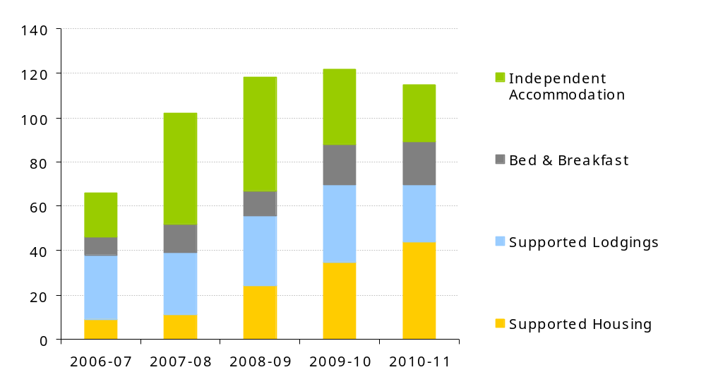
Figure 37 Accommodation Type – Care Leavers and Older Looked After Children

From the information gathered it should be noted that the overall numbers supported has increased and in recent years the use of bed and breakfast has also risen.
As part of the West Sussex Joint Strategic Needs Assessment specific work was undertaken, in 2008, to examine the needs of vulnerable and looked after children
Needs Assessment Of Vulnerable And Looked After Children In West Sussex
(NHS West Sussex, West Sussex County Council 2008)

This needs assessment highlighted what was working well in West Sussex and areas which needed improvement. Foyer services were identified as working well for young people, access to housing and accommodation identified as an area needing improvement.

This needs assessment interviewed young people and professionals who suggested potential solutions to problems identified. In relation to access to housing and accommodation three specific solutions were identified:-

- To widen the referral criteria for the Foyer.
- To ensure sufficient resources to support families on the verge of crisis.
- Improve the quality of bail addresses for offending LAC leaving custody.

PEOPLE WITH MENTAL HEALTH PROBLEMS

There is a lack of robust data on wider mental health needs in the population and accommodation needs, in relation to identifying housing needs and people known to services this review noted:-

- A snapshot of data relating to the third quarter of 2009/10 showed that there were approximately 2,500 referrals to the Working Age Mental Health Service.

- Housing need is not recorded at point of referral, it is recognised that a mental health need may not translate into need for housing.

- 2009/10 figures relating to adults receiving mental services in settled accommodation appear to shows a very low percentage, less than 20%, of people in settled accommodation.

- A snapshot of delayed transfers of care information showed that delayed transfer was higher in West Sussex than other areas and that the major reason for this was housing, seven people were in beds because of unmet housing needs. Caution: this is a snapshot of information and based on small numbers.

OFFENDERS / EX-OFFENDERS

A strategic review of supported housing for offenders / ex-offenders collated local evidence on needs, including consultation with providers, clients, the Probation Service and Supporting People staff. The review noted:-

- Evidence from key stakeholders indicated a large deficit (against supply) for this client group.
- Sussex Probation provided information 2 years of data relating to the number of offenders recorded at their start of their OASys assessment as having an accommodation need.

Table 69 Offenders with Identified Accommodation Needs
via OASys Assessment

 | 2008/9 | 2009/10
Adur | 47 | 45
Arun | 143 | 93
Chichester | 77 | 46
Crawley | 141 | 103
Horsham | 78 | 50
Mid Sussex | 63 | 34
Worthing | 105 | 88
West Sussex | 654 | 459

- Whilst the review focused on adult provision, it was noted that in relation to young offenders approximately 1 in 10 within West Sussex were found not to be in “suitable” accommodation. This is higher than the national level.

GYPSIES AND TRAVELLERS

In relation to supported housing needs, evidence from two locally commissioned needs assessments has been used in this report: -

- Health and Social Care Needs of Gypsies and Travellers in West Sussex (2010)
Report by The Office for Public Management (OPM), commissioned by NHS West Sussex and West Sussex County Council as part of the Joint Strategic Needs Assessment.

- West Sussex Gypsy & Traveller Accommodation Needs Assessment Final Report (2007). Report by David Couttie Associates (DCA), commissioned by West Sussex County Council.

Population Estimates and Site Locations

The population of Gypsies and Travellers in West Sussex is estimated to be 3,000 to 3,500; this means Gypsies and Travellers form one of the largest Black and Minority Ethnic groups in the county. Over 250 children in West Sussex state schools were identified coming from Gypsy and Irish Traveller families.

There are: -

- 11 well established local authority run sites with a total of 124 pitches,

- 82 pitches at private authorised sites-concentrated in Chichester, Horsham and Mid Sussex, Unauthorised sites and developments -concentrated in Horsham, Arun, Chichester and Mid Sussex. In January 2010, 59 of the 82 unauthorised sites and developments were on land owned by Gypsies and Travellers

In addition, although there are no local figures, around two-thirds of Gypsies and Travellers nationally, and in West Sussex, are thought to live in settled / bricks and mortar accommodation.

Travelling, Accommodation and Site Conditions

The 2007 Accommodation Needs Assessment identified a lack of pitches, low turnover on existing authorised sites and waiting lists; in part increasing unauthorised encampments and Gypsy and Traveller households leaving the county due to lack of provision.

The impact of travelling, sites and accommodation status is complex, with travelling itself found to have both positive and negative impacts on health.

Lack of available authorised pitches is associated with increased travelling and living by the roadside, with little or no facilities.

Some problems were identified on authorised sites including accessing basic washing facilities and safe play spaces for children.

The impact of moving into settled “bricks and mortar” accommodation is also complex, while such moves are often triggered by a health or social care need, some research shows moving into a house is associated with poorer health and increased levels of mental stress and depression for Gypsies and Travellers.

The 2007 Accommodation Needs Assessment found evidence of people accessing Local Authority support to adapt accommodation, including caravans, for example adaptations to toilets, showers, handrails etc; although most adaptations were undertaken by the members of the community themselves.

Gypsy and Travellers - Conclusions and Recommendations in Relation to Housing and Supported Housing Needs

- The lack of capacity of both authorised and transit sites are fundamental to the health and social care needs of the Gypsy and Traveller community. The lack of provision increases the use of roadside/unauthorised encampment and this means reduced access to basic, let alone supported housing, services; this has a direct impact on the health and social care of the Gypsy and Traveller community.

- Some of the problems identified on authorised sites include access to basic services and amenities.

- In relation to the access of specific support, the 2010 Health and Social Care Needs Assessment noted the low level uptake of social care support including statutory entitlements. The report recommended that NHS West Sussex and WSCC recognise the importance of using trusted intermediary organisations to increase access to personal budget, adaptations and aids and other forms of social care. The report also recommended cultural awareness training for staff in organisations, including statutory organisations.

NICE Housing And Public Health: A Review Of Reviews Of Interventions For Improving Health Evidence Briefing December 2005
In June 2010 ONS issued updated population figures for 2002-2009 for all local authority areas, these replaced previous population estimates. The updated population figures were produced using a revised methodology for estimating internal and international migration.
Supported housing refers to are services which “develop a person’s capacity to live independently, or sustaining his/her capacity to do so”. Housing related support includes a range of activities including services which help people manage a tenancy agreement, skills such as cleaning, managing a budget, or services based on site, for example on site help to maintain health and well being.
Lower Super Output Area (LSOA) - Developed by the Office of National Statistics to provide a more consistent statistical geography. These are small areas – approx 3-5 LSOAs per ward. Each LSOA has a population of 1,500 people. England is split into 32,482 LSOAs, West Sussex has 503.
This is the individual that represents that household and is usually taken as the eldest male within the household.
There is no simple single definition of affordable housing. Affordable housing includes social rented, affordable rented and intermediate housing, provided to eligible households whose needs are not met by the market.
Fuel Poverty And Health : A Guide For Primary Care Organisations, And Public Health And Primary Care Professionals (National Heart Forum, the Eaga Partnership Charitable Trust, the Faculty of Public Health Medicine, Help the Aged and the Met Office)
For detail on how local authorities record prevention and relief refer to the DCLG guidance “Recording Homelessness Prevention and Relief at E10 of the P1E Quarterly Return” (2009)
Report on Adults - Autism Spectrum Disorders in adults living in households throughout England (Brugha et al 2007) Report on children - Baird G. et al. (2006). Prevalence of disorders of the autism spectrum in a population cohort of children in South Thames: the Special Needs and Autism Project (SNAP). Lancet, 368(9531, pp. 210-215.
OASys is the abbreviated term for the Offender Assessment System used in England and Wales by HM Prison Service and the National Probation Service. It is a risk assessment tool for the purposes of sentence management and resettlement. The OASys is a series of computer based forms which are broken down into ten different areas addressing issues such as accommodation, lifestyle, drug and/or alcohol abuse.

