An Analysis of the West Sussex 2011 Year 11 Cohort
West Sussex Research Unit Subject Matter Briefing

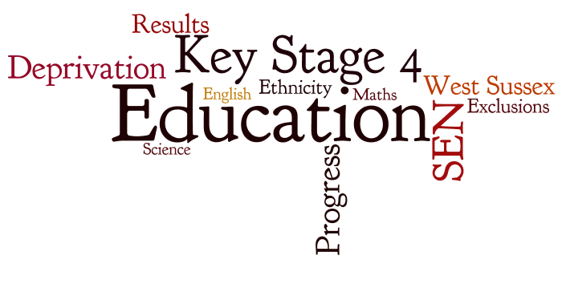


Vila Vasoodaven
Ross Maconachie
May 2012
Key Findings
- As has been observed in previous years, the correlation between social deprivation and educational attainment at Key Stage 4 in West Sussex is extremely strong.
- The correlation was stronger in relation to maths and science progress and achievement than it was on English progress and achievement.
- Principal areas of concern are the LNIA wards along the south coast of the county and the manhood peninsula south of Chichester.
- Chichester and Arun exhibited the greatest range in educational performance between wards.
- The high percentage of students with poor achievement at Key Stage 4 that are also making poor progress is a concern, particularly in Science.
- The number of students supported for Special Educational Needs (SEN) was also highly correlated with social deprivation.
- Students supported for SEN are far less likely to achieve high GCSE grades and make progress between KS2 and KS4.
- Girls generally performed better than boys in English, but results were similar in maths and science.
- There was a greater difference in educational performance between the top and bottom deprivation deciles for girls than there was for boys.
- Students for whom English was not their first language performed worse than native English speakers in GCSE English but achieved similar results in maths and science.
- Students excluded from school (on either a temporary or permanent basis) between September 2007 and December 2010 were three times less likely to achieve 5A*-C grades including English and maths.

Introduction
Education is a key variable in determining a person’s health outcomes. Students leaving school with a good level of education are more likely to find work, continue to higher education and university and to adopt positive health behaviours. Adults who left school with a low level of education are more likely to smoke, misuse drugs and alcohol, have a poor diet, be obese and suffer mental health problems. Education, therefore, is of key interest to public health departments.
This briefing brings together datasets containing pupil characteristics with educational performance data from the 2011 Year 11 cohort in West Sussex. The aim of which is to conduct a descriptive analysis, exploring relationships and patterns within the data to inform local policy.
The Data
Included in the analysis are:-
- GCSE results data (with special attention paid to English, Maths and Science)
- Progress ratings between key stages 2 and 4
- Attendance
- Special Educational Needs (SEN) status
- Free School Meals (FSM) status
- Geographical data such as deprivation level, ward and district
- Information relating to other characteristics including sex, ethnicity and language
The cohort consisted of 8,126 pupils attending West Sussex maintained schools, 7,797 of which had postcodes mapped to West Sussex addresses. About a third of the remainder lived outside the county border and two thirds had missing address data. Where specific reference is made to areas in which pupils live, this only refers to those pupils with mapped addresses. Where a whole cohort is referenced, this refers to as many of the 8,126 as there were complete data for. Each pupil dataset included a certain amount of missing data; this has been noted where it could be considered an issue of statistical significance.

Geographical and Demographic Overview
Table 1 below shows the distribution of students by gender; males represent more than 50% of the cohort.
Table 1 - Cohort
 | Frequency | Percent
Females | 3,966 | 48.8%
Males | 4,160 | 51.2%
Total | 8,126 | 100%

The data in Table 2 show the numbers and percentages of students living in each of the districts in West Sussex. The percentage split is fairly representative of the population split, with the biggest differences occurring in Chichester and Crawley. This can be explained through their relatively old and young population profiles. Arun district has an older age profile than Chichester but the pupil population seems more representative of their total population, however.

Table 2 – Local Authority Breakdown of Mapped Pupils

 | Number of Pupils | % of Pupils | % of Total Population
Adur | 562 | 7.2% | 7.7%
Arun | 1,455 | 18.7% | 18.8%
Chichester | 922 | 11.8% | 14.2%
Crawley | 1,143 | 14.7% | 13.5%
Horsham | 1,328 | 17.0% | 16.4%
Mid Sussex | 1,361 | 17.5% | 16.6%
Worthing | 1,025 | 13.1% | 12.9%
Total | 7,796 | 100% | 100%

Figure 1 – Mapped Pupils
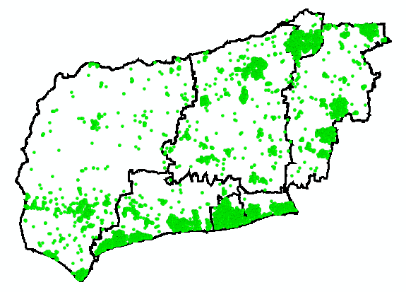

Approximately 19% of the pupil cohort lived in Local Neighbourhood Improvement Areas (LNIAs), in line with the LNIAs overall share of the population. LNIAs are locally identified areas of social deprivation located within Bognor Regis, Littlehampton, Worthing, Adur and Crawley; these areas are characterised by relatively poor health outcomes and are the focus of many public health policies.
The ethnic breakdown of the cohort was somewhat different from that of the 2001 Census for West Sussex. This is expected given the changing demographic profile of the county. There are less “White Other” students than would be representative of the current expected ethnic breakdown of the county. It is expected that people of “White-Other” ethnicity now make up a larger proportion of the county than they did in the 2001 Census due to inward migration from Eastern Europe. It is possible that this migration has not significantly affected the school age population or that recording practices differ between the school census and the main Census.
Table 3 Ethnic Background of Cohort (2011)
Ethnicity | Number | % | % Census 2001
White British | 7,175 | 89.1% | 93.5%
White Other | 217 | 2.7% | 3.1%
Asian | 260 | 3.2% | 1.7%
Black | 88 | 1.1% | 0.4%
Chinese | 21 | 0.3% | 0.3%
Mixed | 205 | 2.5% | 0.8%
Other Ethnic Group | 89 | 1.1% | 0.3%

Educational Achievement
The most frequently analysed Department for Education (DfE) target is the achievement of 5+ A*- C grades including English and Maths, and special reference is made to this throughout this report. Nationally, the percentage of pupils achieving this target has been steadily increasing for a number of years and the trend is the same in West Sussex.
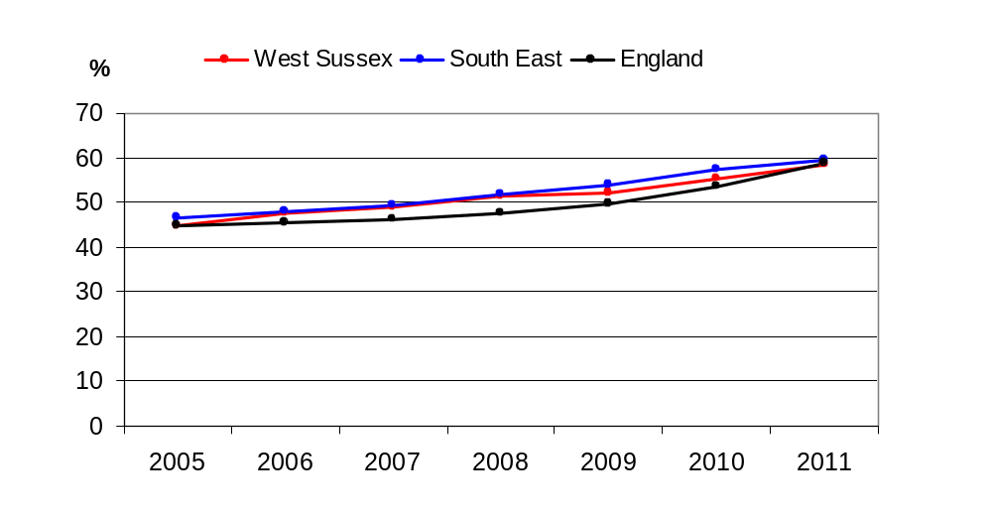
Figure 2 Percentage of Pupils Achieving 5+ A*-C Grades at GCSE (including English and Maths) between 2005 and 2011

Figure 3 shows West Sussex’s 5+ A*-C including English and Maths performance compared to neighbouring authorities. The county has performed averagely when compared to these authorities for the last few years, exhibiting the same steady upward trend.
Figure 3 GCSE and Equivalent Results, Percentage of Pupils Achieving 5+ A*-C Grades at GCSE including English and Maths between 2005 and 2011
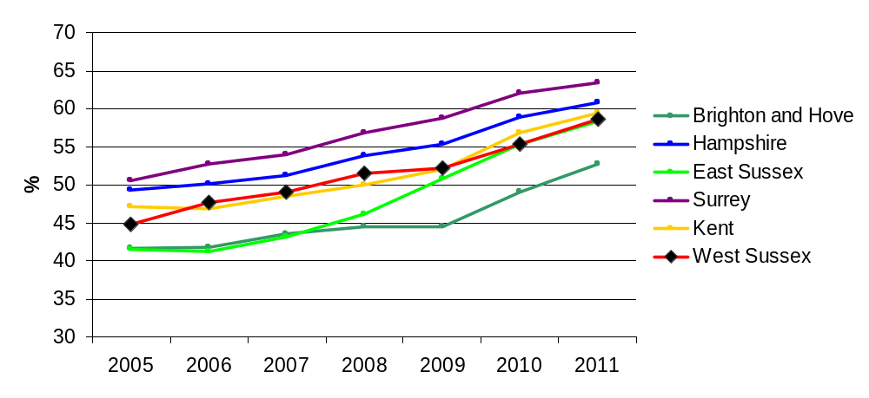
79% of students in last year’s cohort achieved 5+ A*- C grades in all subjects, whereas only 59% (55.8% when only including those with mappable West Sussex postcodes) of students achieved the same when including C+ passes in English and Maths.
Figure 4 shows that of the core subjects, pupils in West Sussex achieve the best results in English, with over 70% achieving at least a C and the worst results in Science, where around 50% achieve at least a C.
Figure 4 Percentage of Students Achieving GCSE Grade C and Above in 2011
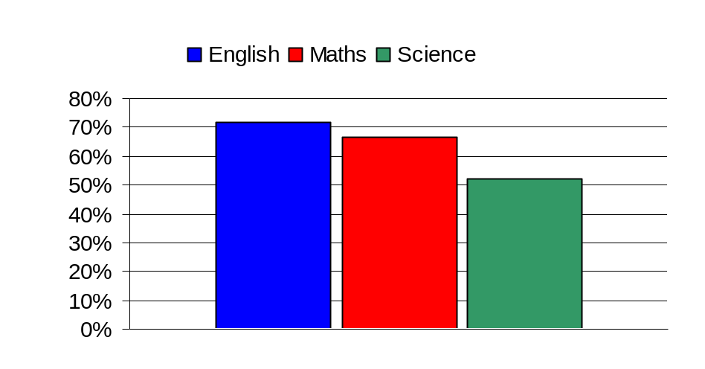
Figure 5 below show children living in Adur and Arun having the lowest district level achievement while Horsham and Mid Sussex had the highest.
Figure 5 Percentage of Pupils Achieving 5+ A*-C Grades (including English and Maths) for 2011
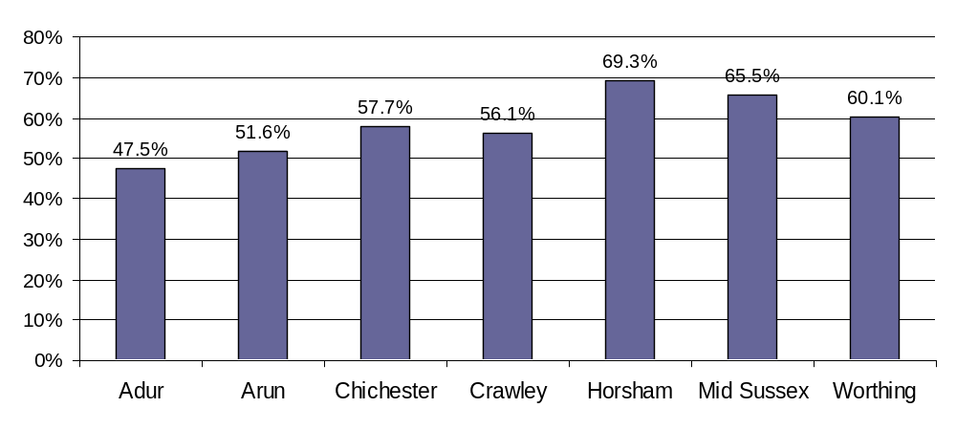

Figure 6 shows that the trend in figure 4 is the same in each district, but achievement levels in science appear to be particularly lower than English and Maths in Adur, Arun and Worthing.
Figure 6 Percentage of Pupils Achieving A*-C GCSE in English, Maths and Science by District (2011)
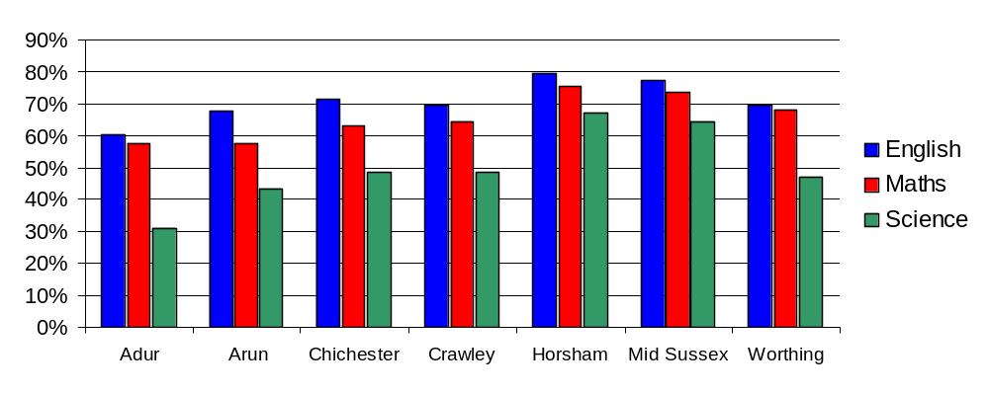
NOTE: where ward level data are referenced data for 2009, 2010 and 2011 have been amalgamated to improve the statistical significance of the results. Due to the relatively small cohorts in each of these areas (average 55 pupils per year), pass rates may vary considerably from one year to the next.
Figure 7a and Table 4 show the breakdown of GCSE attainment by electoral ward. In Table 4 the cells that are not highlighted are the district level averages, these ranges are also shown in Graph 3. All ward level results shown in Table 4 are statistically significantly different from their district average.
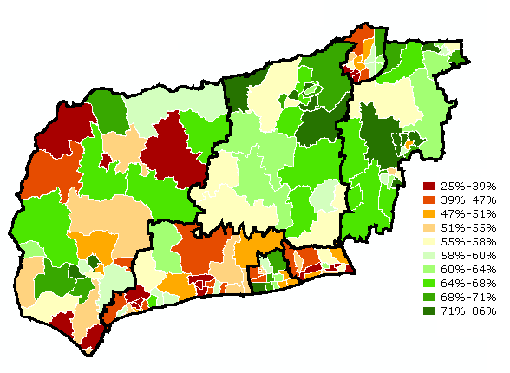
Figure 7a Percentage of Pupils Achieving 5+ A*-C at GCSE – Wards by West Sussex Decile (2011)

Table 4 Highest and Lowest Ward Level Scores (5AC Eng/Maths by District 2009-2011)
Adur | Churchill | 31.9%
Adur |  | 44.7%
Adur | St Nicolas | 62.6%
Arun | Ham | 25.7%
Arun |  | 47.0%
Arun | Felpham West | 66.7%
Chichester | Selsey North | 32.8%
Chichester |  | 52.9%
Chichester | Fishbourne | 78.3%
Crawley | Bewbush | 35.9%
Crawley |  | 50.6%
Crawley | Pound Hill North | 68.4%
Horsham | Bramber, Upper Beeding and Woodmancote | 55.1%
Horsham |  | 66.1%
Horsham | Forest | 86.4%
Mid Sussex | Haywards Heath Bentswood | 50.0%
Mid Sussex |  | 64.8%
Mid Sussex | East Grinstead Imberhorne | 80.3%
Worthing | Northbrook | 44.4%
Worthing |  | 57.2%
Worthing | Goring | 73.2%

The lines in the middle of each bar in Figure 8 represent the district average, the bottom of each bar represents the value of the lowest achieving ward and the top of each bar represents the value of the highest achieving ward. Chichester and Arun districts have the greatest range in results, Mid Sussex and Worthing the smallest range.

Figure 7b Wards Significantly Different from their District Averages – 5AC Eng/Maths (2009-2011)
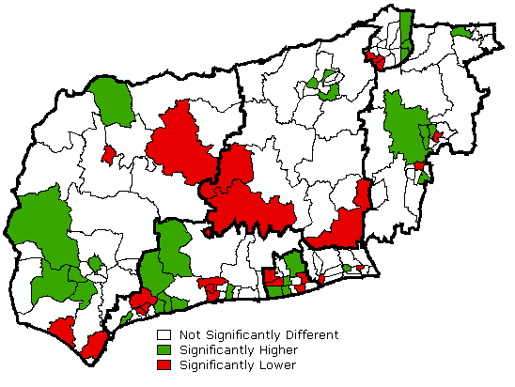

Figure 8 District Averages With Range Between Best and Worst Performing Wards (2011)
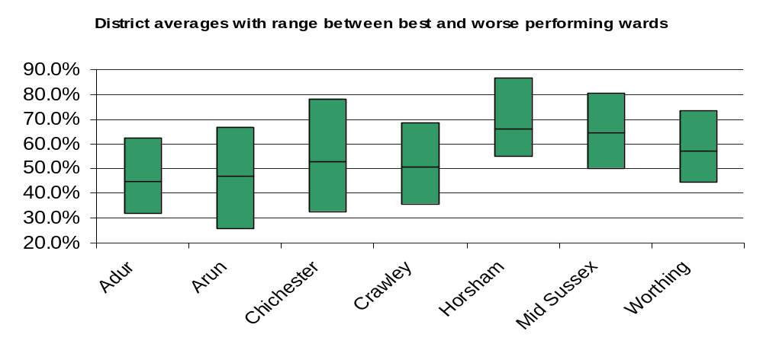
It is clear that educational performance differs considerably across different areas of the county; the next few sections will examine some of the causes of this variation and look more deeply into educational performance at Key Stage 4.

The effect of deprivation
Social deprivation is significantly correlated with many health outcomes and socio-demographic variables such as disease prevalence, mortality, crime rates and teenage pregnancy, and is also correlated with educational attainment.
Figure 9 shows that children from high socioeconomic status (SES) families have higher levels of cognitive development by age 10, regardless of whether they started from a low baseline at age 22 months. The opposite trend is true of those children from low SES families who began with a high level of cognitive development, indicating that socioeconomic status is a far more important factor in determining a child’s development than innate ability.
Figure 9 (Source: Fair Society, Healthy Lives: The Marmot Review)
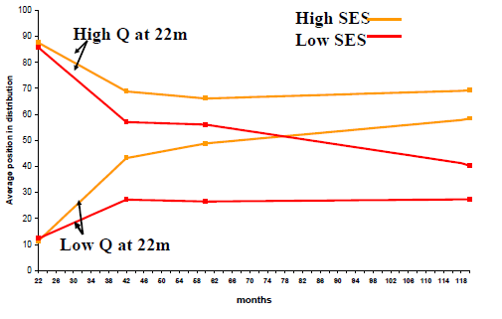
Social deprivation is measured using the Department for Communities and Local Government (DCLG)’s Index of Multiple Deprivation (IMD). The IMD is made up of several ‘domains’ including income, employment, health and disability, crime, living environment and barriers to housing and services. The data we use in this analysis is from the IMD 2010.
Figure 10 below shows how closely correlated deprivation is with GCSE achievement. Each bar represents 10% (one ‘decile’) of West Sussex’s Lower Super Output Areas (LSOAs – these are statistical ‘neighbourhoods’), with the most deprived 10% on the left and the least deprived 10% on the right. GCSE results fall steadily with each increasing decile of deprivation, so steadily that the R-squared value (displayed on the chart), where 0 represents no correlation between two variables and 1 represents a perfect correlation, sits at 0.98. This means that relative social deprivation is an extremely good predictor of achievement levels within West Sussex.

Figure 10 Percentage of Pupils Achieving 5A*-C Grades including English and Maths by Deprivation Decile (2011)
y = 0.0392x + 0.3797
R
2
= 0.9838
0.0%
20.0%
40.0%
60.0%
80.0%
Most
Deprived
Least
Deprived
This pattern is very similar for English, Maths and Science individually, with deprivation being slightly more correlated with the latter two subjects. The strong correlation between deprivation and achievement is further illustrated in the graph below comparing LNIA wards with non-LNIA wards (Figure 11).
Figure 11 Percentage of Pupils Achieving Grade C and Above (2011)
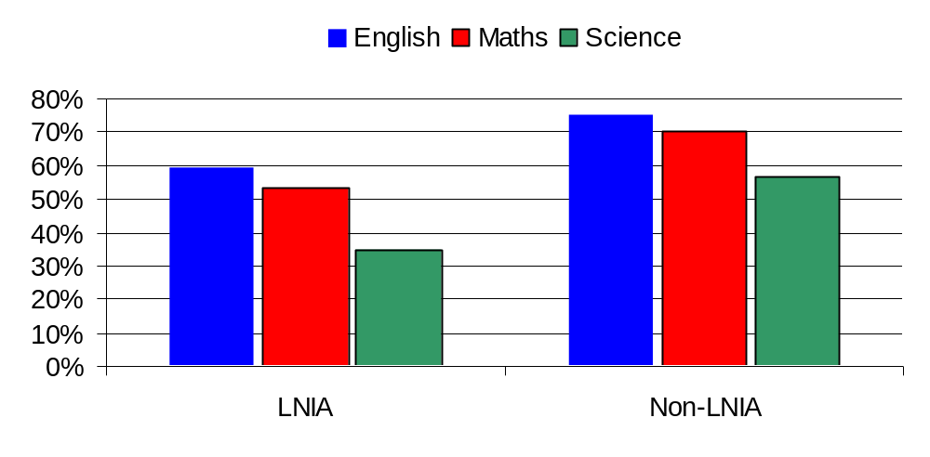
Nationally, there are considerable differences between the achievement of pupils eligible for a Free School Meal (FSM) compared with those not eligible; this is also true in West Sussex, with students eligible for a Free School Meals less than half as likely to achieve 5 A-Cs incl. English and Maths than their peers (31% vs 64%).

Figure 12 Percentage of Pupils Achieving Grade C and Above in Core Subjects by FSM Status (2011)
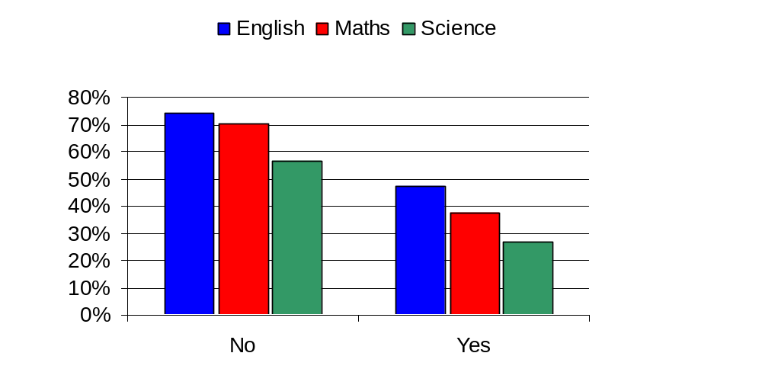

The power of progress
It will not always be possible for students to achieve high grades academically but teachers strive to ensure that pupils progress in their understanding of subjects regardless of their academic ability. A measure of expected progress is calculated using results at Key Stages 2 and 4, obviously this variable is highly correlated with academic achievement but there are some interesting differences between the two that are described in the section below.
Table 5 Expected Progress Achievement Calculation
Expected Progress Made | KS 4 Grade
Expected Progress Made |  | U | G | F | E | D | C | B | A
KS 2 Level | <1 | No | Yes | Yes | Yes | Yes | Yes | Yes | Yes
KS 2 Level | 1 | No | No | Yes | Yes | Yes | Yes | Yes | Yes
KS 2 Level | 2 | No | No | No | Yes | Yes | Yes | Yes | Yes
KS 2 Level | 3 | No | No | No | No | Yes | Yes | Yes | Yes
KS 2 Level | 4 | No | No | No | No | No | Yes | Yes | Yes
KS 2 Level | 5 | No | No | No | No | No | No | Yes | Yes
KS 2 Level | 6 | No | No | No | No | No | No | Yes | Yes

Figure 13 Percentage of Pupils Making Good Progress by Core Subjects and Deprivation Decile (2011)
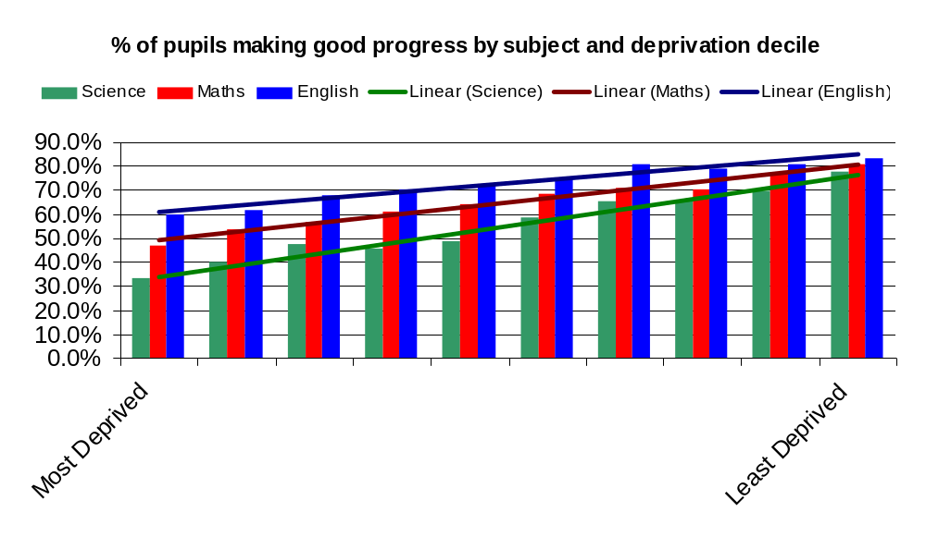
The figure above shows that the progress between KS2 and KS4 is strongly correlated with social deprivation, with Science having the steepest trend line (33.1% in the most deprived areas to 77.7% in the least).
In figure 14 below we have divided the cohort into four sectors based on good or poor progress and higher or lower achievement. The vast majority of the cohort either had Good Progress / High Achievement or Poor Progress / Low Achievement. Those with Good Progress / Low Achievement are likely to be of lower academic ability but still advancing their knowledge of the subject area while those with High Achievement / Poor Progress will have been on a high baseline at Key Stage 2 but failed to advance their knowledge as we would expect.
Figure 14 Distribution of Cohort Based on Progress and Achievement Level (2011)
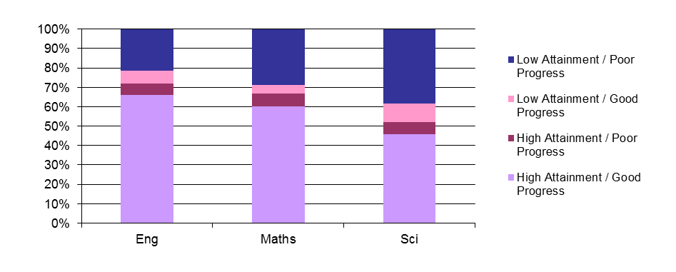

In the figure below Crawley is shown to have the highest percentage of pupils with High Achievement / Poor Progress (HA/PP) in English at 7.8%. Mid Sussex appears to have a high % of HA/PP pupils in maths and Arun high levels in maths and science. The number of pupils with these results is too small for ward level data to be statistically significant.
Figure 15 Percentage of Pupils with High Attainment but Poor Progress from KS2 (2011)
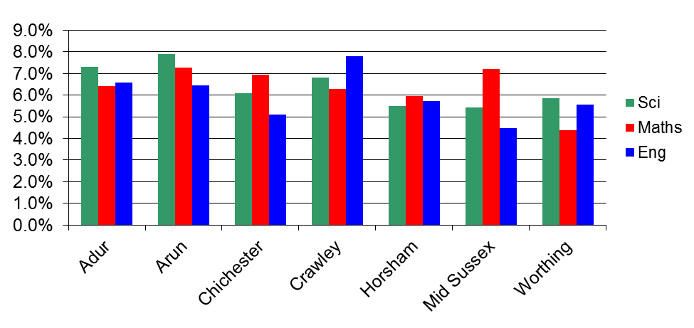
The figure below shows the percentage of students with both poor achievement and poor progress. It is clear that Science is an area of concern, particularly for the coastal districts.
Figure 16 Percentage of pupils with poor attainment and poor progress by district (2011)
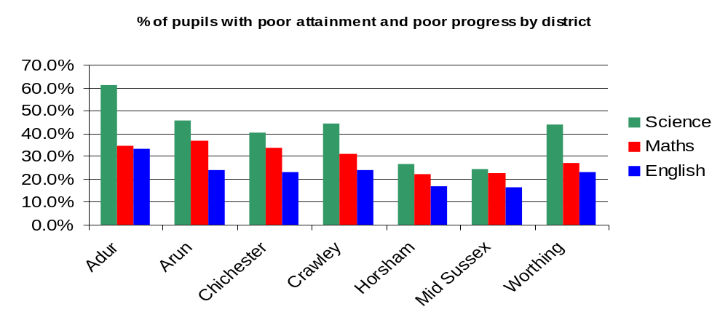

Special Education Needs (SEN)
The term 'special educational needs' (SEN) has a legal definition, referring to children who have learning difficulties or disabilities that make it harder for them to learn or access education than most children of the same age. The level of additional support provided is based on the needs of the child and may involved extra help from outside the school. The three main categories for support are:-
School Action – extra help provided by the school in the form of different teaching methods, use of equipment such as computer or small group teaching
School Action Plus – the school gets advice from external sources such as a specialist teacher, speech and language therapist or occupational therapist.
Statement – if School Action or School Action plus are not helping the child to progress or they need a lot of extra help then the local authority may decide to conduct an assessment, which may lead to a Statement of Special Educational Needs. Statements set out the needs of the child and they help they should receive and are reviewed annually.
26.9% of pupils in the cohort were recorded as having Special Educational Needs, the vast majority of these students were on School Action or School Action Plus and boys were much more likely to have SEN, particularly statements, than girls. Details are given in the table below.
Table 6 Students with Special Education Needs (SEN) for 2011

SEN | Female | Male | Total | Percent
No Action | 3,169 | 2,774 | 5,943 | 73.1%
School Action | 435 | 725 | 1,160 | 14.3%
School Action Plus | 308 | 503 | 811 | 10.0%
Statement | 54 | 158 | 212 | 2.6%
All SEN | 797 | 1,386 | 2,183 | 26.9%
Total | 3,966 | 4,160 | 8,126 | 100.0%

SEN status and Area of Residence
The number of students requiring SEN support varies by the district as seen in the figure below.
Crawley had the highest percentage of students requiring additional support, at 37% while Chichester, Horsham and Mid Sussex show the lowest percentage of students (between 22-23%).

Figure 17 SEN Provision by District (2011)
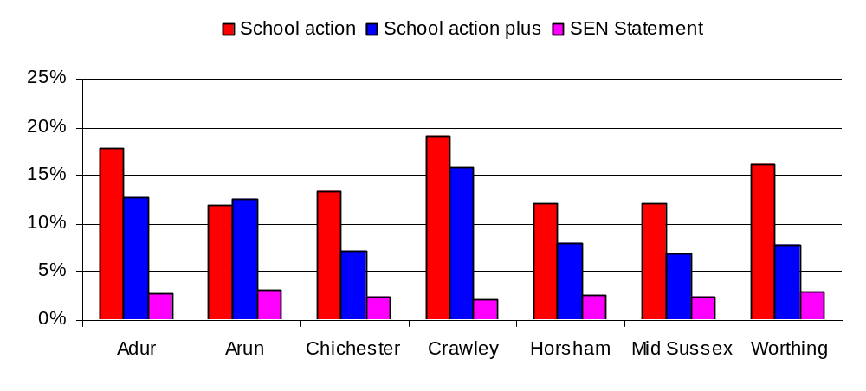
Crawley has the highest number of students on school action and school action plus compared to the rest of the districts. The percentage of SEN statement students is consistent at 2-3% for all districts.
Figure 18 below shows there is a clear correlation between SEN and deprivation particularly for students on school action plus.
Figure 18 Percentage of Pupils with SEN by Deprivation Decile (2011)
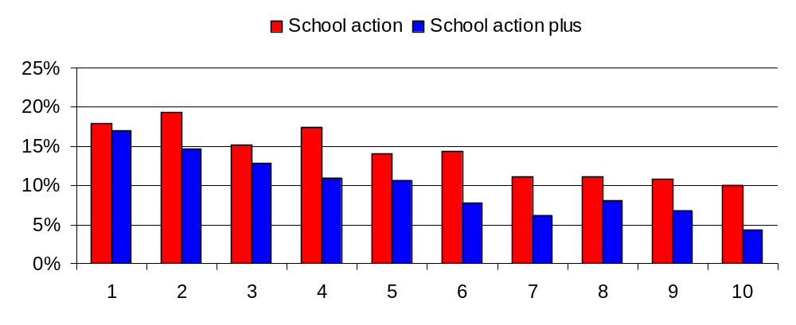

Comparison between SEN statement students and deprivation shows a different trend with higher numbers of students in the first 3 deprivation deciles compared to the remaining deciles.
Figure 19 Pupils with a SEN Statement by Deprivation Decile (Rate per 1000 pupils) for 2011
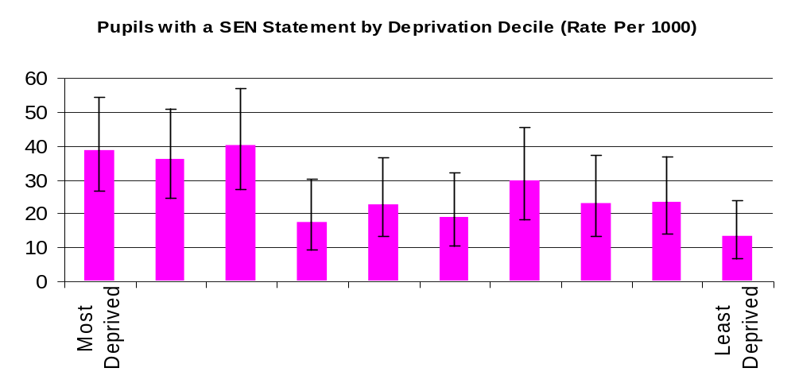
A large difference is observed between students that do not require extra help in school and students on school action or higher levels of need. Progressively smaller differences are observed for students with higher SEN needs.
Figure 20 Percentage of Pupils Achieving A*-C Grades in English, Maths and Science by SEN Provision (2011)
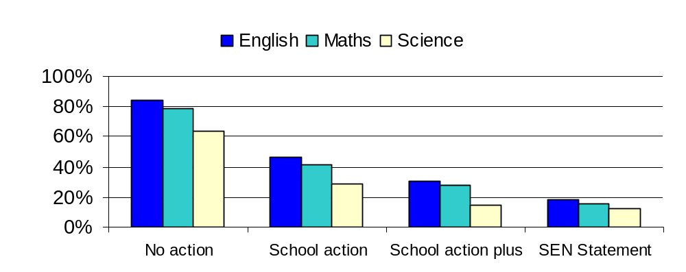
Similar to achievement results, the number of students with good progress in English, Maths and Science is higher for students not receiving additional support compared to students with SEN. Furthermore, the number of students making good progress decreases with the level of support so that SEN statement students are making the worst progress in these subjects.

Figure 21 Percentage of Pupils Making Good Progress in English, Maths and Science (2011)
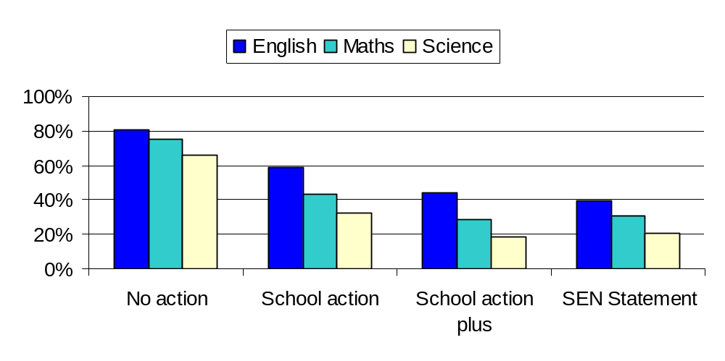

Demographic characteristics and performance

Gender
The figure below shows the gender distribution by deprivation decile, which is quite similar across all deciles apart from decile 8 and 10. In both these deciles, there are higher numbers of males than females.
Figure 22 Gender Distribution by Deprivation Decile (2011)
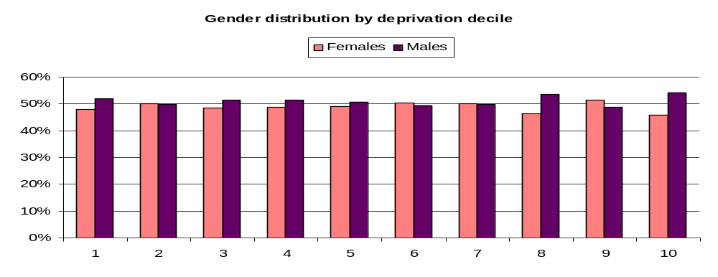

At national and at West Sussex level, GSCE achievement for girls is better compared with boys. The results from last years GCSE results, as seen in Figure 23 below, continues to follow this trend although there are subject differences in achievement level. Approximately 15% more girls achieve a C grade or higher in English, results are closer for Maths and Science, with achievement gap being less than 2% in these subjects.

Figure 23 Percentage of Pupils Achieving Grade C and Above by Gender (2011)
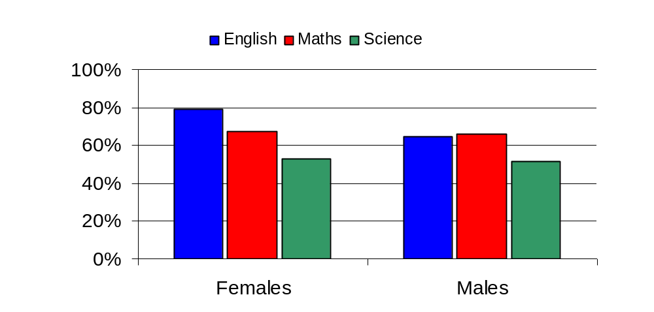
Deprivation correlated very closely with achievement for both boys and girls. While the correlation was slightly stronger for boys, the strength of the effect (the gradient of the slope) was slightly greater in girls, with a 34% achievement gap between the top and bottom decile in boys and a 42% gap in girls. 14% more girls achieved 5+A*-Cs (incl English and Maths) in the least deprived decile than boys, where only 6% more girls achieved the same target in the most deprived decile than boys.
Figure 24 Percentage of Boys and Girls Achieving 5+ A*-C Grades Including English and Maths by Deprivation Decile (2011)
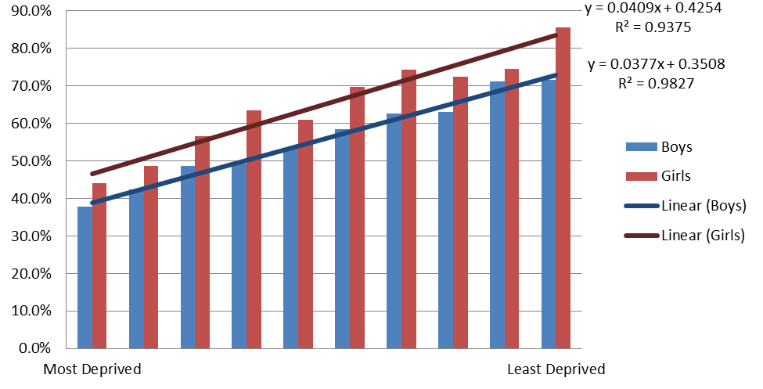
The correlation between progress ratings and achievement levels at GCSE differs for males and females. 73% of females that maintained good progress ratings through key stages achieved GCSE grades at A*-C in English compared with 59% of males. For Maths and Science, a similar percentage of males and females achieved both good progress and high achievement at GCSE.
Figure 25 Percentage of Boys and Girls with Good Progress and High Achievement by Subject (2011)
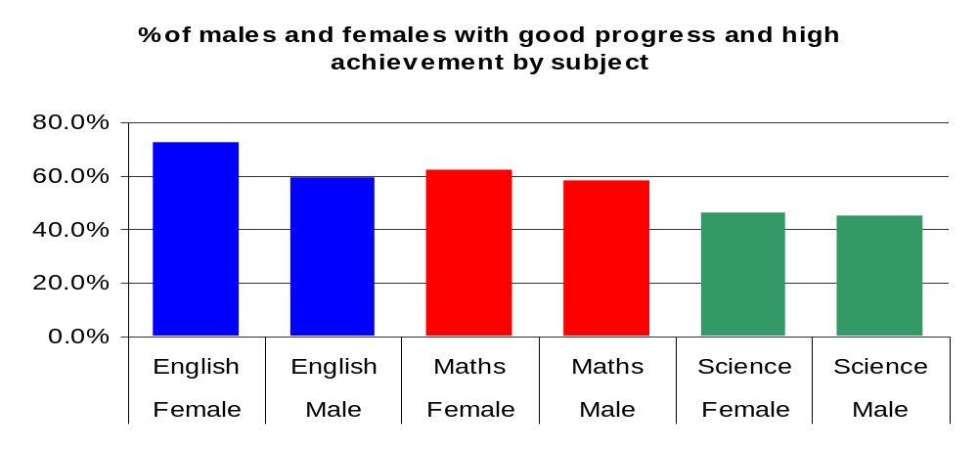
Ethnicity
The figure below shows achievement levels of the core subjects by the main ethnic groups. Due to large differences in the sample size by ethnic groups, the results below should be treated with caution.
Students from Chinese backgrounds have the highest number of A*-C grades in all core subjects while students from Black African/Caribbean and all other ethnic groups had the lowest achievement levels. However, achievement levels for Science is still lower compared to English and Maths for all ethnic groups, which follows the trend seen for overall core subject achievement levels.
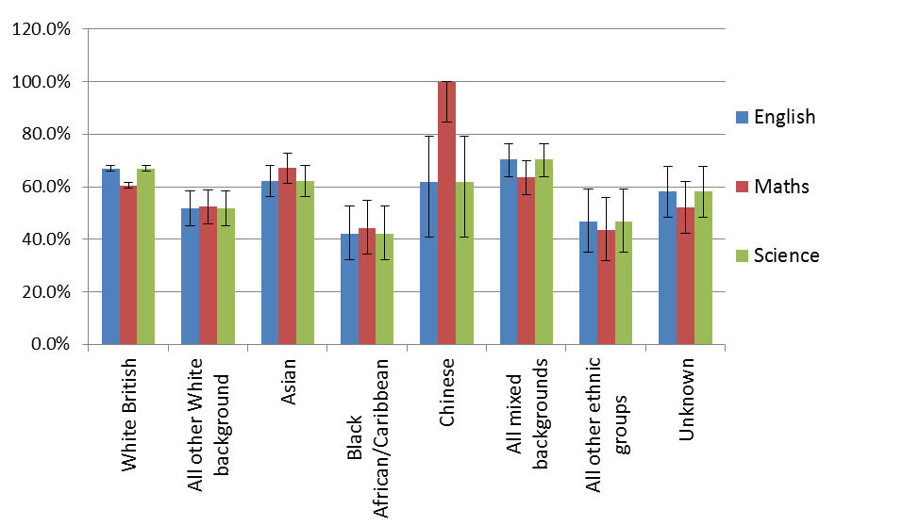
Figure 26 Percentage of Pupils Achieving Grade C and Above by Ethnicity (2011)

The table below shows the percentage of students that have been making good progress between key stages and high GCSE achievement (measured as number of students achieving grade A*-C). Students from Chinese backgrounds made the best progress throughout the key stages and GCSE results compared to students from other ethnic backgrounds.
Figure 27 Percentage of Pupils Achieving A*-C GCSE Grades and Good Progress Ratings by Ethnicity
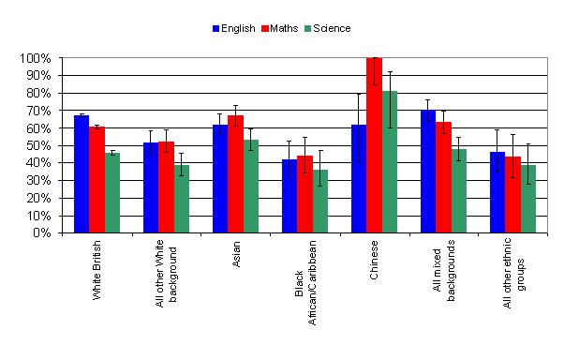

Languages and achievement
There is a higher percentage of students whose main language is English compared to students speaking other languages as would be expected based on the ethnic distribution of West Sussex. The majority of the languages spoken aside from English are from Asian origins with Urdu, Bengali, Gujerati and Tagalog accounting for 0.9% of languages spoken. Another main language spoken is Polish, accounting for 0.3% of the population.
Table 7 Main Languages Spoken by Year 11 Cohort (2011)
Main languages spoken | Total | Percentage
English | 7,661 | 94.3%
Urdu | 23 | 0.3%
Tagalog/Filipino | 14 | 0.2%
Portugese | 18 | 0.2%
Polish | 23 | 0.3%
Bengali | 15 | 0.2%
Gujarati | 14 | 0.2%
Other | 358 | 4.4%

Comparison of achievement levels for all core subjects between English speaking students and students speaking all other languages show that the difference in English achievement results is greater compared to Maths and Science.
Figure 28 Percentage of Pupils Achieving A*-C Grades in Core Subjects by Language Spoken (2011)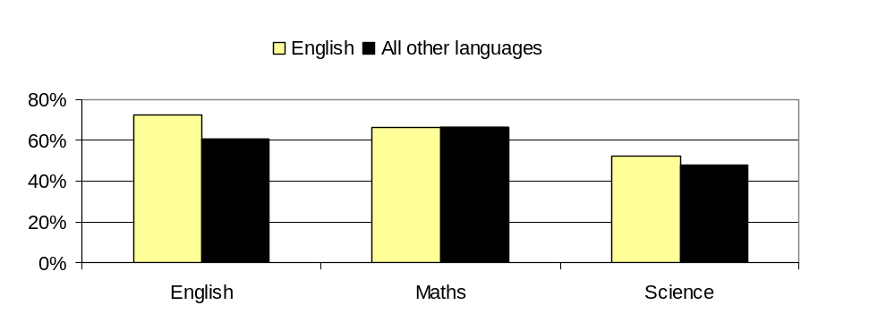
There are variations in achievement levels by the main languages spoken by the cohort. Tagalog, Portugese and Bengali students show high levels of achievement in all core subjects. However, as the number of pupils with first languages other than English is relatively small, these results should be treated with caution. None of these results are statistically significantly different from one another.
Figure 29 Percentage of Students Achieving A*-C Grades by Main Languages Spoken (2011)
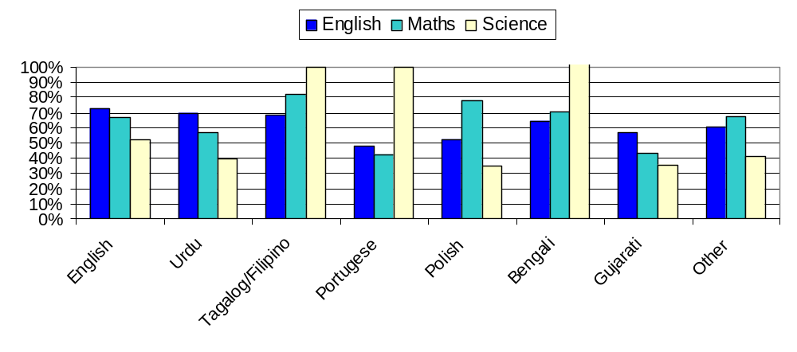
Absence Rates
Absence rates did not appear to correlate with achievement rates across the cohort.
Figure 30 Percentage of Pupils Achieving 5A*-C Grades including English and Maths by Absence Rate Deciles (2011)
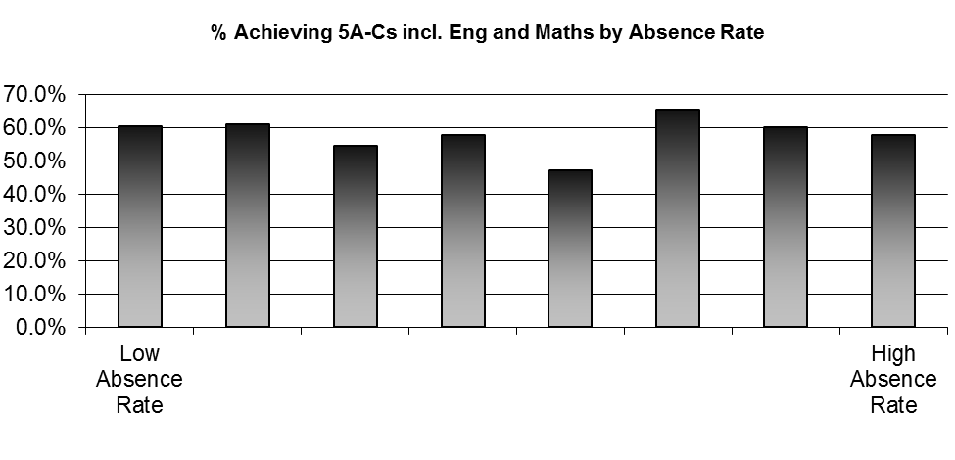

Data on excluded students
Data on exclusions were available for this cohort between September 2007 and December 2010. Throughout this period of their secondary schooling, 857 students were excluded on temporary and/or permanent bases. There were 2,600 individual exclusions (both temporary and permanent) amongst year 11 students in the cohort; this includes students that have been excluded more than once. The table below shows the reasons why students were excluded during the period. The most common reasons were persistent disruptive behaviour and verbal abuse or threatening behaviour against an adult.
Table 8 Reasons for Exclusions (2011 Cohort Sept 2007 – Dec 2010)
Reason for exclusion | Total | Percentage
Persistent disruptive behaviour | 825 | 31.7%
Verbal abuse/threatening behaviour against an adult | 749 | 28.8%
Physical assault against a pupil | 529 | 20.3%
Damage | 107 | 4.1%
Verbal abuse/threatening behaviour against a pupil | 74 | 2.8%
Physical assault against an adult | 70 | 2.7%
Drug and alcohol related | 66 | 2.5%
Theft | 44 | 1.7%
Other | 41 | 1.6%
Bullying | 37 | 1.4%
Racist abuse | 32 | 1.2%
Sexual misconduct | 26 | 1%
Total | 2,600

Overall Performance
The analysis of achievement and progress levels below are based on 851 students that were temporarily excluded. Permanently excluded students were not included in this analysis due to the small number of students (a total of 6) in the cohort compared to the significantly larger number of temporarily excluded students. Secondly, they were excluded from the analysis due to possible differences in performance levels between temporary and permanently excluded students.

Figure 31 shows that for students that were excluded, 22% achieved 5 or more A*-C GCSE grades in English and Maths, which is lower than the 64% of students that had not been excluded at any point during their academic schooling.

Figure 31 Percentage of Pupils Achieving 5+ A*-C including English and Maths by exclusion Status (2011)
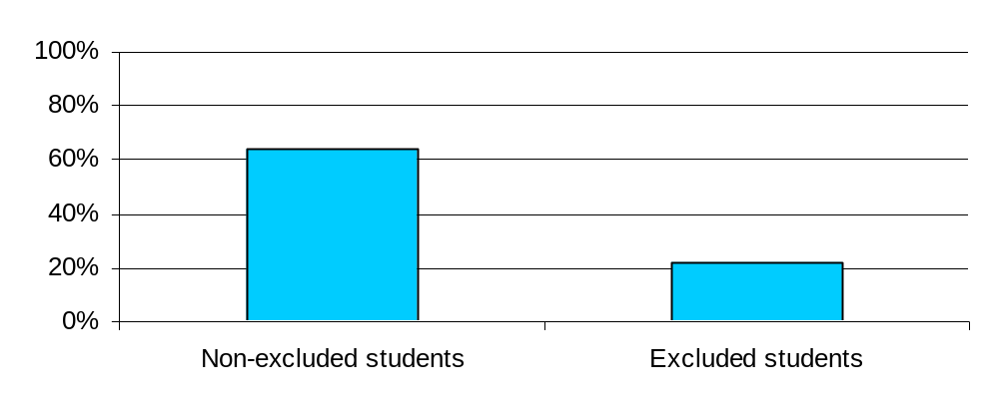

Progress and Achievement
A high number of excluded students fall under the poor progress/poor achievement category.
Achievement levels for English were generally better than Maths and Science. Figure 32 shows a higher number of excluded students falling under the poor progress/low achievement level category in Maths and Science compared with English.
Figure 32 Progress and Achievement levels of Excluded Pupils (2011)
0%
10%
20%
30%
40%
50%
60%
70%
80%
90%
100%
English
Maths
Science
High achievement/poor
progress
High achievement/ good
progress
Low achievement/good
progress
Low achievement/poor
progress

Achievement by District
The figure below shows achievement levels of excluded students by core subjects. Crawley followed by Mid Sussex has the highest percentage of students achieving A*- C GSCE grades.
The figure also shows variations in achievement levels by subject, particularly for Science where Adur and Chichester show low percentages of students achieving A*-C grades in GCSE.
Figure 33 Percentage of Excluded Pupils Achieving GCSE grades A*-C by District (2011)

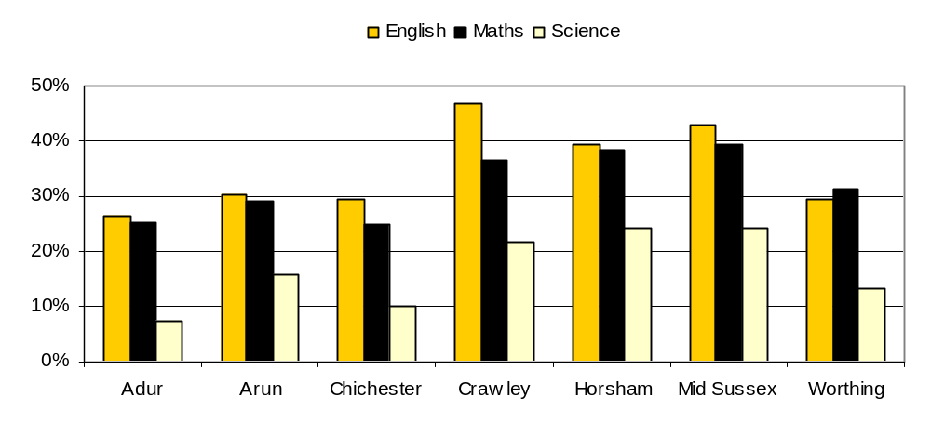

The number of non-excluded students achieving 5 or more GCSE grade A*-C is almost 3 times higher than excluded students (64% vs 22%). Further breakdown of achievement levels by district show a similar trend with Chichester exhibiting the highest difference in performance between excluded and non-excluded students.
Figure 34 Percentage of Pupils Achieving 5+ A*-C Grades by Exclusion Status (2011)
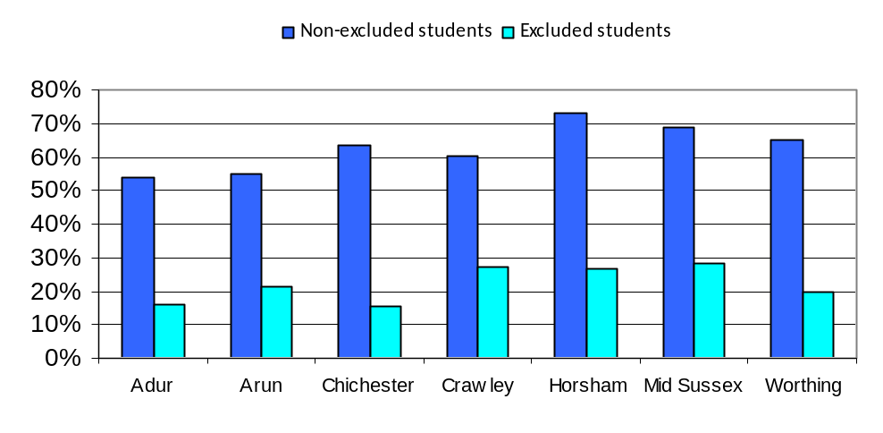

Achievement and Deprivation
Although it may have been expected that educational achievement of excluded students would be lower for students from deprived backgrounds, the figure below shows that there is no obvious correlation between deprivation and academic performance of excluded students.
Figure 35 Percentage of Excluded Pupils Achieving A*-C Grades by Subject and Deprivation Decile (2011)
