COMP7940 Cloud Computing – Project Report

Chatbot ID: Telegram @Utbm_bot
Student(s): Wang Shangbo
Group size: 1
Date: 2026-04-13

Table of contents
1. Summary of the App 3
2. Team & Job Division 4
3. Architecture and Design 4
3.1 High-level architecture 4
3.2 Components 4
3.3 Data flow 5
4. Implementation Details 5
4.1 Configuration and secrets management 5
4.2 LLM integration (HKBU GenAI) 5
4.3 Database logging (AWS RDS PostgreSQL) 5
4.4 Basic observability (/stats) 6
5. Evidence of Fulfilling Technical Requirements (Must-Have) 8
5.1 Telegram chatbot 8
5.2 Cloud database logging 8
5.3 Cloud hosting 9
5.4 Use LLM API 10
5.5 Git management 10
5.6 Container technologies 10
5.7 Monitoring and cost awareness 10
6. DevOps Workflow (Nice-to-Have) 11
7. Load Balancing, Scalability, and Multi-Container Orchestration (Nice-to-Have) 11
8. Security Considerations 12
9. Monitoring and Cost Management 12
9.1 Monitoring 12
9.2 Cost management 12
10. Deployment & Reproducibility 13
11. Limitations and Future Work 14
12. References 14

1. Summary of the App
This project extends the COMP7940 lab chatbot into a cloud-deployed Telegram assistant powered by the HKBU GenAI REST API. The system runs on AWS EC2 with Docker Compose, logs conversation events to AWS RDS PostgreSQL, and is delivered through a lightweight GitHub Actions CI/CD pipeline. Beyond the basic chatbot workflow, the prototype now includes two meaningful student-oriented features: interest-based user matching and activity recommendations. The design goal is to demonstrate practical cloud engineering, observability, deployment automation, and feature prototyping rather than a complex front-end interface.
Target users and use cases:
- University students who need quick Q&A support for study, coding, coursework, or general academic help.
- Students who want to discover peers with similar interests and receive suggestions for relevant activities, workshops, competitions, or study communities.
Main user flow:
- A user sends a natural-language message or a bot command in Telegram.
- The bot receives the update through polling or webhook mode, depending on deployment configuration.
- For normal chat and recommendation requests, the bot calls the HKBU GenAI chat completions API with an appropriate system prompt.
- The bot returns the generated reply or recommendation in Telegram.
- The bot logs request/response metadata to AWS RDS PostgreSQL and can also store user interest profiles for matching.
Key features implemented:
- Telegram chatbot with LLM-powered responses (HKBU GenAI).
- Cloud hosting on AWS EC2 using Docker containers and docker compose.
- Cloud database logging on AWS RDS (PostgreSQL) with de-duplication by Telegram update_id.
- Basic observability using /stats (and /status alias) showing last-24-hour totals, errors, and latency.
- Automated CI/CD with GitHub Actions for build and deployment.
- Interest-based profile matching using /setprofile, /myprofile, and /match.
- Activity recommendations using /recommend, backed by the HKBU GenAI API.

2. Team & Job Division
This is an individual project.
Member list:
- Wang Shangbo (25434705) - Architecture design, backend implementation, LLM integration, database logging, feature prototyping, deployment, testing, and report writing.

3. Architecture and Design

3.1 High-level architecture
The system uses Telegram as the user interface. The bot application runs in Docker containers on AWS EC2. AWS RDS (PostgreSQL) stores both chat logs and user profile data. HKBU GenAI provides LLM responses and recommendation generation through a REST API. For scalable webhook deployment, nginx acts as an HTTPS reverse proxy and routes /telegram requests to bot replicas behind Docker Compose.
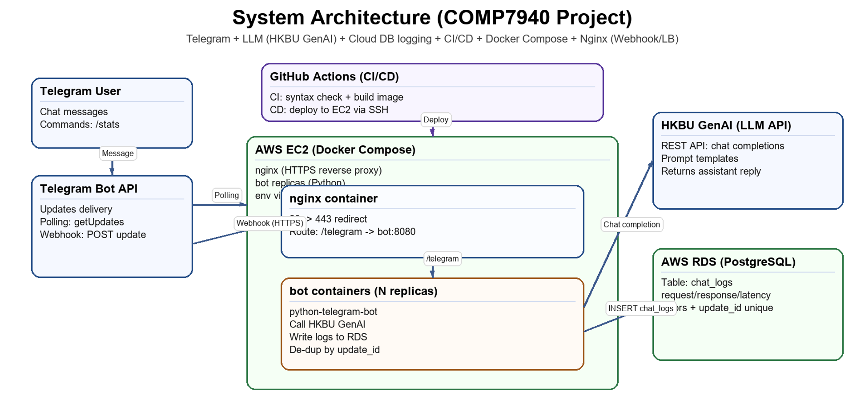

3.2 Components
- Telegram Bot API: delivers user updates and accepts replies from the bot.
- Bot application (Python): handles chat messages, commands, profile matching, recommendation generation, database logging, and /stats.
- nginx (Docker): reverse proxy for /telegram and HTTPS termination when webhook mode is enabled.
- AWS RDS PostgreSQL: stores chat_logs for auditing/metrics and user_profiles for the matching feature.
- GitHub Actions: runs CI checks and deploys the updated container image to EC2.

3.3 Data flow
- Telegram updates arrive through webhook mode or are pulled through polling.
- The bot parses commands and user text, extracts Telegram metadata, and decides whether to run chat, matching, recommendation, or observability logic.
- For chat and recommendation flows, the bot calls the HKBU GenAI endpoint and receives a completion.
- The bot replies in Telegram and, when relevant, reads or writes profile data for matching.
- The bot writes request logs, latency, and error status into PostgreSQL chat_logs with update_id-based de-duplication.

4. Implementation Details

4.1 Configuration and secrets management
Sensitive values are not committed to Git. The repository keeps only config structure in config.ini, while runtime secrets are provided through environment variables on EC2 (server-side .env) and GitHub Secrets for SSH deployment. The application reads configuration with environment variables first and config.ini as a fallback, which keeps secrets out of source control.
Key environment variables:
- TELEGRAM_ACCESS_TOKEN
- CHATGPT_API_KEY, CHATGPT_BASE_URL, CHATGPT_MODEL, CHATGPT_API_VER
- DATABASE_URL
- TELEGRAM_MODE=polling|webhook
- TELEGRAM_WEBHOOK_URL, TELEGRAM_WEBHOOK_PATH, TELEGRAM_WEBHOOK_SECRET

4.2 LLM integration (HKBU GenAI)
The bot integrates with the HKBU GenAI REST API (chat completions). A default system prompt supports general student Q&A, while the recommendation feature uses a task-specific system prompt to generate concise activity ideas. The request is sent through httpx with configurable model and API version values, and the assistant response is returned directly to Telegram. Errors are caught gracefully so the bot can respond without crashing.

4.3 Database logging (AWS RDS PostgreSQL)
All interactions are logged to AWS RDS PostgreSQL. On startup, the bot ensures the chat_logs table exists and adds the unique index needed for webhook-safe de-duplication. Each record stores Telegram identifiers, user input, assistant output, latency, model metadata, and error information. The logging query uses ON CONFLICT DO NOTHING against update_id so retries or multi-replica processing do not create duplicate records. The same database also stores a user_profiles table for the interest matching feature.
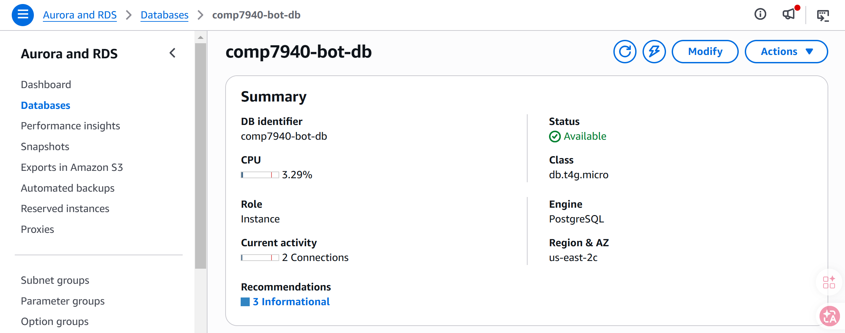

4.4 Basic observability (/stats)
The /stats command (and /status alias) queries the database for the last 24 hours and returns:
- Total requests
- Error count
- Average latency (ms)
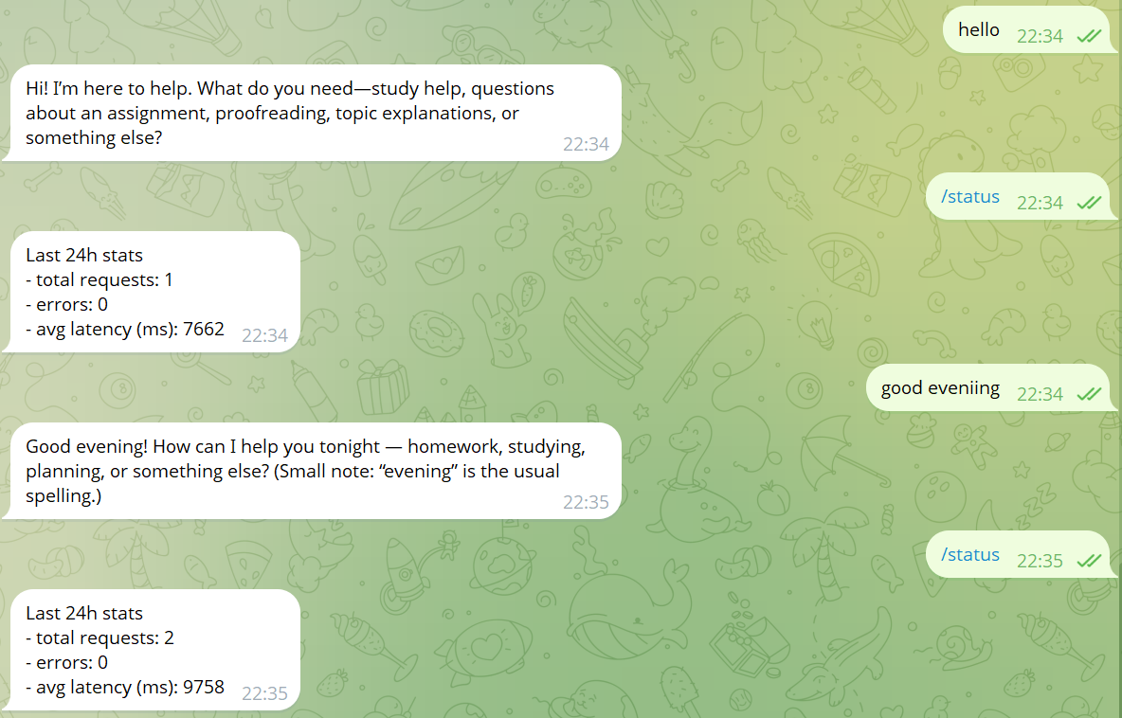

4.5 Interest matching
The prototype includes an interest-based matching feature for students. Users create a lightweight profile with /setprofile, including interest keywords and an optional short bio. These profiles are stored in the user_profiles table in PostgreSQL. When /match is used, the bot normalizes the saved interests, compares overlap across users, and returns the most relevant peers with shared interests. This feature extends the chatbot beyond one-to-one Q&A and demonstrates a meaningful student networking use case.
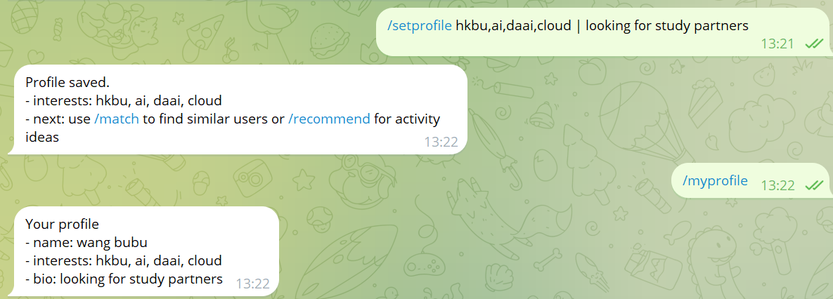
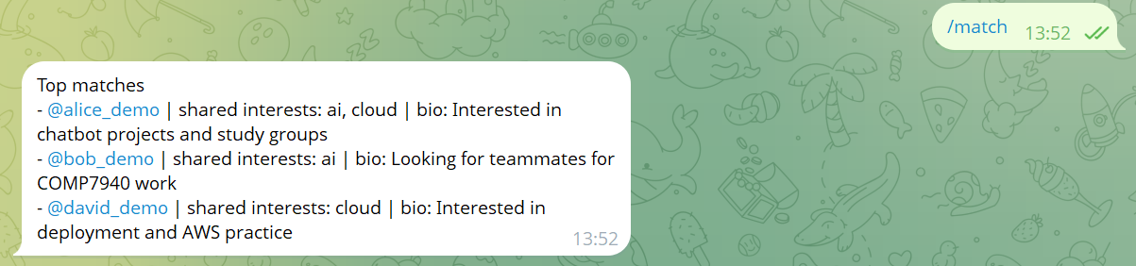

4.6 Activity recommendations
The /recommend command provides activity suggestions based on a user-supplied topic or the interests already saved in the user profile. The bot sends a task-specific prompt to the HKBU GenAI API and asks for concise recommendations suitable for university students, such as workshops, competitions, study groups, or online communities. This design keeps the feature practical while reusing the same LLM infrastructure as the core chatbot.
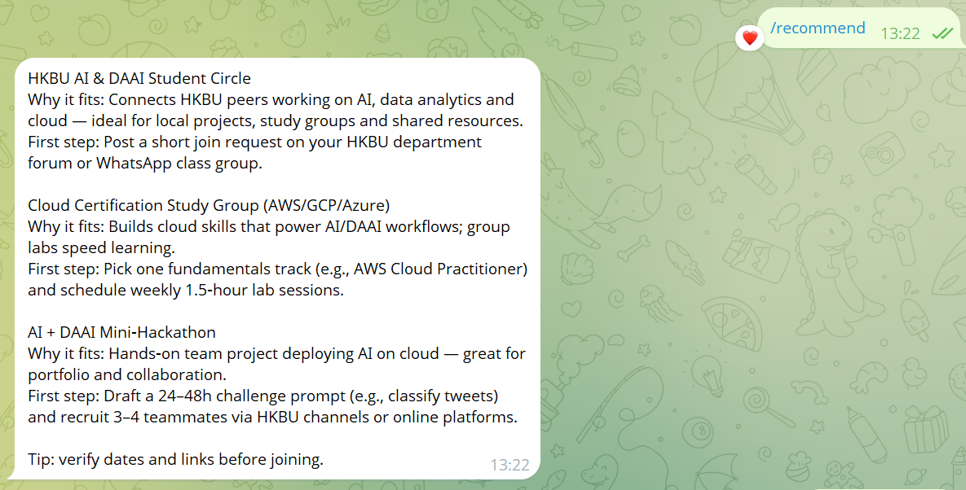

5. Evidence of Fulfilling Technical Requirements (Must-Have)
This section maps directly to the seven must-have requirements. For each item, include at least one screenshot as evidence.

5.1 Telegram chatbot
The bot runs on Telegram and responds to user messages.
It also supports command-driven interactions such as /setprofile, /match, and /recommend, showing that the bot can handle feature-oriented workflows instead of only basic chat replies.
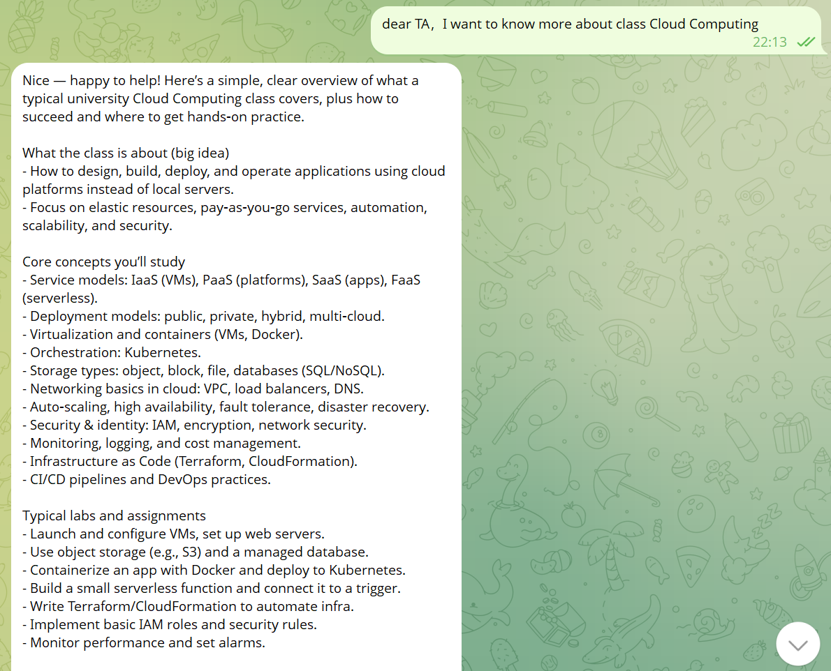

5.2 Cloud database logging
A cloud database (AWS RDS PostgreSQL) is used to log requests and responses.
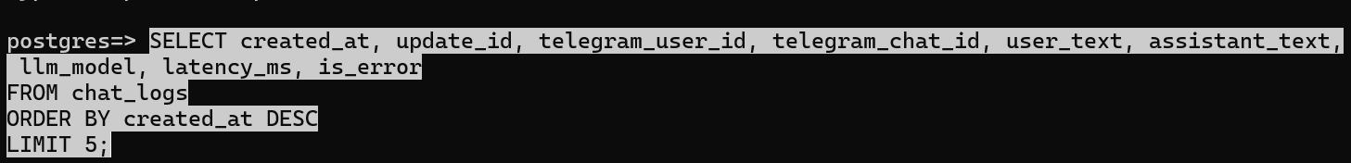
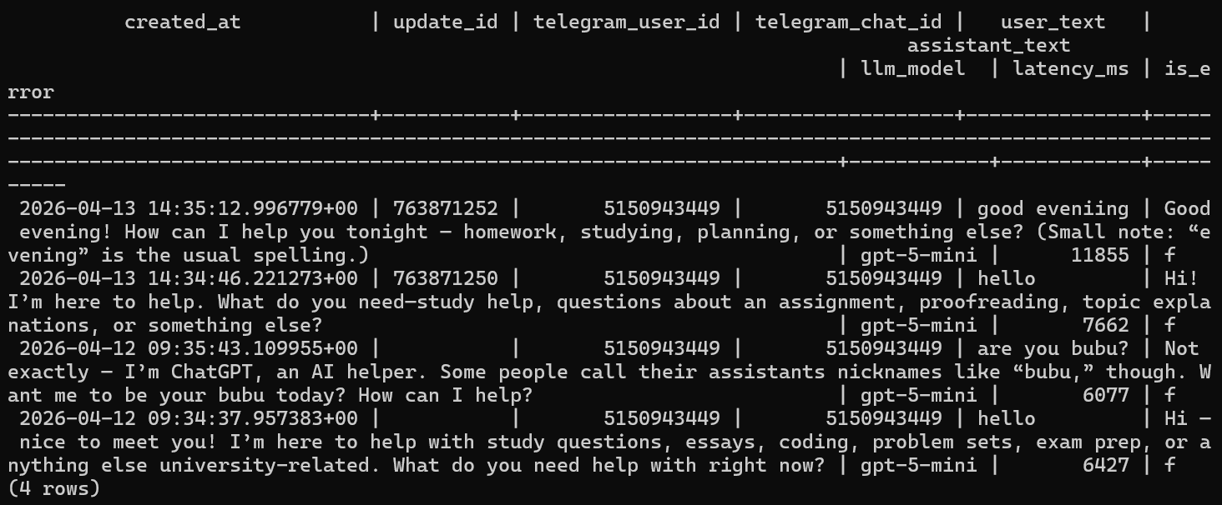

5.3 Cloud hosting
The application is hosted on a cloud platform (AWS EC2).
Evidence:
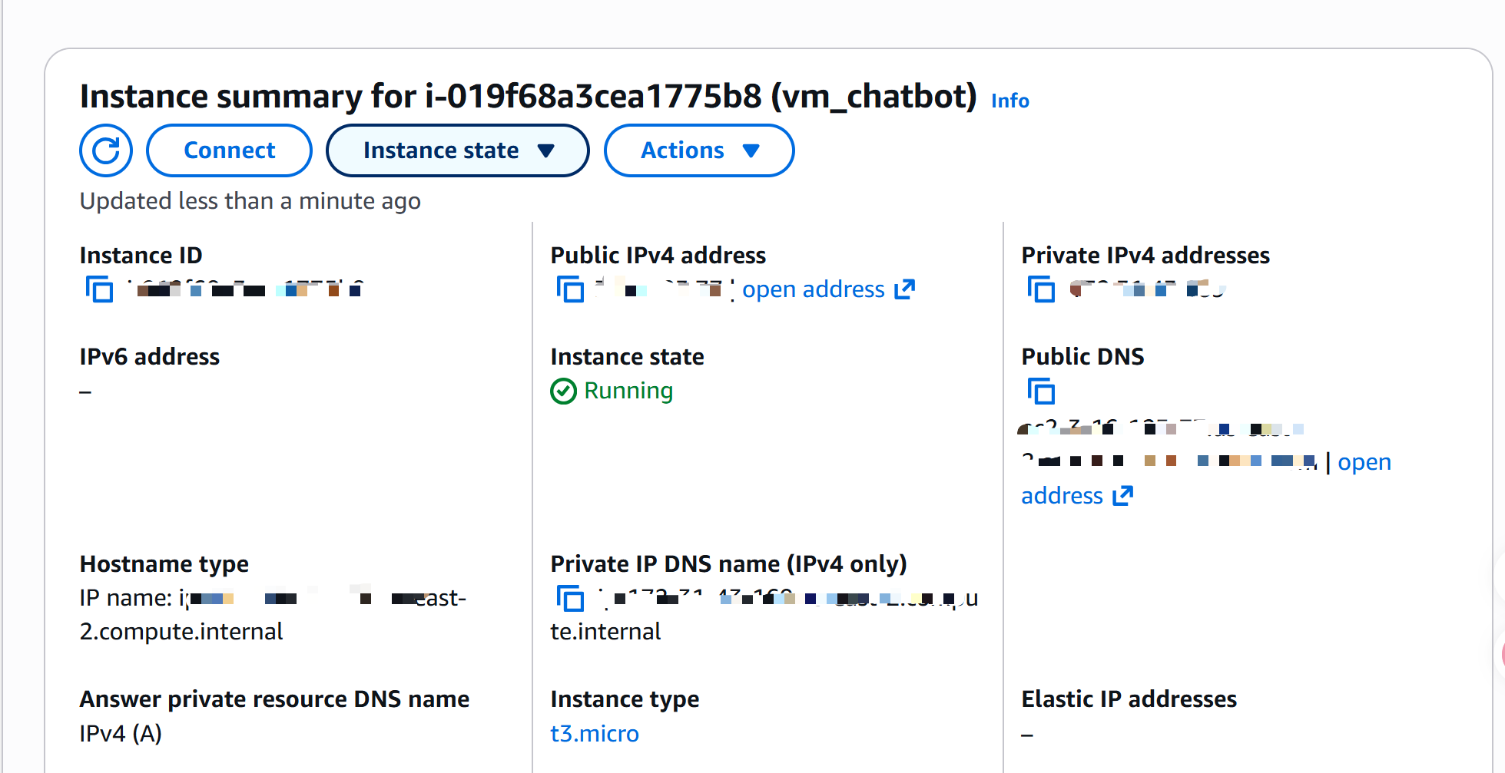
AWS EC2
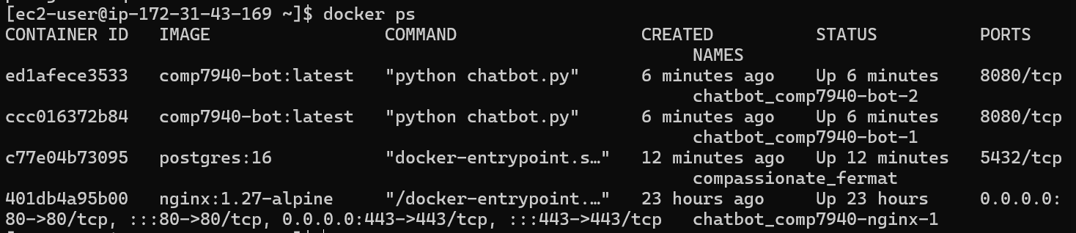
Docker compose

5.4 Use LLM API
The bot uses an LLM API (HKBU GenAI REST API).
Besides general question answering, the LLM is also used to generate concise activity recommendations tailored to student interests, which makes the API usage more meaningful than a simple demo call.

5.5 Git management
The project is managed by git and hosted on GitHub.
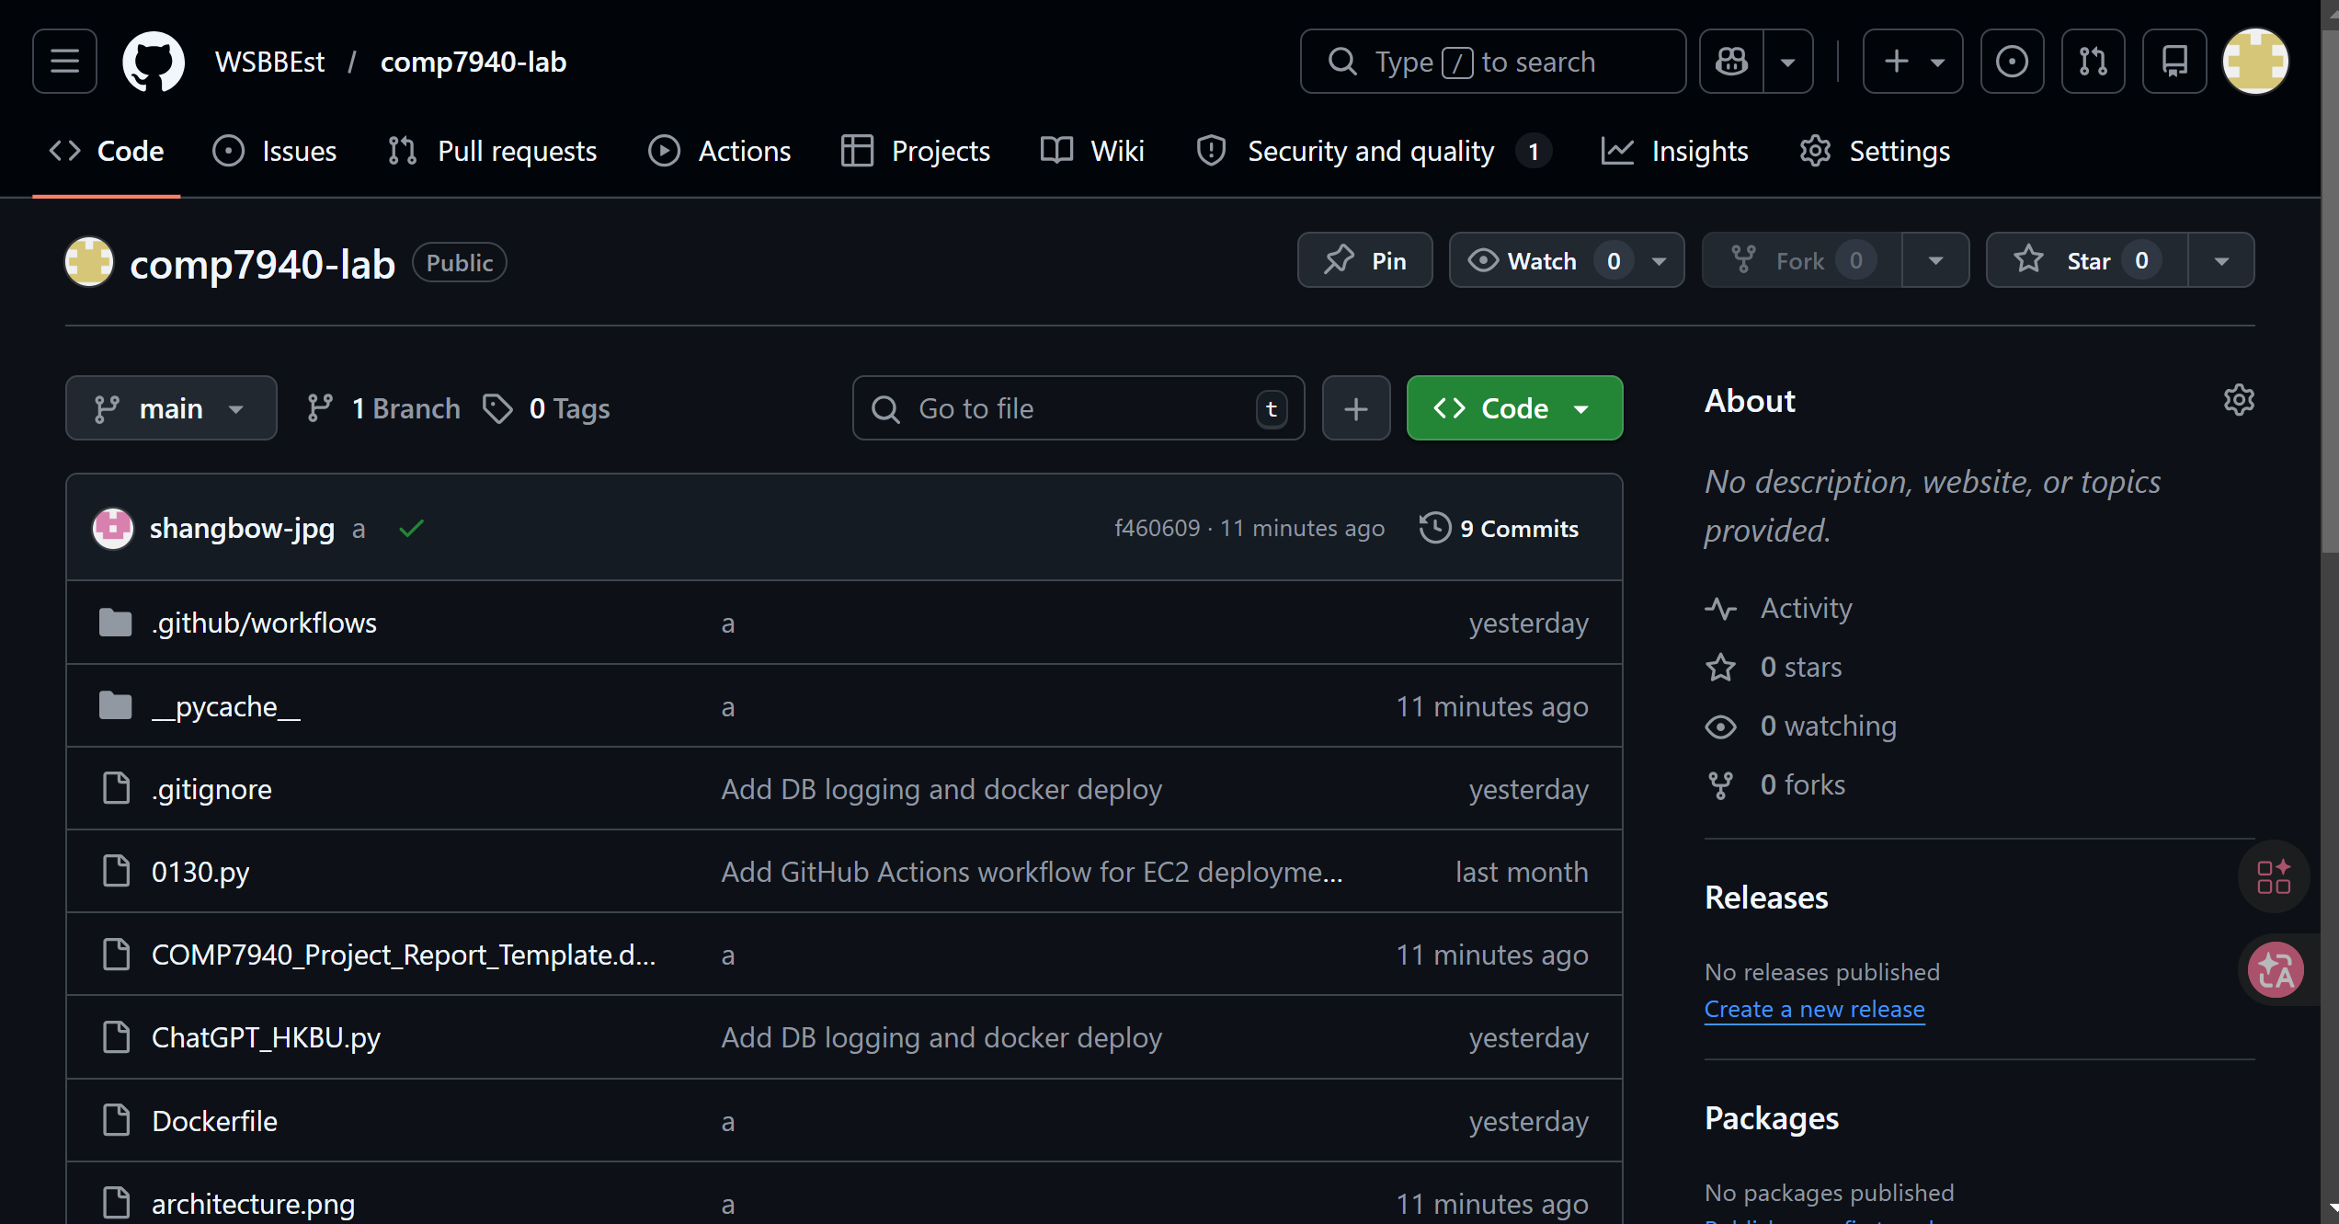

5.6 Container technologies
The application uses container technologies (Docker) and is deployed as containers.
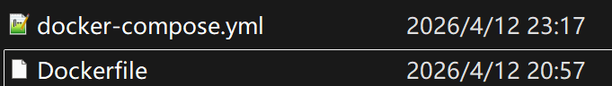

5.7 Monitoring and cost awareness
Monitoring and cost management are demonstrated with lightweight metrics and AWS billing controls.
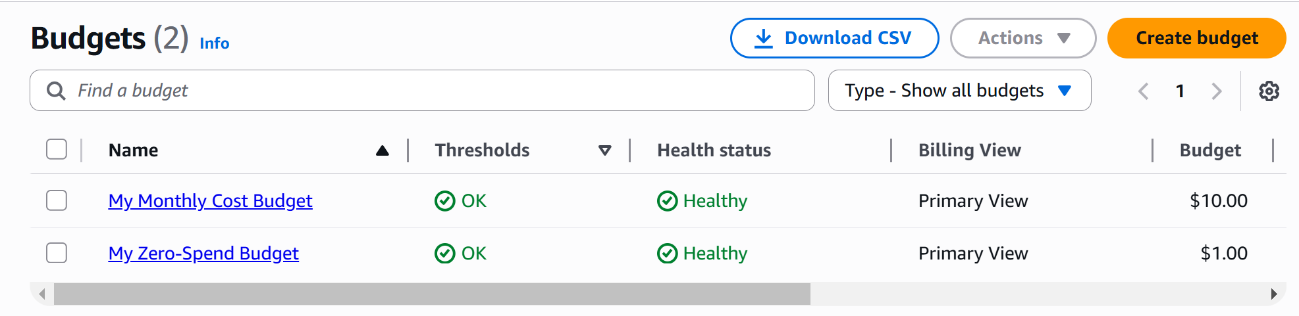

6. DevOps Workflow (Nice-to-Have)
We implemented an automated CI/CD workflow using GitHub Actions. On every push to main, CI checks run first, then a container image is built and deployed to EC2. This reduces manual operations and provides repeatable deployments.
CI (quality gate):
- Docker image build in CI to ensure reproducible packaging.
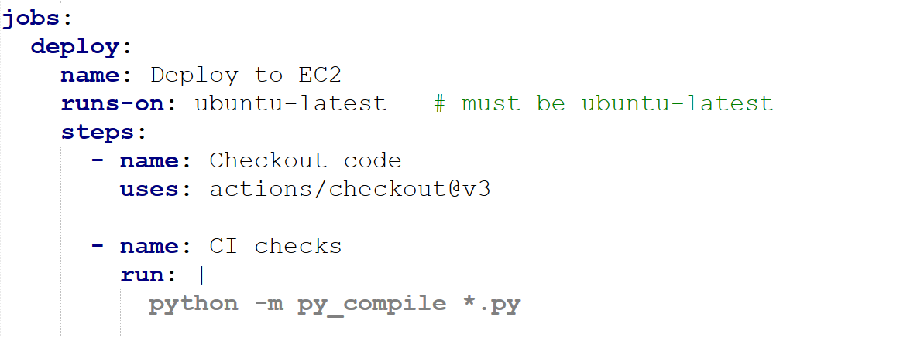
CD (deployment):
- Build Docker image on GitHub runner.
- Transfer image to EC2 (docker save → gzip → ssh → docker load).
- Copy docker-compose.yml and nginx.conf to EC2.
- Run docker compose up with scaling (e.g., --scale bot=2).
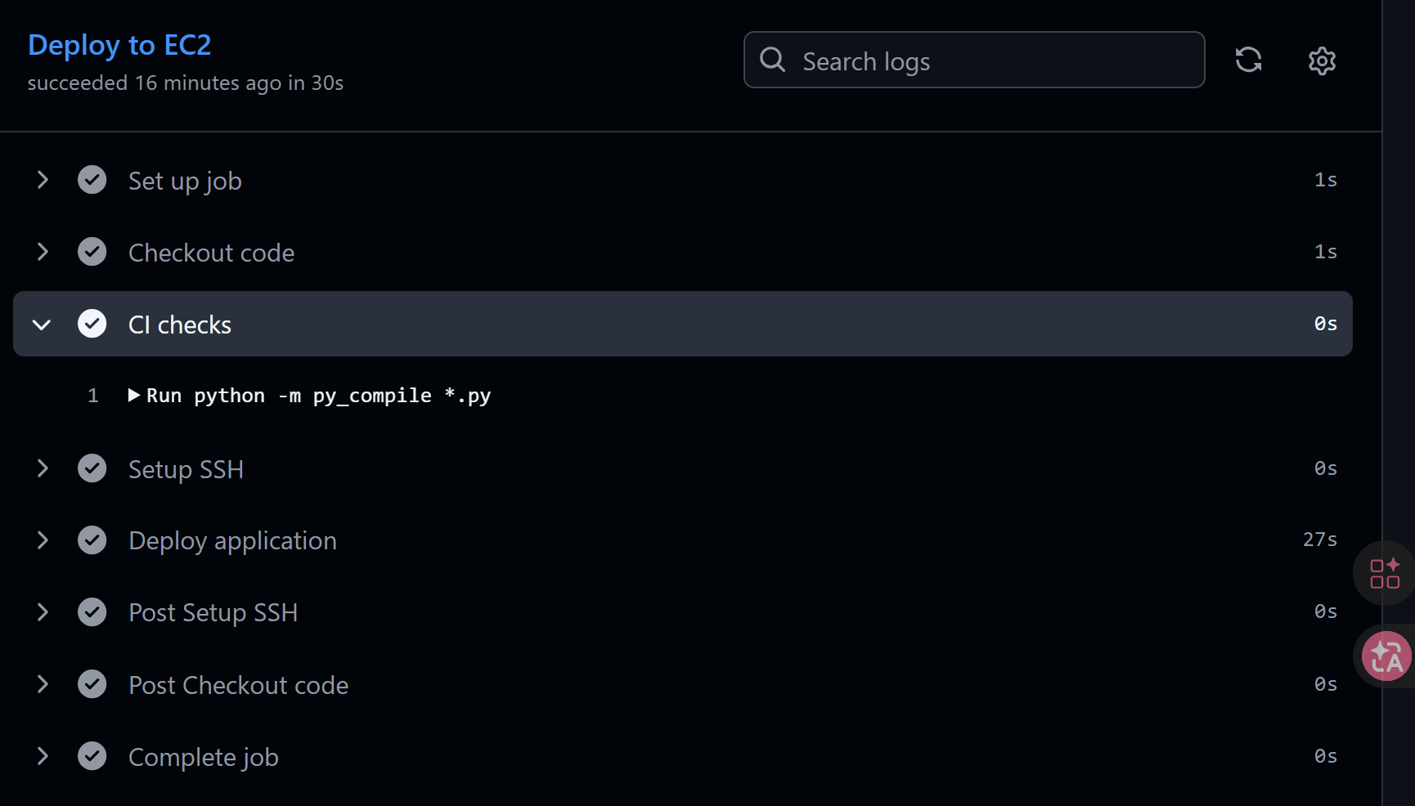

7. Load Balancing, Scalability, and Multi-Container Orchestration (Nice-to-Have)
We use docker compose to orchestrate multiple containers (nginx + bot). In webhook mode, nginx routes /telegram to the bot service. With multiple bot replicas, incoming webhook traffic can be distributed across replicas. Database-level de-duplication (update_id) ensures safe handling of webhook retries and multi-replica operation.
Because both chat_logs and user_profiles are stored in PostgreSQL, all bot replicas share the same logging and profile state, which keeps matching and recommendation features consistent across containers.
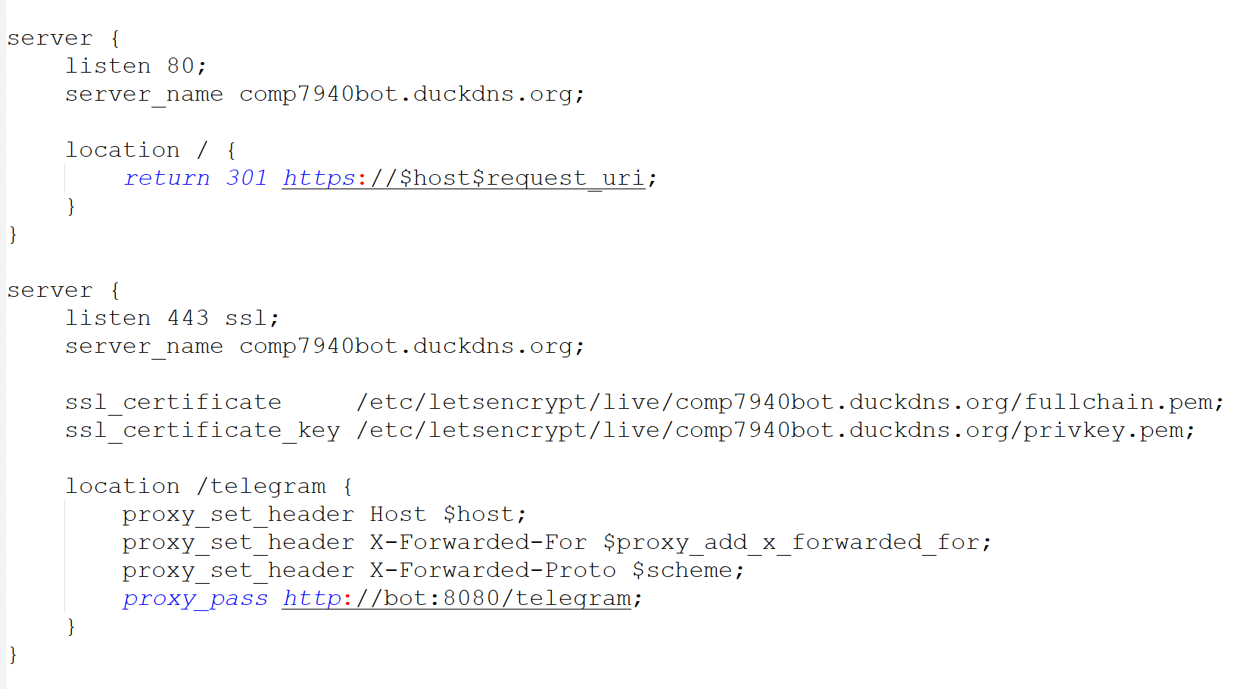

8. Security Considerations
Security measures focus on preventing secret leakage, limiting database exposure, and protecting webhook traffic.
- Secrets are stored in server-side .env and GitHub Secrets; they are not committed to Git.
- RDS access is restricted by security groups (only EC2 can access PostgreSQL port 5432).

9. Monitoring and Cost Management

9.1 Monitoring
- Application logs via docker logs (bot/nginx).
- /stats command for last-24h totals, errors, and latency.

9.2 Cost management
To avoid unexpected charges, we configured AWS Budgets alerts and monitor costs by service. We also stop or terminate resources when they are not needed.
- AWS Budgets monthly cost limit + alert rules (actual and forecast).
- Billing/Cost Explorer reviewed by service (EC2, RDS, EBS).
- Operational practice: stop EC2/RDS when not used; delete resources after demo if no longer needed.
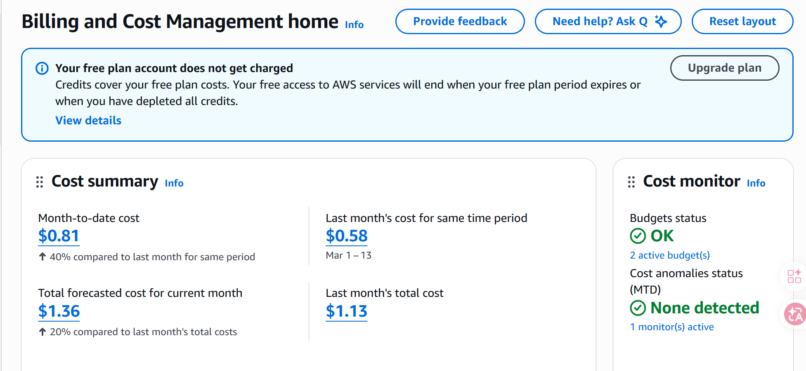

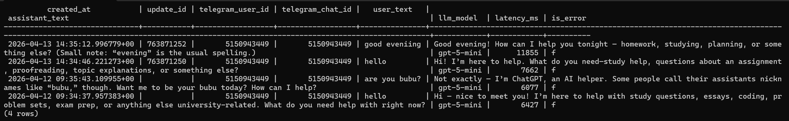
RDS sql logs

10. Deployment & Reproducibility
Prerequisites:
- AWS EC2 instance with Docker and docker compose available.
- AWS RDS PostgreSQL instance and DATABASE_URL.
- Telegram bot token and HKBU GenAI API key.
- GitHub repository with GitHub Actions secrets for EC2 SSH deployment.
Deployment steps:
- Create server-side .env on EC2 containing required environment variables (do not commit).
- Push code to the main branch.
- GitHub Actions builds the image and deploys to EC2 automatically.
- Verify with docker compose ps and test Telegram bot responses, /stats, /setprofile, /match, and /recommend.

11. Limitations and Future Work
Limitations:
- Monitoring is lightweight; dashboards and alerting can be improved if needed.
- LLM responses depend on prompt/model; no RAG/knowledge base is included in this version.
- Webhook mode requires an HTTPS endpoint; certificate and DNS management are operational dependencies.
Interest matching currently relies on normalized keyword overlap rather than semantic similarity, so it works well for simple prototypes but is not yet a full recommendation engine.
Activity recommendations are prompt-based and do not currently use real-time event feeds or verified external listings.
Future work:
- Add product features (recommendations, matching, group discussion moderation).
- Add structured logging and metrics dashboards (e.g., CloudWatch/Grafana) with alerts.
- Hardening: webhook secret verification, secret rotation, least-privilege IAM, and rate limiting.
Future work can add semantic interest matching, richer group discussion features, and integration with real event sources so recommendations become more personalized and time-aware.
- Load testing and capacity planning to quantify scalability.

12. References
- python-telegram-bot documentation (polling/webhooks).
- AWS documentation: EC2, RDS, Security Groups, Budgets, Billing.
- Certbot / Let's Encrypt documentation (certificate issuance and renewal).

