# First Assessment Summer 2022

# 40 Algorithm challenges booklet

This booklet has been created to help students become familiar with creating flowcharts, and using pseudocode or OCR Reference Language.

Reference may be made to the OCR Reference Language guide at the back of the GCSE (9-1) Computer Science specification when creating more formally written answers.  
  
Students may wish to write in the programming language that they use within the classroom.

Guidance on assessment of answers may be found in our Sample Assessment Materials for [Component 02](https://www.ocr.org.uk/Images/552502-computational-thinking-algorithms-and-programming.pdf), and within the [Assessment Story](https://www.ocr.org.uk/Images/562109-assessment-story-exploring-our-question-papers.pdf) document.

It should be noted that there may be **different ways** to solve eachchallenge. Credit should be given for a solution where it meets the requirements and is technically correct.

As good practice, we suggest allowing time for students to discuss different solutions. They should reflect on different ideas and techniques, looking at how other students have used them. This provides good exposure to alternate solution/problem solving and builds confidence in techniques.

Whilst the challenges are graded from 1 to 10 in difficulty, these are approximate, and are suggested only. The grading in difficulty does not necessarily reflect the GCSE 9-1 grading system.

A list of relevant techniques that students may need to understand to solve these challenges may be found in the current GCSE (9-1) Computer Science specification. This is available to download from the [J277 Web page](https://www.ocr.org.uk/qualifications/gcse/computer-science-j277-from-2020/textbooks/).

### Contents

Difficulty 1 Challenges 4

Challenge 1 4

Challenge 2 4

Challenge 3 4

Challenge 4 4

Difficulty 2 Challenges 5

Challenge 5: 5

Challenge 6 5

Challenge 7: 5

Difficulty 3 Challenges 6

Challenge 8 6

Difficulty 4 Challenges 6

Challenge 9 6

Challenge 10 6

Challenge 11 7

Challenge 12 7

Challenge 13: 7

Difficulty 5 Challenges 8

Challenge 14 8

Challenge 15 8

Challenge 16 8

Challenge 17 9

Challenge 18 9

Challenge 19 9

Pseudocode only challenges 10

Challenge 20 10

Challenge 21: 10

Challenge 22 10

Challenge 23 11

No help given, pseudocode only! 12

Challenge 24 12

Challenge 25 12

Challenge 26 12

Challenge 27 13

Difficulty 6 Challenges 14

Challenge 28 14

Challenge 29 14

Challenge 30: 14

Challenge 31 15

Challenge 32: 15

Difficulty 7 Challenges 16

Challenge 33 16

Challenge 34 16

Challenge 35 16

Difficulty 8 challenges 17

Challenge 36 17

Challenge 37: 17

Difficulty 9 Challenges 18

Challenge 38 18

Challenge 39: 18

Challenge Rating 10: 18

Challenge 40 18

### 

### Difficulty Level 1Difficulty 1 Challenges

### Challenge 1

Design a program which asks the user to **input** their name, age and favourite colour.

|  |  |  |  |
| --- | --- | --- | --- |
| **You may need the following…** | | | |
| **Arithmetic** | **Operations** | **Decisions** | **Iteration** |
| **-** | **BEGIN / END**  **INPUT** | **-** | **-** |

### Challenge 2

The program asks the user to **input** their first name. The program then **outputs** the users first name.

|  |  |  |  |
| --- | --- | --- | --- |
| **Suggested Pseudocode Statements** | | | |
| **Arithmetic** | **Operations** | **Decisions** | **Repetition** |
| **-** | **BEGIN / END**  **INPUT**  **OUTPUT** | **-** | **-** |

### Challenge 3

The program asks the user to **input** their surname and then their first name. The program then **outputs** the user’s first name and then their surname **separately**.

|  |  |  |  |
| --- | --- | --- | --- |
| **Suggested Pseudocode Statements** | | | |
| **Arithmetic** | **Operations** | **Decisions** | **Repetition** |
| **-** | **BEGIN / END**  **INPUT**  **OUTPUT** | **-** | **-** |

### Challenge 4

The program asks the user to **input** their first name and then their surname. The program then **outputs** the user’s first name and then their surname **on the same line**.

|  |  |  |  |
| --- | --- | --- | --- |
| **Suggested Pseudocode Statements** | | | |
| **Arithmetic** | **Operations** | **Decisions** | **Repetition** |
| **-** | **BEGIN / END**  **INPUT**  **OUTPUT** | **-** | **-** |

### 

### Difficulty Level 2Difficulty 2 Challenges

### Challenge 5

The program asks the user to **input** two numbers. The program adds them together and then **outputs** the total.

|  |  |  |  |
| --- | --- | --- | --- |
| **Suggested Pseudocode Statements** | | | |
| **Arithmetic** | **Operations** | **Decisions** | **Repetition** |
| **+**  **=** | **BEGIN / END**  **INPUT**  **OUTPUT** | **-** | **-** |

### Challenge 6

The program asks the user to **input** two numbers. The program will then **output**:

* The two numbers added together followed by…
* The two numbers multiplied together.

|  |  |  |  |
| --- | --- | --- | --- |
| **Suggested Pseudocode Statements** | | | |
| **Arithmetic** | **Operations** | **Decisions** | **Repetition** |
| **+**  **\***  **=** | **BEGIN / END**  **INPUT**  **OUTPUT** | **-** | **-** |

**Tip:** Speed = Distance / Time

### Challenge 7

Write an algorithm that:

* Asks the user for the distance (in metres).
* Asks the user for the time in seconds that a journey was completed in.
* Calculates and outputs the average speed using a function.

|  |  |  |  |
| --- | --- | --- | --- |
| **Suggested Pseudocode Statements** | | | |
| **Arithmetic** | **Operations** | **Decisions** | **Repetition** |
| **/**  **=** | **BEGIN / END**  **INPUT**  **OUTPUT** | **-** | **-** |

### 

### Difficulty Level 3Difficulty 3 Challenges

### Challenge 8

The program asks the user to **input** how many minutes and texts they have used in the last month and then **outputs** the total cost of the bill. This is calculated by working out:

* The total cost of the minutes (at £0.10 per minute) and….
* Adding this to the total cost of the texts (at £0.05 per text) and….
* Adding on an additional monthly charge of £10.00.

|  |  |  |  |
| --- | --- | --- | --- |
| **Suggested Pseudocode Statements** | | | |
| **Arithmetic** | **Operations** | **Decisions** | **Repetition** |
| **+**  **\***  **=** | **BEGIN / END**  **INPUT**  **OUTPUT** | **-** | **-** |

### Challenge 9

Write an algorithm that:

* Stores a random first name as a variable.
* Asks the user to input their first name.
* If it is the same as the stored name, outputs 'You’re cool.'
* Otherwise outputs 'Nice to meet you.'

|  |  |  |  |
| --- | --- | --- | --- |
| **Suggested Pseudocode Statements** | | | |
| **Arithmetic** | **Operations** | **Decisions** | **Repetition** |
| **=** | **BEGIN / END**  **INPUT**  **OUTPUT** | **IF**  **ELSE**  **==** | **-** |

### Challenge 10

The program asks the user to **input** the number of letters in the alphabet. The program must then **output** whether they got it correct or incorrect.

|  |  |  |  |
| --- | --- | --- | --- |
| **Suggested Pseudocode Statements** | | | |
| **Arithmetic** | **Operations** | **Decisions** | **Repetition** |
| **-** | **BEGIN / END**  **INPUT**  **OUTPUT** | **IF**  **ELSE**  **==** | **-** |

### 

### Difficulty Level 4Difficulty 4 Challenges

### Challenge 11

The program asks the user to **input** two numbers. It will then **output** the larger of these two numbers.

|  |  |  |  |
| --- | --- | --- | --- |
| **Suggested Pseudocode Statements** | | | |
| **Arithmetic** | **Operations** | **Decisions** | **Repetition** |
| **>**  **=** | **BEGIN / END**  **INPUT**  **OUTPUT** | **IF**  **ELSE** | **-** |

### Challenge 12

Write an algorithm that:

* Generates a random number between 1 and 10.
* It must then ask the user to guess this number.
* If they guess it correctly it should display ‘Correct’
* Otherwise, display ‘Not what I was thinking’

|  |  |  |  |
| --- | --- | --- | --- |
| **Suggested Pseudocode Statements** | | | |
| **Arithmetic** | **Operations** | **Decisions** | **Repetition** |
| **=**  **RANDOM** | **BEGIN / END**  **INPUT**  **OUTPUT** | **IF**  **ELSE**  **==** | **-** |

### Challenge 13

A company calculates holiday allowance for employees.

The company gives each employees 28 days holiday each year. Holidays are awarded based on the following rules:

1. Full time employees who work 5 days a week get 28 days holiday a year
2. Part time employees get a proportion of holiday allowance based on how many days they work, e.g. An employee who works 1 day a week would only get 1/5th of the holidays allowed.

|  |  |  |  |
| --- | --- | --- | --- |
| **Suggested Pseudocode Statements** | | | |
| **Arithmetic** | **Operations** | **Decisions** | **Repetition** |
| **/**  **\***  **=** | **BEGIN / END**  **INPUT**  **OUTPUT** | **IF**  **ELSE**  **==** | **-** |

### 

### Difficulty Level 5Difficulty 5 Challenges

### Challenge 14

Write an algorithm that:

* Asks the user to input the traffic light colour.
* If the traffic light colour is green, outputs ‘Go.’
* If the traffic light colour is amber, outputs ‘Get Ready.’
* Otherwise outputs ‘Stop.’

|  |  |  |  |
| --- | --- | --- | --- |
| **Suggested Pseudocode Statements** | | | |
| **Arithmetic** | **Operations** | **Decisions** | **Repetition** |
| **-** | **BEGIN / END**  **INPUT**  **OUTPUT** | **IF**  **ELIF**  **ELSE**  **==** | **-** |

### Challenge 15

Write a program that:

* Asks the user to name one of the Olympic Values (Respect, Excellence and Friendship)
* If they correctly name one, output 'That’s correct‘
* Otherwise outputs ‘Incorrect’

|  |  |  |  |
| --- | --- | --- | --- |
| **Suggested Pseudocode Statements** | | | |
| **Arithmetic** | **Operations** | **Decisions** | **Repetition** |
| **-** | **BEGIN / END**  **INPUT**  **OUTPUT** | **IF**  **ELIF**  **ELSE**  **==** | **-** |

### Challenge 16

Write an algorithm that:

* Asks the user how long on average they spend watching TV each day.
* If it is less than 2 hours, outputs ‘That should be ok’
* If it is between 2 and 4 hours, outputs ‘That will rot your brain’
* Otherwise outputs “That is too much TV”

|  |  |  |  |
| --- | --- | --- | --- |
| **Suggested Pseudocode Statements** | | | |
| **Arithmetic** | **Operations** | **Decisions** | **Repetition** |
| **<**  **>=**  **<**  **AND** | **BEGIN / END**  **INPUT**  **OUTPUT** | **IF**  **ELIF**  **ELSE** | **-** |

### Challenge 17

Write an algorithm that:

* Outputs all numbers between 1 and 10 only.

|  |  |  |  |
| --- | --- | --- | --- |
| **Suggested Pseudocode Statements** | | | |
| **Arithmetic** | **Operations** | **Decisions** | **Repetition** |
| **<**  **+**  **=** | **BEGIN / END**  **OUPUT** | **-** | **WHILE or FOR** |

### Challenge 18

Write an algorithm that:

* Outputs all odd numbers between 1 and 20 only.

|  |  |  |  |
| --- | --- | --- | --- |
| **Suggested Pseudocode Statements** | | | |
| **Arithmetic** | **Operations** | **Decisions** | **Repetition** |
| **<**  **+**  **=** | **BEGIN / END**  **OUTPUT** | **-** | **WHILE or FOR** |

### Challenge 19

Write an algorithm that:

* Asks the user to input a number and repeat this until they guess the number 7.
* Congratulate the user with a ‘Well Done’ message when they guess correctly.

|  |  |  |  |
| --- | --- | --- | --- |
| **Suggested Pseudocode Statements** | | | |
| **Arithmetic** | **Operations** | **Decisions** | **Repetition** |
| **=** | **BEGIN / END**  **INPUT**  **OUPUT** | **IF**  **ELSE**  **==** | **-** |

**ELSE**

### 

### OCR Reference Language/High-level programming language only challenges

### Challenge 20

Deleted

### Challenge 21

A local swimming centre offers the following discounts:

1. Members who are **aged between 13 and 15** receive a 30% discount.
2. Members who are **aged between 16 and 17** receive a 20% discount.
3. Members who are **aged 50 and over** receive a 40% discount.
4. All other members receive no discount.

Create an algorithm using Pseudocode for the above actions.

|  |  |  |  |
| --- | --- | --- | --- |
| **Suggested Pseudocode Statements** | | | |
| **Arithmetic** | **Operations** | **Decisions** | **Repetition** |
| **>=**  **<=**  **AND , OR**  **=** | **BEGIN / END**  **INPUT**  **OUTPUT** | **IF**  **ELIF**  **ELSE** | **-** |

### 

### Challenge 22

Write an algorithm that:

* Asks the user to input how many marks they got on a test.
* It should then convert this to a grade between 1 to 9 using the table below and then output the grade to the user. If they have not scored enough to be given a grade than a ‘U’ grade must be output.

|  |  |
| --- | --- |
| Mark | Grade |
| Greater than or equal to 10 | 1 |
| Greater than or equal to 20 | 2 |
| Greater than or equal to 30 | 3 |
| etc |  |

|  |  |  |  |
| --- | --- | --- | --- |
| **Suggested Pseudocode Statements** | | | |
| **Arithmetic** | **Operations** | **Decisions** | **Repetition** |
| **>=**  **<**  **AND**  **=** | **BEGIN / END**  **INPUT**  **OUTPUT** | **IF**  **ELIF**  **ELSE**  **==** | **-** |

### Challenge 23

Create an algorithm that will:

* Allow the user to input how much money they want to change to coins.
* Select which coin they want to convert the money into £1, 50p, 20p, 10p, 5p, 2p ,p
* Calculate how many of each coin will be given in.

|  |  |  |  |
| --- | --- | --- | --- |
| **Suggested Pseudocode Statements** | | | |
| **Arithmetic** | **Operations** | **Decisions** | **Repetition** |
| **/**  **=** | **BEGIN / END** | **IF**  **ELIF**  **ELSE**  **==** | **-** |

### 

### Challenge 24

Create an algorithm that that:

* Randomly generates the computer status ‘rock’ ‘paper’ or ‘scissors.’
* Asks the user to input their status ‘rock’ ‘paper’ or ‘scissors.’
* If the computer and user have the same status then output ‘Game Tied.’
* If the computer generates ‘Rock’ and user generates ‘Scissors’ then output ‘Computer Wins’
* If the computer generates ‘Paper’ and user generates ‘Rock’ then output ‘Computer Wins’
* If the computer generates ‘Scissors’ and user generates ‘Paper’ then output ‘Computer Wins’

Otherwise output ‘You Win!’

### Challenge 25

**Deleted**

### Challenge 26

A dog that is 5 years old is equivalent to a 42 year old human. Ashok is writing a program which converts the age of the dog to the equivalent age for a human.

The program uses the following method:

* The user inputs age of the dog in years
* If the age is 2 or less, the human equivalent is 12 times the age
* If the age is more hen 2, the human equivalent id 24 for the first 2 years, plus 6 for every additional year.

Write an algorithm to calculate and output the human equivalent of the age of the dog using the method described.

### 

### Challenge 27

The cost of a day-time journey is £3 for the first kilometre and £2 for every kilometre after that. If there are five of more passengers in the taxi, and extra 50% is added to the charge.

Write an algorithm to calculate the cost of a day-time journey.

Your algorithm should:

* Allow the number of passengers and he distance of the journey to be input as whole numbers,
* Calculate the cost of the journey,
* Output the cost that has been calculated.

### 

### Difficulty Level 6Difficulty 6 Challenges

### Challenge 28

A gardener needs to buy some turf for a project they are working on. The garden is rectangular with a circular flower bed in the middle.

Produce an algorithm that:

* Asks the user for the dimensions of the lawn and the radius of the circle (in metres)
* Calculates and output the amount of turf needed

**Tip:** Circle area = Pi x Radius2

### Challenge 29

The wages earned by a worker is either £2 for every teddy bear the have made or £5 for every hour they have worked, whichever is larger.

Write an algorithm that:

* allows the user to input the number of teddy bears made and the number of hours worked
* calculates the wages for the number of teddy bears made
* calculates the wages for the number of hours worked
* outputs the larger of the two results.

### Challenge 30

An isosceles triangle is a triangle that has at least two equal sides. The diagram below shows examples of isosceles triangles. In each diagram the marked sides are equal.

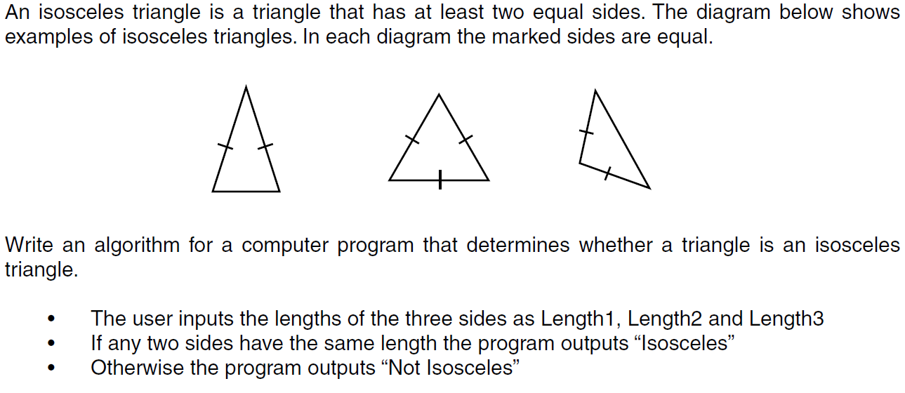

Write an algorithm for a computer program that determines whether a triangle in an isosceles triangle.

* The user inputs the lengths of the three sides as Length 1, Length 2 and Length 3
* If any two side have the same length the program outputs “Isosceles”
* Otherwise the program outputs “Not Isosceles”

### 

### Challenge 31

The student is writing an algorithm to solve a problem.

* The user will provide a series of numbers, representing the weights in grams of individual fruits.
* The weights are always **whole positive numbers**.
* The number of weights to be entered will also be provided by the user.
* The solution should calculate and report the **mean** weight of the fruits to **two decimal places**.

Two examples of the executing solution are shown below:

How many weights do you want to enter?

3

Enter a weight:

138

Enter a weight:

135

Enter a weight:

285

Average weight is: 186.00

How many weights do you want to enter?

4

Enter a weight:

279

Enter a weight:

135

Enter a weight:

145

Enter a weight:

138

Average weight is: 174.25

Write an algorithm for the process described above.

### Challenge 32:

Norma would like to invest her savings in a bank account that generates the most money. She would like a program that will allow her to:

* Enter the amount of money she wants to save.
* Input the number of bank accounts she wants to compare.
* Enter the interest rate for each account.
* The interest is calculated by dividing the money to be saved by 100 and then multiplying this by the interest rate.
* The total is calculated by adding the money to be saved to the interest and then outputted.
* The program should repeat this for all bank accounts.

Create an algorithm for the above actions.

### 

### Difficulty Level 7Difficulty 7 Challenges

### Challenge 33

Write an algorithm that:

* Ask the user to input how many GCSE’s they have.
* They should then be allowed to enter a result for each GCSE grade.
* The computer should work out how many points they have got (9=9, 8=8, 7=7 etc).
* If their score is 40 or over it should output ‘You can go to the sixth form’
* If they their score between 35 and 39 it should output ‘A discussion is needed’
* Otherwise it should say ‘Sorry not enough points.’

### Challenge 34

Roger has switched to a new electric supplier. He will receive free electric one day a week. He will not pay for the day that he uses the least amount of electric. Write an algorithm that will:

* Allow the user to input the day of the week and then unit of units of electric used.
* Compare them until all comparisons are completed.

Output the day that will be free of charge.

### Challenge 35

Write an algorithm that:

* Asks the user to **input** many cars are available for a trip.
* Asks the user to **input** how many people are going on the trip.
* If there are enough seats it should output ‘We have enough seats’
* If there are not enough seats it calculates how many extra cars are needed and then output ‘Another x cars are needed’ with x being the number of cars.

NOTE: Assume you can fit FIVE people in each car.

### 

### Difficulty level 8Difficulty 8 challenges

### Challenge 36

* Petrol costs £1.40 per litre. Diesel costs £1.55 per litre. LPG costs £0.95 per litre.
* Ask the user for which type of fuel their car uses and how much they have put into it.
* Calculate the correct price of the fuel they have taken.
* Ask how much money they have handed over and calculate the amount of change they are due.
* Finally, ask them if they have a loyalty card and if they do calculate how many points they should have added to it using the following – 1 point for every litre of fuel they’ve taken plus 1 point for every full pound they’ve paid.
* If the number of points they get is more than 100 they get a bonus 10% extra points.
* The number of points should then be outputted

### Challenge 37

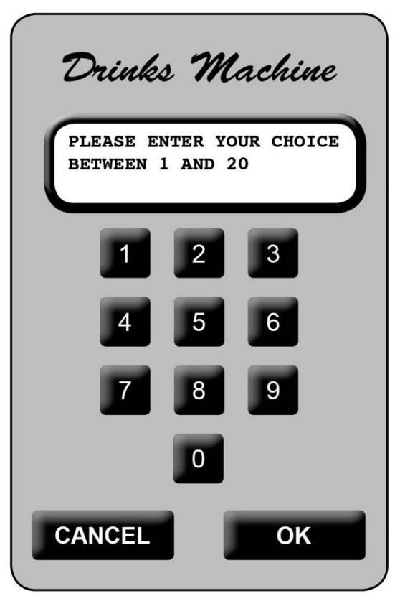A free drinks machine in an office provides 20 different drinks.

The machine has a small keypad with keys 0 to 9, OK and CANCEL. It also has a small LCD screen, which can display a short message.

To get a drink, users select an item number between 1 and 20 with the keypad and confirm their choice by pressing OK. If they make a mistake, they can press the CANCEL button and start again. If the selection is valid and the drink is available it dispenses the drink. The display screen is used to show suitable short messages throughout the process.

Write an algorithm of the process described above.

### Difficulty Level 9Difficulty 9 Challenges

### Challenge 38

The company also offers a saving plan. Customers pay a fixed amount each year into the savings plan. At the end of each year, the company adds the value of the savings plan at the start of the year to the amount paid, and then adds interest of 10% to obtain the final value for the year.

For example, if a customer saves £100 each year, the value of the savings plan for 5 years is shown in the table below.

|  |  |  |  |  |
| --- | --- | --- | --- | --- |
| Year | Start | Paid in | Interest | Final |
| 1 | 0.00 | 100.00 | 10.00 | 110.00 |
| 2 | 110.00 | 100.00 | 21.00 | 231.00 |
| 3 | 231.00 | 100.00 | 33.10 | 364.10 |
| 4 | 364.10 | 100.00 | 46.41 | 510.51 |
| 5 | 510.51 | 100.00 | 61.05 | 671.56 |

Write an algorithm which allows the user to input the amount saved each year and the number of years, and the outputs the growth of the savings plan in the format shown above.

### Challenge 39

A primary school teacher wants a computer program to test the basic arithmetic skills of her students. The program should generate a quiz consisting of a series of random questions, using in each case any two numbers and addition, subtraction and multiplication. The system should ask student’s name, then ask 10 questions, output if the answer to each question is correct or not and produce a final score out of 10.

Scores from the quiz should be stored and added to when a student takes a new quiz.

Write an algorithm for the process described above.

### Challenge Rating 10

### Challenge 40

Write an algorithm for a game of your choice that:

* Gives the user 3 lives at the start of the game.
* Allows the user to play the game until their have no lives left.
* They should move onto the next level for every 5 points they earn.
* The game is complete when they receive 20 points.
* At the end of the game it should tell the user which level they got up to.

We’d like to know your view on the resources we produce. Click ‘[Like’](mailto:resources.feedback@ocr.org.uk?subject=I%20liked%20the%20J277%20GCSE%20Computer%20Science%20Algorithm%20challenge%20booklet) or [‘Dislike’](mailto:resources.feedback@ocr.org.uk?subject=I%20disliked%20the%20J277%20GCSE%20Computer%20Science%20Algorithm%20challenge%20booklet) to send us an auto generated email about this resource. Add comments if you want to. Let us know how we can improve this resource or what else you need. Your email will not be used or shared for any marketing purposes.

Looking for another resource? There is now a quick and easy search [tool to help find free resources](http://www.ocr.org.uk/i-want-to/find-resources/) for your qualification.

**Resources**: the small print

OCR provides resources to help you deliver our qualifications. These resources do not represent any particular teaching method we expect you to use. We update our resources regularly and aim to make sure content is accurate but please check the OCR website so that you have the most up to date version. OCR cannot be held responsible for any errors or omissions in these resources.

Though we make every effort to check our resources, there may be contradictions between published support and the specification, so it is important that you always use information in the latest specification. We indicate any specification changes within the document itself, change the version number and provide a summary of the changes. If you do notice a discrepancy between the specification and a resource, please [contact us](mailto:resources.feeback@ocr.org.uk).

© OCR 2020 - You can copy and distribute this resource freely if you keep the OCR logo and this small print intact and you acknowledge OCR as the originator of the resource.

OCR acknowledges the use of the following content: N/A

Whether you already offer OCR qualifications, are new to OCR or are thinking about switching, you can request more information using our [Expression of Interest form](https://www.ocr.org.uk/qualifications/expression-of-interest/).

Please [get in touch](mailto:resources.feedback@ocr.org.uk) if you want to discuss the accessibility of resources we offer to support you in delivering our qualifications.