**Administrative Functions**

The Admin menu has received a new item named “Maintenance Work Operations”. This item contains some sub menu items that will provide more functionality for Admin’s to manage the Work Operations table. See Figure 1. *Please note that originally the* ***Add/Update*** *option was under the Forms/Activities menu.*

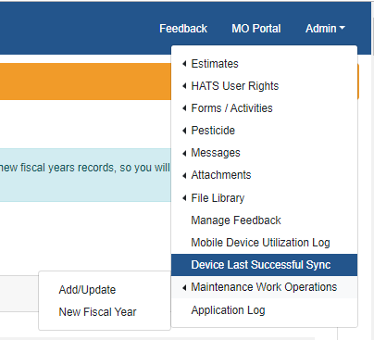

Figure

The “Add/Update” menu item is basically the old screen with a few changes to help manage work operations. The “New Fiscal Year” menu item is a new screen created to facilitate creating work operation for the new fiscal year. By having separate menu items, there is a clear separation of duties between minor changes and a completely new fiscal year.

**Add/Update Changes**

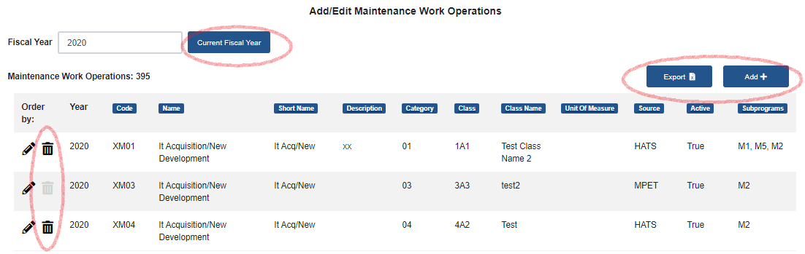

Figure

The changes to this screen are mostly cosmetic. The red circles in Figure 2 show the key changes. First the “Current Fiscal Year” button will always set your search filter to the current fiscal year. If you change the value in the “Fiscal Year” input box, you will see the list change and display data (if any) for the year entered. The “Export” button has moved and the addition of the “Add” button will facilitate new entries into the Work Operations Table. The Add dialog will appear after you click the button and you must save the changes to add the record to the table. The addition of a trash can in the list will allow you to remove a work operation from the table. There are two types of trash cans black and light grey. These colors represent whether you can remove the item or not. If a work operation is black, it can be removed. If its light grey, it’s associated to an activity it cannot be removed. The only way you can remove it is to break the association. This would require using the Admin>Forms/Activity>Feature Activities Screen to update the activity. That about sums up the changes to this screen.

**New Fiscal Year Screen**

This screen is intended to be used at the end of a fiscal year. This is when you want to create new Work Operations for the new fiscal year. Traditionally all these records (currently 392) had to be manually added one by one through the add screen. With this new screen, it will automatically copy the previous year’s data to the new fiscal year. Not only does it copy them, it will also wire them up to their associate activities. For this reason, you would want to perform this process as late in the fiscal year and you can. Here’s how it works.

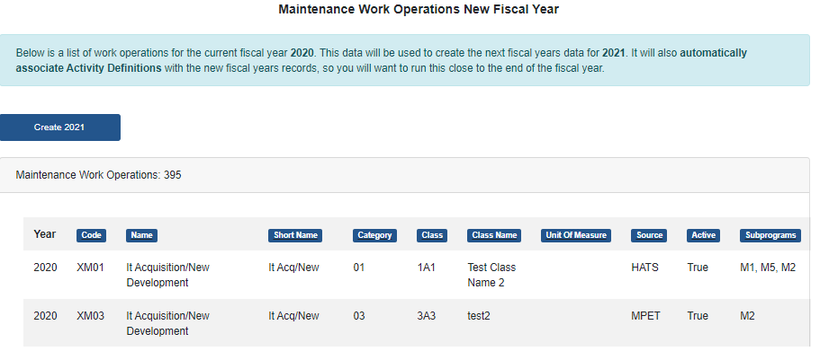

Figure

Figure 3 shows how the screen will work when it’s possible to create fiscal year data. There will be a “Create YYYY” button available and the list below will display the current fiscal year data. This is the data that will be cloned to create the new fiscal year’s data. In Figure 3, the current date is November 14th 2019, which makes the current fiscal year 2020, and the next fiscal year 2021. If you aren’t clear on what’s going to happen when you click on the button, read the information message. After you create the 2021 data, you get a success message and the button and list will no longer appear. No further actions are necessary on this screen.

If you refresh the screen or leave and reenter, the screen will look different. No button will appear and the list will be empty. Please read the information message. This means that new fiscal year data cannot be created. Criteria for creating new fiscal year data.

* Must be within a year of the current fiscal year.

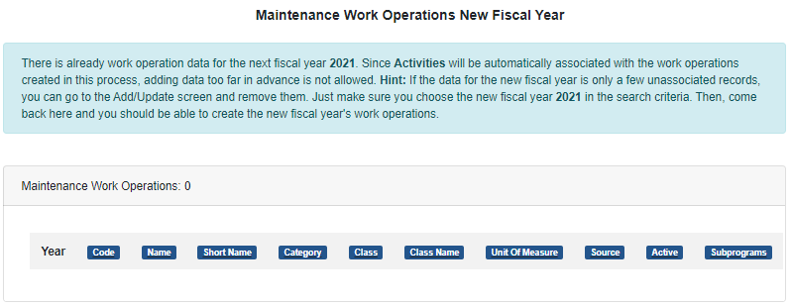

* Must not be any data present for the new fiscal year being created (not even one record).

You can verify the above conditions by navigating to the Add/Update screen and changing the fiscal year input box to new fiscal year. If data is present it will appear. The screens newly added functionality should help clean up any abnormalities. Once all the data for the new fiscal year is removed you can return to the “New Fiscal Year” screen and complete your mission. If there is already a lot of data present, then an Admin has already ran this process or added them manually, for the new fiscal year and it doesn’t need to be ran.