HC Cable User Guide Version 3.0

Revisions

|  |  |  |
| --- | --- | --- |
| 01/11/2012 | Brice | NOAA changed the procedure for downloading annual tide data as well as the format of the data. Updated HC_TIDE program and documented new procedures for downloading the tide data. |
| 01/14/2020 | Brice | NOAA changed the procedure for downloading annual tide data as well as the format of the data. Updated HC_TIDE program and documented new procedures for downloading the tide data.  Removed Windows Mobile device version of the software as it is no longer used.  Added date calculation mode to HC Cable.  Added command line options to HC Tide. |

# Introduction

This manual describes the installation and use of HC Tides and HC Cable; software programs for predicting tide data and anchor cable pressure gauge readings for the Hood Canal Floating Bridge. HC Tides downloads annual high/low tide predictions from NOAA for Seattle, WA, adjusts them to Port Gamble, WA, and estimates tidal elevations on 10 minute intervals. Tide predictions are used by the HC Cable program to predict anchor cable pressure gauge readings.

# Software Installation

The HC Cable program is installed using the HC_Cable.msi file located in J:\Installs\HC_Cable.

# Running HC Tides

HC Tides must be run before using HC Cable for the first time.

HC Tides generates the tide prediction data for HC Cable. Run HC Tides once annually in December or January to update the tide predictions for the next year.

Run HC Tides by selecting **Start > HC Cable > HC Tides**. This will run the program with default settings. HC Tides will download the current year (if the date is on or after December 15, the next year) annual high/low tide predictions for the Seattle station (Station ID: 9447130) from NOAA (<https://tidesandcurrents.noaa.gov>). The high/low tide predictions are adjusted to Port Gamble, WA using the following factors:

|  |  |
| --- | --- |
| Tide | Correction Factor |
| High Level | Seattle times 0.90 |
| High Time | Seattle minus 9 minutes |
| Low Level | Seattle times 0.95 |
| Low Time | Seattle minus 5 minutes |

Ten minute tide elevations are computed for each month of the year and stored in files with the names PortGamble_mm_yyyy.tides, where mm is the two digit month number and yyyy is the year. Tide prediction files are stored in C:\ProgramData\HC_Tides.

## HC Tides Options

HC Tides can be run from the command line. Tidal predictions can be adjusted with command line options.

|  |  |
| --- | --- |
| Option | Description |
| <blank> | Uses the default options |
| help | List the command line options |
| year | Year, with century, for tidal predictions. Default: current year, or following year if the current day is December 15 or later. |
| id | Tide station id. Default: 9447130 |
| htf | High tide factor. High tide is the high tide from the tide station data multiplied by this value. Default: 0.90 |
| hto | High tide offset (minutes). High tide times are the high tide time at the tide station plus this time offset. Default: -9 minutes |
| ltf | Low tide factor. Low tide is the low tide from the tide station data multiplied by this value. Default: 0.95 |
| lto | Low tide offset (minutes). Low tide times are the low tide time at the tide station plus this time offset. Default: -5 minutes |

### Examples

|  |  |
| --- | --- |
| Command | Description |
| hc_tides.exe --help | Displays the command line options |
| hc_tides.exe --year 2019 | Generates tidal predictions for 2019 |
| Hc_tides.exe --hto -10 --lto 6 | Generates tidal predictions for the current year with high tides occurring 10 minutes before and low tides occurring 6 minutes after they occur at the tide station |

# Running HC Cable

Before running HC Cable for the first time, run HC Tides to create the tide data files.

HC Cable has three modes of operation; Real-Time Mode, Date/Time Mode, and Elevation Mode. In Real-Time Mode, predicted cable gauge pressures are automatically computed on a 10 minute interval. In Date/Time Mode, predicted cable gauge pressures are computed for a specified date and time. In Elevation Mode (previously known as Static Mode), a tidal elevation is input and the corresponding cable gauge pressure predictions are computed.

Run HC Cable by selecting **Start > HC Cable > HC Cable**. This will start the program in Real-Time Mode as shown below. The main window displays predicted gauge pressures for cables, the current date and time (black text), and the prediction time and tide (red text).

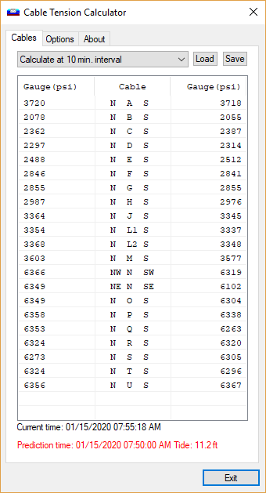

Use the mode selector to switch to Date/Time Mode or Elevation Mode.

In Date/Time Mode, enter a date and time for the gauge pressure predictions. The date and time can be entered directly into the input box. Additionally, press the down arrow on the right edge of the input box to select a date from a calendar. Press [Update] to update the gauge pressure predictions. Note that the tide file for the selected date must be loaded. See Options below.

In Elevation Mode, enter a tide elevation and press [Update] to update the gauge pressure predictions. Note that the current date and time do not factor into the calculations for this mode.

## Recording Gauge Readings

The gauge readings can be recorded in HC Cable and saved for later analysis. To record a gauge reading, double click on a row in the cable list. This will open the Record Cable Tensions window.

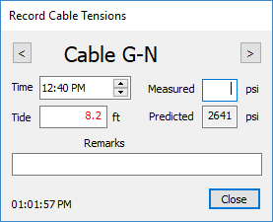

Enter the measured gauge pressure and an optional remark. You can adjust the tide time and predicted tide elevation by entering appropriate values.

Use the [<] and [>] buttons to switch to the previous and next cable, respectively. Once you move from a cable record it becomes locked. If you return to a record, call of the fields will be disabled. This is to prevent accidental overwriting of data input.

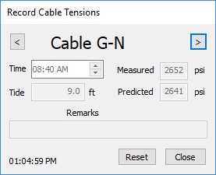

To unlock the record, press [Reset].

To delete a record, remove the value from the Measured field.

An asterisks (*) symbol will be displayed in the cable list to indicate that data has been recorded for a particular cable.

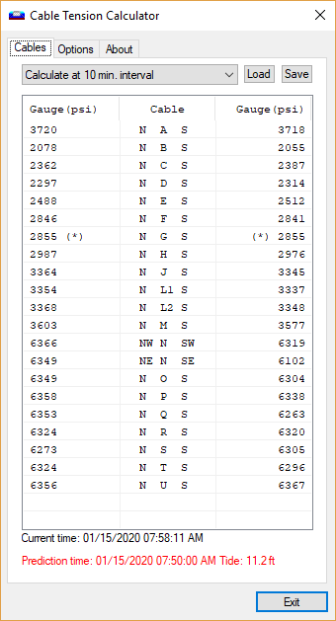

Press [Save] to save the data for further analysis. Details of the data file are given below.

Press [Load] to load previously saved cable records.

## Daylight Saving Time

HC Cable automatically adjusted for daylight saving time.

## Options

The location of the Cable File and Tide File are specified on the Options tab.

The Cable File specifies the cables and their geometric parameters. This file is installed with the software and typically will not need to be changed.

The Tide File provides 10 minute tide data for a one month period. The tide files are generated by the HC Tides program. When computing cable gauge pressure predictions for a specified date and time in Date/Time Mode, make sure the current tide file includes the specified date. For example, if the specified date is 01/21/2018, the tide file should be PortGamble_01_2018.tides. Tide files are stored in C:\ProgramData\HC_Tides.

# Cable Tension Data File

The cable tension data file is a text file containing comma delimited data. The data fields are:

* Cable Identifier
* Date of gauge reading
* Time of gauge reading in local standard time
* Tide at time of gauge reading
* Predicted gauge reading
* Time of actual gauge reading in local standard time
* Actual gauge reading
* Remarks

If a gauge reading was not recorded, the actual gauge reading field will contain a value of -1.