Bridge Data Modeling for Interoperability;
Bridge Data Protocols for Interoperability and Life Cycle Management
S. S. Chen, Ph.D., P.E. bridgedataguy@gmail.com
AASHTO/NSBA TG-15
FHWA DTFH61-11-RA-00010 Task 12
https://www.transportationresearch.gov/dot/fhwa/SitePages/register.aspx
for assistance: email to rohit.srikonda@gmail.com

What is rapidly becoming arguably the single most important need in our information technology enabled era must be the advancement of communication (interoperability) among various stakeholders in the still-all-too-fragmented bridge industry. In our increasingly resource-constrained era, building bridges will require closer collaboration among planners, engineers, fabricators, constructors, and owners. The mere “electronifying” of conventional written documents and engineering drawings will not suffice to bring effective data re-use and information integration to streamline the process with maximal efficiency.

Due to the lack of data interoperability, it is known that all stakeholders in the related capital facilities industry – designers, contractors, product suppliers and owners – are wasting a huge amount of money. Specifically, in a NIST report, Cost Analysis of Inadequate Interoperability in the U.S. Capital Facilities Industry (2004), it is estimated that operations and maintenance personnel spent US $4.8 billion during 2002, verifying that documentation accurately represented existing conditions, and another US $613 million transferring that information into a useful format.

This research will develop, implement and demonstrate an efficient and robust digital data protocol that could be used to automate the exchange of bridge information in the design, detailing, fabrication, construction, inspection, and evaluation. This data protocol would be public domain and provide the relevant information that requires exchange on the bridge from “cradle to grave.” The data exchange protocol would be made software neutral, but is to be developed with consideration of relevant software solution providers to facilitate their development of conforming translators to automate the transfer of data among software applications. Focus shall be placed on common “workhorse” steel and concrete girder bridge structures.
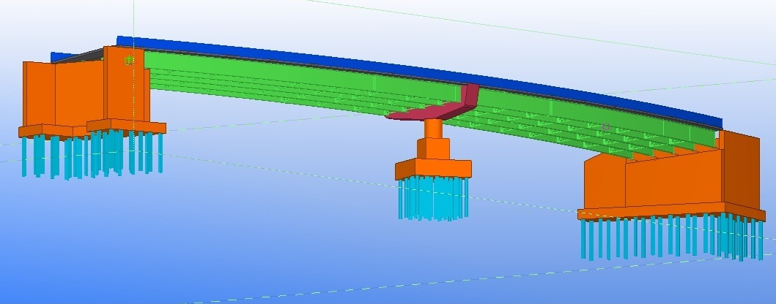

i.e., towards info exchange standards to get models at different stages to “talk to each other”

Highway-compliant geometry  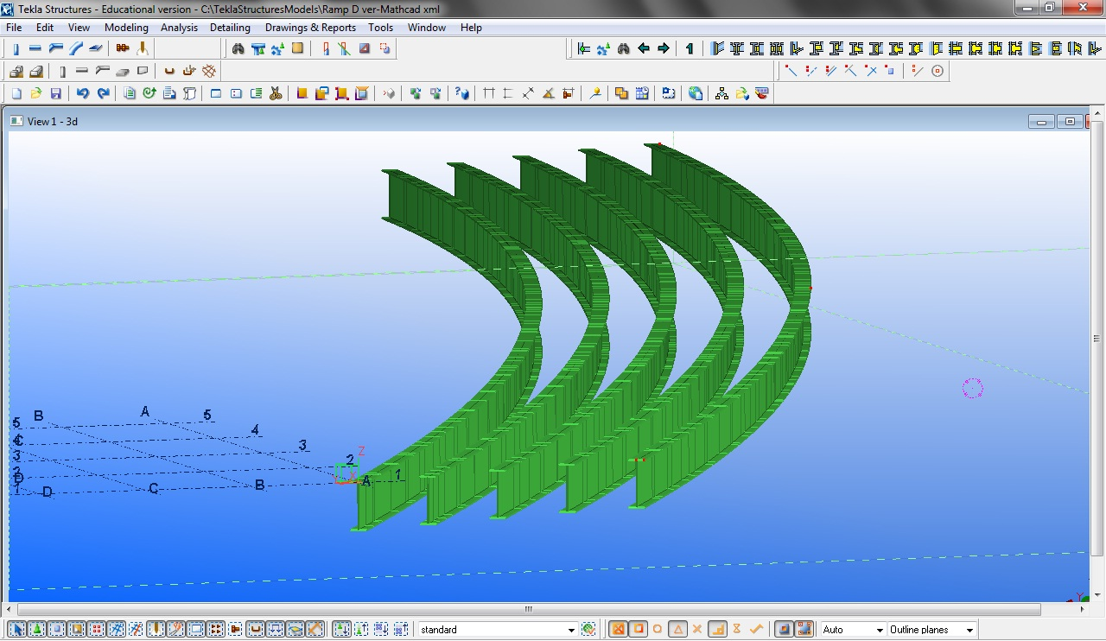 | Analysis Model  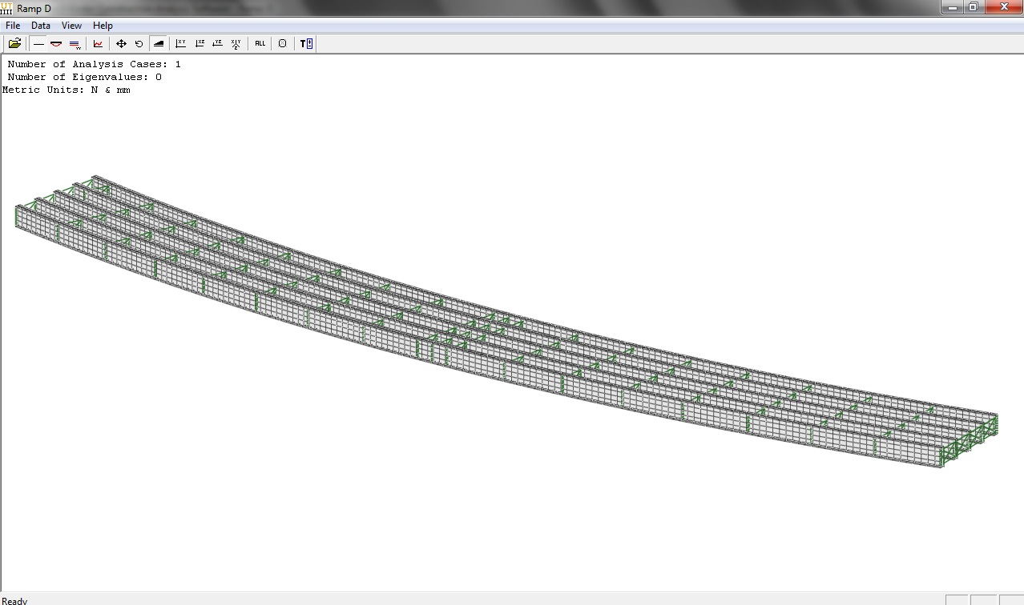
Physical Model  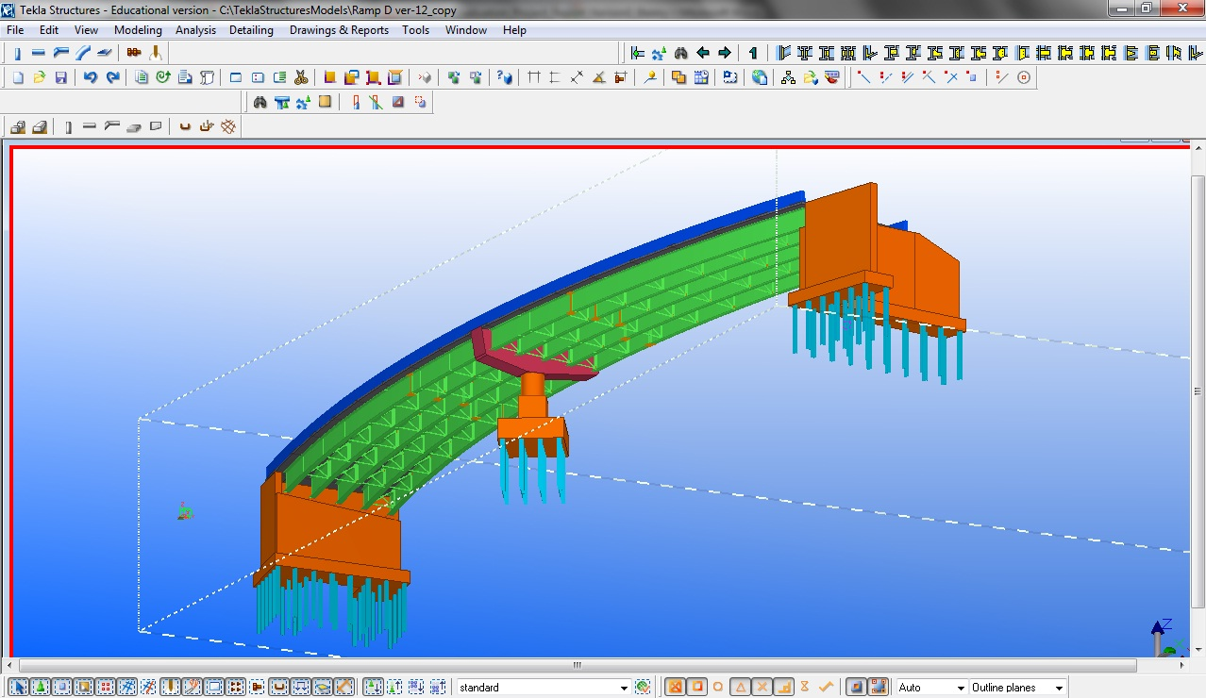 | Detailing Model  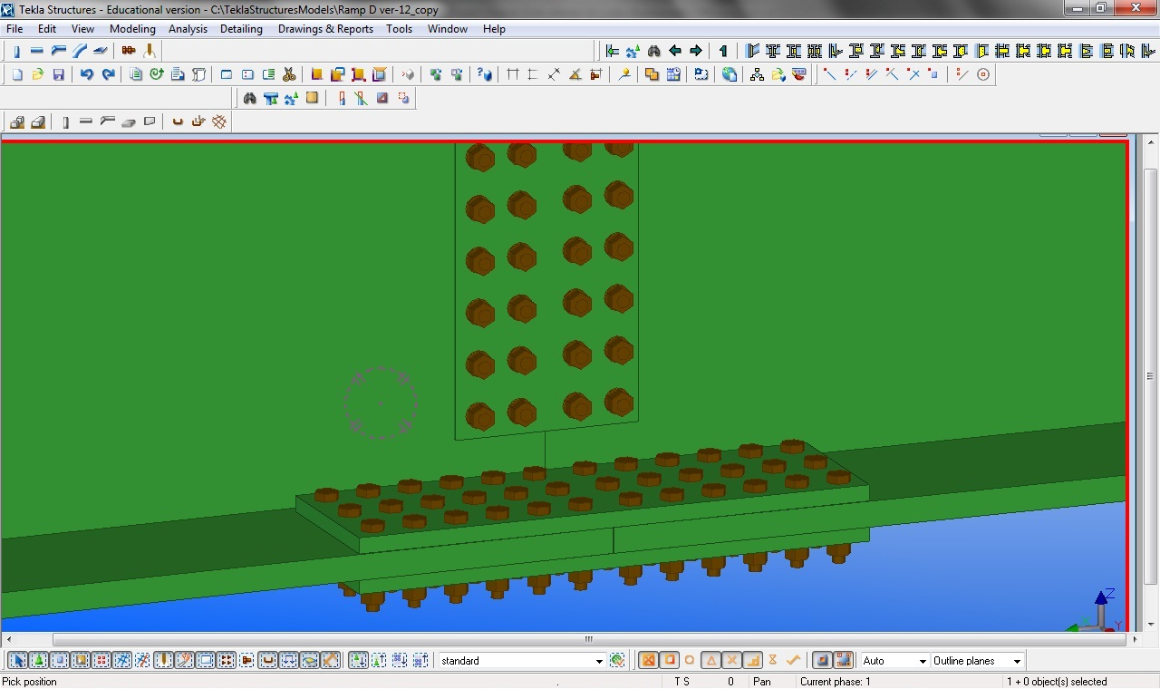
Erection Model(s)  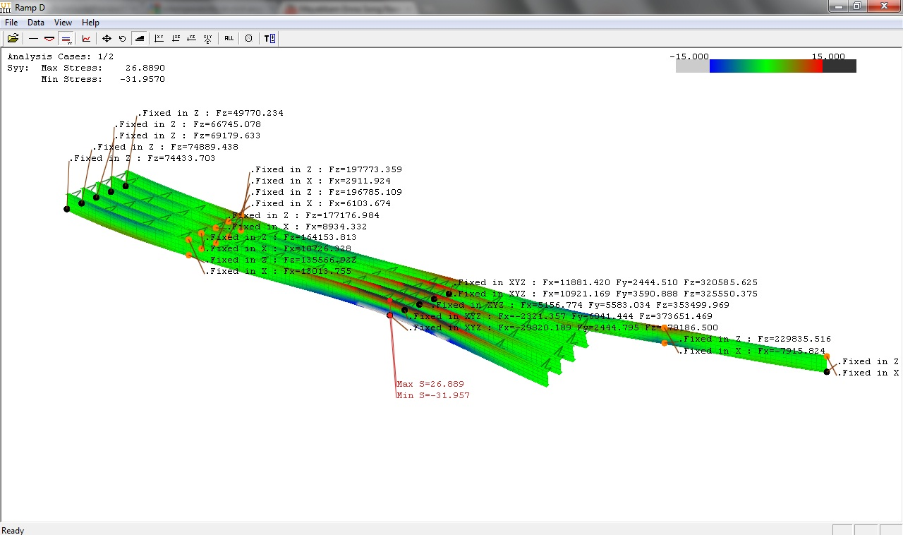 | And Into Asset Management  