Schema LandXML-1.0.xsd

schema location: | http://www.landxml.org/schema/LandXML-1.0.xsd
targetNamespace: | http://www.landxml.org/schema/LandXML-1.0

Elements | Complex types | Simple types
AdverseSE | PointType | adverseSEType
Alignment | PointType3dReq | alignmentNameRef
Alignments |  | alignmentNameRefs
Application |  | angle
Author |  | angularType
Backsight |  | beaconProtectionType
BacksightPoint |  | beaconType
BeginRunoffSta |  | bridgeProjectType
BeginRunoutSta |  | cgPointsNameRef
BikeFacilities |  | cgPointsNameRefs
Boundaries |  | ChainType
Boundary |  | clockwise
Breakline |  | coordGeomNameRef
Breaklines |  | coordGeomNameRefs
BridgeElement |  | cornerType
Center |  | crashIntersectionRelation
CgPoint |  | crashSeverityType
CgPoints |  | crossSectionPnt
Chain |  | crossSlope
Channel |  | curbType
CircCurve |  | curveType
CircPipe |  | direction
CircStruct |  | ditchBottomShape
Classification |  | drivewayDensity
ClimbLane |  | DTMAttributeType
Connection |  | equipmentType
Contour |  | FaceType
Contours |  | functionalClassType
ControlChecks |  | GPSSolutionFrequencyEnum
CoordGeom |  | GPSSolutionTypeEnum
CoordinateSystem |  | GPSTime
Corner |  | gradeModelNameRef
Corrections |  | gradeModelNameRefs
CrashData |  | impArea
CrashHistory |  | impDiameter
CrossSect |  | impFlow
CrossSects |  | impHeight
CrossSectSurf |  | impLinear
Curb |  | impPressure
Curve |  | impTemperature
DailyTrafficVolume |  | impVelocity
DataPoints |  | impVolume
DecisionSightDistance |  | impWidth
Definition |  | inOut
DesignHour |  | intersectionConstructionType
DesignSpeed |  | laneTaperType
DesignSpeed85th |  | maneuverType
Ditch |  | metArea
DrivewayDensity |  | metDiameter
ElliPipe |  | metFlow
End |  | metHeight
EndofRunoutSta |  | metLinear
Equipment |  | metPressure
F |  | metTemperature
Faces |  | metVelocity
Feature |  | metVolume
FieldNote |  | metWidth
FullSuperelev |  | monumentCategory
FullSuperSta |  | monumentCondition
GPSAntennaDetails |  | monumentNameRef
GPSPosition |  | monumentPurpose
GPSQCInfoLevel1 |  | monumentState
GPSQCInfoLevel2 |  | monumentType
GPSReceiverDetails |  | observationType
GPSSetup |  | offsetDistance
GPSVector |  | offsetElevation
GradeModel |  | parcelClass
GradeSurface |  | parcelNameRef
HazardRating |  | parcelNameRefs
Imperial |  | parcelStateType
InletStruct |  | pavementSurfaceType
InstrumentDetails |  | pipeNameRef
InstrumentPoint |  | pipeNameRefs
InstrumentSetup |  | pipeNetworkType
Intersection |  | Point
Intersections |  | Point2dReq
Invert |  | Point3dOpt
IrregularLine |  | Point3dReq
LandXML |  | pointGeometryType
Lanes |  | pointNameRef
LaserDetails |  | pointNameRefs
LaserSetup |  | purposeType
Line |  | roadSignType
Location |  | roadTerrainType
MapPoint |  | roadwayNameRef
Metric |  | roadwayNameRefs
Monument |  | shoulderCategoryType
Monuments |  | shoulderMaterialType
NoPassingZone |  | sideofRoadType
ObservationGroup |  | sideType
ObstructionOffset |  | slope
OffsetLane |  | speed
OffsetVals |  | spiralType
Outlet |  | stateType
OutletStruct |  | station
P |  | structNameRef
ParaCurve |  | structNameRefs
Parcel |  | surfaceNameRef
Parcels |  | surfaceNameRefs
PassingLane |  | surfBndType
PeakHour |  | surfFaceType
Personnel |  | surfTypeEnum
PI |  | surfVolCMethodType
Pipe |  | surveyRoleType
PipeFlow |  | surveyType
PipeNetwork |  | survPntType
PipeNetworks |  | trafficControlPosition
Pipes |  | trafficControlType
PlanFeature |  | trafficTurnRestriction
PlanFeatures |  | turnLaneType
PntList2D |  | waterShedNameRef
PntList3D |  | xsVolCalcMethodType
Pnts |  | zoneCategoryType
PointFile |  | zoneHingeType
PointFiles |  | zoneMaterialType
PointResults |  | zoneNumberType
PostedSpeed |  | zoneOffsetType
ProfAlign |  | zonePlacementType
Profile |  | zoneSurfaceType
ProfSurf |  | zoneTransitionType
Project |  | zoneVertType
Property
PVI
RawObservation
RectPipe
RectStruct
ReducedArcObservation
ReducedObservation
RetWall
RetWallPnt
Roadside
RoadSign
Roadway
Roadways
RunoffSta
SourceData
Speeds
Spiral
StaEquation
Start
StartofRunoutSta
Struct
StructFlow
Structs
Superelevation
Surface
Surfaces
SurfVolume
SurfVolumes
Survey
SurveyHeader
SurveyMonument
TargetPoint
TargetSetup
ThruLane
Timing
Title
TrafficControl
TrafficVolume
TurnLane
TurnRestriction
TurnSpeed
TwoWayLeftTurnLane
Units
UnsymParaCurve
Volume
Watershed
Watersheds
WideningLane
Zone
ZoneCrossSectStructure
ZoneCutFill
ZoneHinge
ZoneMaterial
Zones
ZoneSlope
ZoneWidth

element AdverseSE
diagram | 
namespace | http://www.landxml.org/schema/LandXML-1.0
type | adverseSEType
used by
  element | Superelevation
facets
  enumeration | non-adverse
  enumeration | adverse
source | <xs:element name="AdverseSE" type="adverseSEType"/>

element Alignment
diagram | 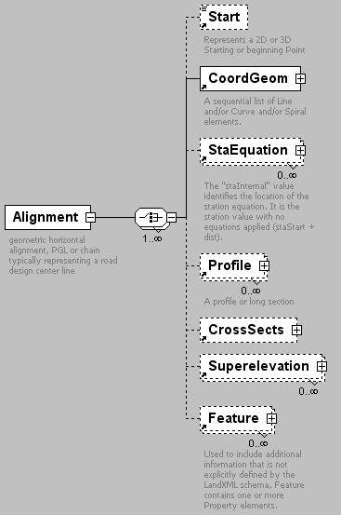
namespace | http://www.landxml.org/schema/LandXML-1.0
children | Start CoordGeom StaEquation Profile CrossSects Superelevation Feature
used by
  element | Alignments
attributes
  Name | Type | Use | Default | Fixed | Annotation
  name | xs:string | required
  length | xs:double | required
  staStart | xs:double | required
  desc | xs:string
  oID | xs:string
  state | stateType
annotation
  documentation | geometric horizontal alignment, PGL or chain typically representing a road design center line
source | <xs:element name="Alignment">  <xs:annotation>  <xs:documentation>geometric horizontal alignment, PGL or chain typically representing a road design center line</xs:documentation>  </xs:annotation>  <xs:complexType>  <xs:choice maxOccurs="unbounded">  <xs:element ref="Start" minOccurs="0"/>  <xs:element ref="CoordGeom"/>  <xs:element ref="StaEquation" minOccurs="0" maxOccurs="unbounded"/>  <xs:element ref="Profile" minOccurs="0" maxOccurs="unbounded"/>  <xs:element ref="CrossSects" minOccurs="0"/>  <xs:element ref="Superelevation" minOccurs="0" maxOccurs="unbounded"/>  <xs:element ref="Feature" minOccurs="0" maxOccurs="unbounded"/>  </xs:choice>  <xs:attribute name="name" type="xs:string" use="required"/>  <xs:attribute name="length" type="xs:double" use="required"/>  <xs:attribute name="staStart" type="xs:double" use="required"/>  <xs:attribute name="desc" type="xs:string"/>  <xs:attribute name="oID" type="xs:string"/>  <xs:attribute name="state" type="stateType"/>  </xs:complexType>  </xs:element>

element Alignments
diagram | 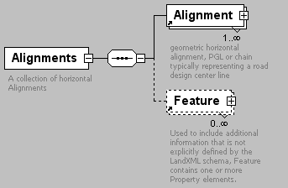
namespace | http://www.landxml.org/schema/LandXML-1.0
children | Alignment Feature
used by
  element | LandXML
attributes
  Name | Type | Use | Default | Fixed | Annotation
  desc | xs:string
  name | xs:string
  state | stateType
annotation
  documentation | A collection of horizontal Alignments
source | <xs:element name="Alignments">  <xs:annotation>  <xs:documentation>A collection of horizontal Alignments</xs:documentation>  </xs:annotation>  <xs:complexType>  <xs:sequence>  <xs:element ref="Alignment" maxOccurs="unbounded"/>  <xs:element ref="Feature" minOccurs="0" maxOccurs="unbounded"/>  </xs:sequence>  <xs:attribute name="desc" type="xs:string"/>  <xs:attribute name="name" type="xs:string"/>  <xs:attribute name="state" type="stateType"/>  </xs:complexType>  </xs:element>

element Application
diagram | 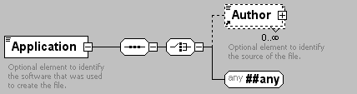
namespace | http://www.landxml.org/schema/LandXML-1.0
children | Author
used by
  element | LandXML
attributes
  Name | Type | Use | Default | Fixed | Annotation
  name | xs:string | required
  desc | xs:string
  manufacturer | xs:string
  version | xs:string
  manufacturerURL | xs:string
  timeStamp | xs:dateTime | optional
annotation
  documentation | Optional element to identify the software that was used to create the file.
source | <xs:element name="Application">  <xs:annotation>  <xs:documentation>Optional element to identify the software that was used to create the file.</xs:documentation>  </xs:annotation>  <xs:complexType mixed="true">  <xs:sequence>  <xs:choice>  <xs:element ref="Author" minOccurs="0" maxOccurs="unbounded"/>  <xs:any namespace="##any" processContents="skip"/>  </xs:choice>  </xs:sequence>  <xs:attribute name="name" type="xs:string" use="required"/>  <xs:attribute name="desc" type="xs:string"/>  <xs:attribute name="manufacturer" type="xs:string"/>  <xs:attribute name="version" type="xs:string"/>  <xs:attribute name="manufacturerURL" type="xs:string"/>  <xs:attribute name="timeStamp" type="xs:dateTime" use="optional"/>  </xs:complexType>  </xs:element>

element Author
diagram | 
namespace | http://www.landxml.org/schema/LandXML-1.0
used by
  element | Application
attributes
  Name | Type | Use | Default | Fixed | Annotation
  createdBy | xs:string
  createdByEmail | xs:string
  company | xs:string
  companyURL | xs:string
  timeStamp | xs:dateTime | optional
annotation
  documentation | Optional element to identify the source of the file.
source | <xs:element name="Author">  <xs:annotation>  <xs:documentation>Optional element to identify the source of the file.</xs:documentation>  </xs:annotation>  <xs:complexType mixed="true">  <xs:sequence>  <xs:any namespace="##any" processContents="skip"/>  </xs:sequence>  <xs:attribute name="createdBy" type="xs:string"/>  <xs:attribute name="createdByEmail" type="xs:string"/>  <xs:attribute name="company" type="xs:string"/>  <xs:attribute name="companyURL" type="xs:string"/>  <xs:attribute name="timeStamp" type="xs:dateTime" use="optional"/>  </xs:complexType>  </xs:element>

element Backsight
diagram | 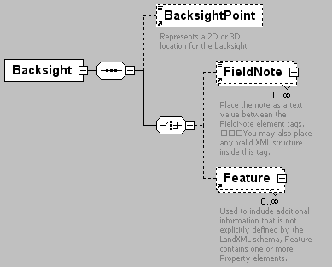
namespace | http://www.landxml.org/schema/LandXML-1.0
children | BacksightPoint FieldNote Feature
used by
  elements | InstrumentSetup LaserSetup ObservationGroup
attributes
  Name | Type | Use | Default | Fixed | Annotation
  id | xs:ID
  azimuth | direction
  targetHeight | xs:double
  circle | angle | required
  setupID | xs:IDREF
source | <xs:element name="Backsight">  <xs:annotation>  <xs:documentation/>  </xs:annotation>  <xs:complexType>  <xs:sequence>  <xs:element ref="BacksightPoint" minOccurs="0"/>  <xs:choice>  <xs:element ref="FieldNote" minOccurs="0" maxOccurs="unbounded"/>  <xs:element ref="Feature" minOccurs="0" maxOccurs="unbounded"/>  </xs:choice>  </xs:sequence>  <xs:attribute name="id" type="xs:ID"/>  <xs:attribute name="azimuth" type="direction"/>  <xs:attribute name="targetHeight" type="xs:double"/>  <xs:attribute name="circle" type="angle" use="required"/>  <xs:attribute name="setupID" type="xs:IDREF"/>  </xs:complexType>  </xs:element>

element BacksightPoint
diagram | 
namespace | http://www.landxml.org/schema/LandXML-1.0
type | PointType
used by
  element | Backsight
facets
  minLength | 0
  maxLength | 3
attributes
  Name | Type | Use | Default | Fixed | Annotation
  name | xs:string
  desc | xs:string
  code | xs:string
  state | stateType
  pntRef | pointNameRef
  pointGeometry | pointGeometryType
  DTMAttribute | DTMAttributeType
  timeStamp | xs:dateTime | optional
  role | surveyRoleType | optional
annotation
  documentation | Represents a 2D or 3D location for the backsight
  documentation | It is defined by either a coordinate text value ("north east" or "north east elev") or a CgPoint number reference "pntRef" attribute.
source | <xs:element name="BacksightPoint" type="PointType">  <xs:annotation>  <xs:documentation>Represents a 2D or 3D location for the backsight</xs:documentation>  <xs:documentation>It is defined by either a coordinate text value ("north east" or "north east elev") or a CgPoint number reference "pntRef" attribute.</xs:documentation>  </xs:annotation>  </xs:element>

element BeginRunoffSta
diagram | 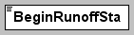
namespace | http://www.landxml.org/schema/LandXML-1.0
type | station
used by
  element | Superelevation
source | <xs:element name="BeginRunoffSta" type="station" nillable="true"/>

element BeginRunoutSta
diagram | 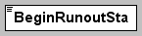
namespace | http://www.landxml.org/schema/LandXML-1.0
type | station
used by
  element | Superelevation
source | <xs:element name="BeginRunoutSta" type="station" nillable="true"/>

element BikeFacilities
diagram | 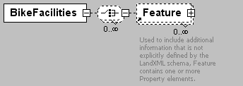
namespace | http://www.landxml.org/schema/LandXML-1.0
children | Feature
used by
  element | Roadside
attributes
  Name | Type | Use | Default | Fixed | Annotation
  staStart | station
  staEnd | station
  width | xs:double
  sideofRoad | sideofRoadType
source | <xs:element name="BikeFacilities">  <xs:complexType>  <xs:choice minOccurs="0" maxOccurs="unbounded">  <xs:element ref="Feature" minOccurs="0" maxOccurs="unbounded"/>  </xs:choice>  <xs:attribute name="staStart" type="station"/>  <xs:attribute name="staEnd" type="station"/>  <xs:attribute name="width" type="xs:double"/>  <xs:attribute name="sideofRoad" type="sideofRoadType"/>  </xs:complexType>  </xs:element>

element Boundaries
diagram | 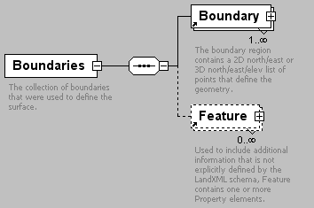
namespace | http://www.landxml.org/schema/LandXML-1.0
children | Boundary Feature
used by
  element | SourceData
annotation
  documentation | The collection of boundaries that were used to define the surface.
  documentation | Use is optional.
source | <xs:element name="Boundaries">  <xs:annotation>  <xs:documentation>The collection of boundaries that were used to define the surface.</xs:documentation>  <xs:documentation>Use is optional.</xs:documentation>  </xs:annotation>  <xs:complexType>  <xs:sequence>  <xs:element ref="Boundary" maxOccurs="unbounded"/>  <xs:element ref="Feature" minOccurs="0" maxOccurs="unbounded"/>  </xs:sequence>  </xs:complexType>  </xs:element>

element Boundary
diagram | 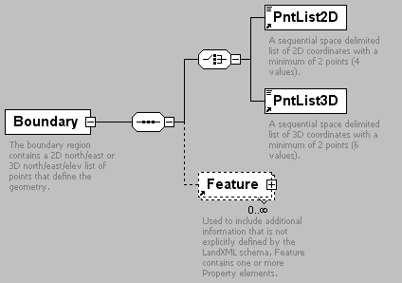
namespace | http://www.landxml.org/schema/LandXML-1.0
children | PntList2D PntList3D Feature
used by
  element | Boundaries
attributes
  Name | Type | Use | Default | Fixed | Annotation
  bndType | surfBndType | required
  edgeTrim | xs:boolean | required
  area | xs:double
  desc | xs:string
  name | xs:string
  state | stateType
annotation
  documentation | The boundary region contains a 2D north/east or 3D north/east/elev list of points that define the geometry.
  documentation | is identified by the "name" attribute.
  documentation | If the "edgeTrim" attribute is true the faces are trimmed at the boundary edge, otherwise faces are not trimmed
  documentation | and must exist entirely within the boundary.
source | <xs:element name="Boundary">  <xs:annotation>  <xs:documentation>The boundary region contains a 2D north/east or 3D north/east/elev list of points that define the geometry.</xs:documentation>  <xs:documentation>is identified by the "name" attribute.</xs:documentation>  <xs:documentation>If the "edgeTrim" attribute is true the faces are trimmed at the boundary edge, otherwise faces are not trimmed</xs:documentation>  <xs:documentation>and must exist entirely within the boundary.</xs:documentation>  </xs:annotation>  <xs:complexType>  <xs:sequence>  <xs:choice>  <xs:element ref="PntList2D"/>  <xs:element ref="PntList3D"/>  <!-- Here PntList2D represents 2D planametric coordinate pairs expressed as space delimited Northing Easting pairs. -->  </xs:choice>  <xs:element ref="Feature" minOccurs="0" maxOccurs="unbounded"/>  </xs:sequence>  <xs:attribute name="bndType" type="surfBndType" use="required"/>  <xs:attribute name="edgeTrim" type="xs:boolean" use="required"/>  <xs:attribute name="area" type="xs:double"/>  <xs:attribute name="desc" type="xs:string"/>  <xs:attribute name="name" type="xs:string"/>  <xs:attribute name="state" type="stateType"/>  </xs:complexType>  </xs:element>

element Breakline
diagram | 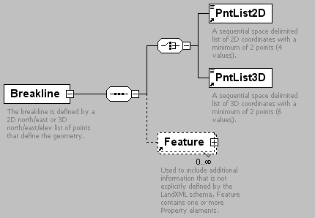
namespace | http://www.landxml.org/schema/LandXML-1.0
children | PntList2D PntList3D Feature
used by
  element | Breaklines
attributes
  Name | Type | Use | Default | Fixed | Annotation
  brkType |  | required
  desc | xs:string
  name | xs:string
  state | stateType
annotation
  documentation | The breakline is defined by a 2D north/east or 3D north/east/elev list of points that define the geometry.
  documentation | is identified by the "name" attribute.
source | <xs:element name="Breakline">  <xs:annotation>  <xs:documentation>The breakline is defined by a 2D north/east or 3D north/east/elev list of points that define the geometry.</xs:documentation>  <xs:documentation>is identified by the "name" attribute.</xs:documentation>  </xs:annotation>  <xs:complexType>  <xs:sequence>  <xs:choice>  <xs:element ref="PntList2D"/>  <xs:element ref="PntList3D"/>  <!-- Here PntList2D represents 2D planametric coordinate pairs expressed as space delimited Northing Easting pairs. -->  </xs:choice>  <xs:element ref="Feature" minOccurs="0" maxOccurs="unbounded"/>  </xs:sequence>  <xs:attribute name="brkType" use="required"/>  <xs:attribute name="desc" type="xs:string"/>  <xs:attribute name="name" type="xs:string"/>  <xs:attribute name="state" type="stateType"/>  </xs:complexType>  </xs:element>

element Breaklines
diagram | 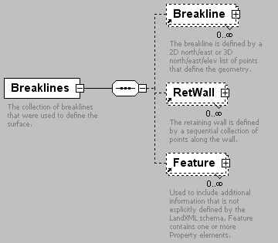
namespace | http://www.landxml.org/schema/LandXML-1.0
children | Breakline RetWall Feature
used by
  element | SourceData
annotation
  documentation | The collection of breaklines that were used to define the surface.
  documentation | Use is optional.
source | <xs:element name="Breaklines">  <xs:annotation>  <xs:documentation>The collection of breaklines that were used to define the surface.</xs:documentation>  <xs:documentation>Use is optional.</xs:documentation>  </xs:annotation>  <xs:complexType>  <xs:sequence>  <xs:element ref="Breakline" minOccurs="0" maxOccurs="unbounded"/>  <xs:element ref="RetWall" minOccurs="0" maxOccurs="unbounded"/>  <xs:element ref="Feature" minOccurs="0" maxOccurs="unbounded"/>  </xs:sequence>  </xs:complexType>  </xs:element>

element BridgeElement
diagram | 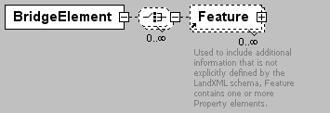
namespace | http://www.landxml.org/schema/LandXML-1.0
children | Feature
used by
  element | Roadway
attributes
  Name | Type | Use | Default | Fixed | Annotation
  staStart | station
  staEnd | station
  width | xs:double
  projectType | bridgeProjectType
source | <xs:element name="BridgeElement">  <xs:complexType>  <xs:choice minOccurs="0" maxOccurs="unbounded">  <xs:element ref="Feature" minOccurs="0" maxOccurs="unbounded"/>  </xs:choice>  <xs:attribute name="staStart" type="station"/>  <xs:attribute name="staEnd" type="station"/>  <xs:attribute name="width" type="xs:double"/>  <xs:attribute name="projectType" type="bridgeProjectType"/>  </xs:complexType>  </xs:element>

element Center
diagram | 
namespace | http://www.landxml.org/schema/LandXML-1.0
type | PointType
used by
  elements | Curve Parcel Struct
facets
  minLength | 0
  maxLength | 3
attributes
  Name | Type | Use | Default | Fixed | Annotation
  name | xs:string
  desc | xs:string
  code | xs:string
  state | stateType
  pntRef | pointNameRef
  pointGeometry | pointGeometryType
  DTMAttribute | DTMAttributeType
  timeStamp | xs:dateTime | optional
  role | surveyRoleType | optional
annotation
  documentation | Represents a 2D or 3D Center Point
  documentation | Defined by either a coordinate text value ("north east" or "north east elev") or a CgPoint number reference "pntRef" attribute.
source | <xs:element name="Center" type="PointType">  <xs:annotation>  <xs:documentation>Represents a 2D or 3D Center Point</xs:documentation>  <xs:documentation>Defined by either a coordinate text value ("north east" or "north east elev") or a CgPoint number reference "pntRef" attribute.</xs:documentation>  </xs:annotation>  </xs:element>

element CgPoint
diagram | 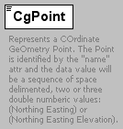
namespace | http://www.landxml.org/schema/LandXML-1.0
type | extension of PointType
used by
  element | CgPoints
facets
  minLength | 0
  maxLength | 3
attributes
  Name | Type | Use | Default | Fixed | Annotation
  name | xs:string
  desc | xs:string
  code | xs:string
  state | stateType
  pntRef | pointNameRef
  pointGeometry | pointGeometryType
  DTMAttribute | DTMAttributeType
  timeStamp | xs:dateTime | optional
  role | surveyRoleType | optional
  oID | xs:string
  surveyOrder | xs:string
  pntSurv | survPntType
  zoneNumber | zoneNumberType
  surveyHorizontalOrder | xs:string
  surveyVerticalOrder | xs:string
annotation
  documentation | Represents a COrdinate GeOmetry Point. The Point is identified by the "name" attr and the data value will be a sequence of space delimented, two or three double numberic values: (Northing Easting) or (Northing Easting Elevation).
source | <xs:element name="CgPoint">  <xs:annotation>  <xs:documentation>Represents a COrdinate GeOmetry Point. The Point is identified by the "name" attr and the data value will be a sequence of space delimented, two or three double numberic values: (Northing Easting) or (Northing Easting Elevation).</xs:documentation>  </xs:annotation>  <xs:complexType mixed="true">  <xs:simpleContent>  <xs:extension base="PointType">  <xs:attribute name="oID" type="xs:string"/>  <xs:attribute name="surveyOrder" type="xs:string"/>  <xs:attribute name="pntSurv" type="survPntType"/>  <xs:attribute name="zoneNumber" type="zoneNumberType"/>  <xs:attribute name="surveyHorizontalOrder" type="xs:string"/>  <xs:attribute name="surveyVerticalOrder" type="xs:string"/>  </xs:extension>  </xs:simpleContent>  </xs:complexType>  </xs:element>

element CgPoints
diagram | 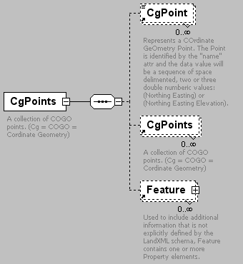
namespace | http://www.landxml.org/schema/LandXML-1.0
children | CgPoint CgPoints Feature
used by
  elements | CgPoints LandXML Survey
attributes
  Name | Type | Use | Default | Fixed | Annotation
  desc | xs:string
  name | xs:string
  state | stateType
  code | xs:string
  zoneNumber | zoneNumberType
  DTMAttribute | DTMAttributeType
annotation
  documentation | A collection of COGO points. (Cg = COGO = Cordinate Geometry)
source | <xs:element name="CgPoints">  <xs:annotation>  <xs:documentation>A collection of COGO points. (Cg = COGO = Cordinate Geometry)</xs:documentation>  </xs:annotation>  <xs:complexType>  <xs:sequence>  <xs:element ref="CgPoint" minOccurs="0" maxOccurs="unbounded"/>  <xs:element ref="CgPoints" minOccurs="0" maxOccurs="unbounded"/>  <xs:element ref="Feature" minOccurs="0" maxOccurs="unbounded"/>  <!-- Allow nested CgPoints collections -->  </xs:sequence>  <xs:attribute name="desc" type="xs:string"/>  <xs:attribute name="name" type="xs:string"/>  <xs:attribute name="state" type="stateType"/>  <xs:attribute name="code" type="xs:string"/>  <xs:attribute name="zoneNumber" type="zoneNumberType"/>  <xs:attribute name="DTMAttribute" type="DTMAttributeType"/>  </xs:complexType>  </xs:element>

element Chain
diagram | 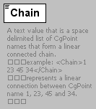
namespace | http://www.landxml.org/schema/LandXML-1.0
type | extension of ChainType
used by
  elements | CoordGeom SourceData
attributes
  Name | Type | Use | Default | Fixed | Annotation
  name | xs:string
  desc | xs:string
  code | xs:string
  state | stateType
  pointGeometry | pointGeometryType
  DTMAttribute | DTMAttributeType
  timeStamp | xs:dateTime | optional
  role | surveyRoleType | optional
annotation
  documentation | A text value that is a space delimited list of CgPoint names that form a linear connected chain.  example: <Chain>1 23 45 34</Chain>  represents a linear connection between CgPoint name 1, 23, 45 and 34.
source | <xs:element name="Chain">  <xs:annotation>  <xs:documentation>A text value that is a space delimited list of CgPoint names that form a linear connected chain.  example: <Chain>1 23 45 34</Chain>  represents a linear connection between CgPoint name 1, 23, 45 and 34.  </xs:documentation>  </xs:annotation>  <xs:complexType mixed="true">  <xs:simpleContent>  <xs:extension base="ChainType">  <xs:attribute name="name" type="xs:string"/>  <xs:attribute name="desc" type="xs:string"/>  <xs:attribute name="code" type="xs:string"/>  <xs:attribute name="state" type="stateType"/>  <xs:attribute name="pointGeometry" type="pointGeometryType"/>  <xs:attribute name="DTMAttribute" type="DTMAttributeType"/>  <xs:attribute name="timeStamp" type="xs:dateTime" use="optional"/>  <xs:attribute name="role" type="surveyRoleType" use="optional"/>  </xs:extension>  </xs:simpleContent>  </xs:complexType>  </xs:element>

element Channel
diagram | 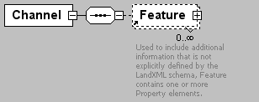
namespace | http://www.landxml.org/schema/LandXML-1.0
children | Feature
used by
  element | Pipe
attributes
  Name | Type | Use | Default | Fixed | Annotation
  height | xs:double | required
  widthTop | xs:double | required
  widthBottom | xs:double | required
  desc | xs:string
  hazenWilliams | xs:double
  mannings | xs:double
  material
  thickness | xs:double
source | <xs:element name="Channel">  <xs:annotation>  <xs:documentation/>  </xs:annotation>  <xs:complexType>  <xs:sequence>  <xs:element ref="Feature" minOccurs="0" maxOccurs="unbounded"/>  </xs:sequence>  <xs:attribute name="height" type="xs:double" use="required"/>  <xs:attribute name="widthTop" type="xs:double" use="required"/>  <xs:attribute name="widthBottom" type="xs:double" use="required"/>  <xs:attribute name="desc" type="xs:string"/>  <xs:attribute name="hazenWilliams" type="xs:double"/>  <xs:attribute name="mannings" type="xs:double"/>  <xs:attribute name="material"/>  <xs:attribute name="thickness" type="xs:double"/>  </xs:complexType>  </xs:element>

element CircCurve
diagram | 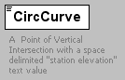
namespace | http://www.landxml.org/schema/LandXML-1.0
type | extension of Point
used by
  element | ProfAlign
attributes
  Name | Type | Use | Default | Fixed | Annotation
  length | xs:double | required
  radius | xs:double | required
  desc | xs:string
annotation
  documentation | A Point of Vertical Intersection with a space delimited "station elevation" text value
  documentation | with a circular vertical curve defined by "length and "radius" attributes.
source | <xs:element name="CircCurve">  <xs:annotation>  <xs:documentation>A Point of Vertical Intersection with a space delimited "station elevation" text value</xs:documentation>  <xs:documentation>with a circular vertical curve defined by "length and "radius" attributes.</xs:documentation>  </xs:annotation>  <xs:complexType mixed="true">  <xs:simpleContent>  <xs:extension base="Point">  <xs:attribute name="length" type="xs:double" use="required"/>  <xs:attribute name="radius" type="xs:double" use="required"/>  <xs:attribute name="desc" type="xs:string"/>  </xs:extension>  </xs:simpleContent>  </xs:complexType>  </xs:element>

element CircPipe
diagram | 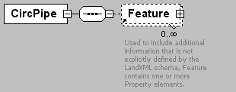
namespace | http://www.landxml.org/schema/LandXML-1.0
children | Feature
used by
  element | Pipe
attributes
  Name | Type | Use | Default | Fixed | Annotation
  diameter | xs:double | required
  desc | xs:string
  hazenWilliams | xs:double
  mannings | xs:double
  material
  thickness | xs:double
source | <xs:element name="CircPipe">  <xs:annotation>  <xs:documentation/>  </xs:annotation>  <xs:complexType>  <xs:sequence>  <xs:element ref="Feature" minOccurs="0" maxOccurs="unbounded"/>  </xs:sequence>  <xs:attribute name="diameter" type="xs:double" use="required"/>  <xs:attribute name="desc" type="xs:string"/>  <xs:attribute name="hazenWilliams" type="xs:double"/>  <xs:attribute name="mannings" type="xs:double"/>  <xs:attribute name="material"/>  <xs:attribute name="thickness" type="xs:double"/>  </xs:complexType>  </xs:element>

element CircStruct
diagram | 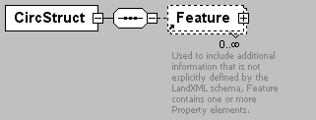
namespace | http://www.landxml.org/schema/LandXML-1.0
children | Feature
used by
  element | Struct
attributes
  Name | Type | Use | Default | Fixed | Annotation
  diameter | xs:double | required
  desc | xs:string
  inletCase
  lossCoeff | xs:double
  material
  thickness | xs:double
source | <xs:element name="CircStruct">  <xs:annotation>  <xs:documentation/>  </xs:annotation>  <xs:complexType>  <xs:sequence>  <xs:element ref="Feature" minOccurs="0" maxOccurs="unbounded"/>  </xs:sequence>  <xs:attribute name="diameter" type="xs:double" use="required"/>  <xs:attribute name="desc" type="xs:string"/>  <xs:attribute name="inletCase"/>  <xs:attribute name="lossCoeff" type="xs:double"/>  <xs:attribute name="material"/>  <xs:attribute name="thickness" type="xs:double"/>  </xs:complexType>  </xs:element>

element Classification
diagram | 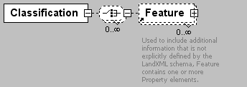
namespace | http://www.landxml.org/schema/LandXML-1.0
children | Feature
used by
  element | Roadway
attributes
  Name | Type | Use | Default | Fixed | Annotation
  staStart | station
  staEnd | station
  functionalClass | functionalClassType
source | <xs:element name="Classification">  <xs:complexType>  <xs:choice minOccurs="0" maxOccurs="unbounded">  <xs:element ref="Feature" minOccurs="0" maxOccurs="unbounded"/>  </xs:choice>  <xs:attribute name="staStart" type="station"/>  <xs:attribute name="staEnd" type="station"/>  <xs:attribute name="functionalClass" type="functionalClassType"/>  </xs:complexType>  </xs:element>

element ClimbLane
diagram | 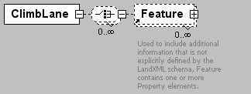
namespace | http://www.landxml.org/schema/LandXML-1.0
children | Feature
used by
  element | Lanes
attributes
  Name | Type | Use | Default | Fixed | Annotation
  staStart | station
  staEnd | station
  beginFullWidthSta | station
  endFullWidthSta | station
  width | xs:double
  sideofRoad | sideofRoadType
source | <xs:element name="ClimbLane">  <xs:complexType>  <xs:choice minOccurs="0" maxOccurs="unbounded">  <xs:element ref="Feature" minOccurs="0" maxOccurs="unbounded"/>  </xs:choice>  <xs:attribute name="staStart" type="station"/>  <xs:attribute name="staEnd" type="station"/>  <xs:attribute name="beginFullWidthSta" type="station"/>  <xs:attribute name="endFullWidthSta" type="station"/>  <xs:attribute name="width" type="xs:double"/>  <xs:attribute name="sideofRoad" type="sideofRoadType"/>  </xs:complexType>  </xs:element>

element Connection
diagram | 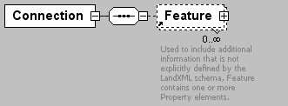
namespace | http://www.landxml.org/schema/LandXML-1.0
children | Feature
used by
  element | Struct
source | <xs:element name="Connection">  <xs:annotation>  <xs:documentation/>  </xs:annotation>  <xs:complexType>  <xs:sequence>  <xs:element ref="Feature" minOccurs="0" maxOccurs="unbounded"/>  </xs:sequence>  </xs:complexType>  </xs:element>

element Contour
diagram | 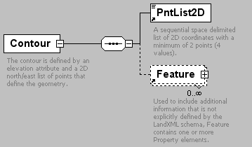
namespace | http://www.landxml.org/schema/LandXML-1.0
children | PntList2D Feature
used by
  element | Contours
attributes
  Name | Type | Use | Default | Fixed | Annotation
  elev | xs:double | required
annotation
  documentation | The contour is defined by an elevation attribute and a 2D north/east list of points that define the geometry.
  documentation | is identified by the "name" attribute.
source | <xs:element name="Contour">  <xs:annotation>  <xs:documentation>The contour is defined by an elevation attribute and a 2D north/east list of points that define the geometry.</xs:documentation>  <xs:documentation>is identified by the "name" attribute.</xs:documentation>  </xs:annotation>  <xs:complexType>  <xs:sequence>  <xs:element ref="PntList2D"/>  <xs:element ref="Feature" minOccurs="0" maxOccurs="unbounded"/>  <!-- Here PntList2D represents 2D planametric coordinate pairs expressed as space delimited Northing Easting pairs. -->  </xs:sequence>  <xs:attribute name="elev" type="xs:double" use="required"/>  </xs:complexType>  </xs:element>

element Contours
diagram | 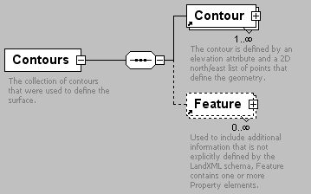
namespace | http://www.landxml.org/schema/LandXML-1.0
children | Contour Feature
used by
  element | SourceData
annotation
  documentation | The collection of contours that were used to define the surface.
source | <xs:element name="Contours">  <xs:annotation>  <xs:documentation>The collection of contours that were used to define the surface.</xs:documentation>  </xs:annotation>  <xs:complexType>  <xs:sequence>  <xs:element ref="Contour" maxOccurs="unbounded"/>  <xs:element ref="Feature" minOccurs="0" maxOccurs="unbounded"/>  </xs:sequence>  </xs:complexType>  </xs:element>

element ControlChecks
diagram | 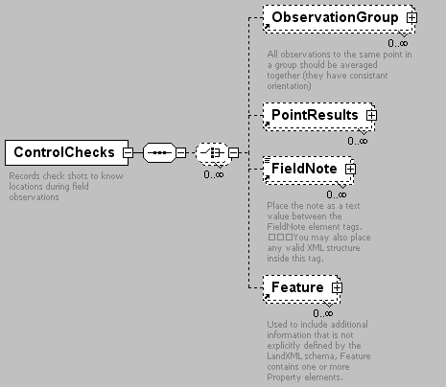
namespace | http://www.landxml.org/schema/LandXML-1.0
children | ObservationGroup PointResults FieldNote Feature
used by
  elements | InstrumentSetup Survey
annotation
  documentation | Records check shots to know locations during field observations
source | <xs:element name="ControlChecks">  <xs:annotation>  <xs:documentation>Records check shots to know locations during field observations</xs:documentation>  </xs:annotation>  <xs:complexType>  <xs:sequence>  <xs:choice minOccurs="0" maxOccurs="unbounded">  <xs:element ref="ObservationGroup" minOccurs="0" maxOccurs="unbounded"/>  <xs:element ref="PointResults" minOccurs="0" maxOccurs="unbounded"/>  <xs:element ref="FieldNote" minOccurs="0" maxOccurs="unbounded"/>  <xs:element ref="Feature" minOccurs="0" maxOccurs="unbounded"/>  </xs:choice>  </xs:sequence>  </xs:complexType>  </xs:element>

element CoordGeom
diagram | 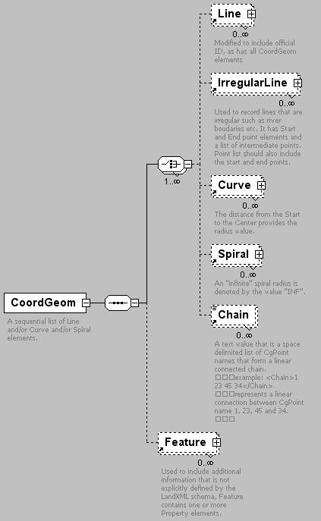
namespace | http://www.landxml.org/schema/LandXML-1.0
children | Line IrregularLine Curve Spiral Chain Feature
used by
  elements | Alignment Parcel PlanFeature
attributes
  Name | Type | Use | Default | Fixed | Annotation
  desc | xs:string
  name | xs:string
  state | stateType
annotation
  documentation | A sequential list of Line and/or Curve and/or Spiral elements.
source | <xs:element name="CoordGeom">  <xs:annotation>  <xs:documentation>A sequential list of Line and/or Curve and/or Spiral elements.</xs:documentation>  </xs:annotation>  <xs:complexType>  <xs:sequence>  <xs:choice maxOccurs="unbounded">  <xs:element ref="Line" minOccurs="0" maxOccurs="unbounded"/>  <xs:element ref="IrregularLine" minOccurs="0" maxOccurs="unbounded"/>  <xs:element ref="Curve" minOccurs="0" maxOccurs="unbounded"/>  <xs:element ref="Spiral" minOccurs="0" maxOccurs="unbounded"/>  <xs:element ref="Chain" minOccurs="0" maxOccurs="unbounded"/>  </xs:choice>  <xs:element ref="Feature" minOccurs="0" maxOccurs="unbounded"/>  </xs:sequence>  <xs:attribute name="desc" type="xs:string"/>  <xs:attribute name="name" type="xs:string"/>  <xs:attribute name="state" type="stateType"/>  </xs:complexType>  </xs:element>

element CoordinateSystem
diagram | 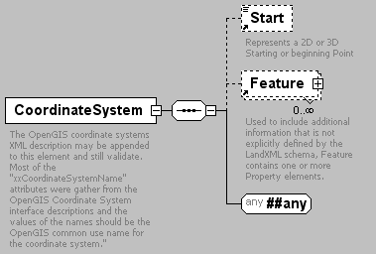
namespace | http://www.landxml.org/schema/LandXML-1.0
children | Start Feature
used by
  elements | LandXML SurveyHeader
attributes
  Name | Type | Use | Default | Fixed | Annotation
  desc | xs:string
  name | xs:string
  rotationAngle | angle
  datum | xs:string
  horizontalDatum | xs:string
  verticalDatum | xs:string
  ellipsoidName | xs:string
  fittedCoordinateSystemName | xs:string
  horizontalCoordinateSystemName | xs:string
  compoundCoordinateSystemName | xs:string
  localCoordinateSystemName | xs:string
  geographicCoordinateSystemName | xs:string
  projectedCoordinateSystemName | xs:string
  geocentricCoordinateSystemName | xs:string
  verticalCoordinateSystemName | xs:string
  fileLocation | xs:anyURI | required
annotation
  documentation | The OpenGIS coordinate systems XML description may be appended to this element and still validate. Most of the "xxCoordinateSystemName" attributes were gather from the OpenGIS Coordinate System interface descriptions and the values of the names should be the OpenGIS common use name for the coordinate system."
source | <xs:element name="CoordinateSystem">  <xs:annotation>  <xs:documentation>The OpenGIS coordinate systems XML description may be appended to this element and still validate. Most of the "xxCoordinateSystemName" attributes were gather from the OpenGIS Coordinate System interface descriptions and the values of the names should be the OpenGIS common use name for the coordinate system."</xs:documentation>  </xs:annotation>  <xs:complexType>  <xs:sequence>  <xs:element ref="Start" minOccurs="0"/>  <xs:element ref="Feature" minOccurs="0" maxOccurs="unbounded"/>  <xs:any namespace="##any" processContents="skip"/>  </xs:sequence>  <xs:attribute name="desc" type="xs:string"/>  <xs:attribute name="name" type="xs:string"/>  <xs:attribute name="rotationAngle" type="angle"/>  <xs:attribute name="datum" type="xs:string"/>  <xs:attribute name="horizontalDatum" type="xs:string"/>  <xs:attribute name="verticalDatum" type="xs:string"/>  <xs:attribute name="ellipsoidName" type="xs:string"/>  <xs:attribute name="fittedCoordinateSystemName" type="xs:string"/>  <xs:attribute name="horizontalCoordinateSystemName" type="xs:string"/>  <xs:attribute name="compoundCoordinateSystemName" type="xs:string"/>  <xs:attribute name="localCoordinateSystemName" type="xs:string"/>  <xs:attribute name="geographicCoordinateSystemName" type="xs:string"/>  <xs:attribute name="projectedCoordinateSystemName" type="xs:string"/>  <xs:attribute name="geocentricCoordinateSystemName" type="xs:string"/>  <xs:attribute name="verticalCoordinateSystemName" type="xs:string"/>  <xs:attribute name="fileLocation" type="xs:anyURI" use="required"/>  </xs:complexType>  </xs:element>

element Corner
diagram | 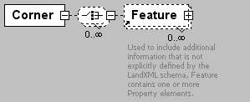
namespace | http://www.landxml.org/schema/LandXML-1.0
children | Feature
used by
  element | Intersection
attributes
  Name | Type | Use | Default | Fixed | Annotation
  staStart | station
  staEnd | station
  type | cornerType
source | <xs:element name="Corner">  <xs:complexType>  <xs:choice minOccurs="0" maxOccurs="unbounded">  <xs:element ref="Feature" minOccurs="0" maxOccurs="unbounded"/>  </xs:choice>  <xs:attribute name="staStart" type="station"/>  <xs:attribute name="staEnd" type="station"/>  <xs:attribute name="type" type="cornerType"/>  </xs:complexType>  </xs:element>

element Corrections
diagram | 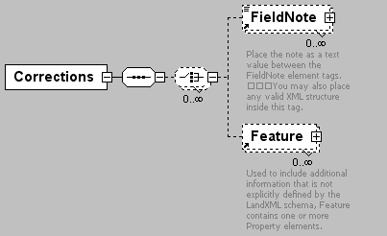
namespace | http://www.landxml.org/schema/LandXML-1.0
children | FieldNote Feature
used by
  element | InstrumentDetails
attributes
  Name | Type | Use | Default | Fixed | Annotation
  refractionCoefficient | xs:double
  applyRefractionCoefficient | xs:boolean
  sphericity | xs:double
  prismEccentricity | xs:double
source | <xs:element name="Corrections">  <xs:annotation>  <xs:documentation/>  </xs:annotation>  <xs:complexType>  <xs:sequence>  <xs:choice minOccurs="0" maxOccurs="unbounded">  <xs:element ref="FieldNote" minOccurs="0" maxOccurs="unbounded"/>  <xs:element ref="Feature" minOccurs="0" maxOccurs="unbounded"/>  </xs:choice>  </xs:sequence>  <xs:attribute name="refractionCoefficient" type="xs:double"/>  <xs:attribute name="applyRefractionCoefficient" type="xs:boolean"/>  <xs:attribute name="sphericity" type="xs:double"/>  <xs:attribute name="prismEccentricity" type="xs:double"/>  <!-- if 'true' then atmospheric corrections are to be applied to the measured distances read from the file -->  <!-- if 'true' then sea level corrections are to be applied to the measured distances read from the file -->  <!-- this is for recording the refraction coefficient used in the curvature and refraction correction of zenith angles -->  <!-- if 'true' then RefractionCoefficient should be applied to the measured zenith angles read from the file -->  </xs:complexType>  </xs:element>

element CrashData
diagram | 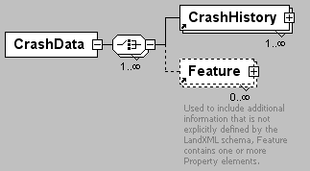
namespace | http://www.landxml.org/schema/LandXML-1.0
children | CrashHistory Feature
used by
  element | Roadway
source | <xs:element name="CrashData">  <xs:complexType>  <xs:choice maxOccurs="unbounded">  <xs:element ref="CrashHistory" maxOccurs="unbounded"/>  <xs:element ref="Feature" minOccurs="0" maxOccurs="unbounded"/>  </xs:choice>  </xs:complexType>  </xs:element>

element CrashHistory
diagram | 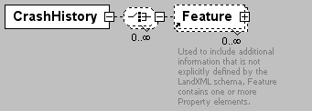
namespace | http://www.landxml.org/schema/LandXML-1.0
children | Feature
used by
  element | CrashData
attributes
  Name | Type | Use | Default | Fixed | Annotation
  year | xs:date
  location-1 | station
  location-2 | station
  severity | crashSeverityType
  intersectionRelation | crashIntersectionRelation
  intersectionLocation | station
source | <xs:element name="CrashHistory">  <xs:complexType>  <xs:choice minOccurs="0" maxOccurs="unbounded">  <xs:element ref="Feature" minOccurs="0" maxOccurs="unbounded"/>  </xs:choice>  <xs:attribute name="year" type="xs:date"/>  <xs:attribute name="location-1" type="station"/>  <xs:attribute name="location-2" type="station"/>  <xs:attribute name="severity" type="crashSeverityType"/>  <xs:attribute name="intersectionRelation" type="crashIntersectionRelation"/>  <xs:attribute name="intersectionLocation" type="station"/>  </xs:complexType>  </xs:element>

element CrossSect
diagram | 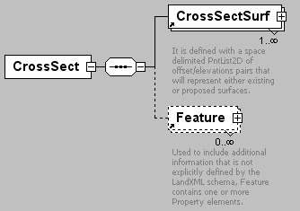
namespace | http://www.landxml.org/schema/LandXML-1.0
children | CrossSectSurf Feature
used by
  element | CrossSects
attributes
  Name | Type | Use | Default | Fixed | Annotation
  sta | xs:double | required
  angleSkew | angle
  areaCut | xs:double
  areaFill | xs:double
  centroidCut | xs:double
  centroidFill | xs:double
  desc | xs:string
  name | xs:string
  sectType
  volumeCut | xs:double
  volumeFill | xs:double
source | <xs:element name="CrossSect">  <xs:annotation>  <xs:documentation/>  </xs:annotation>  <xs:complexType>  <xs:sequence>  <xs:element ref="CrossSectSurf" maxOccurs="unbounded"/>  <xs:element ref="Feature" minOccurs="0" maxOccurs="unbounded"/>  </xs:sequence>  <xs:attribute name="sta" type="xs:double" use="required"/>  <xs:attribute name="angleSkew" type="angle"/>  <xs:attribute name="areaCut" type="xs:double"/>  <xs:attribute name="areaFill" type="xs:double"/>  <xs:attribute name="centroidCut" type="xs:double"/>  <xs:attribute name="centroidFill" type="xs:double"/>  <xs:attribute name="desc" type="xs:string"/>  <xs:attribute name="name" type="xs:string"/>  <xs:attribute name="sectType"/>  <xs:attribute name="volumeCut" type="xs:double"/>  <xs:attribute name="volumeFill" type="xs:double"/>  </xs:complexType>  </xs:element>

element CrossSects
diagram | 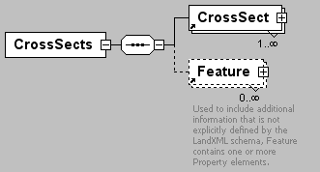
namespace | http://www.landxml.org/schema/LandXML-1.0
children | CrossSect Feature
used by
  element | Alignment
attributes
  Name | Type | Use | Default | Fixed | Annotation
  desc | xs:string
  name | xs:string
  state | stateType
  calcMethod | xsVolCalcMethodType
  curveCorrection | xs:boolean
  swellFactor | xs:double
  shrinkFactor | xs:double
source | <xs:element name="CrossSects">  <xs:annotation>  <xs:documentation/>  </xs:annotation>  <xs:complexType>  <xs:sequence>  <xs:element ref="CrossSect" maxOccurs="unbounded"/>  <xs:element ref="Feature" minOccurs="0" maxOccurs="unbounded"/>  </xs:sequence>  <xs:attribute name="desc" type="xs:string"/>  <xs:attribute name="name" type="xs:string"/>  <xs:attribute name="state" type="stateType"/>  <xs:attribute name="calcMethod" type="xsVolCalcMethodType"/>  <xs:attribute name="curveCorrection" type="xs:boolean"/>  <xs:attribute name="swellFactor" type="xs:double"/>  <xs:attribute name="shrinkFactor" type="xs:double"/>  </xs:complexType>  </xs:element>

element CrossSectSurf
diagram | 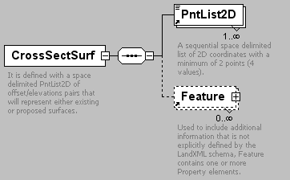
namespace | http://www.landxml.org/schema/LandXML-1.0
children | PntList2D Feature
used by
  element | CrossSect
attributes
  Name | Type | Use | Default | Fixed | Annotation
  name | xs:string | required
  desc | xs:string
  state | stateType
annotation
  documentation | It is defined with a space delimited PntList2D of offset/elevations pairs that will represent either existing or proposed surfaces.
  documentation | Example: "-60.00 86.52 -36.26 86.89 12.41 87.01 60.00 87.83"
  documentation | Note: Gaps in the surface are handled by having 2 or more PntList2D elements.
source | <xs:element name="CrossSectSurf">  <xs:annotation>  <xs:documentation>It is defined with a space delimited PntList2D of offset/elevations pairs that will represent either existing or proposed surfaces. </xs:documentation>  <xs:documentation>Example: "-60.00 86.52 -36.26 86.89 12.41 87.01 60.00 87.83" </xs:documentation>  <xs:documentation>Note: Gaps in the surface are handled by having 2 or more PntList2D elements.</xs:documentation>  </xs:annotation>  <xs:complexType>  <xs:sequence>  <xs:element ref="PntList2D" maxOccurs="unbounded"/>  <xs:element ref="Feature" minOccurs="0" maxOccurs="unbounded"/>  </xs:sequence>  <xs:attribute name="name" type="xs:string" use="required"/>  <xs:attribute name="desc" type="xs:string"/>  <xs:attribute name="state" type="stateType"/>  </xs:complexType>  </xs:element>

element Curb
diagram | 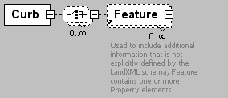
namespace | http://www.landxml.org/schema/LandXML-1.0
children | Feature
used by
  element | Intersection
attributes
  Name | Type | Use | Default | Fixed | Annotation
  staStart | station
  staEnd | station
  sideofRoad | sideofRoadType
  type | curbType
source | <xs:element name="Curb">  <xs:complexType>  <xs:choice minOccurs="0" maxOccurs="unbounded">  <xs:element ref="Feature" minOccurs="0" maxOccurs="unbounded"/>  </xs:choice>  <xs:attribute name="staStart" type="station"/>  <xs:attribute name="staEnd" type="station"/>  <xs:attribute name="sideofRoad" type="sideofRoadType"/>  <xs:attribute name="type" type="curbType"/>  </xs:complexType>  </xs:element>

element Curve
diagram | 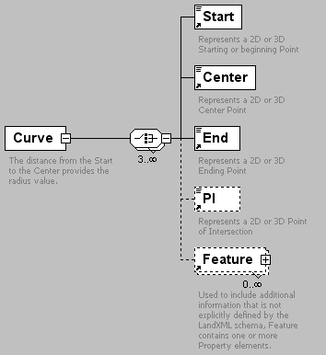
namespace | http://www.landxml.org/schema/LandXML-1.0
children | Start Center End PI Feature
used by
  element | CoordGeom
attributes
  Name | Type | Use | Default | Fixed | Annotation
  rot | clockwise | required
  chord | xs:double
  crvType | curveType
  delta | angle
  desc | xs:string
  dirEnd | direction
  dirStart | direction
  external | xs:double
  length | xs:double
  midOrd | xs:double
  name | xs:string
  radius | xs:double
  staStart | xs:double
  state | stateType
  tangent | xs:double
  oID | xs:string
annotation
  documentation | The distance from the Start to the Center provides the radius value.
  documentation | The rotation attribute "rot" defines whether the arc travels clockwise or counter-clockwise from the Start to End point.
source | <xs:element name="Curve">  <xs:annotation>  <xs:documentation>The distance from the Start to the Center provides the radius value.</xs:documentation>  <xs:documentation>The rotation attribute "rot" defines whether the arc travels clockwise or counter-clockwise from the Start to End point.</xs:documentation>  </xs:annotation>  <xs:complexType>  <xs:choice minOccurs="3" maxOccurs="unbounded">  <xs:element ref="Start"/>  <xs:element ref="Center"/>  <xs:element ref="End"/>  <xs:element ref="PI" minOccurs="0"/>  <xs:element ref="Feature" minOccurs="0" maxOccurs="unbounded"/>  </xs:choice>  <xs:attribute name="rot" type="clockwise" use="required"/>  <xs:attribute name="chord" type="xs:double"/>  <xs:attribute name="crvType" type="curveType"/>  <xs:attribute name="delta" type="angle"/>  <xs:attribute name="desc" type="xs:string"/>  <xs:attribute name="dirEnd" type="direction"/>  <xs:attribute name="dirStart" type="direction"/>  <xs:attribute name="external" type="xs:double"/>  <xs:attribute name="length" type="xs:double"/>  <xs:attribute name="midOrd" type="xs:double"/>  <xs:attribute name="name" type="xs:string"/>  <xs:attribute name="radius" type="xs:double"/>  <xs:attribute name="staStart" type="xs:double"/>  <xs:attribute name="state" type="stateType"/>  <xs:attribute name="tangent" type="xs:double"/>  <xs:attribute name="oID" type="xs:string"/>  </xs:complexType>  </xs:element>

element DailyTrafficVolume
diagram | 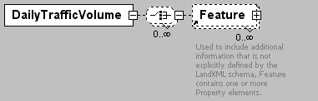
namespace | http://www.landxml.org/schema/LandXML-1.0
children | Feature
used by
  element | TrafficVolume
attributes
  Name | Type | Use | Default | Fixed | Annotation
  staStart | station
  staEnd | station
  ADT | xs:double
  year | xs:date
  escFactor | xs:double
source | <xs:element name="DailyTrafficVolume">  <xs:complexType>  <xs:choice minOccurs="0" maxOccurs="unbounded">  <xs:element ref="Feature" minOccurs="0" maxOccurs="unbounded"/>  </xs:choice>  <xs:attribute name="staStart" type="station"/>  <xs:attribute name="staEnd" type="station"/>  <xs:attribute name="ADT" type="xs:double"/>  <xs:attribute name="year" type="xs:date"/>  <xs:attribute name="escFactor" type="xs:double"/>  <!-- ADT, the average daily traffic for the specified year. This item specifies the average daily traffic for the specified year. No value needs to be specified for this item. The unit of measure for this item is vehicles/day. -->  <!-- escFactor is the subsequent year annual traffic volume escalation factor. This item specifies the annual percent increase (or decrease) in traffic volume for subsequent traffic volume years. No value needs to be specified for this item. The unit of measure for this item is percent %. -->  </xs:complexType>  </xs:element>

element DataPoints
diagram | 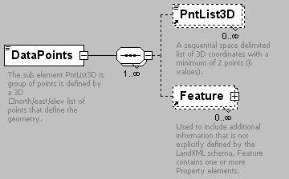
namespace | http://www.landxml.org/schema/LandXML-1.0
children | PntList3D Feature
used by
  element | SourceData
attributes
  Name | Type | Use | Default | Fixed | Annotation
  name | xs:string
  desc | xs:string
  code | xs:string
  state | stateType
  pntRef | pointNameRef
  pointGeometry | pointGeometryType
  DTMAttribute | DTMAttributeType
annotation
  documentation | The sub element PntList3D is group of points is defined by a 3D  north/east/elev list of points that define the geometry.
source | <xs:element name="DataPoints">  <xs:annotation>  <xs:documentation>The sub element PntList3D is group of points is defined by a 3D  north/east/elev list of points that define the geometry.</xs:documentation>  </xs:annotation>  <xs:complexType mixed="true">  <xs:sequence maxOccurs="unbounded">  <xs:element ref="PntList3D" minOccurs="0" maxOccurs="unbounded"/>  <xs:element ref="Feature" minOccurs="0" maxOccurs="unbounded"/>  </xs:sequence>  <xs:attribute name="name" type="xs:string"/>  <xs:attribute name="desc" type="xs:string"/>  <xs:attribute name="code" type="xs:string"/>  <xs:attribute name="state" type="stateType"/>  <xs:attribute name="pntRef" type="pointNameRef"/>  <xs:attribute name="pointGeometry" type="pointGeometryType"/>  <xs:attribute name="DTMAttribute" type="DTMAttributeType"/>  </xs:complexType>  </xs:element>

element DecisionSightDistance
diagram | 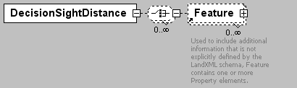
namespace | http://www.landxml.org/schema/LandXML-1.0
children | Feature
used by
  element | Roadway
attributes
  Name | Type | Use | Default | Fixed | Annotation
  station | station
  maneuver | maneuverType
source | <xs:element name="DecisionSightDistance">  <xs:complexType>  <xs:choice minOccurs="0" maxOccurs="unbounded">  <xs:element ref="Feature" minOccurs="0" maxOccurs="unbounded"/>  </xs:choice>  <xs:attribute name="station" type="station"/>  <xs:attribute name="maneuver" type="maneuverType"/>  </xs:complexType>  </xs:element>

element Definition
diagram | 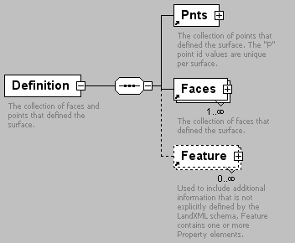
namespace | http://www.landxml.org/schema/LandXML-1.0
children | Pnts Faces Feature
used by
  element | Surface
attributes
  Name | Type | Use | Default | Fixed | Annotation
  surfType | surfTypeEnum | required
  area2DSurf | xs:double
  area3DSurf | xs:double
  elevMax | xs:double
  elevMin | xs:double
annotation
  documentation | The collection of faces and points that defined the surface.
source | <xs:element name="Definition">  <xs:annotation>  <xs:documentation>The collection of faces and points that defined the surface.</xs:documentation>  </xs:annotation>  <xs:complexType>  <xs:sequence>  <xs:element ref="Pnts"/>  <xs:element ref="Faces" maxOccurs="unbounded"/>  <xs:element ref="Feature" minOccurs="0" maxOccurs="unbounded"/>  </xs:sequence>  <xs:attribute name="surfType" type="surfTypeEnum" use="required"/>  <xs:attribute name="area2DSurf" type="xs:double"/>  <xs:attribute name="area3DSurf" type="xs:double"/>  <xs:attribute name="elevMax" type="xs:double"/>  <xs:attribute name="elevMin" type="xs:double"/>  </xs:complexType>  </xs:element>

element DesignHour
diagram | 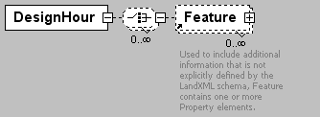
namespace | http://www.landxml.org/schema/LandXML-1.0
children | Feature
used by
  element | TrafficVolume
attributes
  Name | Type | Use | Default | Fixed | Annotation
  staStart | station
  staEnd | station
  volume | xs:double
source | <xs:element name="DesignHour">  <xs:complexType>  <xs:choice minOccurs="0" maxOccurs="unbounded">  <xs:element ref="Feature" minOccurs="0" maxOccurs="unbounded"/>  </xs:choice>  <xs:attribute name="staStart" type="station"/>  <xs:attribute name="staEnd" type="station"/>  <xs:attribute name="volume" type="xs:double"/>  </xs:complexType>  <!-- Design Hour Volume - This item is the design hourly volume (DHV). The 30th highest volume of the year should be used as the DHV, which can be approximated as 15 percent of the average daily traffic (ADT). On two-lane rural highways, the DHV is the total traffic in both directions of travel. The unit of measure for this item is vehicles/hour. -->  </xs:element>

element DesignSpeed
diagram | 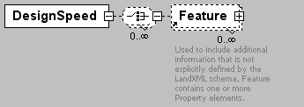
namespace | http://www.landxml.org/schema/LandXML-1.0
children | Feature
used by
  element | Speeds
attributes
  Name | Type | Use | Default | Fixed | Annotation
  staStart | station
  staEnd | station
  speed | speed
source | <xs:element name="DesignSpeed">  <xs:complexType>  <xs:choice minOccurs="0" maxOccurs="unbounded">  <xs:element ref="Feature" minOccurs="0" maxOccurs="unbounded"/>  </xs:choice>  <xs:attribute name="staStart" type="station"/>  <xs:attribute name="staEnd" type="station"/>  <xs:attribute name="speed" type="speed"/>  </xs:complexType>  </xs:element>

element DesignSpeed85th
diagram | 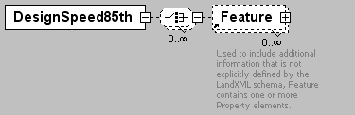
namespace | http://www.landxml.org/schema/LandXML-1.0
children | Feature
used by
  element | Speeds
attributes
  Name | Type | Use | Default | Fixed | Annotation
  staStart | station
  staEnd | station
  sideofRoad | sideofRoadType
  speed | speed
source | <xs:element name="DesignSpeed85th">  <xs:complexType>  <xs:choice minOccurs="0" maxOccurs="unbounded">  <xs:element ref="Feature" minOccurs="0" maxOccurs="unbounded"/>  </xs:choice>  <xs:attribute name="staStart" type="station"/>  <xs:attribute name="staEnd" type="station"/>  <xs:attribute name="sideofRoad" type="sideofRoadType"/>  <xs:attribute name="speed" type="speed"/>  </xs:complexType>  </xs:element>

element Ditch
diagram | 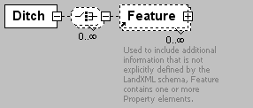
namespace | http://www.landxml.org/schema/LandXML-1.0
children | Feature
used by
  element | Roadside
attributes
  Name | Type | Use | Default | Fixed | Annotation
  staStart | station | required
  staEnd | station | required
  bottomWidth | xs:double | required
  bottomShape | ditchBottomShape
source | <xs:element name="Ditch">  <xs:complexType>  <xs:choice minOccurs="0" maxOccurs="unbounded">  <xs:element ref="Feature" minOccurs="0" maxOccurs="unbounded"/>  </xs:choice>  <xs:attribute name="staStart" type="station" use="required"/>  <xs:attribute name="staEnd" type="station" use="required"/>  <xs:attribute name="bottomWidth" type="xs:double" use="required"/>  <xs:attribute name="bottomShape" type="ditchBottomShape"/>  </xs:complexType>  </xs:element>

element DrivewayDensity
diagram | 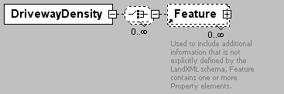
namespace | http://www.landxml.org/schema/LandXML-1.0
children | Feature
used by
  element | Roadside
attributes
  Name | Type | Use | Default | Fixed | Annotation
  staStart | station
  staEnd | station
  density | xs:int
source | <xs:element name="DrivewayDensity">  <xs:complexType>  <xs:choice minOccurs="0" maxOccurs="unbounded">  <xs:element ref="Feature" minOccurs="0" maxOccurs="unbounded"/>  </xs:choice>  <xs:attribute name="staStart" type="station"/>  <xs:attribute name="staEnd" type="station"/>  <xs:attribute name="density" type="xs:int"/>  <!-- Driveway Density - Unit of measure: integer. The driveway density for both sides of the roadway combined. The unit of measure for this item is driveways/kilometer (driveways/mile). -->  </xs:complexType>  </xs:element>

element ElliPipe
diagram | 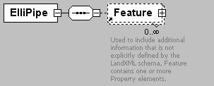
namespace | http://www.landxml.org/schema/LandXML-1.0
children | Feature
used by
  element | Pipe
attributes
  Name | Type | Use | Default | Fixed | Annotation
  height | xs:double | required
  span | xs:double | required
  desc | xs:string
  hazenWilliams | xs:double
  mannings | xs:double
  material
  thickness | xs:double
source | <xs:element name="ElliPipe">  <xs:annotation>  <xs:documentation/>  </xs:annotation>  <xs:complexType>  <xs:sequence>  <xs:element ref="Feature" minOccurs="0" maxOccurs="unbounded"/>  </xs:sequence>  <xs:attribute name="height" type="xs:double" use="required"/>  <xs:attribute name="span" type="xs:double" use="required"/>  <xs:attribute name="desc" type="xs:string"/>  <xs:attribute name="hazenWilliams" type="xs:double"/>  <xs:attribute name="mannings" type="xs:double"/>  <xs:attribute name="material"/>  <xs:attribute name="thickness" type="xs:double"/>  </xs:complexType>  </xs:element>

element End
diagram | 
namespace | http://www.landxml.org/schema/LandXML-1.0
type | PointType
used by
  elements | Curve IrregularLine Line Spiral
facets
  minLength | 0
  maxLength | 3
attributes
  Name | Type | Use | Default | Fixed | Annotation
  name | xs:string
  desc | xs:string
  code | xs:string
  state | stateType
  pntRef | pointNameRef
  pointGeometry | pointGeometryType
  DTMAttribute | DTMAttributeType
  timeStamp | xs:dateTime | optional
  role | surveyRoleType | optional
annotation
  documentation | Represents a 2D or 3D Ending Point
  documentation | Defined by either a coordinate text value ("north east" or "north east elev") or a CgPoint number reference "pntRef" attribute.
source | <xs:element name="End" type="PointType">  <xs:annotation>  <xs:documentation>Represents a 2D or 3D Ending Point</xs:documentation>  <xs:documentation>Defined by either a coordinate text value ("north east" or "north east elev") or a CgPoint number reference "pntRef" attribute.</xs:documentation>  </xs:annotation>  </xs:element>

element EndofRunoutSta
diagram | 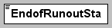
namespace | http://www.landxml.org/schema/LandXML-1.0
type | station
used by
  element | Superelevation
source | <xs:element name="EndofRunoutSta" type="station" nillable="true"/>

element Equipment
diagram | 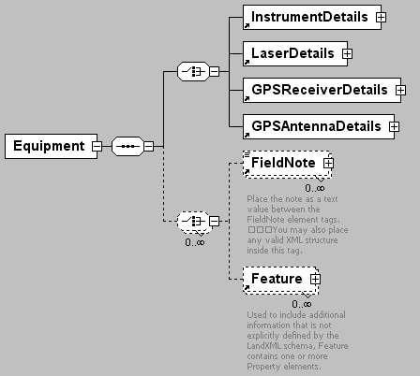
namespace | http://www.landxml.org/schema/LandXML-1.0
children | InstrumentDetails LaserDetails GPSReceiverDetails GPSAntennaDetails FieldNote Feature
used by
  element | Survey
source | <xs:element name="Equipment">  <xs:annotation>  <xs:documentation/>  </xs:annotation>  <xs:complexType>  <xs:sequence>  <xs:choice>  <xs:element ref="InstrumentDetails"/>  <xs:element ref="LaserDetails"/>  <xs:element ref="GPSReceiverDetails"/>  <xs:element ref="GPSAntennaDetails"/>  </xs:choice>  <xs:choice minOccurs="0" maxOccurs="unbounded">  <xs:element ref="FieldNote" minOccurs="0" maxOccurs="unbounded"/>  <xs:element ref="Feature" minOccurs="0" maxOccurs="unbounded"/>  </xs:choice>  </xs:sequence>  </xs:complexType>  </xs:element>

element F
diagram | 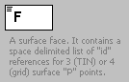
namespace | http://www.landxml.org/schema/LandXML-1.0
type | restriction of FaceType
used by
  element | Faces
facets
  minLength | 3
  maxLength | 4
annotation
  documentation | A surface face. It contains a space delimited list of "id" references for 3 (TIN) or 4 (grid) surface "P" points.
  documentation | The 3 or 4 numbers represent the vertices on the face. Each number is a reference to the ID value of a surface point "P" for the face coordinates.
source | <xs:element name="F">  <xs:annotation>  <xs:documentation>A surface face. It contains a space delimited list of "id" references for 3 (TIN) or 4 (grid) surface "P" points. </xs:documentation>  <xs:documentation>The 3 or 4 numbers represent the vertices on the face. Each number is a reference to the ID value of a surface point "P" for the face coordinates.</xs:documentation>  </xs:annotation>  <xs:simpleType>  <xs:restriction base="FaceType">  <xs:minLength value="3"/>  <xs:maxLength value="4"/>  </xs:restriction>  </xs:simpleType>  </xs:element>

element Faces
diagram | 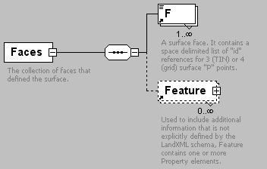
namespace | http://www.landxml.org/schema/LandXML-1.0
children | F Feature
used by
  element | Definition
attributes
  Name | Type | Use | Default | Fixed | Annotation
  desc | xs:string
  name | xs:string
  state | stateType
annotation
  documentation | The collection of faces that defined the surface.
  documentation | The faces are defined by either 3 (TIN) or 4 (grid) points, as indicated by the "surfType" attribute
  documentation | For the north/east/elev values, each point of the face references a "P"point element point in the SurfPnts collection.
source | <xs:element name="Faces">  <xs:annotation>  <xs:documentation>The collection of faces that defined the surface.</xs:documentation>  <xs:documentation>The faces are defined by either 3 (TIN) or 4 (grid) points, as indicated by the "surfType" attribute</xs:documentation>  <xs:documentation>For the north/east/elev values, each point of the face references a "P"point element point in the SurfPnts collection.</xs:documentation>  </xs:annotation>  <xs:complexType>  <xs:sequence>  <xs:element ref="F" maxOccurs="unbounded"/>  <xs:element ref="Feature" minOccurs="0" maxOccurs="unbounded"/>  </xs:sequence>  <xs:attribute name="desc" type="xs:string"/>  <xs:attribute name="name" type="xs:string"/>  <xs:attribute name="state" type="stateType"/>  </xs:complexType>  </xs:element>

element Feature
diagram | 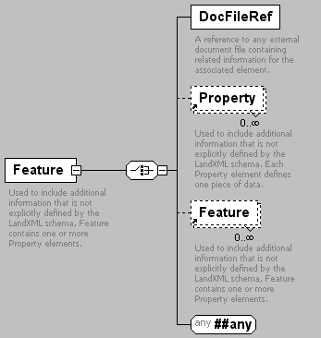
namespace | http://www.landxml.org/schema/LandXML-1.0
children | DocFileRef Property Feature
used by
  elements | Alignment Alignments Backsight BikeFacilities Boundaries Boundary Breakline Breaklines BridgeElement CgPoints Channel CircPipe CircStruct Classification ClimbLane Connection Contour Contours ControlChecks CoordGeom CoordinateSystem Corner Corrections CrashData CrashHistory CrossSect CrossSects CrossSectSurf Curb Curve DailyTrafficVolume DataPoints DecisionSightDistance Definition DesignHour DesignSpeed DesignSpeed85th Ditch DrivewayDensity ElliPipe Equipment Faces Feature GPSAntennaDetails GPSPosition GPSReceiverDetails GPSSetup GPSVector GradeModel GradeSurface HazardRating InletStruct InstrumentDetails InstrumentSetup Intersection Intersections IrregularLine Lanes LaserDetails LaserSetup Line Monuments NoPassingZone ObservationGroup ObstructionOffset OffsetLane OutletStruct Parcel Parcels PassingLane PeakHour Pipe PipeFlow PipeNetwork PipeNetworks Pipes PlanFeature PlanFeatures PointFiles PointResults PostedSpeed ProfAlign Profile ProfSurf Project RawObservation RectPipe RectStruct ReducedArcObservation ReducedObservation RetWall Roadside RoadSign Roadway Roadways SourceData Speeds Spiral StaEquation Struct StructFlow Structs Superelevation Surface Surfaces SurfVolume SurfVolumes Survey SurveyHeader SurveyMonument TargetSetup ThruLane Timing TrafficControl TrafficVolume TurnLane TurnRestriction TurnSpeed TwoWayLeftTurnLane Volume Watershed Watersheds WideningLane Zone ZoneCrossSectStructure ZoneCutFill ZoneHinge ZoneMaterial Zones ZoneSlope ZoneWidth
attributes
  Name | Type | Use | Default | Fixed | Annotation
  code | xs:string | required
  source |  | optional
annotation
  documentation | Used to include additional information that is not explicitly defined by the LandXML schema, Feature contains one or more Property elements.
  documentation | Each Property element defines one piece of data.
source | <xs:element name="Feature">  <xs:annotation>  <xs:documentation>Used to include additional information that is not explicitly defined by the LandXML schema, Feature contains one or more Property elements.</xs:documentation>  <xs:documentation>Each Property element defines one piece of data.</xs:documentation>  </xs:annotation>  <xs:complexType>  <xs:choice>  <xs:element name="DocFileRef">  <xs:annotation>  <xs:documentation>A reference to any external document file containing related information for the associated element.</xs:documentation>  </xs:annotation>  <xs:complexType>  <xs:attribute name="name" use="required"/>  <xs:attribute name="location" type="xs:anyURI" use="required"/>  <xs:attribute name="fileType" type="xs:string"/>  <xs:attribute name="fileFormat" type="xs:string"/>  </xs:complexType>  </xs:element>  <xs:element ref="Property" minOccurs="0" maxOccurs="unbounded"/>  <xs:element ref="Feature" minOccurs="0" maxOccurs="unbounded"/>  <xs:any namespace="##any" processContents="skip"/>  </xs:choice>  <xs:attribute name="code" type="xs:string" use="required"/>  <xs:attribute name="source" use="optional"/>  </xs:complexType>  </xs:element>

element Feature/DocFileRef
diagram | 
attributes
  Name | Type | Use | Default | Fixed | Annotation
  name |  | required
  location | xs:anyURI | required
  fileType | xs:string
  fileFormat | xs:string
annotation
  documentation | A reference to any external document file containing related information for the associated element.
source | <xs:element name="DocFileRef">  <xs:annotation>  <xs:documentation>A reference to any external document file containing related information for the associated element.</xs:documentation>  </xs:annotation>  <xs:complexType>  <xs:attribute name="name" use="required"/>  <xs:attribute name="location" type="xs:anyURI" use="required"/>  <xs:attribute name="fileType" type="xs:string"/>  <xs:attribute name="fileFormat" type="xs:string"/>  </xs:complexType>  </xs:element>

element FieldNote
diagram | 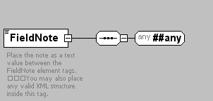
namespace | http://www.landxml.org/schema/LandXML-1.0
used by
  elements | Backsight ControlChecks Corrections Equipment GPSAntennaDetails GPSPosition GPSReceiverDetails GPSSetup GPSVector InstrumentDetails InstrumentSetup LaserDetails LaserSetup ObservationGroup PointResults RawObservation ReducedArcObservation ReducedObservation Survey SurveyHeader TargetSetup
annotation
  documentation | Place the note as a text value between the FieldNote element tags.  You may also place any valid XML structure inside this tag.
source | <xs:element name="FieldNote">  <xs:annotation>  <xs:documentation>Place the note as a text value between the FieldNote element tags.  You may also place any valid XML structure inside this tag.</xs:documentation>  </xs:annotation>  <xs:complexType mixed="true">  <xs:sequence>  <xs:any namespace="##any" processContents="skip"/>  </xs:sequence>  </xs:complexType>  </xs:element>

element FullSuperelev
diagram | 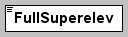
namespace | http://www.landxml.org/schema/LandXML-1.0
type | slope
used by
  element | Superelevation
source | <xs:element name="FullSuperelev" type="slope"/>

element FullSuperSta
diagram | 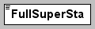
namespace | http://www.landxml.org/schema/LandXML-1.0
type | station
used by
  element | Superelevation
source | <xs:element name="FullSuperSta" type="station"/>

element GPSAntennaDetails
diagram | 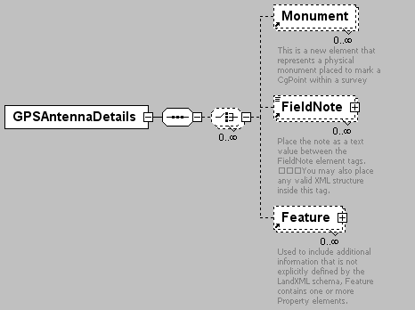
namespace | http://www.landxml.org/schema/LandXML-1.0
children | Monument FieldNote Feature
used by
  element | Equipment
attributes
  Name | Type | Use | Default | Fixed | Annotation
  id | xs:ID | required
  manufacturer | xs:string
  model | xs:string
  serialNumber | xs:string
  latitude | xs:double
  longitude | xs:double
  altitude | xs:double
  ellipsiodnalHeight | xs:double
  orthometricHeight | xs:double
source | <xs:element name="GPSAntennaDetails">  <xs:annotation>  <xs:documentation/>  </xs:annotation>  <xs:complexType>  <xs:sequence>  <xs:choice minOccurs="0" maxOccurs="unbounded">  <xs:element ref="Monument" minOccurs="0" maxOccurs="unbounded"/>  <xs:element ref="FieldNote" minOccurs="0" maxOccurs="unbounded"/>  <xs:element ref="Feature" minOccurs="0" maxOccurs="unbounded"/>  </xs:choice>  </xs:sequence>  <xs:attribute name="id" type="xs:ID" use="required"/>  <xs:attribute name="manufacturer" type="xs:string"/>  <xs:attribute name="model" type="xs:string"/>  <xs:attribute name="serialNumber" type="xs:string"/>  <xs:attribute name="latitude" type="xs:double"/>  <xs:attribute name="longitude" type="xs:double"/>  <xs:attribute name="altitude" type="xs:double"/>  <xs:attribute name="ellipsiodnalHeight" type="xs:double"/>  <xs:attribute name="orthometricHeight" type="xs:double"/>  </xs:complexType>  </xs:element>

element GPSPosition
diagram | 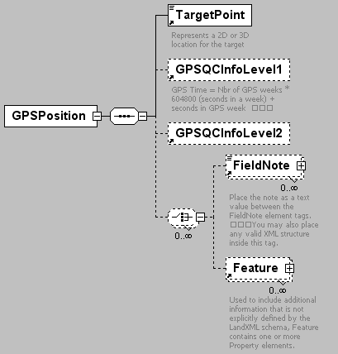
namespace | http://www.landxml.org/schema/LandXML-1.0
children | TargetPoint GPSQCInfoLevel1 GPSQCInfoLevel2 FieldNote Feature
used by
  elements | GPSSetup Survey
attributes
  Name | Type | Use | Default | Fixed | Annotation
  setupID | xs:IDREF
  setID
  wgsHeight | xs:double | required
  wgsLatitude | xs:double | required
  wgsLongitude | xs:double | required
  purpose
  coordGeomRefs | coordGeomNameRefs
  pntRef | pointNameRef
source | <xs:element name="GPSPosition">  <xs:annotation>  <xs:documentation/>  </xs:annotation>  <xs:complexType>  <xs:sequence>  <xs:element ref="TargetPoint"/>  <xs:element ref="GPSQCInfoLevel1" minOccurs="0"/>  <xs:element ref="GPSQCInfoLevel2" minOccurs="0"/>  <xs:choice minOccurs="0" maxOccurs="unbounded">  <xs:element ref="FieldNote" minOccurs="0" maxOccurs="unbounded"/>  <xs:element ref="Feature" minOccurs="0" maxOccurs="unbounded"/>  </xs:choice>  </xs:sequence>  <xs:attribute name="setupID" type="xs:IDREF"/>  <xs:attribute name="setID"/>  <xs:attribute name="wgsHeight" type="xs:double" use="required"/>  <xs:attribute name="wgsLatitude" type="xs:double" use="required"/>  <xs:attribute name="wgsLongitude" type="xs:double" use="required"/>  <xs:attribute name="purpose"/>  <xs:attribute name="coordGeomRefs" type="coordGeomNameRefs"/>  <xs:attribute name="pntRef" type="pointNameRef"/>  <!-- coordGeomRefs identifies one or more 'name' values that link to specific <Line>, <Curve>, <Spiral> or <IrregularLine> in a <CoordGeom> element. This allows linking an survey observation to specific <Parcel>.<CoordGeom> based geometry. -->  </xs:complexType>  </xs:element>

element GPSQCInfoLevel1
diagram | 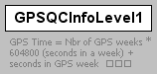
namespace | http://www.landxml.org/schema/LandXML-1.0
used by
  elements | GPSPosition GPSVector
attributes
  Name | Type | Use | Default | Fixed | Annotation
  GPSSolnType | GPSSolutionTypeEnum
  GPSSolnFreq | GPSSolutionFrequencyEnum
  nbrSatellites | xs:integer
  RDOP | xs:double
annotation
  documentation | GPS Time = Nbr of GPS weeks * 604800 (seconds in a week) + seconds in GPS week
source | <xs:element name="GPSQCInfoLevel1">  <xs:annotation>  <xs:documentation>GPS Time = Nbr of GPS weeks * 604800 (seconds in a week) + seconds in GPS week </xs:documentation>  </xs:annotation>  <xs:complexType>  <xs:attribute name="GPSSolnType" type="GPSSolutionTypeEnum"/>  <xs:attribute name="GPSSolnFreq" type="GPSSolutionFrequencyEnum"/>  <xs:attribute name="nbrSatellites" type="xs:integer"/>  <xs:attribute name="RDOP" type="xs:double"/>  </xs:complexType>  </xs:element>

element GPSQCInfoLevel2
diagram | 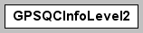
namespace | http://www.landxml.org/schema/LandXML-1.0
used by
  elements | GPSPosition GPSVector
attributes
  Name | Type | Use | Default | Fixed | Annotation
  covarianceXX | xs:double
  covarianceXY | xs:double
  covarianceXZ | xs:double
  covarianceYY | xs:double
  covarianceYZ | xs:double
  covarianceZZ | xs:double
  GPSSolnType | GPSSolutionTypeEnum
  GPSSolnFreq | GPSSolutionFrequencyEnum
  RMS | xs:double
  ratio | xs:double
  referenceVariance | xs:double
  nbrSatellites | xs:integer
  startTime | GPSTime
  stopTime | GPSTime
source | <xs:element name="GPSQCInfoLevel2">  <xs:annotation>  <xs:documentation/>  </xs:annotation>  <xs:complexType>  <xs:attribute name="covarianceXX" type="xs:double"/>  <xs:attribute name="covarianceXY" type="xs:double"/>  <xs:attribute name="covarianceXZ" type="xs:double"/>  <xs:attribute name="covarianceYY" type="xs:double"/>  <xs:attribute name="covarianceYZ" type="xs:double"/>  <xs:attribute name="covarianceZZ" type="xs:double"/>  <xs:attribute name="GPSSolnType" type="GPSSolutionTypeEnum"/>  <xs:attribute name="GPSSolnFreq" type="GPSSolutionFrequencyEnum"/>  <xs:attribute name="RMS" type="xs:double"/>  <xs:attribute name="ratio" type="xs:double"/>  <xs:attribute name="referenceVariance" type="xs:double"/>  <xs:attribute name="nbrSatellites" type="xs:integer"/>  <xs:attribute name="startTime" type="GPSTime"/>  <xs:attribute name="stopTime" type="GPSTime"/>  <!-- GPS Time = Nbr of GPS weeks * 604800 (seconds in a week) + seconds in GPS week -->  </xs:complexType>  </xs:element>

element GPSReceiverDetails
diagram | 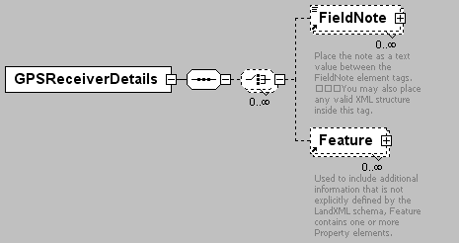
namespace | http://www.landxml.org/schema/LandXML-1.0
children | FieldNote Feature
used by
  element | Equipment
attributes
  Name | Type | Use | Default | Fixed | Annotation
  id | xs:ID | required
  manufacturer | xs:string
  model | xs:string
  serialNumber | xs:string
source | <xs:element name="GPSReceiverDetails">  <xs:annotation>  <xs:documentation/>  </xs:annotation>  <xs:complexType>  <xs:sequence>  <xs:choice minOccurs="0" maxOccurs="unbounded">  <xs:element ref="FieldNote" minOccurs="0" maxOccurs="unbounded"/>  <xs:element ref="Feature" minOccurs="0" maxOccurs="unbounded"/>  </xs:choice>  </xs:sequence>  <xs:attribute name="id" type="xs:ID" use="required"/>  <xs:attribute name="manufacturer" type="xs:string"/>  <xs:attribute name="model" type="xs:string"/>  <xs:attribute name="serialNumber" type="xs:string"/>  </xs:complexType>  </xs:element>

element GPSSetup
diagram | 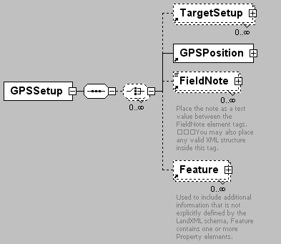
namespace | http://www.landxml.org/schema/LandXML-1.0
children | TargetSetup GPSPosition FieldNote Feature
used by
  element | Survey
attributes
  Name | Type | Use | Default | Fixed | Annotation
  id | xs:ID | required
  antennaHeight | xs:double | required
  stationName |  | required
  GPSAntennaDetailsID | xs:IDREF
  GPSReceiverDetailsID | xs:IDREF
  observationDataLink
  stationDescription
  startTime | GPSTime
  stopTime | GPSTime
source | <xs:element name="GPSSetup">  <xs:annotation>  <xs:documentation/>  </xs:annotation>  <xs:complexType>  <xs:sequence>  <xs:choice minOccurs="0" maxOccurs="unbounded">  <xs:element ref="TargetSetup" minOccurs="0" maxOccurs="unbounded"/>  <xs:element ref="GPSPosition"/>  <xs:element ref="FieldNote" minOccurs="0" maxOccurs="unbounded"/>  <xs:element ref="Feature" minOccurs="0" maxOccurs="unbounded"/>  </xs:choice>  </xs:sequence>  <xs:attribute name="id" type="xs:ID" use="required"/>  <xs:attribute name="antennaHeight" type="xs:double" use="required"/>  <xs:attribute name="stationName" use="required"/>  <xs:attribute name="GPSAntennaDetailsID" type="xs:IDREF"/>  <xs:attribute name="GPSReceiverDetailsID" type="xs:IDREF"/>  <xs:attribute name="observationDataLink"/>  <xs:attribute name="stationDescription"/>  <xs:attribute name="startTime" type="GPSTime"/>  <xs:attribute name="stopTime" type="GPSTime"/>  <!-- GPS Time = Nbr of GPS weeks * 604800 (seconds in a week) + seconds in GPS week -->  </xs:complexType>  </xs:element>

element GPSVector
diagram | 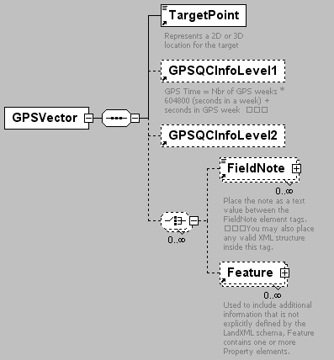
namespace | http://www.landxml.org/schema/LandXML-1.0
children | TargetPoint GPSQCInfoLevel1 GPSQCInfoLevel2 FieldNote Feature
used by
  element | Survey
attributes
  Name | Type | Use | Default | Fixed | Annotation
  dX | xs:double | required
  dY | xs:double | required
  dZ | xs:double | required
  setupID_A | xs:IDREF | required
  setupID_B | xs:IDREF | required
  startTime | xs:dateTime | optional
  endTime | xs:dateTime | optional
  horizontalPrecision | xs:double | optional
  verticalPrecision | xs:double | optional
  purpose | purposeType
  setID
  solutionDataLink
  coordGeomRefs | coordGeomNameRefs
source | <xs:element name="GPSVector">  <xs:annotation>  <xs:documentation/>  </xs:annotation>  <xs:complexType>  <xs:sequence>  <xs:element ref="TargetPoint"/>  <xs:element ref="GPSQCInfoLevel1" minOccurs="0"/>  <xs:element ref="GPSQCInfoLevel2" minOccurs="0"/>  <xs:choice minOccurs="0" maxOccurs="unbounded">  <xs:element ref="FieldNote" minOccurs="0" maxOccurs="unbounded"/>  <xs:element ref="Feature" minOccurs="0" maxOccurs="unbounded"/>  </xs:choice>  </xs:sequence>  <xs:attribute name="dX" type="xs:double" use="required"/>  <xs:attribute name="dY" type="xs:double" use="required"/>  <xs:attribute name="dZ" type="xs:double" use="required"/>  <xs:attribute name="setupID_A" type="xs:IDREF" use="required"/>  <xs:attribute name="setupID_B" type="xs:IDREF" use="required"/>  <xs:attribute name="startTime" type="xs:dateTime" use="optional"/>  <xs:attribute name="endTime" type="xs:dateTime" use="optional"/>  <xs:attribute name="horizontalPrecision" type="xs:double" use="optional"/>  <xs:attribute name="verticalPrecision" type="xs:double" use="optional"/>  <xs:attribute name="purpose" type="purposeType"/>  <xs:attribute name="setID"/>  <xs:attribute name="solutionDataLink"/>  <xs:attribute name="coordGeomRefs" type="coordGeomNameRefs"/>  <!-- coordGeomRefs identifies one or more 'name' values that link to specific <Line>, <Curve>, <Spiral> or <IrregularLine> in a <CoordGeom> element. This allows linking an survey observation to specific <Parcel>.<CoordGeom> based geometry. -->  </xs:complexType>  </xs:element>

element GradeModel
diagram | 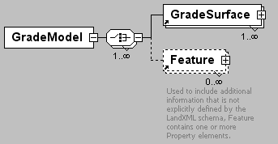
namespace | http://www.landxml.org/schema/LandXML-1.0
children | GradeSurface Feature
used by
  element | LandXML
attributes
  Name | Type | Use | Default | Fixed | Annotation
  desc | xs:string
  name | xs:string
  state | stateType
source | <xs:element name="GradeModel">  <xs:complexType>  <xs:choice maxOccurs="unbounded">  <xs:element ref="GradeSurface" maxOccurs="unbounded"/>  <xs:element ref="Feature" minOccurs="0" maxOccurs="unbounded"/>  </xs:choice>  <xs:attribute name="desc" type="xs:string"/>  <xs:attribute name="name" type="xs:string"/>  <xs:attribute name="state" type="stateType"/>  </xs:complexType>  </xs:element>

element GradeSurface
diagram | 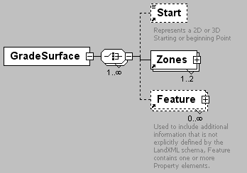
namespace | http://www.landxml.org/schema/LandXML-1.0
children | Start Zones Feature
used by
  element | GradeModel
attributes
  Name | Type | Use | Default | Fixed | Annotation
  alignmentRef | alignmentNameRef | required
  stationAlignmentRef | alignmentNameRef
  surfaceType | zoneSurfaceType | required
  surfaceRef | surfaceNameRef
  surfaceRefs | surfaceNameRefs
  cgPointRefs | pointNameRefs
  name | xs:string
  desc | xs:string
  state | stateType
source | <xs:element name="GradeSurface">  <xs:complexType>  <xs:choice maxOccurs="unbounded">  <xs:element ref="Start" minOccurs="0"/>  <xs:element ref="Zones" maxOccurs="2"/>  <xs:element ref="Feature" minOccurs="0" maxOccurs="unbounded"/>  </xs:choice>  <xs:attribute name="alignmentRef" type="alignmentNameRef" use="required"/>  <xs:attribute name="stationAlignmentRef" type="alignmentNameRef"/>  <xs:attribute name="surfaceType" type="zoneSurfaceType" use="required"/>  <xs:attribute name="surfaceRef" type="surfaceNameRef"/>  <xs:attribute name="surfaceRefs" type="surfaceNameRefs"/>  <xs:attribute name="cgPointRefs" type="pointNameRefs"/>  <xs:attribute name="name" type="xs:string"/>  <xs:attribute name="desc" type="xs:string"/>  <xs:attribute name="state" type="stateType"/>  </xs:complexType>  </xs:element>

element HazardRating
diagram | 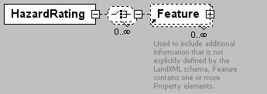
namespace | http://www.landxml.org/schema/LandXML-1.0
children | Feature
used by
  element | Roadside
attributes
  Name | Type | Use | Default | Fixed | Annotation
  staStart | station
  staEnd | station
  rating | xs:int
source | <xs:element name="HazardRating">  <xs:complexType>  <xs:choice minOccurs="0" maxOccurs="unbounded">  <xs:element ref="Feature" minOccurs="0" maxOccurs="unbounded"/>  </xs:choice>  <xs:attribute name="staStart" type="station"/>  <xs:attribute name="staEnd" type="station"/>  <xs:attribute name="rating" type="xs:int"/>  <!-- Unit of measure: INT. Roadside Hazard Rating - The roadside hazard rating for both sides of the road. The enumeration values are: 1, 2, 3, 4, 5, 6 and 7. -->  </xs:complexType>  </xs:element>

element Imperial
diagram | 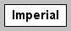
namespace | http://www.landxml.org/schema/LandXML-1.0
used by
  element | Units
attributes
  Name | Type | Use | Default | Fixed | Annotation
  areaUnit | impArea | required
  linearUnit | impLinear | required
  volumeUnit | impVolume | required
  temperatureUnit | impTemperature | required
  pressureUnit | impPressure | required
  diameterUnit | impDiameter
  widthUnit | impWidth
  heightUnit | impHeight
  velocityUnit | impVelocity
  flowUnit | impFlow
  angularUnit | angularType |  | radians
  directionUnit | angularType |  | radians
source | <xs:element name="Imperial">  <xs:annotation>  <xs:documentation/>  </xs:annotation>  <xs:complexType>  <xs:attribute name="areaUnit" type="impArea" use="required"/>  <xs:attribute name="linearUnit" type="impLinear" use="required"/>  <xs:attribute name="volumeUnit" type="impVolume" use="required"/>  <xs:attribute name="temperatureUnit" type="impTemperature" use="required"/>  <xs:attribute name="pressureUnit" type="impPressure" use="required"/>  <xs:attribute name="diameterUnit" type="impDiameter"/>  <xs:attribute name="widthUnit" type="impWidth"/>  <xs:attribute name="heightUnit" type="impHeight"/>  <xs:attribute name="velocityUnit" type="impVelocity"/>  <xs:attribute name="flowUnit" type="impFlow"/>  <xs:attribute name="angularUnit" type="angularType" default="radians"/>  <xs:attribute name="directionUnit" type="angularType" default="radians"/>  </xs:complexType>  </xs:element>

element InletStruct
diagram | 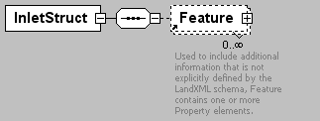
namespace | http://www.landxml.org/schema/LandXML-1.0
children | Feature
used by
  element | Struct
source | <xs:element name="InletStruct">  <xs:annotation>  <xs:documentation/>  </xs:annotation>  <xs:complexType>  <xs:sequence>  <xs:element ref="Feature" minOccurs="0" maxOccurs="unbounded"/>  </xs:sequence>  </xs:complexType>  </xs:element>

element InstrumentDetails
diagram | 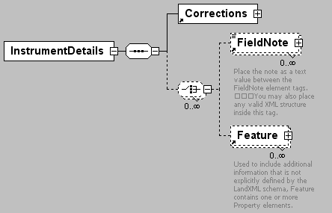
namespace | http://www.landxml.org/schema/LandXML-1.0
children | Corrections FieldNote Feature
used by
  element | Equipment
attributes
  Name | Type | Use | Default | Fixed | Annotation
  id | xs:ID | required
  edmAccuracyConstant | xs:double
  edmAccuracyppm | xs:double
  edmVertOffset | xs:double
  horizAnglePrecision | xs:double
  manufacturer | xs:string
  model | xs:string
  serialNumber | xs:string
  zenithAnglePrecision | xs:double
  carrierWavelength | xs:double
  refractiveIndex | xs:double
  horizCollimation | xs:double
  vertCollimation | xs:double
source | <xs:element name="InstrumentDetails">  <xs:annotation>  <xs:documentation/>  </xs:annotation>  <xs:complexType>  <xs:sequence>  <xs:element ref="Corrections"/>  <xs:choice minOccurs="0" maxOccurs="unbounded">  <xs:element ref="FieldNote" minOccurs="0" maxOccurs="unbounded"/>  <xs:element ref="Feature" minOccurs="0" maxOccurs="unbounded"/>  </xs:choice>  </xs:sequence>  <xs:attribute name="id" type="xs:ID" use="required"/>  <xs:attribute name="edmAccuracyConstant" type="xs:double"/>  <xs:attribute name="edmAccuracyppm" type="xs:double"/>  <xs:attribute name="edmVertOffset" type="xs:double"/>  <xs:attribute name="horizAnglePrecision" type="xs:double"/>  <xs:attribute name="manufacturer" type="xs:string"/>  <xs:attribute name="model" type="xs:string"/>  <xs:attribute name="serialNumber" type="xs:string"/>  <xs:attribute name="zenithAnglePrecision" type="xs:double"/>  <xs:attribute name="carrierWavelength" type="xs:double"/>  <xs:attribute name="refractiveIndex" type="xs:double"/>  <xs:attribute name="horizCollimation" type="xs:double"/>  <xs:attribute name="vertCollimation" type="xs:double"/>  <!-- In order to compute the atmospheric corrections correctly record the  EDM instrument carrier wavelength (carrierWavelength) and the group refractive index  for the instrument (refractiveIndex). -->  <!-- To allow for older style top mounted EDM's -->  </xs:complexType>  </xs:element>

element InstrumentPoint
diagram | 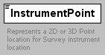
namespace | http://www.landxml.org/schema/LandXML-1.0
type | PointType
used by
  elements | InstrumentSetup LaserSetup
facets
  minLength | 0
  maxLength | 3
attributes
  Name | Type | Use | Default | Fixed | Annotation
  name | xs:string
  desc | xs:string
  code | xs:string
  state | stateType
  pntRef | pointNameRef
  pointGeometry | pointGeometryType
  DTMAttribute | DTMAttributeType
  timeStamp | xs:dateTime | optional
  role | surveyRoleType | optional
annotation
  documentation | Represents a 2D or 3D Point location for Survey instrument location
  documentation | Defined by either a coordinate text value ("north east" or "north east elev") or a PointType number reference "pntRef" attribute.
source | <xs:element name="InstrumentPoint" type="PointType">  <xs:annotation>  <xs:documentation>Represents a 2D or 3D Point location for Survey instrument location</xs:documentation>  <xs:documentation>Defined by either a coordinate text value ("north east" or "north east elev") or a PointType number reference "pntRef" attribute.</xs:documentation>  </xs:annotation>  </xs:element>

element InstrumentSetup
diagram | 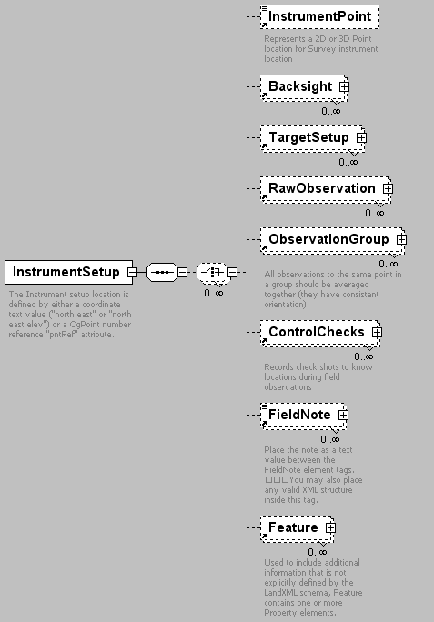
namespace | http://www.landxml.org/schema/LandXML-1.0
children | InstrumentPoint Backsight TargetSetup RawObservation ObservationGroup ControlChecks FieldNote Feature
used by
  element | Survey
attributes
  Name | Type | Use | Default | Fixed | Annotation
  id | xs:ID | required
  instrumentDetailsID | xs:IDREF
  stationName | xs:string | required
  instrumentHeight | xs:double | required
  orientationAzimuth | direction
  circleAzimuth | direction
annotation
  documentation | The Instrument setup location is defined by either a coordinate text value ("north east" or "north east elev") or a CgPoint number reference "pntRef" attribute.
source | <xs:element name="InstrumentSetup">  <xs:annotation>  <xs:documentation>The Instrument setup location is defined by either a coordinate text value ("north east" or "north east elev") or a CgPoint number reference "pntRef" attribute.</xs:documentation>  </xs:annotation>  <xs:complexType>  <xs:sequence>  <xs:choice minOccurs="0" maxOccurs="unbounded">  <xs:element ref="InstrumentPoint" minOccurs="0"/>  <xs:element ref="Backsight" minOccurs="0" maxOccurs="unbounded"/>  <xs:element ref="TargetSetup" minOccurs="0" maxOccurs="unbounded"/>  <xs:element ref="RawObservation" minOccurs="0" maxOccurs="unbounded"/>  <xs:element ref="ObservationGroup" minOccurs="0" maxOccurs="unbounded"/>  <xs:element ref="ControlChecks" minOccurs="0" maxOccurs="unbounded"/>  <xs:element ref="FieldNote" minOccurs="0" maxOccurs="unbounded"/>  <xs:element ref="Feature" minOccurs="0" maxOccurs="unbounded"/>  </xs:choice>  </xs:sequence>  <xs:attribute name="id" type="xs:ID" use="required"/>  <xs:attribute name="instrumentDetailsID" type="xs:IDREF"/>  <xs:attribute name="stationName" type="xs:string" use="required"/>  <xs:attribute name="instrumentHeight" type="xs:double" use="required"/>  <xs:attribute name="orientationAzimuth" type="direction"/>  <xs:attribute name="circleAzimuth" type="direction"/>  </xs:complexType>  </xs:element>

element Intersection
diagram | 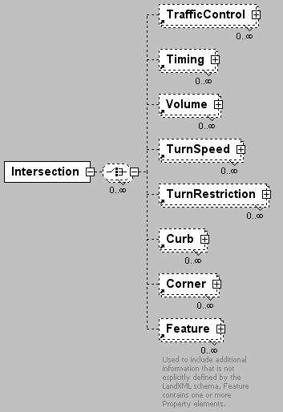
namespace | http://www.landxml.org/schema/LandXML-1.0
children | TrafficControl Timing Volume TurnSpeed TurnRestriction Curb Corner Feature
used by
  element | Intersections
attributes
  Name | Type | Use | Default | Fixed | Annotation
  roadwayRef | roadwayNameRef
  roadwayPI | station
  intersectingRoadwayRef | roadwayNameRef
  intersectRoadwayPI | station
  contructionType | intersectionConstructionType
source | <xs:element name="Intersection">  <xs:complexType>  <xs:choice minOccurs="0" maxOccurs="unbounded">  <xs:element ref="TrafficControl" minOccurs="0" maxOccurs="unbounded"/>  <xs:element ref="Timing" minOccurs="0" maxOccurs="unbounded"/>  <xs:element ref="Volume" minOccurs="0" maxOccurs="unbounded"/>  <xs:element ref="TurnSpeed" minOccurs="0" maxOccurs="unbounded"/>  <xs:element ref="TurnRestriction" minOccurs="0" maxOccurs="unbounded"/>  <xs:element ref="Curb" minOccurs="0" maxOccurs="unbounded"/>  <xs:element ref="Corner" minOccurs="0" maxOccurs="unbounded"/>  <xs:element ref="Feature" minOccurs="0" maxOccurs="unbounded"/>  </xs:choice>  <xs:attribute name="roadwayRef" type="roadwayNameRef"/>  <xs:attribute name="roadwayPI" type="station"/>  <xs:attribute name="intersectingRoadwayRef" type="roadwayNameRef"/>  <xs:attribute name="intersectRoadwayPI" type="station"/>  <xs:attribute name="contructionType" type="intersectionConstructionType"/>  </xs:complexType>  </xs:element>

element Intersections
diagram | 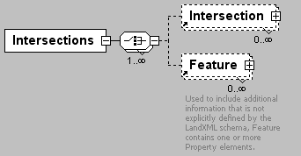
namespace | http://www.landxml.org/schema/LandXML-1.0
children | Intersection Feature
used by
  element | Roadways
source | <xs:element name="Intersections">  <xs:complexType>  <xs:choice maxOccurs="unbounded">  <xs:element ref="Intersection" minOccurs="0" maxOccurs="unbounded"/>  <xs:element ref="Feature" minOccurs="0" maxOccurs="unbounded"/>  </xs:choice>  </xs:complexType>  </xs:element>

element Invert
diagram | 
namespace | http://www.landxml.org/schema/LandXML-1.0
used by
  element | Struct
attributes
  Name | Type | Use | Default | Fixed | Annotation
  desc | xs:string
  elev | xs:double | required
  flowDir | inOut | required
  refPipe | pipeNameRef | required
source | <xs:element name="Invert">  <xs:annotation>  <xs:documentation/>  </xs:annotation>  <xs:complexType>  <xs:attribute name="desc" type="xs:string"/>  <xs:attribute name="elev" type="xs:double" use="required"/>  <xs:attribute name="flowDir" type="inOut" use="required"/>  <xs:attribute name="refPipe" type="pipeNameRef" use="required"/>  </xs:complexType>  </xs:element>

element IrregularLine
diagram | 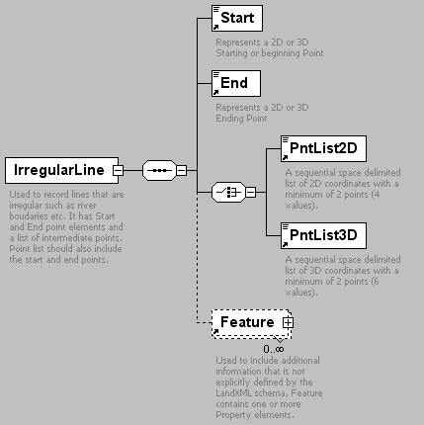
namespace | http://www.landxml.org/schema/LandXML-1.0
children | Start End PntList2D PntList3D Feature
used by
  element | CoordGeom
attributes
  Name | Type | Use | Default | Fixed | Annotation
  desc | xs:string
  dir | direction
  length | xs:double
  name | xs:string
  staStart | xs:double
  state | stateType
  oID | xs:string
annotation
  documentation | Used to record lines that are irregular such as river boudaries etc. It has Start and End point elements and a list of intermediate points. Point list should also include the start and end points.
source | <xs:element name="IrregularLine">  <xs:annotation>  <xs:documentation>Used to record lines that are irregular such as river boudaries etc. It has Start and End point elements and a list of intermediate points. Point list should also include the start and end points.</xs:documentation>  </xs:annotation>  <xs:complexType>  <xs:sequence>  <xs:element ref="Start"/>  <xs:element ref="End"/>  <xs:choice>  <xs:element ref="PntList2D"/>  <xs:element ref="PntList3D"/>  <!-- Here PntList2D represents 2D planametric coordinate pairs expressed as space delimited Northing Easting pairs. -->  </xs:choice>  <xs:element ref="Feature" minOccurs="0" maxOccurs="unbounded"/>  </xs:sequence>  <xs:attribute name="desc" type="xs:string"/>  <xs:attribute name="dir" type="direction"/>  <xs:attribute name="length" type="xs:double"/>  <xs:attribute name="name" type="xs:string"/>  <xs:attribute name="staStart" type="xs:double"/>  <xs:attribute name="state" type="stateType"/>  <xs:attribute name="oID" type="xs:string"/>  </xs:complexType>  </xs:element>

element LandXML
diagram | 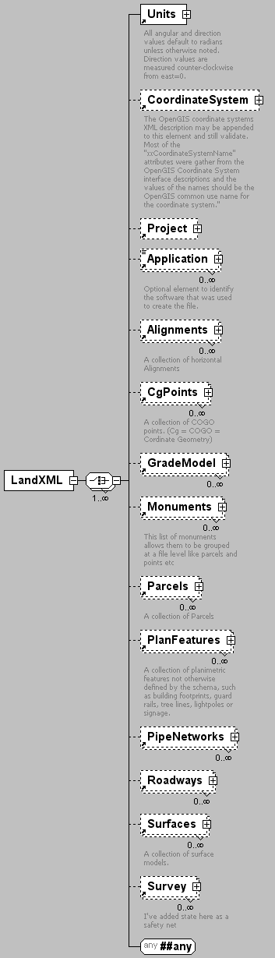
namespace | http://www.landxml.org/schema/LandXML-1.0
children | Units CoordinateSystem Project Application Alignments CgPoints GradeModel Monuments Parcels PlanFeatures PipeNetworks Roadways Surfaces Survey
attributes
  Name | Type | Use | Default | Fixed | Annotation
  date | xs:date | required
  time | xs:time | required
  version | xs:string | required
  language | xs:string
  readOnly | xs:boolean
  LandXMLId | xs:int
  crc | xs:integer
identity constraints
   | Name | Refer | Selector | Field(s)
  unique | uCoordGeomName |  | CoordGeom | @name
  unique | uCgPointsName |  | CgPoints | @name
  unique | uPntName |  | CgPoints/CgPoint | @name
  unique | uMntName |  | Monuments/Monument | @name
  unique | uSrfName |  | Surface | @name
  unique | uSrfPntNum |  | Surface/Definition/Pnts/P | @id
  unique | uPclName |  | Parcels/Parcel | @name
  unique | uAlnName |  | Alignments/Alignment | @name
  unique | uPipeNetName |  | PipeNetworks/PipeNetwork | @name
  unique | uPipeNum |  | PipeNetwork/Pipes/Pipe | @name
  unique | uStructNum |  | PipeNetwork/Stucts/Struct | @name
  unique | uCrossSectSta |  | CrossSect | @sta
  unique | uRoadwayName |  | Roadways/Roadway | @name
  unique | uGradeModelName |  | GradeModel | @name
  key | CgPointKey |  | CgPoints/CgPoint | @name
  keyref | Start | CgPointKey | .//Start | @pntRef
  keyref | End | CgPointKey | .//End | @pntRef
  keyref | Center | CgPointKey | .//Center | @pntRef
  keyref | PI | CgPointKey | .//PI | @pntRef
  key | MonumentKey |  | Monuments/Monument | @name
  keyref | SurveyMonument | MonumentKey | .//SurveyMonument | @mntRef
  key | StructKey |  | .//PipeNetwork/*/Struct | @name
  keyref | PipeStart | StructKey | .//PipeNetwork/*/Pipe | @refStart
  keyref | PipeEnd | StructKey | .//PipeNetwork/*/Pipe | @refEnd
  key | PipeKey |  | .//PipeNetwork/*/Pipe | @name
  keyref | StructInvert | PipeKey | .//PipeNetwork/*/Struct/Invert | @refPipe
source | <xs:element name="LandXML">  <xs:complexType>  <xs:choice maxOccurs="unbounded">  <xs:element ref="Units"/>  <xs:element ref="CoordinateSystem" minOccurs="0"/>  <xs:element ref="Project" minOccurs="0"/>  <xs:element ref="Application" minOccurs="0" maxOccurs="unbounded"/>  <xs:element ref="Alignments" minOccurs="0" maxOccurs="unbounded"/>  <xs:element ref="CgPoints" minOccurs="0" maxOccurs="unbounded"/>  <xs:element ref="GradeModel" minOccurs="0" maxOccurs="unbounded"/>  <xs:element ref="Monuments" minOccurs="0" maxOccurs="unbounded"/>  <xs:element ref="Parcels" minOccurs="0" maxOccurs="unbounded"/>  <xs:element ref="PlanFeatures" minOccurs="0" maxOccurs="unbounded"/>  <xs:element ref="PipeNetworks" minOccurs="0" maxOccurs="unbounded"/>  <xs:element ref="Roadways" minOccurs="0" maxOccurs="unbounded"/>  <xs:element ref="Surfaces" minOccurs="0" maxOccurs="unbounded"/>  <xs:element ref="Survey" minOccurs="0" maxOccurs="unbounded"/>  <xs:any namespace="##any" processContents="skip"/>  </xs:choice>  <xs:attribute name="date" type="xs:date" use="required"/>  <xs:attribute name="time" type="xs:time" use="required"/>  <xs:attribute name="version" type="xs:string" use="required"/>  <xs:attribute name="language" type="xs:string"/>  <xs:attribute name="readOnly" type="xs:boolean"/>  <xs:attribute name="LandXMLId" type="xs:int"/>  <xs:attribute name="crc" type="xs:integer"/>  </xs:complexType>  <xs:unique name="uCoordGeomName">  <xs:selector xpath="CoordGeom"/>  <xs:field xpath="@name"/>  </xs:unique>  <xs:unique name="uCgPointsName">  <xs:selector xpath="CgPoints"/>  <xs:field xpath="@name"/>  </xs:unique>  <xs:unique name="uPntName">  <xs:selector xpath="CgPoints/CgPoint"/>  <xs:field xpath="@name"/>  </xs:unique>  <xs:unique name="uMntName">  <xs:selector xpath="Monuments/Monument"/>  <xs:field xpath="@name"/>  </xs:unique>  <xs:unique name="uSrfName">  <xs:selector xpath="Surface"/>  <xs:field xpath="@name"/>  </xs:unique>  <xs:unique name="uSrfPntNum">  <xs:selector xpath="Surface/Definition/Pnts/P"/>  <xs:field xpath="@id"/>  </xs:unique>  <xs:unique name="uPclName">  <xs:selector xpath="Parcels/Parcel"/>  <xs:field xpath="@name"/>  </xs:unique>  <xs:unique name="uAlnName">  <xs:selector xpath="Alignments/Alignment"/>  <xs:field xpath="@name"/>  </xs:unique>  <xs:unique name="uPipeNetName">  <xs:selector xpath="PipeNetworks/PipeNetwork"/>  <xs:field xpath="@name"/>  </xs:unique>  <xs:unique name="uPipeNum">  <xs:selector xpath="PipeNetwork/Pipes/Pipe"/>  <xs:field xpath="@name"/>  </xs:unique>  <xs:unique name="uStructNum">  <xs:selector xpath="PipeNetwork/Stucts/Struct"/>  <xs:field xpath="@name"/>  </xs:unique>  <xs:unique name="uCrossSectSta">  <xs:selector xpath="CrossSect"/>  <xs:field xpath="@sta"/>  </xs:unique>  <xs:unique name="uRoadwayName">  <xs:selector xpath="Roadways/Roadway"/>  <xs:field xpath="@name"/>  </xs:unique>  <xs:unique name="uGradeModelName">  <xs:selector xpath="GradeModel"/>  <xs:field xpath="@name"/>  </xs:unique>  <xs:key name="CgPointKey">  <xs:selector xpath="CgPoints/CgPoint"/>  <xs:field xpath="@name"/>  </xs:key>  <xs:keyref name="Start" refer="CgPointKey">  <xs:selector xpath=".//Start"/>  <xs:field xpath="@pntRef"/>  </xs:keyref>  <xs:keyref name="End" refer="CgPointKey">  <xs:selector xpath=".//End"/>  <xs:field xpath="@pntRef"/>  </xs:keyref>  <xs:keyref name="Center" refer="CgPointKey">  <xs:selector xpath=".//Center"/>  <xs:field xpath="@pntRef"/>  </xs:keyref>  <xs:keyref name="PI" refer="CgPointKey">  <xs:selector xpath=".//PI"/>  <xs:field xpath="@pntRef"/>  </xs:keyref>  <xs:key name="MonumentKey">  <xs:selector xpath="Monuments/Monument"/>  <xs:field xpath="@name"/>  </xs:key>  <xs:keyref name="SurveyMonument" refer="MonumentKey">  <xs:selector xpath=".//SurveyMonument"/>  <xs:field xpath="@mntRef"/>  </xs:keyref>  <xs:key name="StructKey">  <xs:selector xpath=".//PipeNetwork/*/Struct"/>  <xs:field xpath="@name"/>  </xs:key>  <xs:keyref name="PipeStart" refer="StructKey">  <xs:selector xpath=".//PipeNetwork/*/Pipe"/>  <xs:field xpath="@refStart"/>  </xs:keyref>  <xs:keyref name="PipeEnd" refer="StructKey">  <xs:selector xpath=".//PipeNetwork/*/Pipe"/>  <xs:field xpath="@refEnd"/>  </xs:keyref>  <xs:key name="PipeKey">  <xs:selector xpath=".//PipeNetwork/*/Pipe"/>  <xs:field xpath="@name"/>  </xs:key>  <xs:keyref name="StructInvert" refer="PipeKey">  <xs:selector xpath=".//PipeNetwork/*/Struct/Invert"/>  <xs:field xpath="@refPipe"/>  </xs:keyref>  <!-- unique definitions for elements that should not have duplicate name values -->  <!-- key/keyref definitions -->  </xs:element>

element Lanes
diagram | 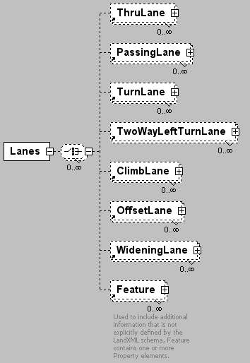
namespace | http://www.landxml.org/schema/LandXML-1.0
children | ThruLane PassingLane TurnLane TwoWayLeftTurnLane ClimbLane OffsetLane WideningLane Feature
used by
  element | Roadway
source | <xs:element name="Lanes">  <xs:complexType>  <xs:choice minOccurs="0" maxOccurs="unbounded">  <xs:element ref="ThruLane" minOccurs="0" maxOccurs="unbounded"/>  <xs:element ref="PassingLane" minOccurs="0" maxOccurs="unbounded"/>  <xs:element ref="TurnLane" minOccurs="0" maxOccurs="unbounded"/>  <xs:element ref="TwoWayLeftTurnLane" minOccurs="0" maxOccurs="unbounded"/>  <xs:element ref="ClimbLane" minOccurs="0" maxOccurs="unbounded"/>  <xs:element ref="OffsetLane" minOccurs="0" maxOccurs="unbounded"/>  <xs:element ref="WideningLane" minOccurs="0" maxOccurs="unbounded"/>  <xs:element ref="Feature" minOccurs="0" maxOccurs="unbounded"/>  </xs:choice>  </xs:complexType>  </xs:element>

element LaserDetails
diagram | 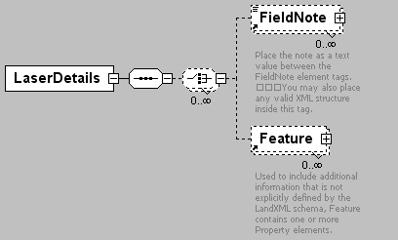
namespace | http://www.landxml.org/schema/LandXML-1.0
children | FieldNote Feature
used by
  element | Equipment
attributes
  Name | Type | Use | Default | Fixed | Annotation
  id | xs:ID | required
  laserVertOffset | xs:double
  manufacturer | xs:string
  model | xs:string
  serialNumber | xs:string
source | <xs:element name="LaserDetails">  <xs:annotation>  <xs:documentation/>  </xs:annotation>  <xs:complexType>  <xs:sequence>  <xs:choice minOccurs="0" maxOccurs="unbounded">  <xs:element ref="FieldNote" minOccurs="0" maxOccurs="unbounded"/>  <xs:element ref="Feature" minOccurs="0" maxOccurs="unbounded"/>  </xs:choice>  </xs:sequence>  <xs:attribute name="id" type="xs:ID" use="required"/>  <xs:attribute name="laserVertOffset" type="xs:double"/>  <xs:attribute name="manufacturer" type="xs:string"/>  <xs:attribute name="model" type="xs:string"/>  <xs:attribute name="serialNumber" type="xs:string"/>  </xs:complexType>  </xs:element>

element LaserSetup
diagram | 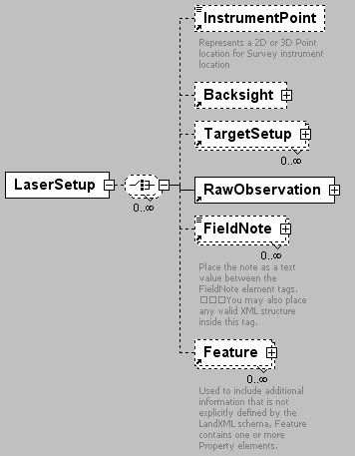
namespace | http://www.landxml.org/schema/LandXML-1.0
children | InstrumentPoint Backsight TargetSetup RawObservation FieldNote Feature
used by
  element | Survey
attributes
  Name | Type | Use | Default | Fixed | Annotation
  id | xs:ID | required
  stationName |  | required
  instrumentHeight | xs:double
  laserDetailsID | xs:IDREF
  magDeclination | xs:double
source | <xs:element name="LaserSetup">  <xs:annotation>  <xs:documentation/>  </xs:annotation>  <xs:complexType>  <xs:choice minOccurs="0" maxOccurs="unbounded">  <xs:element ref="InstrumentPoint" minOccurs="0"/>  <xs:element ref="Backsight" minOccurs="0"/>  <xs:element ref="TargetSetup" minOccurs="0" maxOccurs="unbounded"/>  <xs:element ref="RawObservation"/>  <xs:element ref="FieldNote" minOccurs="0" maxOccurs="unbounded"/>  <xs:element ref="Feature" minOccurs="0" maxOccurs="unbounded"/>  </xs:choice>  <xs:attribute name="id" type="xs:ID" use="required"/>  <xs:attribute name="stationName" use="required"/>  <xs:attribute name="instrumentHeight" type="xs:double"/>  <xs:attribute name="laserDetailsID" type="xs:IDREF"/>  <xs:attribute name="magDeclination" type="xs:double"/>  </xs:complexType>  </xs:element>

element Line
diagram | 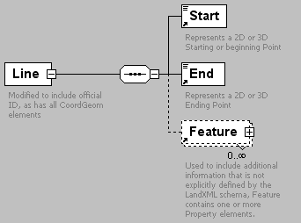
namespace | http://www.landxml.org/schema/LandXML-1.0
children | Start End Feature
used by
  element | CoordGeom
attributes
  Name | Type | Use | Default | Fixed | Annotation
  desc | xs:string
  dir | direction
  length | xs:double
  name | xs:string
  staStart | xs:double
  state | stateType
  oID | xs:string
annotation
  documentation | Modified to include official ID, as has all CoordGeom elements
source | <xs:element name="Line">  <xs:annotation>  <xs:documentation>Modified to include official ID, as has all CoordGeom elements</xs:documentation>  </xs:annotation>  <xs:complexType>  <xs:sequence>  <xs:element ref="Start"/>  <xs:element ref="End"/>  <xs:element ref="Feature" minOccurs="0" maxOccurs="unbounded"/>  </xs:sequence>  <xs:attribute name="desc" type="xs:string"/>  <xs:attribute name="dir" type="direction"/>  <xs:attribute name="length" type="xs:double"/>  <xs:attribute name="name" type="xs:string"/>  <xs:attribute name="staStart" type="xs:double"/>  <xs:attribute name="state" type="stateType"/>  <xs:attribute name="oID" type="xs:string"/>  </xs:complexType>  </xs:element>

element Location
diagram | 
namespace | http://www.landxml.org/schema/LandXML-1.0
type | PointType
used by
  element | PlanFeature
facets
  minLength | 0
  maxLength | 3
attributes
  Name | Type | Use | Default | Fixed | Annotation
  name | xs:string
  desc | xs:string
  code | xs:string
  state | stateType
  pntRef | pointNameRef
  pointGeometry | pointGeometryType
  DTMAttribute | DTMAttributeType
  timeStamp | xs:dateTime | optional
  role | surveyRoleType | optional
annotation
  documentation | Represents a 2D or 3D Point location for a PlanFeature.
  documentation | Defined by either a coordinate text value ("north east" or "north east elev") or a CgPoint number reference "pntRef" attribute.
source | <xs:element name="Location" type="PointType">  <xs:annotation>  <xs:documentation>Represents a 2D or 3D Point location for a PlanFeature.</xs:documentation>  <xs:documentation>Defined by either a coordinate text value ("north east" or "north east elev") or a CgPoint number reference "pntRef" attribute.</xs:documentation>  </xs:annotation>  </xs:element>

element MapPoint
diagram | 
namespace | http://www.landxml.org/schema/LandXML-1.0
type | PointType
used by
  element | SurveyHeader
facets
  minLength | 0
  maxLength | 3
attributes
  Name | Type | Use | Default | Fixed | Annotation
  name | xs:string
  desc | xs:string
  code | xs:string
  state | stateType
  pntRef | pointNameRef
  pointGeometry | pointGeometryType
  DTMAttribute | DTMAttributeType
  timeStamp | xs:dateTime | optional
  role | surveyRoleType | optional
annotation
  documentation | Represents a 2D or 3D Point location for general Survey location
  documentation | Defined by either a coordinate text value ("north east" or "north east elev") or a PointType number reference "pntRef" attribute.
source | <xs:element name="MapPoint" type="PointType">  <xs:annotation>  <xs:documentation>Represents a 2D or 3D Point location for general Survey location</xs:documentation>  <xs:documentation>Defined by either a coordinate text value ("north east" or "north east elev") or a PointType number reference "pntRef" attribute.</xs:documentation>  </xs:annotation>  </xs:element>

element Metric
diagram | 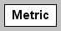
namespace | http://www.landxml.org/schema/LandXML-1.0
used by
  element | Units
attributes
  Name | Type | Use | Default | Fixed | Annotation
  areaUnit | metArea | required
  linearUnit | metLinear | required
  volumeUnit | metVolume | required
  temperatureUnit | metTemperature | required
  pressureUnit | metPressure | required
  diameterUnit | metDiameter
  widthUnit | metWidth
  heightUnit | metHeight
  velocityUnit | metVelocity
  flowUnit | metFlow
  angularUnit | angularType |  | radians
  directionUnit | angularType |  | radians
source | <xs:element name="Metric">  <xs:annotation>  <xs:documentation/>  </xs:annotation>  <xs:complexType>  <xs:attribute name="areaUnit" type="metArea" use="required"/>  <xs:attribute name="linearUnit" type="metLinear" use="required"/>  <xs:attribute name="volumeUnit" type="metVolume" use="required"/>  <xs:attribute name="temperatureUnit" type="metTemperature" use="required"/>  <xs:attribute name="pressureUnit" type="metPressure" use="required"/>  <xs:attribute name="diameterUnit" type="metDiameter"/>  <xs:attribute name="widthUnit" type="metWidth"/>  <xs:attribute name="heightUnit" type="metHeight"/>  <xs:attribute name="velocityUnit" type="metVelocity"/>  <xs:attribute name="flowUnit" type="metFlow"/>  <xs:attribute name="angularUnit" type="angularType" default="radians"/>  <xs:attribute name="directionUnit" type="angularType" default="radians"/>  </xs:complexType>  </xs:element>

element Monument
diagram | 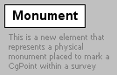
namespace | http://www.landxml.org/schema/LandXML-1.0
used by
  elements | GPSAntennaDetails Monuments
attributes
  Name | Type | Use | Default | Fixed | Annotation
  name | xs:string | required
  pntRef | pointNameRef | required
  desc | xs:string
  state | stateType
  type | monumentType
  condition | monumentCondition
  category | monumentCategory
  beacon | beaconType
  beaconProtection | beaconProtectionType
  oID | xs:string
annotation
  documentation | This is a new element that represents a physical monument placed to mark a CgPoint within a survey
source | <xs:element name="Monument">  <xs:annotation>  <xs:documentation>This is a new element that represents a physical monument placed to mark a CgPoint within a survey</xs:documentation>  </xs:annotation>  <xs:complexType>  <xs:attribute name="name" type="xs:string" use="required"/>  <xs:attribute name="pntRef" type="pointNameRef" use="required"/>  <xs:attribute name="desc" type="xs:string"/>  <xs:attribute name="state" type="stateType"/>  <xs:attribute name="type" type="monumentType"/>  <xs:attribute name="condition" type="monumentCondition"/>  <xs:attribute name="category" type="monumentCategory"/>  <xs:attribute name="beacon" type="beaconType"/>  <xs:attribute name="beaconProtection" type="beaconProtectionType"/>  <xs:attribute name="oID" type="xs:string"/>  </xs:complexType>  </xs:element>

element Monuments
diagram | 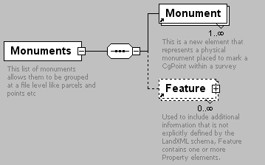
namespace | http://www.landxml.org/schema/LandXML-1.0
children | Monument Feature
used by
  element | LandXML
attributes
  Name | Type | Use | Default | Fixed | Annotation
  desc | xs:string
  name | xs:string
  state | stateType
annotation
  documentation | This list of monuments allows them to be grouped at a file level like parcels and points etc
source | <xs:element name="Monuments">  <xs:annotation>  <xs:documentation>This list of monuments allows them to be grouped at a file level like parcels and points etc</xs:documentation>  </xs:annotation>  <xs:complexType>  <xs:sequence>  <xs:element ref="Monument" maxOccurs="unbounded"/>  <xs:element ref="Feature" minOccurs="0" maxOccurs="unbounded"/>  </xs:sequence>  <xs:attribute name="desc" type="xs:string"/>  <xs:attribute name="name" type="xs:string"/>  <xs:attribute name="state" type="stateType"/>  </xs:complexType>  </xs:element>

element NoPassingZone
diagram | 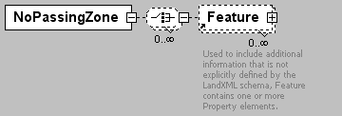
namespace | http://www.landxml.org/schema/LandXML-1.0
children | Feature
used by
  element | Roadway
attributes
  Name | Type | Use | Default | Fixed | Annotation
  staStart | station
  staEnd | station
  sideofRoad | sideofRoadType
source | <xs:element name="NoPassingZone">  <xs:complexType>  <xs:choice minOccurs="0" maxOccurs="unbounded">  <xs:element ref="Feature" minOccurs="0" maxOccurs="unbounded"/>  </xs:choice>  <xs:attribute name="staStart" type="station"/>  <xs:attribute name="staEnd" type="station"/>  <xs:attribute name="sideofRoad" type="sideofRoadType"/>  </xs:complexType>  </xs:element>

element ObservationGroup
diagram | 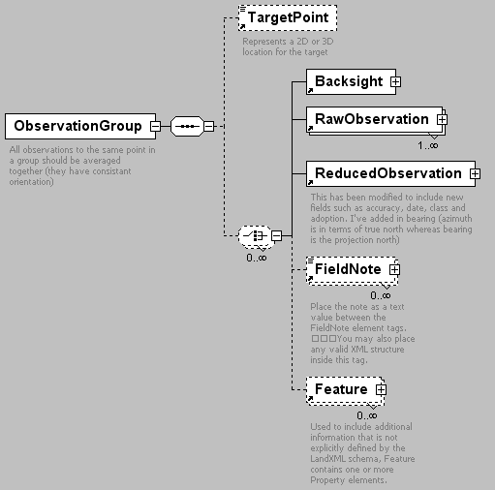
namespace | http://www.landxml.org/schema/LandXML-1.0
children | TargetPoint Backsight RawObservation ReducedObservation FieldNote Feature
used by
  elements | ControlChecks InstrumentSetup Survey
attributes
  Name | Type | Use | Default | Fixed | Annotation
  id | xs:ID | required
  purpose | purposeType
  setupID | xs:IDREF
  targetSetupID | xs:IDREF
  setID
  coordGeomRefs | coordGeomNameRefs
annotation
  documentation | All observations to the same point in a group should be averaged together (they have consistant orientation)
source | <xs:element name="ObservationGroup">  <xs:annotation>  <xs:documentation>All observations to the same point in a group should be averaged together (they have consistant orientation)</xs:documentation>  </xs:annotation>  <xs:complexType>  <xs:sequence>  <xs:element ref="TargetPoint" minOccurs="0"/>  <xs:choice minOccurs="0" maxOccurs="unbounded">  <xs:element ref="Backsight"/>  <xs:element ref="RawObservation" maxOccurs="unbounded"/>  <xs:element ref="ReducedObservation"/>  <xs:element ref="FieldNote" minOccurs="0" maxOccurs="unbounded"/>  <xs:element ref="Feature" minOccurs="0" maxOccurs="unbounded"/>  </xs:choice>  </xs:sequence>  <xs:attribute name="id" type="xs:ID" use="required"/>  <xs:attribute name="purpose" type="purposeType"/>  <xs:attribute name="setupID" type="xs:IDREF"/>  <xs:attribute name="targetSetupID" type="xs:IDREF"/>  <xs:attribute name="setID"/>  <xs:attribute name="coordGeomRefs" type="coordGeomNameRefs"/>  <!-- coordGeomRefs identifies one or more 'name' values that link to specific <Line>, <Curve>, <Spiral> or <IrregularLine> in a <CoordGeom> element. This allows linking an survey observation to specific <Parcel>.<CoordGeom> based geometry. -->  </xs:complexType>  </xs:element>

element ObstructionOffset
diagram | 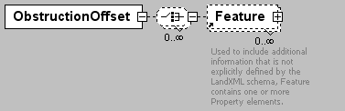
namespace | http://www.landxml.org/schema/LandXML-1.0
children | Feature
used by
  element | Roadside
attributes
  Name | Type | Use | Default | Fixed | Annotation
  staStart | station
  staEnd | station
  offset | offsetDistance
  sideofRoad | sideofRoadType
source | <xs:element name="ObstructionOffset">  <xs:complexType>  <xs:choice minOccurs="0" maxOccurs="unbounded">  <xs:element ref="Feature" minOccurs="0" maxOccurs="unbounded"/>  </xs:choice>  <xs:attribute name="staStart" type="station"/>  <xs:attribute name="staEnd" type="station"/>  <xs:attribute name="offset" type="offsetDistance"/>  <xs:attribute name="sideofRoad" type="sideofRoadType"/>  </xs:complexType>  </xs:element>

element OffsetLane
diagram | 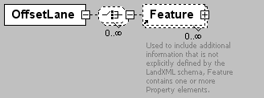
namespace | http://www.landxml.org/schema/LandXML-1.0
children | Feature
used by
  element | Lanes
attributes
  Name | Type | Use | Default | Fixed | Annotation
  staStart | station
  staEnd | station
  beginFullWidthSta | station
  endFullWidthSta | station
  fullOffset | offsetDistance
  width | xs:double
  sideofRoad | sideofRoadType
source | <xs:element name="OffsetLane">  <xs:complexType>  <xs:choice minOccurs="0" maxOccurs="unbounded">  <xs:element ref="Feature" minOccurs="0" maxOccurs="unbounded"/>  </xs:choice>  <xs:attribute name="staStart" type="station"/>  <xs:attribute name="staEnd" type="station"/>  <xs:attribute name="beginFullWidthSta" type="station"/>  <xs:attribute name="endFullWidthSta" type="station"/>  <xs:attribute name="fullOffset" type="offsetDistance"/>  <xs:attribute name="width" type="xs:double"/>  <xs:attribute name="sideofRoad" type="sideofRoadType"/>  </xs:complexType>  </xs:element>

element OffsetVals
diagram | 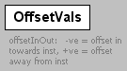
namespace | http://www.landxml.org/schema/LandXML-1.0
used by
  elements | RawObservation ReducedArcObservation ReducedObservation
attributes
  Name | Type | Use | Default | Fixed | Annotation
  offsetInOut | xs:double
  offsetLeftRight | xs:double
  offsetUpDown | xs:double
annotation
  documentation | offsetInOut: -ve = offset in towards inst, +ve = offset away from inst
  documentation | offsetLeftRight: -ve = left, +ve = right (as viewed from instrument)
  documentation | offsetUpDown: -ve = down, +ve = up
source | <xs:element name="OffsetVals">  <xs:annotation>  <xs:documentation>offsetInOut: -ve = offset in towards inst, +ve = offset away from inst </xs:documentation>  <xs:documentation>offsetLeftRight: -ve = left, +ve = right (as viewed from instrument) </xs:documentation>  <xs:documentation>offsetUpDown: -ve = down, +ve = up</xs:documentation>  </xs:annotation>  <xs:complexType>  <xs:attribute name="offsetInOut" type="xs:double"/>  <xs:attribute name="offsetLeftRight" type="xs:double"/>  <xs:attribute name="offsetUpDown" type="xs:double"/>  </xs:complexType>  </xs:element>

element Outlet
diagram | 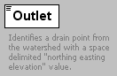
namespace | http://www.landxml.org/schema/LandXML-1.0
type | extension of PointType3dReq
used by
  element | Watershed
facets
  minLength | 0
  maxLength | 3
attributes
  Name | Type | Use | Default | Fixed | Annotation
  name | xs:string
  desc | xs:string
  code | xs:string
  state | stateType
  pntRef | pointNameRef
  pointGeometry | pointGeometryType
  DTMAttribute | DTMAttributeType
  timeStamp | xs:dateTime | optional
  role | surveyRoleType | optional
  refWS | waterShedNameRef
annotation
  documentation | Identifies a drain point from the watershed with a space delimited "northing easting elevation" value.
  documentation | If it drains to another known watershed, then the name of that watershed is identified by the "refWs" attribute.
source | <xs:element name="Outlet">  <xs:annotation>  <xs:documentation>Identifies a drain point from the watershed with a space delimited "northing easting elevation" value.</xs:documentation>  <xs:documentation>If it drains to another known watershed, then the name of that watershed is identified by the "refWs" attribute.</xs:documentation>  </xs:annotation>  <xs:complexType mixed="true">  <xs:simpleContent>  <xs:extension base="PointType3dReq">  <xs:attribute name="refWS" type="waterShedNameRef"/>  </xs:extension>  </xs:simpleContent>  </xs:complexType>  </xs:element>

element OutletStruct
diagram | 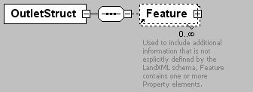
namespace | http://www.landxml.org/schema/LandXML-1.0
children | Feature
used by
  element | Struct
source | <xs:element name="OutletStruct">  <xs:annotation>  <xs:documentation/>  </xs:annotation>  <xs:complexType>  <xs:sequence>  <xs:element ref="Feature" minOccurs="0" maxOccurs="unbounded"/>  </xs:sequence>  </xs:complexType>  </xs:element>

element P
diagram | 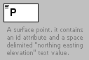
namespace | http://www.landxml.org/schema/LandXML-1.0
type | extension of PointType
used by
  element | Pnts
facets
  minLength | 0
  maxLength | 3
attributes
  Name | Type | Use | Default | Fixed | Annotation
  name | xs:string
  desc | xs:string
  code | xs:string
  state | stateType
  pntRef | pointNameRef
  pointGeometry | pointGeometryType
  DTMAttribute | DTMAttributeType
  timeStamp | xs:dateTime | optional
  role | surveyRoleType | optional
  id | xs:positiveInteger | required
annotation
  documentation | A surface point. it contains an id attribute and a space delimited "northing easting elevation" text value.
  documentation | The id values are referenced by the surface faces for the coordinate values.
source | <xs:element name="P">  <xs:annotation>  <xs:documentation>A surface point. it contains an id attribute and a space delimited "northing easting elevation" text value.</xs:documentation>  <xs:documentation>The id values are referenced by the surface faces for the coordinate values.</xs:documentation>  </xs:annotation>  <xs:complexType mixed="true">  <xs:simpleContent>  <xs:extension base="PointType">  <xs:attribute name="id" type="xs:positiveInteger" use="required"/>  </xs:extension>  </xs:simpleContent>  </xs:complexType>  </xs:element>

element ParaCurve
diagram | 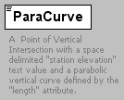
namespace | http://www.landxml.org/schema/LandXML-1.0
type | extension of Point2dReq
used by
  element | ProfAlign
facets
  length | 2
attributes
  Name | Type | Use | Default | Fixed | Annotation
  length | xs:double | required
  desc | xs:string
annotation
  documentation | A Point of Vertical Intersection with a space delimited "station elevation" text value and a parabolic vertical curve defined by the "length" attribute.
source | <xs:element name="ParaCurve">  <xs:annotation>  <xs:documentation>A Point of Vertical Intersection with a space delimited "station elevation" text value and a parabolic vertical curve defined by the "length" attribute.</xs:documentation>  </xs:annotation>  <xs:complexType mixed="true">  <xs:simpleContent>  <xs:extension base="Point2dReq">  <xs:attribute name="length" type="xs:double" use="required"/>  <xs:attribute name="desc" type="xs:string"/>  </xs:extension>  </xs:simpleContent>  </xs:complexType>  </xs:element>

element Parcel
diagram | 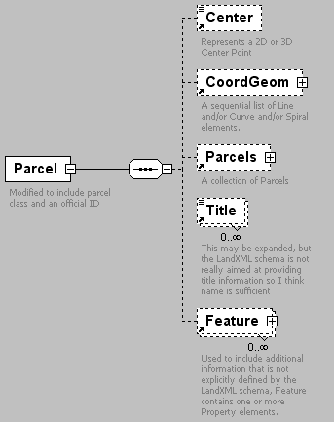
namespace | http://www.landxml.org/schema/LandXML-1.0
children | Center CoordGeom Parcels Title Feature
used by
  element | Parcels
attributes
  Name | Type | Use | Default | Fixed | Annotation
  name | xs:string | required
  oID | xs:string
  area | xs:double
  desc | xs:string
  dirClosure | direction
  distClosure | xs:double
  owner | xs:string
  parcelType | xs:string
  setbackFront | xs:double
  setbackRear | xs:double
  setbackSide | xs:double
  state | parcelStateType
  taxId | xs:string
  class | parcelClass
annotation
  documentation | Modified to include parcel class and an official ID
source | <xs:element name="Parcel">  <xs:annotation>  <xs:documentation>Modified to include parcel class and an official ID</xs:documentation>  </xs:annotation>  <xs:complexType>  <xs:sequence>  <xs:element ref="Center" minOccurs="0"/>  <xs:element ref="CoordGeom" minOccurs="0"/>  <xs:element ref="Parcels" minOccurs="0"/>  <xs:element ref="Title" minOccurs="0" maxOccurs="unbounded"/>  <xs:element ref="Feature" minOccurs="0" maxOccurs="unbounded"/>  </xs:sequence>  <xs:attribute name="name" type="xs:string" use="required"/>  <xs:attribute name="oID" type="xs:string"/>  <xs:attribute name="area" type="xs:double"/>  <xs:attribute name="desc" type="xs:string"/>  <xs:attribute name="dirClosure" type="direction"/>  <xs:attribute name="distClosure" type="xs:double"/>  <xs:attribute name="owner" type="xs:string"/>  <xs:attribute name="parcelType" type="xs:string"/>  <xs:attribute name="setbackFront" type="xs:double"/>  <xs:attribute name="setbackRear" type="xs:double"/>  <xs:attribute name="setbackSide" type="xs:double"/>  <xs:attribute name="state" type="parcelStateType"/>  <xs:attribute name="taxId" type="xs:string"/>  <xs:attribute name="class" type="parcelClass"/>  </xs:complexType>  </xs:element>

element Parcels
diagram | 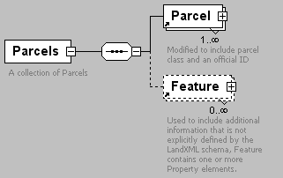
namespace | http://www.landxml.org/schema/LandXML-1.0
children | Parcel Feature
used by
  elements | LandXML Parcel
attributes
  Name | Type | Use | Default | Fixed | Annotation
  desc | xs:string
  name | xs:string
  state | stateType
annotation
  documentation | A collection of Parcels
source | <xs:element name="Parcels">  <xs:annotation>  <xs:documentation>A collection of Parcels</xs:documentation>  </xs:annotation>  <xs:complexType>  <xs:sequence>  <xs:element ref="Parcel" maxOccurs="unbounded"/>  <xs:element ref="Feature" minOccurs="0" maxOccurs="unbounded"/>  </xs:sequence>  <xs:attribute name="desc" type="xs:string"/>  <xs:attribute name="name" type="xs:string"/>  <xs:attribute name="state" type="stateType"/>  </xs:complexType>  </xs:element>

element PassingLane
diagram | 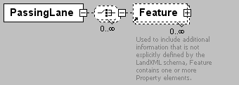
namespace | http://www.landxml.org/schema/LandXML-1.0
children | Feature
used by
  element | Lanes
attributes
  Name | Type | Use | Default | Fixed | Annotation
  staStart | station
  staEnd | station
  beginFullWidthSta | station
  endFullWidthSta | station
  width | xs:double
  sideofRoad | sideofRoadType
source | <xs:element name="PassingLane">  <xs:complexType>  <xs:choice minOccurs="0" maxOccurs="unbounded">  <xs:element ref="Feature" minOccurs="0" maxOccurs="unbounded"/>  </xs:choice>  <xs:attribute name="staStart" type="station"/>  <xs:attribute name="staEnd" type="station"/>  <xs:attribute name="beginFullWidthSta" type="station"/>  <xs:attribute name="endFullWidthSta" type="station"/>  <xs:attribute name="width" type="xs:double"/>  <xs:attribute name="sideofRoad" type="sideofRoadType"/>  </xs:complexType>  </xs:element>

element PeakHour
diagram | 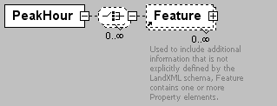
namespace | http://www.landxml.org/schema/LandXML-1.0
children | Feature
used by
  element | TrafficVolume
attributes
  Name | Type | Use | Default | Fixed | Annotation
  staStart | station
  staEnd | station
  sideofRoad | sideofRoadType
  volume | xs:double
source | <xs:element name="PeakHour">  <xs:complexType>  <xs:choice minOccurs="0" maxOccurs="unbounded">  <xs:element ref="Feature" minOccurs="0" maxOccurs="unbounded"/>  </xs:choice>  <xs:attribute name="staStart" type="station"/>  <xs:attribute name="staEnd" type="station"/>  <xs:attribute name="sideofRoad" type="sideofRoadType"/>  <xs:attribute name="volume" type="xs:double"/>  </xs:complexType>  <!-- Peak Hour Volume - This item is the peak hour volume (PHV). The 30th highest volume of the year should be used as the PHV, which can be approximated as 15 percent of the average daily traffic (ADT). On two-lane rural highways, the DHV is the total traffic in both directions of travel. The unit of measure for this item is vehicles/hour. -->  </xs:element>

element Personnel
diagram | 
namespace | http://www.landxml.org/schema/LandXML-1.0
used by
  element | SurveyHeader
attributes
  Name | Type | Use | Default | Fixed | Annotation
  name | xs:string
  role | xs:string
source | <xs:element name="Personnel">  <xs:complexType>  <xs:attribute name="name" type="xs:string"/>  <xs:attribute name="role" type="xs:string"/>  </xs:complexType>  </xs:element>

element PI
diagram | 
namespace | http://www.landxml.org/schema/LandXML-1.0
type | PointType
used by
  elements | Curve Spiral
facets
  minLength | 0
  maxLength | 3
attributes
  Name | Type | Use | Default | Fixed | Annotation
  name | xs:string
  desc | xs:string
  code | xs:string
  state | stateType
  pntRef | pointNameRef
  pointGeometry | pointGeometryType
  DTMAttribute | DTMAttributeType
  timeStamp | xs:dateTime | optional
  role | surveyRoleType | optional
annotation
  documentation | Represents a 2D or 3D Point of Intersection
  documentation | Defined by either a coordinate text value ("north east" or "north east elev") or a CgPoint number reference "pntRef" attribute.
source | <xs:element name="PI" type="PointType">  <xs:annotation>  <xs:documentation>Represents a 2D or 3D Point of Intersection</xs:documentation>  <xs:documentation>Defined by either a coordinate text value ("north east" or "north east elev") or a CgPoint number reference "pntRef" attribute.</xs:documentation>  </xs:annotation>  </xs:element>

element Pipe
diagram | 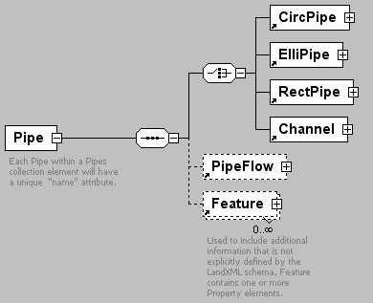
namespace | http://www.landxml.org/schema/LandXML-1.0
children | CircPipe ElliPipe RectPipe Channel PipeFlow Feature
used by
  element | Pipes
attributes
  Name | Type | Use | Default | Fixed | Annotation
  name | xs:string | required
  refEnd | structNameRef | required
  refStart | structNameRef | required
  desc | xs:string
  length | xs:double
  oID | xs:string
  slope | xs:double
  state | stateType
annotation
  documentation | Each Pipe within a Pipes collection element will have a unique "name" attribute.
  documentation | The pipe type is determined by the existance of one of the following elements: CircPipe, ElliPipe or RectPipe.
  documentation | The "startRef and "endRef" attributes reference Struct "name" values.
  documentation | The start and end invert elevations for the pipe are defined in the Invert elements of referenced structures.
  documentation | Since a struct may have more than one Invert element, the Invert "pipeRef" attribute is used to select the correct invert element.
source | <xs:element name="Pipe">  <xs:annotation>  <xs:documentation>Each Pipe within a Pipes collection element will have a unique "name" attribute.</xs:documentation>  <xs:documentation>The pipe type is determined by the existance of one of the following elements: CircPipe, ElliPipe or RectPipe.</xs:documentation>  <xs:documentation>The "startRef and "endRef" attributes reference Struct "name" values.</xs:documentation>  <xs:documentation>The start and end invert elevations for the pipe are defined in the Invert elements of referenced structures.</xs:documentation>  <xs:documentation>Since a struct may have more than one Invert element, the Invert "pipeRef" attribute is used to select the correct invert element.</xs:documentation>  </xs:annotation>  <xs:complexType>  <xs:sequence>  <xs:choice>  <xs:element ref="CircPipe"/>  <xs:element ref="ElliPipe"/>  <xs:element ref="RectPipe"/>  <xs:element ref="Channel"/>  </xs:choice>  <xs:element ref="PipeFlow" minOccurs="0"/>  <xs:element ref="Feature" minOccurs="0" maxOccurs="unbounded"/>  </xs:sequence>  <xs:attribute name="name" type="xs:string" use="required"/>  <xs:attribute name="refEnd" type="structNameRef" use="required"/>  <xs:attribute name="refStart" type="structNameRef" use="required"/>  <xs:attribute name="desc" type="xs:string"/>  <xs:attribute name="length" type="xs:double"/>  <xs:attribute name="oID" type="xs:string"/>  <xs:attribute name="slope" type="xs:double"/>  <xs:attribute name="state" type="stateType"/>  </xs:complexType>  </xs:element>

element PipeFlow
diagram | 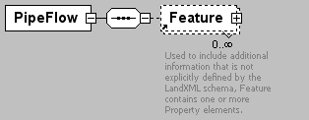
namespace | http://www.landxml.org/schema/LandXML-1.0
children | Feature
used by
  element | Pipe
attributes
  Name | Type | Use | Default | Fixed | Annotation
  flowIn | xs:double | required
  areaCatchment | xs:double
  desc | xs:string
  depthCritical | xs:double
  hglDown | xs:double
  hglUp | xs:double
  intensity | xs:double
  runoffCoeff | xs:double
  slopeCritical | xs:double
  timeInlet | xs:double
  velocityCritical | xs:double
source | <xs:element name="PipeFlow">  <xs:annotation>  <xs:documentation/>  </xs:annotation>  <xs:complexType>  <xs:sequence>  <xs:element ref="Feature" minOccurs="0" maxOccurs="unbounded"/>  </xs:sequence>  <xs:attribute name="flowIn" type="xs:double" use="required"/>  <xs:attribute name="areaCatchment" type="xs:double"/>  <xs:attribute name="desc" type="xs:string"/>  <xs:attribute name="depthCritical" type="xs:double"/>  <xs:attribute name="hglDown" type="xs:double"/>  <xs:attribute name="hglUp" type="xs:double"/>  <xs:attribute name="intensity" type="xs:double"/>  <xs:attribute name="runoffCoeff" type="xs:double"/>  <xs:attribute name="slopeCritical" type="xs:double"/>  <xs:attribute name="timeInlet" type="xs:double"/>  <xs:attribute name="velocityCritical" type="xs:double"/>  </xs:complexType>  </xs:element>

element PipeNetwork
diagram | 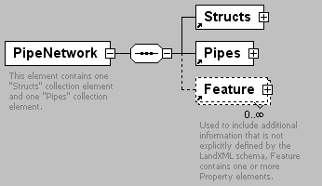
namespace | http://www.landxml.org/schema/LandXML-1.0
children | Structs Pipes Feature
used by
  element | PipeNetworks
attributes
  Name | Type | Use | Default | Fixed | Annotation
  name | xs:string | required
  pipeNetType | pipeNetworkType | required
  alignmentRef | alignmentNameRef
  desc | xs:string
  oID | xs:string
  state | stateType
annotation
  documentation | This element contains one "Structs" collection element and one "Pipes" collection element.
  documentation | keyRef is a Schema validation mechanism that ensures that the "structRef" and "pipeRef" attribute values have corresponding Pipe and Struct "name" values"
source | <xs:element name="PipeNetwork">  <xs:annotation>  <xs:documentation>This element contains one "Structs" collection element and one "Pipes" collection element.</xs:documentation>  <xs:documentation>keyRef is a Schema validation mechanism that ensures that the "structRef" and "pipeRef" attribute values have corresponding Pipe and Struct "name" values"</xs:documentation>  </xs:annotation>  <xs:complexType>  <xs:sequence>  <xs:element ref="Structs"/>  <xs:element ref="Pipes"/>  <xs:element ref="Feature" minOccurs="0" maxOccurs="unbounded"/>  </xs:sequence>  <xs:attribute name="name" type="xs:string" use="required"/>  <xs:attribute name="pipeNetType" type="pipeNetworkType" use="required"/>  <xs:attribute name="alignmentRef" type="alignmentNameRef"/>  <xs:attribute name="desc" type="xs:string"/>  <xs:attribute name="oID" type="xs:string"/>  <xs:attribute name="state" type="stateType"/>  </xs:complexType>  </xs:element>

element PipeNetworks
diagram | 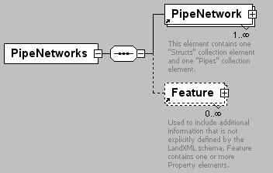
namespace | http://www.landxml.org/schema/LandXML-1.0
children | PipeNetwork Feature
used by
  element | LandXML
attributes
  Name | Type | Use | Default | Fixed | Annotation
  desc | xs:string
  name | xs:string
  state | stateType
source | <xs:element name="PipeNetworks">  <xs:annotation>  <xs:documentation/>  </xs:annotation>  <xs:complexType>  <xs:sequence>  <xs:element ref="PipeNetwork" maxOccurs="unbounded"/>  <xs:element ref="Feature" minOccurs="0" maxOccurs="unbounded"/>  </xs:sequence>  <xs:attribute name="desc" type="xs:string"/>  <xs:attribute name="name" type="xs:string"/>  <xs:attribute name="state" type="stateType"/>  </xs:complexType>  </xs:element>

element Pipes
diagram | 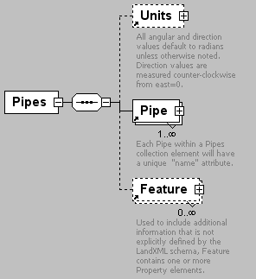
namespace | http://www.landxml.org/schema/LandXML-1.0
children | Units Pipe Feature
used by
  element | PipeNetwork
source | <xs:element name="Pipes">  <xs:annotation>  <xs:documentation/>  </xs:annotation>  <xs:complexType>  <xs:sequence>  <xs:element ref="Units" minOccurs="0"/>  <xs:element ref="Pipe" maxOccurs="unbounded"/>  <xs:element ref="Feature" minOccurs="0" maxOccurs="unbounded"/>  </xs:sequence>  </xs:complexType>  </xs:element>

element PlanFeature
diagram | 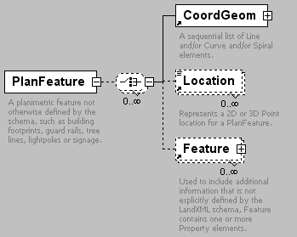
namespace | http://www.landxml.org/schema/LandXML-1.0
children | CoordGeom Location Feature
used by
  element | PlanFeatures
attributes
  Name | Type | Use | Default | Fixed | Annotation
  desc | xs:string
  name | xs:string
  state | stateType
annotation
  documentation | A planimetric feature not otherwise defined by the schema, such as building footprints, guard rails, tree lines, lightpoles or signage.
source | <xs:element name="PlanFeature">  <xs:annotation>  <xs:documentation>A planimetric feature not otherwise defined by the schema, such as building footprints, guard rails, tree lines, lightpoles or signage.</xs:documentation>  </xs:annotation>  <xs:complexType>  <xs:choice minOccurs="0" maxOccurs="unbounded">  <xs:element ref="CoordGeom"/>  <xs:element ref="Location" minOccurs="0" maxOccurs="unbounded"/>  <xs:element ref="Feature" minOccurs="0" maxOccurs="unbounded"/>  </xs:choice>  <xs:attribute name="desc" type="xs:string"/>  <xs:attribute name="name" type="xs:string"/>  <xs:attribute name="state" type="stateType"/>  </xs:complexType>  </xs:element>

element PlanFeatures
diagram | 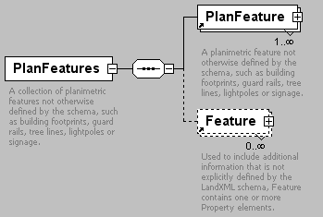
namespace | http://www.landxml.org/schema/LandXML-1.0
children | PlanFeature Feature
used by
  element | LandXML
attributes
  Name | Type | Use | Default | Fixed | Annotation
  desc | xs:string
  name | xs:string
  state | stateType
annotation
  documentation | A collection of planimetric features not otherwise defined by the schema, such as building footprints, guard rails, tree lines, lightpoles or signage.
  documentation | Typically a PlanFeatures element will contain a collection of similar items.
source | <xs:element name="PlanFeatures">  <xs:annotation>  <xs:documentation>A collection of planimetric features not otherwise defined by the schema, such as building footprints, guard rails, tree lines, lightpoles or signage.</xs:documentation>  <xs:documentation>Typically a PlanFeatures element will contain a collection of similar items.</xs:documentation>  </xs:annotation>  <xs:complexType>  <xs:sequence>  <xs:element ref="PlanFeature" maxOccurs="unbounded"/>  <xs:element ref="Feature" minOccurs="0" maxOccurs="unbounded"/>  </xs:sequence>  <xs:attribute name="desc" type="xs:string"/>  <xs:attribute name="name" type="xs:string"/>  <xs:attribute name="state" type="stateType"/>  </xs:complexType>  </xs:element>

element PntList2D
diagram | 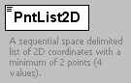
namespace | http://www.landxml.org/schema/LandXML-1.0
type | restriction of Point
used by
  elements | Boundary Breakline Contour CrossSectSurf IrregularLine ProfSurf Watershed ZoneCrossSectStructure
facets
  minLength | 2
annotation
  documentation | A sequential space delimited list of 2D coordinates with a minimum of 2 points (4 values).
  documentation | It is primarily used for ProfileSurf to hold the list of station/elevations and CrossSectSurf for offset/elevation.
  documentation | Example: "0.000 86.52 6.267 86.89 12.413 87.01 26.020 87.83"
source | <xs:element name="PntList2D">  <xs:annotation>  <xs:documentation>A sequential space delimited list of 2D coordinates with a minimum of 2 points (4 values). </xs:documentation>  <xs:documentation>It is primarily used for ProfileSurf to hold the list of station/elevations and CrossSectSurf for offset/elevation. </xs:documentation>  <xs:documentation>Example: "0.000 86.52 6.267 86.89 12.413 87.01 26.020 87.83" </xs:documentation>  </xs:annotation>  <xs:simpleType>  <xs:restriction base="Point">  <xs:minLength value="2"/>  </xs:restriction>  </xs:simpleType>  </xs:element>

element PntList3D
diagram | 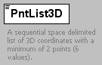
namespace | http://www.landxml.org/schema/LandXML-1.0
type | restriction of Point
used by
  elements | Boundary Breakline DataPoints IrregularLine Watershed
facets
  minLength | 3
annotation
  documentation | A sequential space delimited list of 3D coordinates with a minimum of 2 points (6 values).
  documentation | Primarily used to store lists of northing/easting/elevation for Terrain Surface data.
  documentation | Example: "0.000 86.52 50.0 6.267 86.89 50.0 12.413 87.01 50.0 26.020 87.83 50.0"
source | <xs:element name="PntList3D">  <xs:annotation>  <xs:documentation>A sequential space delimited list of 3D coordinates with a minimum of 2 points (6 values). </xs:documentation>  <xs:documentation>Primarily used to store lists of northing/easting/elevation for Terrain Surface data. </xs:documentation>  <xs:documentation>Example: "0.000 86.52 50.0 6.267 86.89 50.0 12.413 87.01 50.0 26.020 87.83 50.0" </xs:documentation>  </xs:annotation>  <xs:simpleType>  <xs:restriction base="Point">  <xs:minLength value="3"/>  </xs:restriction>  </xs:simpleType>  </xs:element>

element Pnts
diagram | 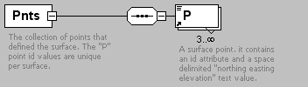
namespace | http://www.landxml.org/schema/LandXML-1.0
children | P
used by
  element | Definition
annotation
  documentation | The collection of points that defined the surface. The "P" point id values are unique per surface.
  documentation | The id values are referenced by the surface faces and breaklines.
source | <xs:element name="Pnts">  <xs:annotation>  <xs:documentation>The collection of points that defined the surface. The "P" point id values are unique per surface.</xs:documentation>  <xs:documentation>The id values are referenced by the surface faces and breaklines.</xs:documentation>  </xs:annotation>  <xs:complexType>  <xs:sequence>  <xs:element ref="P" minOccurs="3" maxOccurs="unbounded"/>  </xs:sequence>  </xs:complexType>  </xs:element>

element PointFile
diagram | 
namespace | http://www.landxml.org/schema/LandXML-1.0
used by
  element | PointFiles
attributes
  Name | Type | Use | Default | Fixed | Annotation
  fileName |  | required
  fileType |  | required
  fileFormat |  | required
annotation
  documentation | A reference to an external file containing point information.
  documentation | The format of the information is defined by the order and delimeter attributes.
source | <xs:element name="PointFile">  <xs:annotation>  <xs:documentation>A reference to an external file containing point information.</xs:documentation>  <xs:documentation>The format of the information is defined by the order and delimeter attributes.</xs:documentation>  </xs:annotation>  <xs:complexType>  <xs:attribute name="fileName" use="required"/>  <xs:attribute name="fileType" use="required"/>  <xs:attribute name="fileFormat" use="required"/>  </xs:complexType>  </xs:element>

element PointFiles
diagram | 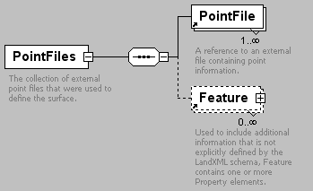
namespace | http://www.landxml.org/schema/LandXML-1.0
children | PointFile Feature
used by
  element | SourceData
annotation
  documentation | The collection of external point files that were used to define the surface.
  documentation | Use is optional.
source | <xs:element name="PointFiles">  <xs:annotation>  <xs:documentation>The collection of external point files that were used to define the surface.</xs:documentation>  <xs:documentation>Use is optional.</xs:documentation>  </xs:annotation>  <xs:complexType>  <xs:sequence>  <xs:element ref="PointFile" maxOccurs="unbounded"/>  <xs:element ref="Feature" minOccurs="0" maxOccurs="unbounded"/>  </xs:sequence>  </xs:complexType>  </xs:element>

element PointResults
diagram | 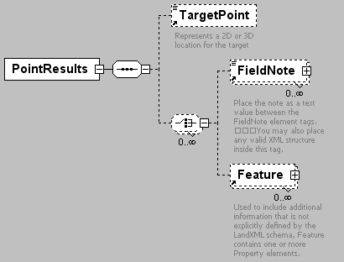
namespace | http://www.landxml.org/schema/LandXML-1.0
children | TargetPoint FieldNote Feature
used by
  element | ControlChecks
attributes
  Name | Type | Use | Default | Fixed | Annotation
  setupID | xs:IDREF
  targetSetupID | xs:IDREF
  meanHorizAngle | xs:double
  horizStdDeviation | xs:double
  meanzenithAngle | xs:double
  vertStdDeviation | xs:double
  meanSlopeDistance | xs:double
  slopeDistanceStdDeviation | xs:double
source | <xs:element name="PointResults">  <xs:annotation>  <xs:documentation/>  </xs:annotation>  <xs:complexType>  <xs:sequence>  <xs:element ref="TargetPoint" minOccurs="0"/>  <xs:choice minOccurs="0" maxOccurs="unbounded">  <xs:element ref="FieldNote" minOccurs="0" maxOccurs="unbounded"/>  <xs:element ref="Feature" minOccurs="0" maxOccurs="unbounded"/>  </xs:choice>  </xs:sequence>  <xs:attribute name="setupID" type="xs:IDREF"/>  <xs:attribute name="targetSetupID" type="xs:IDREF"/>  <xs:attribute name="meanHorizAngle" type="xs:double"/>  <xs:attribute name="horizStdDeviation" type="xs:double"/>  <xs:attribute name="meanzenithAngle" type="xs:double"/>  <xs:attribute name="vertStdDeviation" type="xs:double"/>  <xs:attribute name="meanSlopeDistance" type="xs:double"/>  <xs:attribute name="slopeDistanceStdDeviation" type="xs:double"/>  </xs:complexType>  </xs:element>

element PostedSpeed
diagram | 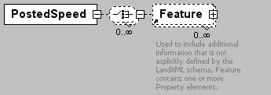
namespace | http://www.landxml.org/schema/LandXML-1.0
children | Feature
used by
  element | Speeds
attributes
  Name | Type | Use | Default | Fixed | Annotation
  staStart | station
  staEnd | station
  sideofRoad | sideofRoadType
  speedLimit | speed
source | <xs:element name="PostedSpeed">  <xs:complexType>  <xs:choice minOccurs="0" maxOccurs="unbounded">  <xs:element ref="Feature" minOccurs="0" maxOccurs="unbounded"/>  </xs:choice>  <xs:attribute name="staStart" type="station"/>  <xs:attribute name="staEnd" type="station"/>  <xs:attribute name="sideofRoad" type="sideofRoadType"/>  <xs:attribute name="speedLimit" type="speed"/>  </xs:complexType>  </xs:element>

element ProfAlign
diagram | 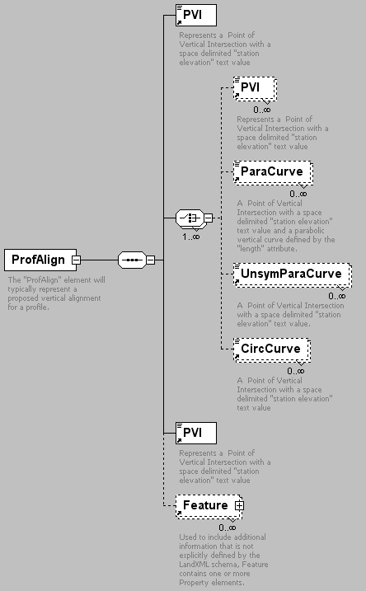
namespace | http://www.landxml.org/schema/LandXML-1.0
children | PVI ParaCurve UnsymParaCurve CircCurve Feature
used by
  element | Profile
attributes
  Name | Type | Use | Default | Fixed | Annotation
  name | xs:string | required
  desc | xs:string
  state | stateType
annotation
  documentation | The "ProfAlign" element will typically represent a proposed vertical alignment for a profile.
  documentation | It is defined by a sequential series of any combination of the four "PVI" element types.
source | <xs:element name="ProfAlign">  <xs:annotation>  <xs:documentation>The "ProfAlign" element will typically represent a proposed vertical alignment for a profile.</xs:documentation>  <xs:documentation>It is defined by a sequential series of any combination of the four "PVI" element types.</xs:documentation>  </xs:annotation>  <xs:complexType>  <xs:sequence>  <xs:element ref="PVI"/>  <xs:choice maxOccurs="unbounded">  <xs:element ref="PVI" minOccurs="0" maxOccurs="unbounded"/>  <xs:element ref="ParaCurve" minOccurs="0" maxOccurs="unbounded"/>  <xs:element ref="UnsymParaCurve" minOccurs="0" maxOccurs="unbounded"/>  <xs:element ref="CircCurve" minOccurs="0" maxOccurs="unbounded"/>  </xs:choice>  <xs:element ref="PVI"/>  <xs:element ref="Feature" minOccurs="0" maxOccurs="unbounded"/>  </xs:sequence>  <xs:attribute name="name" type="xs:string" use="required"/>  <xs:attribute name="desc" type="xs:string"/>  <xs:attribute name="state" type="stateType"/>  </xs:complexType>  </xs:element>

element Profile
diagram | 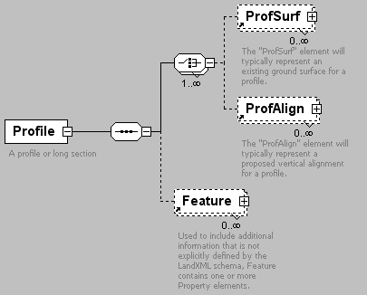
namespace | http://www.landxml.org/schema/LandXML-1.0
children | ProfSurf ProfAlign Feature
used by
  element | Alignment
attributes
  Name | Type | Use | Default | Fixed | Annotation
  desc | xs:string
  name | xs:string
  staStart | xs:double
  state | stateType
annotation
  documentation | A profile or long section
source | <xs:element name="Profile">  <xs:annotation>  <xs:documentation>A profile or long section</xs:documentation>  </xs:annotation>  <xs:complexType>  <xs:sequence>  <xs:choice maxOccurs="unbounded">  <xs:element ref="ProfSurf" minOccurs="0" maxOccurs="unbounded"/>  <xs:element ref="ProfAlign" minOccurs="0" maxOccurs="unbounded"/>  </xs:choice>  <xs:element ref="Feature" minOccurs="0" maxOccurs="unbounded"/>  </xs:sequence>  <xs:attribute name="desc" type="xs:string"/>  <xs:attribute name="name" type="xs:string"/>  <xs:attribute name="staStart" type="xs:double"/>  <xs:attribute name="state" type="stateType"/>  </xs:complexType>  </xs:element>

element ProfSurf
diagram | 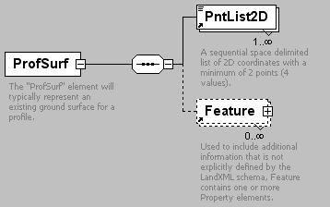
namespace | http://www.landxml.org/schema/LandXML-1.0
children | PntList2D Feature
used by
  element | Profile
attributes
  Name | Type | Use | Default | Fixed | Annotation
  name | xs:string | required
  desc | xs:string
  state | stateType
annotation
  documentation | The "ProfSurf" element will typically represent an existing ground surface for a profile.
  documentation | It is defined with a space delimited PntList2D of station/elevations pairs.
  documentation | Example: "0.000 86.52 6.267 86.89 12.413 87.01 26.020 87.83"
  documentation | Note: Gaps in the profile are handled by having 2 or more PntList2D elements.
source | <xs:element name="ProfSurf">  <xs:annotation>  <xs:documentation>The "ProfSurf" element will typically represent an existing ground surface for a profile. </xs:documentation>  <xs:documentation>It is defined with a space delimited PntList2D of station/elevations pairs. </xs:documentation>  <xs:documentation>Example: "0.000 86.52 6.267 86.89 12.413 87.01 26.020 87.83" </xs:documentation>  <xs:documentation>Note: Gaps in the profile are handled by having 2 or more PntList2D elements.</xs:documentation>  </xs:annotation>  <xs:complexType>  <xs:sequence>  <xs:element ref="PntList2D" maxOccurs="unbounded"/>  <xs:element ref="Feature" minOccurs="0" maxOccurs="unbounded"/>  </xs:sequence>  <xs:attribute name="name" type="xs:string" use="required"/>  <xs:attribute name="desc" type="xs:string"/>  <xs:attribute name="state" type="stateType"/>  </xs:complexType>  </xs:element>

element Project
diagram | 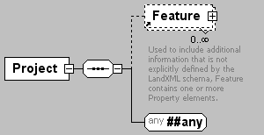
namespace | http://www.landxml.org/schema/LandXML-1.0
children | Feature
used by
  element | LandXML
attributes
  Name | Type | Use | Default | Fixed | Annotation
  name | xs:string | required
  desc | xs:string
  state | stateType
source | <xs:element name="Project">  <xs:complexType>  <xs:sequence>  <xs:element ref="Feature" minOccurs="0" maxOccurs="unbounded"/>  <xs:any namespace="##any" processContents="skip"/>  </xs:sequence>  <xs:attribute name="name" type="xs:string" use="required"/>  <xs:attribute name="desc" type="xs:string"/>  <xs:attribute name="state" type="stateType"/>  </xs:complexType>  </xs:element>

element Property
diagram | 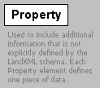
namespace | http://www.landxml.org/schema/LandXML-1.0
used by
  element | Feature
attributes
  Name | Type | Use | Default | Fixed | Annotation
  label |  | required
  value |  | required
annotation
  documentation | Used to include additional information that is not explicitly defined by the LandXML schema. Each Property element defines one piece of data.
  documentation | The "label" attribute defines the name of the value held in the "value" attribute.
source | <xs:element name="Property">  <xs:annotation>  <xs:documentation>Used to include additional information that is not explicitly defined by the LandXML schema. Each Property element defines one piece of data.</xs:documentation>  <xs:documentation>The "label" attribute defines the name of the value held in the "value" attribute.</xs:documentation>  </xs:annotation>  <xs:complexType>  <xs:attribute name="label" use="required"/>  <xs:attribute name="value" use="required"/>  </xs:complexType>  </xs:element>

element PVI
diagram | 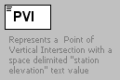
namespace | http://www.landxml.org/schema/LandXML-1.0
type | extension of Point2dReq
used by
  elements | ProfAlign ProfAlign ProfAlign
facets
  length | 2
attributes
  Name | Type | Use | Default | Fixed | Annotation
  desc | xs:string
annotation
  documentation | Represents a Point of Vertical Intersection with a space delimited "station elevation" text value
source | <xs:element name="PVI">  <xs:annotation>  <xs:documentation>Represents a Point of Vertical Intersection with a space delimited "station elevation" text value</xs:documentation>  </xs:annotation>  <xs:complexType mixed="true">  <xs:simpleContent>  <xs:extension base="Point2dReq">  <xs:attribute name="desc" type="xs:string"/>  </xs:extension>  </xs:simpleContent>  </xs:complexType>  </xs:element>

element RawObservation
diagram | 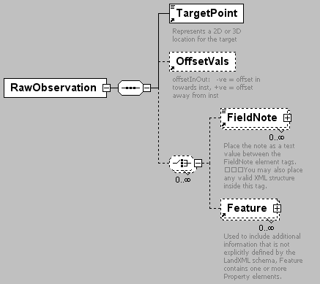
namespace | http://www.landxml.org/schema/LandXML-1.0
children | TargetPoint OffsetVals FieldNote Feature
used by
  elements | InstrumentSetup LaserSetup ObservationGroup
attributes
  Name | Type | Use | Default | Fixed | Annotation
  setupID | xs:IDREF
  targetSetupID | xs:IDREF
  setID
  purpose | purposeType
  targetHeight | xs:double
  horizAngle | angle | optional
  slopeDistance | xs:double | optional
  zenithAngle | angle | optional
  horizDistance | xs:double
  vertDistance | xs:double
  azimuth | direction | optional
  unused | xs:boolean
  directFace | xs:boolean
  coordGeomRefs | coordGeomNameRefs
  timeStamp | xs:dateTime
source | <xs:element name="RawObservation">  <xs:annotation>  <xs:documentation/>  </xs:annotation>  <xs:complexType>  <xs:sequence>  <xs:element ref="TargetPoint"/>  <xs:element ref="OffsetVals" minOccurs="0"/>  <xs:choice minOccurs="0" maxOccurs="unbounded">  <xs:element ref="FieldNote" minOccurs="0" maxOccurs="unbounded"/>  <xs:element ref="Feature" minOccurs="0" maxOccurs="unbounded"/>  </xs:choice>  </xs:sequence>  <xs:attribute name="setupID" type="xs:IDREF"/>  <xs:attribute name="targetSetupID" type="xs:IDREF"/>  <xs:attribute name="setID"/>  <xs:attribute name="purpose" type="purposeType"/>  <xs:attribute name="targetHeight" type="xs:double"/>  <xs:attribute name="horizAngle" type="angle" use="optional"/>  <xs:attribute name="slopeDistance" type="xs:double" use="optional"/>  <xs:attribute name="zenithAngle" type="angle" use="optional"/>  <xs:attribute name="horizDistance" type="xs:double"/>  <xs:attribute name="vertDistance" type="xs:double"/>  <xs:attribute name="azimuth" type="direction" use="optional"/>  <xs:attribute name="unused" type="xs:boolean"/>  <xs:attribute name="directFace" type="xs:boolean"/>  <xs:attribute name="coordGeomRefs" type="coordGeomNameRefs"/>  <xs:attribute name="timeStamp" type="xs:dateTime"/>  <!-- ‘unused’ = boolean attribute to indicate the record is not used.  'directFace' = indicates the scope is flipped – true if the scope is not flipped, false if it is. -->  <!-- coordGeomRefs identifies one or more 'name' values that link to specific <Line>, <Curve>, <Spiral> or <IrregularLine> in a <CoordGeom> element. This allows linking an survey observation to specific <Parcel>.<CoordGeom> based geometry. -->  </xs:complexType>  </xs:element>

element RectPipe
diagram | 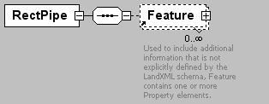
namespace | http://www.landxml.org/schema/LandXML-1.0
children | Feature
used by
  element | Pipe
attributes
  Name | Type | Use | Default | Fixed | Annotation
  height | xs:double | required
  width | xs:double | required
  desc | xs:string
  hazenWilliams | xs:double
  mannings | xs:double
  material
  thickness | xs:double
source | <xs:element name="RectPipe">  <xs:annotation>  <xs:documentation/>  </xs:annotation>  <xs:complexType>  <xs:sequence>  <xs:element ref="Feature" minOccurs="0" maxOccurs="unbounded"/>  </xs:sequence>  <xs:attribute name="height" type="xs:double" use="required"/>  <xs:attribute name="width" type="xs:double" use="required"/>  <xs:attribute name="desc" type="xs:string"/>  <xs:attribute name="hazenWilliams" type="xs:double"/>  <xs:attribute name="mannings" type="xs:double"/>  <xs:attribute name="material"/>  <xs:attribute name="thickness" type="xs:double"/>  </xs:complexType>  </xs:element>

element RectStruct
diagram | 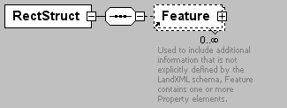
namespace | http://www.landxml.org/schema/LandXML-1.0
children | Feature
used by
  element | Struct
attributes
  Name | Type | Use | Default | Fixed | Annotation
  length | xs:double | required
  lengthDir | direction | optional
  width | xs:double | required
  desc | xs:string
  inletCase
  lossCoeff | xs:double
  material
  thickness | xs:double
source | <xs:element name="RectStruct">  <xs:annotation>  <xs:documentation/>  </xs:annotation>  <xs:complexType>  <xs:sequence>  <xs:element ref="Feature" minOccurs="0" maxOccurs="unbounded"/>  </xs:sequence>  <xs:attribute name="length" type="xs:double" use="required"/>  <xs:attribute name="lengthDir" type="direction" use="optional"/>  <xs:attribute name="width" type="xs:double" use="required"/>  <xs:attribute name="desc" type="xs:string"/>  <xs:attribute name="inletCase"/>  <xs:attribute name="lossCoeff" type="xs:double"/>  <xs:attribute name="material"/>  <xs:attribute name="thickness" type="xs:double"/>  </xs:complexType>  </xs:element>

element ReducedArcObservation
diagram | 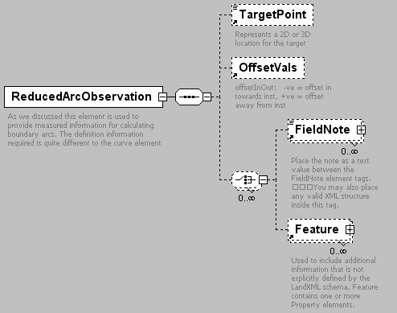
namespace | http://www.landxml.org/schema/LandXML-1.0
children | TargetPoint OffsetVals FieldNote Feature
attributes
  Name | Type | Use | Default | Fixed | Annotation
  purpose | purposeType
  setupID | xs:IDREF
  targetSetupID | xs:IDREF
  setID
  chordAzimuth | direction | required
  radius | xs:double | required
  length | xs:double | required
  rot | clockwise | required
  equipmentUsed | equipmentType
  arcAzimuthAccuracy | xs:double
  arcLengthAccuracy | xs:double
  date | xs:date
  arcType | observationType
  adoptedSurvey | xs:string
  lengthAccClass | xs:string
  azimuthAccClass | xs:string
  azimuthAdoptionFactor | xs:double
  lengthAdoptionFactor | xs:double
  coordGeomRefs | coordGeomNameRefs
annotation
  documentation | As we discussed this element is used to provide measured information for calculating boundary arcs. The definition information required is quite different to the curve element
source | <xs:element name="ReducedArcObservation">  <xs:annotation>  <xs:documentation>As we discussed this element is used to provide measured information for calculating boundary arcs. The definition information required is quite different to the curve element</xs:documentation>  </xs:annotation>  <xs:complexType>  <xs:sequence>  <xs:element ref="TargetPoint" minOccurs="0"/>  <xs:element ref="OffsetVals" minOccurs="0"/>  <xs:choice minOccurs="0" maxOccurs="unbounded">  <xs:element ref="FieldNote" minOccurs="0" maxOccurs="unbounded"/>  <xs:element ref="Feature" minOccurs="0" maxOccurs="unbounded"/>  </xs:choice>  </xs:sequence>  <xs:attribute name="purpose" type="purposeType"/>  <xs:attribute name="setupID" type="xs:IDREF"/>  <xs:attribute name="targetSetupID" type="xs:IDREF"/>  <xs:attribute name="setID"/>  <xs:attribute name="chordAzimuth" type="direction" use="required"/>  <xs:attribute name="radius" type="xs:double" use="required"/>  <xs:attribute name="length" type="xs:double" use="required"/>  <xs:attribute name="rot" type="clockwise" use="required"/>  <xs:attribute name="equipmentUsed" type="equipmentType"/>  <xs:attribute name="arcAzimuthAccuracy" type="xs:double"/>  <xs:attribute name="arcLengthAccuracy" type="xs:double"/>  <xs:attribute name="date" type="xs:date"/>  <xs:attribute name="arcType" type="observationType"/>  <xs:attribute name="adoptedSurvey" type="xs:string"/>  <xs:attribute name="lengthAccClass" type="xs:string"/>  <xs:attribute name="azimuthAccClass" type="xs:string"/>  <xs:attribute name="azimuthAdoptionFactor" type="xs:double"/>  <xs:attribute name="lengthAdoptionFactor" type="xs:double"/>  <xs:attribute name="coordGeomRefs" type="coordGeomNameRefs"/>  <!-- coordGeomRefs identifies one or more 'name' values that link to specific <Line>, <Curve>, <Spiral> or <IrregularLine> in a <CoordGeom> element. This allows linking an survey observation to specific <Parcel>.<CoordGeom> based geometry. -->  </xs:complexType>  </xs:element>

element ReducedObservation
diagram | 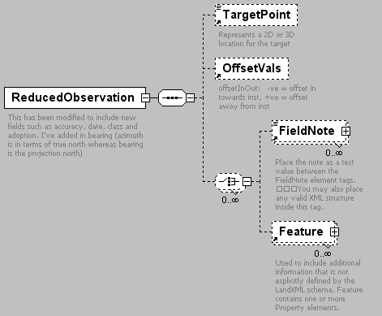
namespace | http://www.landxml.org/schema/LandXML-1.0
children | TargetPoint OffsetVals FieldNote Feature
used by
  element | ObservationGroup
attributes
  Name | Type | Use | Default | Fixed | Annotation
  purpose | purposeType
  setupID | xs:IDREF
  targetSetupID | xs:IDREF
  setID
  targetHeight | xs:double
  azimuth | direction | optional
  horizDistance | xs:double | optional
  vertDistance | xs:double | optional
  horizAngle | angle | optional
  slopeDistance | xs:double | optional
  zenithAngle | angle | optional
  equipmentUsed | equipmentType
  azimuthAccuracy | xs:double
  distanceAccuracy | xs:double
  date | xs:date
  distanceType | observationType
  azimuthType | observationType
  adoptedAzimuthSurvey | xs:string
  adoptedDistanceSurvey | xs:string
  distanceAccClass | xs:string
  azimuthAccClass | xs:string
  azimuthAdoptionFactor | xs:double
  distanceAdoptionFactor | xs:double
  coordGeomRefs | coordGeomNameRefs
annotation
  documentation | This has been modified to include new fields such as accuracy, date, class and adoption. I've added in bearing (azimuth is in terms of true north whereas bearing is the projection north)
  documentation | - maybe this doesn't matter, may need to discuss
source | <xs:element name="ReducedObservation">  <xs:annotation>  <xs:documentation>This has been modified to include new fields such as accuracy, date, class and adoption. I've added in bearing (azimuth is in terms of true north whereas bearing is the projection north) </xs:documentation>  <xs:documentation> - maybe this doesn't matter, may need to discuss</xs:documentation>  </xs:annotation>  <xs:complexType>  <xs:sequence>  <xs:element ref="TargetPoint" minOccurs="0"/>  <xs:element ref="OffsetVals" minOccurs="0"/>  <xs:choice minOccurs="0" maxOccurs="unbounded">  <xs:element ref="FieldNote" minOccurs="0" maxOccurs="unbounded"/>  <xs:element ref="Feature" minOccurs="0" maxOccurs="unbounded"/>  </xs:choice>  </xs:sequence>  <xs:attribute name="purpose" type="purposeType"/>  <xs:attribute name="setupID" type="xs:IDREF"/>  <xs:attribute name="targetSetupID" type="xs:IDREF"/>  <xs:attribute name="setID"/>  <xs:attribute name="targetHeight" type="xs:double"/>  <xs:attribute name="azimuth" type="direction" use="optional"/>  <xs:attribute name="horizDistance" type="xs:double" use="optional"/>  <xs:attribute name="vertDistance" type="xs:double" use="optional"/>  <xs:attribute name="horizAngle" type="angle" use="optional"/>  <xs:attribute name="slopeDistance" type="xs:double" use="optional"/>  <xs:attribute name="zenithAngle" type="angle" use="optional"/>  <xs:attribute name="equipmentUsed" type="equipmentType"/>  <xs:attribute name="azimuthAccuracy" type="xs:double"/>  <xs:attribute name="distanceAccuracy" type="xs:double"/>  <xs:attribute name="date" type="xs:date"/>  <xs:attribute name="distanceType" type="observationType"/>  <xs:attribute name="azimuthType" type="observationType"/>  <xs:attribute name="adoptedAzimuthSurvey" type="xs:string"/>  <xs:attribute name="adoptedDistanceSurvey" type="xs:string"/>  <xs:attribute name="distanceAccClass" type="xs:string"/>  <xs:attribute name="azimuthAccClass" type="xs:string"/>  <xs:attribute name="azimuthAdoptionFactor" type="xs:double"/>  <xs:attribute name="distanceAdoptionFactor" type="xs:double"/>  <xs:attribute name="coordGeomRefs" type="coordGeomNameRefs"/>  <!-- coordGeomRefs identifies one or more 'name' values that link to specific <Line>, <Curve>, <Spiral> or <IrregularLine> in a <CoordGeom> element. This allows linking an survey observation to specific <Parcel>.<CoordGeom> based geometry. -->  </xs:complexType>  </xs:element>

element RetWall
diagram | 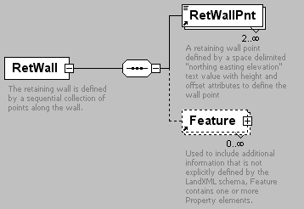
namespace | http://www.landxml.org/schema/LandXML-1.0
children | RetWallPnt Feature
used by
  element | Breaklines
attributes
  Name | Type | Use | Default | Fixed | Annotation
  desc | xs:string
  name | xs:string
  state | stateType
annotation
  documentation | The retaining wall is defined by a sequential collection of points along the wall.
  documentation | Each point has a location (northing/easting/elevation), height of wall and offset to the wall point.
source | <xs:element name="RetWall">  <xs:annotation>  <xs:documentation>The retaining wall is defined by a sequential collection of points along the wall.</xs:documentation>  <xs:documentation>Each point has a location (northing/easting/elevation), height of wall and offset to the wall point.</xs:documentation>  </xs:annotation>  <xs:complexType>  <xs:sequence>  <xs:element ref="RetWallPnt" minOccurs="2" maxOccurs="unbounded"/>  <xs:element ref="Feature" minOccurs="0" maxOccurs="unbounded"/>  </xs:sequence>  <xs:attribute name="desc" type="xs:string"/>  <xs:attribute name="name" type="xs:string"/>  <xs:attribute name="state" type="stateType"/>  </xs:complexType>  </xs:element>

element RetWallPnt
diagram | 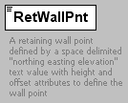
namespace | http://www.landxml.org/schema/LandXML-1.0
type | extension of PointType3dReq
used by
  element | RetWall
facets
  minLength | 0
  maxLength | 3
attributes
  Name | Type | Use | Default | Fixed | Annotation
  name | xs:string
  desc | xs:string
  code | xs:string
  state | stateType
  pntRef | pointNameRef
  pointGeometry | pointGeometryType
  DTMAttribute | DTMAttributeType
  timeStamp | xs:dateTime | optional
  role | surveyRoleType | optional
  height | xs:double | required
  offset | xs:double | required
annotation
  documentation | A retaining wall point defined by a space delimited "northing easting elevation" text value with height and offset attributes to define the wall point
  documentation | The height value is positive if the northing/easting/elevation point is at the bottom of the wall, negative if the point is at the top of the wall.
  documentation | The offset value is negative for left and positive for right.
source | <xs:element name="RetWallPnt">  <xs:annotation>  <xs:documentation>A retaining wall point defined by a space delimited "northing easting elevation" text value with height and offset attributes to define the wall point</xs:documentation>  <xs:documentation>The height value is positive if the northing/easting/elevation point is at the bottom of the wall, negative if the point is at the top of the wall.</xs:documentation>  <xs:documentation>The offset value is negative for left and positive for right.</xs:documentation>  </xs:annotation>  <xs:complexType mixed="true">  <xs:simpleContent>  <xs:extension base="PointType3dReq">  <xs:attribute name="height" type="xs:double" use="required"/>  <xs:attribute name="offset" type="xs:double" use="required"/>  </xs:extension>  </xs:simpleContent>  </xs:complexType>  </xs:element>

element Roadside
diagram | 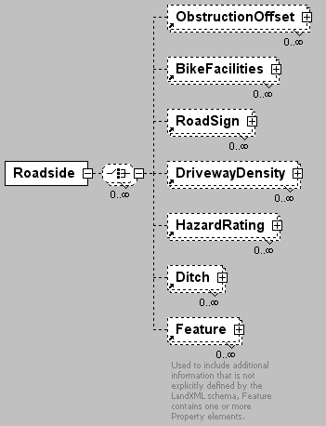
namespace | http://www.landxml.org/schema/LandXML-1.0
children | ObstructionOffset BikeFacilities RoadSign DrivewayDensity HazardRating Ditch Feature
used by
  element | Roadway
source | <xs:element name="Roadside">  <xs:complexType>  <xs:choice minOccurs="0" maxOccurs="unbounded">  <xs:element ref="ObstructionOffset" minOccurs="0" maxOccurs="unbounded"/>  <xs:element ref="BikeFacilities" minOccurs="0" maxOccurs="unbounded"/>  <xs:element ref="RoadSign" minOccurs="0" maxOccurs="unbounded"/>  <xs:element ref="DrivewayDensity" minOccurs="0" maxOccurs="unbounded"/>  <xs:element ref="HazardRating" minOccurs="0" maxOccurs="unbounded"/>  <xs:element ref="Ditch" minOccurs="0" maxOccurs="unbounded"/>  <xs:element ref="Feature" minOccurs="0" maxOccurs="unbounded"/>  </xs:choice>  </xs:complexType>  </xs:element>

element RoadSign
diagram | 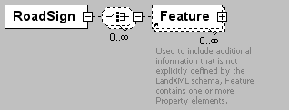
namespace | http://www.landxml.org/schema/LandXML-1.0
children | Feature
used by
  element | Roadside
attributes
  Name | Type | Use | Default | Fixed | Annotation
  MUTCDCode | xs:string
  station | station
  offset | offsetDistance
  sideofRoad | sideofRoadType
  type | roadSignType
  mountHeight | xs:double
  width | xs:double
  height | xs:double
source | <xs:element name="RoadSign">  <xs:complexType>  <xs:choice minOccurs="0" maxOccurs="unbounded">  <xs:element ref="Feature" minOccurs="0" maxOccurs="unbounded"/>  </xs:choice>  <xs:attribute name="MUTCDCode" type="xs:string"/>  <xs:attribute name="station" type="station"/>  <xs:attribute name="offset" type="offsetDistance"/>  <xs:attribute name="sideofRoad" type="sideofRoadType"/>  <xs:attribute name="type" type="roadSignType"/>  <xs:attribute name="mountHeight" type="xs:double"/>  <xs:attribute name="width" type="xs:double"/>  <xs:attribute name="height" type="xs:double"/>  </xs:complexType>  </xs:element>

element Roadway
diagram | 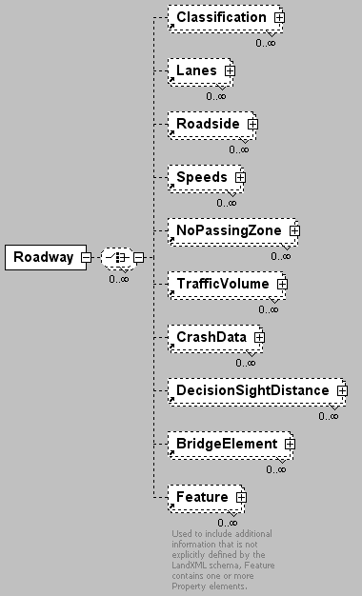
namespace | http://www.landxml.org/schema/LandXML-1.0
children | Classification Lanes Roadside Speeds NoPassingZone TrafficVolume CrashData DecisionSightDistance BridgeElement Feature
used by
  element | Roadways
attributes
  Name | Type | Use | Default | Fixed | Annotation
  name | xs:string | required
  alignmentRefs | alignmentNameRefs | required
  gradeModelRefs | gradeModelNameRefs | required
  staStart | station
  staEnd | station
  desc | xs:string
  roadTerrain | roadTerrainType
  state | stateType
source | <xs:element name="Roadway">  <xs:complexType>  <xs:choice minOccurs="0" maxOccurs="unbounded">  <xs:element ref="Classification" minOccurs="0" maxOccurs="unbounded"/>  <xs:element ref="Lanes" minOccurs="0" maxOccurs="unbounded"/>  <xs:element ref="Roadside" minOccurs="0" maxOccurs="unbounded"/>  <xs:element ref="Speeds" minOccurs="0" maxOccurs="unbounded"/>  <xs:element ref="NoPassingZone" minOccurs="0" maxOccurs="unbounded"/>  <xs:element ref="TrafficVolume" minOccurs="0" maxOccurs="unbounded"/>  <xs:element ref="CrashData" minOccurs="0" maxOccurs="unbounded"/>  <xs:element ref="DecisionSightDistance" minOccurs="0" maxOccurs="unbounded"/>  <xs:element ref="BridgeElement" minOccurs="0" maxOccurs="unbounded"/>  <xs:element ref="Feature" minOccurs="0" maxOccurs="unbounded"/>  </xs:choice>  <xs:attribute name="name" type="xs:string" use="required"/>  <xs:attribute name="alignmentRefs" type="alignmentNameRefs" use="required"/>  <xs:attribute name="gradeModelRefs" type="gradeModelNameRefs" use="required"/>  <xs:attribute name="staStart" type="station"/>  <xs:attribute name="staEnd" type="station"/>  <xs:attribute name="desc" type="xs:string"/>  <xs:attribute name="roadTerrain" type="roadTerrainType"/>  <xs:attribute name="state" type="stateType"/>  </xs:complexType>  </xs:element>

element Roadways
diagram
namespace | http://www.landxml.org/schema/LandXML-1.0
children | Roadway Intersections Feature
used by
  element | LandXML
attributes
  Name | Type | Use | Default | Fixed | Annotation
  name | xs:string
  desc | xs:string
  state | stateType
source | <xs:element name="Roadways">  <xs:complexType>  <xs:choice>  <xs:element ref="Roadway" maxOccurs="unbounded"/>  <xs:element ref="Intersections" minOccurs="0" maxOccurs="unbounded"/>  <xs:element ref="Feature" minOccurs="0" maxOccurs="unbounded"/>  </xs:choice>  <xs:attribute name="name" type="xs:string"/>  <xs:attribute name="desc" type="xs:string"/>  <xs:attribute name="state" type="stateType"/>  </xs:complexType>  </xs:element>

element RunoffSta
diagram | 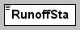
namespace | http://www.landxml.org/schema/LandXML-1.0
type | station
used by
  element | Superelevation
source | <xs:element name="RunoffSta" type="station" nillable="true"/>

element SourceData
diagram | 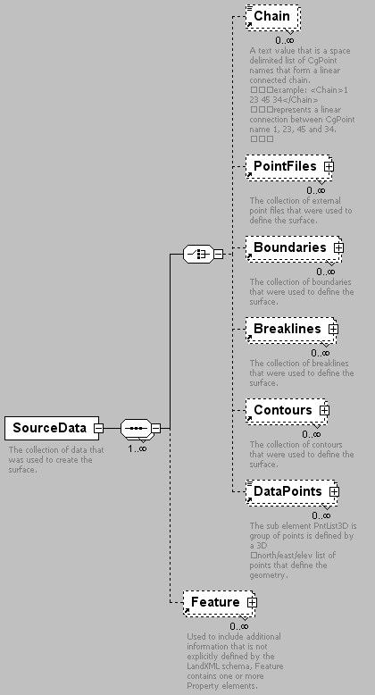
namespace | http://www.landxml.org/schema/LandXML-1.0
children | Chain PointFiles Boundaries Breaklines Contours DataPoints Feature
used by
  element | Surface
annotation
  documentation | The collection of data that was used to create the surface.
source | <xs:element name="SourceData">  <xs:annotation>  <xs:documentation>The collection of data that was used to create the surface.</xs:documentation>  </xs:annotation>  <xs:complexType>  <xs:sequence maxOccurs="unbounded">  <xs:choice>  <xs:element ref="Chain" minOccurs="0" maxOccurs="unbounded"/>  <xs:element ref="PointFiles" minOccurs="0" maxOccurs="unbounded"/>  <xs:element ref="Boundaries" minOccurs="0" maxOccurs="unbounded"/>  <xs:element ref="Breaklines" minOccurs="0" maxOccurs="unbounded"/>  <xs:element ref="Contours" minOccurs="0" maxOccurs="unbounded"/>  <xs:element ref="DataPoints" minOccurs="0" maxOccurs="unbounded"/>  </xs:choice>  <xs:element ref="Feature" minOccurs="0" maxOccurs="unbounded"/>  </xs:sequence>  </xs:complexType>  </xs:element>

element Speeds
diagram | 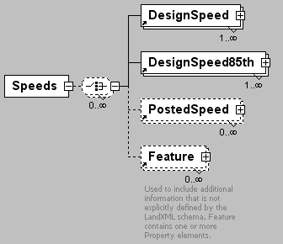
namespace | http://www.landxml.org/schema/LandXML-1.0
children | DesignSpeed DesignSpeed85th PostedSpeed Feature
used by
  element | Roadway
source | <xs:element name="Speeds">  <xs:complexType>  <xs:choice minOccurs="0" maxOccurs="unbounded">  <xs:element ref="DesignSpeed" maxOccurs="unbounded"/>  <xs:element ref="DesignSpeed85th" maxOccurs="unbounded"/>  <xs:element ref="PostedSpeed" minOccurs="0" maxOccurs="unbounded"/>  <xs:element ref="Feature" minOccurs="0" maxOccurs="unbounded"/>  </xs:choice>  </xs:complexType>  </xs:element>

element Spiral
diagram | 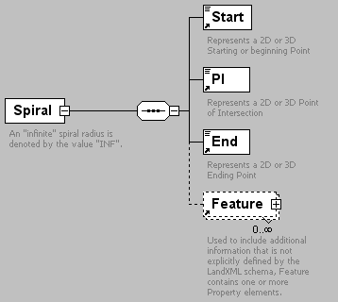
namespace | http://www.landxml.org/schema/LandXML-1.0
children | Start PI End Feature
used by
  element | CoordGeom
attributes
  Name | Type | Use | Default | Fixed | Annotation
  length | xs:double | required
  radiusEnd | xs:double | required
  radiusStart | xs:double | required
  rot | clockwise | required
  spiType | spiralType | required
  chord | xs:double
  constant | xs:double
  desc | xs:string
  dirEnd | direction
  dirStart | direction
  name | xs:string
  theta | angle
  totalY | xs:double
  totalX | xs:double
  staStart | xs:double
  state | stateType
  tanLong | xs:double
  tanShort | xs:double
  oID | xs:string
annotation
  documentation | An "infinite" spiral radius is denoted by the value "INF".
  documentation | This conforms to XML Schema which defines infinity as "INF" or "-INF" for all numeric datatypes
source | <xs:element name="Spiral">  <xs:annotation>  <xs:documentation>An "infinite" spiral radius is denoted by the value "INF". </xs:documentation>  <xs:documentation>This conforms to XML Schema which defines infinity as "INF" or "-INF" for all numeric datatypes </xs:documentation>  </xs:annotation>  <xs:complexType>  <xs:sequence>  <xs:element ref="Start"/>  <xs:element ref="PI"/>  <xs:element ref="End"/>  <xs:element ref="Feature" minOccurs="0" maxOccurs="unbounded"/>  </xs:sequence>  <xs:attribute name="length" type="xs:double" use="required"/>  <xs:attribute name="radiusEnd" type="xs:double" use="required"/>  <xs:attribute name="radiusStart" type="xs:double" use="required"/>  <xs:attribute name="rot" type="clockwise" use="required"/>  <xs:attribute name="spiType" type="spiralType" use="required"/>  <xs:attribute name="chord" type="xs:double"/>  <xs:attribute name="constant" type="xs:double"/>  <xs:attribute name="desc" type="xs:string"/>  <xs:attribute name="dirEnd" type="direction"/>  <xs:attribute name="dirStart" type="direction"/>  <xs:attribute name="name" type="xs:string"/>  <xs:attribute name="theta" type="angle"/>  <xs:attribute name="totalY" type="xs:double"/>  <xs:attribute name="totalX" type="xs:double"/>  <xs:attribute name="staStart" type="xs:double"/>  <xs:attribute name="state" type="stateType"/>  <xs:attribute name="tanLong" type="xs:double"/>  <xs:attribute name="tanShort" type="xs:double"/>  <xs:attribute name="oID" type="xs:string"/>  </xs:complexType>  </xs:element>

element StaEquation
diagram | 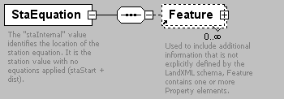
namespace | http://www.landxml.org/schema/LandXML-1.0
children | Feature
used by
  element | Alignment
attributes
  Name | Type | Use | Default | Fixed | Annotation
  staAhead | xs:double | required
  staBack | xs:double
  staInternal | xs:double | required
  desc | xs:string
annotation
  documentation | The "staInternal" value identifies the location of the station equation. It is the station value with no equations applied (staStart + dist).
source | <xs:element name="StaEquation">  <xs:annotation>  <xs:documentation>The "staInternal" value identifies the location of the station equation. It is the station value with no equations applied (staStart + dist).</xs:documentation>  </xs:annotation>  <xs:complexType>  <xs:sequence>  <xs:element ref="Feature" minOccurs="0" maxOccurs="unbounded"/>  </xs:sequence>  <xs:attribute name="staAhead" type="xs:double" use="required"/>  <xs:attribute name="staBack" type="xs:double"/>  <xs:attribute name="staInternal" type="xs:double" use="required"/>  <xs:attribute name="desc" type="xs:string"/>  </xs:complexType>  </xs:element>

element Start
diagram | 
namespace | http://www.landxml.org/schema/LandXML-1.0
type | PointType
used by
  elements | Alignment CoordinateSystem Curve GradeSurface IrregularLine Line Spiral
facets
  minLength | 0
  maxLength | 3
attributes
  Name | Type | Use | Default | Fixed | Annotation
  name | xs:string
  desc | xs:string
  code | xs:string
  state | stateType
  pntRef | pointNameRef
  pointGeometry | pointGeometryType
  DTMAttribute | DTMAttributeType
  timeStamp | xs:dateTime | optional
  role | surveyRoleType | optional
annotation
  documentation | Represents a 2D or 3D Starting or beginning Point
  documentation | Defined by either a coordinate text value ("north east" or "north east elev") or a CgPoint number reference "pntRef" attribute.
source | <xs:element name="Start" type="PointType">  <xs:annotation>  <xs:documentation>Represents a 2D or 3D Starting or beginning Point</xs:documentation>  <xs:documentation>Defined by either a coordinate text value ("north east" or "north east elev") or a CgPoint number reference "pntRef" attribute.</xs:documentation>  </xs:annotation>  </xs:element>

element StartofRunoutSta
diagram | 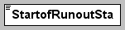
namespace | http://www.landxml.org/schema/LandXML-1.0
type | station
used by
  element | Superelevation
source | <xs:element name="StartofRunoutSta" type="station" nillable="true"/>

element Struct
diagram | 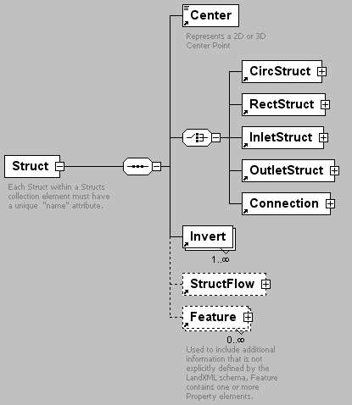
namespace | http://www.landxml.org/schema/LandXML-1.0
children | Center CircStruct RectStruct InletStruct OutletStruct Connection Invert StructFlow Feature
used by
  element | Structs
attributes
  Name | Type | Use | Default | Fixed | Annotation
  name | xs:string | required
  desc | xs:string
  elevRim | xs:double
  elevSump | xs:double
  oID | xs:string
  state | stateType
annotation
  documentation | Each Struct within a Structs collection element must have a unique "name" attribute.
  documentation | The structure type is determined by the existance of one of the following elements: CircStruct or RectStruct.
  documentation | The Center element will contain the "north east" coordinate text value or a CgPoint "refPnt" attribute.
  documentation | Each Invert element contains a "refPipe" attribute to reference a Pipe element "name"
source | <xs:element name="Struct">  <xs:annotation>  <xs:documentation>Each Struct within a Structs collection element must have a unique "name" attribute.</xs:documentation>  <xs:documentation>The structure type is determined by the existance of one of the following elements: CircStruct or RectStruct.</xs:documentation>  <xs:documentation>The Center element will contain the "north east" coordinate text value or a CgPoint "refPnt" attribute.</xs:documentation>  <xs:documentation>Each Invert element contains a "refPipe" attribute to reference a Pipe element "name"</xs:documentation>  </xs:annotation>  <xs:complexType>  <xs:sequence>  <xs:element ref="Center"/>  <xs:choice>  <xs:element ref="CircStruct"/>  <xs:element ref="RectStruct"/>  <xs:element ref="InletStruct"/>  <xs:element ref="OutletStruct"/>  <xs:element ref="Connection"/>  </xs:choice>  <xs:element ref="Invert" maxOccurs="unbounded"/>  <xs:element ref="StructFlow" minOccurs="0"/>  <xs:element ref="Feature" minOccurs="0" maxOccurs="unbounded"/>  </xs:sequence>  <xs:attribute name="name" type="xs:string" use="required"/>  <xs:attribute name="desc" type="xs:string"/>  <xs:attribute name="elevRim" type="xs:double"/>  <xs:attribute name="elevSump" type="xs:double"/>  <xs:attribute name="oID" type="xs:string"/>  <xs:attribute name="state" type="stateType"/>  </xs:complexType>  </xs:element>

element StructFlow
diagram | 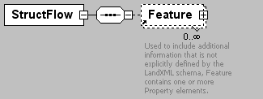
namespace | http://www.landxml.org/schema/LandXML-1.0
children | Feature
used by
  element | Struct
attributes
  Name | Type | Use | Default | Fixed | Annotation
  lossIn | xs:double | required
  lossOut | xs:double | required
  desc | xs:string
  hglIn | xs:double
  hglOut | xs:double
  localDepression | xs:double
  slopeSurf | xs:double
  slopeGutter | xs:double
  widthGutter | xs:double
source | <xs:element name="StructFlow">  <xs:annotation>  <xs:documentation/>  </xs:annotation>  <xs:complexType>  <xs:sequence>  <xs:element ref="Feature" minOccurs="0" maxOccurs="unbounded"/>  </xs:sequence>  <xs:attribute name="lossIn" type="xs:double" use="required"/>  <xs:attribute name="lossOut" type="xs:double" use="required"/>  <xs:attribute name="desc" type="xs:string"/>  <xs:attribute name="hglIn" type="xs:double"/>  <xs:attribute name="hglOut" type="xs:double"/>  <xs:attribute name="localDepression" type="xs:double"/>  <xs:attribute name="slopeSurf" type="xs:double"/>  <xs:attribute name="slopeGutter" type="xs:double"/>  <xs:attribute name="widthGutter" type="xs:double"/>  </xs:complexType>  </xs:element>

element Structs
diagram | 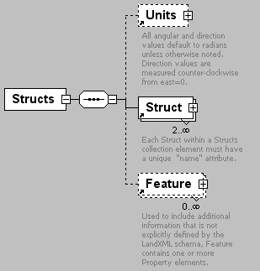
namespace | http://www.landxml.org/schema/LandXML-1.0
children | Units Struct Feature
used by
  element | PipeNetwork
source | <xs:element name="Structs">  <xs:annotation>  <xs:documentation/>  </xs:annotation>  <xs:complexType>  <xs:sequence>  <xs:element ref="Units" minOccurs="0"/>  <xs:element ref="Struct" minOccurs="2" maxOccurs="unbounded"/>  <xs:element ref="Feature" minOccurs="0" maxOccurs="unbounded"/>  </xs:sequence>  </xs:complexType>  </xs:element>

element Superelevation
diagram | 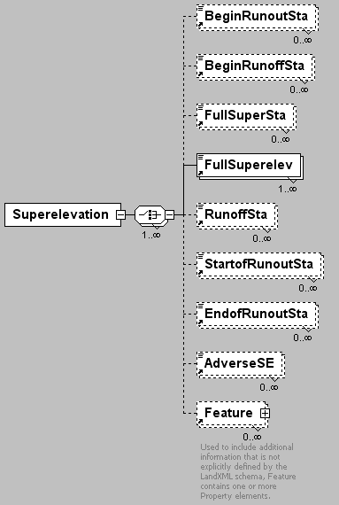
namespace | http://www.landxml.org/schema/LandXML-1.0
children | BeginRunoutSta BeginRunoffSta FullSuperSta FullSuperelev RunoffSta StartofRunoutSta EndofRunoutSta AdverseSE Feature
used by
  element | Alignment
attributes
  Name | Type | Use | Default | Fixed | Annotation
  staStart | station
  staEnd | station
source | <xs:element name="Superelevation">  <xs:complexType>  <xs:choice maxOccurs="unbounded">  <xs:element ref="BeginRunoutSta" minOccurs="0" maxOccurs="unbounded"/>  <xs:element ref="BeginRunoffSta" minOccurs="0" maxOccurs="unbounded"/>  <xs:element ref="FullSuperSta" minOccurs="0" maxOccurs="unbounded"/>  <xs:element ref="FullSuperelev" maxOccurs="unbounded"/>  <xs:element ref="RunoffSta" minOccurs="0" maxOccurs="unbounded"/>  <xs:element ref="StartofRunoutSta" minOccurs="0" maxOccurs="unbounded"/>  <xs:element ref="EndofRunoutSta" minOccurs="0" maxOccurs="unbounded"/>  <xs:element ref="AdverseSE" minOccurs="0" maxOccurs="unbounded"/>  <xs:element ref="Feature" minOccurs="0" maxOccurs="unbounded"/>  </xs:choice>  <xs:attribute name="staStart" type="station"/>  <xs:attribute name="staEnd" type="station"/>  </xs:complexType>  </xs:element>

element Surface
diagram | 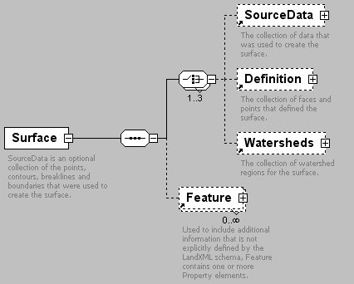
namespace | http://www.landxml.org/schema/LandXML-1.0
children | SourceData Definition Watersheds Feature
used by
  element | Surfaces
attributes
  Name | Type | Use | Default | Fixed | Annotation
  name | xs:string | required
  desc | xs:string
  OID | xs:string
  state | stateType
annotation
  documentation | SourceData is an optional collection of the points, contours, breaklines and boundaries that were used to create the surface.
  documentation | Definition is a collection of points and faces that define the surface.
  documentation | Watersheds is a collection the watershed boundaries for the surface.
source | <xs:element name="Surface">  <xs:annotation>  <xs:documentation>SourceData is an optional collection of the points, contours, breaklines and boundaries that were used to create the surface.</xs:documentation>  <xs:documentation>Definition is a collection of points and faces that define the surface.</xs:documentation>  <xs:documentation>Watersheds is a collection the watershed boundaries for the surface.</xs:documentation>  </xs:annotation>  <xs:complexType>  <xs:sequence>  <xs:choice maxOccurs="3">  <xs:element ref="SourceData" minOccurs="0"/>  <xs:element ref="Definition" minOccurs="0"/>  <xs:element ref="Watersheds" minOccurs="0"/>  </xs:choice>  <xs:element ref="Feature" minOccurs="0" maxOccurs="unbounded"/>  </xs:sequence>  <xs:attribute name="name" type="xs:string" use="required"/>  <xs:attribute name="desc" type="xs:string"/>  <xs:attribute name="OID" type="xs:string"/>  <xs:attribute name="state" type="stateType"/>  </xs:complexType>  </xs:element>

element Surfaces
diagram | 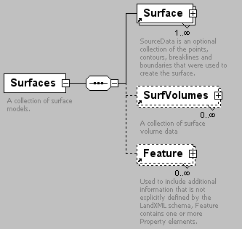
namespace | http://www.landxml.org/schema/LandXML-1.0
children | Surface SurfVolumes Feature
used by
  element | LandXML
attributes
  Name | Type | Use | Default | Fixed | Annotation
  desc | xs:string
  name | xs:string
  state | stateType
annotation
  documentation | A collection of surface models.
source | <xs:element name="Surfaces">  <xs:annotation>  <xs:documentation>A collection of surface models.</xs:documentation>  </xs:annotation>  <xs:complexType>  <xs:sequence>  <xs:element ref="Surface" maxOccurs="unbounded"/>  <xs:element ref="SurfVolumes" minOccurs="0" maxOccurs="unbounded"/>  <xs:element ref="Feature" minOccurs="0" maxOccurs="unbounded"/>  </xs:sequence>  <xs:attribute name="desc" type="xs:string"/>  <xs:attribute name="name" type="xs:string"/>  <xs:attribute name="state" type="stateType"/>  </xs:complexType>  </xs:element>

element SurfVolume
diagram | 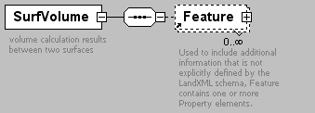
namespace | http://www.landxml.org/schema/LandXML-1.0
children | Feature
used by
  element | SurfVolumes
attributes
  Name | Type | Use | Default | Fixed | Annotation
  surfBase | surfaceNameRef | required
  surfCompare | surfaceNameRef | required
  volCut | xs:double | required
  volFill | xs:double | required
  volTotal | xs:double | required
  desc | xs:string
  name | xs:string
annotation
  documentation | volume calculation results between two surfaces
source | <xs:element name="SurfVolume">  <xs:annotation>  <xs:documentation>volume calculation results between two surfaces</xs:documentation>  </xs:annotation>  <xs:complexType>  <xs:sequence>  <xs:element ref="Feature" minOccurs="0" maxOccurs="unbounded"/>  </xs:sequence>  <xs:attribute name="surfBase" type="surfaceNameRef" use="required"/>  <xs:attribute name="surfCompare" type="surfaceNameRef" use="required"/>  <xs:attribute name="volCut" type="xs:double" use="required"/>  <xs:attribute name="volFill" type="xs:double" use="required"/>  <xs:attribute name="volTotal" type="xs:double" use="required"/>  <xs:attribute name="desc" type="xs:string"/>  <xs:attribute name="name" type="xs:string"/>  </xs:complexType>  </xs:element>

element SurfVolumes
diagram | 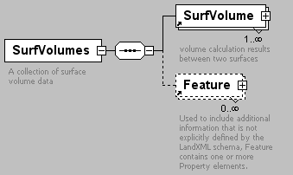
namespace | http://www.landxml.org/schema/LandXML-1.0
children | SurfVolume Feature
used by
  element | Surfaces
attributes
  Name | Type | Use | Default | Fixed | Annotation
  desc | xs:string
  name | xs:string
  surfVolCalcMethod | surfVolCMethodType | required
annotation
  documentation | A collection of surface volume data
source | <xs:element name="SurfVolumes">  <xs:annotation>  <xs:documentation>A collection of surface volume data</xs:documentation>  </xs:annotation>  <xs:complexType>  <xs:sequence>  <xs:element ref="SurfVolume" maxOccurs="unbounded"/>  <xs:element ref="Feature" minOccurs="0" maxOccurs="unbounded"/>  </xs:sequence>  <xs:attribute name="desc" type="xs:string"/>  <xs:attribute name="name" type="xs:string"/>  <xs:attribute name="surfVolCalcMethod" type="surfVolCMethodType" use="required"/>  </xs:complexType>  </xs:element>

element Survey
diagram | 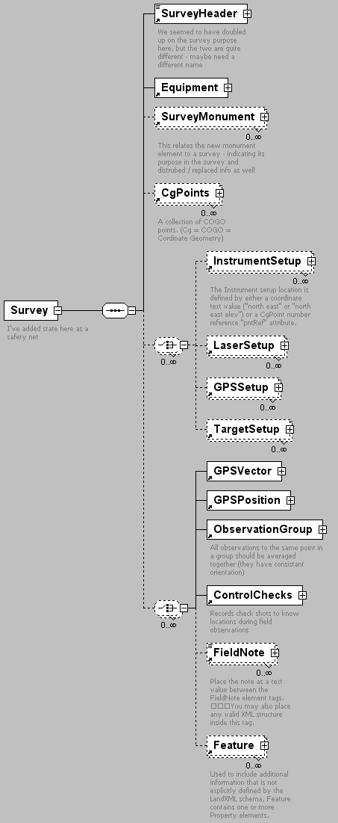
namespace | http://www.landxml.org/schema/LandXML-1.0
children | SurveyHeader Equipment SurveyMonument CgPoints InstrumentSetup LaserSetup GPSSetup TargetSetup GPSVector GPSPosition ObservationGroup ControlChecks FieldNote Feature
used by
  element | LandXML
attributes
  Name | Type | Use | Default | Fixed | Annotation
  desc | xs:string
  date | xs:date
  startTime | xs:dateTime
  endTime | xs:dateTime
  state | stateType
  horizontalAccuracy | xs:string
  verticalAccuracy | xs:string
annotation
  documentation | I've added state here as a safety net
source | <xs:element name="Survey">  <xs:annotation>  <xs:documentation>I've added state here as a safety net</xs:documentation>  </xs:annotation>  <xs:complexType>  <xs:sequence>  <xs:element ref="SurveyHeader"/>  <xs:element ref="Equipment"/>  <xs:element ref="SurveyMonument" minOccurs="0" maxOccurs="unbounded"/>  <xs:element ref="CgPoints" minOccurs="0" maxOccurs="unbounded"/>  <xs:choice minOccurs="0" maxOccurs="unbounded">  <xs:element ref="InstrumentSetup" minOccurs="0" maxOccurs="unbounded"/>  <xs:element ref="LaserSetup" minOccurs="0" maxOccurs="unbounded"/>  <xs:element ref="GPSSetup" minOccurs="0" maxOccurs="unbounded"/>  <xs:element ref="TargetSetup" minOccurs="0" maxOccurs="unbounded"/>  </xs:choice>  <xs:choice minOccurs="0" maxOccurs="unbounded">  <xs:element ref="GPSVector"/>  <xs:element ref="GPSPosition"/>  <xs:element ref="ObservationGroup"/>  <xs:element ref="ControlChecks"/>  <xs:element ref="FieldNote" minOccurs="0" maxOccurs="unbounded"/>  <xs:element ref="Feature" minOccurs="0" maxOccurs="unbounded"/>  </xs:choice>  </xs:sequence>  <xs:attribute name="desc" type="xs:string"/>  <xs:attribute name="date" type="xs:date"/>  <xs:attribute name="startTime" type="xs:dateTime"/>  <xs:attribute name="endTime" type="xs:dateTime"/>  <xs:attribute name="state" type="stateType"/>  <xs:attribute name="horizontalAccuracy" type="xs:string"/>  <xs:attribute name="verticalAccuracy" type="xs:string"/>  </xs:complexType>  </xs:element>

element SurveyHeader
diagram | 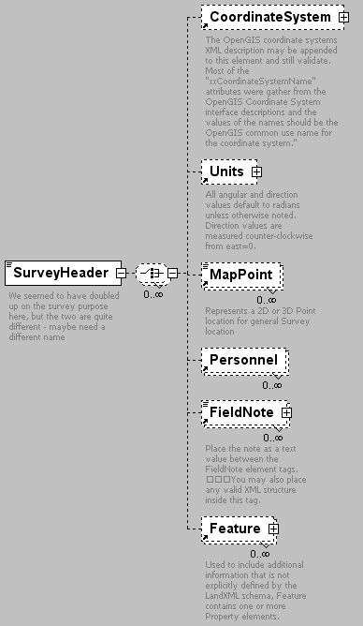
namespace | http://www.landxml.org/schema/LandXML-1.0
children | CoordinateSystem Units MapPoint Personnel FieldNote Feature
used by
  element | Survey
attributes
  Name | Type | Use | Default | Fixed | Annotation
  name | xs:string
  desc | xs:string
  purpose | purposeType
  startTime | xs:dateTime
  endTime | xs:dateTime
  surveyor | xs:string
  surveyorFirm | xs:string
  surveyorReference | xs:string
  surveyorRegistration | xs:string
  surveyPurpose | xs:string
  type | surveyType
  class | xs:string
  county | xs:string
  applyAtmosphericCorrection | xs:boolean
  pressure | xs:double
  temperature | xs:double
  applySeaLevelCorrection | xs:boolean
  scaleFactor | xs:double
  seaLevelCorrectionFactor | xs:double
  combinedFactor | xs:double
annotation
  documentation | We seemed to have doubled up on the survey purpose here, but the two are quite different - maybe need a different name
source | <xs:element name="SurveyHeader">  <xs:annotation>  <xs:documentation>We seemed to have doubled up on the survey purpose here, but the two are quite different - maybe need a different name</xs:documentation>  </xs:annotation>  <xs:complexType mixed="true">  <xs:choice minOccurs="0" maxOccurs="unbounded">  <xs:element ref="CoordinateSystem" minOccurs="0"/>  <xs:element ref="Units" minOccurs="0"/>  <xs:element ref="MapPoint" minOccurs="0" maxOccurs="unbounded"/>  <xs:element ref="Personnel" minOccurs="0" maxOccurs="unbounded"/>  <xs:element ref="FieldNote" minOccurs="0" maxOccurs="unbounded"/>  <xs:element ref="Feature" minOccurs="0" maxOccurs="unbounded"/>  </xs:choice>  <xs:attribute name="name" type="xs:string"/>  <xs:attribute name="desc" type="xs:string"/>  <xs:attribute name="purpose" type="purposeType"/>  <xs:attribute name="startTime" type="xs:dateTime"/>  <xs:attribute name="endTime" type="xs:dateTime"/>  <xs:attribute name="surveyor" type="xs:string"/>  <xs:attribute name="surveyorFirm" type="xs:string"/>  <xs:attribute name="surveyorReference" type="xs:string"/>  <xs:attribute name="surveyorRegistration" type="xs:string"/>  <xs:attribute name="surveyPurpose" type="xs:string"/>  <xs:attribute name="type" type="surveyType"/>  <xs:attribute name="class" type="xs:string"/>  <xs:attribute name="county" type="xs:string"/>  <xs:attribute name="applyAtmosphericCorrection" type="xs:boolean"/>  <xs:attribute name="pressure" type="xs:double"/>  <xs:attribute name="temperature" type="xs:double"/>  <xs:attribute name="applySeaLevelCorrection" type="xs:boolean"/>  <xs:attribute name="scaleFactor" type="xs:double"/>  <xs:attribute name="seaLevelCorrectionFactor" type="xs:double"/>  <xs:attribute name="combinedFactor" type="xs:double"/>  </xs:complexType>  </xs:element>

element SurveyMonument
diagram | 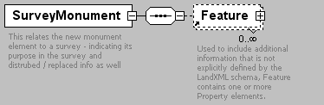
namespace | http://www.landxml.org/schema/LandXML-1.0
children | Feature
used by
  element | Survey
attributes
  Name | Type | Use | Default | Fixed | Annotation
  mntRef | monumentNameRef | required
  purpose | monumentPurpose | required
  state | monumentState
  adoptedSurvey | xs:string
  disturbedMonument | xs:string
  disturbedDate | xs:date
  disturbedAnnotation | xs:string
  replacedMonument | xs:string
  replacedDate | xs:date
  replacedAnnotation | xs:string
annotation
  documentation | This relates the new monument element to a survey - indicating its purpose in the survey and distrubed / replaced info as well
source | <xs:element name="SurveyMonument">  <xs:annotation>  <xs:documentation>This relates the new monument element to a survey - indicating its purpose in the survey and distrubed / replaced info as well</xs:documentation>  </xs:annotation>  <xs:complexType>  <xs:sequence>  <xs:element ref="Feature" minOccurs="0" maxOccurs="unbounded"/>  </xs:sequence>  <xs:attribute name="mntRef" type="monumentNameRef" use="required"/>  <xs:attribute name="purpose" type="monumentPurpose" use="required"/>  <xs:attribute name="state" type="monumentState"/>  <xs:attribute name="adoptedSurvey" type="xs:string"/>  <xs:attribute name="disturbedMonument" type="xs:string"/>  <xs:attribute name="disturbedDate" type="xs:date"/>  <xs:attribute name="disturbedAnnotation" type="xs:string"/>  <xs:attribute name="replacedMonument" type="xs:string"/>  <xs:attribute name="replacedDate" type="xs:date"/>  <xs:attribute name="replacedAnnotation" type="xs:string"/>  </xs:complexType>  </xs:element>

element TargetPoint
diagram | 
namespace | http://www.landxml.org/schema/LandXML-1.0
type | PointType
used by
  elements | GPSPosition GPSVector ObservationGroup PointResults RawObservation ReducedArcObservation ReducedObservation
facets
  minLength | 0
  maxLength | 3
attributes
  Name | Type | Use | Default | Fixed | Annotation
  name | xs:string
  desc | xs:string
  code | xs:string
  state | stateType
  pntRef | pointNameRef
  pointGeometry | pointGeometryType
  DTMAttribute | DTMAttributeType
  timeStamp | xs:dateTime | optional
  role | surveyRoleType | optional
annotation
  documentation | Represents a 2D or 3D location for the target
  documentation | It is defined by either a coordinate text value ("north east" or "north east elev") or a CgPoint number reference "pntRef" attribute.
source | <xs:element name="TargetPoint" type="PointType">  <xs:annotation>  <xs:documentation>Represents a 2D or 3D location for the target</xs:documentation>  <xs:documentation>It is defined by either a coordinate text value ("north east" or "north east elev") or a CgPoint number reference "pntRef" attribute.</xs:documentation>  </xs:annotation>  </xs:element>

element TargetSetup
diagram | 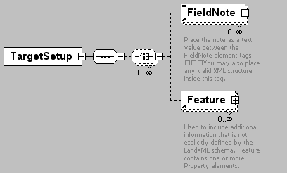
namespace | http://www.landxml.org/schema/LandXML-1.0
children | FieldNote Feature
used by
  elements | GPSSetup InstrumentSetup LaserSetup Survey
attributes
  Name | Type | Use | Default | Fixed | Annotation
  id | xs:ID
  targetHeight | xs:double
  edmTargetVertOffset | xs:double
  prismConstant | xs:double
source | <xs:element name="TargetSetup">  <xs:annotation>  <xs:documentation/>  </xs:annotation>  <xs:complexType>  <xs:sequence>  <xs:choice minOccurs="0" maxOccurs="unbounded">  <xs:element ref="FieldNote" minOccurs="0" maxOccurs="unbounded"/>  <xs:element ref="Feature" minOccurs="0" maxOccurs="unbounded"/>  </xs:choice>  </xs:sequence>  <xs:attribute name="id" type="xs:ID"/>  <xs:attribute name="targetHeight" type="xs:double"/>  <xs:attribute name="edmTargetVertOffset" type="xs:double"/>  <xs:attribute name="prismConstant" type="xs:double"/>  <!-- To allow for older style EDM's -->  </xs:complexType>  </xs:element>

element ThruLane
diagram | 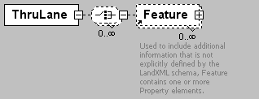
namespace | http://www.landxml.org/schema/LandXML-1.0
children | Feature
used by
  element | Lanes
attributes
  Name | Type | Use | Default | Fixed | Annotation
  staStart | station
  staEnd | station
  width | xs:double
  sideofRoad | sideofRoadType
source | <xs:element name="ThruLane">  <xs:complexType>  <xs:choice minOccurs="0" maxOccurs="unbounded">  <xs:element ref="Feature" minOccurs="0" maxOccurs="unbounded"/>  </xs:choice>  <xs:attribute name="staStart" type="station"/>  <xs:attribute name="staEnd" type="station"/>  <xs:attribute name="width" type="xs:double"/>  <xs:attribute name="sideofRoad" type="sideofRoadType"/>  </xs:complexType>  </xs:element>

element Timing
diagram | 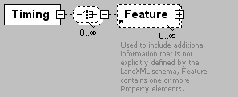
namespace | http://www.landxml.org/schema/LandXML-1.0
children | Feature
used by
  element | Intersection
attributes
  Name | Type | Use | Default | Fixed | Annotation
  station | station
  legNumber | xs:int
  protectedTurnPercent | xs:double
  unprotectedTurnPercent | xs:double
source | <xs:element name="Timing">  <xs:complexType>  <xs:choice minOccurs="0" maxOccurs="unbounded">  <xs:element ref="Feature" minOccurs="0" maxOccurs="unbounded"/>  </xs:choice>  <xs:attribute name="station" type="station"/>  <xs:attribute name="legNumber" type="xs:int"/>  <xs:attribute name="protectedTurnPercent" type="xs:double"/>  <xs:attribute name="unprotectedTurnPercent" type="xs:double"/>  </xs:complexType>  </xs:element>

element Title
diagram | 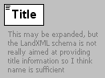
namespace | http://www.landxml.org/schema/LandXML-1.0
used by
  element | Parcel
attributes
  Name | Type | Use | Default | Fixed | Annotation
  name | xs:string | required
annotation
  documentation | This may be expanded, but the LandXML schema is not really aimed at providing title information so I think name is sufficient
source | <xs:element name="Title">  <xs:annotation>  <xs:documentation>This may be expanded, but the LandXML schema is not really aimed at providing title information so I think name is sufficient</xs:documentation>  </xs:annotation>  <xs:complexType mixed="true">  <xs:attribute name="name" type="xs:string" use="required"/>  </xs:complexType>  </xs:element>

element TrafficControl
diagram | 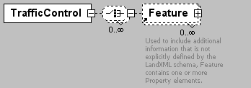
namespace | http://www.landxml.org/schema/LandXML-1.0
children | Feature
used by
  element | Intersection
attributes
  Name | Type | Use | Default | Fixed | Annotation
  station | station
  signalPeriod | xs:double
  controlPosition | trafficControlPosition
  controlType | trafficControlType
source | <xs:element name="TrafficControl">  <xs:complexType>  <xs:choice minOccurs="0" maxOccurs="unbounded">  <xs:element ref="Feature" minOccurs="0" maxOccurs="unbounded"/>  </xs:choice>  <xs:attribute name="station" type="station"/>  <xs:attribute name="signalPeriod" type="xs:double"/>  <xs:attribute name="controlPosition" type="trafficControlPosition"/>  <xs:attribute name="controlType" type="trafficControlType"/>  </xs:complexType>  </xs:element>

element TrafficVolume
diagram | 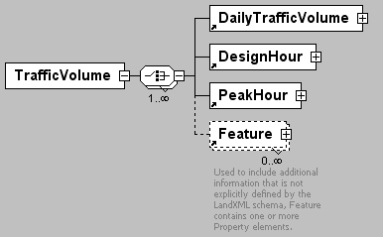
namespace | http://www.landxml.org/schema/LandXML-1.0
children | DailyTrafficVolume DesignHour PeakHour Feature
used by
  element | Roadway
source | <xs:element name="TrafficVolume">  <xs:complexType>  <xs:choice maxOccurs="unbounded">  <xs:element ref="DailyTrafficVolume"/>  <xs:element ref="DesignHour"/>  <xs:element ref="PeakHour"/>  <xs:element ref="Feature" minOccurs="0" maxOccurs="unbounded"/>  </xs:choice>  </xs:complexType>  </xs:element>

element TurnLane
diagram | 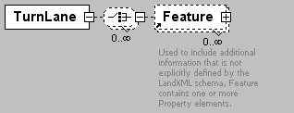
namespace | http://www.landxml.org/schema/LandXML-1.0
children | Feature
used by
  element | Lanes
attributes
  Name | Type | Use | Default | Fixed | Annotation
  staStart | station
  staEnd | station
  beginFullWidthSta | station
  width | xs:double
  sideofRoad | sideofRoadType
  type | turnLaneType
  taperType | laneTaperType
  taperTangentLength | xs:double
source | <xs:element name="TurnLane">  <xs:complexType>  <xs:choice minOccurs="0" maxOccurs="unbounded">  <xs:element ref="Feature" minOccurs="0" maxOccurs="unbounded"/>  </xs:choice>  <xs:attribute name="staStart" type="station"/>  <xs:attribute name="staEnd" type="station"/>  <xs:attribute name="beginFullWidthSta" type="station"/>  <xs:attribute name="width" type="xs:double"/>  <xs:attribute name="sideofRoad" type="sideofRoadType"/>  <xs:attribute name="type" type="turnLaneType"/>  <xs:attribute name="taperType" type="laneTaperType"/>  <xs:attribute name="taperTangentLength" type="xs:double"/>  </xs:complexType>  </xs:element>

element TurnRestriction
diagram | 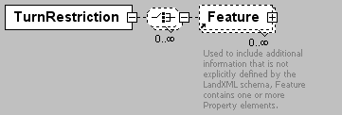
namespace | http://www.landxml.org/schema/LandXML-1.0
children | Feature
used by
  element | Intersection
attributes
  Name | Type | Use | Default | Fixed | Annotation
  station | station
  legNumber | xs:int
  type | trafficTurnRestriction
source | <xs:element name="TurnRestriction">  <xs:complexType>  <xs:choice minOccurs="0" maxOccurs="unbounded">  <xs:element ref="Feature" minOccurs="0" maxOccurs="unbounded"/>  </xs:choice>  <xs:attribute name="station" type="station"/>  <xs:attribute name="legNumber" type="xs:int"/>  <xs:attribute name="type" type="trafficTurnRestriction"/>  </xs:complexType>  </xs:element>

element TurnSpeed
diagram | 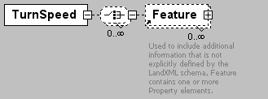
namespace | http://www.landxml.org/schema/LandXML-1.0
children | Feature
used by
  element | Intersection
attributes
  Name | Type | Use | Default | Fixed | Annotation
  station | station
  legNumber | xs:int
  speed | xs:double
source | <xs:element name="TurnSpeed">  <xs:complexType>  <xs:choice minOccurs="0" maxOccurs="unbounded">  <xs:element ref="Feature" minOccurs="0" maxOccurs="unbounded"/>  </xs:choice>  <xs:attribute name="station" type="station"/>  <xs:attribute name="legNumber" type="xs:int"/>  <xs:attribute name="speed" type="xs:double"/>  </xs:complexType>  </xs:element>

element TwoWayLeftTurnLane
diagram | 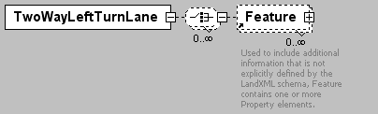
namespace | http://www.landxml.org/schema/LandXML-1.0
children | Feature
used by
  element | Lanes
attributes
  Name | Type | Use | Default | Fixed | Annotation
  staStart | station
  staEnd | station
  beginFullWidthSta | station
  endFullWidthSta | station
  startOffset | offsetDistance
  endOffset | offsetDistance
  width | xs:double
  sideofRoad | sideofRoadType
source | <xs:element name="TwoWayLeftTurnLane">  <xs:complexType>  <xs:choice minOccurs="0" maxOccurs="unbounded">  <xs:element ref="Feature" minOccurs="0" maxOccurs="unbounded"/>  </xs:choice>  <xs:attribute name="staStart" type="station"/>  <xs:attribute name="staEnd" type="station"/>  <xs:attribute name="beginFullWidthSta" type="station"/>  <xs:attribute name="endFullWidthSta" type="station"/>  <xs:attribute name="startOffset" type="offsetDistance"/>  <xs:attribute name="endOffset" type="offsetDistance"/>  <xs:attribute name="width" type="xs:double"/>  <xs:attribute name="sideofRoad" type="sideofRoadType"/>  </xs:complexType>  <!--  * Start Centerline Offset - Unit of measure: SHORT_DIST. Start Centerline Offset - This item is the starting lateral offset of the TWLTL relative to the roadway centerline. This item specifies the lateral offset of the start of the two-way left turn lane from the centerline of the roadway. A poistive value represents an offset to the right side of the road (relative to the direction of increasing stations) and a negative value represent represents an offset to the left side of the road. The unit of measure for this item is meters (feet).  * Begin Full Width - Unit of measure: STATION. Begin Full Width - This item is the station location at which full lane width begins. It specifies the station at which the initial taper ends and the full width begins.  Lane Width - Unit of measure: SHORT_DIST. Lane Width - This item is the width of lane. The unit of measure for this item is meters (feet).  * End Full Width - Unit of measure: STATION. End Full Width - This item is the station location at which final taper begins. This item specifies the station at which the full width ends and the final taper begins.  * End Centerline Offset - Unit of measure: SHORT_DIST. End Centerline Offset - This item is the ending lateral offset of the TWLTL relative to the roadway centerline. This item specifies the lateral offset of the end of the two-way left turn lane from the centerline of the roadway. A poistive value represents an offset to the right side of the road (relative to the direction of increasing stations) and a negative value represent represents an offset to the left side of the road. The unit of measure for this item is meters (feet). -->  </xs:element>

element Units
diagram | 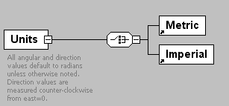
namespace | http://www.landxml.org/schema/LandXML-1.0
children | Metric Imperial
used by
  elements | LandXML Pipes Structs SurveyHeader
annotation
  documentation | All angular and direction values default to radians unless otherwise noted. Direction values are measured counter-clockwise from east=0.
source | <xs:element name="Units">  <xs:annotation>  <xs:documentation>All angular and direction values default to radians unless otherwise noted. Direction values are measured counter-clockwise from east=0.</xs:documentation>  </xs:annotation>  <xs:complexType>  <xs:choice>  <xs:element ref="Metric"/>  <xs:element ref="Imperial"/>  </xs:choice>  </xs:complexType>  </xs:element>

element UnsymParaCurve
diagram | 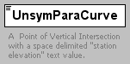
namespace | http://www.landxml.org/schema/LandXML-1.0
type | extension of Point2dReq
used by
  element | ProfAlign
facets
  length | 2
attributes
  Name | Type | Use | Default | Fixed | Annotation
  lengthIn | xs:double | required
  lengthOut | xs:double | required
  desc | xs:string
annotation
  documentation | A Point of Vertical Intersection with a space delimited "station elevation" text value.
  documentation | with an unsymetrical parabolic vertical curve defined by "lengthIn and "lengthOut" attributes.
source | <xs:element name="UnsymParaCurve">  <xs:annotation>  <xs:documentation>A Point of Vertical Intersection with a space delimited "station elevation" text value.</xs:documentation>  <xs:documentation>with an unsymetrical parabolic vertical curve defined by "lengthIn and "lengthOut" attributes.</xs:documentation>  </xs:annotation>  <xs:complexType mixed="true">  <xs:simpleContent>  <xs:extension base="Point2dReq">  <xs:attribute name="lengthIn" type="xs:double" use="required"/>  <xs:attribute name="lengthOut" type="xs:double" use="required"/>  <xs:attribute name="desc" type="xs:string"/>  </xs:extension>  </xs:simpleContent>  </xs:complexType>  </xs:element>

element Volume
diagram | 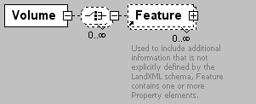
namespace | http://www.landxml.org/schema/LandXML-1.0
children | Feature
used by
  element | Intersection
attributes
  Name | Type | Use | Default | Fixed | Annotation
  station | station
  legNumber | xs:int
  turnPercent | xs:double
  percentTrucks | xs:double
source | <xs:element name="Volume">  <xs:complexType>  <xs:choice minOccurs="0" maxOccurs="unbounded">  <xs:element ref="Feature" minOccurs="0" maxOccurs="unbounded"/>  </xs:choice>  <xs:attribute name="station" type="station"/>  <xs:attribute name="legNumber" type="xs:int"/>  <xs:attribute name="turnPercent" type="xs:double"/>  <xs:attribute name="percentTrucks" type="xs:double"/>  </xs:complexType>  </xs:element>

element Watershed
diagram | 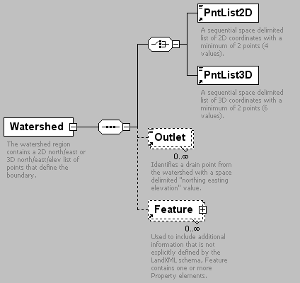
namespace | http://www.landxml.org/schema/LandXML-1.0
children | PntList2D PntList3D Outlet Feature
used by
  element | Watersheds
attributes
  Name | Type | Use | Default | Fixed | Annotation
  name | xs:string | required
  area | xs:double
  desc | xs:string
annotation
  documentation | The watershed region contains a 2D north/east or 3D north/east/elev list of points that define the boundary.
  documentation | A watershed is identified by the "name" attribute.
  documentation | It may have 1 or more Outlet elements.
source | <xs:element name="Watershed">  <xs:annotation>  <xs:documentation>The watershed region contains a 2D north/east or 3D north/east/elev list of points that define the boundary.</xs:documentation>  <xs:documentation>A watershed is identified by the "name" attribute.</xs:documentation>  <xs:documentation>It may have 1 or more Outlet elements.</xs:documentation>  </xs:annotation>  <xs:complexType>  <xs:sequence>  <xs:choice>  <xs:element ref="PntList2D"/>  <xs:element ref="PntList3D"/>  <!-- Here PntList2D represents 2D planametric coordinate pairs expressed as space delimited Northing Easting pairs. -->  </xs:choice>  <xs:element ref="Outlet" minOccurs="0" maxOccurs="unbounded"/>  <xs:element ref="Feature" minOccurs="0" maxOccurs="unbounded"/>  </xs:sequence>  <xs:attribute name="name" type="xs:string" use="required"/>  <xs:attribute name="area" type="xs:double"/>  <xs:attribute name="desc" type="xs:string"/>  </xs:complexType>  </xs:element>

element Watersheds
diagram | 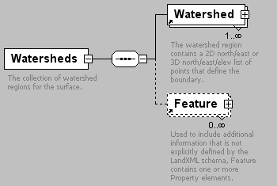
namespace | http://www.landxml.org/schema/LandXML-1.0
children | Watershed Feature
used by
  element | Surface
annotation
  documentation | The collection of watershed regions for the surface.
source | <xs:element name="Watersheds">  <xs:annotation>  <xs:documentation>The collection of watershed regions for the surface.</xs:documentation>  </xs:annotation>  <xs:complexType>  <xs:sequence>  <xs:element ref="Watershed" maxOccurs="unbounded"/>  <xs:element ref="Feature" minOccurs="0" maxOccurs="unbounded"/>  </xs:sequence>  </xs:complexType>  </xs:element>

element WideningLane
diagram | 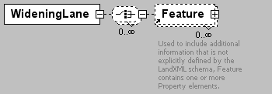
namespace | http://www.landxml.org/schema/LandXML-1.0
children | Feature
used by
  element | Lanes
attributes
  Name | Type | Use | Default | Fixed | Annotation
  staStart | station
  staEnd | station
  beginFullWidthSta | station
  endFullWidthSta | station
  offset | offsetDistance
  widening | xs:double
  width | xs:double
  sideofRoad | sideofRoadType
source | <xs:element name="WideningLane">  <xs:complexType>  <xs:choice minOccurs="0" maxOccurs="unbounded">  <xs:element ref="Feature" minOccurs="0" maxOccurs="unbounded"/>  </xs:choice>  <xs:attribute name="staStart" type="station"/>  <xs:attribute name="staEnd" type="station"/>  <xs:attribute name="beginFullWidthSta" type="station"/>  <xs:attribute name="endFullWidthSta" type="station"/>  <xs:attribute name="offset" type="offsetDistance"/>  <xs:attribute name="widening" type="xs:double"/>  <xs:attribute name="width" type="xs:double"/>  <xs:attribute name="sideofRoad" type="sideofRoadType"/>  </xs:complexType>  </xs:element>

element Zone
diagram | 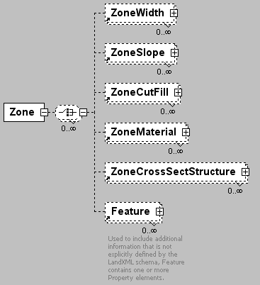
namespace | http://www.landxml.org/schema/LandXML-1.0
children | ZoneWidth ZoneSlope ZoneCutFill ZoneMaterial ZoneCrossSectStructure Feature
used by
  element | Zones
attributes
  Name | Type | Use | Default | Fixed | Annotation
  desc | xs:string
  name | xs:string
  state | stateType
  priority | xs:int | required
  category | zoneCategoryType | required
  staStart | station | required
  staEnd | station
  startWidth | xs:double | required
  startVertValue | xs:double | required
  startVertType | zoneVertType | required
  endWidth | xs:double
  endVertValue | xs:double
  endVertType | zoneVertType
source | <xs:element name="Zone">  <xs:complexType>  <xs:choice minOccurs="0" maxOccurs="unbounded">  <xs:element ref="ZoneWidth" minOccurs="0" maxOccurs="unbounded"/>  <xs:element ref="ZoneSlope" minOccurs="0" maxOccurs="unbounded"/>  <xs:element ref="ZoneCutFill" minOccurs="0" maxOccurs="unbounded"/>  <xs:element ref="ZoneMaterial" minOccurs="0" maxOccurs="unbounded"/>  <xs:element ref="ZoneCrossSectStructure" minOccurs="0" maxOccurs="unbounded"/>  <xs:element ref="Feature" minOccurs="0" maxOccurs="unbounded"/>  </xs:choice>  <xs:attribute name="desc" type="xs:string"/>  <xs:attribute name="name" type="xs:string"/>  <xs:attribute name="state" type="stateType"/>  <xs:attribute name="priority" type="xs:int" use="required"/>  <xs:attribute name="category" type="zoneCategoryType" use="required"/>  <xs:attribute name="staStart" type="station" use="required"/>  <xs:attribute name="staEnd" type="station"/>  <xs:attribute name="startWidth" type="xs:double" use="required"/>  <xs:attribute name="startVertValue" type="xs:double" use="required"/>  <xs:attribute name="startVertType" type="zoneVertType" use="required"/>  <xs:attribute name="endWidth" type="xs:double"/>  <xs:attribute name="endVertValue" type="xs:double"/>  <xs:attribute name="endVertType" type="zoneVertType"/>  </xs:complexType>  </xs:element>

element ZoneCrossSectStructure
diagram | 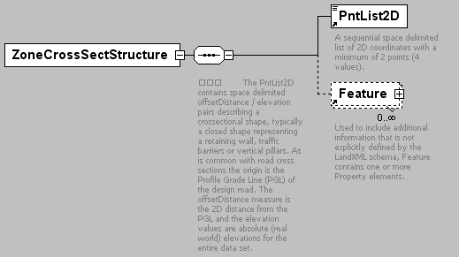
namespace | http://www.landxml.org/schema/LandXML-1.0
children | PntList2D Feature
used by
  element | Zone
attributes
  Name | Type | Use | Default | Fixed | Annotation
  name | xs:string
  innerConnectPnt | crossSectionPnt | required
  outerConnectPnt | crossSectionPnt | required
  offsetMode | zoneOffsetType |  | zone
  startOffset | offsetDistance |  | 0.0
  startOffsetElev | offsetElevation |  | 0.0
  endOffset | offsetDistance |  | 0.0
  endOffsetElev | offsetElevation |  | 0.0
  transition | zoneTransitionType |  | parallel
  placement | zonePlacementType |  | dependent
  catalogReference | xs:anyURI | optional
source | <xs:element name="ZoneCrossSectStructure">  <xs:complexType>  <xs:sequence>  <xs:annotation>  <xs:documentation>  The PntList2D contains space delimited offsetDistance / elevation pairs describing a crossectional shape, typically a closed shape representing a retaining wall, traffic barriers or vertical pillars. As is common with road cross sections the origin is the Profile Grade Line (PGL) of the design road. The offsetDistance measure is the 2D distance from the PGL and the elevation values are absolute (real world) elevations for the entire data set.</xs:documentation>  </xs:annotation>  <xs:element ref="PntList2D"/>  <xs:element ref="Feature" minOccurs="0" maxOccurs="unbounded"/>  </xs:sequence>  <xs:attribute name="name" type="xs:string"/>  <xs:attribute name="innerConnectPnt" type="crossSectionPnt" use="required"/>  <xs:attribute name="outerConnectPnt" type="crossSectionPnt" use="required"/>  <xs:attribute name="offsetMode" type="zoneOffsetType" default="zone"/>  <xs:attribute name="startOffset" type="offsetDistance" default="0.0"/>  <xs:attribute name="startOffsetElev" type="offsetElevation" default="0.0"/>  <xs:attribute name="endOffset" type="offsetDistance" default="0.0"/>  <xs:attribute name="endOffsetElev" type="offsetElevation" default="0.0"/>  <xs:attribute name="transition" type="zoneTransitionType" default="parallel"/>  <xs:attribute name="placement" type="zonePlacementType" default="dependent"/>  <xs:attribute name="catalogReference" type="xs:anyURI" use="optional"/>  </xs:complexType>  </xs:element>

element ZoneCutFill
diagram | 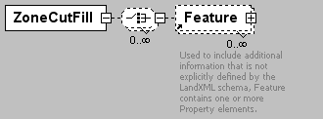
namespace | http://www.landxml.org/schema/LandXML-1.0
children | Feature
used by
  element | Zone
attributes
  Name | Type | Use | Default | Fixed | Annotation
  staStart | station | required
  staEnd | station | required
  cutSlope | crossSlope
  fillSlope | crossSlope
source | <xs:element name="ZoneCutFill">  <xs:complexType>  <xs:choice minOccurs="0" maxOccurs="unbounded">  <xs:element ref="Feature" minOccurs="0" maxOccurs="unbounded"/>  </xs:choice>  <xs:attribute name="staStart" type="station" use="required"/>  <xs:attribute name="staEnd" type="station" use="required"/>  <xs:attribute name="cutSlope" type="crossSlope"/>  <xs:attribute name="fillSlope" type="crossSlope"/>  </xs:complexType>  </xs:element>

element ZoneHinge
diagram | 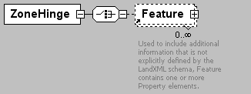
namespace | http://www.landxml.org/schema/LandXML-1.0
children | Feature
used by
  element | Zones
attributes
  Name | Type | Use | Default | Fixed | Annotation
  staStart | station | required
  staEnd | station | required
  hingeType | zoneHingeType | required
  zonePriorityRef | xs:int | required
source | <xs:element name="ZoneHinge">  <xs:complexType>  <xs:choice>  <xs:element ref="Feature" minOccurs="0" maxOccurs="unbounded"/>  </xs:choice>  <xs:attribute name="staStart" type="station" use="required"/>  <xs:attribute name="staEnd" type="station" use="required"/>  <xs:attribute name="hingeType" type="zoneHingeType" use="required"/>  <xs:attribute name="zonePriorityRef" type="xs:int" use="required"/>  </xs:complexType>  <!-- This element describes the non-center hinge point for superelevated roadways  The zonePriorityRef should contain the zone priority number (zone identifier) where the hinge point is located. The hingeType attribute identifies the left or right side of the zone to use as the hinge point.  -->  </xs:element>

element ZoneMaterial
diagram | 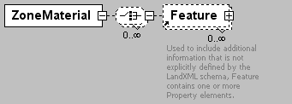
namespace | http://www.landxml.org/schema/LandXML-1.0
children | Feature
used by
  element | Zone
attributes
  Name | Type | Use | Default | Fixed | Annotation
  staStart | station | required
  staEnd | station | required
  material | zoneMaterialType | required
source | <xs:element name="ZoneMaterial">  <xs:complexType>  <xs:choice minOccurs="0" maxOccurs="unbounded">  <xs:element ref="Feature" minOccurs="0" maxOccurs="unbounded"/>  </xs:choice>  <xs:attribute name="staStart" type="station" use="required"/>  <xs:attribute name="staEnd" type="station" use="required"/>  <xs:attribute name="material" type="zoneMaterialType" use="required"/>  </xs:complexType>  </xs:element>

element Zones
diagram | 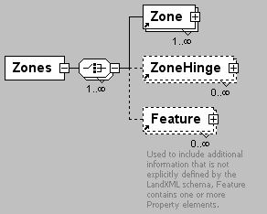
namespace | http://www.landxml.org/schema/LandXML-1.0
children | Zone ZoneHinge Feature
used by
  element | GradeSurface
attributes
  Name | Type | Use | Default | Fixed | Annotation
  side | sideofRoadType | required
  desc | xs:string
  name | xs:string
  state | stateType
source | <xs:element name="Zones">  <xs:complexType>  <xs:choice maxOccurs="unbounded">  <xs:element ref="Zone" maxOccurs="unbounded"/>  <xs:element ref="ZoneHinge" minOccurs="0" maxOccurs="unbounded"/>  <xs:element ref="Feature" minOccurs="0" maxOccurs="unbounded"/>  </xs:choice>  <xs:attribute name="side" type="sideofRoadType" use="required"/>  <xs:attribute name="desc" type="xs:string"/>  <xs:attribute name="name" type="xs:string"/>  <xs:attribute name="state" type="stateType"/>  </xs:complexType>  </xs:element>

element ZoneSlope
diagram | 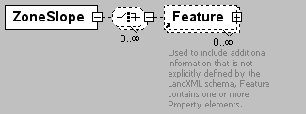
namespace | http://www.landxml.org/schema/LandXML-1.0
children | Feature
used by
  element | Zone
attributes
  Name | Type | Use | Default | Fixed | Annotation
  staStart | station | required
  staEnd | station | required
  startVertValue | xs:double
  startVertType | zoneVertType
  endVertValue | xs:double | required
  endVertType | zoneVertType | required
  parabolicStartStation | station
  parabolicEndStation | station
source | <xs:element name="ZoneSlope">  <xs:complexType>  <xs:choice minOccurs="0" maxOccurs="unbounded">  <xs:element ref="Feature" minOccurs="0" maxOccurs="unbounded"/>  </xs:choice>  <xs:attribute name="staStart" type="station" use="required"/>  <xs:attribute name="staEnd" type="station" use="required"/>  <xs:attribute name="startVertValue" type="xs:double"/>  <xs:attribute name="startVertType" type="zoneVertType"/>  <xs:attribute name="endVertValue" type="xs:double" use="required"/>  <xs:attribute name="endVertType" type="zoneVertType" use="required"/>  <xs:attribute name="parabolicStartStation" type="station"/>  <xs:attribute name="parabolicEndStation" type="station"/>  <!-- changeType is a flag that indicates the use of slope or vertical change it can be either "slope" or "vertDistance"-->  </xs:complexType>  </xs:element>

element ZoneWidth
diagram | 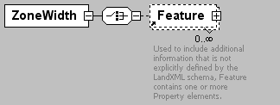
namespace | http://www.landxml.org/schema/LandXML-1.0
children | Feature
used by
  element | Zone
attributes
  Name | Type | Use | Default | Fixed | Annotation
  staStart | station | required
  staEnd | station | required
  startWidth | xs:double | required
  endWidth | xs:double
source | <xs:element name="ZoneWidth">  <xs:complexType>  <xs:choice>  <xs:element ref="Feature" minOccurs="0" maxOccurs="unbounded"/>  </xs:choice>  <xs:attribute name="staStart" type="station" use="required"/>  <xs:attribute name="staEnd" type="station" use="required"/>  <xs:attribute name="startWidth" type="xs:double" use="required"/>  <xs:attribute name="endWidth" type="xs:double"/>  </xs:complexType>  </xs:element>

complexType PointType
diagram | 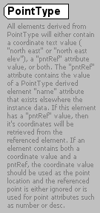
namespace | http://www.landxml.org/schema/LandXML-1.0
type | extension of Point3dOpt
used by
  elements | BacksightPoint Center CgPoint End InstrumentPoint Location MapPoint P PI Start TargetPoint
facets
  minLength | 0
  maxLength | 3
attributes
  Name | Type | Use | Default | Fixed | Annotation
  name | xs:string
  desc | xs:string
  code | xs:string
  state | stateType
  pntRef | pointNameRef
  pointGeometry | pointGeometryType
  DTMAttribute | DTMAttributeType
  timeStamp | xs:dateTime | optional
  role | surveyRoleType | optional
annotation
  documentation | All elements derived from PointType will either contain a coordinate text value ( "north east" or "north east elev"), a "pntRef" attribute value, or both. The "pntRef" attribute contains the value of a PointType derived element "name" attribute that exists elsewhere the instance data. If this element has a "pntRef" value, then it's coordinates will be retrieved from the referenced element. If an element contains both a coordinate value and a pntRef, the coordinate value should be used as the point location and the referenced point is either ignored or is used for point attributes such as number or desc.
source | <xs:complexType name="PointType" mixed="true">  <xs:annotation>  <xs:documentation>All elements derived from PointType will either contain a coordinate text value ( "north east" or "north east elev"), a "pntRef" attribute value, or both. The "pntRef" attribute contains the value of a PointType derived element "name" attribute that exists elsewhere the instance data. If this element has a "pntRef" value, then it's coordinates will be retrieved from the referenced element. If an element contains both a coordinate value and a pntRef, the coordinate value should be used as the point location and the referenced point is either ignored or is used for point attributes such as number or desc.</xs:documentation>  </xs:annotation>  <xs:simpleContent>  <xs:extension base="Point3dOpt">  <xs:attribute name="name" type="xs:string"/>  <xs:attribute name="desc" type="xs:string"/>  <xs:attribute name="code" type="xs:string"/>  <xs:attribute name="state" type="stateType"/>  <xs:attribute name="pntRef" type="pointNameRef"/>  <xs:attribute name="pointGeometry" type="pointGeometryType"/>  <xs:attribute name="DTMAttribute" type="DTMAttributeType"/>  <xs:attribute name="timeStamp" type="xs:dateTime" use="optional"/>  <xs:attribute name="role" type="surveyRoleType" use="optional"/>  </xs:extension>  </xs:simpleContent>  </xs:complexType>

complexType PointType3dReq
diagram
namespace | http://www.landxml.org/schema/LandXML-1.0
type | extension of Point3dReq
used by
  elements | Outlet RetWallPnt
facets
  minLength | 0
  maxLength | 3
attributes
  Name | Type | Use | Default | Fixed | Annotation
  name | xs:string
  desc | xs:string
  code | xs:string
  state | stateType
  pntRef | pointNameRef
  pointGeometry | pointGeometryType
  DTMAttribute | DTMAttributeType
  timeStamp | xs:dateTime | optional
  role | surveyRoleType | optional
source | <xs:complexType name="PointType3dReq">  <xs:simpleContent>  <xs:extension base="Point3dReq">  <xs:attribute name="name" type="xs:string"/>  <xs:attribute name="desc" type="xs:string"/>  <xs:attribute name="code" type="xs:string"/>  <xs:attribute name="state" type="stateType"/>  <xs:attribute name="pntRef" type="pointNameRef"/>  <xs:attribute name="pointGeometry" type="pointGeometryType"/>  <xs:attribute name="DTMAttribute" type="DTMAttributeType"/>  <xs:attribute name="timeStamp" type="xs:dateTime" use="optional"/>  <xs:attribute name="role" type="surveyRoleType" use="optional"/>  </xs:extension>  </xs:simpleContent>  </xs:complexType>

simpleType adverseSEType
namespace | http://www.landxml.org/schema/LandXML-1.0
type | restriction of xs:string
used by
  element | AdverseSE
facets
  enumeration | non-adverse
  enumeration | adverse
source | <xs:simpleType name="adverseSEType">  <xs:restriction base="xs:string">  <xs:enumeration value="non-adverse"/>  <xs:enumeration value="adverse"/>  </xs:restriction>  </xs:simpleType>

simpleType alignmentNameRef
namespace | http://www.landxml.org/schema/LandXML-1.0
type | xs:string
used by
  attributes | PipeNetwork/@alignmentRef GradeSurface/@alignmentRef GradeSurface/@stationAlignmentRef
annotation
  documentation | A reference name value referring to Alignment.name attribute.
source | <xs:simpleType name="alignmentNameRef">  <xs:annotation>  <xs:documentation>A reference name value referring to Alignment.name attribute.</xs:documentation>  </xs:annotation>  <xs:restriction base="xs:string"/>  </xs:simpleType>

simpleType alignmentNameRefs
namespace | http://www.landxml.org/schema/LandXML-1.0
type | list of xs:string
used by
  attribute | Roadway/@alignmentRefs
annotation
  documentation | A list of reference names values refering to one or more Alignment.name attributes.
source | <xs:simpleType name="alignmentNameRefs">  <xs:annotation>  <xs:documentation>A list of reference names values refering to one or more Alignment.name attributes.</xs:documentation>  </xs:annotation>  <xs:list itemType="xs:string"/>  </xs:simpleType>

simpleType angle
namespace | http://www.landxml.org/schema/LandXML-1.0
type | xs:double
used by
  attributes | CrossSect/@angleSkew Backsight/@circle Curve/@delta RawObservation/@horizAngle ReducedObservation/@horizAngle CoordinateSystem/@rotationAngle Spiral/@theta RawObservation/@zenithAngle ReducedObservation/@zenithAngle
annotation
  documentation | Represents a normalized angular value in the specified Angular units.
source | <xs:simpleType name="angle">  <xs:annotation>  <xs:documentation>Represents a normalized angular value in the specified Angular units.</xs:documentation>  </xs:annotation>  <xs:restriction base="xs:double"/>  </xs:simpleType>

simpleType angularType
namespace | http://www.landxml.org/schema/LandXML-1.0
type | restriction of xs:string
used by
  attributes | Metric/@angularUnit Imperial/@angularUnit Metric/@directionUnit Imperial/@directionUnit
facets
  enumeration | radians
  enumeration | grads
  enumeration | decimal degrees
  enumeration | decimal dd.mm.ss
annotation
  documentation | angular values expressed in "decimal dd.mm.ss" units have the numeric  format "45.3025" representing 45 degrees 30 minutes and 25 seconds. Both the minutes and seconds must be two characters with a numeric range between 00 to 60.
source | <xs:simpleType name="angularType">  <xs:annotation>  <xs:documentation>angular values expressed in "decimal dd.mm.ss" units have the numeric  format "45.3025" representing 45 degrees 30 minutes and 25 seconds. Both the minutes and seconds must be two characters with a numeric range between 00 to 60.  </xs:documentation>  </xs:annotation>  <xs:restriction base="xs:string">  <xs:enumeration value="radians"/>  <xs:enumeration value="grads"/>  <xs:enumeration value="decimal degrees"/>  <xs:enumeration value="decimal dd.mm.ss"/>  </xs:restriction>  </xs:simpleType>

simpleType beaconProtectionType
namespace | http://www.landxml.org/schema/LandXML-1.0
type | restriction of xs:string
used by
  attribute | Monument/@beaconProtection
facets
  enumeration | cover
  enumeration | cover and box
  enumeration | fence enclosure
  enumeration | marker post
  enumeration | no protection
  enumeration | other
  enumeration | quadripod
  enumeration | unknown
annotation
  documentation | Indicates any structure that protects the  monument, these enumerations may need expanding
source | <xs:simpleType name="beaconProtectionType">  <xs:annotation>  <xs:documentation>Indicates any structure that protects the  monument, these enumerations may need expanding</xs:documentation>  </xs:annotation>  <xs:restriction base="xs:string">  <xs:enumeration value="cover"/>  <xs:enumeration value="cover and box"/>  <xs:enumeration value="fence enclosure"/>  <xs:enumeration value="marker post"/>  <xs:enumeration value="no protection"/>  <xs:enumeration value="other"/>  <xs:enumeration value="quadripod"/>  <xs:enumeration value="unknown"/>  </xs:restriction>  </xs:simpleType>

simpleType beaconType
namespace | http://www.landxml.org/schema/LandXML-1.0
type | restriction of xs:string
used by
  attribute | Monument/@beacon
facets
  enumeration | cairn
  enumeration | chimney
  enumeration | large quadripod
  enumeration | lighthouse
  enumeration | marine beacon
  enumeration | mast
  enumeration | mast with targets
  enumeration | no beacon
  enumeration | other
  enumeration | pillar
  enumeration | post
  enumeration | small quadripod
  enumeration | tower
  enumeration | tripod
  enumeration | unknown
annotation
  documentation | Indicates whether there is any physical structure  for the monument - helps location, these enumerations may need expanding
source | <xs:simpleType name="beaconType">  <xs:annotation>  <xs:documentation>Indicates whether there is any physical structure  for the monument - helps location, these enumerations may need expanding  </xs:documentation>  </xs:annotation>  <xs:restriction base="xs:string">  <xs:enumeration value="cairn"/>  <xs:enumeration value="chimney"/>  <xs:enumeration value="large quadripod"/>  <xs:enumeration value="lighthouse"/>  <xs:enumeration value="marine beacon"/>  <xs:enumeration value="mast"/>  <xs:enumeration value="mast with targets"/>  <xs:enumeration value="no beacon"/>  <xs:enumeration value="other"/>  <xs:enumeration value="pillar"/>  <xs:enumeration value="post"/>  <xs:enumeration value="small quadripod"/>  <xs:enumeration value="tower"/>  <xs:enumeration value="tripod"/>  <xs:enumeration value="unknown"/>  </xs:restriction>  </xs:simpleType>

simpleType bridgeProjectType
namespace | http://www.landxml.org/schema/LandXML-1.0
type | restriction of xs:string
used by
  attribute | BridgeElement/@projectType
facets
  enumeration | new
  enumeration | existing
source | <xs:simpleType name="bridgeProjectType">  <xs:restriction base="xs:string">  <xs:enumeration value="new"/>  <xs:enumeration value="existing"/>  </xs:restriction>  </xs:simpleType>

simpleType cgPointsNameRef
namespace | http://www.landxml.org/schema/LandXML-1.0
type | xs:string
annotation
  documentation | A reference name value referring to a CgPoints name attribute. An attribute if this type contains the value of a CgPoints element "name" attribute that exists elsewhere the instance data.
source | <xs:simpleType name="cgPointsNameRef">  <xs:annotation>  <xs:documentation>A reference name value referring to a CgPoints name attribute. An attribute if this type contains the value of a CgPoints element "name" attribute that exists elsewhere the instance data.</xs:documentation>  </xs:annotation>  <xs:restriction base="xs:string"/>  </xs:simpleType>

simpleType cgPointsNameRefs
namespace | http://www.landxml.org/schema/LandXML-1.0
type | list of xs:string
annotation
  documentation | A list of reference names values refering to one or more CgPoints element name attributes.
source | <xs:simpleType name="cgPointsNameRefs">  <xs:annotation>  <xs:documentation>A list of reference names values refering to one or more CgPoints element name attributes.</xs:documentation>  </xs:annotation>  <xs:list itemType="xs:string"/>  </xs:simpleType>

simpleType ChainType
namespace | http://www.landxml.org/schema/LandXML-1.0
type | list of pointNameRef
used by
  element | Chain
annotation
  documentation | A text value that is a space delimited list of CgPoint names that form a linear connected chain.  example: <Chain>1 23 45 34</Chain>  represents a linear connection between CgPoint name 1, 23, 45 and 34.
source | <xs:simpleType name="ChainType">  <xs:annotation>  <xs:documentation>A text value that is a space delimited list of CgPoint names that form a linear connected chain.  example: <Chain>1 23 45 34</Chain>  represents a linear connection between CgPoint name 1, 23, 45 and 34.  </xs:documentation>  </xs:annotation>  <xs:list itemType="pointNameRef"/>  </xs:simpleType>

simpleType clockwise
namespace | http://www.landxml.org/schema/LandXML-1.0
type | restriction of xs:string
used by
  attributes | Curve/@rot Spiral/@rot ReducedArcObservation/@rot
facets
  enumeration | cw
  enumeration | ccw
source | <xs:simpleType name="clockwise">  <xs:restriction base="xs:string">  <xs:enumeration value="cw"/>  <xs:enumeration value="ccw"/>  </xs:restriction>  </xs:simpleType>

simpleType coordGeomNameRef
namespace | http://www.landxml.org/schema/LandXML-1.0
type | xs:string
annotation
  documentation | A reference name value referring to CoordGeom.name attribute.
source | <xs:simpleType name="coordGeomNameRef">  <xs:annotation>  <xs:documentation>A reference name value referring to CoordGeom.name attribute.</xs:documentation>  </xs:annotation>  <xs:restriction base="xs:string"/>  </xs:simpleType>

simpleType coordGeomNameRefs
namespace | http://www.landxml.org/schema/LandXML-1.0
type | list of xs:string
used by
  attributes | RawObservation/@coordGeomRefs GPSVector/@coordGeomRefs GPSPosition/@coordGeomRefs ObservationGroup/@coordGeomRefs ReducedObservation/@coordGeomRefs ReducedArcObservation/@coordGeomRefs
annotation
  documentation | A list of reference names values refering to one or more CoordGeom.name attributes.
source | <xs:simpleType name="coordGeomNameRefs">  <xs:annotation>  <xs:documentation>A list of reference names values refering to one or more CoordGeom.name attributes.</xs:documentation>  </xs:annotation>  <xs:list itemType="xs:string"/>  </xs:simpleType>

simpleType cornerType
namespace | http://www.landxml.org/schema/LandXML-1.0
type | restriction of xs:string
used by
  attribute | Corner/@type
facets
  enumeration | unknown
source | <xs:simpleType name="cornerType">  <xs:restriction base="xs:string">  <xs:enumeration value="unknown"/>  </xs:restriction>  <!-- PLACEHOLDER NEED ENUMERATION VALUES ! -->  </xs:simpleType>

simpleType crashIntersectionRelation
namespace | http://www.landxml.org/schema/LandXML-1.0
type | restriction of xs:string
used by
  attribute | CrashHistory/@intersectionRelation
facets
  enumeration | unknown
  enumeration | non-intersection-related
  enumeration | intersection-related
source | <xs:simpleType name="crashIntersectionRelation">  <xs:restriction base="xs:string">  <xs:enumeration value="unknown"/>  <xs:enumeration value="non-intersection-related"/>  <xs:enumeration value="intersection-related"/>  </xs:restriction>  </xs:simpleType>

simpleType crashSeverityType
namespace | http://www.landxml.org/schema/LandXML-1.0
type | restriction of xs:string
used by
  attribute | CrashHistory/@severity
facets
  enumeration | fatal
  enumeration | nonfatal
  enumeration | propery-damage-only
source | <xs:simpleType name="crashSeverityType">  <xs:restriction base="xs:string">  <xs:enumeration value="fatal"/>  <xs:enumeration value="nonfatal "/>  <xs:enumeration value="propery-damage-only"/>  </xs:restriction>  </xs:simpleType>

simpleType crossSectionPnt
namespace | http://www.landxml.org/schema/LandXML-1.0
type | Point2dReq
used by
  attributes | ZoneCrossSectStructure/@innerConnectPnt ZoneCrossSectStructure/@outerConnectPnt
facets
  length | 2
annotation
  documentation | Attribute that represents a space delimited, cross section offset/elevation pair.  Example: crossSectionPnt="12.0 723.3456"
source | <xs:simpleType name="crossSectionPnt">  <xs:annotation>  <xs:documentation>Attribute that represents a space delimited, cross section offset/elevation pair.  Example: crossSectionPnt="12.0 723.3456"  </xs:documentation>  </xs:annotation>  <xs:restriction base="Point2dReq"/>  </xs:simpleType>

simpleType crossSlope
namespace | http://www.landxml.org/schema/LandXML-1.0
type | xs:double
used by
  attributes | ZoneCutFill/@cutSlope ZoneCutFill/@fillSlope
annotation
  documentation | This item is the cross slope, the slope of the traveled way as measure perpendicular to the horizontal alignment, negative when the shoulder has a lower elevation than the centerline. The unit of measure for this item is PERCENT %.
source | <xs:simpleType name="crossSlope">  <xs:annotation>  <xs:documentation>This item is the cross slope, the slope of the traveled way as measure perpendicular to the horizontal alignment, negative when the shoulder has a lower elevation than the centerline. The unit of measure for this item is PERCENT %.</xs:documentation>  </xs:annotation>  <xs:restriction base="xs:double"/>  </xs:simpleType>

simpleType curbType
namespace | http://www.landxml.org/schema/LandXML-1.0
type | restriction of xs:string
used by
  attribute | Curb/@type
facets
  enumeration | unknown
source | <xs:simpleType name="curbType">  <xs:restriction base="xs:string">  <xs:enumeration value="unknown"/>  </xs:restriction>  <!-- PLACEHOLDER NEED ENUMERATION VALUES ! -->  </xs:simpleType>

simpleType curveType
namespace | http://www.landxml.org/schema/LandXML-1.0
type | restriction of xs:string
used by
  attribute | Curve/@crvType
facets
  enumeration | arc
  enumeration | chord
source | <xs:simpleType name="curveType">  <xs:restriction base="xs:string">  <xs:enumeration value="arc"/>  <xs:enumeration value="chord"/>  </xs:restriction>  </xs:simpleType>

simpleType direction
namespace | http://www.landxml.org/schema/LandXML-1.0
type | xs:double
used by
  attributes | Backsight/@azimuth RawObservation/@azimuth ReducedObservation/@azimuth ReducedArcObservation/@chordAzimuth InstrumentSetup/@circleAzimuth IrregularLine/@dir Line/@dir Parcel/@dirClosure Curve/@dirEnd Spiral/@dirEnd Curve/@dirStart Spiral/@dirStart RectStruct/@lengthDir InstrumentSetup/@orientationAzimuth
annotation
  documentation | Represents a normalized angular value that indicates a horizontal direction, expressed in the specified Direction units. Assume 0 degrees = north
source | <xs:simpleType name="direction">  <xs:annotation>  <xs:documentation>Represents a normalized angular value that indicates a horizontal direction, expressed in the specified Direction units. Assume 0 degrees = north</xs:documentation>  </xs:annotation>  <xs:restriction base="xs:double"/>  </xs:simpleType>

simpleType ditchBottomShape
namespace | http://www.landxml.org/schema/LandXML-1.0
type | restriction of xs:string
used by
  attribute | Ditch/@bottomShape
facets
  enumeration | true-V
  enumeration | rounded-V
  enumeration | rounded-trapezoidal
  enumeration | flat-trapezoidal
source | <xs:simpleType name="ditchBottomShape">  <xs:restriction base="xs:string">  <xs:enumeration value="true-V"/>  <xs:enumeration value="rounded-V"/>  <xs:enumeration value="rounded-trapezoidal"/>  <xs:enumeration value="flat-trapezoidal"/>  </xs:restriction>  </xs:simpleType>

simpleType drivewayDensity
namespace | http://www.landxml.org/schema/LandXML-1.0
type | xs:double
annotation
  documentation | This item is the driveway density for both sides of the roadway combined. The unit of measure for this item is driveways/kilometer for Metric units and driveways/mile for Imperial.
source | <xs:simpleType name="drivewayDensity">  <xs:annotation>  <xs:documentation>This item is the driveway density for both sides of the roadway combined. The unit of measure for this item is driveways/kilometer for Metric units and driveways/mile for Imperial. </xs:documentation>  </xs:annotation>  <xs:restriction base="xs:double"/>  </xs:simpleType>

simpleType DTMAttributeType
namespace | http://www.landxml.org/schema/LandXML-1.0
type | restriction of xs:string
used by
  attributes | CgPoints/@DTMAttribute Chain/@DTMAttribute DataPoints/@DTMAttribute PointType/@DTMAttribute PointType3dReq/@DTMAttribute
facets
  enumeration | determinebyfeature
  enumeration | donotinclude
  enumeration | spot
  enumeration | spotandbreak
  enumeration | void
  enumeration | drapevoid
  enumeration | breakvoid
  enumeration | island
  enumeration | boundary
  enumeration | contour
  enumeration | feature
  enumeration | ground
  enumeration | xsection
  enumeration | user
source | <xs:simpleType name="DTMAttributeType">  <xs:restriction base="xs:string">  <xs:enumeration value="determinebyfeature"/>  <xs:enumeration value="donotinclude"/>  <xs:enumeration value="spot"/>  <xs:enumeration value="spotandbreak"/>  <xs:enumeration value="void"/>  <xs:enumeration value="drapevoid"/>  <xs:enumeration value="breakvoid"/>  <xs:enumeration value="island"/>  <xs:enumeration value="boundary"/>  <xs:enumeration value="contour"/>  <xs:enumeration value="feature"/>  <xs:enumeration value="ground"/>  <xs:enumeration value="xsection"/>  <xs:enumeration value="user"/>  </xs:restriction>  </xs:simpleType>

simpleType equipmentType
namespace | http://www.landxml.org/schema/LandXML-1.0
type | restriction of xs:string
used by
  attributes | ReducedObservation/@equipmentUsed ReducedArcObservation/@equipmentUsed
facets
  enumeration | theodolite EDM
  enumeration | theodolite tape
  enumeration | GPS
  enumeration | scale
  enumeration | other
  enumeration | unknown
annotation
  documentation | This is a rough indication of the type of equipment
source | <xs:simpleType name="equipmentType">  <xs:annotation>  <xs:documentation>This is a rough indication of the type of equipment</xs:documentation>  </xs:annotation>  <xs:restriction base="xs:string">  <xs:enumeration value="theodolite EDM"/>  <xs:enumeration value="theodolite tape"/>  <xs:enumeration value="GPS"/>  <xs:enumeration value="scale"/>  <xs:enumeration value="other"/>  <xs:enumeration value="unknown"/>  </xs:restriction>  </xs:simpleType>

simpleType FaceType
namespace | http://www.landxml.org/schema/LandXML-1.0
type | list of xs:integer
used by
  element | F
source | <xs:simpleType name="FaceType">  <xs:list itemType="xs:integer"/>  </xs:simpleType>

simpleType functionalClassType
namespace | http://www.landxml.org/schema/LandXML-1.0
type | restriction of xs:string
used by
  attribute | Classification/@functionalClass
facets
  enumeration | arterial
  enumeration | collector
  enumeration | local
source | <xs:simpleType name="functionalClassType">  <xs:restriction base="xs:string">  <xs:enumeration value="arterial"/>  <xs:enumeration value="collector "/>  <xs:enumeration value="local"/>  </xs:restriction>  </xs:simpleType>

simpleType GPSSolutionFrequencyEnum
namespace | http://www.landxml.org/schema/LandXML-1.0
type | restriction of xs:string
used by
  attributes | GPSQCInfoLevel1/@GPSSolnFreq GPSQCInfoLevel2/@GPSSolnFreq
facets
  enumeration | Unknown
  enumeration | L1
  enumeration | L2
  enumeration | L2 Squared
  enumeration | Wide Lane
  enumeration | Narrow Lane
  enumeration | Iono Free
annotation
  documentation | The GPS solution frequency indicates the GPS frequencies used in the computed solution for a GPS vector or position
source | <xs:simpleType name="GPSSolutionFrequencyEnum">  <xs:annotation>  <xs:documentation>The GPS solution frequency indicates the GPS frequencies used in the computed solution for a GPS vector or position </xs:documentation>  </xs:annotation>  <xs:restriction base="xs:string">  <xs:enumeration value="Unknown"/>  <xs:enumeration value="L1"/>  <xs:enumeration value="L2"/>  <xs:enumeration value="L2 Squared"/>  <xs:enumeration value="Wide Lane"/>  <xs:enumeration value="Narrow Lane"/>  <xs:enumeration value="Iono Free"/>  </xs:restriction>  </xs:simpleType>

simpleType GPSSolutionTypeEnum
namespace | http://www.landxml.org/schema/LandXML-1.0
type | restriction of xs:string
used by
  attributes | GPSQCInfoLevel1/@GPSSolnType GPSQCInfoLevel2/@GPSSolnType
facets
  enumeration | Unknown
  enumeration | Code
  enumeration | Float
  enumeration | Fixed
  enumeration | Network Float
  enumeration | Network Fixed
  enumeration | WAAS Float
  enumeration | WAAS Fixed
annotation
  documentation | The GPS solution type indicates the type of computed solution for a GPS vector or position
source | <xs:simpleType name="GPSSolutionTypeEnum">  <xs:annotation>  <xs:documentation>The GPS solution type indicates the type of computed solution for a GPS vector or position</xs:documentation>  </xs:annotation>  <xs:restriction base="xs:string">  <xs:enumeration value="Unknown"/>  <xs:enumeration value="Code"/>  <xs:enumeration value="Float"/>  <xs:enumeration value="Fixed"/>  <xs:enumeration value="Network Float"/>  <xs:enumeration value="Network Fixed"/>  <xs:enumeration value="WAAS Float"/>  <xs:enumeration value="WAAS Fixed"/>  </xs:restriction>  </xs:simpleType>

simpleType GPSTime
namespace | http://www.landxml.org/schema/LandXML-1.0
type | xs:double
used by
  attributes | GPSSetup/@startTime GPSQCInfoLevel2/@startTime GPSSetup/@stopTime GPSQCInfoLevel2/@stopTime
annotation
  documentation | GPS Time = Nbr of GPS weeks * 604800 (seconds in a week) + seconds in GPS week.
source | <xs:simpleType name="GPSTime">  <xs:annotation>  <xs:documentation> GPS Time = Nbr of GPS weeks * 604800 (seconds in a week) + seconds in GPS week.</xs:documentation>  </xs:annotation>  <xs:restriction base="xs:double"/>  <!-- GPS Time = Nbr of GPS weeks * 604800 (seconds in a week) + seconds in GPS week -->  </xs:simpleType>

simpleType gradeModelNameRef
namespace | http://www.landxml.org/schema/LandXML-1.0
type | xs:string
annotation
  documentation | A reference name value referring to GradeModel.name attribute.
source | <xs:simpleType name="gradeModelNameRef">  <xs:annotation>  <xs:documentation>A reference name value referring to GradeModel.name attribute.</xs:documentation>  </xs:annotation>  <xs:restriction base="xs:string"/>  </xs:simpleType>

simpleType gradeModelNameRefs
namespace | http://www.landxml.org/schema/LandXML-1.0
type | list of xs:string
used by
  attribute | Roadway/@gradeModelRefs
annotation
  documentation | A list of reference names values refering to one or more GradeModel.name attributes.
source | <xs:simpleType name="gradeModelNameRefs">  <xs:annotation>  <xs:documentation>A list of reference names values refering to one or more GradeModel.name attributes.</xs:documentation>  </xs:annotation>  <xs:list itemType="xs:string"/>  </xs:simpleType>

simpleType impArea
namespace | http://www.landxml.org/schema/LandXML-1.0
type | restriction of xs:string
used by
  attribute | Imperial/@areaUnit
facets
  enumeration | acre
  enumeration | squareFoot
  enumeration | squareInch
  enumeration | squareMiles
source | <xs:simpleType name="impArea">  <xs:restriction base="xs:string">  <xs:enumeration value="acre"/>  <xs:enumeration value="squareFoot"/>  <xs:enumeration value="squareInch"/>  <xs:enumeration value="squareMiles"/>  </xs:restriction>  </xs:simpleType>

simpleType impDiameter
namespace | http://www.landxml.org/schema/LandXML-1.0
type | restriction of xs:string
used by
  attribute | Imperial/@diameterUnit
facets
  enumeration | foot
  enumeration | USSurveyFoot
  enumeration | inch
source | <xs:simpleType name="impDiameter">  <xs:restriction base="xs:string">  <xs:enumeration value="foot"/>  <xs:enumeration value="USSurveyFoot"/>  <xs:enumeration value="inch"/>  </xs:restriction>  </xs:simpleType>

simpleType impFlow
namespace | http://www.landxml.org/schema/LandXML-1.0
type | restriction of xs:string
used by
  attribute | Imperial/@flowUnit
facets
  enumeration | US_gallonPerDay
  enumeration | IMP_gallonPerDay
  enumeration | cubicFeetDay
  enumeration | US_gallonPerMinute
  enumeration | IMP_gallonPerMinute
  enumeration | acreFeetDay
  enumeration | cubicFeetSecond
source | <xs:simpleType name="impFlow">  <xs:restriction base="xs:string">  <xs:enumeration value="US_gallonPerDay"/>  <xs:enumeration value="IMP_gallonPerDay"/>  <xs:enumeration value="cubicFeetDay"/>  <xs:enumeration value="US_gallonPerMinute"/>  <xs:enumeration value="IMP_gallonPerMinute"/>  <xs:enumeration value="acreFeetDay"/>  <xs:enumeration value="cubicFeetSecond"/>  </xs:restriction>  </xs:simpleType>

simpleType impHeight
namespace | http://www.landxml.org/schema/LandXML-1.0
type | restriction of xs:string
used by
  attribute | Imperial/@heightUnit
facets
  enumeration | foot
  enumeration | USSurveyFoot
  enumeration | inch
source | <xs:simpleType name="impHeight">  <xs:restriction base="xs:string">  <xs:enumeration value="foot"/>  <xs:enumeration value="USSurveyFoot"/>  <xs:enumeration value="inch"/>  </xs:restriction>  </xs:simpleType>

simpleType impLinear
namespace | http://www.landxml.org/schema/LandXML-1.0
type | restriction of xs:string
used by
  attribute | Imperial/@linearUnit
facets
  enumeration | foot
  enumeration | USSurveyFoot
  enumeration | inch
  enumeration | mile
source | <xs:simpleType name="impLinear">  <xs:restriction base="xs:string">  <xs:enumeration value="foot"/>  <xs:enumeration value="USSurveyFoot"/>  <xs:enumeration value="inch"/>  <xs:enumeration value="mile"/>  </xs:restriction>  </xs:simpleType>

simpleType impPressure
namespace | http://www.landxml.org/schema/LandXML-1.0
type | restriction of xs:string
used by
  attribute | Imperial/@pressureUnit
facets
  enumeration | inchHG
  enumeration | inHG
source | <xs:simpleType name="impPressure">  <xs:restriction base="xs:string">  <xs:enumeration value="inchHG"/>  <xs:enumeration value="inHG"/>  </xs:restriction>  </xs:simpleType>

simpleType impTemperature
namespace | http://www.landxml.org/schema/LandXML-1.0
type | restriction of xs:string
used by
  attribute | Imperial/@temperatureUnit
facets
  enumeration | fahrenheit
  enumeration | kelvin
source | <xs:simpleType name="impTemperature">  <xs:restriction base="xs:string">  <xs:enumeration value="fahrenheit"/>  <xs:enumeration value="kelvin"/>  </xs:restriction>  </xs:simpleType>

simpleType impVelocity
namespace | http://www.landxml.org/schema/LandXML-1.0
type | restriction of xs:string
used by
  attribute | Imperial/@velocityUnit
facets
  enumeration | feetPerSecond
  enumeration | milesPerHour
source | <xs:simpleType name="impVelocity">  <xs:restriction base="xs:string">  <xs:enumeration value="feetPerSecond"/>  <xs:enumeration value="milesPerHour"/>  </xs:restriction>  </xs:simpleType>

simpleType impVolume
namespace | http://www.landxml.org/schema/LandXML-1.0
type | restriction of xs:string
used by
  attribute | Imperial/@volumeUnit
facets
  enumeration | US_gallon
  enumeration | IMP_gallon
  enumeration | cubicInch
  enumeration | cubicFeet
  enumeration | cubicYard
  enumeration | acreFeet
source | <xs:simpleType name="impVolume">  <xs:restriction base="xs:string">  <xs:enumeration value="US_gallon"/>  <xs:enumeration value="IMP_gallon"/>  <xs:enumeration value="cubicInch"/>  <xs:enumeration value="cubicFeet"/>  <xs:enumeration value="cubicYard"/>  <xs:enumeration value="acreFeet"/>  </xs:restriction>  </xs:simpleType>

simpleType impWidth
namespace | http://www.landxml.org/schema/LandXML-1.0
type | restriction of xs:string
used by
  attribute | Imperial/@widthUnit
facets
  enumeration | foot
  enumeration | USSurveyFoot
  enumeration | inch
source | <xs:simpleType name="impWidth">  <xs:restriction base="xs:string">  <xs:enumeration value="foot"/>  <xs:enumeration value="USSurveyFoot"/>  <xs:enumeration value="inch"/>  </xs:restriction>  </xs:simpleType>

simpleType inOut
namespace | http://www.landxml.org/schema/LandXML-1.0
type | restriction of xs:string
used by
  attribute | Invert/@flowDir
facets
  enumeration | in
  enumeration | out
source | <xs:simpleType name="inOut">  <xs:restriction base="xs:string">  <xs:enumeration value="in"/>  <xs:enumeration value="out"/>  </xs:restriction>  </xs:simpleType>

simpleType intersectionConstructionType
namespace | http://www.landxml.org/schema/LandXML-1.0
type | restriction of xs:string
used by
  attribute | Intersection/@contructionType
facets
  enumeration | existing
  enumeration | improvement
  enumeration | new
source | <xs:simpleType name="intersectionConstructionType">  <xs:restriction base="xs:string">  <xs:enumeration value="existing"/>  <xs:enumeration value="improvement"/>  <xs:enumeration value="new"/>  </xs:restriction>  </xs:simpleType>

simpleType laneTaperType
namespace | http://www.landxml.org/schema/LandXML-1.0
type | restriction of xs:string
used by
  attribute | TurnLane/@taperType
facets
  enumeration | straight-line
  enumeration | partial-tangent
  enumeration | symmetrical-reverse-curve
  enumeration | asymmetrical-reverse-curve
source | <xs:simpleType name="laneTaperType">  <xs:restriction base="xs:string">  <xs:enumeration value="straight-line"/>  <xs:enumeration value="partial-tangent"/>  <xs:enumeration value="symmetrical-reverse-curve"/>  <xs:enumeration value="asymmetrical-reverse-curve"/>  </xs:restriction>  </xs:simpleType>

simpleType maneuverType
namespace | http://www.landxml.org/schema/LandXML-1.0
type | restriction of xs:string
used by
  attribute | DecisionSightDistance/@maneuver
facets
  enumeration | A-stop-on-rural-road
  enumeration | C-speed-path-direction-change-on-rural-road
source | <xs:simpleType name="maneuverType">  <xs:restriction base="xs:string">  <xs:enumeration value="A-stop-on-rural-road"/>  <xs:enumeration value="C-speed-path-direction-change-on-rural-road"/>  </xs:restriction>  </xs:simpleType>

simpleType metArea
namespace | http://www.landxml.org/schema/LandXML-1.0
type | restriction of xs:string
used by
  attribute | Metric/@areaUnit
facets
  enumeration | hectare
  enumeration | squareMeter
  enumeration | squareMillimeter
  enumeration | squareCentimeter
source | <xs:simpleType name="metArea">  <xs:restriction base="xs:string">  <xs:enumeration value="hectare"/>  <xs:enumeration value="squareMeter"/>  <xs:enumeration value="squareMillimeter"/>  <xs:enumeration value="squareCentimeter"/>  </xs:restriction>  </xs:simpleType>

simpleType metDiameter
namespace | http://www.landxml.org/schema/LandXML-1.0
type | restriction of xs:string
used by
  attribute | Metric/@diameterUnit
facets
  enumeration | millimeter
  enumeration | centimeter
  enumeration | meter
  enumeration | kilometer
source | <xs:simpleType name="metDiameter">  <xs:restriction base="xs:string">  <xs:enumeration value="millimeter"/>  <xs:enumeration value="centimeter"/>  <xs:enumeration value="meter"/>  <xs:enumeration value="kilometer"/>  </xs:restriction>  </xs:simpleType>

simpleType metFlow
namespace | http://www.landxml.org/schema/LandXML-1.0
type | restriction of xs:string
used by
  attribute | Metric/@flowUnit
facets
  enumeration | cubicMeterSecond
  enumeration | literPerSecond
  enumeration | literPerMinute
source | <xs:simpleType name="metFlow">  <xs:restriction base="xs:string">  <xs:enumeration value="cubicMeterSecond"/>  <xs:enumeration value="literPerSecond"/>  <xs:enumeration value="literPerMinute"/>  </xs:restriction>  </xs:simpleType>

simpleType metHeight
namespace | http://www.landxml.org/schema/LandXML-1.0
type | restriction of xs:string
used by
  attribute | Metric/@heightUnit
facets
  enumeration | millimeter
  enumeration | centimeter
  enumeration | meter
  enumeration | kilometer
source | <xs:simpleType name="metHeight">  <xs:restriction base="xs:string">  <xs:enumeration value="millimeter"/>  <xs:enumeration value="centimeter"/>  <xs:enumeration value="meter"/>  <xs:enumeration value="kilometer"/>  </xs:restriction>  </xs:simpleType>

simpleType metLinear
namespace | http://www.landxml.org/schema/LandXML-1.0
type | restriction of xs:string
used by
  attribute | Metric/@linearUnit
facets
  enumeration | millimeter
  enumeration | centimeter
  enumeration | meter
  enumeration | kilometer
source | <xs:simpleType name="metLinear">  <xs:restriction base="xs:string">  <xs:enumeration value="millimeter"/>  <xs:enumeration value="centimeter"/>  <xs:enumeration value="meter"/>  <xs:enumeration value="kilometer"/>  </xs:restriction>  </xs:simpleType>

simpleType metPressure
namespace | http://www.landxml.org/schema/LandXML-1.0
type | restriction of xs:string
used by
  attribute | Metric/@pressureUnit
facets
  enumeration | HPA
  enumeration | milliBars
  enumeration | mmHG
  enumeration | millimeterHG
source | <xs:simpleType name="metPressure">  <xs:restriction base="xs:string">  <xs:enumeration value="HPA"/>  <xs:enumeration value="milliBars"/>  <xs:enumeration value="mmHG"/>  <xs:enumeration value="millimeterHG"/>  </xs:restriction>  </xs:simpleType>

simpleType metTemperature
namespace | http://www.landxml.org/schema/LandXML-1.0
type | restriction of xs:string
used by
  attribute | Metric/@temperatureUnit
facets
  enumeration | celsius
  enumeration | kelvin
source | <xs:simpleType name="metTemperature">  <xs:restriction base="xs:string">  <xs:enumeration value="celsius"/>  <xs:enumeration value="kelvin"/>  </xs:restriction>  </xs:simpleType>

simpleType metVelocity
namespace | http://www.landxml.org/schema/LandXML-1.0
type | restriction of xs:string
used by
  attribute | Metric/@velocityUnit
facets
  enumeration | metersPerSecond
  enumeration | kilometersPerHour
source | <xs:simpleType name="metVelocity">  <xs:restriction base="xs:string">  <xs:enumeration value="metersPerSecond"/>  <xs:enumeration value="kilometersPerHour"/>  </xs:restriction>  </xs:simpleType>

simpleType metVolume
namespace | http://www.landxml.org/schema/LandXML-1.0
type | restriction of xs:string
used by
  attribute | Metric/@volumeUnit
facets
  enumeration | cubicMeter
  enumeration | liter
  enumeration | hectareMeter
source | <xs:simpleType name="metVolume">  <xs:restriction base="xs:string">  <xs:enumeration value="cubicMeter"/>  <xs:enumeration value="liter"/>  <xs:enumeration value="hectareMeter"/>  </xs:restriction>  </xs:simpleType>

simpleType metWidth
namespace | http://www.landxml.org/schema/LandXML-1.0
type | restriction of xs:string
used by
  attribute | Metric/@widthUnit
facets
  enumeration | millimeter
  enumeration | centimeter
  enumeration | meter
  enumeration | kilometer
source | <xs:simpleType name="metWidth">  <xs:restriction base="xs:string">  <xs:enumeration value="millimeter"/>  <xs:enumeration value="centimeter"/>  <xs:enumeration value="meter"/>  <xs:enumeration value="kilometer"/>  </xs:restriction>  </xs:simpleType>

simpleType monumentCategory
namespace | http://www.landxml.org/schema/LandXML-1.0
type | restriction of xs:string
used by
  attribute | Monument/@category
facets
  enumeration | benchmark
  enumeration | central
  enumeration | reference
  enumeration | rural
  enumeration | standard traverse
  enumeration | urban standard traverse
annotation
  documentation | This indicates the category of a geodetic Monument
source | <xs:simpleType name="monumentCategory">  <xs:annotation>  <xs:documentation>This indicates the category of a geodetic Monument</xs:documentation>  </xs:annotation>  <xs:restriction base="xs:string">  <xs:enumeration value="benchmark"/>  <xs:enumeration value="central"/>  <xs:enumeration value="reference"/>  <xs:enumeration value="rural"/>  <xs:enumeration value="standard traverse"/>  <xs:enumeration value="urban standard traverse"/>  </xs:restriction>  </xs:simpleType>

simpleType monumentCondition
namespace | http://www.landxml.org/schema/LandXML-1.0
type | restriction of xs:string
used by
  attribute | Monument/@condition
facets
  enumeration | damaged
  enumeration | destroyed
  enumeration | disturbed
  enumeration | not accessible
  enumeration | not found
  enumeration | not specified
  enumeration | reliable
  enumeration | removed
  enumeration | submerged
  enumeration | temporary
  enumeration | threatened
  enumeration | unstable
annotation
  documentation | This gives a general indication of the condition of the monument
source | <xs:simpleType name="monumentCondition">  <xs:annotation>  <xs:documentation>This gives a general indication of the condition of the monument</xs:documentation>  </xs:annotation>  <xs:restriction base="xs:string">  <xs:enumeration value="damaged"/>  <xs:enumeration value="destroyed"/>  <xs:enumeration value="disturbed"/>  <xs:enumeration value="not accessible"/>  <xs:enumeration value="not found"/>  <xs:enumeration value="not specified"/>  <xs:enumeration value="reliable"/>  <xs:enumeration value="removed"/>  <xs:enumeration value="submerged"/>  <xs:enumeration value="temporary"/>  <xs:enumeration value="threatened"/>  <xs:enumeration value="unstable"/>  </xs:restriction>  </xs:simpleType>

simpleType monumentNameRef
namespace | http://www.landxml.org/schema/LandXML-1.0
type | xs:string
used by
  attribute | SurveyMonument/@mntRef
annotation
  documentation | A reference name value referring to monument.name attribute.
source | <xs:simpleType name="monumentNameRef">  <xs:annotation>  <xs:documentation>A reference name value referring to monument.name attribute.</xs:documentation>  </xs:annotation>  <xs:restriction base="xs:string"/>  </xs:simpleType>

simpleType monumentPurpose
namespace | http://www.landxml.org/schema/LandXML-1.0
type | list of (restriction of xs:string)
used by
  attribute | SurveyMonument/@purpose
annotation
  documentation | This indicates the purpose of a monument within a survey
source | <xs:simpleType name="monumentPurpose">  <xs:annotation>  <xs:documentation>This indicates the purpose of a monument within a survey</xs:documentation>  </xs:annotation>  <xs:list>  <xs:simpleType>  <xs:restriction base="xs:string">  <xs:enumeration value="boundary"/>  <xs:enumeration value="naturalBoundary"/>  <xs:enumeration value="origin"/>  <xs:enumeration value="traverse"/>  <xs:enumeration value="witness"/>  </xs:restriction>  </xs:simpleType>  </xs:list>  </xs:simpleType>

simpleType monumentState
namespace | http://www.landxml.org/schema/LandXML-1.0
type | restriction of xs:string
used by
  attribute | SurveyMonument/@state
facets
  enumeration | adopted
  enumeration | disturbed
  enumeration | replaced
  enumeration | original
  enumeration | new
annotation
  documentation | Indicates how the mark is sourced for the survey and whether it replaces any other marks
source | <xs:simpleType name="monumentState">  <xs:annotation>  <xs:documentation>Indicates how the mark is sourced for the survey and whether it replaces any other marks</xs:documentation>  </xs:annotation>  <xs:restriction base="xs:string">  <xs:enumeration value="adopted"/>  <xs:enumeration value="disturbed"/>  <xs:enumeration value="replaced"/>  <xs:enumeration value="original"/>  <xs:enumeration value="new"/>  </xs:restriction>  </xs:simpleType>

simpleType monumentType
namespace | http://www.landxml.org/schema/LandXML-1.0
type | restriction of xs:string
used by
  attribute | Monument/@type
facets
  enumeration | disk
  enumeration | nail
  enumeration | not monumented
  enumeration | other
  enumeration | peg
  enumeration | pin
  enumeration | plaque
  enumeration | plug
  enumeration | post
  enumeration | spike
  enumeration | tube
  enumeration | unknown
annotation
  documentation | This indicates the material makeup of the Monument
source | <xs:simpleType name="monumentType">  <xs:annotation>  <xs:documentation>This indicates the material makeup of the Monument</xs:documentation>  </xs:annotation>  <xs:restriction base="xs:string">  <xs:enumeration value="disk"/>  <xs:enumeration value="nail"/>  <xs:enumeration value="not monumented"/>  <xs:enumeration value="other"/>  <xs:enumeration value="peg"/>  <xs:enumeration value="pin"/>  <xs:enumeration value="plaque"/>  <xs:enumeration value="plug"/>  <xs:enumeration value="post"/>  <xs:enumeration value="spike"/>  <xs:enumeration value="tube"/>  <xs:enumeration value="unknown"/>  </xs:restriction>  </xs:simpleType>

simpleType observationType
namespace | http://www.landxml.org/schema/LandXML-1.0
type | restriction of xs:string
used by
  attributes | ReducedArcObservation/@arcType ReducedObservation/@azimuthType ReducedObservation/@distanceType
facets
  enumeration | measured
  enumeration | calculated
  enumeration | scaled
  enumeration | adopted
annotation
  documentation | This enumeration indicates whether the reduced observation information provided was actually measured (observed), calculated or deduced from observations, or adopted from another survey
source | <xs:simpleType name="observationType">  <xs:annotation>  <xs:documentation>This enumeration indicates whether the reduced observation information provided was actually measured (observed), calculated or deduced from observations, or adopted from another survey</xs:documentation>  </xs:annotation>  <xs:restriction base="xs:string">  <xs:enumeration value="measured"/>  <xs:enumeration value="calculated"/>  <xs:enumeration value="scaled"/>  <xs:enumeration value="adopted"/>  </xs:restriction>  </xs:simpleType>

simpleType offsetDistance
namespace | http://www.landxml.org/schema/LandXML-1.0
type | xs:double
used by
  attributes | ZoneCrossSectStructure/@endOffset TwoWayLeftTurnLane/@endOffset OffsetLane/@fullOffset WideningLane/@offset ObstructionOffset/@offset RoadSign/@offset ZoneCrossSectStructure/@startOffset TwoWayLeftTurnLane/@startOffset
annotation
  documentation | Represents a linear offset distance. When associated with horizontal (planametric) road or coordinate geometry, the offset is a 2D distance measured perpendicular to the road centerline or coordinate geometry used as the origin. When used in cross sections of long section (profile) the offset is a 2d linear measurement from the origin of the cross section or long section. In all cases a positive value indicates an offset to the RIGHT of the origin and negative values indicate and offset to the LEFT of the origin. The value is in decimal form expressed in length units.
source | <xs:simpleType name="offsetDistance">  <xs:annotation>  <xs:documentation>Represents a linear offset distance. When associated with horizontal (planametric) road or coordinate geometry, the offset is a 2D distance measured perpendicular to the road centerline or coordinate geometry used as the origin. When used in cross sections of long section (profile) the offset is a 2d linear measurement from the origin of the cross section or long section. In all cases a positive value indicates an offset to the RIGHT of the origin and negative values indicate and offset to the LEFT of the origin. The value is in decimal form expressed in length units.</xs:documentation>  </xs:annotation>  <xs:restriction base="xs:double"/>  </xs:simpleType>

simpleType offsetElevation
namespace | http://www.landxml.org/schema/LandXML-1.0
type | xs:double
used by
  attributes | ZoneCrossSectStructure/@endOffsetElev ZoneCrossSectStructure/@startOffsetElev
annotation
  documentation | Represents a vertical offset distance or elevational shift. In all cases a positive value indicates a vertical elevational shift above the origin and negative values indicate a vertical elevational shift below the origin. The value is in decimal form expressed in length units.
source | <xs:simpleType name="offsetElevation">  <xs:annotation>  <xs:documentation>Represents a vertical offset distance or elevational shift. In all cases a positive value indicates a vertical elevational shift above the origin and negative values indicate a vertical elevational shift below the origin. The value is in decimal form expressed in length units.</xs:documentation>  </xs:annotation>  <xs:restriction base="xs:double"/>  </xs:simpleType>

simpleType parcelClass
namespace | http://www.landxml.org/schema/LandXML-1.0
type | restriction of xs:string
used by
  attribute | Parcel/@class
facets
  enumeration | accessory building
  enumeration | accretion
  enumeration | allotment
  enumeration | building
  enumeration | covenant
  enumeration | cross parcel easement
  enumeration | cross parcel easement centerline
  enumeration | easement
  enumeration | easement centerline
  enumeration | erosion
  enumeration | hydrography
  enumeration | lease
  enumeration | legalisation
  enumeration | other
  enumeration | railway
  enumeration | reclamation
  enumeration | reserve
  enumeration | road
  enumeration | strata
annotation
  documentation | The parcel class combines both parcel intent and topology class.
source | <xs:simpleType name="parcelClass">  <xs:annotation>  <xs:documentation>The parcel class combines both parcel intent and topology class.</xs:documentation>  </xs:annotation>  <xs:restriction base="xs:string">  <xs:enumeration value="accessory building"/>  <xs:enumeration value="accretion"/>  <xs:enumeration value="allotment"/>  <xs:enumeration value="building"/>  <xs:enumeration value="covenant"/>  <xs:enumeration value="cross parcel easement"/>  <xs:enumeration value="cross parcel easement centerline"/>  <xs:enumeration value="easement"/>  <xs:enumeration value="easement centerline"/>  <xs:enumeration value="erosion"/>  <xs:enumeration value="hydrography"/>  <xs:enumeration value="lease"/>  <xs:enumeration value="legalisation"/>  <xs:enumeration value="other"/>  <xs:enumeration value="railway"/>  <xs:enumeration value="reclamation"/>  <xs:enumeration value="reserve"/>  <xs:enumeration value="road"/>  <xs:enumeration value="strata"/>  </xs:restriction>  </xs:simpleType>

simpleType parcelNameRef
namespace | http://www.landxml.org/schema/LandXML-1.0
type | xs:string
annotation
  documentation | A reference name value referring to Parcel.name attribute.
source | <xs:simpleType name="parcelNameRef">  <xs:annotation>  <xs:documentation>A reference name value referring to Parcel.name attribute.</xs:documentation>  </xs:annotation>  <xs:restriction base="xs:string"/>  </xs:simpleType>

simpleType parcelNameRefs
namespace | http://www.landxml.org/schema/LandXML-1.0
type | list of xs:string
annotation
  documentation | A list of reference names values refering to one or more Parcel.name attributes.
source | <xs:simpleType name="parcelNameRefs">  <xs:annotation>  <xs:documentation>A list of reference names values refering to one or more Parcel.name attributes.</xs:documentation>  </xs:annotation>  <xs:list itemType="xs:string"/>  </xs:simpleType>

simpleType parcelStateType
namespace | http://www.landxml.org/schema/LandXML-1.0
type | restriction of xs:string
used by
  attribute | Parcel/@state
facets
  enumeration | affected
  enumeration | created
  enumeration | encroached
  enumeration | extinguished
  enumeration | referenced
  enumeration | proposed
  enumeration | existing
annotation
  documentation | This is an extension of the LandXML state type, but is specific to parcels
source | <xs:simpleType name="parcelStateType">  <xs:annotation>  <xs:documentation>This is an extension of the LandXML state type, but is specific to parcels</xs:documentation>  </xs:annotation>  <xs:restriction base="xs:string">  <xs:enumeration value="affected"/>  <xs:enumeration value="created"/>  <xs:enumeration value="encroached"/>  <xs:enumeration value="extinguished"/>  <xs:enumeration value="referenced"/>  <xs:enumeration value="proposed"/>  <xs:enumeration value="existing"/>  </xs:restriction>  </xs:simpleType>

simpleType pavementSurfaceType
namespace | http://www.landxml.org/schema/LandXML-1.0
type | restriction of xs:string
facets
  enumeration | high-type
  enumeration | intermediate-type
  enumeration | low-type
source | <xs:simpleType name="pavementSurfaceType">  <xs:restriction base="xs:string">  <xs:enumeration value="high-type"/>  <xs:enumeration value="intermediate-type"/>  <xs:enumeration value="low-type"/>  </xs:restriction>  </xs:simpleType>

simpleType pipeNameRef
namespace | http://www.landxml.org/schema/LandXML-1.0
type | xs:string
used by
  attribute | Invert/@refPipe
annotation
  documentation | A reference name value referring to Pipe.name attribute.
source | <xs:simpleType name="pipeNameRef">  <xs:annotation>  <xs:documentation>A reference name value referring to Pipe.name attribute.</xs:documentation>  </xs:annotation>  <xs:restriction base="xs:string"/>  </xs:simpleType>

simpleType pipeNameRefs
namespace | http://www.landxml.org/schema/LandXML-1.0
type | list of xs:string
annotation
  documentation | A list of reference names values refering to one or more Pipe.name attributes.
source | <xs:simpleType name="pipeNameRefs">  <xs:annotation>  <xs:documentation>A list of reference names values refering to one or more Pipe.name attributes.</xs:documentation>  </xs:annotation>  <xs:list itemType="xs:string"/>  </xs:simpleType>

simpleType pipeNetworkType
namespace | http://www.landxml.org/schema/LandXML-1.0
type | restriction of xs:string
used by
  attribute | PipeNetwork/@pipeNetType
facets
  enumeration | sanitary
  enumeration | storm
  enumeration | water
  enumeration | other
source | <xs:simpleType name="pipeNetworkType">  <xs:restriction base="xs:string">  <xs:enumeration value="sanitary"/>  <xs:enumeration value="storm"/>  <xs:enumeration value="water"/>  <xs:enumeration value="other"/>  </xs:restriction>  </xs:simpleType>

simpleType Point
namespace | http://www.landxml.org/schema/LandXML-1.0
type | list of xs:double
used by
  elements | CircCurve PntList2D PntList3D
  simpleTypes | Point2dReq Point3dOpt Point3dReq
annotation
  documentation | A text value that is a space delimited list of doubles. It is used as the base type to define point coordinates in the form of "northing easting" or "northing easting elevation" as well as point lists of 2D or 3D points with items such as surface boundaries or "station elevation", "station offset" lists for items such as profiles and cross sections:  Example, "1632.546 2391.045 240.30"
source | <xs:simpleType name="Point">  <xs:annotation>  <xs:documentation>A text value that is a space delimited list of doubles. It is used as the base type to define point coordinates in the form of "northing easting" or "northing easting elevation" as well as point lists of 2D or 3D points with items such as surface boundaries or "station elevation", "station offset" lists for items such as profiles and cross sections:  Example, "1632.546 2391.045 240.30"</xs:documentation>  </xs:annotation>  <xs:list itemType="xs:double"/>  </xs:simpleType>

simpleType Point2dReq
namespace | http://www.landxml.org/schema/LandXML-1.0
type | restriction of Point
used by
  elements | ParaCurve PVI UnsymParaCurve
  simpleType | crossSectionPnt
facets
  length | 2
source | <xs:simpleType name="Point2dReq">  <xs:restriction base="Point">  <xs:length value="2"/>  </xs:restriction>  </xs:simpleType>

simpleType Point3dOpt
namespace | http://www.landxml.org/schema/LandXML-1.0
type | restriction of Point
used by
  complexType | PointType
facets
  minLength | 0
  maxLength | 3
source | <xs:simpleType name="Point3dOpt">  <xs:restriction base="Point">  <xs:minLength value="0"/>  <xs:maxLength value="3"/>  </xs:restriction>  </xs:simpleType>

simpleType Point3dReq
namespace | http://www.landxml.org/schema/LandXML-1.0
type | restriction of Point
used by
  complexType | PointType3dReq
facets
  minLength | 0
  maxLength | 3
source | <xs:simpleType name="Point3dReq">  <xs:restriction base="Point">  <xs:minLength value="0"/>  <xs:maxLength value="3"/>  </xs:restriction>  </xs:simpleType>

simpleType pointGeometryType
namespace | http://www.landxml.org/schema/LandXML-1.0
type | restriction of xs:string
used by
  attributes | Chain/@pointGeometry DataPoints/@pointGeometry PointType/@pointGeometry PointType3dReq/@pointGeometry
facets
  enumeration | point
  enumeration | curve
source | <xs:simpleType name="pointGeometryType">  <xs:restriction base="xs:string">  <xs:enumeration value="point"/>  <xs:enumeration value="curve"/>  </xs:restriction>  </xs:simpleType>

simpleType pointNameRef
namespace | http://www.landxml.org/schema/LandXML-1.0
type | xs:string
used by
  simpleType | ChainType
  attributes | GPSPosition/@pntRef Monument/@pntRef DataPoints/@pntRef PointType/@pntRef PointType3dReq/@pntRef
annotation
  documentation | A reference name value referring to a PointType derived name attribute. An attribute if this type contains the value of a PointType derived element "name" attribute that exists elsewhere the instance data.
source | <xs:simpleType name="pointNameRef">  <xs:annotation>  <xs:documentation>A reference name value referring to a PointType derived name attribute. An attribute if this type contains the value of a PointType derived element "name" attribute that exists elsewhere the instance data.</xs:documentation>  </xs:annotation>  <xs:restriction base="xs:string"/>  </xs:simpleType>

simpleType pointNameRefs
namespace | http://www.landxml.org/schema/LandXML-1.0
type | list of xs:string
used by
  attribute | GradeSurface/@cgPointRefs
annotation
  documentation | A list of reference names values refering to one or more PointType derived name attributes.
source | <xs:simpleType name="pointNameRefs">  <xs:annotation>  <xs:documentation>A list of reference names values refering to one or more PointType derived name attributes.</xs:documentation>  </xs:annotation>  <xs:list itemType="xs:string"/>  </xs:simpleType>

simpleType purposeType
namespace | http://www.landxml.org/schema/LandXML-1.0
type | restriction of xs:string
used by
  attributes | SurveyHeader/@purpose RawObservation/@purpose GPSVector/@purpose ObservationGroup/@purpose ReducedObservation/@purpose ReducedArcObservation/@purpose
facets
  enumeration | normal
  enumeration | check
  enumeration | backsight
  enumeration | foresight
  enumeration | traverse
  enumeration | sideshot
  enumeration | resection
  enumeration | levelLoop
  enumeration | digitalLevel
  enumeration | remoteElevation
  enumeration | recipricalObservation
  enumeration | topo
  enumeration | cutSheets
  enumeration | asbuilt
annotation
  documentation | Used by many of the Survey elements
source | <xs:simpleType name="purposeType">  <xs:annotation>  <xs:documentation>Used by many of the Survey elements</xs:documentation>  </xs:annotation>  <xs:restriction base="xs:string">  <xs:enumeration value="normal"/>  <xs:enumeration value="check"/>  <xs:enumeration value="backsight"/>  <xs:enumeration value="foresight"/>  <xs:enumeration value="traverse"/>  <xs:enumeration value="sideshot"/>  <xs:enumeration value="resection"/>  <xs:enumeration value="levelLoop"/>  <xs:enumeration value="digitalLevel"/>  <xs:enumeration value="remoteElevation"/>  <xs:enumeration value="recipricalObservation"/>  <xs:enumeration value="topo"/>  <xs:enumeration value="cutSheets"/>  <xs:enumeration value="asbuilt"/>  </xs:restriction>  </xs:simpleType>

simpleType roadSignType
namespace | http://www.landxml.org/schema/LandXML-1.0
type | restriction of xs:string
used by
  attribute | RoadSign/@type
facets
  enumeration | regulatory
  enumeration | guide
  enumeration | warning
  enumeration | specificService
  enumeration | tourist
  enumeration | recreation-cultural
  enumeration | emergencyManagement
source | <xs:simpleType name="roadSignType">  <xs:restriction base="xs:string">  <xs:enumeration value="regulatory"/>  <xs:enumeration value="guide"/>  <xs:enumeration value="warning"/>  <xs:enumeration value="specificService"/>  <xs:enumeration value="tourist"/>  <xs:enumeration value="recreation-cultural"/>  <xs:enumeration value="emergencyManagement"/>  </xs:restriction>  </xs:simpleType>

simpleType roadTerrainType
namespace | http://www.landxml.org/schema/LandXML-1.0
type | restriction of xs:string
used by
  attribute | Roadway/@roadTerrain
facets
  enumeration | flat
  enumeration | rolling
  enumeration | mountainous
source | <xs:simpleType name="roadTerrainType">  <xs:restriction base="xs:string">  <xs:enumeration value="flat"/>  <xs:enumeration value="rolling"/>  <xs:enumeration value="mountainous"/>  </xs:restriction>  </xs:simpleType>

simpleType roadwayNameRef
namespace | http://www.landxml.org/schema/LandXML-1.0
type | xs:string
used by
  attributes | Intersection/@intersectingRoadwayRef Intersection/@roadwayRef
annotation
  documentation | A reference name value referring to Raodway.name attribute.
source | <xs:simpleType name="roadwayNameRef">  <xs:annotation>  <xs:documentation>A reference name value referring to Raodway.name attribute.</xs:documentation>  </xs:annotation>  <xs:restriction base="xs:string"/>  </xs:simpleType>

simpleType roadwayNameRefs
namespace | http://www.landxml.org/schema/LandXML-1.0
type | list of xs:string
annotation
  documentation | A list of reference names values refering to one or more Roadway.name attributes.
source | <xs:simpleType name="roadwayNameRefs">  <xs:annotation>  <xs:documentation>A list of reference names values refering to one or more Roadway.name attributes. </xs:documentation>  </xs:annotation>  <xs:list itemType="xs:string"/>  </xs:simpleType>

simpleType shoulderCategoryType
namespace | http://www.landxml.org/schema/LandXML-1.0
type | restriction of xs:string
facets
  enumeration | usable
  enumeration | graded
source | <xs:simpleType name="shoulderCategoryType">  <xs:restriction base="xs:string">  <xs:enumeration value="usable"/>  <xs:enumeration value="graded"/>  </xs:restriction>  </xs:simpleType>

simpleType shoulderMaterialType
namespace | http://www.landxml.org/schema/LandXML-1.0
type | restriction of xs:string
facets
  enumeration | turf
  enumeration | gravel
  enumeration | paved
  enumeration | composite
source | <xs:simpleType name="shoulderMaterialType">  <xs:restriction base="xs:string">  <xs:enumeration value="turf"/>  <xs:enumeration value="gravel"/>  <xs:enumeration value="paved"/>  <xs:enumeration value="composite"/>  </xs:restriction>  </xs:simpleType>

simpleType sideofRoadType
namespace | http://www.landxml.org/schema/LandXML-1.0
type | restriction of xs:string
used by
  attributes | Zones/@side DesignSpeed85th/@sideofRoad PeakHour/@sideofRoad ThruLane/@sideofRoad PassingLane/@sideofRoad TurnLane/@sideofRoad TwoWayLeftTurnLane/@sideofRoad ClimbLane/@sideofRoad OffsetLane/@sideofRoad WideningLane/@sideofRoad ObstructionOffset/@sideofRoad BikeFacilities/@sideofRoad RoadSign/@sideofRoad Curb/@sideofRoad PostedSpeed/@sideofRoad NoPassingZone/@sideofRoad
facets
  enumeration | right
  enumeration | left
  enumeration | both
source | <xs:simpleType name="sideofRoadType">  <xs:restriction base="xs:string">  <xs:enumeration value="right"/>  <xs:enumeration value="left"/>  <xs:enumeration value="both"/>  </xs:restriction>  </xs:simpleType>

simpleType sideType
namespace | http://www.landxml.org/schema/LandXML-1.0
type | restriction of xs:string
facets
  enumeration | right
  enumeration | left
source | <xs:simpleType name="sideType">  <xs:restriction base="xs:string">  <xs:enumeration value="right"/>  <xs:enumeration value="left"/>  </xs:restriction>  </xs:simpleType>

simpleType slope
namespace | http://www.landxml.org/schema/LandXML-1.0
type | xs:double
used by
  element | FullSuperelev
annotation
  documentation | This item is the slope. Unit of measure for this item is PERCENT %.
source | <xs:simpleType name="slope">  <xs:annotation>  <xs:documentation>This item is the slope. Unit of measure for this item is PERCENT %.</xs:documentation>  </xs:annotation>  <xs:restriction base="xs:double"/>  </xs:simpleType>

simpleType speed
namespace | http://www.landxml.org/schema/LandXML-1.0
type | xs:double
used by
  attributes | DesignSpeed/@speed DesignSpeed85th/@speed PostedSpeed/@speedLimit
annotation
  documentation | This item is the speed or velocity of travel. The unit of measure for this item is kilometers/hour for Metric units and miles/hour for Imperial.
source | <xs:simpleType name="speed">  <xs:annotation>  <xs:documentation>This item is the speed or velocity of travel. The unit of measure for this item is kilometers/hour for Metric units and miles/hour for Imperial. </xs:documentation>  </xs:annotation>  <xs:restriction base="xs:double"/>  </xs:simpleType>

simpleType spiralType
namespace | http://www.landxml.org/schema/LandXML-1.0
type | restriction of xs:string
used by
  attribute | Spiral/@spiType
facets
  enumeration | biquadratic
  enumeration | bloss
  enumeration | clothoid
  enumeration | cosine
  enumeration | cubic
  enumeration | sinusoid
  enumeration | revBiquadratic
  enumeration | revBloss
  enumeration | revCosine
  enumeration | revSinusoid
source | <xs:simpleType name="spiralType">  <xs:restriction base="xs:string">  <xs:enumeration value="biquadratic"/>  <xs:enumeration value="bloss"/>  <xs:enumeration value="clothoid"/>  <xs:enumeration value="cosine"/>  <xs:enumeration value="cubic"/>  <xs:enumeration value="sinusoid"/>  <xs:enumeration value="revBiquadratic"/>  <xs:enumeration value="revBloss"/>  <xs:enumeration value="revCosine"/>  <xs:enumeration value="revSinusoid"/>  </xs:restriction>  </xs:simpleType>

simpleType stateType
namespace | http://www.landxml.org/schema/LandXML-1.0
type | restriction of xs:string
used by
  attributes | Parcels/@state Alignments/@state Alignment/@state Profile/@state ProfSurf/@state ProfAlign/@state PipeNetworks/@state PipeNetwork/@state Pipe/@state Struct/@state PlanFeatures/@state PlanFeature/@state GradeModel/@state GradeSurface/@state Zones/@state Zone/@state Roadways/@state Roadway/@state PointType/@state PointType3dReq/@state CgPoints/@state IrregularLine/@state Chain/@state Curve/@state Spiral/@state CoordGeom/@state Line/@state CrossSects/@state CrossSectSurf/@state Project/@state Survey/@state Monuments/@state Monument/@state Surfaces/@state Surface/@state DataPoints/@state Boundary/@state Breakline/@state RetWall/@state Faces/@state
facets
  enumeration | abandoned
  enumeration | destroyed
  enumeration | existing
  enumeration | proposed
source | <xs:simpleType name="stateType">  <xs:restriction base="xs:string">  <xs:enumeration value="abandoned"/>  <xs:enumeration value="destroyed"/>  <xs:enumeration value="existing"/>  <xs:enumeration value="proposed"/>  </xs:restriction>  </xs:simpleType>

simpleType station
namespace | http://www.landxml.org/schema/LandXML-1.0
type | xs:double
used by
  elements | BeginRunoffSta BeginRunoutSta EndofRunoutSta FullSuperSta RunoffSta StartofRunoutSta
  attributes | TwoWayLeftTurnLane/@beginFullWidthSta ClimbLane/@beginFullWidthSta WideningLane/@beginFullWidthSta PassingLane/@beginFullWidthSta TurnLane/@beginFullWidthSta OffsetLane/@beginFullWidthSta TwoWayLeftTurnLane/@endFullWidthSta ClimbLane/@endFullWidthSta PassingLane/@endFullWidthSta OffsetLane/@endFullWidthSta WideningLane/@endFullWidthSta CrashHistory/@intersectionLocation Intersection/@intersectRoadwayPI CrashHistory/@location-1 CrashHistory/@location-2 ZoneSlope/@parabolicEndStation ZoneSlope/@parabolicStartStation Intersection/@roadwayPI ClimbLane/@staEnd TwoWayLeftTurnLane/@staEnd DrivewayDensity/@staEnd BikeFacilities/@staEnd TurnLane/@staEnd OffsetLane/@staEnd WideningLane/@staEnd PassingLane/@staEnd HazardRating/@staEnd ThruLane/@staEnd ObstructionOffset/@staEnd Ditch/@staEnd BridgeElement/@staEnd Zone/@staEnd ZoneWidth/@staEnd NoPassingZone/@staEnd ZoneSlope/@staEnd ZoneHinge/@staEnd PostedSpeed/@staEnd ZoneCutFill/@staEnd ZoneMaterial/@staEnd Roadway/@staEnd Classification/@staEnd DesignSpeed/@staEnd Corner/@staEnd DesignSpeed85th/@staEnd DailyTrafficVolume/@staEnd Curb/@staEnd DesignHour/@staEnd PeakHour/@staEnd Superelevation/@staEnd DrivewayDensity/@staStart PostedSpeed/@staStart Corner/@staStart HazardRating/@staStart NoPassingZone/@staStart BikeFacilities/@staStart Curb/@staStart BridgeElement/@staStart Zone/@staStart ZoneWidth/@staStart ZoneSlope/@staStart ZoneHinge/@staStart ZoneCutFill/@staStart ZoneMaterial/@staStart Roadway/@staStart Classification/@staStart DesignSpeed/@staStart DesignSpeed85th/@staStart DailyTrafficVolume/@staStart DesignHour/@staStart PeakHour/@staStart ObstructionOffset/@staStart Ditch/@staStart WideningLane/@staStart OffsetLane/@staStart ClimbLane/@staStart TwoWayLeftTurnLane/@staStart TurnLane/@staStart PassingLane/@staStart ThruLane/@staStart Superelevation/@staStart TrafficControl/@station RoadSign/@station Timing/@station TurnRestriction/@station DecisionSightDistance/@station TurnSpeed/@station Volume/@station
annotation
  documentation | Represents a station value in decimal form expressed in length units
source | <xs:simpleType name="station">  <xs:annotation>  <xs:documentation>Represents a station value in decimal form expressed in length units</xs:documentation>  </xs:annotation>  <xs:restriction base="xs:double"/>  </xs:simpleType>

simpleType structNameRef
namespace | http://www.landxml.org/schema/LandXML-1.0
type | xs:string
used by
  attributes | Pipe/@refEnd Pipe/@refStart
annotation
  documentation | A reference name value referring to Struct.name attribute.
source | <xs:simpleType name="structNameRef">  <xs:annotation>  <xs:documentation>A reference name value referring to Struct.name attribute.</xs:documentation>  </xs:annotation>  <xs:restriction base="xs:string"/>  </xs:simpleType>

simpleType structNameRefs
namespace | http://www.landxml.org/schema/LandXML-1.0
type | list of xs:string
annotation
  documentation | A list of reference names values refering to one or more Struct.name attributes.
source | <xs:simpleType name="structNameRefs">  <xs:annotation>  <xs:documentation>A list of reference names values refering to one or more Struct.name attributes.</xs:documentation>  </xs:annotation>  <xs:list itemType="xs:string"/>  </xs:simpleType>

simpleType surfaceNameRef
namespace | http://www.landxml.org/schema/LandXML-1.0
type | xs:string
used by
  attributes | GradeSurface/@surfaceRef SurfVolume/@surfBase SurfVolume/@surfCompare
annotation
  documentation | A reference name value referring to Surface.name attribute.
source | <xs:simpleType name="surfaceNameRef">  <xs:annotation>  <xs:documentation>A reference name value referring to Surface.name attribute.</xs:documentation>  </xs:annotation>  <xs:restriction base="xs:string"/>  </xs:simpleType>

simpleType surfaceNameRefs
namespace | http://www.landxml.org/schema/LandXML-1.0
type | list of xs:string
used by
  attribute | GradeSurface/@surfaceRefs
annotation
  documentation | A list of reference names values refering to one or more Surface.name attributes.
source | <xs:simpleType name="surfaceNameRefs">  <xs:annotation>  <xs:documentation>A list of reference names values refering to one or more Surface.name attributes.</xs:documentation>  </xs:annotation>  <xs:list itemType="xs:string"/>  </xs:simpleType>

simpleType surfBndType
namespace | http://www.landxml.org/schema/LandXML-1.0
type | restriction of xs:string
used by
  attribute | Boundary/@bndType
facets
  enumeration | outer
  enumeration | void
  enumeration | island
annotation
  documentation | Surface boundaries can be one of three types: outer, void, island
source | <xs:simpleType name="surfBndType">  <xs:annotation>  <xs:documentation>Surface boundaries can be one of three types: outer, void, island</xs:documentation>  </xs:annotation>  <xs:restriction base="xs:string">  <xs:enumeration value="outer"/>  <xs:enumeration value="void"/>  <xs:enumeration value="island"/>  </xs:restriction>  </xs:simpleType>

simpleType surfFaceType
namespace | http://www.landxml.org/schema/LandXML-1.0
type | list of xs:positiveInteger
annotation
  documentation | Represents a face on a 3D surface by referencing points from the Pnts collection"
  documentation | The number of poitns are determined by the surfType attrinute: 3 for TIN, 4 for grid
  documentation | Note: TIN is the acronym for "triangulated irregular network"
  documentation | The point references are stored as a space delimited text value in the form of "id id id"
  documentation | Example, "62 68 44" for TIN, ""62 68 44 71" for Grid
source | <xs:simpleType name="surfFaceType">  <xs:annotation>  <xs:documentation>Represents a face on a 3D surface by referencing points from the Pnts collection"</xs:documentation>  <xs:documentation>The number of poitns are determined by the surfType attrinute: 3 for TIN, 4 for grid</xs:documentation>  <xs:documentation>Note: TIN is the acronym for "triangulated irregular network"</xs:documentation>  <xs:documentation>The point references are stored as a space delimited text value in the form of "id id id"</xs:documentation>  <xs:documentation>Example, "62 68 44" for TIN, ""62 68 44 71" for Grid</xs:documentation>  </xs:annotation>  <xs:list itemType="xs:positiveInteger"/>  </xs:simpleType>

simpleType surfTypeEnum
namespace | http://www.landxml.org/schema/LandXML-1.0
type | restriction of xs:string
used by
  attribute | Definition/@surfType
facets
  enumeration | TIN
  enumeration | grid
annotation
  documentation | TIN is the acronym for "triangulated irregular network", a surface comprised of 3 point faces
  documentation | grid is a surface comprised of 4 point faces.
source | <xs:simpleType name="surfTypeEnum">  <xs:annotation>  <xs:documentation>TIN is the acronym for "triangulated irregular network", a surface comprised of 3 point faces</xs:documentation>  <xs:documentation>grid is a surface comprised of 4 point faces.</xs:documentation>  </xs:annotation>  <xs:restriction base="xs:string">  <xs:enumeration value="TIN"/>  <xs:enumeration value="grid"/>  </xs:restriction>  </xs:simpleType>

simpleType surfVolCMethodType
namespace | http://www.landxml.org/schema/LandXML-1.0
type | restriction of xs:string
used by
  attribute | SurfVolumes/@surfVolCalcMethod
facets
  enumeration | grid
  enumeration | composite
source | <xs:simpleType name="surfVolCMethodType">  <xs:restriction base="xs:string">  <xs:enumeration value="grid"/>  <xs:enumeration value="composite"/>  </xs:restriction>  </xs:simpleType>

simpleType surveyRoleType
namespace | http://www.landxml.org/schema/LandXML-1.0
type | restriction of xs:string
used by
  attributes | Chain/@role PointType/@role PointType3dReq/@role
facets
  enumeration | measured
  enumeration | to stake out
  enumeration | staked out
  enumeration | calculated
  enumeration | assistance point
  enumeration | user entered point
  enumeration | control point
source | <xs:simpleType name="surveyRoleType">  <xs:restriction base="xs:string">  <xs:enumeration value="measured"/>  <xs:enumeration value="to stake out"/>  <xs:enumeration value="staked out"/>  <xs:enumeration value="calculated"/>  <xs:enumeration value="assistance point"/>  <xs:enumeration value="user entered point"/>  <xs:enumeration value="control point"/>  </xs:restriction>  </xs:simpleType>

simpleType surveyType
namespace | http://www.landxml.org/schema/LandXML-1.0
type | restriction of xs:string
used by
  attribute | SurveyHeader/@type
facets
  enumeration | compiled
  enumeration | computed
  enumeration | surveyed
annotation
  documentation | This enumeration indicates whether the survey was acutally performed in the field, compiled from a series of existing surveys, or simply computed using known observations and maths
source | <xs:simpleType name="surveyType">  <xs:annotation>  <xs:documentation>This enumeration indicates whether the survey was acutally performed in the field, compiled from a series of existing surveys, or simply computed using known observations and maths</xs:documentation>  </xs:annotation>  <xs:restriction base="xs:string">  <xs:enumeration value="compiled"/>  <xs:enumeration value="computed"/>  <xs:enumeration value="surveyed"/>  </xs:restriction>  </xs:simpleType>

simpleType survPntType
namespace | http://www.landxml.org/schema/LandXML-1.0
type | restriction of xs:string
used by
  attribute | CgPoint/@pntSurv
facets
  enumeration | monument
  enumeration | control
  enumeration | sideShot
annotation
  documentation | Optional COGO Point attribute to designate the survey point type.
source | <xs:simpleType name="survPntType">  <xs:annotation>  <xs:documentation>Optional COGO Point attribute to designate the survey point type.</xs:documentation>  </xs:annotation>  <xs:restriction base="xs:string">  <xs:enumeration value="monument"/>  <xs:enumeration value="control"/>  <xs:enumeration value="sideShot"/>  </xs:restriction>  </xs:simpleType>

simpleType trafficControlPosition
namespace | http://www.landxml.org/schema/LandXML-1.0
type | restriction of xs:string
used by
  attribute | TrafficControl/@controlPosition
facets
  enumeration | side
  enumeration | overhead
source | <xs:simpleType name="trafficControlPosition">  <xs:restriction base="xs:string">  <xs:enumeration value="side"/>  <xs:enumeration value="overhead"/>  </xs:restriction>  </xs:simpleType>

simpleType trafficControlType
namespace | http://www.landxml.org/schema/LandXML-1.0
type | restriction of xs:string
used by
  attribute | TrafficControl/@controlType
facets
  enumeration | none
  enumeration | signal
  enumeration | stop
  enumeration | yield
source | <xs:simpleType name="trafficControlType">  <xs:restriction base="xs:string">  <xs:enumeration value="none"/>  <xs:enumeration value="signal"/>  <xs:enumeration value="stop"/>  <xs:enumeration value="yield"/>  </xs:restriction>  </xs:simpleType>

simpleType trafficTurnRestriction
namespace | http://www.landxml.org/schema/LandXML-1.0
type | restriction of xs:string
used by
  attribute | TurnRestriction/@type
facets
  enumeration | none
  enumeration | no-left-turn
  enumeration | no-right-turn
  enumeration | no-U-turn
  enumeration | no-turn
source | <xs:simpleType name="trafficTurnRestriction">  <xs:restriction base="xs:string">  <xs:enumeration value="none"/>  <xs:enumeration value="no-left-turn"/>  <xs:enumeration value="no-right-turn"/>  <xs:enumeration value="no-U-turn "/>  <xs:enumeration value="no-turn "/>  </xs:restriction>  </xs:simpleType>

simpleType turnLaneType
namespace | http://www.landxml.org/schema/LandXML-1.0
type | restriction of xs:string
used by
  attribute | TurnLane/@type
facets
  enumeration | left
  enumeration | right
source | <xs:simpleType name="turnLaneType">  <xs:restriction base="xs:string">  <xs:enumeration value="left"/>  <xs:enumeration value="right"/>  </xs:restriction>  </xs:simpleType>

simpleType waterShedNameRef
namespace | http://www.landxml.org/schema/LandXML-1.0
type | xs:string
used by
  attribute | Outlet/@refWS
annotation
  documentation | A reference name value referring to WaterShed.name attribute.
source | <xs:simpleType name="waterShedNameRef">  <xs:annotation>  <xs:documentation>A reference name value referring to WaterShed.name attribute.</xs:documentation>  </xs:annotation>  <xs:restriction base="xs:string"/>  </xs:simpleType>

simpleType xsVolCalcMethodType
namespace | http://www.landxml.org/schema/LandXML-1.0
type | restriction of xs:string
used by
  attribute | CrossSects/@calcMethod
facets
  enumeration | AverageEndArea
  enumeration | Prismoidal
source | <xs:simpleType name="xsVolCalcMethodType">  <xs:restriction base="xs:string">  <xs:enumeration value="AverageEndArea"/>  <xs:enumeration value="Prismoidal"/>  </xs:restriction>  </xs:simpleType>

simpleType zoneCategoryType
namespace | http://www.landxml.org/schema/LandXML-1.0
type | restriction of xs:string
used by
  attribute | Zone/@category
facets
  enumeration | road surface
  enumeration | road subsurface
  enumeration | road shoulder
  enumeration | road foreSlope
  enumeration | road backSlope
  enumeration | road curb-gutter
  enumeration | bridge surface
  enumeration | bridge body
  enumeration | sidewalk
  enumeration | ground
  enumeration | ditch
  enumeration | wall
  enumeration | channel
  enumeration | bike facilities
  enumeration | obstruction offset
  enumeration | longitudinal barrier
  enumeration | sound barrier
  enumeration | bridge abutment
  enumeration | vertical pillar
source | <xs:simpleType name="zoneCategoryType">  <xs:restriction base="xs:string">  <xs:enumeration value="road surface"/>  <xs:enumeration value="road subsurface"/>  <xs:enumeration value="road shoulder"/>  <xs:enumeration value="road foreSlope"/>  <xs:enumeration value="road backSlope"/>  <xs:enumeration value="road curb-gutter"/>  <xs:enumeration value="bridge surface"/>  <xs:enumeration value="bridge body"/>  <xs:enumeration value="sidewalk"/>  <xs:enumeration value="ground"/>  <xs:enumeration value="ditch"/>  <xs:enumeration value="wall"/>  <xs:enumeration value="channel"/>  <xs:enumeration value="bike facilities"/>  <xs:enumeration value="obstruction offset"/>  <xs:enumeration value="longitudinal barrier"/>  <xs:enumeration value="sound barrier"/>  <xs:enumeration value="bridge abutment"/>  <xs:enumeration value="vertical pillar"/>  </xs:restriction>  </xs:simpleType>

simpleType zoneHingeType
namespace | http://www.landxml.org/schema/LandXML-1.0
type | restriction of xs:string
used by
  attribute | ZoneHinge/@hingeType
facets
  enumeration | center
  enumeration | left edge
  enumeration | right edge
source | <xs:simpleType name="zoneHingeType">  <xs:restriction base="xs:string">  <xs:enumeration value="center"/>  <xs:enumeration value="left edge"/>  <xs:enumeration value="right edge"/>  </xs:restriction>  </xs:simpleType>

simpleType zoneMaterialType
namespace | http://www.landxml.org/schema/LandXML-1.0
type | restriction of xs:string
used by
  attribute | ZoneMaterial/@material
facets
  enumeration | pavement-high-type
  enumeration | pavement-intermediate-type
  enumeration | pavement-low-type
  enumeration | soil
  enumeration | concrete
  enumeration | stone
  enumeration | riprap
  enumeration | turf
  enumeration | gravel
  enumeration | paved
  enumeration | metal
  enumeration | metal grate
  enumeration | composite
  enumeration | timber
  enumeration | other
source | <xs:simpleType name="zoneMaterialType">  <xs:restriction base="xs:string">  <xs:enumeration value="pavement-high-type"/>  <xs:enumeration value="pavement-intermediate-type"/>  <xs:enumeration value="pavement-low-type"/>  <xs:enumeration value="soil"/>  <xs:enumeration value="concrete"/>  <xs:enumeration value="stone"/>  <xs:enumeration value="riprap"/>  <xs:enumeration value="turf"/>  <xs:enumeration value="gravel"/>  <xs:enumeration value="paved"/>  <xs:enumeration value="metal"/>  <xs:enumeration value="metal grate"/>  <xs:enumeration value="composite"/>  <xs:enumeration value="timber"/>  <xs:enumeration value="other"/>  </xs:restriction>  </xs:simpleType>

simpleType zoneNumberType
namespace | http://www.landxml.org/schema/LandXML-1.0
type | restriction of xs:positiveInteger
used by
  attributes | CgPoints/@zoneNumber CgPoint/@zoneNumber
facets
  minInclusive | 1
  maxInclusive | 99
source | <xs:simpleType name="zoneNumberType">  <xs:restriction base="xs:positiveInteger">  <xs:minInclusive value="1"/>  <xs:maxInclusive value="99"/>  </xs:restriction>  </xs:simpleType>

simpleType zoneOffsetType
namespace | http://www.landxml.org/schema/LandXML-1.0
type | restriction of xs:string
used by
  attribute | ZoneCrossSectStructure/@offsetMode
facets
  enumeration | centerline
  enumeration | zone
source | <xs:simpleType name="zoneOffsetType">  <xs:restriction base="xs:string">  <xs:enumeration value="centerline"/>  <xs:enumeration value="zone"/>  </xs:restriction>  </xs:simpleType>

simpleType zonePlacementType
namespace | http://www.landxml.org/schema/LandXML-1.0
type | restriction of xs:string
used by
  attribute | ZoneCrossSectStructure/@placement
facets
  enumeration | dependent
  enumeration | independent
source | <xs:simpleType name="zonePlacementType">  <xs:restriction base="xs:string">  <xs:enumeration value="dependent"/>  <xs:enumeration value="independent"/>  </xs:restriction>  </xs:simpleType>

simpleType zoneSurfaceType
namespace | http://www.landxml.org/schema/LandXML-1.0
type | restriction of xs:string
used by
  attribute | GradeSurface/@surfaceType
facets
  enumeration | finalSurface
  enumeration | subgrade
source | <xs:simpleType name="zoneSurfaceType">  <xs:restriction base="xs:string">  <xs:enumeration value="finalSurface"/>  <xs:enumeration value="subgrade"/>  </xs:restriction>  </xs:simpleType>

simpleType zoneTransitionType
namespace | http://www.landxml.org/schema/LandXML-1.0
type | restriction of xs:string
used by
  attribute | ZoneCrossSectStructure/@transition
facets
  enumeration | parallel
  enumeration | linear
source | <xs:simpleType name="zoneTransitionType">  <xs:restriction base="xs:string">  <xs:enumeration value="parallel"/>  <xs:enumeration value="linear"/>  </xs:restriction>  </xs:simpleType>

simpleType zoneVertType
namespace | http://www.landxml.org/schema/LandXML-1.0
type | restriction of xs:string
used by
  attributes | Zone/@endVertType ZoneSlope/@endVertType Zone/@startVertType ZoneSlope/@startVertType
facets
  enumeration | slope
  enumeration | vertical distance
source | <xs:simpleType name="zoneVertType">  <xs:restriction base="xs:string">  <xs:enumeration value="slope"/>  <xs:enumeration value="vertical distance"/>  </xs:restriction>  </xs:simpleType>

XML Schema documentation generated with XML Spy Schema Editor www.xmlspy.com

