Introduction
Introduction
Welcome to QConBridge
A Bit of History
About the Manual
Organization
Conventions
Choosing Commands
The Toolbar
Menus
File Menu
Edit Menu
Span/Support Menu
Loads Menu
Bridge Menu
Options Menu
View Menu
Window Menu
Help Menu
Keyboard Alternatives and Shortcuts
Alternatives
Shortcuts
Context Menus
Editor View
Add Span/Support and Edit Span/Support Dialog Boxes
Shear and Moment Diagram Views
Tabular Report View
Report View
Symbols

Introduction

Welcome to QConBridge
QConBridge is a live load analysis program designed to implement the AASHTO-LRFD Bridge Design Specification. QConBridge models simple and continuous bridge structures of virtually any cross section. Dead load, HL93 live load (including the optional dual tandem truck train), fatigue truck, and pedestrian live load cases are supported. Load combinations are performed for the Strength I, Service I, Service II, Service III, and Fatigue limit states.

QConBridge provides a Bridge-centric approach to structural engineering software. Traditional engineering software forces the engineer to focus his/her attention on cryptic data files or verbose problem oriented languages. The Bridge-centric approach employs the principles of visualization and direction manipulation resulting in software that enables the engineer to concentrate on the bridge and its behavior.

A Bit of History
QConBridge is the third generation of live load analysis programs produced by the Washington State Department of Transportation, Bridge and Structures Office. The first program was known as ConBridge. This program generated dead loads, live loads, and load combinations for working stress design. When ultimate strength design came onto the scene, ConBridge was upgraded to UConBridge to handle the ultimate load combinations. The U was added to the name to reflect the ultimate strength load equation, 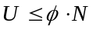. Now that LRFD design is upon us, it is time for yet another version of ConBridge, QConBridge. A Q was added to the ConBridge name for similar reasons the U was added for ultimate strength design. The total factored load equation in LRFD is 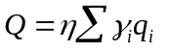.

About the Manual

Organization
The chapters in the User Guide are organized in the following way:
- The Introduction gives an overview of QConBridge and the manual. In addition, all the menus and toolbar commands are described in one location for your reference.
- The next seven chapters are arranged by bridge building tasks: Creating a Bridge Model, Editing a Bridge Model, Adding and Modifying Spans and Supports, Modifying Loads, Analyzing the Bridge, Viewing Results and Printing files.
- The appendix includes information on Windows Management, Using Help and Notes to the Engineer.
- The Glossary and Index are at the end.

Conventions
The QConBridge documentation uses a few special symbols and conventions.

- Specific text you are to type in and the names of commands to choose are shown in bold.
- Keys are frequently used in combinations or sequences. For example, SHIFT+F1(with a + sign) means to hold down the SHIFT key while pressing F1, and ALT, F, A (with comma) means to press and release each of these keys in order: first ALT, then F, and then A.
- To choose a command from a menu, you can use the mouse or press a key combination. In procedures, key sequences follow the menu and command names. For example: From the File menu, choose Open (ALT, F, O).
- For commands with a toolbar button alternative, the button appears in the left-hand margin.
- For operations with a context menu alternative, the mouse symbol 8 appears in the left-hand margin.

Choosing Commands
There are several ways of choosing commands in QConBridge. All commands are available on the pull-down menus from the Main Menu. Frequently-used commands are buttons on the Toolbar that you click with your mouse. All commands have keyboard alternatives, some of them also have keyboard shortcuts. If you are new to Windows, see the Appendix for information on Windows management.

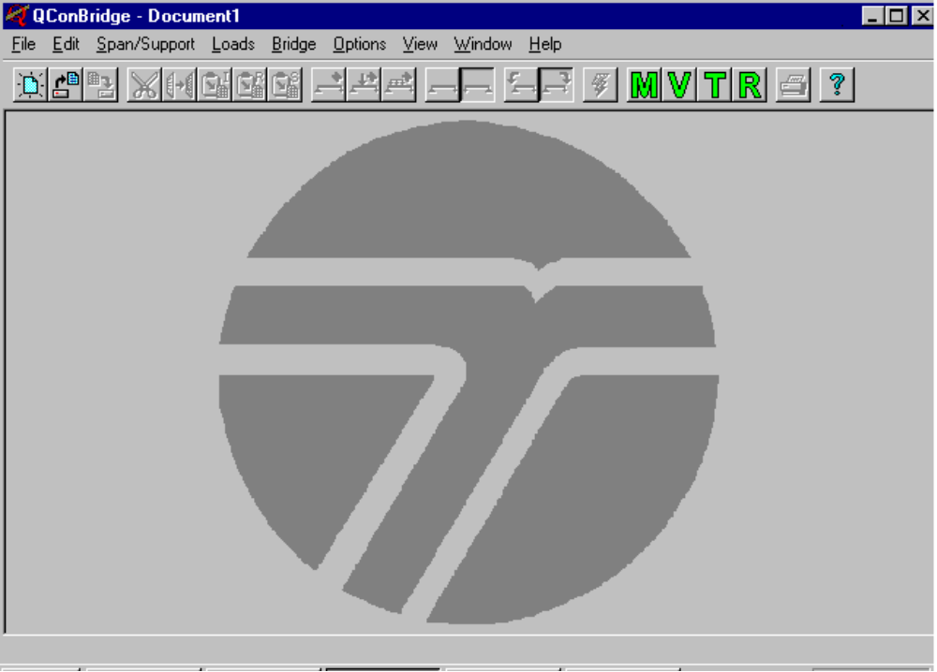
Toolbar
Main Menu
Figure 1-1 - QConBridge window when you first start the program
You can also use your right mouse button to choose commands from context (also know as speed) menus. The context menus are shown at the end of this section.

Note - While most of the commands do the same thing no matter where they are initiated; the manual notes a few that have slightly different behavior.

The Toolbar
The toolbar is located across the top of your window. You can use a button when it is highlighted. The following two diagrams of the toolbar explain the icons in different ways. The first diagram gives the commands names and the second groups them into task categories.

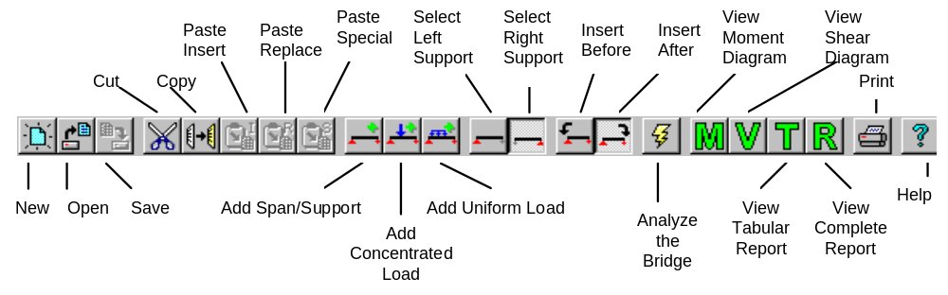
Figure 1-2 - Toolbar Commands

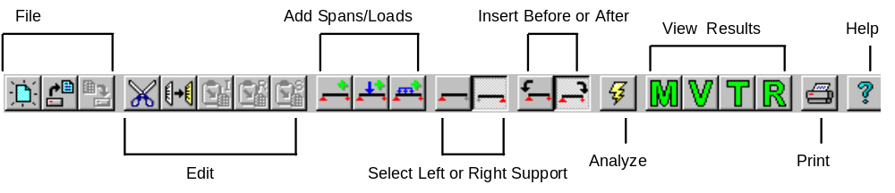
Figure 1-3 - Toolbar Commands - Tasking Categories

Menus
All commands are available on pull-down menus from the Main Menu commands. All the menus are shown in this section with a brief explanation and the associated icon from the toolbar.

File Menu

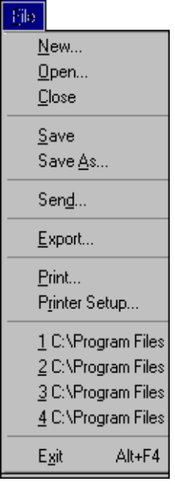
 | Command | Description
 | New | Create a new, untitled, document (model).  There is a difference between clicking the New button and choosing New from the menu. See the note below this table.
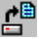 | Open | Open an existing document
 | Close | Close the current document.
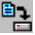 | Save | Save the current document if its contents have changed.
 | Save As | Save the current document under a new name.
 | Send | Sends a mail message with the current document as an attachment.
 | Export | Export a table or report to an external file.
 | Print | Print the contents of current view.
 | Printer Setup | Select and setup a printer.
 | Exit | Exit QConBridge.

Note - Choosing New from the File menu, activates the Bridge Contractor which generates a framework that requires minimal input. If you click New , you get a blank Editor window to create a bridge model from scratch with a “blank sheet”. See Chapter 2, Creating a Bridge Model.

Edit Menu
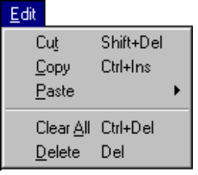
 | Command | Description
 | Cut | Removes the selected span/support pair or load and places it onto the clipboard.
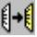 | Copy | Copies selected span/support pair or load to the clipboard.
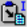 | Paste Insert | Inserts the contents of the clipboard into the bridge model.
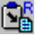 | Paste Replace | Replaces the current selection with the contents of the clipboard.
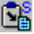 | Paste Special | Performs custom paste operations with the contents of the clipboard.
 | Clear All | Deletes the entire bridge model.
 | Delete | Deletes selected span/support pair or load.

Span/Support Menu
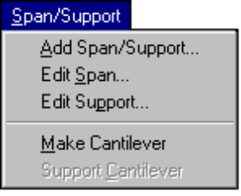
 | Command | Description
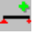 | Add Span/Support | Adds a span/support pair to the bridge model.
 | Edit Span | Edits the selected span
 | Edit Support | Edits the selected support
 | Make Cantilever | Removes a support to cantilever a span
 | Support Cantilever | Adds a support to a cantilevered span

Loads Menu
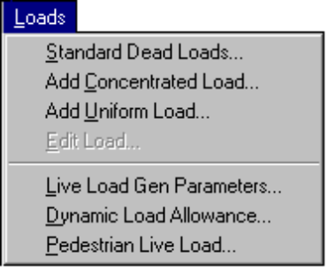
 | Command | Description
 | Standard Dead Loads | Edit the standard dead loads.
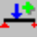 | Add Concentrated Load | Add a concentrated load.
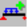 | Add Uniform Load | Add Uniform Load
 | Edit Load | Edit the selected load.
 | Live Load Gen Parameters | Edit the live load generation parameters.
 | Dynamic Load Allowance | Edit the dynamic load allowance factors.
 | Pedestrian Live Load | Edit the pedestrian live load.

Bridge Menu
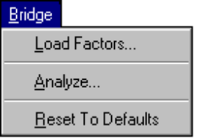
 | Command | Description
 | Load Factors | Edit Load Factors.
 | Analyze | Analyze the bridge model.  There is a difference between clicking the Analyze icon and choosing Analyze from the Bridge menu. See the note below this table.
 | Reset to Defaults | Reset to default values.  - Dynamic Load Allowance Factors (impact)  - Live Load Generation Factors  - Load Factors

Note - Choosing Analyze from the menu, brings up a window to modify report format whereas clicking Analyze skips the modify window and starts the analysis immediately.

Options Menu
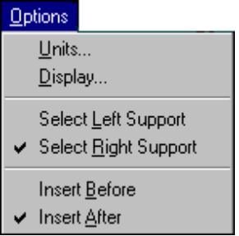
 | Command | Description
 | Units | Change the system of units.
 | Display | Edit screen and print display options.
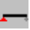 | Select Left Support | Switches the selection mode to Left Support.
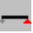 | Select Right Support | Switches the selection mode to Right Support.
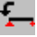 | Insert Before | Switches the insertion mode to Insert Before.
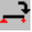 | Insert After | Switches the insertion mode to Insert After.

View Menu
You can have multiple views open at a time, except for the Editor (You may have only one Editor view open at a time). For example, several moment and shear diagrams depicting different loads can be open at the same time for comparison.

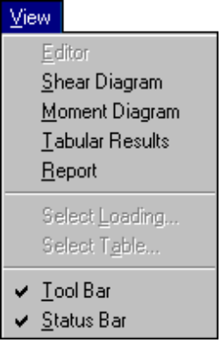
 | Command | Description
 | Editor | Open the editor window.
 | Shear Diagram | Open a shear diagram window.
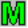 | Moment Diagram | Open a moment diagram window.
 | Tabular Results | Open a tabular results window.
 | Report | Open a report window.
 | Select Loading | Select a loading for which results will be displayed.
 | Select Table | Select a results table.
 | Tool Bar | Toggle displays or removes toolbar from screen.
 | Status Bar | Toggle displays or removes Status Bar from the screen.

Window Menu
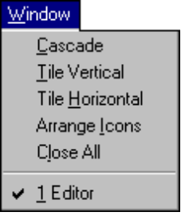
 | Command | Description
 | Cascade | Resize and position all windows in an overlapping pattern.
 | Tile Vertical | Resize and position all windows in a vertical non overlapping pattern.
 | Tile Horizontal | Resize and position all windows in a horizontal non overlapping pattern.
 | Arrange Icons | Align all iconized windows along a grid.
 | Close All | Close all windows.
 | n View | Brings an open view to the front

Help Menu
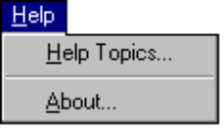
 | Command | Description
 | Help Topics | Help topic contents.
 | About | Information about QConBridge.

Keyboard Alternatives and Shortcuts
All commands have keyboard alternatives. Some have shortcuts. They are all shown on the pull-down menus.

Alternatives
- Alt, _ Alt followed by one other key opens the menu that has the letter of the second key underlined. For example, you open the File menu with (ALT,F).
- Alt,_,_ ALT followed by two other key strokes opens a menu and executes a command on that menu—this sequence is an extension of the one above. For example, to execute the New command in the File menu, use (Alt, F, N).

Shortcuts
Some commands on the File and Edit menu have keyboard shortcuts. They are shown on the menus next to the command. For example, you can execute Exit the program by pressing Alt+F4.

Context Menus
Context menus (also known as Speed menus) provide quick access to commonly used commands within the context of a certain task. They group commands together that otherwise you might have to choose off several pull-down menus from the main menu commands.

Activate the context menus by pressing the right (secondary) mouse button and selecting the desired command.

Note - In the Reference Manual, the mouse symbol8 in the left-hand margin indicates a context menu is available for that procedure.

For example, in the Editor view when you highlight a span and press the right mouse button, you get a context menu with commands from the Edit, Span/Support and Load menus. This context menu includes all commands necessary to do operations with a span at the touch of the mouse button.

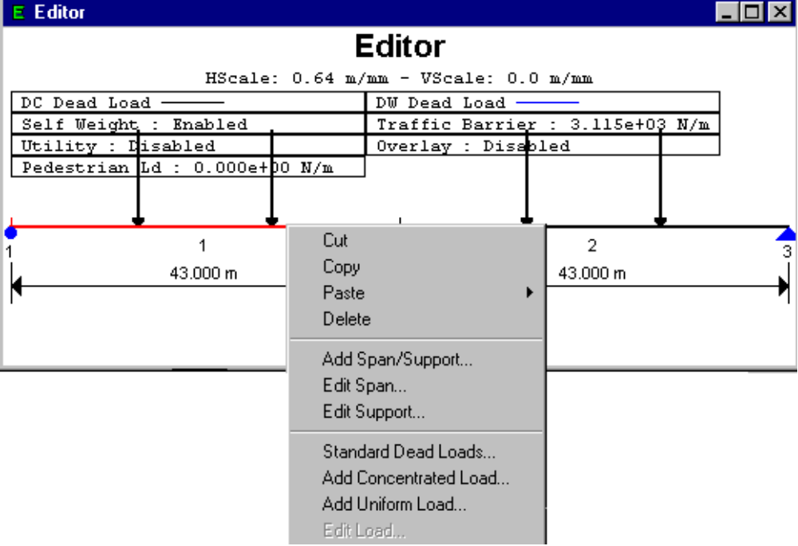
Figure 1-4 - Sample Context Menu
Context Menus are available for the following parts of QConBridge:

Editor View
This context menu is available when your are working in the Editor window. Highlight a span/support pair or load by positioning the mouse on the item and press the left (primary) mouse button. Click the right mouse button and the context menu in Figure 1-4 appears.
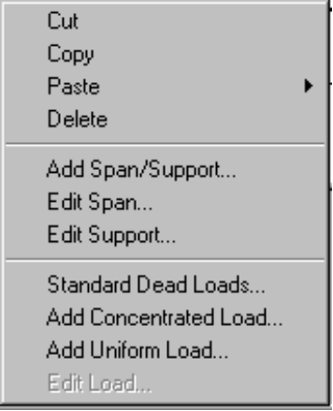

Add Span/Support and Edit Span/Support Dialog Boxes
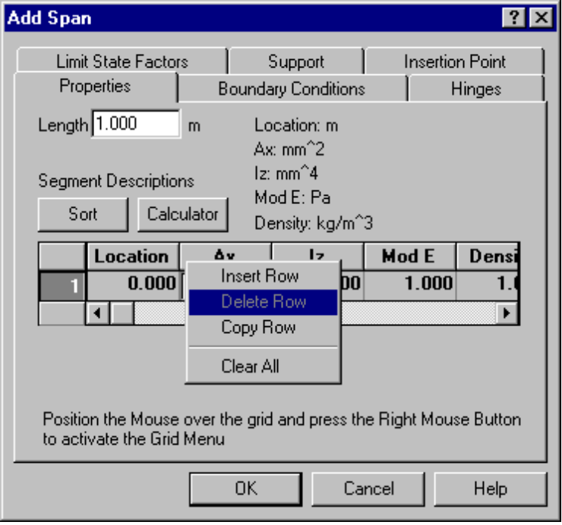
Figure 1-5 - Context Menu - Properties Tab
There is a context menu for adding segments to a span in the Properties Tab of the Edit and Add Span/Support dialog boxes. Point the mouse to any value cell in the grid and click the right mouse button. The context menu shown in Figure 1-5 appears.

Shear and Moment Diagram Views
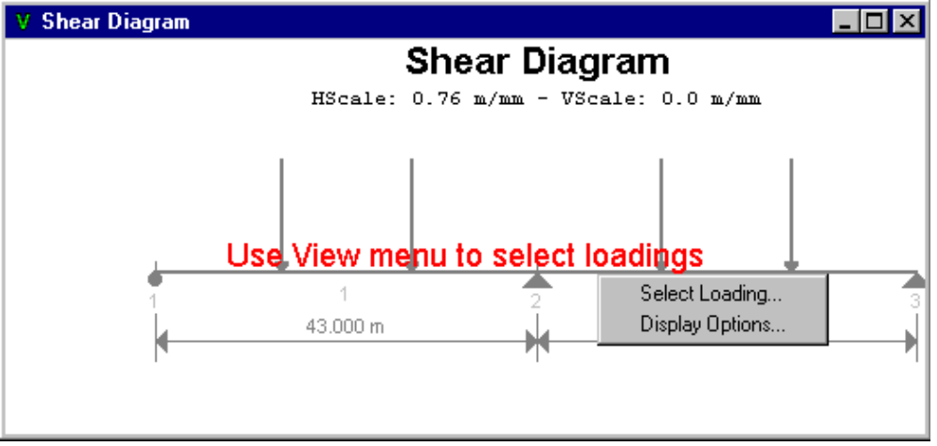
Figure 1-6 - Context Menu in Shear Diagram View
Click the right mouse button anywhere in the Moment or Shear Diagram window and the context menu shown in Figure 1-6 appears.

Tabular Report View
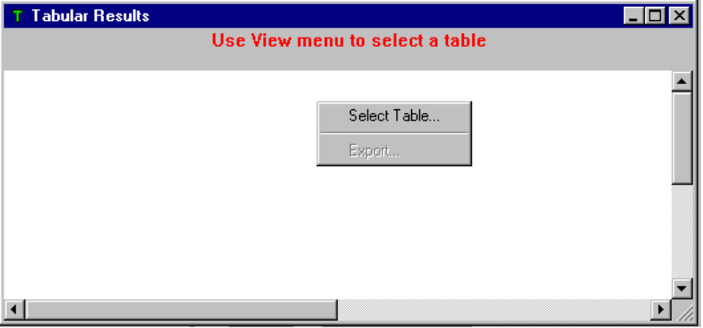
Figure 1-7 - Context Menu in Tabular Report View
Figure 1-7 shows the context menu available in the Tabular Report view.

Report View
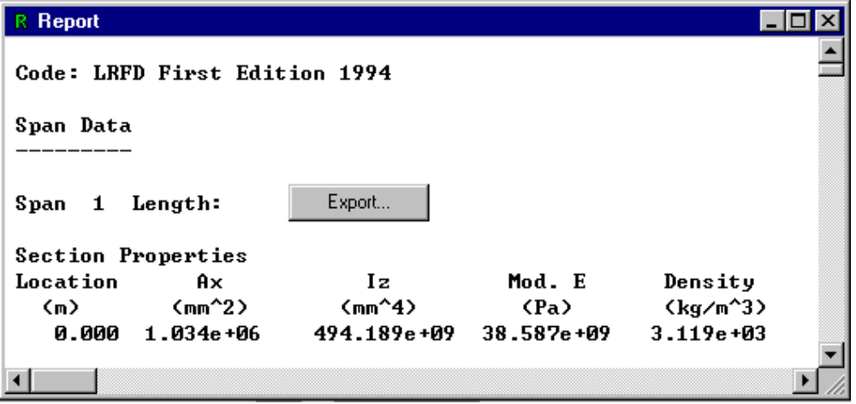
Figure 1-8 - Context Menu in Report View
In the Report window, you may click the right mouse button and choose the Export command.

Symbols
QConBridge uses special symbols to represent elements of the bridge model. They appear in the Editor, Shear Diagram and Moment Diagram Views. The symbols and what they represent are shown in the following table.

Symbol | Description
 | Roller Support
 | Pinned Support
 | Fixed Support
 | Hinge. A point in the structure where the moment continuity has been removed. Hinges can appear at the top of a column, at the left and right ends of a span, or within a span.
 | Concentrated Load
 | Uniform Load

