Creating a Bridge Model
Introduction
Creating a Bridge Model
Using the Bridge Contractor
Guidelines for building a model with the Bridge Contractor
To Use the Bridge Contractor
Bridge Contractor - General Properties
Number of Spans
Span Continuity
Select System of Units
Bridge Geometry
Span Geometry
Boundary Conditions
Cross Section Description
Interior Support Description
Support Geometry
Section/Material Properties
Boundary Conditions
Bridge Model in the Editor Window
Creating a Bridge Model with a “Blank Sheet”
To Create a new bridge model with a “Blank Sheet”
Saving a Model
To Save an Existing Model
To Save a New, Unnamed Model
Opening an Existing Model
To Open an existing model

Introduction
QConBridge builds bridge models that support the AASHTO LRFD Bridge Design Specification, First Edition 1994. The program models simple and continuous bridge structures of virtually any cross section. They can be full width or line of girders models. QConBridge does both Live and Dead Load analysis.

Creating a Bridge Model
QConBridge offers two ways to create a new bridge model. You can build a bridge model automatically with the Bridge Contractor or you can build the model from scratch. The purpose of the Bridge Contractor is to quickly generate the framework of a bridge model with a minimal amount of input. Once you have a basic model, use QConBridge’s editing features to make modifications. QConBridge also gives you the option of building the bridge model from scratch using the “Blank Sheet” method. Using this method, you are not constrained by the limitations of the Bridge Contractor, which builds symmetrical, prismatic bridges. This chapter describes these two methods of creating your bridge model.

Using the Bridge Contractor
Using the Bridge Contractor is a quick and simple way of creating a bridge model. The Bridge Contractor leads you through an interview process to gather information about your bridge. Once the specifications for your bridge are complete, the Bridge Contractor builds the bridge for you.

In order to keep the amount of information required to build the bridge to a minimum, the Bridge Contractor only builds symmetrical structures with prismatic spans.

Guidelines for building a model with the Bridge Contractor
- The minimal input recommended to build a reasonable bridge model is:
- Number of Spans (General Properties window)
- Span Length (Bridge Geometry window)
- Column Height (If you have columns - Interior Support Description window)
- If you are modeling a line of girders for a steel, prestressed concrete, or wood beam and slab bridge, use the Section Properties Calculator to quickly obtain the section properties, material properties, and live load distribution factors.
- Enter any values you know and accept the defaults for all others. You can edit them later.

Tip - If your bridge is not symmetrical, the Bridge Contractor is still of great importance to you. Use the Bridge Contractor to build a framework for your bridge, and then edit it accordingly. This technique has proven to be much faster than building the entire model manually. This is also true if your bridge has non-prismatic spans. Bridge Contractor builds a prismatic bridge but QConBridge has editing features that offer a method for modeling non-prismatic bridges as well. See Chapter 4, p. 4, Segment Descriptions.

To Use the Bridge Contractor
- From the File menu, choose New (Alt,F,N).
The General Properties window appears.

Caution - Do not press the New  button on the toolbar. This creates a “blank sheet” for a new bridge model rather than using the Bridge Contractor. For information on creating a bridge model without using the Bridge Contractor, see section entitled “Blank Sheet”.

- In each of the Bridge Contractor windows, click Next to move to the next window, Back to return to the previous window and Cancel to leave Bridge Contractor.

Note - Clicking Cancel while running the Bridge Contractor returns you to the Editor with a blank screen where you can build a bridge model from scratch. See section on “Blank Sheet”.

- Once you click Finish in the final window, Bridge Contractor builds the model.
- The bridge model appears in the Editor window.

Bridge Contractor - General Properties

Number of Spans
Use the up and down arrows to increase or decrease the Number of Spans you want for your bridge model, or simply enter the desired number of spans.

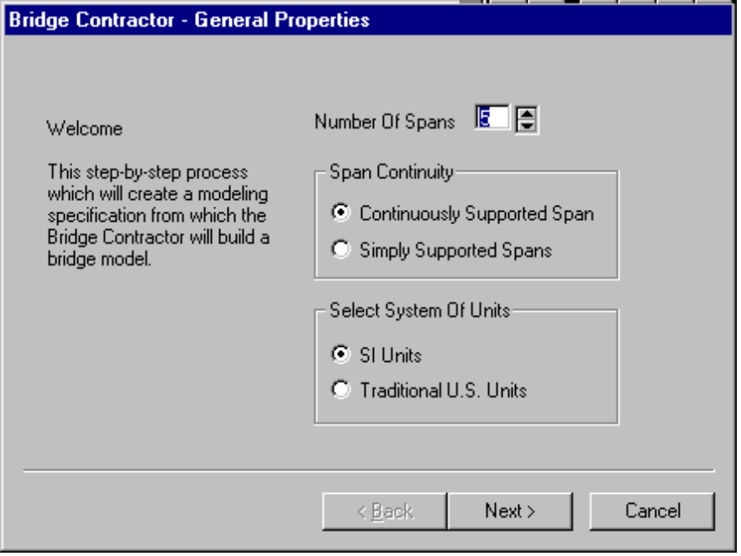
Figure 2-1 - General Properties

Span Continuity
Select one of the options in this group to guide the Bridge Contractor in the construction of your bridge model. By selecting Continuously Support Span the Bridge Contractor will create a continuous bridge model. By selecting Simply Supported Spans, the Bridge Contractor will create a model with a series of simple spans. In a simple span bridge, there is no moment continuity between spans.

Note - When a bridge model is Simply Supported, QConBridge disables the Dual Truck Train loading. The Dual Truck Train loading only applies to negative moments which will not occur with simply supported spans.

Select System of Units
Select the system of units for Bridge Contractor to use for this model. This will be the system of units the Bridge Contractor will use during the remainder of the interview process. The Bridge Contractor will set QConBridge’s units mode to this system of units as well.

Once you are finished building the bridge model with Bridge Contractor, you may change the system of units at anytime while editing your model by choosing Units from the Options menu and switching to the other system of units. This capability can be very helpful, for example, when you have to analyze a bridge that was designed in US units but need to have the answers in SI units. You designate US units for all the input and analysis and change to SI units to display the answers.

Warning - QConBridge does all of its calculations in SI units. All code specific implementation is based on the SI Units version of the AASHTO LRFD Bridge Design Specification. When comparing results produced by hand calculations or other software implementing the Customary U.S. Units version of the code, slight discrepancies may result.

Bridge Geometry
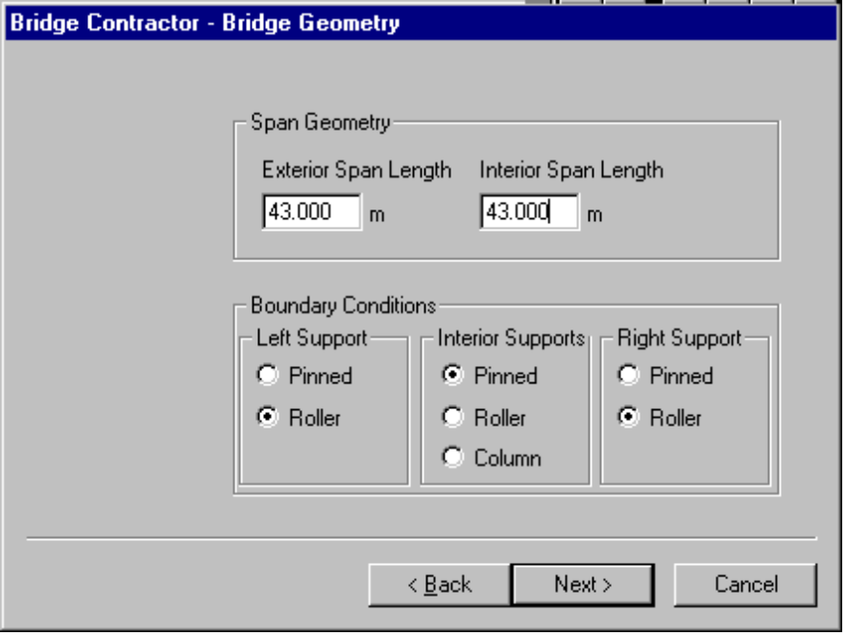
Figure 2-2 - Bridge Geometry

Span Geometry
Enter the Length of the Spans for Bridge Contractor to use. Bridges of less than 3 spans have a Left and a Right Span length, whereas bridges of 3 or greater spans have an Exterior Span length and an Interior Span length.

Boundary Conditions
The Boundary Conditions describe how the bridge is supported. Supports can be modeled with Pin, Roller, or Column elements.

Cross Section Description
If you are building a bridge model of more than 2 spans, Bridge Contractor displays windows for the Cross Section properties for the Exterior and Interior Spans. If the bridge has two spans, the Bridge Contractor asks you for Cross Section Descriptions for the Left and Right Spans.

Calculator
The Section Properties Calculator, activated by clicking , computes the material and section properties and the live load distribution factors for a variety of typical bridge cross sections. It currently computes properties for steel plate girders, steel wide flange beams, precast prestressed I-Beams/Bulb-Tees, and wood beams.

The properties and factors computed by the Section Properties Calculator are imported into QConBridge. QConBridge remembers these values, but forgets where they came from.
If you know what type of bridge you are modeling, use the Calculator when creating the model. Figure 2-3 shows the values calculated using the Calculator. For more information on the Section Properties Calculator, see Chapter 4.

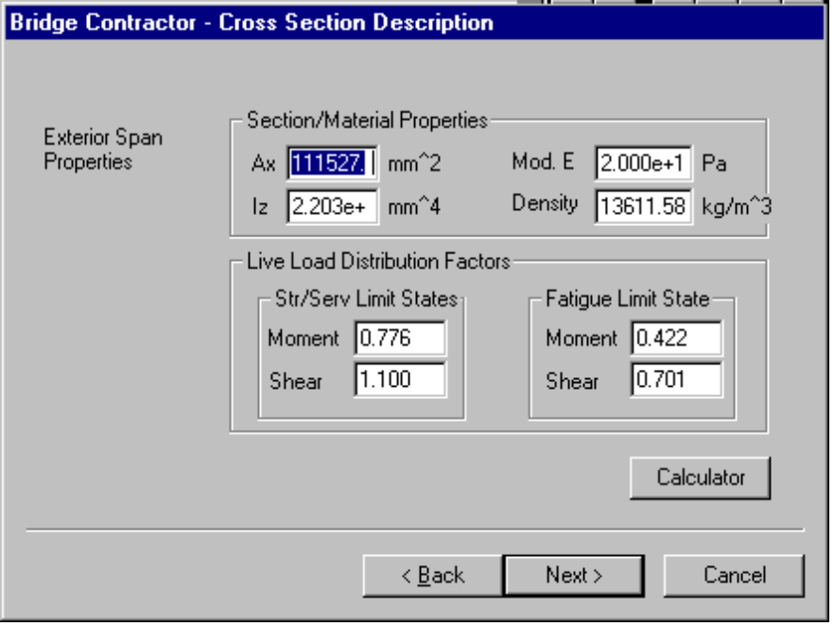
Figure 2-3 - Cross Section Description - Exterior Span (using Calculator)
You can also accept the defaults and use the Calculator when editing your bridge model after it is built. Figure 2-4 shows the defaults for the Interior Span properties.

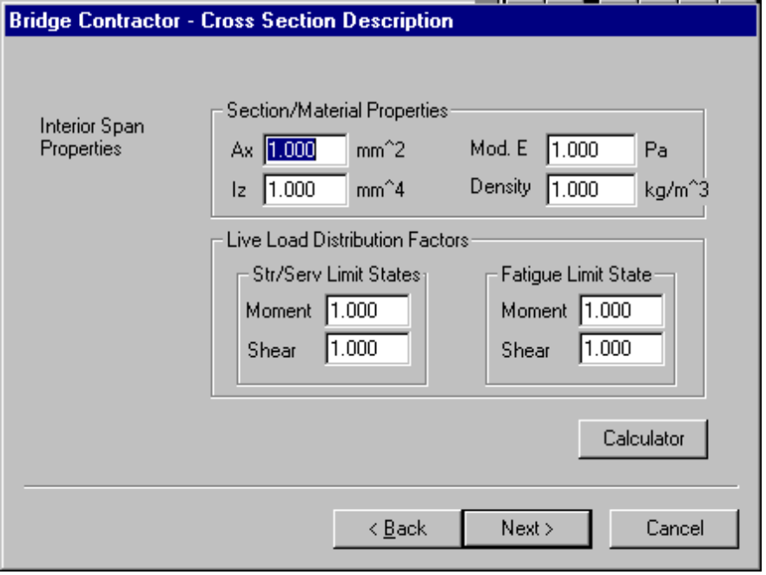
Figure 2-4 - Cross Section Description - Interior Span Properties (accepting defaults)

Interior Support Description

Support Geometry
If you have a Column support, the Interior Support Description window appears.
You enter the Column Height which is 5 meters in the following sample screen.

Section/Material Properties
Enter the cross-sectional properties or accept the defaults.

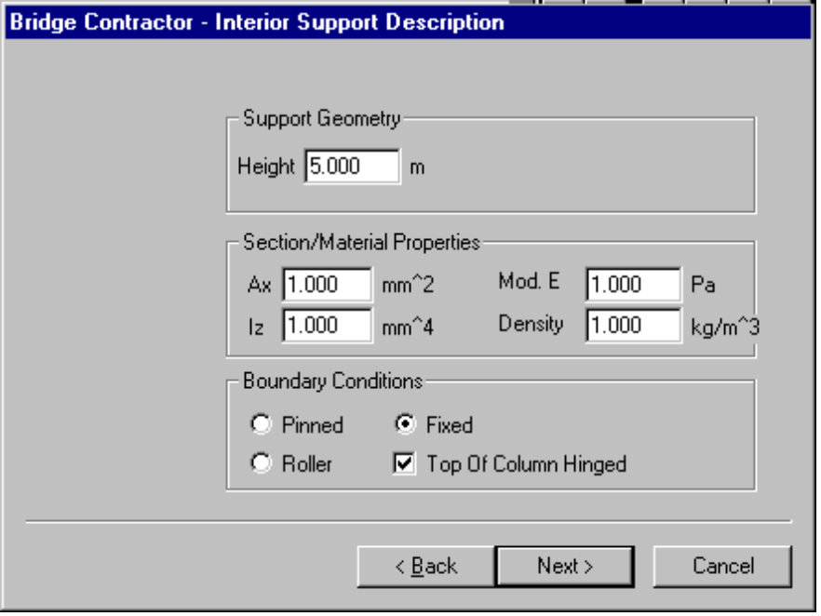
Figure 2-5 - Interior Support Description (Bridge Model with Column Support)

Remember! - Work in the context of the problem you are trying to solve. If you are modeling a Line of Girders and you have a multi-column support, you need to enter section properties that are consistent with this type of model. If you are doing a Full Width Bridge model, then your properties need to be consistent with that type of model.

Boundary Conditions
The Column can be Pinned, Roller, Fixed.
If Top of Column Hinged box is checked, there is no moment continuity between the column and the connecting span members.

Bridge Model in the Editor Window
Once you click Finish in the Done window, Bridge Contractor builds the model and draws it in the Editor window.

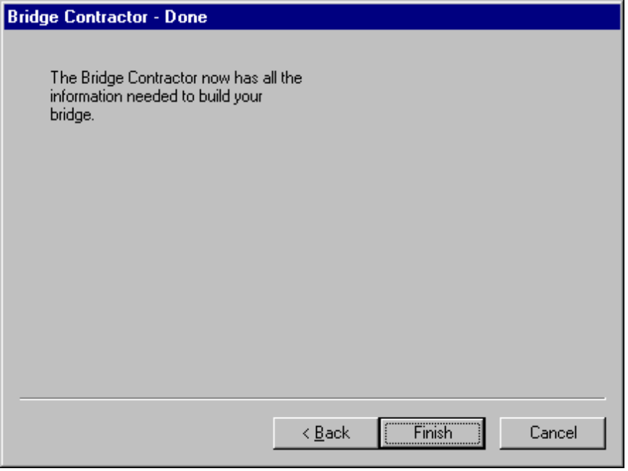
Figure 2-6 - Done window

For example, the model drawn in the Editor window in Figure 2-7 shows a 5 span bridge with hinged column supports.

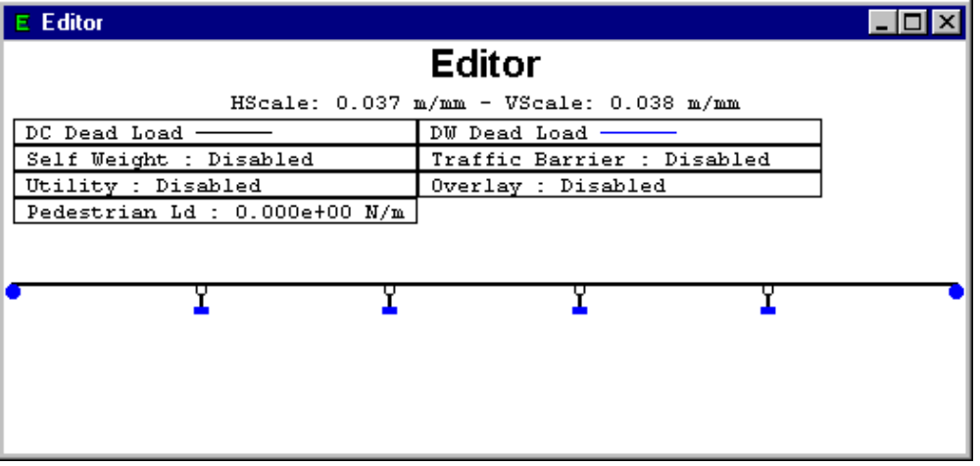
Figure 2-7 - Bridge model drawn in the Editor window.
If the Bridge Contractor was able to build the model you wanted, you are ready to add some loads, if not now is the time to make any necessary modifications. Refer to Chapters 3 and 4 for more information about editing a model.

Creating a Bridge Model with a “Blank Sheet”
You can create a bridge model completely from scratch using the “Blank Sheet” method in QConBridge. Rather than running the Bridge Contractor and ending up with a basic model built in the Editor window, you start out with a blank Editor window and add spans, supports and loads to create what ever kind of model you need..

To Create a new bridge model with a “Blank Sheet”
- Click on the toolbar. A blank Editor window appears.
- Use the editing features to add spans, supports and loads. To start, see Chapter 3 and 4 on Editing Features and Adding Spans and Supports.

Saving a Model
Save your bridge model by using either the Save command or the Save As command. The Save command allows you to quickly save an existing model. The Save As command saves the model under a new name.

To Save an Existing Model
 From the File menu, choose Save (Alt, F, S).
The model is saved under its same name.

To Save a New, Unnamed Model
From the File menu, choose Save As (Alt, F, A).
The Save As dialog box appears. Enter a name and click OK.

Opening an Existing Model

To Open an existing model
 1. From the File menu, choose Open (Alt, F, O).
The Open dialog box appears.
2. Choose the model you want to edit and click OK.
QConBridge displays the model.

OR
1. Drag the file from Explorer and Drop it on QConBridge’s main menu.
QConBridge displays the model.

